Password Strength Checker
Security Logic & Validation — Project 1
DecodeLabs Industrial Training Kit — Batch 2026
Prepared by: Damilola

1. Objective
Build a Python program that evaluates whether a password is Weak, Medium, or Strong, based on length and character variety — demonstrating fundamental security logic: data validation, conditional risk classification, and awareness of entropy (unpredictability) in password design.

2. Approach
The checker validates two dimensions of password strength:
1. Length — passwords under 8 characters are automatically classified Weak, regardless of complexity, since short strings are exponentially more vulnerable to brute-force attacks.
2. Character variety score — counts how many of 4 categories are present: uppercase, lowercase, digit, and symbol. A password reaching 3 or more categories at sufficient length is classified Strong; 2 categories is Medium; fewer is Weak.

3. Source Code
def check_password_strength(password):
length = len(password)
has_upper = any(char.isupper() for char in password)
has_lower = any(char.islower() for char in password)
has_digit = any(char.isdigit() for char in password)
has_symbol = any(char in "!@#$%^&*()_+-=[]{}|;:,.<>?" for char in password)

score = sum([has_upper, has_lower, has_digit, has_symbol])

if length < 8:
return "Weak (too short — must be at least 8 characters)"
elif length >= 8 and score >= 3:
return "Strong (good length + mix of character types)"
elif length >= 8 and score == 2:
return "Medium (decent length, but add more variety)"
else:
return "Weak (add uppercase, numbers, or symbols)"

4. Test Results
Password | Result | Reasoning
abc123 | Weak ❌ | Too short (< 8 characters)
Password1 | Strong ✅ | 8+ chars, 3/4 categories (upper, lower, digit)
P@ssw0rd!23 | Strong ✅ | 8+ chars, all 4 categories present
12345678 | Weak ❌ | 8 chars but only digits (1/4 categories)
Str0ng&Secure99 | Strong ✅ | 8+ chars, all 4 categories present

Evidence: full Colab execution below, including an interactive live test.
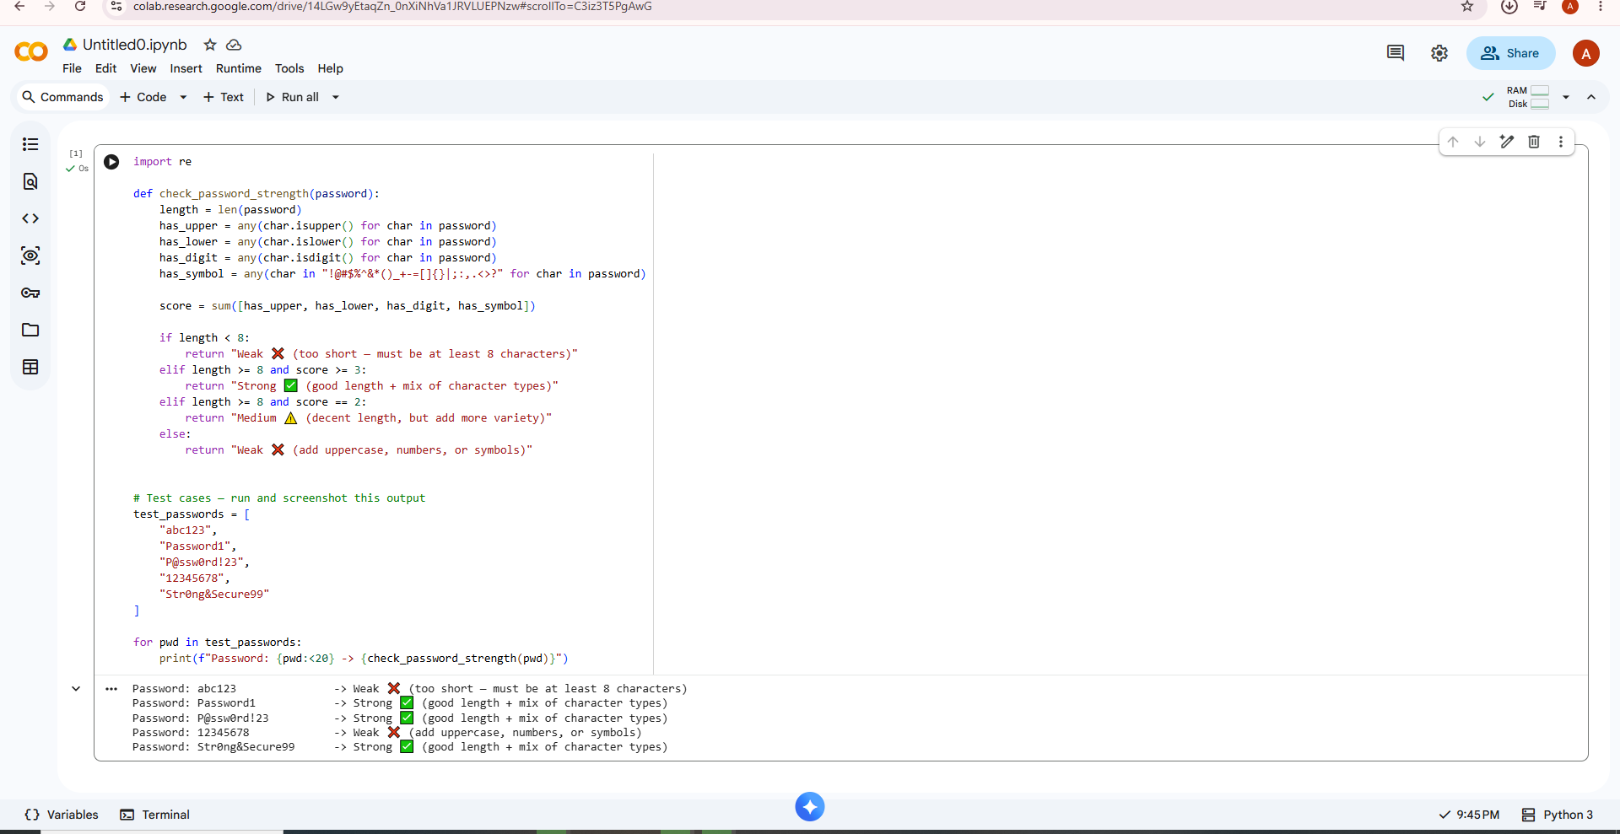
Figure 1 — Full test suite run against 5 sample passwords in Google Colab.
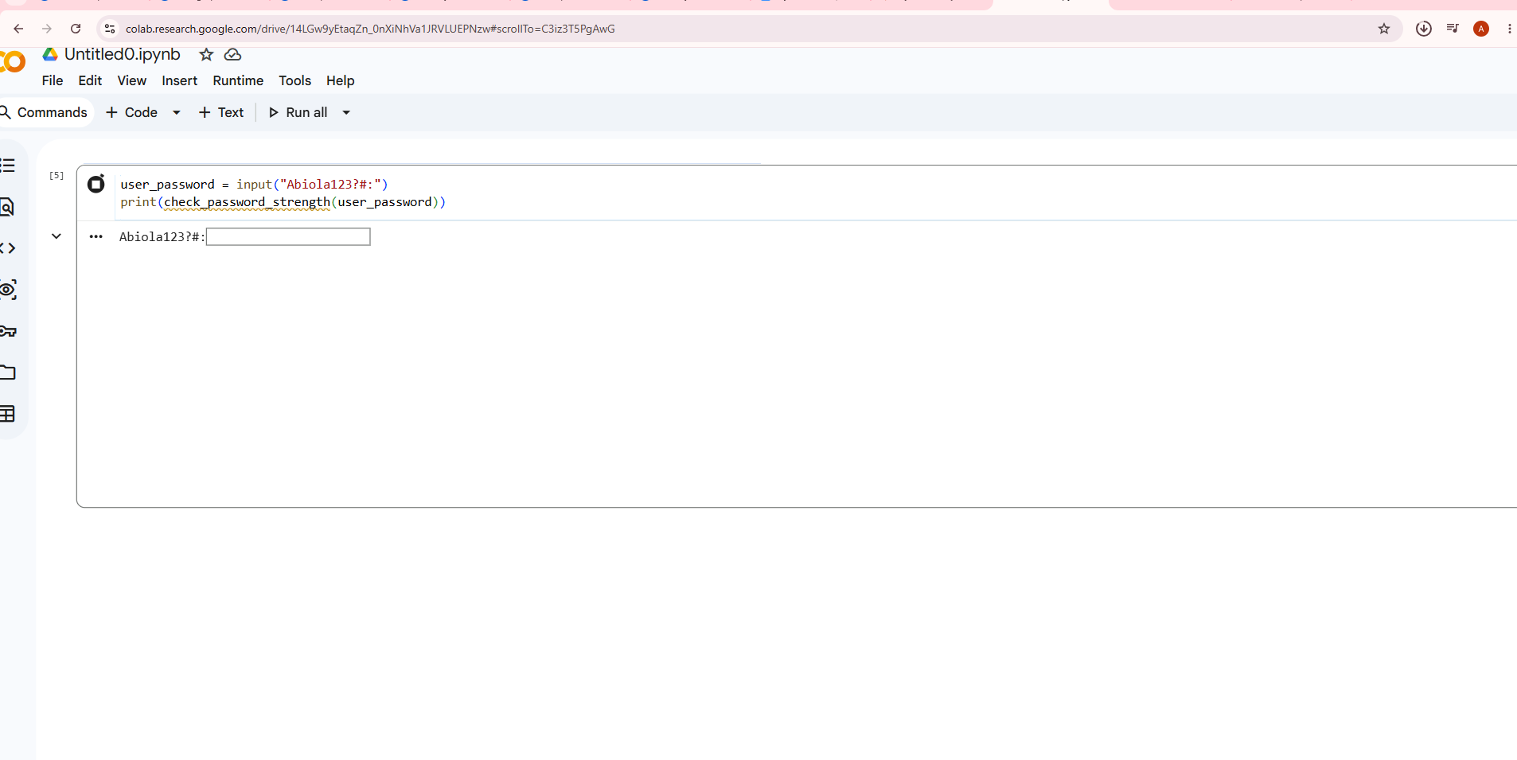
Figure 2 — Interactive input cell for live password testing.

5. Key Learning / Limitation Noted
“Password1” scores as Strong under this logic, since it hits 3 of 4 character categories at 8+ characters — despite being a fairly common, guessable, dictionary-based password in real-world use.
This highlights a genuine limitation of simple category-counting checks: character variety alone does not measure true unpredictability (entropy). A more robust checker would additionally screen input against a list of common or previously leaked passwords, not rely on structural rules alone. This distinction — structural complexity vs. actual guessability — is a key concept in real password policy design.

6. Conclusion
This project demonstrates the foundational logic behind password policy enforcement: validating input against multiple criteria and classifying risk accordingly. While simple, the same core pattern (length checks, character-class checks, scoring) underpins real authentication systems, and understanding its limitations — as identified above — is as valuable as building the checker itself.

