Mental Health and Psychosocial Outcomes Among Individuals With Mayer-Rokitansky-Küster-Hauser (MRKH) Syndrome: A Scoping Review
Running title: Mental health in MRKH syndrome: a scoping review
Ifeoluwanimi P. Shobayo, BSc, MSPHc¹; Paul Okojie, PhD¹; Robyn Anderson, PhD¹
¹Department of Public and Community Health, Liberty University, Lynchburg, Virginia, USA

Corresponding author: Ifeoluwanimi P. Shobayo, Department of Public and Community Health, Liberty University, Lynchburg, VA, USA. Email: [corresponding author email]
Word count (main text): 2,575 Tables: 4 Figures: 4 Supplementary material: Appendices A–C
Prior presentation: An abstract of this work was submitted to the American Public Health Association (APHA) 2026 Annual Meeting & Expo, Sexual and Reproductive Health Section, and accepted for poster presentation.
Keywords: Mayer-Rokitansky-Küster-Hauser syndrome; Müllerian agenesis; mental health; coping; psychosocial outcomes; quality of life; reproductive health

Abstract
Background: Mayer-Rokitansky-Küster-Hauser (MRKH) syndrome is a rare congenital condition, affecting approximately 1 in 4,500–5,000 female births, characterized by uterovaginal agenesis in individuals with a 46,XX karyotype and functional ovaries. Typically diagnosed during adolescence, MRKH is associated with significant psychosocial burden, yet mental health outcomes and coping mechanisms remain insufficiently synthesized, limiting their integration into clinical care and public health planning. This scoping review mapped the mental health outcomes, coping mechanisms, and healthcare system gaps reported among individuals with MRKH.
Methods: Following Arksey and O'Malley's framework and the PRISMA Extension for Scoping Reviews (PRISMA-ScR), we searched PubMed, Scopus, and (via EBSCOhost) MEDLINE, CINAHL, APA PsycInfo, and Women's Studies International for studies published between January 2019 and March 2026. Eligible studies were primary quantitative, qualitative, and mixed-methods research reporting psychological outcomes and/or coping mechanisms in MRKH populations.
Results: Of 516 records identified (324 after deduplication), 35 studies were included. Psychosexual and relational challenges were the most frequently reported outcomes (n = 24; 69%), followed by reduced quality of life, body image, and self-esteem (n = 19; 54%), broader psychological distress (n = 20; 57%), and depression and anxiety (n = 14; 40%). Coping mechanisms were documented in 15 studies, mostly peer support and self-management, and healthcare system gaps in 10. Studies came mainly from Europe (n = 14) and Asia (n = 14).
Conclusions: MRKH-related psychosocial burden is substantial yet under-integrated into care models. Multidisciplinary, mental health–inclusive care and greater research investment, particularly in underrepresented and low-resource settings, are urgently needed.

Introduction
Mayer-Rokitansky-Küster-Hauser (MRKH) syndrome, also termed Müllerian agenesis or Müllerian aplasia, is a congenital condition characterized by absence of the uterus and upper two-thirds of the vagina in individuals with a 46,XX karyotype, functional ovaries, and typical secondary sexual development. It affects approximately 1 in 4,500–5,000 female births¹; a nationwide Danish registry study estimated a prevalence of 1 in 4,982 live female births.² MRKH is classified as type I (isolated uterovaginal aplasia) or type II (accompanied by extragenital anomalies, most often renal, skeletal, auditory, or cardiac).³ Diagnosis is usually made in adolescence during evaluation for primary amenorrhea,^{1,3} a developmental period that is critical for identity formation, body image, and social relationships.
The diagnosis carries profound implications for fertility, psychosexual development, and self-image. Management commonly includes vaginal dilation as first-line treatment, surgical creation of a neovagina when indicated, and fertility options such as gestational surrogacy and, more recently, uterus transplantation.^{1,3} The American College of Obstetricians and Gynecologists identifies psychosocial counseling as one of the most important components of effective management.¹ Earlier studies documented elevated psychological distress and lower self-esteem among women with MRKH compared with controls,⁴ higher anxiety scores among affected adolescents,⁵ and poorer mental health–related quality of life, higher anxiety, and impaired sexual wellness relative to normative data.⁶ A review of this early literature concluded that creating a neovagina alone does not ensure a good psychological outcome and that psychological support at critical times can be helpful,⁷ while qualitative work described how young women manage intimacy, a sensitivity to difference, and threats to identity after diagnosis.⁸ More recent qualitative studies describe emotional turmoil at diagnosis, challenges to sexual identity and intimate relationships, the profound impact of infertility,⁹ and reduced self-esteem and sexual wellbeing.¹⁰
Two systematic reviews have since synthesized the psychological, quality-of-life, and sexual outcomes of MRKH.^{11,12} However, to our knowledge, the more recent literature has not been mapped with a public health lens that jointly considers mental health outcomes, the coping mechanisms individuals use, and the healthcare system gaps that shape access to psychosocial support. As a result, psychosocial outcomes remain insufficiently integrated into clinical and public health frameworks for this population.
A scoping review is well suited to mapping a heterogeneous body of quantitative, qualitative, and mixed-methods evidence and identifying gaps for future research and practice.^{13,14} This scoping review therefore addressed the following research question: What mental health outcomes and coping mechanisms are reported among individuals with MRKH syndrome, and what healthcare system gaps exist?

Methods

Study Design
This scoping review followed Arksey and O'Malley's five-stage methodological framework¹³—(1) identifying the research question; (2) identifying relevant studies; (3) selecting studies; (4) charting the data; and (5) collating, summarizing, and reporting the results—and is reported in accordance with the PRISMA Extension for Scoping Reviews (PRISMA-ScR; Appendix C),¹⁴ informed by published guidance on the steps of conducting a scoping review.¹⁵ A review protocol was not registered.

Eligibility Criteria
Eligibility was defined using the Population–Concept–Context approach. The population was individuals diagnosed with MRKH syndrome; the concepts were psychological or mental health outcomes and coping mechanisms; and the context was any healthcare or community setting in any country. We included primary quantitative, qualitative, and mixed-methods studies published between January 2019 and March 2026 that reported psychological outcomes and/or coping mechanisms among individuals with MRKH. Studies focused solely on anatomical, surgical, or fertility outcomes were excluded, as were records published before January 2019 and records not published in English (the English-only criterion recorded in the review's March 2026 screening tracker). Reviews, commentaries, editorials, and case reports were excluded as not primary research.

Information Sources and Search Strategy
Searches were run and exported on March 29, 2026, in PubMed, Scopus, and EBSCOhost [confirm the PubMed search was also run on this date]. The EBSCOhost search covered MEDLINE Ultimate, CINAHL Ultimate, APA PsycInfo, and Women's Studies International, and APA PsycInfo was also exported separately (Appendix A). Date limits were not applied identically across interfaces: the Scopus search was limited to 2019–2026, the PubMed export covered 2021–2026 (MEDLINE records from 2019–2020 were captured through the EBSCOhost MEDLINE search), and EBSCOhost results were exported without a date limit. Records published before January 2019 were therefore removed during title and abstract screening. Search strategies combined controlled vocabulary and free-text terms for MRKH (e.g., “Mayer-Rokitansky-Küster-Hauser,” “MRKH,” “Müllerian agenesis,” “vaginal agenesis”) with terms for mental health and coping (e.g., “depression,” “anxiety,” “psychological distress,” “quality of life,” “body image,” “coping”). Records retrieved from each source are reported in Appendix A. [Verify that the example terms above match the search you ran; recover exact strings from your PubMed, Scopus, and EBSCOhost search histories if saved.]

Study Selection
The original screening records could not be recovered, so study selection was repeated from the original export files. Records from all sources were merged and 192 duplicates were identified by matching DOIs and normalized titles, leaving 324 unique records. Titles and abstracts were screened in two steps: objective criteria (publication year and article type) were applied first, and each remaining record was then read against the eligibility criteria. An AI tool (Claude, Anthropic) proposed a decision and reason for every record; [the first author and a second reviewer independently verified each decision, and disagreements were resolved by discussion — complete once verification is done]. Records that could not be classified from the exported title and abstract were assessed for eligibility using the published abstract; studies with mixed samples were included only if results were reported separately for participants with MRKH or at least 80% of participants had MRKH. Full texts were then obtained for 30 of the 35 included studies and checked against the same criteria; at this stage one study of adults with differences of sex development was excluded because only 2 of its 15 participants had MRKH and their findings were not analyzed separately. [The full texts of the remaining 5 studies could not be obtained; their inclusion rests on the published abstract or title.] The screening workbook, with a decision and reason for every record, is available as supplementary material.

Data Charting
For each included study, data were charted on author, year, country, study design, sample size, reported mental health and psychosocial outcomes, coping mechanisms, and healthcare system gaps. Charted items were checked against the full text for 30 of 35 studies; the remaining 5 were charted from the title and abstract [and should be checked when their full texts are obtained]. Outcomes were coded into four domains—depression and anxiety; quality of life, body image, and self-esteem; psychosexual and relational challenges; and broader psychological distress—and coping mechanisms into seven categories.

Synthesis
Findings were collated using a descriptive numerical summary—the number and proportion of included studies reporting each outcome domain—and a qualitative content analysis that grouped findings into outcome domains, coping mechanisms, and healthcare system gaps. Because a single study could report multiple domains, domain counts are not mutually exclusive. Consistent with scoping review methodology, a formal critical appraisal of study quality was not performed.^{13,14} Ethical approval was not required because this review analyzed published data.

Results

Selection of Sources of Evidence
The searches identified 516 records. After removal of 192 duplicates, 324 records were screened and 282 were excluded: published before 2019 (n = 89); case report / surgical case series (n = 75); not primary research (n = 48); surgical/functional outcomes only (n = 38); wrong population / topic (n = 28); not in english (n = 4). Of the 42 records assessed for eligibility, 7 were excluded (mixed sample, mrkh not separate, n = 5; no psychological outcome, n = 2), and 35 studies were included (Figure 1).
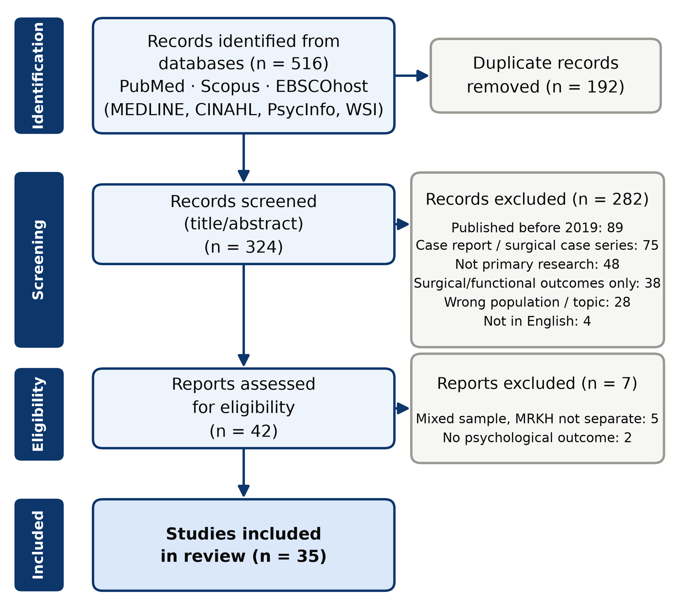
Figure 1. PRISMA-ScR flow diagram of study selection. Counts are pending confirmation by the review team.

Characteristics of Included Studies
The 35 included studies were published between 2019 and 2026 and comprised 18 quantitative studies (51.4%), 14 qualitative studies (40.0%), and 2 mixed-methods studies (5.7%); the design of 1 study could not be determined because only its title was available (Table 1; Figure 2). Quantitative designs included cross-sectional surveys, case-control comparisons, cohort and pre–post studies, and 1 randomized controlled trial.¹⁶ Most studies came from Europe (n = 14) and Asia (n = 14), followed by North America (n = 3), Africa (n = 1), and Oceania (n = 1); 2 studies recruited internationally, and none came from South America (Figure 3). China contributed the most studies (n = 6). Sample sizes, where reported, ranged from 5 to 616 participants. Two Chinese reports appear to draw on the same sample of 141 patients.^{17,18} Characteristics of each study are listed in Appendix B.
Table 1. Study design and geographic distribution of included studies (N = 35)
Characteristic | n | %
Study design
Quantitative | 18 | 51.4%
Qualitative | 14 | 40.0%
Mixed methods | 2 | 5.7%
Not reported | 1 | 2.9%
Region
Europe | 14 | 40.0%
Asia | 14 | 40.0%
North America | 3 | 8.6%
Multinational | 2 | 5.7%
Africa | 1 | 2.9%
Oceania | 1 | 2.9%
South America | 0 | 0.0%
Percentages are of all included studies (N = 35) and may not total 100% because of rounding. Five studies were charted from the abstract or title only.
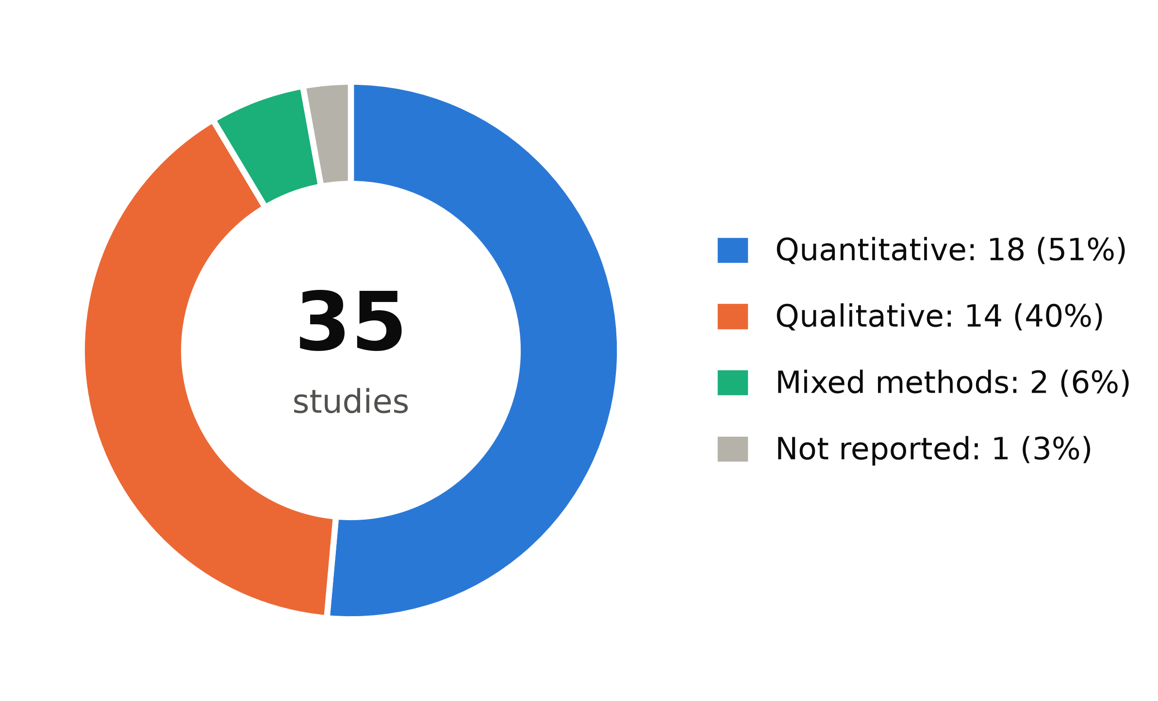
Figure 2. Distribution of included studies by design (N = 35).
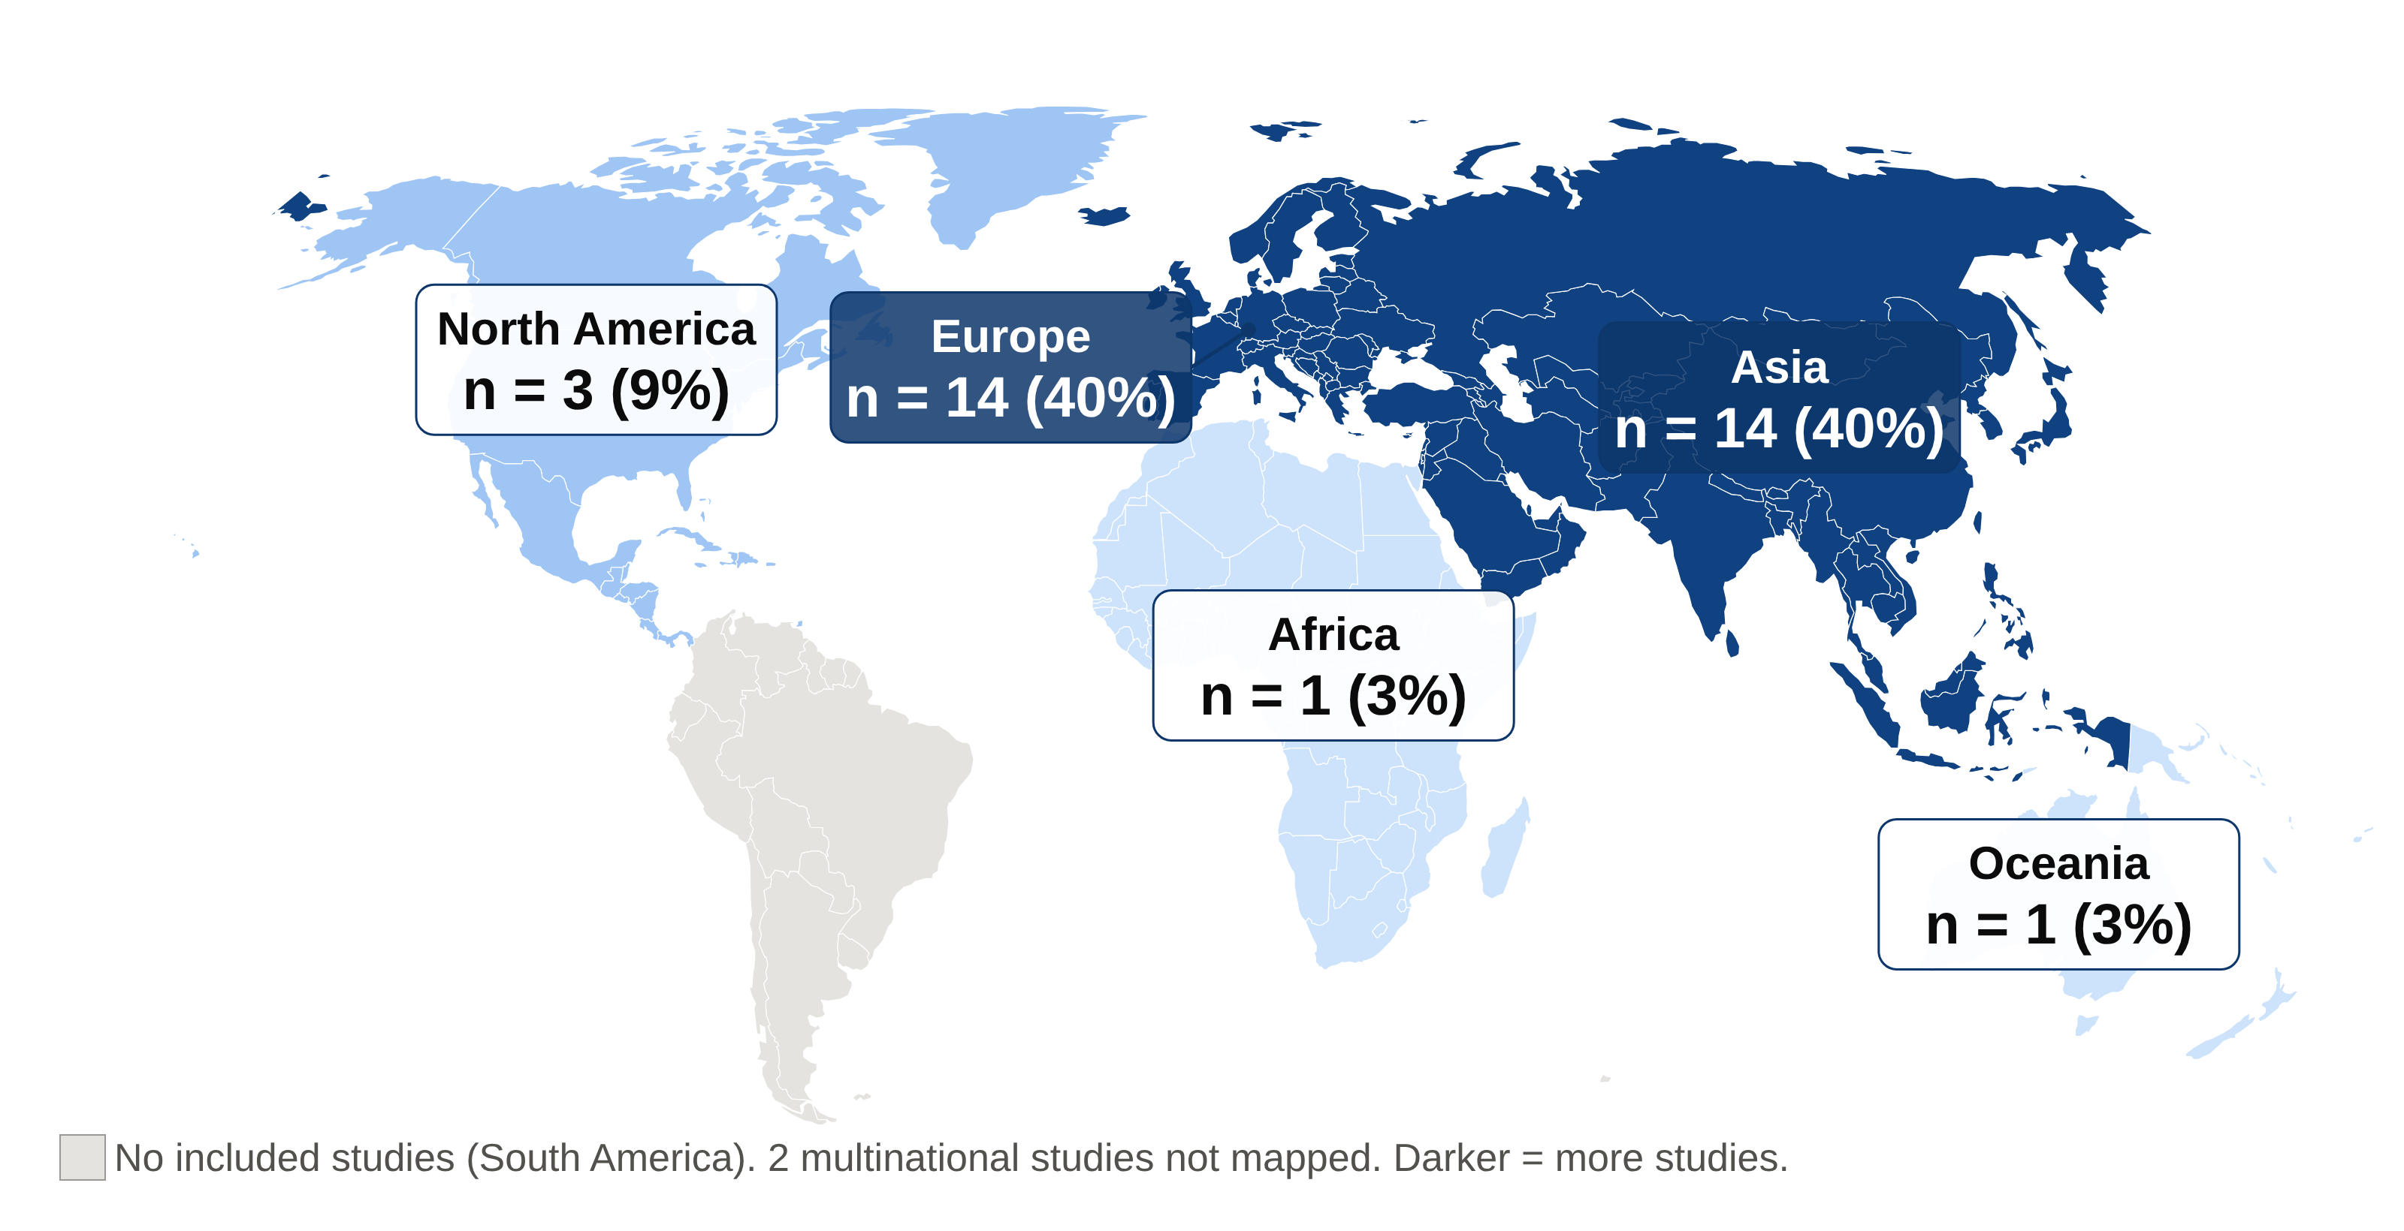
Figure 3. Geographic distribution of included studies by region (N = 35). Darker shading indicates more studies; 2 multinational studies are not mapped.

Mental Health and Psychosocial Outcomes
Psychosexual and relational challenges were the most frequently reported domain (24 of 35 studies; 68.6%), followed by quality of life, body image, and self-esteem (19; 54.3%), broader psychological distress (20; 57.1%), and depression and anxiety (14; 40.0%) (Table 2; Figure 4).
Psychosexual and relational challenges. Compared with controls, women with MRKH reported lower sexual esteem, a more negative genital self-image, and more sexual distress, even after neovagina creation.^{19,20} Qualitative studies described insecurity about the neovagina, low sexual confidence, and anxiety about disclosing the diagnosis to partners.^{10,21–23} One randomized trial found that e-learning psychosexual education improved genital self-image and reduced sexual distress.¹⁶ In an African qualitative study, cultural and religious expectations about virginity discouraged vaginal dilation.²⁴
Quality of life, body image, and self-esteem. A prospective study found impaired mental health–related quality of life despite normal body image,²⁵ and an international survey of 263 patients reported higher distress and lower self-esteem than the general population.²⁶ Low self-esteem was also reported in a further study.²⁷ Others found similar quality of life across treatment approaches²⁸ or improvements in well-being and body image after treatment.^{29,30}
Broader psychological distress. Qualitative studies described shock, anger, sadness, shame, and secrecy around the diagnosis, and portrayed diagnosis as a turning point that disrupted imagined futures and female identity.^{9,31,32} The diagnostic process itself was experienced as upsetting and potentially traumatizing.³³ Uterus transplant recipients described changes in self-perception, body, and sexuality.³⁴
Depression and anxiety. Where measured with validated scales, findings were mixed. Depressive symptoms were reported in 75.2% of 141 Chinese patients (34.0% moderate to severe),¹⁸ moderate-to-severe anxiety in 24.1%,¹⁷ and depression and anxiety in 32.5% and 37.7% of 77 Malaysian women.³⁵ After vaginoplasty, 45.3% of 53 women reported mild-to-moderate depression and 34.0% mild anxiety.³⁶ A US cohort found anxiety and depressive disorders about twice as common as in male, but not female, referents.³⁷ In contrast, some samples after neovagina creation or awaiting uterus transplantation showed few depressive symptoms.^{38,39} Among other uterus transplant candidates, however, MMPI-2 profiles showed elevated depression scales,⁴⁰ and women with congenital uterine absence more often reported severe depression and anxiety symptoms than women with acquired uterine absence.⁴¹
Table 2. Mental health and psychosocial outcome domains reported in included studies (N = 35)
Outcome domain | Description | Studies, n (%)
Psychosexual and relational challenges | Sexual esteem, sexual distress and wellbeing, intimacy, partner relationships, disclosure | 24 (68.6%)
Quality of life, body image and self-esteem | Overall or mental health–related quality of life; body or genital image; global self-esteem | 19 (54.3%)
Broader psychological distress | Distress, shame, identity disruption, psychopathology | 20 (57.1%)
Depression and anxiety | Depressive and/or anxiety symptoms or diagnoses | 14 (40.0%)
Studies could report more than one domain; counts are not mutually exclusive.
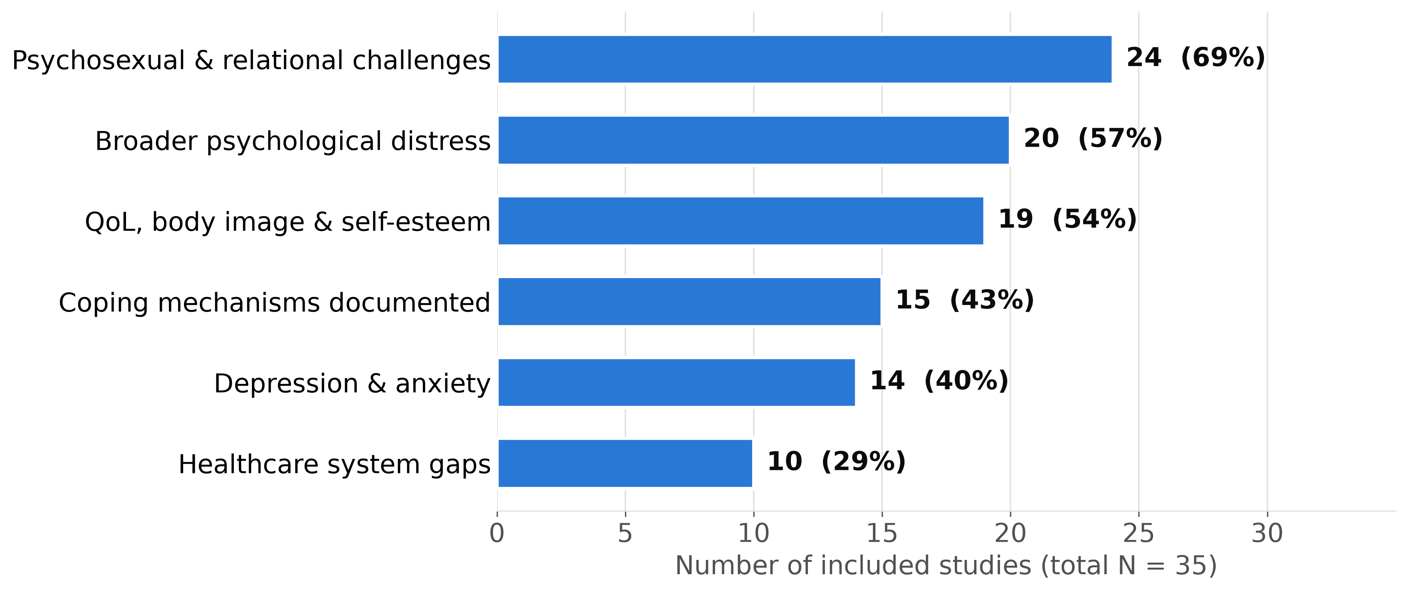
Figure 4. Number of included studies reporting each outcome domain, coping mechanisms, and healthcare system gaps (N = 35). Studies could contribute to more than one category.

Coping Mechanisms
Coping mechanisms were documented in 15 studies (42.9%; Table 3). Peer, family, and social support was most common,^{23,25,26,32,33,42,43} including MRKH support groups and online communities. Avoidance and concealment—such as pretending to menstruate or hiding the diagnosis—were the most frequently documented maladaptive strategies.^{23,24,31,42–44} One qualitative study traced a shift from avoidance to empowerment through positive reappraisal and spiritual coping,⁴² and illness coherence and positive affect appeared protective for psychological adjustment.²⁶ Structured psychological or psychosexual interventions were evaluated in only 2 studies.^{16,45}
Table 3. Coping mechanisms documented in included studies
Coping mechanism | Type | Studies, n
Peer, family & social support | Adaptive | 7
Avoidance / concealment (maladaptive) | Maladaptive | 6
Identity reconstruction / positive reappraisal | Adaptive | 3
Psychological counseling/intervention | Adaptive | 2
Acceptance | Adaptive | 2
Spiritual coping | Adaptive | 1
Self-advocacy | Adaptive | 1
A study could document more than one coping mechanism.

Healthcare System Gaps
Healthcare system gaps were reported in 10 studies (28.6%; Table 4). Participants described providers with limited knowledge of MRKH and the need to advocate for themselves,^{31,46} delayed diagnosis and insensitive communication at diagnosis, including stigmatizing language,^{23,33,43} confusion after medical encounters in several African countries,²⁴ scarce information, psychological support, and fertility counseling,^{43,44,47} and variable counseling around vaginal lengthening treatment.⁴⁸
Table 4. Healthcare system gaps identified and corresponding public health implications
Gap identified | Public health implication
Providers' limited knowledge of MRKH; patients must self-advocate | Train providers in psychosocially informed MRKH care
Delayed diagnosis and insensitive communication at diagnosis | Integrate psychosocial support and mental health screening into diagnostic pathways
Scarce information, psychological support, and fertility counseling | Develop multidisciplinary protocols including psychology and social work; build peer support infrastructure
Variable counseling around vaginal lengthening treatment | Standardize counseling and shared decision-making for treatment
Few studies from Africa and none from South America (research gap) | Expand research investment in underrepresented and low-resource settings

Discussion

Summary of Evidence
This scoping review mapped 35 studies published between 2019 and 2026 on the mental health and psychosocial outcomes of individuals with MRKH syndrome. Psychosexual and relational challenges were the most frequently reported outcome, reported in about two of every three studies, while broader psychological distress and quality of life, body image, and self-esteem were each reported in about half. Depression and anxiety were measured less often, and results were mixed. Coping was documented in more than one in three studies and relied largely on peer support and self-management, and more than one in four studies described healthcare system gaps.
These findings are consistent with earlier evidence that women with MRKH experience greater psychological distress and lower self-esteem than controls,⁴ higher anxiety in adolescence,⁵ and poorer mental health–related quality of life and sexual wellness.⁶ Prior systematic reviews likewise highlighted poor sexual esteem and genital image.^{11,12} The present review indicates that psychosexual concerns remain central in the recent literature and extends earlier syntheses by mapping coping mechanisms and healthcare system gaps.

Coping and Psychosocial Support
Peer support, reappraisal, and spiritual coping suggest considerable resilience after diagnosis, consistent with earlier qualitative accounts of women managing threats to identity and intimacy.⁸ At the same time, avoidance and concealment were common and may delay help-seeking. Evidence that structured intervention helps is available—a randomized trial of group cognitive-behavioural therapy improved psychological outcomes,⁴⁹ and recent studies of psychological support and psychosexual education reported benefits^{16,45}—yet only a few studies evaluated such support, suggesting it has not been translated into routine care.

Healthcare System Gaps and Equity
Although professional guidance identifies psychosocial counseling as central to MRKH management,¹ participants described providers unfamiliar with the condition, insensitive communication, and scarce psychological and fertility counseling, indicating a gap between recommendations and practice. The evidence base is more geographically diverse than earlier literature—Asia contributed nearly as many studies as Europe—yet only 1 study came from Africa and none from South America, where expectations regarding fertility, marriage, and womanhood and access to specialized care may differ substantially. Studies from Türkiye, Vietnam, and Japan illustrate how cultural context shapes experiences of diagnosis, disclosure, and infertility.^{9,44,50}

Implications for Practice, Policy, and Research
Five priorities emerge. First, psychosocial support and mental health screening should be integrated into MRKH diagnostic pathways. Second, multidisciplinary care protocols should include psychology and social work alongside gynecology. Third, psychosexual counseling should accompany vaginal lengthening treatment, given the prominence of sexual esteem and genital image concerns. Fourth, providers should be trained in sensitive, non-stigmatizing communication. Fifth, research investment should be expanded in underrepresented and low-resource settings. Future studies should use validated measures, longitudinal designs, and trials of psychosocial interventions delivered within routine care.

Strengths and Limitations
Strengths include an established methodological framework, PRISMA-ScR reporting, a search of biomedical, nursing, psychological, and women's studies databases, and inclusion of quantitative, qualitative, and mixed-methods evidence. The most important limitation is that the original screening records were lost and selection was repeated from the original exports with AI-assisted screening and charting. Charting was checked against the full text for 30 of the 35 included studies, but the remaining 5 rest on abstracts or titles, and [reviewer verification of all decisions is still required]. Two Danish reports and two Chinese reports appear to share samples. In addition, the review was limited to 2019–2026, date limits were applied inconsistently across database interfaces and enforced at screening, designs and measures were heterogeneous, and other studies may also share samples. Consistent with scoping methodology, study quality was not appraised, and counts reflect how often outcomes were studied, not their prevalence. Grey literature was not searched, and many included studies had small, single-center samples, which limits generalizability.

Conclusions
MRKH-related psychosocial burden is substantial yet under-integrated into care models. Psychosexual and relational challenges, reduced quality of life and self-esteem, and psychological distress are frequently reported, while coping relies largely on peer support and self-management rather than systematic clinical pathways. Multidisciplinary, mental health–inclusive care and greater research investment are urgently needed, particularly in underrepresented and low-resource settings.

Declarations
Acknowledgements: This scoping review was conducted under the mentorship of Dr. Paul Okojie and Dr. Robyn Anderson, Department of Public and Community Health, Liberty University.
Funding: No external funding was received.
Conflicts of interest: [The authors declare no conflicts of interest. — confirm with all authors.]
Author contributions: [e.g., I.P.S.: conceptualization, search, screening, data charting, analysis, writing—original draft; P.O. and R.A.: supervision, methodology, writing—review and editing. Edit to reflect actual contributions (CRediT taxonomy).]
Ethics approval: Not applicable; this review analyzed published studies.
Data availability: The data charting form and extracted data are available from the corresponding author on reasonable request.
Use of AI tools: Generative AI (Claude, Anthropic) was used to propose title and abstract screening decisions, chart data from abstracts, draft and edit the manuscript, verify reference details, and prepare figures. The authors reviewed and verified all content and take full responsibility for the work. [Confirm wording against the target journal's AI policy.]

References
1. American College of Obstetricians and Gynecologists' Committee on Adolescent Health Care. ACOG Committee Opinion No. 728: Müllerian agenesis: diagnosis, management, and treatment. Obstet Gynecol. 2018;131(1):e35-e42. doi:10.1097/AOG.0000000000002458
2. Herlin M, Bjørn AMB, Rasmussen M, Trolle B, Petersen MB. Prevalence and patient characteristics of Mayer-Rokitansky-Küster-Hauser syndrome: a nationwide registry-based study. Hum Reprod. 2016;31(10):2384-2390. doi:10.1093/humrep/dew220
3. Herlin MK, Petersen MB, Brännström M. Mayer-Rokitansky-Küster-Hauser (MRKH) syndrome: a comprehensive update. Orphanet J Rare Dis. 2020;15(1):214. doi:10.1186/s13023-020-01491-9
4. Heller-Boersma JG, Schmidt UH, Edmonds DK. Psychological distress in women with uterovaginal agenesis (Mayer-Rokitansky-Kuster-Hauser syndrome, MRKH). Psychosomatics. 2009;50(3):277-281. doi:10.1176/appi.psy.50.3.277
5. Laggari V, Diareme S, Christogiorgos S, et al. Anxiety and depression in adolescents with polycystic ovary syndrome and Mayer-Rokitansky-Küster-Hauser syndrome. J Psychosom Obstet Gynaecol. 2009;30(2):83-88. doi:10.1080/01674820802546204
6. Liao LM, Conway GS, Ismail-Pratt I, Bikoo M, Creighton SM. Emotional and sexual wellness and quality of life in women with Rokitansky syndrome. Am J Obstet Gynecol. 2011;205(2):117.e1-117.e6. doi:10.1016/j.ajog.2011.03.013
7. Bean EJ, Mazur T, Robinson AD. Mayer-Rokitansky-Küster-Hauser syndrome: sexuality, psychological effects, and quality of life. J Pediatr Adolesc Gynecol. 2009;22(6):339-346. doi:10.1016/j.jpag.2008.11.006
8. Patterson CJ, Crawford R, Jahoda A. Exploring the psychological impact of Mayer-Rokitansky-Küster-Hauser syndrome on young women: an interpretative phenomenological analysis. J Health Psychol. 2016;21(7):1228-1240. doi:10.1177/1359105314551077
9. Güner P, Ulukaya T, Pehlivan Sarıbudak T. "I felt like a woman": a phenomenological qualitative study of disease-related experiences in Mayer-Rokitansky-Küster-Hauser syndrome (MRKH syndrome). J Health Psychol. 2025;30(11):3137-3152. doi:10.1177/13591053241305941
10. Rajesh Z, Marshall N, Hunker KE, et al. Understanding the impact of Mayer-Rokitansky-Küster-Hauser syndrome on sexual wellbeing—a qualitative study. J Sex Med. 2026;23(1):qdaf309. doi:10.1093/jsxmed/qdaf309
11. Facchin F, Francini F, Ravani S, et al. Psychological impact and health-related quality-of-life outcomes of Mayer-Rokitansky-Küster-Hauser syndrome: a systematic review and narrative synthesis. J Health Psychol. 2021;26(1):26-39. doi:10.1177/1359105319901308
12. Tsarna E, Eleftheriades A, Eleftheriades M, Kalampokas E, Liakopoulou MK, Christopoulos P. The impact of Mayer-Rokitansky-Küster-Hauser syndrome on psychology, quality of life, and sexual life of patients: a systematic review. Children (Basel). 2022;9(4):484. doi:10.3390/children9040484
13. Arksey H, O'Malley L. Scoping studies: towards a methodological framework. Int J Soc Res Methodol. 2005;8(1):19-32. doi:10.1080/1364557032000119616
14. Tricco AC, Lillie E, Zarin W, et al. PRISMA Extension for Scoping Reviews (PRISMA-ScR): checklist and explanation. Ann Intern Med. 2018;169(7):467-473. doi:10.7326/M18-0850
15. Mak S, Thomas A. Steps for conducting a scoping review. J Grad Med Educ. 2022;14(5):565-567. doi:10.4300/JGME-D-22-00621.1
16. Vosoughi N, Maasoumi R, Haeri Mehrizi AA, Ghanbari Z. The effect of psychosexual education on promoting sexual function, genital self-image, and sexual distress among women with Rokitansky syndrome: a randomized controlled clinical trial. J Pediatr Adolesc Gynecol. 2022;35(1):73-81. doi:10.1016/j.jpag.2021.06.008
17. Song S, Chen N, Duan YP, et al. Anxiety symptoms in patients with Mayer-Rokitansky-Küster-Hauser syndrome: a cross-sectional study. Chin Med J (Engl). 2020;133(4):388-394. doi:10.1097/cm9.0000000000000648
18. Chen N, Song S, Duan Y, et al. Study on depressive symptoms in patients with Mayer-Rokitansky-Küster-Hauser syndrome: an analysis of 141 cases. Orphanet J Rare Dis. 2020;15(1):121. doi:10.1186/s13023-020-01405-9
19. Weijenborg PTM, Kluivers KB, Dessens AB, ten Kate-Booij MJ, Both S. Sexual functioning, sexual esteem, genital self-image and psychological and relational functioning in women with Mayer-Rokitansky-Küster-Hauser syndrome: a case-control study. Hum Reprod. 2019;34(9):1661-1673. doi:10.1093/humrep/dez130
20. Beisert MJ, Chodecka AM, Walczyk-Matyja K, Szymańska-Pytlińska ME, Kędzia W, Kapczuk K. Psychological correlates of sexual self-esteem in young women with Mayer-Rokitansky-Küster-Hauser syndrome. Curr Issues Personal Psychol. 2022;10(4):333-342. doi:10.5114/cipp.2022.114044
21. Jensen AH, Herlin MK, Trolle B, Vogel I, Lou S. Experiences of vaginal lengthening treatment and sexual well-being in women with Mayer-Rokitansky-Küster-Hauser (MRKH) syndrome: an interview study. BJOG. 2024;131(13):1841-1850. doi:10.1111/1471-0528.17916
22. Stepanow C, Naderer A, Alexopoulos J, Walch K, Wenzl R, Leithner K. Sexual health and sexual well-being of women with Mayer-Rokitansky-Kuester-Hauser syndrome after vaginal reconstruction: a qualitative analysis. J Sex Med. 2023;20(1):57-64. doi:10.1093/jsxmed/qdac011
23. Tsitoura A, Michala L. The sexuality of adolescents and young women with MRKH syndrome: a qualitative study. J Sex Med. 2021;18(12):2012-2019. doi:10.1016/j.jsxm.2021.09.006
24. Ngoumou RD. How does the experience of the medical encounter with Mayer-Rokitansky-Küster-Hauser (MRKH) syndrome impact women in Africa? Pan Afr Med J. 2022;42:314. doi:10.11604/pamj.2022.42.314.32830
25. Rall K, Schenk B, Schäffeler N, et al. Long term findings concerning the mental and physical condition, quality of life and sexuality after laparoscopically assisted creation of a neovagina (modified Vecchietti technique) in young MRKHS (Mayer-Rokitansky-Küster-Hauser-Syndrome) patients. J Clin Med. 2021;10(6):1269. doi:10.3390/jcm10061269
26. Carroll S, Laufer MR, Thomas-Kowal P, Lossie AC, Moss-Morris R. From engulfment to enrichment: associations between illness representations, self-concept, and psychological adjustment in Mayer-Rokitansky-Küster-Hauser syndrome. J Pediatr Adolesc Gynecol. 2020;33(6):639-648. doi:10.1016/j.jpag.2020.07.006
27. Arsy GR, Ratnawati R, Rachmawati SD. Low self-esteem of women suffering Mayer Rokitansky Kuster Hauser syndrome. Indian J Public Health Res Dev. 2019;10(8):2042-2045. doi:10.5958/0976-5506.2019.02155.7
28. Kang J, Chen N, Song S, et al. Sexual function and quality of life after the creation of a neovagina in women with Mayer-Rokitansky-Küster-Hauser syndrome: comparison of vaginal dilation and surgical procedures. Fertil Steril. 2020;113(5):1024-1031. doi:10.1016/j.fertnstert.2020.01.017
29. Sabatucci I, Palaia I, Marchese C, et al. Treatment of the Mayer-Rokitansky-Küster-Hauser syndrome with autologous in vitro cultured vaginal tissue: descriptive study of long-term results and patient outcomes. BJOG. 2019;126(1):123-127. doi:10.1111/1471-0528.15477
30. Mao M, Zhang Y, Fu H, Wang Q, Bai J, Guo R. Long-term results of sexual function and body image after vaginoplasty with acellular dermal matrix in women with Mayer-Rokitansky-Küster-Hauser syndrome. J Minim Invasive Gynecol. 2024;31(1):37-42. doi:10.1016/j.jmig.2023.10.003
31. Gilfillan R, Carter P. Issues of identity, perceptions and isolation: an interpretative phenomenological analysis of women's experience of Mayer-Rokitansky-Küster-Hauser (MRKH) syndrome. J Health Psychol. 2024;29(3):200-212. doi:10.1177/13591053231199253
32. Jensen AH, Herlin MK, Vogel I, Lou S. A life course perspective on Mayer-Rokitansky-Küster-Hauser syndrome: women's experiences and negotiations of living with an underdeveloped uterus and vagina. Disabil Rehabil. 2024;46(6):1130-1140. doi:10.1080/09638288.2023.2191014
33. Lou S, Jensen AH, Vogel I, Trolle B, Herlin MK. Understanding the diagnostic odyssey of women with Mayer-Rokitansky-Küster-Hauser (MRKH) syndrome in Denmark: a qualitative interview study. J Pediatr Adolesc Gynecol. 2024;37(4):412-418. doi:10.1016/j.jpag.2024.03.003
34. Järvholm S, Enskog A, Hammarling C, Dahm-Kähler P, Brännström M. Uterus transplantation: joys and frustrations of becoming a "complete" woman—a qualitative study regarding self-image in the 5-year period after transplantation. Hum Reprod. 2020;35(8):1855-1863. doi:10.1093/humrep/deaa143
35. Khairudin KB, Nik Mhd Nor NS, Childs JF, et al. Prevalence of anxiety and depression in women with Mayer-Rokitansky-Küster-Hauser (MRKH) syndrome in Malaysia. J Pediatr Adolesc Gynecol. 2026;39(2):215-220. doi:10.1016/j.jpag.2025.11.005
36. Lei XH, Wang X, Shao SY, Hua KQ, Zhang Y. Self-esteem, depression, anxiety and sexual function in Mayer-Rokitansky-Küster-Hauser syndrome with neovagina: a case series. Eur J Obstet Gynecol Reprod Biol. 2024;298:85-90. doi:10.1016/j.ejogrb.2024.04.027
37. Sorouri Khorashad B, Kaabi O, Gardner MD, et al. Psychiatric comorbidities in women with complete androgen insensitivity syndrome or Müllerian duct aplasia/agenesis. J Clin Endocrinol Metab. 2025;110(7):1906-1914. doi:10.1210/clinem/dgae720
38. Karpel L, Nicaise M, Carbonnel M, et al. Psychological evaluation of candidates for the uterus transplantation French trial. Acta Obstet Gynecol Scand. 2025;104(3):522-527. doi:10.1111/aogs.15004
39. Jha S, Singh S. Sexual and psychosocial outcome after neovaginoplasty using Interceed in females with Mayer-Rokitansky-Küster-Hauser syndrome: a case-control study. J Obstet Gynaecol Can. 2022;44(8):926-930. doi:10.1016/j.jogc.2022.03.018
40. Scollo P, Pecorino B, La Spina S, Veroux P, Giaquinta A, Scibilia G. Psychological and personality assessment in patients candidates for uterus transplantation from deceased donor: preliminary results. Ital J Gynaecol Obstet. 2020;32(4):287-292. doi:10.36129/jog.32.04.08
41. Pittman J, Gerstl B, Walch A, Lotz M, Deans R, Morrison N. Psychological well-being of women with uterine infertility before considering uterus transplantation as a treatment option. Aust N Z J Obstet Gynaecol. 2025;65(2):263-268. doi:10.1111/ajo.13895
42. Güner P, Ulukaya T. From avoidance to empowerment: coping strategies in women with Müllerian agenesis (MRKH) after McIndoe reconstruction: a descriptive phenomenological study. J Pediatr Adolesc Gynecol. 2026;39(1):101-108. doi:10.1016/j.jpag.2025.10.013
43. Hatim H, Zainuddin AA, Anizah A, et al. The missing uterus, the missed diagnosis, and the missing care. Mayer-Rokitansky-Küster-Hauser syndrome in the lives of women in Malaysia. J Pediatr Adolesc Gynecol. 2021;34(2):161-167. doi:10.1016/j.jpag.2020.11.009
44. Le TTQ, Le NTH, Vu TA, Nguyen HH, Vuong LN. Perception of having children through surrogacy in individuals with MRKH in Vietnam: a qualitative study. Front Psychol. 2024;15:1372405. doi:10.3389/fpsyg.2024.1372405
45. Shao S, Wang X, Lei X, Hua K, Zhang Y. Psychological intervention in women with Mayer-Rokitansky-Küster-Hauser syndrome after artificial vaginoplasty: a prospective study. Int Urogynecol J. 2022;33(3):723-729. doi:10.1007/s00192-022-05075-y
46. Marshall N, Rajesh Z, Hunker K, et al. "Don't give up, advocate for yourself": a pilot study examining healthcare experiences of people with Mayer Rokitansky Küster Hauser syndrome. J Pediatr Adolesc Gynecol. 2025;38(2):167-173. doi:10.1016/j.jpag.2024.12.001
47. Di Mattei VE, Taranto P, Perego G, et al. Illness experience and (unmet) needs of women with Mayer-Rokitansky-Küster-Hauser syndrome (MRKH): a qualitative analysis of an online forum. Psychol Health. 2026;41(1):53-75. doi:10.1080/08870446.2024.2390647
48. Pennesi CM, Berkeley J, Lossie AC, Quint EH, Zieman KD, Carroll S. International experiences with vaginal lengthening treatment among individuals with Müllerian agenesis: a mixed-methods study. J Pediatr Adolesc Gynecol. 2023;36(5):476-483. doi:10.1016/j.jpag.2023.05.004
49. Heller-Boersma JG, Schmidt UH, Edmonds DK. A randomized controlled trial of a cognitive-behavioural group intervention versus waiting-list control for women with uterovaginal agenesis (Mayer-Rokitansky-Küster-Hauser syndrome: MRKH). Hum Reprod. 2007;22(8):2296-2301. doi:10.1093/humrep/dem167
50. Okunomiya A, Tsuyuki K, Ohsuga T, et al. Long-term psychosocial outcomes in Japanese Mayer-Rokitansky-Küster-Hauser syndrome: a single-center study. J Obstet Gynaecol Res. 2026;52(5):e70291. doi:10.1111/jog.70291

Appendix A. Search Strategy
Searches were exported on March 29, 2026. Record counts below are taken from the export files and total 516, matching Figure 1. [Paste the exact search string for each database if it can be recovered from your search history.]
[Suggested PubMed/MEDLINE string for comparison. Replace it with the string you actually ran; do not report a search you did not run:]
("Mayer-Rokitansky-Kuster-Hauser"[tiab] OR "Mayer-Rokitansky-Küster-Hauser"[tiab] OR MRKH[tiab] OR Rokitansky[tiab] OR "Mullerian agenesis"[tiab] OR "Mullerian aplasia"[tiab] OR "vaginal agenesis"[tiab] OR "uterovaginal agenesis"[tiab] OR "Mullerian Ducts/abnormalities"[Mesh]) AND (depress[tiab] OR anxiety[tiab] OR "mental health"[tiab] OR psycholog[tiab] OR distress[tiab] OR "quality of life"[tiab] OR "body image"[tiab] OR "self-esteem"[tiab] OR coping[tiab] OR psychosocial[tiab] OR "Mental Health"[Mesh] OR "Adaptation, Psychological"[Mesh] OR "Quality of Life"[Mesh]) AND ("2019/01/01"[dp] : "2026/03/31"[dp])
[Scopus: TITLE-ABS-KEY(...) with the same two concept blocks; PsycINFO and CINAHL: the same keywords plus each database's own subject headings (e.g., APA Thesaurus “Coping Behavior”; CINAHL Headings “Quality of Life”).]
Table A1. Records retrieved by database
Database | Platform | Date searched | Records retrieved
MEDLINE Ultimate; CINAHL Ultimate; Women's Studies International; APA PsycInfo (combined export: 145; 39; 15; 8) | EBSCOhost | Mar 29, 2026 | 207
APA PsycInfo (separate export) | EBSCOhost | Mar 29, 2026 | 20
MEDLINE (publications 2021–2026) | PubMed | [Mar 29, 2026?] | 146
Scopus (publications 2019–2026) | Scopus | Mar 29, 2026 | 143
Total |  |  | 516
Records published before 2019 (100 exported records; 89 after deduplication, all from EBSCOhost) were excluded at title and abstract screening.

Appendix B. Characteristics of Included Studies
Data charting was checked against the full text for 30 of 35 studies; entries marked † were charted from the abstract or title only. Domains: D, depression/anxiety; Q, quality of life, body image, self-esteem; S, psychosexual and relational; P, broader psychological distress; C, coping documented; H, healthcare system gaps. Reference numbers refer to the main reference list.
Table B1. Characteristics of included studies (N = 35)
Study | Country | Design | n | Domains | Coping
Arsy 2019²⁷† | Indonesia | Not reported in export (no abstract) | NR | Q | —
Beisert 2022²⁰ | Poland | Case-control | 32 (+32 controls) | D Q S P | —
Carroll 2020²⁶ | Multinational | Cross-sectional online survey | 263 | Q P C | Peer, family & social support; Identity reconstruction / positive reappraisal
Chen 2020¹⁸ | China | Cross-sectional (with controls) | 141 (+178 controls) | D S | —
Di Mattei 2026⁴⁷† | Italy | Thematic analysis of online forum | NR | S P H | —
Gilfillan 2024³¹ | United Kingdom | Interpretative phenomenological analysis | 13 | P C H | Acceptance; Avoidance / concealment (maladaptive)
Güner 2025⁹ | Türkiye | Phenomenological interviews | 10 | S P | —
Güner 2026⁴² | Türkiye | Descriptive phenomenological interviews | 10 | S P C | Avoidance / concealment (maladaptive); Identity reconstruction / positive reappraisal; Spiritual coping; Peer, family & social support
Hatim 2021⁴³ | Malaysia | Qualitative with quantitative component | 12 | D Q S P C H | Peer, family & social support; Avoidance / concealment (maladaptive)
Jensen 2024³²† | Denmark | Semi-structured interviews (life course) | 18 | S P C H | Peer, family & social support
Jensen 2024²¹ | Denmark | Semi-structured interviews | 18 | Q S P | —
Jha 2022³⁹† | India | Case-control | NR | D Q S | —
Järvholm 2020³⁴ | Sweden | Interviews after uterus transplantation | 9 (8 MRKH) | Q S P | —
Kang 2020²⁸ | China | Cross-sectional (dilation vs surgery) | 133 | Q S | —
Karpel 2025³⁸ | France | Cross-sectional (uterus transplant candidates) | 16 recipients (+16 partners, 16 donors) | D Q S P | —
Khairudin 2026³⁵ | Malaysia | Cross-sectional | 77 | D | —
Le 2024⁴⁴ | Vietnam | In-depth interviews | 20 | C H | Avoidance / concealment (maladaptive)
Lei 2024³⁶ | China | Longitudinal case series (2 survey rounds) | 53 | D Q S | —
Lou 2024³³ | Denmark | In-depth interviews | 18 | P C H | Peer, family & social support
Mao 2024³⁰† | China | Retrospective (with controls) | 42 (+30 controls) | Q S | —
Marshall 2025⁴⁶ | United States/Canada | Semi-structured interviews | 12 | C H | Self-advocacy
Ngoumou 2022²⁴ | Cameroon, Côte d'Ivoire, Senegal | In-depth interviews | 5 | Q S P C H | Avoidance / concealment (maladaptive)
Pennesi 2023⁴⁸ | Multinational (40 countries) | Cross-sectional mixed-methods survey | 616 | S P H | —
Pittman 2025⁴¹ | Australia | Cross-sectional survey (congenital vs acquired uterine factor infertility) | 39 (31 MRKH) | D Q P | —
Rajesh 2026¹⁰ | Canada | Semi-structured interviews | 12 | Q S C | Identity reconstruction / positive reappraisal
Rall 2021²⁵ | Germany | Prospective cohort (pre/post surgery) | 82 | D Q S P C | Peer, family & social support
Sabatucci 2019²⁹ | Italy | Descriptive longitudinal | 39 | Q S | —
Scollo 2020⁴⁰ | Italy | Retrospective (MMPI-2; uterus transplant candidates) | 19 (18 MRKH) | D P | —
Shao 2022⁴⁵ | China | Prospective pre/post intervention | 30 | D C | Psychological counseling/intervention
Song 2020¹⁷ | China | Cross-sectional (with controls) | 141 (+178 controls) | D S | —
Sorouri Khorashad 2025³⁷ | United States | Retrospective cohort (EHR, matched referents) | 101 MA (60 uterovaginal agenesis) + 63 CAIS | D P | —
Stepanow 2023²² | Austria | Semi-structured interviews | 10 (+20 controls) | Q S C | Acceptance
Tsitoura 2021²³ | Greece | Semi-structured interviews | 7 | S P C H | Avoidance / concealment (maladaptive); Peer, family & social support
Vosoughi 2022¹⁶ | Iran | Randomized controlled trial | 38 | Q S C | Psychological counseling/intervention
Weijenborg 2019¹⁹ | Netherlands | Case-control | 54 (+79 controls) | D Q S P | —

Appendix C. PRISMA-ScR Checklist
Table C1. PRISMA-ScR checklist (Tricco et al., 2018)
Section / topic | Item | Reported in
Title | 1 | Title page
Structured summary | 2 | Abstract
Rationale | 3 | Introduction
Objectives | 4 | Introduction (research question)
Protocol and registration | 5 | Methods: Study Design [complete]
Eligibility criteria | 6 | Methods: Eligibility Criteria
Information sources | 7 | Methods: Information Sources; Appendix A
Search | 8 | Appendix A [complete]
Selection of sources of evidence | 9 | Methods: Study Selection
Data charting process | 10 | Methods: Data Charting
Data items | 11 | Methods: Data Charting
Critical appraisal of individual sources of evidence (optional) | 12 | Methods: Synthesis (not performed)
Synthesis of results | 13 | Methods: Synthesis
Selection of sources of evidence | 14 | Results; Figure 1
Characteristics of sources of evidence | 15 | Results; Table 1; Appendix B
Critical appraisal within sources of evidence (optional) | 16 | Not applicable
Results of individual sources of evidence | 17 | Appendix B
Synthesis of results | 18 | Results; Tables 2–4; Figures 2–4
Summary of evidence | 19 | Discussion: Summary of Evidence
Limitations | 20 | Discussion: Strengths and Limitations
Conclusions | 21 | Discussion: Conclusions
Funding | 22 | Declarations

