Prevalence of High-Fructose Corn Syrup in the U.S. Branded Food Supply: A Cross-Sectional Analysis of the USDA Global Branded Food Products Database

Author name(s)
Liberty University
Course / department, instructor, and date

ABSTRACT
Background: High-fructose corn syrup (HFCS) is a widely used caloric sweetener in the U.S. food supply, but product-level data on its prevalence are limited. Ingredient lists do not specify amounts, and nutrient databases do not distinguish among types of added sugars.
Objectives: To estimate the prevalence of HFCS as a listed ingredient in U.S. branded food products and to establish a reproducible baseline for future surveillance.
Methods: We conducted a retrospective, cross-sectional, descriptive analysis of the USDA FoodData Central Global Branded Food Products Database (GBFPD), covering products published between April 13, 2019, and December 13, 2025. The primary outcome was the proportion of eligible products listing HFCS as an ingredient. We used descriptive statistics (counts and percentages).
Results: Of 454,324 products identified, 447,607 were eligible for analysis. HFCS was listed as an ingredient in 29,503 products (6.6%), or about 1 in 15. The remaining 418,104 products (93.4%) did not list HFCS.
Conclusions: HFCS remains present in roughly 30,000 U.S. branded food products. Because we measured prevalence by product count rather than weighted by sales or intake, and could not quantify HFCS per product, these findings do not directly measure population exposure. They provide a reproducible baseline for monitoring reformulation and market change. Future work should link ingredient data to sales-weighted datasets and stratify by food category and trade channel.
Keywords: high-fructose corn syrup; added sugars; branded foods; FoodData Central; food supply surveillance

INTRODUCTION
High-fructose corn syrup (HFCS) is a widely used caloric sweetener produced by enzymatically converting cornstarch into a mixture of free fructose and glucose.¹ Its functional properties, including cost-effectiveness, stability, and sweetness, have driven its extensive adoption in the U.S. food and beverage industry, particularly in carbonated soft drinks, baked goods, ready-to-eat meals, and condiments.^{1,2} HFCS is produced in several blends, such as HFCS-42 and HFCS-55, whose numbers indicate the approximate percentage of fructose; HFCS-55 predominates in soft drinks, whereas HFCS-42 is more common in processed foods.^{2,3} Economic incentives stemming from domestic corn production and agricultural policies have historically made HFCS more accessible and less expensive than imported sucrose, facilitating its widespread adoption in the U.S. food supply.¹⁻⁴
Despite shifts in per capita consumption over recent decades, HFCS remains a prevalent additive in the U.S. food supply.⁵ Estimates suggest that it constitutes a substantial proportion of caloric sweeteners in processed foods and beverages, yet comprehensive, product-level data quantifying HFCS prevalence are limited. Ingredient lists do not specify HFCS amounts, and nutrient databases rarely differentiate among types of added sugars. This gap limits the ability of researchers and policymakers to assess population exposure and to design interventions targeting HFCS reduction.
Scientific evidence indicates that excessive HFCS consumption may contribute to metabolic dysregulation. HFCS-sweetened beverages have been shown to increase hepatic lipid accumulation and decrease insulin sensitivity in adults, providing a mechanistic link to cardiometabolic diseases.⁶ Experimental and animal studies suggest that HFCS can alter the gut microbiota and promote obesity, insulin resistance, and nonalcoholic fatty liver disease, highlighting biological pathways through which HFCS may affect long-term health.^{1,7} Additionally, HFCS and apple juice are primary sources of excess free fructose, which occurs when the fructose-to-glucose ratio exceeds 1:1. Excess free fructose can induce fructose malabsorption, gut dysbiosis, and downstream effects on multiple organ systems, potentially contributing to conditions such as asthma, chronic obstructive pulmonary disease, inflammatory bowel disease, cardiovascular disease, and chronic kidney disease.⁸ HFCS intake has also been linked in preclinical studies to chronic inflammation and tumor growth.⁹
The rising prevalence of obesity and related metabolic disorders underscores the public health relevance of added sugars, including HFCS. In the United States, more than two-thirds of adults have overweight or obesity, and childhood obesity rates have more than doubled since 1990.^{4,10,11} Obesity contributes substantially to morbidity and mortality through its links to type 2 diabetes, cardiovascular disease, metabolic syndrome, and other chronic conditions.^{4,10,11} Dietary patterns high in added sugars, including high-fructose sweeteners, have been examined as contributors to this epidemic, although controlled evidence indicates that HFCS and sucrose have broadly similar metabolic effects when consumed in equivalent amounts.^{4,5,10}
The global HFCS market continues to grow, driven by functional benefits in food and beverage applications.² The HFCS market was valued at USD 6.32 billion in 2025 and is projected to reach USD 8.59 billion by 2034.² North America leads global consumption (38%), driven largely by the United States, followed by Europe (27%), Asia-Pacific (23%), and the Middle East and Africa (12%).² Growth in Asia-Pacific is supported by urbanization, rising disposable incomes, and increased processed food consumption.² Despite growing health concerns and shifts toward cane sugar and other alternatives, HFCS remains a cost-effective and functionally advantageous ingredient in numerous food products.²
Given the widespread consumption of HFCS and its potential metabolic consequences, there is a critical need to quantify its prevalence across the U.S. branded food supply. Unlike total added sugars, HFCS exposure cannot be reliably inferred from standard nutrient databases. To address this knowledge gap, the present study employed a retrospective, cross-sectional, descriptive analysis of HFCS presence in commercially available U.S. branded food products. This analysis aims to provide a detailed assessment of HFCS prevalence, inform public health understanding of added sugar exposure, and guide future nutrition policy and labeling initiatives.

METHODS

Study Design and Data Source
This study was a retrospective, cross-sectional, descriptive analysis of the prevalence of HFCS in the U.S. branded food supply. Data were obtained from FoodData Central (FDC), the U.S. Department of Agriculture (USDA) food composition data system, which provides 5 distinct types of data on food and nutrient profiles. One of these data types is the Global Branded Food Products Database (GBFPD), the product of a public–private partnership whose goal is to increase the open sharing of nutrient data on branded and private-label foods. Product information in the GBFPD, including ingredient statements, is supplied by the food industry. The GBFPD contains data on more than 400,000 food products and is updated monthly.^{12,13}

Search Strategy and Eligibility
The search was restricted by FDC published date to products published from April 13, 2019 (the earliest published date available in the database), through December 13, 2025 (the date the search was conducted). The following trade channels were selected: No Trade Channel, Child Nutrition Food Programs, Convenience, Food Service, Vending, Online, Mass Merchandising, Military, and Grocery. Products categorized as “Drug” and products with New Zealand listed as the market country were excluded, so that the analytic sample was limited to products marketed in the United States.

Identification of HFCS
Products containing HFCS were identified by searching the ingredients field with the Boolean query “High” AND “Fructose” AND “Corn” AND “Syrup.” This query returns products whose ingredient statement contains all 4 terms, rather than products containing only some of them (for example, “corn syrup” or “fructose” alone).

Outcome and Analysis
The primary outcome was the prevalence of branded food products containing HFCS, defined as the proportion of eligible products in the GBFPD that listed HFCS as an ingredient. Descriptive statistics, including counts and percentages, were used to summarize the findings. Data analysis was conducted using Microsoft Excel.

RESULTS
A total of 454,324 food products were identified in the GBFPD during the study period. After excluding products from New Zealand and products categorized as drugs (n = 6,717), 447,607 products were included in the final analysis.
Among the 447,607 eligible branded food products, 29,503 (6.6%) listed HFCS as an ingredient, and 418,104 (93.4%) did not (Figures 1 and 2). This corresponds to approximately 1 in every 15 branded food products.
Figure 1. Number of U.S. Branded Food Products With and Without HFCS (N = 447,607)
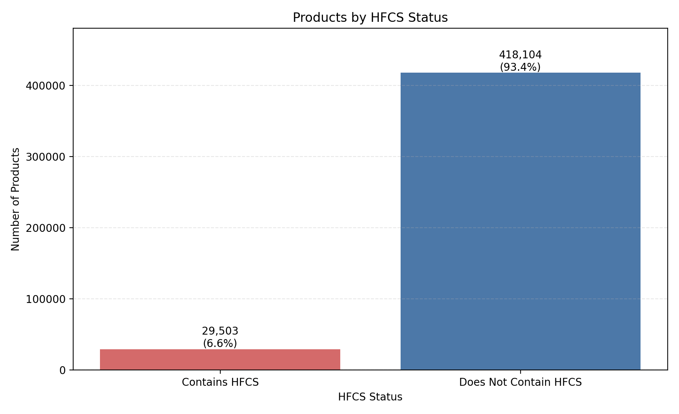
Note. Bars show the number of eligible branded food products in the USDA Global Branded Food Products Database that listed HFCS as an ingredient (n = 29,503; 6.6%) and that did not (n = 418,104; 93.4%). Although most branded foods do not list HFCS, a substantial number of products still contain it.
Figure 2. Percentage of U.S. Branded Food Products Containing HFCS (N = 447,607)
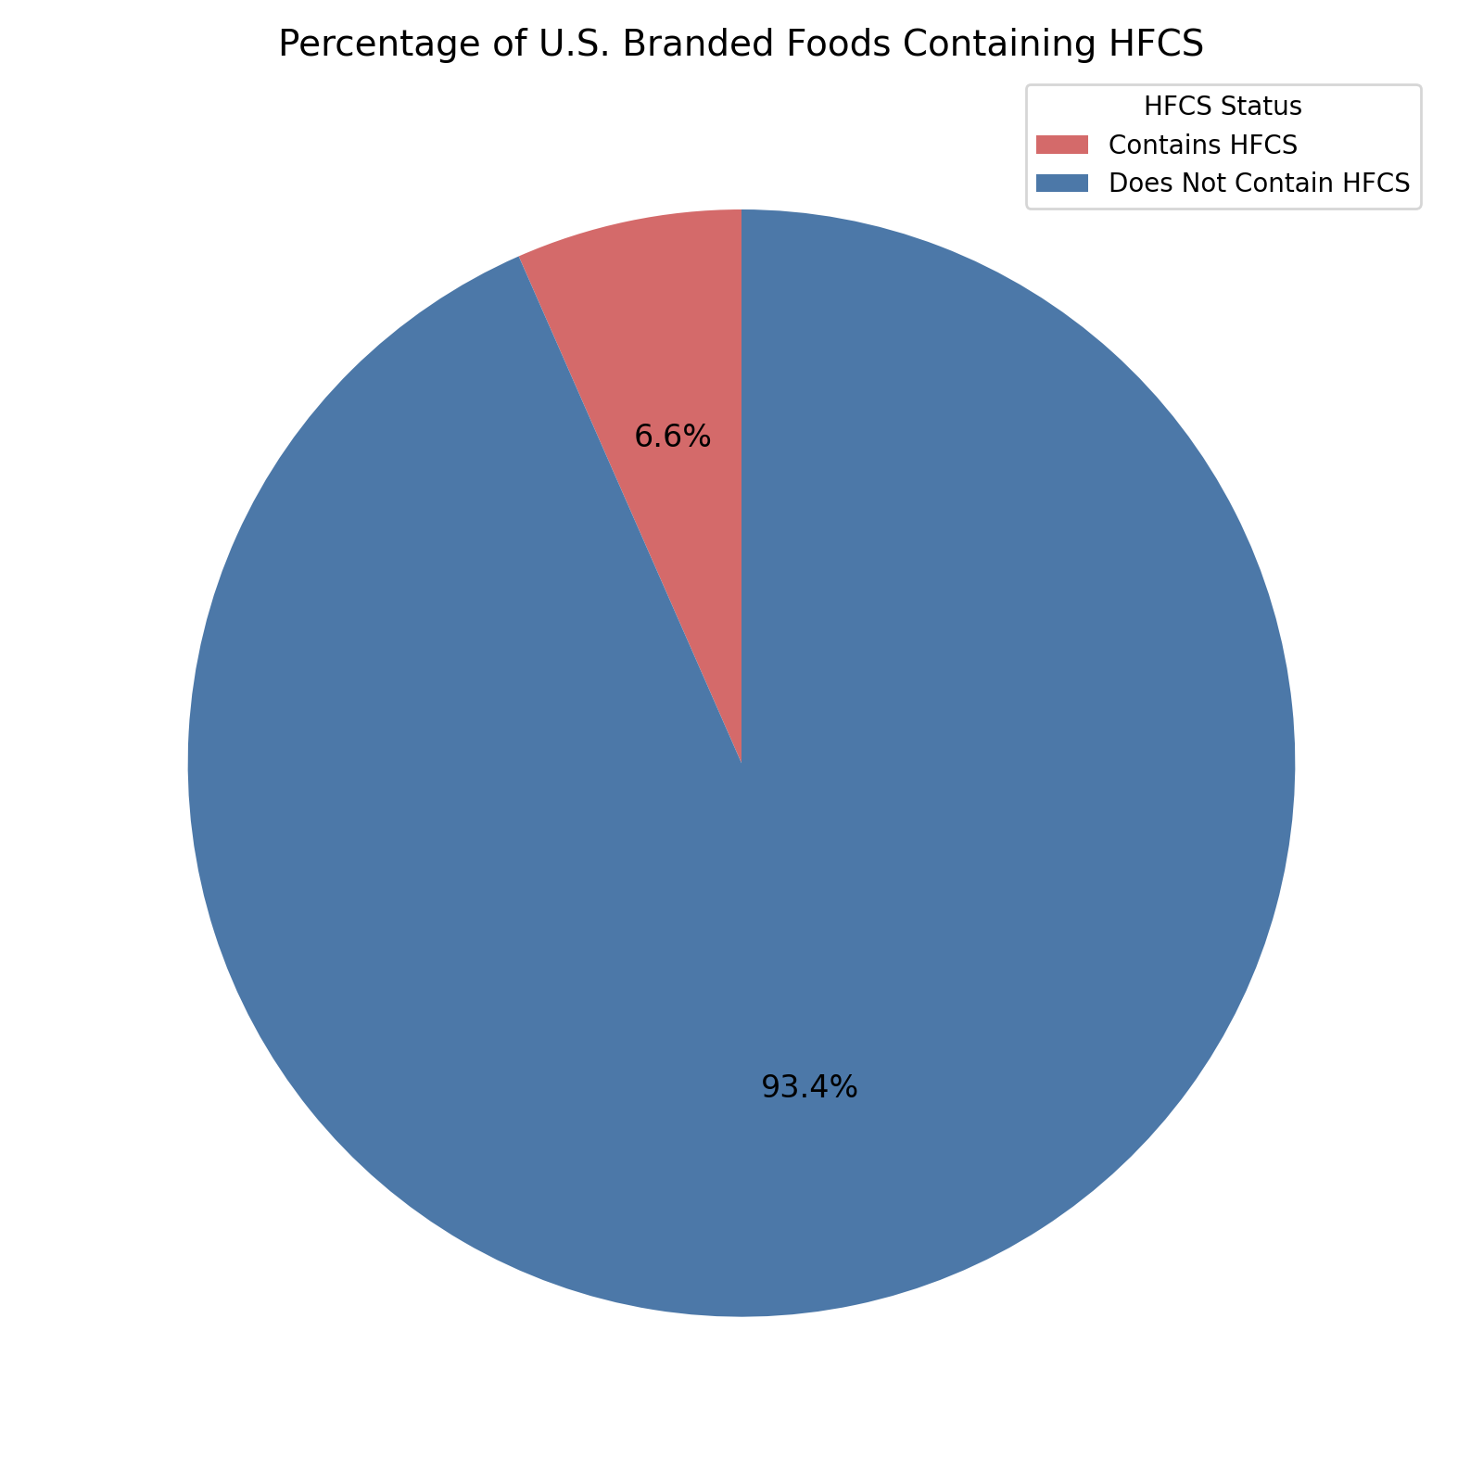
Note. HFCS was listed in 6.6% of eligible products and was absent from 93.4%. Although HFCS is present in a minority of products, its inclusion in approximately 1 in 15 branded food items highlights its continued use in the U.S. food system.

DISCUSSION
In this cross-sectional descriptive analysis of the USDA FoodData Central GBFPD, HFCS was listed as an ingredient in 29,503 of 447,607 eligible U.S. branded food products (6.6%). Although HFCS appears in a minority of products, its presence in nearly 30,000 products shows that it remains a component of the commercial U.S. food supply.
A product-count prevalence of 6.6% should not be interpreted as low population exposure. First, product-count prevalence is not weighted by sales or intake; HFCS may be concentrated in high-consumption categories, such as sweetened beverages, desserts, and condiments, so a comparatively small share of products may contribute disproportionately to dietary exposure. Second, national sweetener supply data indicate that HFCS remains structurally relevant despite long-term declines. According to USDA Economic Research Service data, HFCS availability peaked in 1999, and subsequent declines in corn sweeteners contributed to a decrease of nearly 20% in per capita caloric sweetener availability.^{14,15} Most HFCS research has focused on dietary intake, metabolic processes, or health outcomes rather than on directly monitoring HFCS presence at the product level across a large branded marketplace. This analysis therefore uses a nationally recognized public nutrient database to provide a practical baseline estimate of HFCS ingredient presence. FoodData Central was created to strengthen nutrition surveillance and research capacity by integrating multiple USDA food composition datasets,¹² and the GBFPD extends this coverage to branded and private-label products through a public–private partnership.¹⁶ Establishing a reproducible prevalence estimate with the GBFPD supports future trend monitoring, such as repeated analyses to evaluate reformulation or market shifts, while highlighting the need for complementary methods that better approximate consumption-weighted exposure.
The prevalence of HFCS remains relevant because public health guidance emphasizes limiting added sugars regardless of source. The Dietary Guidelines for Americans, 2020–2025 recommended that individuals aged 2 years and older limit added sugars to less than 10% of daily calories.¹⁷ The Dietary Guidelines for Americans, 2025–2030, released in January 2026, go further, stating that no amount of added sugars is recommended as part of a healthy diet and advising that a single meal contain no more than 10 g of added sugars.¹⁸ HFCS-containing products are frequently ultra-processed foods, which nationally representative analyses have identified as the source of most energy from added sugars in the U.S. diet, indicating structural dietary drivers that extend beyond individual behavior.¹⁹ In addition, updated meta-analytic evidence continues to link greater consumption of sugar-sweetened beverages, which are commonly sweetened with caloric sweeteners such as HFCS, to greater weight gain and higher body mass index in children and adults.²⁰ Because sucrose is rapidly hydrolyzed into glucose and fructose, and common HFCS blends contain similar proportions of fructose, HFCS and sucrose deliver comparable glucose and fructose loads. When matched for calories, controlled studies and meta-analyses generally show no significant differences between HFCS and sucrose for most anthropometric and metabolic outcomes, although one meta-analysis reported higher C-reactive protein levels with HFCS; the principal concern is excess added sugar intake overall.⁵
Although this study did not evaluate intake or health outcomes, documenting HFCS presence in branded products strengthens the empirical basis for surveillance strategies aimed at reducing population-level added sugar exposure.

Strengths and Limitations
The main strengths of this study are its scale and transparency: it applies a reproducible ingredient-query method to a large national branded-food dataset integrated within FoodData Central.¹² The GBFPD provides structured documentation and standardized presentation of industry-supplied data intended to support public health applications.²¹
Several limitations should be considered when interpreting product-count prevalence. First, the analysis detects the presence of HFCS but cannot estimate dietary intake or quantify the amount of HFCS in each product; ingredient lists do not report grams of HFCS, and added sugar values do not distinguish among sweetener types. Second, the GBFPD reflects industry-provided data; although USDA standardizes presentation, contributing organizations remain responsible for the underlying product data, and the online database and downloadable datasets are updated on different schedules.²¹ Third, nutrient databases, even highly valuable ones, face data quality challenges related to representativeness, harmonization, and completeness, which may affect surveillance findings.²² Fourth, the GBFPD records products at the level of individual items (for example, distinct package sizes or product codes), and records published during the study window may include products that are no longer sold; product counts therefore may not correspond one-to-one with distinct foods currently on the market. Finally, term-based identification may misclassify some products. Because the 4 search terms were not required to appear as a contiguous phrase, products in which the words occur separately (for example, “corn syrup,” “fructose,” and “high oleic oil”) could be counted, potentially overstating prevalence; conversely, products that list HFCS under other names or abbreviations (for example, “HFCS,” “glucose-fructose syrup,” or “isoglucose”) or with misspellings would be missed, potentially understating prevalence.

Implications and Future Directions
These results support several practical next steps to improve added sugar and HFCS surveillance. First, to convert ingredient presence into more accurate estimates of consumer exposure, product-level prevalence estimates should be combined with sales-weighted or purchase-linked datasets, such as retail scanner data. Second, future analyses should stratify HFCS prevalence by food category and trade channel to determine where HFCS is concentrated and where reformulation might be most feasible. Third, given the policy emphasis on added sugars, integrating ingredient surveillance with contemporary labeling frameworks could improve actionable monitoring. The U.S. Food and Drug Administration’s revision of the Nutrition Facts label requires the declaration of added sugars in grams and as a percentage of the Daily Value, creating opportunities to combine ingredient presence with added sugar labeling data for more comprehensive monitoring.^{23,24} Finally, repeating the analysis over time, and manually validating a random sample of identified records, would allow reformulation trends to be tracked and the accuracy of the search strategy to be quantified.

CONCLUSIONS
This cross-sectional analysis of the USDA FoodData Central Global Branded Food Products Database found that HFCS was listed as an ingredient in 6.6% of eligible U.S. branded food products. Although HFCS appeared in a minority of products, its presence in nearly 30,000 products indicates that it remains a relevant component of the commercial food supply. Product counts do not reflect consumption volume or the amount of HFCS per product; nevertheless, these findings establish a reproducible baseline for HFCS surveillance to support future research, policy evaluation, and efforts to reduce added sugars in the U.S. food supply.

REFERENCES
1. Wang X, Zhu L, Li X, Wang X, Hao R, Li J. Effects of high fructose corn syrup on intestinal microbiota structure and obesity in mice. NPJ Sci Food. 2022;6(1):17. doi:10.1038/s41538-022-00133-7
2. High fructose corn syrup (HFCS) market trends report [2034]. IndustryResearch.biz. Published December 1, 2025. Accessed (insert date). https://www.industryresearch.biz/market-reports/high-fructose-corn-syrup-hfcs-market-111615
3. White JS. Straight talk about high-fructose corn syrup: what it is and what it ain’t. Am J Clin Nutr. 2008;88(6):1716S-1721S. doi:10.3945/ajcn.2008.25825B
4. Duffey KJ, Popkin BM. High-fructose corn syrup: is this what’s for dinner? Am J Clin Nutr. 2008;88(6):1722S-1732S. doi:10.3945/ajcn.2008.25825C
5. Li X, Luan Y, Li Y, et al. The effect of high-fructose corn syrup vs. sucrose on anthropometric and metabolic parameters: a systematic review and meta-analysis. Front Nutr. 2022;9:1013310. doi:10.3389/fnut.2022.1013310
6. Sigala DM, Hieronimus B, Medici V, et al. Consuming sucrose- or HFCS-sweetened beverages increases hepatic lipid and decreases insulin sensitivity in adults. J Clin Endocrinol Metab. 2021;106(11):3248-3264. doi:10.1210/clinem/dgab508
7. Rizkalla SW. Health implications of fructose consumption: a review of recent data. Nutr Metab (Lond). 2010;7:82. doi:10.1186/1743-7075-7-82
8. DeChristopher LR. 40 years of adding more fructose to high fructose corn syrup than is safe, through the lens of malabsorption and altered gut health—gateways to chronic disease. Nutr J. 2024;23(1):16. doi:10.1186/s12937-024-00919-3
9. Aoyagi T, Ohira G, Hayano K, Martin O, Takabe K. High-fructose corn syrup on inflammation and cancer. World J Oncol. 2025;16(6):531-537. doi:10.14740/wjon2652
10. Rippe JM. The health implications of sucrose, high-fructose corn syrup, and fructose: what do we really know? J Diabetes Sci Technol. 2010;4(4):1008-1011. doi:10.1177/193229681000400433
11. Lancaster KJ. Current intake and demographic disparities in the association of fructose-rich foods and metabolic syndrome. JAMA Netw Open. 2020;3(7):e2010224. doi:10.1001/jamanetworkopen.2020.10224
12. Fukagawa NK, McKillop K, Pehrsson PR, Moshfegh A, Harnly J, Finley J. USDA’s FoodData Central: what is it and why is it needed today? Am J Clin Nutr. 2022;115(3):619-624. doi:10.1093/ajcn/nqab397
13. Branded foods search. FoodData Central, US Department of Agriculture, Agricultural Research Service. Accessed December 13, 2025. https://fdc.nal.usda.gov/food-search?type=Branded
14. US Department of Agriculture, Economic Research Service. High fructose corn syrup availability peaked in 1999. Published May 1, 2013. Accessed December 21, 2025. https://www.ers.usda.gov/data-products/chart-gallery/chart-detail?chartId=57655
15. US Department of Agriculture, Economic Research Service. Caloric sweetener availability dropped nearly 20 percent since 1999. Published December 2, 2024. Accessed December 21, 2025. https://www.ers.usda.gov/data-products/charts-of-note/chart-detail?chartId=110515
16. Larrick B, Kretser A, McKillop K, et al. Update on “A Partnership for Public Health: USDA Global Branded Food Products Database.” J Food Compos Anal. 2022;105:104250. doi:10.1016/j.jfca.2021.104250
17. US Department of Agriculture; US Department of Health and Human Services. Dietary Guidelines for Americans, 2020–2025. 9th ed. Published December 2020. Accessed December 21, 2025. https://www.dietaryguidelines.gov/sites/default/files/2020-12/Dietary_Guidelines_for_Americans_2020-2025.pdf
18. US Department of Agriculture; US Department of Health and Human Services. Dietary Guidelines for Americans, 2025–2030. Published January 7, 2026. Accessed (insert date). https://www.dietaryguidelines.gov
19. Martínez Steele E, Baraldi LG, Louzada ML, Moubarac JC, Mozaffarian D, Monteiro CA. Ultra-processed foods and added sugars in the US diet: evidence from a nationally representative cross-sectional study. BMJ Open. 2016;6(3):e009892. doi:10.1136/bmjopen-2015-009892
20. Nguyen M, Jarvis SE, Tinajero MG, et al. Sugar-sweetened beverage consumption and weight gain in children and adults: a systematic review and meta-analysis of prospective cohort studies and randomized controlled trials. Am J Clin Nutr. 2023;117(1):160-174. doi:10.1016/j.ajcnut.2022.11.008
21. US Department of Agriculture, Agricultural Research Service. FoodData Central: USDA Global Branded Food Products Database (GBFPD) Documentation and Download User Guide. April 2023. Accessed December 21, 2025. https://fdc.nal.usda.gov/docs/GBFPD_Documentation_and_Download_User_Guide_Apr2023.pdf
22. Li Z, Forester S, Jennings-Dobbs E, Heber D. Perspective: a comprehensive evaluation of data quality in nutrient databases. Adv Nutr. 2023;14(3):379-391. doi:10.1016/j.advnut.2023.02.005
23. Food labeling: revision of the Nutrition and Supplement Facts labels. Fed Regist. 2016;81(103):33742-33999. To be codified at 21 CFR §101.
24. US Food and Drug Administration. Added sugars on the Nutrition Facts label. Updated March 5, 2024. Accessed December 21, 2025. https://www.fda.gov/food/nutrition-facts-label/added-sugars-nutrition-facts-label

