Psychosocial Outcomes and Coping Mechanisms Among Women With Premenstrual Dysphoric Disorder: A Global Scoping Review
Ifeoluwanimi P. Shobayo, MSPH, Chelsea R. Mazonde, MPH, Marylyn O. Oduneye, MSPH, Tahirou Diallo, MSPH, Fadzai G. Nyarugwe, MSPH, and Cynthia C. Ilechukwu, MSPH
[Add each author’s department, institution, city, state and country; the corresponding author’s mailing address, email and telephone; and ORCID iDs.]
Keywords: premenstrual dysphoric disorder; psychosocial outcomes; coping mechanisms; global health; scoping review
Word count: abstract 172 words; main text 1982 words; 1 table; 4 figures; 51 references.

ABSTRACT
Objectives. To map psychosocial outcomes and coping mechanisms among women with premenstrual dysphoric disorder (PMDD) and the geographic distribution of this evidence.
Methods. Following Arksey and O’Malley’s framework and PRISMA-ScR, we searched 5 databases for peer-reviewed studies (2010–2025) with PMDD as the primary population and a psychosocial outcome or coping mechanism as a primary aim.
Results. Of 1,943 records, 1,618 were screened after deduplication, 64 were assessed for eligibility and 44 were included. Depression was most documented (n = 39), followed by psychological distress (n = 24), interpersonal functioning (n = 18), suicidal ideation or self-harm (n = 14) and quality of life (n = 14). Only 3 studies examined coping mechanisms. Three studies (6.8%) came from low- and lower-middle-income countries; Nigeria was the only sub-Saharan African setting.
Conclusions. Evidence on the psychosocial burden of PMDD is growing but concentrated in high-income countries, and how women cope remains largely unexamined.
Public Health Implications. Suicide risk screening, integrated mental and reproductive health services and research in African and other low-income settings are needed.

Premenstrual dysphoric disorder (PMDD) is a recurring, hormone-linked mood disorder in which irritability, mood swings, depressed mood and anxiety emerge in the late luteal phase of the menstrual cycle and remit shortly after menses begin. It is classified as a depressive disorder in the Diagnostic and Statistical Manual of Mental Disorders, Fifth Edition (DSM-5),¹ and it is recognized in the International Classification of Diseases, 11th Revision.² Its diagnostic validity is still debated, in part because many studies rely on retrospective recall rather than prospective daily symptom ratings.³
How common PMDD appears depends on how it is diagnosed. A 2024 meta-analysis estimated a pooled prevalence of 3.2% when diagnosis was confirmed with prospective ratings and 7.7% when it was provisional; in community samples with confirmed diagnosis, prevalence was 1.6%, roughly 31 million women and girls worldwide.⁴ Premenstrual symptoms more broadly are common in Africa, where the pooled prevalence of premenstrual syndrome reaches 47%.⁵
Because PMDD recurs every month across the reproductive years, its consequences extend beyond symptom counts. PMDD has been linked with suicidal ideation and attempts,^{6,7} disrupted romantic relationships⁸ and reduced quality of life.⁹ People with PMDD also describe misdiagnosis, medical mistrust and uneven provider knowledge.^{10,11} This evidence is spread across psychiatry, gynecology, nursing and psychology journals, and it is unclear which psychosocial outcomes have been studied, how women cope and where the evidence has been generated. That question matters for public health: a condition whose burden has not been documented in a setting is unlikely to be recognized, screened for or funded there.
We therefore conducted a scoping review to map psychosocial outcomes and coping mechanisms reported among women with PMDD and to identify geographic gaps in the published literature. The review asked: What psychosocial outcomes and coping mechanisms have been reported in studies of women with PMDD published between 2010 and 2025, and how are these studies distributed across geographic settings?
METHODS
Study Design
This scoping review followed the framework of Arksey and O’Malley¹² with the refinements proposed by Levac et al¹³ and is reported according to the Preferred Reporting Items for Systematic Reviews and Meta-Analyses extension for Scoping Reviews (PRISMA-ScR).¹⁴ Consistent with scoping review methodology, the aim was to map the extent and nature of the evidence rather than to appraise study quality or pool effect estimates. [State whether a protocol was registered (e.g., Open Science Framework, with DOI and date) or that no protocol was registered.]
Eligibility Criteria
Eligible studies were peer-reviewed empirical quantitative or qualitative studies published between 2010 and 2025 that had PMDD as the primary population and examined at least one psychosocial outcome or coping mechanism as a primary aim. Psychosocial outcomes included depression, psychological distress (including anxiety and perceived stress), interpersonal functioning, suicidal ideation or self-harm and quality of life. No restriction was placed on country or setting. We excluded animal studies, laboratory research, reviews, intervention studies and non-peer-reviewed publications.
Information Sources and Search
We searched PubMed/MEDLINE, CINAHL, APA PsycInfo, APA PsycArticles and the Cochrane Library. Search strategies combined terms for premenstrual dysphoric disorder (e.g., “premenstrual dysphoric disorder,” “PMDD”) with psychosocial and coping concepts, and results were limited to 2010–2025. [Give the date each database was searched and put the full search string for every database in a supplemental appendix.]
Selection of Sources of Evidence
Records from all databases were combined, and duplicates were identified by digital object identifier and normalized title. After removing duplicates, we screened titles and abstracts against the eligibility criteria. Records that passed this step were assessed for eligibility against the full criteria using their titles, abstracts and database subject terms. Full texts were not reviewed at this stage. [Describe who screened records (e.g., 2 independent reviewers), how disagreements were resolved and, if any software or AI tool assisted screening or writing, disclose it according to AJPH policy.]
Data Charting and Synthesis
For each included study, we charted the first author, publication year, country setting and the psychosocial domains examined. Country was taken from the study setting described in the abstract, and countries were grouped using the World Bank FY2027 income classification.¹⁵ Studies that used online or multinational samples, or whose setting could not be determined from the available records, were not assigned to a country. Each study was coded to every psychosocial domain it examined, so domain counts are not mutually exclusive. Publication years were grouped into 4-year periods. We summarized the results as frequencies and a narrative synthesis organized by domain and setting.
RESULTS
Study Selection and Characteristics
The search identified 1,943 records. After 325 duplicates were removed, 1,618 records were screened by title and abstract, and 1,554 were excluded because they were not focused on PMDD, did not have a psychosocial or coping aim, or were reviews, intervention studies, or animal or laboratory studies. Of the 64 records assessed for eligibility, 20 did not meet the inclusion criteria, and 44 studies were included (Figure 1; Table 1).
Publication increased sharply over the review period: 6 studies were published in 2010–2013, 6 in 2014–2017, 5 in 2018–2021 and 27 (61%) in 2022–2025 (Figure 3). Most were cross-sectional surveys of university students or community samples. The remainder included a nationwide longitudinal cohort,³⁰ a prospective cohort,⁸ ambulatory daily-rating studies,³⁷ a case-control study of suicide attempters,⁴⁰ an interview-based qualitative study¹¹ and a thematic analysis of an online PMDD community.²⁷
Psychosocial Outcomes
Depression was the most frequently documented outcome (39 studies), followed by psychological distress (24), interpersonal functioning (18), suicidal ideation or self-harm (14) and quality of life (14); only 3 studies examined coping mechanisms (Figure 2).
Depression. In a nationwide Taiwanese cohort, women with PMDD had a 2.58-fold higher hazard of later unipolar depression and were diagnosed at a younger age than controls.³⁰ Depression was the most prominent feature of PMDD in a Taiwanese clinical sample,⁴⁷ and PMDD severity, rather than the diagnosis itself, was associated with sensitivity to depression in Türkiye.²⁸ Among Lebanese university students, depression mediated the association between childhood psychological and sexual abuse and PMDD.³⁶ Negative cognitive styles were more common among women with premenstrual disorders,³⁹ whereas a Spanish study found that self-reported PMDD (51.8%) greatly overestimated clinically confirmed PMDD (5.9%) and did not support a cognitive vulnerability to depression.³¹
Psychological distress. Women with PMDD reported greater anxiety sensitivity and difficulty regulating emotions, especially in the luteal phase,^{19,44} and ambulatory studies showed stronger links between rumination and later negative mood than in controls.³⁷ Distress was associated with low resilience and loneliness,²⁵ perceived stress and poor sleep,²² anxious and cyclothymic temperament,²⁹ neuroticism,³⁸ trait anger⁴³ and pain sensitivity.²¹ Adversity was a recurring theme: 83% of women with PMDD in an Australian study reported early-life trauma,³³ adverse childhood experiences were associated with premenstrual disorders in a dose-dependent manner,³⁵ and perceived discrimination was associated with a higher likelihood of PMDD.⁵⁰
Interpersonal functioning. People with PMDD and their partners both reported lower quality of life and relationship quality than controls.¹⁷ In a Swedish cohort, married or cohabiting women with probable severe premenstrual disorders had a higher risk of relationship disruption.⁸ Other studies documented interference with social activities and relationships,⁵¹ reduced occupational competence among university students³⁴ and disruptions at work.²⁶
Suicidal ideation and self-harm. In a nationally representative US sample, PMDD was associated with suicidal ideation, plans and attempts after adjustment for other psychiatric conditions.⁶ A global sample of 599 patients with prospectively confirmed PMDD reported high lifetime rates of suicidal thoughts and behaviors.⁷ Similar associations were reported in Bangladesh,¹⁶ Iran⁴⁰ and South Korea,⁴⁸ and PMDD was associated with trait anger among female suicide attempters in France,⁴³ and 1 article argued that suicidality should be considered for inclusion in the diagnostic criteria for PMDD.¹⁸
Quality of life. PMDD was associated with lower quality of life than premenstrual syndrome in Sweden⁹ and Türkiye⁴⁵ and with poorer health-related quality of life among Iranian adolescents.⁴⁹ Reduced quality of life was also reported in multinational⁵¹ and physical-activity studies.³²
Coping mechanisms. Only 3 studies examined how women cope with PMDD. An analysis of an anonymous online community found that members used shared narratives, camaraderie and information-sharing to fill gaps in social and medical support.²⁷ Related work pointed to psychological flexibility²³ and emotion regulation strategies^{37,44} as possible targets for support, but no study evaluated coping in a low- or lower-middle-income setting. Studies of care experiences described misdiagnosis, masking of symptoms and uneven provider knowledge,^{10,11} and another study reported limited awareness of PMDD.²⁴
Geographic Distribution
Thirty of the 44 studies had an identifiable country setting (Figure 4). Twenty came from high-income countries: the United States (4); Sweden, Poland and Taiwan (2 each); and Australia, Canada, France, Germany, Iceland, Saudi Arabia, South Korea, Spain, the United Kingdom and Hong Kong, China (1 each). Seven came from upper-middle-income countries (Türkiye, 4; Iran, 3). Only 3 (6.8% of 44) came from low- and lower-middle-income countries: Bangladesh,¹⁶ Lebanon³⁶ and Nigeria.⁴⁶ The Nigerian study, a survey of secondary school adolescents in Ibadan published in 2014, was the only study from sub-Saharan Africa.⁴⁶ The remaining 14 studies used online or multinational samples or did not report a single setting in the available records.
DISCUSSION
This scoping review found that research on the psychosocial consequences of PMDD is growing, with most studies published since 2022, but that it is concentrated on depression and distress and on high-income countries. The focus on depression, distress and suicidality is consistent with population studies linking PMDD to these outcomes.^{6–9}
The clearest gap is coping. Only 3 studies examined how women manage PMDD, so little is known about which strategies or supports help, or how coping differs across cultures and health systems. The available evidence suggests that online peer communities fill gaps left by health services²⁷ and that emotion regulation and psychological flexibility may be useful targets for support.^{23,37,44} Because PMDD symptoms recur every month, coping is not a secondary question: it shapes how women function at home, at school and at work between clinical encounters.
The second gap is geographic. Premenstrual symptoms are common across Africa,⁵ yet only 1 study, published more than a decade ago, came from sub-Saharan Africa.⁴⁶ This pattern most likely reflects limited research rather than low burden. Stigma around menstruation, limited mental health services and local explanations of menstrual distress may shape both the burden of PMDD and how women cope in these settings, but these questions have not been studied. The low- and lower-middle-income studies that do exist sampled university or school students,^{16,36,46} so evidence from community, rural and clinical populations is absent.
Diagnostic practice also limits what this evidence can show. Much PMDD research relies on provisional diagnosis from retrospective questionnaires, which can overestimate prevalence and severity.^{4,31} Daily mood varies substantially within and between cycles,⁴¹ and the number and type of symptoms that predict impairment are still debated.⁴² Future studies should confirm PMDD with prospective daily ratings^{3,4} and pair confirmed diagnosis with measures of coping and help-seeking.
Limitations
This review has several limitations. First, studies outside the 5 databases or the 2010–2025 period may have been missed. Second, eligibility was assessed from titles, abstracts and subject terms without full-text review, so some included records, such as a commentary, a narrative review and studies of premenstrual disorders more broadly, may not meet the criteria on full-text review. Third, studies varied in design and in how outcomes and PMDD were defined, which limits direct comparison, and a study could be coded to more than 1 domain. Fourth, a country setting could not be assigned to 14 studies, and complete bibliographic details could not be located for 2 included records. Finally, as is standard for scoping reviews, we did not appraise study quality.^{12,14}
Public Health Implications
Our findings point to 4 practical steps. First, clinicians should ask about suicidal thoughts when women present with severe premenstrual mood symptoms.^{6,7,16} Second, PMDD screening can be integrated into sexual and reproductive health, school and university health services, where many affected young women already seek care. Third, provider training can improve recognition and reduce misdiagnosis and delayed care.^{10,11} Fourth, services should ask how women manage their symptoms and connect them with peer and professional support.²⁷ For research, priorities include prospective confirmation of PMDD, qualitative studies of stigma and coping in African and other low-income settings, validation of screening tools in local languages and evaluation of coping-focused interventions.
Conclusions
PMDD carries a well-documented psychosocial burden, especially depression, distress and suicidality, yet how women cope has received little attention, and evidence from low-income settings and Africa is nearly absent. Culturally responsive screening, integrated mental and reproductive health services and more research in African settings are needed so that health systems can recognize and respond to this burden.

CONTRIBUTORS
[Describe each author’s contribution (e.g., I. P. Shobayo conceptualized the study and led screening and writing; other authors contributed to screening, data charting, interpretation and revision). All authors approved the final version.]
ACKNOWLEDGMENTS
None.
CONFLICTS OF INTEREST
The authors have no conflicts of interest to disclose. [Confirm with all co-authors.]
HUMAN PARTICIPANT PROTECTION
No protocol approval was needed because this study used only published data.

REFERENCES
1. American Psychiatric Association. Diagnostic and Statistical Manual of Mental Disorders. 5th ed. American Psychiatric Association; 2013. doi:10.1176/appi.books.9780890425596
2. World Health Organization. International Classification of Diseases, 11th Revision (ICD-11). World Health Organization; 2022. Accessed September 30, 2026. https://icd.who.int/
3. Naik SS, Nidhi Y, Kumar K, Grover S. Diagnostic validity of premenstrual dysphoric disorder: revisited. Front Glob Womens Health. 2023;4:1181583. doi:10.3389/fgwh.2023.1181583
4. Reilly TJ, Patel S, Unachukwu IC, et al. The prevalence of premenstrual dysphoric disorder: systematic review and meta-analysis. J Affect Disord. 2024;349:534-540. doi:10.1016/j.jad.2024.01.066
5. Andualem F, Melkam M, Takelle GM, et al. Prevalence of premenstrual syndrome and its associated factors in Africa: a systematic review and meta-analysis. Front Psychiatry. 2024;15:1338304. doi:10.3389/fpsyt.2024.1338304
6. Pilver CE, Libby DJ, Hoff RA. Premenstrual dysphoric disorder as a correlate of suicidal ideation, plans, and attempts among a nationally representative sample. Soc Psychiatry Psychiatr Epidemiol. 2013;48(3):437-446. doi:10.1007/s00127-012-0548-z
7. Eisenlohr-Moul T, Divine M, Schmalenberger K, et al. Prevalence of lifetime self-injurious thoughts and behaviors in a global sample of 599 patients reporting prospectively confirmed diagnosis with premenstrual dysphoric disorder. BMC Psychiatry. 2022;22:199. doi:10.1186/s12888-022-03851-0
8. Westermark V, Yang Y, Bertone-Johnson E, et al. Association between severe premenstrual disorders and change of romantic relationship: a prospective cohort of 15,606 women in Sweden. J Affect Disord. 2024;364:132-138. doi:10.1016/j.jad.2024.08.032
9. Wang Q, Keijser R, Chen Y, et al. Premenstrual disorders and quality of life in Sweden. JAMA Netw Open. 2025;8(9):e2533823. doi:10.1001/jamanetworkopen.2025.33823
10. Hantsoo L, Sajid H, Murphy L, et al. Patient experiences of health care providers in premenstrual dysphoric disorder: examining the role of provider specialty. J Womens Health (Larchmt). 2022;31(1):100-109. doi:10.1089/jwh.2020.8797
11. Habib S, Bailey KA, Griffin M. Off-label: lived, embodied, and temporal experiences of premenstrual dysphoric disorder (PMDD) in Canada. Womens Reprod Health (Phila). 2025;12(2):310-329. doi:10.1080/23293691.2024.2436925
12. Arksey H, O’Malley L. Scoping studies: towards a methodological framework. Int J Soc Res Methodol. 2005;8(1):19-32. doi:10.1080/1364557032000119616
13. Levac D, Colquhoun H, O’Brien KK. Scoping studies: advancing the methodology. Implement Sci. 2010;5:69. doi:10.1186/1748-5908-5-69
14. Tricco AC, Lillie E, Zarin W, et al. PRISMA extension for scoping reviews (PRISMA-ScR): checklist and explanation. Ann Intern Med. 2018;169(7):467-473. doi:10.7326/M18-0850
15. World Bank. World Bank country classifications by income level for FY2027. Published July 1, 2026. Accessed September 30, 2026. https://datahelpdesk.worldbank.org/knowledgebase/articles/906519-world-bank-country-and-lending-groups
16. Roy N, Imran SM, Siddiky A, et al. Premenstrual dysphoric disorder and its co-existence with depression, anxiety, and stress as risk factors for suicidal ideation and suicide attempts among university students in Bangladesh: a single-site survey. PLoS One. 2025;20(4):e0321097. doi:10.1371/journal.pone.0321097
17. Hodgetts S, Kinghorn A. Examining the impact of premenstrual dysphoric disorder (PMDD) on life and relationship quality: an online cross-sectional survey study. PLoS One. 2025;20(4):e0322314. doi:10.1371/journal.pone.0322314
18. Gordon JL, Chenji S, Di Florio A, et al. Suicidality should be considered for inclusion in the diagnostic criteria for PMDD. Lancet Psychiatry. 2025;12(2):90-92. doi:10.1016/S2215-0366(24)00288-8
19. Torabi R, Nasiri F, Rahmani F. Menstrual phase associations with transdiagnostic psychological factors: evidence from women with premenstrual dysphoric disorder and premenstrual syndrome. Womens Reprod Health (Phila). 2025;12(4):1103-1114. doi:10.1080/23293691.2025.2542314
20. Jacobs M, Ehman AC. Cycles and the psyche: exploring links between menstruation and mental health with a comparative analysis of PMS and PMDD. Womens Reprod Health (Phila). 2025;12(4):1115-1130. doi:10.1080/23293691.2025.2542315
21. Antosz-Rekucka R, Prochwicz K. Pain sensitivity and depressive triad mediate the relationship between trauma and stress, and symptoms of premenstrual disorders. Clin Psychol Psychother. 2025;32(2):e70062. doi:10.1002/cpp.70062
22. Innab A, Alenezi A, Khaled A, Dewan M, Mostafa M. The relationship between premenstrual dysphoric symptoms, perceived stress, and sleep quality among nursing students: a cross-sectional study. Healthcare (Basel). 2025;13(22):2862. doi:10.3390/healthcare13222862
23. Okajima I, Okajima J. Psychological flexibility as a moderator of the association between premenstrual dysphoric disorder, depression, anxiety, positive parenting, and negative parenting: a cross-sectional study. BioPsychoSoc Med. 2025;19:6. doi:10.1186/s13030-025-00327-x
24. Shahzad M, Saeed M, Shahzad F, Rabia, Hassan A. Revealing the unspoken battle: limited awareness of PMDD and its invisible consequences on women’s well-being in Pakistan. J Pak Med Assoc. 2025. PMID:40269394
25. Lee JJ, Wang T, Park J, et al. Menstrual and psychosocial characteristics associated with high-risk of premenstrual dysphoric disorder among university students: a cross-sectional study. Women Health. 2024;64(2):153-164. doi:10.1080/03630242.2024.2304899
26. Loukzadeh Z, Eslamy N, Dehghan M, Mehrparvar AH. The impact of premenstrual disorders on work disruptions among working women: a cross-sectional study. Int J Reprod Biomed. 2024;22(2):149-156. doi:10.18502/ijrm.v22i2.15712
27. Winslow A, Hooberman L, Rubin L. Werewolves and two-headed monsters: an exploration of coping, sharing, and processing of premenstrual distress among individuals with PMDD on an anonymous internet message board. Womens Reprod Health (Phila). 2023;10(3):420-435. doi:10.1080/23293691.2022.2124652
28. Akyuz Cim EF, Cim N. The effect of premenstrual dysphoric disorder diagnosis and severity on depression sensitivity. J Nerv Ment Dis. 2023;211(11):862-865. doi:10.1097/NMD.0000000000001736
29. Ekmekçi Ertek I, Ünler M, Yay Pençe A, Kayalar A. Frequency and predictors of premenstrual dysphoric disorder and its association with affective temperaments. Klin Psikiyatri Derg. 2023;26(4):254-263.
30. Li DJ, Tsai SJ, Bai YM, et al. Risks of major affective disorders following a diagnosis of premenstrual dysphoric disorder: a nationwide longitudinal study. Asian J Psychiatr. 2023;79:103355. doi:10.1016/j.ajp.2022.103355
31. Senín-Calderón C, Scurtu MC, Ceballos-Munuera C, Perona-Garcelán S, Rodríguez-Testal JF. Cognitive vulnerability to depression or overestimation of premenstrual dysphoric symptoms? Behav Psychol. 2023;31(3):479-500.
32. Liguori F, Saraiello E, Calella P. Premenstrual syndrome and premenstrual dysphoric disorder’s impact on quality of life, and the role of physical activity. Medicina (Kaunas). 2023;59(11):2044. doi:10.3390/medicina59112044
33. Kulkarni J, Leyden O, Gavrilidis E, Thew C, Thomas EHX. The prevalence of early life trauma in premenstrual dysphoric disorder (PMDD). Psychiatry Res. 2022;308:114381. doi:10.1016/j.psychres.2021.114381
34. Pekçetin S, Özdinç S, Ata H, et al. Perceived occupational competence and value among university students with premenstrual dysphoric disorder. Br J Occup Ther. 2022;85(5):327-331. doi:10.1177/03080226211020991
35. Yang Q, Þórðardóttir EB, Hauksdóttir A, et al. Association between adverse childhood experiences and premenstrual disorders: a cross-sectional analysis of 11,973 women. BMC Med. 2022;20(1):60. doi:10.1186/s12916-022-02275-7
36. Younes Y, Hallit S, Obeid S. Premenstrual dysphoric disorder and childhood maltreatment, adulthood stressful life events and depression among Lebanese university students: a structural equation modeling approach. BMC Psychiatry. 2021;21:548. doi:10.1186/s12888-021-03567-7
37. Beddig T, Reinhard I, Ebner-Priemer U, Kuehner C. Reciprocal effects between cognitive and affective states in women with premenstrual dysphoric disorder: an ecological momentary assessment study. Behav Res Ther. 2020;131:103613. doi:10.1016/j.brat.2020.103613
38. Izadi-Mazidi M, Amiri S. Personality characteristics in female students with premenstrual dysphoric disorder and premenstrual syndrome. Adv Nurs Midwifery. 2019;28(3):40-45. doi:10.29252/anm-280307
39. Śliwerski A, Bielawska-Batorowicz E. Negative cognitive styles as risk factors for the occurrence of PMS and PMDD. J Reprod Infant Psychol. 2019;37(3):322-337. doi:10.1080/02646838.2018.1543943
40. Shams-Alizadeh N, Maroufi A, Rashidi M, Roshani D, Farhadifar F, Khazaie H. Premenstrual dysphoric disorder and suicide attempts as a correlation among women in reproductive age. Asian J Psychiatr. 2018;31:63-66. doi:10.1016/j.ajp.2018.01.003
41. Lorenz TK, Gesselman AN, Vitzthum VJ. Variance in mood symptoms across menstrual cycles: implications for premenstrual dysphoric disorder. Womens Reprod Health (Phila). 2017;4(2):77-88. doi:10.1080/23293691.2017.1326248
42. Schmalenberger KM, Eisenlohr-Moul TA, Surana P, Rubinow DR, Girdler SS. Predictors of premenstrual impairment among women undergoing prospective assessment for premenstrual dysphoric disorder: a cycle-level analysis. Psychol Med. 2017;47(9):1585-1596. doi:10.1017/S0033291716003524
43. Ducasse D, Jaussent I, Olié E, Guillaume S, Lopez-Castroman J. Personality traits of suicidality are associated with premenstrual syndrome and premenstrual dysphoric disorder in a suicidal women sample. PLoS One. 2016;11(2):e0148653. doi:10.1371/journal.pone.0148653
44. Petersen N, London ED, Liang L, et al. Emotion regulation in women with premenstrual dysphoric disorder. Arch Womens Ment Health. 2016;19(5):891-898. doi:10.1007/s00737-016-0634-4
45. Balık G, Hocaoğlu Ç, Kağıtcı M, Güvenda Güven ES. Comparison of the effects of PMDD and pre-menstrual syndrome on mood disorders and quality of life: a cross-sectional study. J Obstet Gynaecol. 2015;35(6):616-620. doi:10.3109/01443615.2014.991283
46. Adegoke AA, Olasupo MO, Ayeni OB. Premenstrual dysphoric disorder and psychological health of secondary school female adolescents in Ibadan metropolis, Nigeria. Gend Behav. 2014;12(1):6087-6094.
47. Ko CH, Long CY, Chen SY, Chen IJ, Huang TH, Yen JY. Depression, irritability, and anxiety in women with premenstrual dysphoric disorder. Int J Psychiatry Med. 2013;46(1):39-55. doi:10.2190/PM.46.1.d
48. Hong JP, Park S, Wang HR, et al. Prevalence, correlates, comorbidities, and suicidal tendencies of premenstrual dysphoric disorder in a nationwide sample of Korean women. Soc Psychiatry Psychiatr Epidemiol. 2012;47(12):1937-1945. doi:10.1007/s00127-012-0509-6
49. Delara M, Ghofranipour F, Azadfallah P, Tavafian SS, Kazemnejad A, Montazeri A. Health related quality of life among adolescents with premenstrual disorders: a cross sectional study. Health Qual Life Outcomes. 2012;10(1):1. doi:10.1186/1477-7525-10-1
50. Pilver CE, Desai R, Kasl S, Levy BR. Lifetime discrimination associated with greater likelihood of premenstrual dysphoric disorder. J Womens Health (Larchmt). 2011;20(6):923-931. doi:10.1089/jwh.2010.2456
51. Heinemann LAJ, Minh TD, Filonenko A, Uhl-Hochgräber K. Explorative evaluation of the impact of premenstrual disorder on daily functioning and quality of life. Patient. 2010;3(2):125-132. doi:10.2165/11533750-000000000-00000

FIGURE LEGENDS
Figure 1. Study Selection Flow Diagram. Adapted from PRISMA-ScR.¹⁴
Figure 2. Psychosocial Outcomes Reported in the 44 Included Studies. A study could report more than 1 outcome, so counts should not be summed.
Figure 3. Included Studies by Publication Period. Twenty-seven of 44 studies (61%) were published in 2022–2025.
Figure 4. Country Setting and World Bank Income Group of Included Studies. The map shows the 30 studies with an identifiable country setting; income groups follow the World Bank FY2027 classification.¹⁵ The other 14 studies used online or multinational samples or had no single setting in the available records. The high-income count includes 1 study from Hong Kong, China.

Table 1. Included Studies by Publication Year, Country Setting and World Bank Income Group (n = 44)
Study | Year | Country setting | Income group
Roy et al¹⁶ | 2025 | Bangladesh | Lower-middle
Hodgetts and Kinghorn¹⁷ | 2025 | United Kingdom | High
Gordon et al¹⁸ | 2025 | Not assigned | —
Torabi et al¹⁹ | 2025 | Not assigned | —
Habib et al¹¹ | 2025 | Canada | High
Jacobs and Ehman²⁰ | 2025 | Not assigned | —
Wang et al⁹ | 2025 | Sweden | High
Antosz-Rekucka and Prochwicz²¹ | 2025 | Poland | High
Innab et al²² | 2025 | Saudi Arabia | High
Okajima and Okajima²³ | 2025 | Not assigned | —
Shahzad et al²⁴ | 2025 | Not assigned | —
Westermark et al⁸ | 2024 | Sweden | High
Lee et al²⁵ | 2024 | Hong Kong, China | High
Brown et al [complete citation not located] | 2024 | Not assigned | —
Loukzadeh et al²⁶ | 2024 | Not assigned | —
Winslow et al²⁷ | 2023 | Online (Reddit) | —
Akyuz Cim and Cim²⁸ | 2023 | Türkiye | Upper-middle
Ekmekçi Ertek et al²⁹ | 2023 | Türkiye | Upper-middle
Li et al³⁰ | 2023 | Taiwan | High
Senín-Calderón et al³¹ | 2023 | Spain | High
Liguori et al³² | 2023 | Not assigned | —
Mahmood et al [complete citation not located] | 2023 | Not assigned | —
Kulkarni et al³³ | 2022 | Australia | High
Eisenlohr-Moul et al⁷ | 2022 | Online (international) | —
Pekçetin et al³⁴ | 2022 | Türkiye | Upper-middle
Hantsoo et al¹⁰ | 2022 | Online (international) | —
Yang et al³⁵ | 2022 | Iceland | High
Younes et al³⁶ | 2021 | Lebanon | Lower-middle
Beddig et al³⁷ | 2020 | Germany | High
Izadi-Mazidi and Amiri³⁸ | 2019 | Iran | Upper-middle
Śliwerski and Bielawska-Batorowicz³⁹ | 2019 | Poland | High
Shams-Alizadeh et al⁴⁰ | 2018 | Iran | Upper-middle
Lorenz et al⁴¹ | 2017 | Not assigned | —
Schmalenberger et al⁴² | 2017 | United States | High
Ducasse et al⁴³ | 2016 | France | High
Petersen et al⁴⁴ | 2016 | United States | High
Balık et al⁴⁵ | 2015 | Türkiye | Upper-middle
Adegoke et al⁴⁶ | 2014 | Nigeria | Lower-middle
Ko et al⁴⁷ | 2013 | Taiwan | High
Pilver et al⁶ | 2013 | United States | High
Hong et al⁴⁸ | 2012 | South Korea | High
Delara et al⁴⁹ | 2012 | Iran | Upper-middle
Pilver et al⁵⁰ | 2011 | United States | High
Heinemann et al⁵¹ | 2010 | Multinational | —
Note. Income groups follow the World Bank FY2027 classification.¹⁵ “Not assigned” indicates that a single country setting could not be determined from the available records.

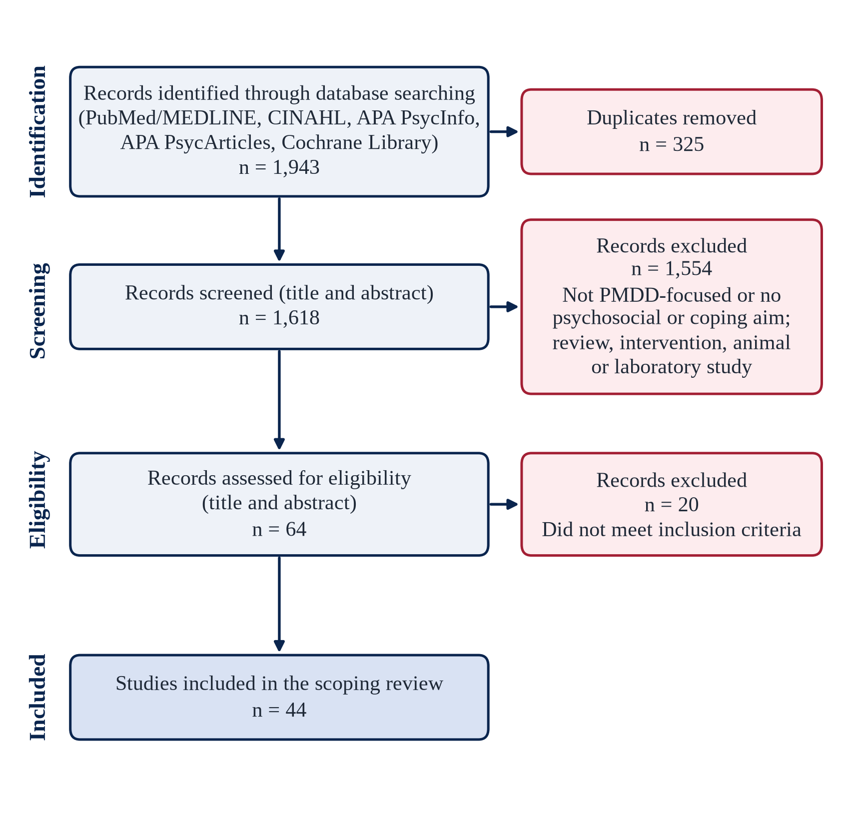
Figure 1. Study Selection Flow Diagram. Adapted from PRISMA-ScR.¹⁴

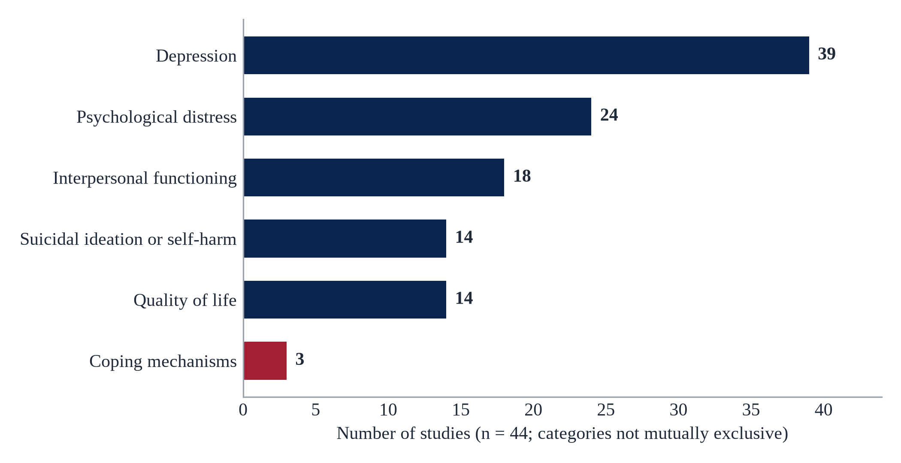
Figure 2. Psychosocial Outcomes Reported in the 44 Included Studies. A study could report more than 1 outcome, so counts should not be summed.

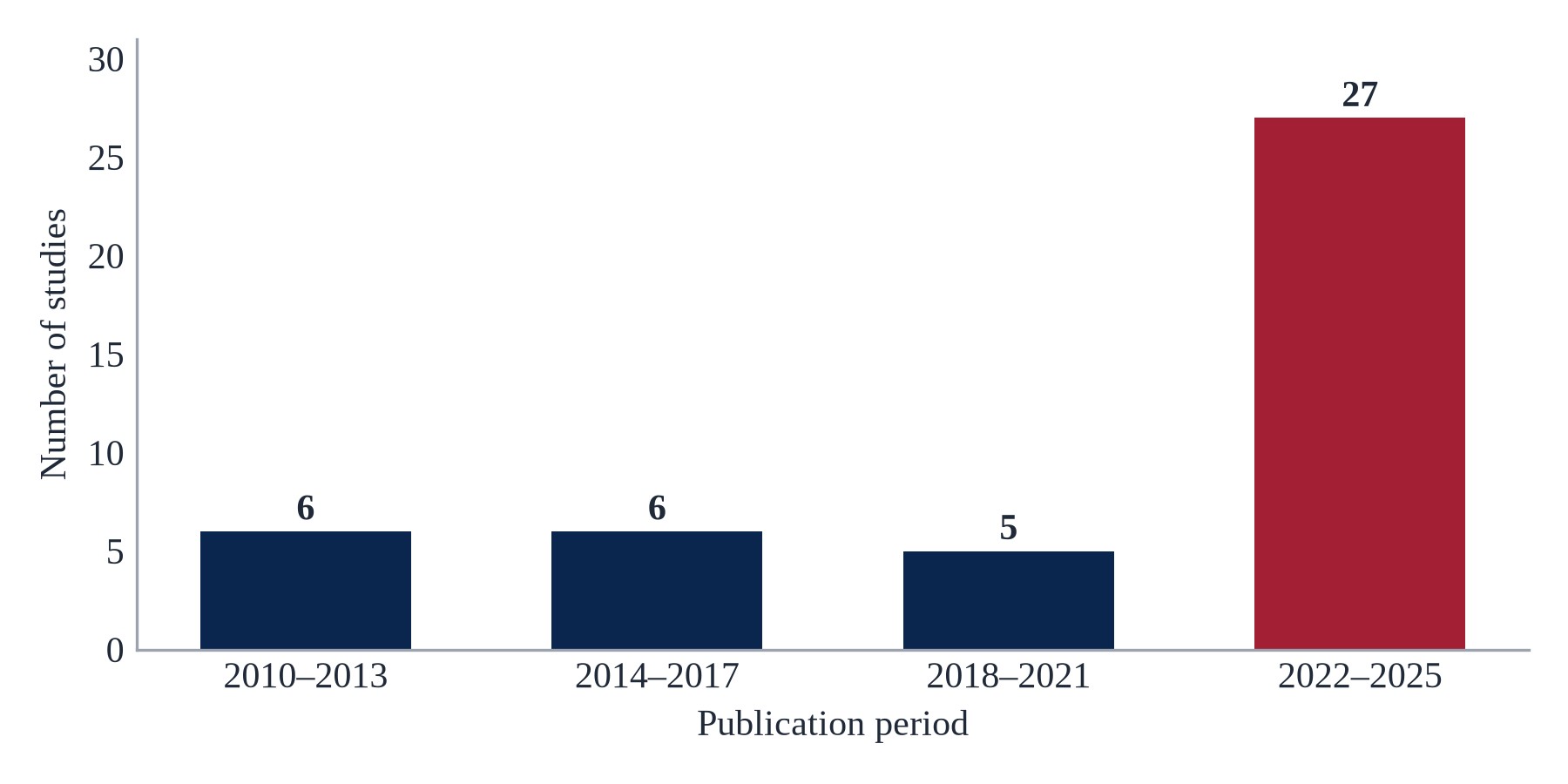
Figure 3. Included Studies by Publication Period. Twenty-seven of 44 studies (61%) were published in 2022–2025.

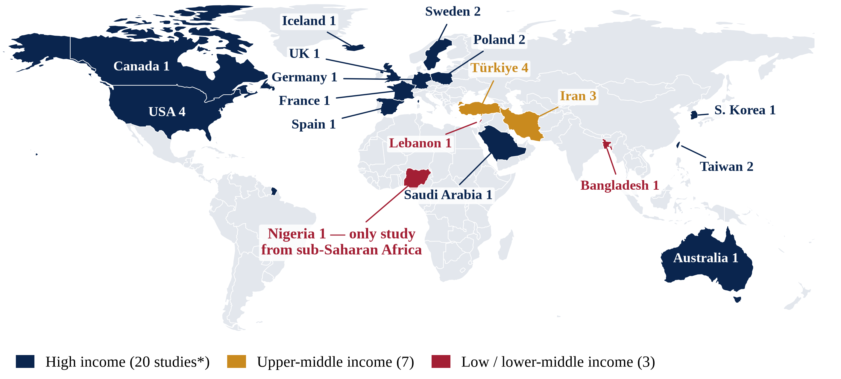
Figure 4. Country Setting and World Bank Income Group of Included Studies. The map shows the 30 studies with an identifiable country setting; income groups follow the World Bank FY2027 classification.¹⁵ The other 14 studies used online or multinational samples or had no single setting in the available records. The high-income count includes 1 study from Hong Kong, China.

