**FEDERAL UNIVERSITY OF AGRICULTURE, ABEOKUTA**

COLLEGE OF PHYSICAL SCIENCES

Course:

CSC 214 – System Analysis and Design

Topic:

SYSTEM ANALYSIS AND DESIGN OF A COURSE ALLOCATION SYSTEM FOR COMPUTER SCIENCE DEPARTMENT, FUNAAB

BY GROUP 21

*Submitted to:*

Department of Computer Science

February 2018.

**GROUP MEMBERS**

|  |  |  |  |
| --- | --- | --- | --- |
| **NAMES** | **MATRIC NO.** | **DEPARTMENT** | **LEVEL** |
|  |  | STS | 400L |
|  |  |  |  |
|  |  |  |  |
|  |  |  |  |
|  |  |  |  |
|  |  |  |  |
|  |  |  |  |
|  |  |  |  |
|  |  |  |  |
|  |  |  |  |

**Table of Content**

1. PROBLEM DEFINITION
2. REQUIREMENT ANALYSIS
3. DESCRIPTIOM OF EXISTING SYSTEM
4. FEASIBILTY STUDY
5. SYSTEM ANALYSIS
6. SYSTEM DESIGN
7. DATABASE DESIGN
8. SYSTEM BUILDING
9. TESTING AND EVALUATION
10. IMPLEMENTATION
11. MAINTAINANCE

**PROBLEM DEFINITION**

It was studied and discovered that automation of departmental course and the manual system of allocation course, their credit unit and lecturer usually waste a lot of time.

Below are some of the problems in this system.

1. It results to high cost of data processing each semester.
2. It wastes much paper and make filling of form cumbersome
3. It delays other departmental duties that are also important
4. It results to inefficiency of course allocation.

Because of these setbacks Computer Science department i.e. the case study has continued to leave activities untended to by the head of department because of volume of work left for him to do alone.

**REQUIREMENT ANALYSIS**

This project work has many aims and objectives to achieve these aims are geared towards carrying investigations in the old course allocation method (manual) and also include;

1. Designing a system that will be more interactive to staff (HOD or secretary) in charge of allocating courses,
2. Provide an automatic system that will reduce the work load of staff especially the HODs.
3. The research will also serve as a source of information to students and lecturer.
4. Provide quicker and more efficient services (course allocation) using automated system (computer).

Definitely, the complete implementation of this work will be introduced as a trend in the present method of allocating course, the change would in-doubt make the management happier, such changes envisage will include the following:

1. The high cost incurred by the management in buying of papers, pens, pencils, makers, measuring ruler etc. The clerical duties involve in course allocation will be reduced drastically because the hard disk, floppies, tape would be used instead of the above mentioned.
2. The time involved in allocating and re-allocating which normally results to delay will be reduced.
3. Automated System would also serve as a reference file for the students and staff since the course, credit units and lectures in charge would be properly recorded.

**DESCRIPTION OF EXISTING SYSTEM**

The existing system of course allocation involve a list of all courses in the department and the available lecturers. Allocation of courses are then done manually by searching through at every allocation to assign a course to a lecturer that is specialized in the area of the scope of the course.

**FEASIBILITY STUDY**

During this phase, the alternative solution to solving the problem was ascertained. The alternative solution devised was a Course Allocation System. This system allows users to add all the departmental courses and available lectures. All the available lecturers and their area of specialization are first added. When new course is being added, the list of all already added lecturers and their area of specialization are provided as options to choose from as the lecturer in charge of the course. This phase also involves defining the scope and objectives of the alternative solution. The scope of the new system covers:

* Interface for list of courses
* Interface for list of lecturers
* Interface to add new course
* Interface to add new lecturer
* Interface to edit already added course

**SYSTEM ANALYSIS**

At this phase the flow of information of the system was analyzed bearing the input and the output the new system in mind. Through this, information needed for the input and output of the system were gathered. Below is a data flow diagram of information of the System Allocation System.

**FLOW CHART DIAGRAM FOR ADDING NEW LECTURER**

LOAD ALL LECTURERS FROM THE DATABASE

DISPLAY NEW LECTURER FORM

IF TRUE

IF FALSE

“LECTURER ALREADY ADDED”

ADD LECTURER TO THE DATABASE

LECTURER ALREADY ON THE DATABASE?

When ‘add new lecturer’ is clicked, a form interface is popped up to fill in lecturer’s information like title, Lecturer’s last name, initials and area of specialization. If the information is entered correctly, the lecturer’s record is added to the lecturer entity on the database.

**FLOW CHART DIAGRAM FOR ADDING NEW COURSE**

LOAD ALL LECTURERS FROM THE DATABASE

DISPLAY ALL LOADED NEW COURSE ADDITION FORM

IF TRUE

“COURSE ALREADY EXIST”

IF FALSE

ADD COURSE TO THE DATABASE

COURSE ALREADY ON THE DATABASE

When ‘add new course is clicked, a form interface is popped up to fill in the new course information like course code, course title, unit and the scope of the course. The list of the available lecturer and their area of specialization is automatically generated from the database to select which lecturer to be in charge of the course. When the form is submitted, a check is run to confirm if the course had not already been added. If the course already exists on the database, the record is rejected and user is notified of the existence of the course on the database.

**FLOW CHART DIAGRAM FOR LOADING COURSE**

LOAD COURSES FOR THE LEVEL FROM DATABASE ASYNCHRONOUSLY

DISPLAY ALL LOADED COURSE FROM THE DATABASE

ANY COURSE ADDED YET FOR THE LEVEL?

IF FALSE

IF TRUE

“NO COURSE ADDED FOR THE LEVEL YET”

“SELECT A PARTICULAR LEVEL”

There would also be a feature to automatically allocate all already added courses to lecture with just a click a click. The course scopes are compared with the lecturer’s area of specialization, any lecturer’s area of specialization that matches the course scope would be automatically be assigned the course. The flow chart of this function is shown below;

LOAD ALL COURSES SCOPE AND LECTURER SPECIALIZATION FROM DATABASE

FOR EACH COURSE, COURSE SCOPE MATCHES LECTURERS SPECILIZATION?

IF TRUE

LOOP THROUGH THE COURSES SCOPES AND LECTURERS

CLICK ‘AUTOMATICALLY ALLOCATE COURSES’

ASSIGN COURSE TO THE LECTURER

**SYSTEM DESIGN**

With the facts gathered during the feasibility study and the system analysis of the system. The system requirement and expectations were translated into feasible technical solution. We came up with a structural design making use of a use case diagram in describing what the whole system looks like. Below is a USECASE diagram graphically representation of the users and different cases.

**USER (DEPARTMENT)**

**COURSE ALLOCATION SYSTEM**

**DATABASE DESIGN**

Two entities (tables) were built to store information for the system. The entities are courses and lecturers. Below is the conceptual design of the database.

**Entity** **Attributes**

* Course code (Primary Key)
* Course title
* Course unit
* Course scope

course

* Lecturer id (Primary Key)
* Title (e.g. Dr.)
* Last name
* Initials
* Area of specialization

Lecturer

The attributes ‘course code’ and ‘lecturer id’ are the primary keys of the entity Course and Lecturer respectively. This primary key enables each record in the entity to be uniquely identified.

**SYSTEM BUILDING**

The system was built based on the system design using HTML, CSS, JavaScript for the front end and using PHP for the backend and MYSQL for the database design. Asynchronous JavaScript and XML (AJAX) API was also used to interact with the database via PHP script asynchronously.

**TESTING AND EVALUATION**

The system has been tested by the builder (not by the targeted users i.e. department yet) and it was found that the system specifications were met. To test and evaluate the system, open the package (which includes the source code for the system) that comes along this report and follow the guide in READ ME.txt. The system would need to run on a server, a local server installer *xampp-win32-5.6.24-1-VC11* is included in the package. This server is to be installed (if there is none on the PC to be tested on). If the system is tested and evaluated to be working well, then it can be hosted on a wider server and the local server would no longer be needed. Below are the screenshots of the interfaces of the system.

NOTE: Sample course and lecturer is added just for demonstration. It can however be deleted.

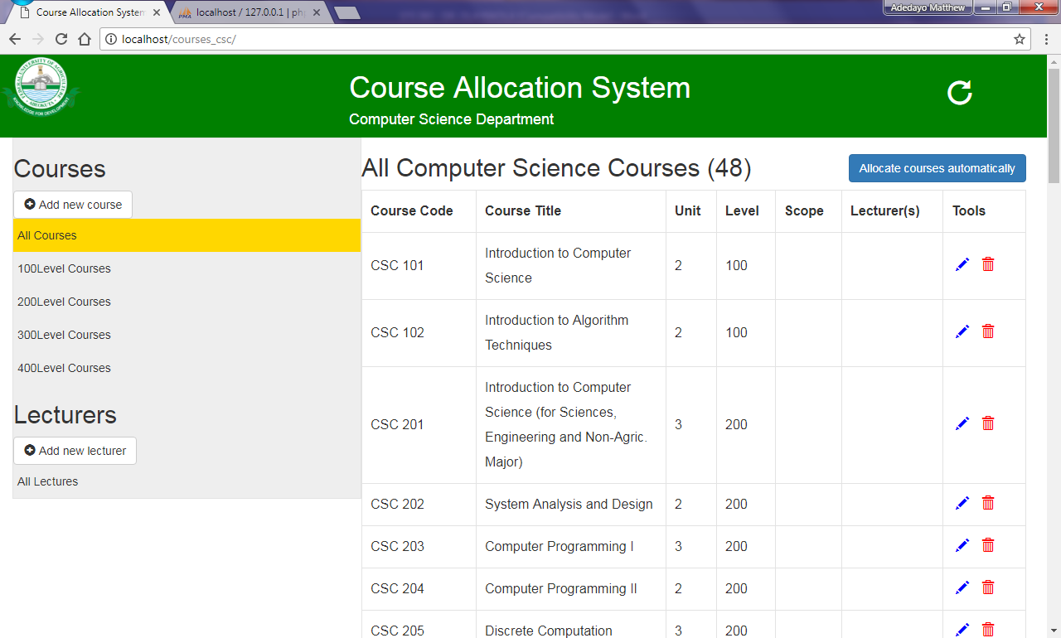

*Courses interface*

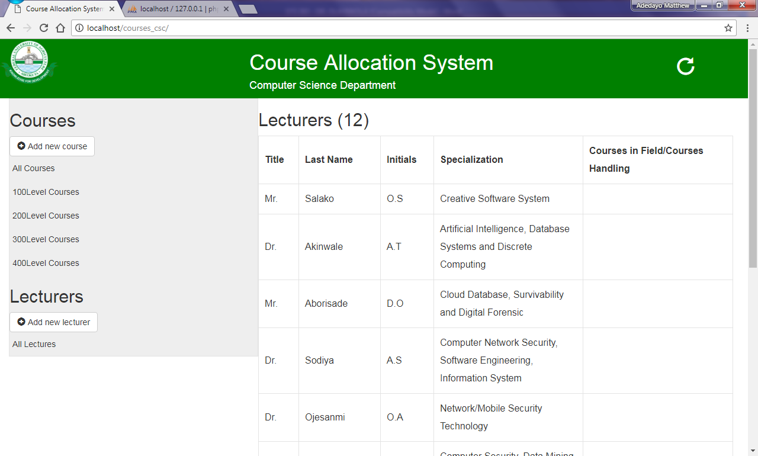

*Lecturers Interface*

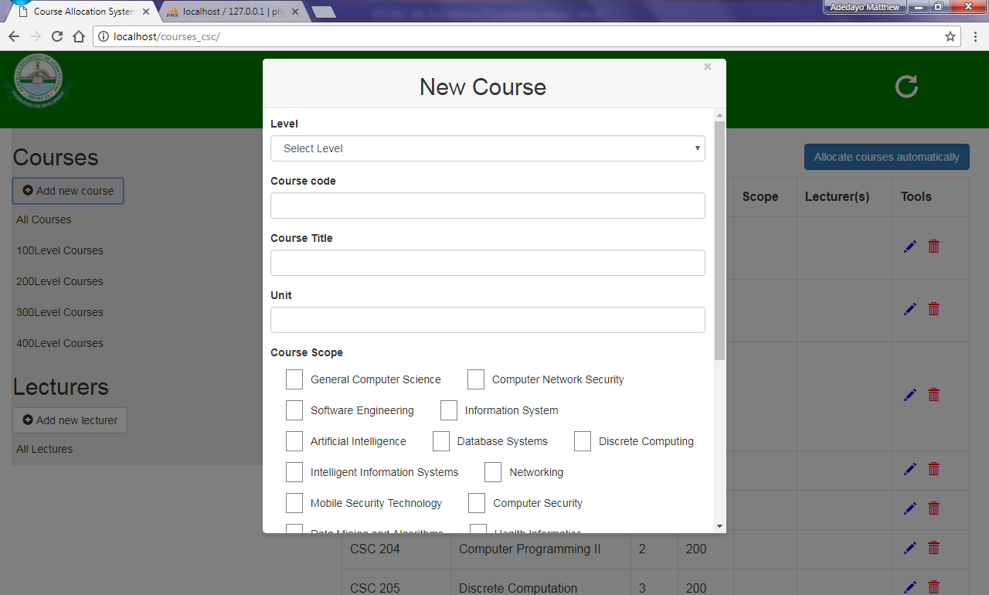

*New course interface*

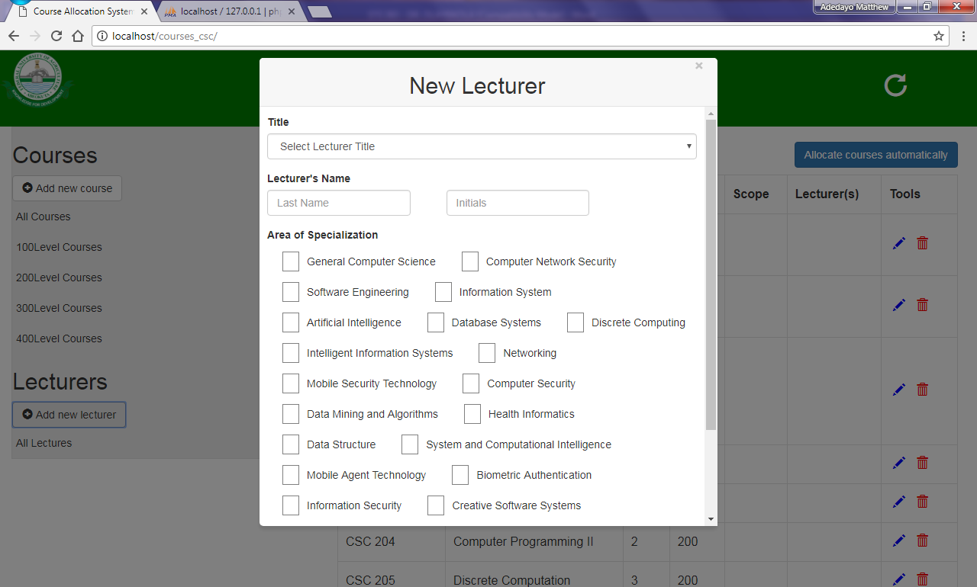

*New Lecturer Interface*

By default, no lecturer is allocated any course. When the user clicks on ‘Allocate courses automatically’, courses that match one or all of a lecturer areas of specialization are allocated respectively. With this, a course can be allocated to more than one lecturer and a lecturer can be allocated with more than one course. Every details about a particular including the lecturer in charge can always be changed by the user at any time by clicking the pencil icon in front of the course to be edited.

**P.S:**

***The courses and lecturers added by default to the system might be outdated as it was gotten from the Student Information Handbook 2012 – 2015 as a result of unavailability of the current handbook as at the time of building the system.***

**IMPLEMENTATION**

To implement this system, kindly follow the guide in READ ME.txt in the package that comes along this report.

**MAINTAINANCE**

Maintenance would be needed to ensure the system keeps working at optimum. Other specifications might also need to be added as the need arises, therefore the source codes, resources, and other libraries that were used for building the system would be ‘pushed’ into a repository on github. Github helps to track every changes that happens in the system source codes and resources.

When the system is hosted on a wider server (perhaps, FUNAAB server), Security feature would be added in future such that only authorized user can use the system.