**FEDERAL UNIVERSITY OF AGRICULTURE, ABEOKUTA**

COLLEGE OF PHYSICAL SCIENCES

Course:

CSC 214 – System Analysis and Design

Topic:

SYSTEM ANALYSIS AND DESIGN OF A SECRETARIAL TODO LIST SYSTEM

BY GROUP 18

*Submitted to:*

Department of Computer Science

February 2018.

**GROUP MEMBERS**

|  |  |  |  |
| --- | --- | --- | --- |
| NAMES | MATRIC NO. | DEPARTMENT | LEVEL |
| ADEKAMBI YOSOLA | 2013/2717 | STS | 400L |
| AKINYEMI SOLOMON | 2013/2733 | STS | 400L |
| AWOLAJA ADEDAYO | 2013/2738 | STS | 400L |
| DADA OLUKUNLE | 2013/2741 | STS | 400L |
| ILEKOYA TITUS | 2013/2755 | STS | 400L |
| ISHAKUNLE FESTUS | 2014/3424 | STS | 400L |
| KAYODE ADEDAYO | 2013/2758 | STS | 400L |
| ODUKOYA ADEDAYO | 2013/2762 | STS | 400L |
| OLANIPEKUN ABDUL - MATEEN | 2014/3449 | STS | 400L |
| OSHONIYI ADETAYO | 2013/2774 | STS | 400L |
| TIJANI ISIAK | 2014/3472 | STS | 400L |

**TABLE OF CONTENTS**

1. DESCRIPTION OF THE EXISTING SYSTEM

2. SYSTEM STUDY (PROBLEM DEFINITION)

3. FEASIBILITY REPORT

4. SYSTEM ANALYSIS

5. SYSTEM DESIGN

6. DATABASE DESIGN

6. SYSTEM BUILDING

7. TESTING AND EVALUATION

8. IMPLEMENTATION

9. MAINTENANCE

**DESCRIPTION OF EXISTING SYSTEM**

The existing system involves secretaries manually planning for daily activities using pen and jotter.

**SYSTEM STUDY (PROBLEM DEFINITION)**

A preliminary survey was carried out to investigate the existing system. This involved visiting some of the departmental secretaries to inquire on how they plan their daily activities. From the responses, we discovered that not all the activities were able to carry out mostly because there was no detailed daily schedule of activities.

**FEASIBILITY STUDY**

During this phase, the alternative solution to solving the problem was ascertained. The alternative solution we were able to come up with is a Secretarial Todo List System (STLS). This STLS enables users to plan their activities at beginning of the day and the real time countdown to the time set for each activity is displayed on the screen. This phase involves defining the scope and objectives of the alternative solution. The scope of the new system covers:

* Login interface for the secretary
* Sign up interface for new secretary
* Interface for adding new activity
* Interface for countdown to pending activities,

**SYSTEM ANALYSIS**

At this phase the flow of information of the system was analyzed bearing the input and the output the new system in mind. Through this information needed for the input and output of the system were gathered. Below is a data flow diagram of information of the STLS.

**FLOW CHART DIAGRAM FOR USER LOGIN**

INPUT USERNAME AND PASSWORD

IF FALSE

IF TRUE

“INCORRECT USERNAME AND/OR PASSWORD”

LOG USER IN

ANY RECORD MATCH THE USERNAME AND PASSWORD?

?

SUBMIT TO DATABASE AND COMPARE THE INPUTS

After entering to the home page of the Secretarial To-do List System, username and password is required as input to continue to use the system. There is also an option for sign up for new user.

**FLOW CHART DIAGRAM FOR NEW ACTIVITY**

“LOGIN TO YOUR ACCOUNT FIRST”

IF TRUE

IF FALSE

“TIME FOR ACTIVITY HAS PASSED”

ADD RECORD TO DATABASE

TIME SET FOR ACTIVITY ELAPSED?

SUBMIT ACTIVITY DETAILS TO DATABASE

USER IS LOGGED IN?

IF FALSE

IF TRUE

“ACTIVITY CREATED SUCCESSFULLY”

“INPUT ACTIVITY DETAILS”

When a user is logged in, there would be an interface on the home page to add new activity, information like activity label, activity time and date would be required, when filled and submitted, just before adding the new activity to the database, there would be a check on the inputs provided by the user. The date and time set for the new activity would be checked if it has not elapsed. If it has elapsed, the user would be prompted to input a future time.

**FLOW CHART DIAGRAM FOR USER SIGN UP**

CREATE USERNAME AND PASSWORD

IF TRUE

IF FALSE

“USERNAME ALREADY EXIST, CHOOSE ANOTHER ONE”

ADD RECORD TO DATABASE

ANY RECORD ALREADY EXIST WITH THE SUBMITTED USERNAME?

?

SUBMIT INPUTS TO DATABASE

In the home page that also feature the login page by default, an option of sign up is provided for new user. The new user would be asked to create a username and password, this username is meant to be unique, there would be verification against the already existing usernames on submission.

**SYSTEM DESIGN**

With the facts gathered during the feasibility study and the system analysis of the system. The system requirement and expectations were translated into feasible technical solution. We came up with a structural design making use of a use case diagram in describing what the whole system looks like. Below is a USECASE diagram graphically representation of the users and different cases.

**SECRETARY**

**SECRETARIAL TODO LIST SYSTEM**

**DATABASE DESIGN**

Two entities (tables) were built to store information for the system. The entities are user and activities. Below is the conceptual design of the database.

**Entity** **Attributes**

* User id (Primary Key)
* Username
* Password
* Timestamp

User

* Activity id (Primary Key)
* User id (Foreign Key)
* Activity Subject
* Activity Detail
* Time created
* Activity date
* Activity Time

Activity

The attributes ‘user id’ and ‘event id’ are the primary keys of the entity Users and Activities respectively. This primary key enables each record in the entity to be uniquely identified. Also, a foreign key was added to the Activities entity. This foreign key helps to maintain ‘table integrity’ such that an activity cannot exist in the Activity entity without the existence of the user record in the users entity. This foreign also help to manage record such that if a record of a user is deleted or updated on the user entity, all the activities associated with that users are deleted or updated automatically as the case may be.

**SYSTEM BUILDING**

he system was built based on the system design using HTML, CSS, JavaScript for the front end and using PHP for the backend and MYSQL for the database design. Asynchronous JavaScript and XML (AJAX) API was also used to interact with the database via PHP script asynchronously.

**TESTING AND EVALUATION**

The system has been tested by the builder (not by the targeted users i.e secretaries yet) and it was found that the system specifications were met. To test and evaluate the system, open the package (which includes the source code for the system) that comes along this report and follow the guide in READ ME.txt. The system would need to run on a server, a local server installer *xampp-win32-5.6.24-1-VC11* is included in the package. This server is to be installed (if there is none on the PC to be tested on). If the system is tested and evaluated to be working well, then it can be hosted on a wider server and the local server would no longer be needed.

The following are the screenshots of different interfaces of the system.

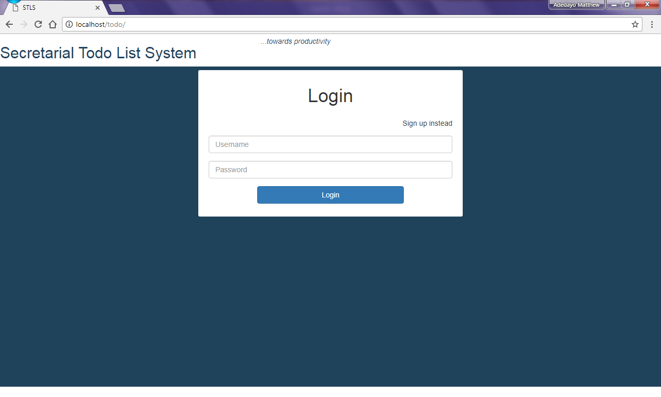

*Login interface*

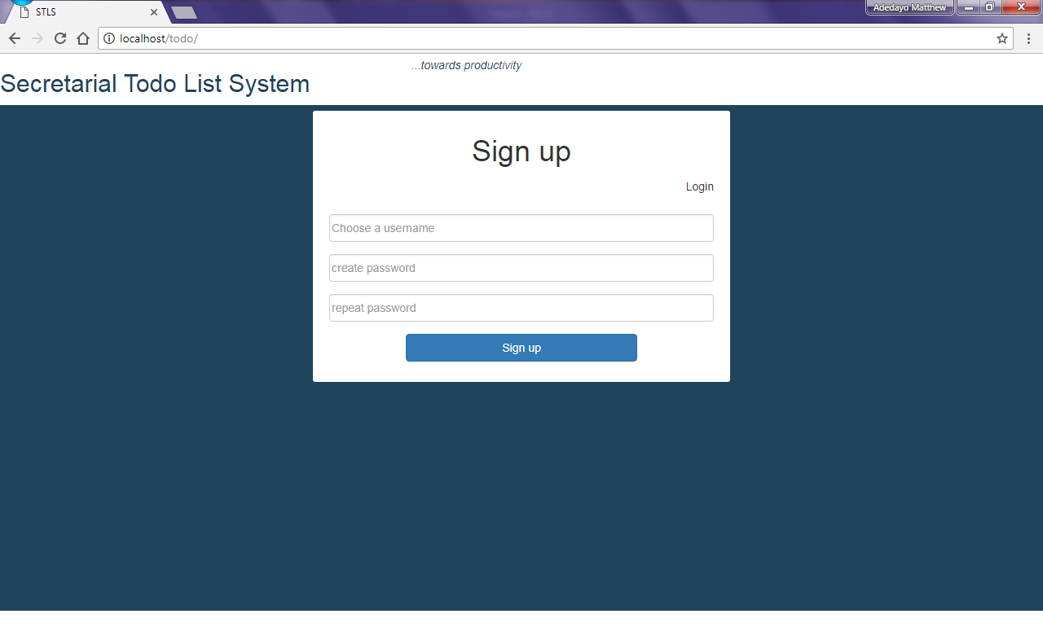

*Sign up interface*

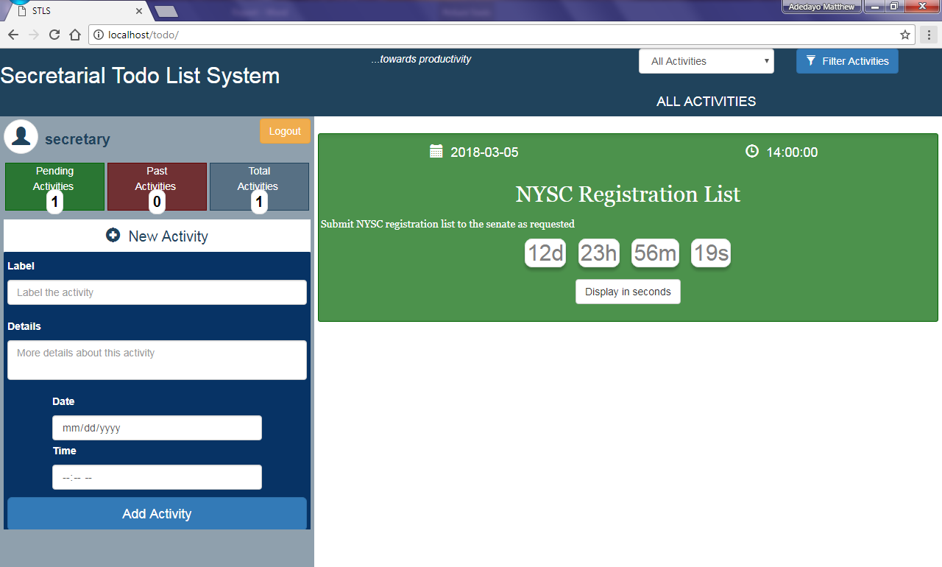

*Activities filter*

*Interface to add new activity*

*Pending activities interface*

**IMPLEMENTATION**

To implement this system, kindly follow the guide in READ ME.txt in the package that comes along this report.

**MAINTAINANCE**

Maintenance would be needed to ensure the system keeps working at optimum. Other specifications might also need to be added as the need arises, therefore the source codes, resources, and other libraries that were used for building the system would be ‘pushed’ into a repository on github. Github helps to track every changes that happens in the system source codes and resources.