Tab 1

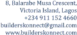
BUILDERSKONNECT MANUFACTURER / BRAND PARTNER REGISTRATION FORM
SECTION A: COMPANY INFORMATION
1. Company Name: Satkay Limited
2. Brand Name: Satkay
3. RC Number: 196060
4. Contact Person: Toluwalope Oni
5. Position/Title: Managing Director/CEO
6. Phone Number: 08106264946
7. Email Address: Toni@satkaygroup.com
8. Office Address: 15, Aromire Avenue, Ikeja, Lagos
9. Factory Address: NIL
10. Website: (optional)
11. Social Media Handles: Bath & Basin by Portland (Instagram)
12. How many years have you been in business?
More than 10 years

SECTION B: PRODUCT INFORMATION
13. What category of products do you manufacture or distribute?
Sanitary Ware, Bath fittings and Accessories.

14. List your top 5 products.
Alca drain (Am101), Jaquar Towel Rail Holder, Jaquar Toilet Roll Holder, Siamp Generation Premium Toillet Seat Cover, Ideal Standard Slimline Basin Mixer.

15. Are these products:
Manufactured by your company
Imported and sold under our own brand.
Distributed on behalf of another manufacturer
Combination of the above: Yes

16. Country of Manufacture: (Global)

17. Upload product catalogue (if available)

18. Upload product images

SECTION C: QUALITY & CERTIFICATION
19. Do your products have any certifications?
SON: Yes
MANCAP
ISO: Yes
International Certifications: Yes

20. Upload copies of available certifications (optional)

21. Do you offer warranty on any of your products?
Yes
If Yes:
22. Warranty Period: 10years
23. Warranty Coverage: Manufacturing defect
SECTION D: SUPPLY CAPACITY
24. Which states do you currently supply? Nationwide
25. Estimated monthly production/supply capacity
26. Minimum Order Quantity (MOQ): 1
27. Average delivery timeline after order confirmation: 48hrs
SECTION E: DECLARATION
I hereby confirm that:
- The information provided is accurate.
- My company owns the brand or is authorized to sell the products listed.
- Any certifications submitted are genuine.
- BuildersKonnect may remove our products if false information is discovered.
- We agree to cooperate with BuildersKonnect during product verification processes.
Name: Toluwalope Oladapo Oni
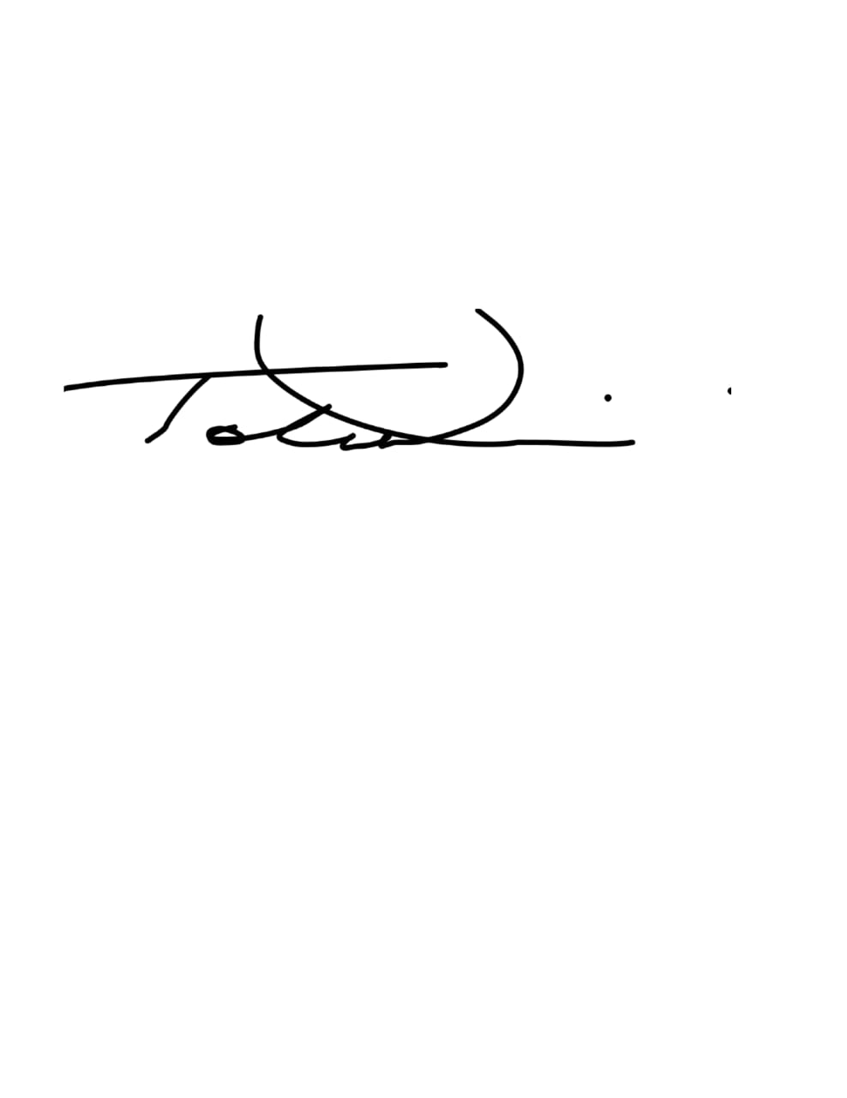
Position: Managing Director/CEO
Signature:
Date: 8th July 2026

Tab 2

