FAKTA:

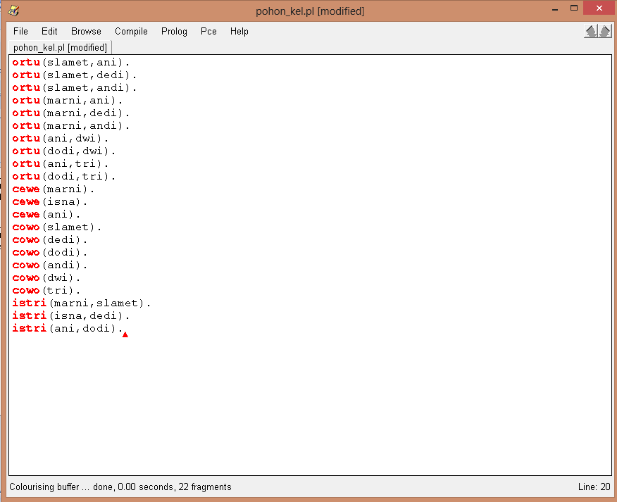

1.1.nama cucu saja

Rules:

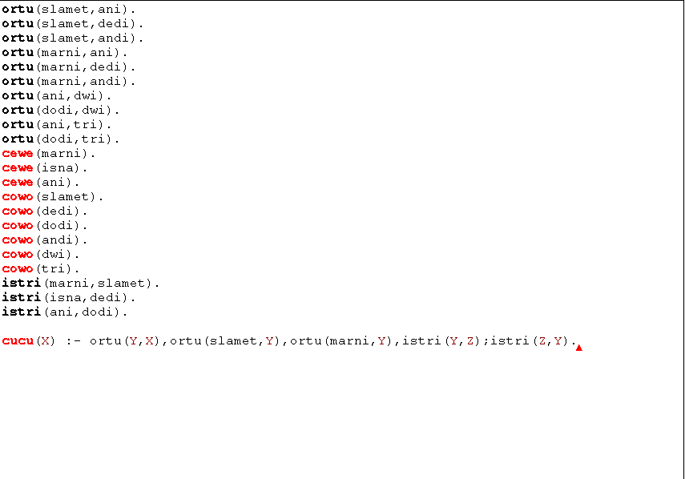

Goal:

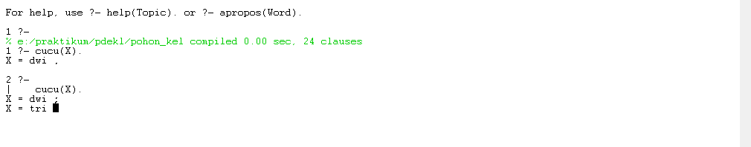

1.2.nama cucu+ibu

Goal:



3.nama cucu+ibu+kakek

Rules:

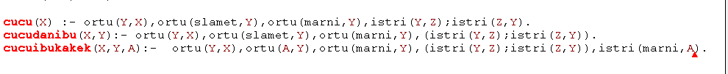

Goal:

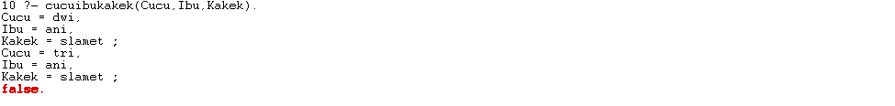

2.1

Cucu+kakek+nenek

Menambah cucu sani:



Rules:

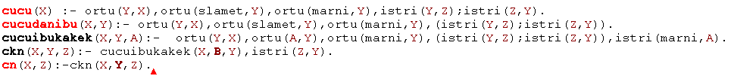

Goal:

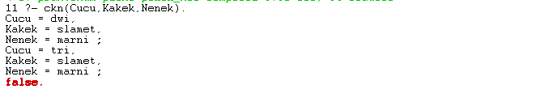

2.2 cucu+nenek

Goal:

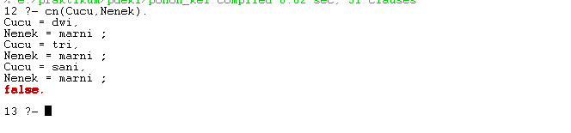

3.1 menantu

Rules:

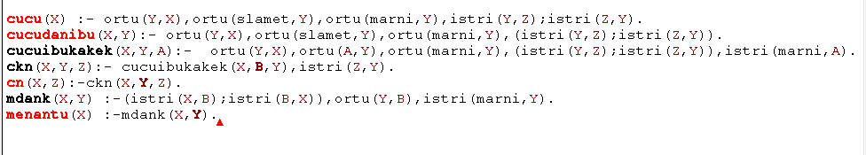

Goal:



3.2 menantu+kakek

Goal:

