Clinical Normalization and Expansion Layers for BM25 Retrieval over Free-Text Clinical Notes: An Ablation Study on MTSamples with OpenMRS Integration

Ade Dwi Prayitno, Aldi Indrawan, Ari Rudiatama, Dimas Ihdam Maulana, and Wiladahtul Awaliah
Department of Computer Science and Electronics, Faculty of Mathematics and Natural Sciences, Universitas Gadjah Mada, Yogyakarta, Indonesia. Student IDs (NIM): A. D. Prayitno 25/563076/PPA/07097; A. Indrawan 25/557923/PPA/07038; A. Rudiatama 25/569437/PPA/07170; D. I. Maulana 25/562999/PPA/07090; W. Awaliah 25/569610/PPA/07174. Corresponding e-mail: aldiindrawan@mail.ugm.ac.id. Source code, dataset and documentation: https://github.com/adedwi1808/stbi-openmrs-bm25.

Abstract—Search in conventional electronic health record (EHR) systems is typically limited to exact keyword matching, which fails to handle synonyms, abbreviations, and terminology variation in free-text clinical notes. This project implements a ranked retrieval engine based on BM25 and integrates it into the open-source OpenMRS platform as an add-on module. Its main contribution is not merely applying BM25, but an ablation study of a clinical normalization and expansion layer: a negation-preserving stopword list, multiword-term detection, and medical abbreviation/synonym expansion. The system is evaluated on the MTSamples dataset, processed into 2,316 final documents, comparing five retrieval variants (V0–V4) side by side. Results show that clinical normalization (V1) is marginally above the naive baseline (V0) on nDCG@10 (0.6865 vs. 0.6832), but the gap is equivalent to only one document moving into the top ten and has not been tested for statistical significance; we therefore report this finding as “does not degrade ranking quality” rather than as a confirmed improvement. The precision drop observed in the expansion variants is reported as-is, together with an analysis of qrels limitations that explains most of the decrease. The resulting module was verified to run on OpenMRS 2.8.8 with a shaded Apache Lucene 8.11.2 index to avoid dependency conflicts.
Index Terms—BM25, clinical information retrieval, text normalization, abbreviation expansion, synonym expansion, OpenMRS, MTSamples, ablation study, Apache Lucene.

I. Introduction
Adoption of Electronic Health Records (EHR) has become an essential standard in modern healthcare delivery. Open-source platforms such as OpenMRS are used by more than 8,000 healthcare facilities in over 70 countries to manage patient data electronically [1], [19]. OpenMRS stores clinical data in multiple forms, including observations, encounters, diagnoses, and free-text clinical notes such as discharge summaries, radiology reports, and progress notes.
However, the search capability of conventional EHR systems is generally limited to exact matching through simple SQL queries. This approach is ineffective for finding relevant clinical cases from free-text notes because it does not understand synonyms, terminology variation, or semantic context. For example, a physician searching for “chronic kidney disease” may fail to find notes that use the abbreviation “CKD” if the system only supports exact keyword matching.
Information Retrieval (IR) offers content-based search that captures the relevance between a query and the content of medical documents. Ranked retrieval algorithms such as BM25 have proven reliable for text search over large collections, including the clinical domain, where document length varies dramatically [2]. This project implements a BM25-based IR module on OpenMRS and evaluates it using the public MTSamples dataset.

A. Problem Statement
Medical information search in legacy EHR systems still relies on exact-keyword mechanisms that limit the effectiveness of clinical case discovery. This approach fails to handle terminology variation, abbreviations, and synonyms, so relevant documents that use different surface forms cannot be found. As a result, clinicians struggle to access a comprehensive view of a patient's clinical history, which can hinder the speed and accuracy of medical decision-making.

B. Scope and Limitations
The scope of this project is bounded as follows.
• The platform used is the OpenMRS Reference Application; this is not an EHR built from scratch.
• The algorithm implemented is BM25; neural retrieval approaches are out of scope.
• The dataset used is MTSamples [9], containing approximately 5,000 medical transcriptions.
• The module is integrated through an HTTP endpoint without modifying OpenMRS's core database schema.
• Evaluation is performed using standard IR metrics only, without a clinical trial involving real patients.

C. Objectives
The objectives of this project are to implement BM25 ranked retrieval, build an inverted-index-based indexing mechanism, integrate the search module into the OpenMRS ecosystem, and evaluate its performance using Precision@K, Recall@K, and nDCG@K [13].

II. Related Work

A. Information Retrieval in Electronic Health Records
IR systems for EHR enable clinical-case search based on the content of medical text rather than only patient metadata. Unlike relational database search, which relies on exact match, IR uses probabilistic or vector-space models to determine document relevance to a query. In the clinical domain, IR challenges include medical terminology variation (synonymy), abbreviations [18], and documents whose length varies widely, from short radiology reports to lengthy surgical reports [3].

B. The BM25 Algorithm
BM25 is a probabilistic document-ranking model developed by Robertson et al. [2], [11] and is an evolution of the classic TF-IDF model [12]. BM25 accounts for three main components: term frequency (TF), which is saturated to avoid domination by very frequent terms; inverse document frequency (IDF), which measures a term's uniqueness within the collection; and document-length normalization. The BM25 score for document D and query Q is computed as
score(D,Q) = Σ_{qi∈Q} IDF(qi)· TF(qi,D)(k1+1) / [TF(qi,D) + k1(1 − b + b·|D|/avgdl)] (1)
where k1 and b are tuning parameters. BM25 was chosen because it has been shown to be superior for collections with extreme variation in document length, as is the case for clinical notes.

C. Research Gap
A review of prior work shows that BM25 on the MTSamples dataset has been tested before, but it is consistently treated as a naive baseline rather than as an object of tokenization optimization. Table I summarizes the comparison.
TABLE I
COMPARISON OF RELATED STUDIES AND THEIR TREATMENT OF BM25
Study | Focus | Treatment of BM25
Mikkelsen (2026) [4] | Embedding vs. BM25 benchmark | Baseline with lowercase + punctuation-stripping tokenization
Zhang (2021) [5] | BM25 score-weight optimization | Improvement in the scoring function, not tokenization
Gayen et al. (2023) [6] | Porting Essie tokenization to Solr | Clinical tokenization, not for BM25 in EHR
Griffon et al. (2012) [7] | UMLS synonym expansion | For PubMed, not for EHR

Based on this comparison, the gap addressed by this project is the absence of a study that specifically evaluates a clinical normalization and abbreviation/synonym-expansion layer for BM25 on the MTSamples dataset, let alone one integrated directly into OpenMRS.

III. Methods

A. System Architecture
The system consists of three main components: a data pipeline (Python), an IR engine (Java/Lucene), and an OpenMRS module. Fig. 1 outlines the pipeline stages, from raw data to evaluation metrics.
Data Pipeline (Python): build_corpus.py → build_lexicon.py → build_qrels.py
IR Engine (Java/Lucene 8): ClinicalNormalizer → IrIndexer (multi-field index) → IrSearcher (BM25)
OpenMRS Module: IrBm25Service → JSON endpoint → UI dropdown (V0–V4)
Evaluation: EvalRunner → Precision@K, Recall@K, nDCG@K
Fig. 1. System pipeline: data preparation, the Lucene-based IR engine, the OpenMRS module, and the evaluation harness.

B. Data Pipeline
The dataset is built from mtsamples.csv (4,999 rows) through three stages: de-duplication, whitespace normalization, and short-document filtering. Duplicate rows are merged rather than dropped, preserving multi-label metadata. The clinical lexicon is built from four sources: negation markers, multiword terms, medical abbreviations, and synonyms. The query set contains 50 clinical queries, with TREC-format relevance judgments (qrels) constructed semi-automatically from the keywords, sample_name, and description columns, and made synonym-aware so that expansion variants are judged fairly. Judgments are binary (relevant/not relevant), with 1,114 total relevant query–document pairs, averaging 22.3 relevant documents per query (median 13.5; range 1–98). The methodological consequences of this qrels construction are discussed in Section V-A.
Table II summarizes the dataset-construction statistics. A key finding is that 91.2% of documents are multi-specialty, so the medical_specialty column cannot serve as a relevance ground truth for evaluation.
TABLE II
DATASET CONSTRUCTION STATISTICS
Metric | Value
Raw rows | 4,999
Empty transcriptions | 33
Duplicate rows | 2,609
Documents < 50 tokens | 41
Final documents | 2,316
Multi-specialty documents | 91.2%

Table III summarizes the clinical lexicon components and their coverage, measured directly on corpus.jsonl to ground the need for clinical tokenization in evidence rather than assumption.
TABLE III
CLINICAL LEXICON COMPONENTS AND COVERAGE (2,316 DOCUMENTS)
Category | Count | Coverage
Negation markers (no, denies, without) | 13 | 88.0%
Multiword terms (shortness of breath) | 28 | 60.9%
Medical abbreviations (c/o, DM, HTN) | 28 | 28.8%
Synonym groups | 15 | –

C. Retrieval Variants
All variants use identical BM25 parameters (k1 = 1.2, b = 0.75); the only difference is the tokenization layer. Table IV summarizes the five variants.
TABLE IV
FIVE RETRIEVAL VARIANTS IN THE ABLATION STUDY
ID | Label | Strategy
V0 | Naive BM25 | lowercase + punctuation removal (baseline)
V1 | Clinical normalization | V0 + negation preserved + multiword terms + abbreviation expansion
V2 | Clinical + expansion | V1 + query-side synonym expansion
V3 | Character n-gram | character n-gram indexing (3–5)
V4 | Clinical + expansion + PRF | V2 + pseudo-relevance feedback

The five variants are designed as an ablation study, not as five equally viable production modes. V0 serves as the control for measuring the pure contribution of each tokenization layer added incrementally. V1 addresses basic clinical-term needs (negation, multiword terms, abbreviations) common in clinical notes. V2 directly targets the core problem statement: the terminology gap between a physician's query and the document's wording (e.g., “CKD” vs. “chronic kidney disease”). V3 is tested as an alternative character-based approach that is robust to morphological variation and typos without relying on a manual lexicon [15]. V4 tests whether automatic expansion via pseudo-relevance feedback [14] can match or exceed the manual expansion used in V2. By keeping BM25 parameters identical across all variants, the differences observed in Table V can be fairly attributed to each variant's tokenization layer.

D. IR Engine Based on Apache Lucene
The IR engine is written in Java using Apache Lucene 8.11.2 [10]. Because OpenMRS bundles an older Lucene version without BM25 support, Lucene 8 is shaded, relocating its packages to org.openmrs.module.irbm25.shaded.lucene to avoid conflicts. The index is built as multi-field (content_naive, content_clinical, content_ngram), allowing all five variants to be compared fairly on a single dataset with identical BM25 parameters.

E. OpenMRS Integration
OpenMRS is an open-source, Java-based EHR platform with a modular architecture on top of the Spring Framework. The platform supports add-on OpenMRS Modules that can be installed independently without disturbing the core system, and it provides a built-in REST API for integration with external applications [8].
The module is packaged as an .omod file and exposes the endpoint GET /module/ir-bm25/search.json?q={keyword}&variant={v0..v4}&limit={k}, which returns ranked documents with score and snippet. The user interface provides a dropdown to select a variant, as well as a “compare all” mode that displays all five variants side by side. This dropdown is not mere navigation but an interactive ablation-study tool: users (or evaluators) can directly observe differences in search results across tokenization layers for the same query, without re-running the evaluation pipeline separately. A navigation link was added to the Legacy UI sidebar via the org.openmrs.gutter.tools extension. Fig. 2 shows the single-variant search interface.
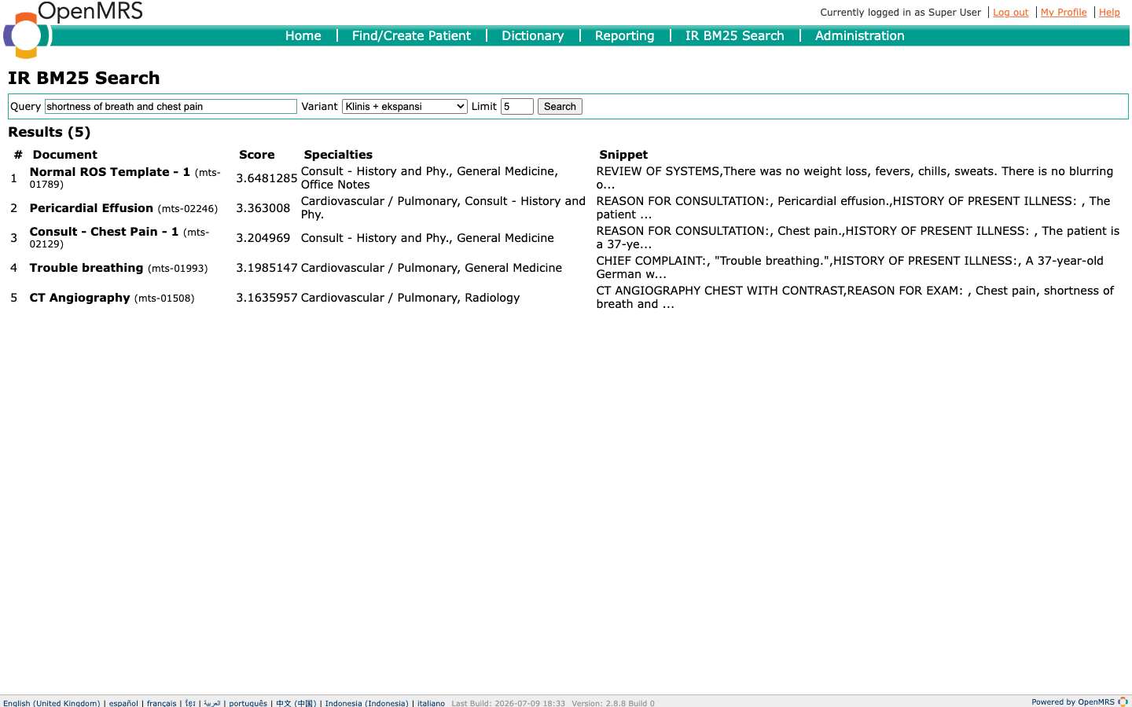
Fig. 2. Single-variant search interface of the ir-bm25 module.

IV. Results

A. Evaluation Setup
Evaluation was performed over 50 queries with cutoff K = 10, using Precision@10, Recall@10, and nDCG@10. Fig. 3 shows the “compare all variants” interface for the query “hypertension,” and results are presented in Table V.
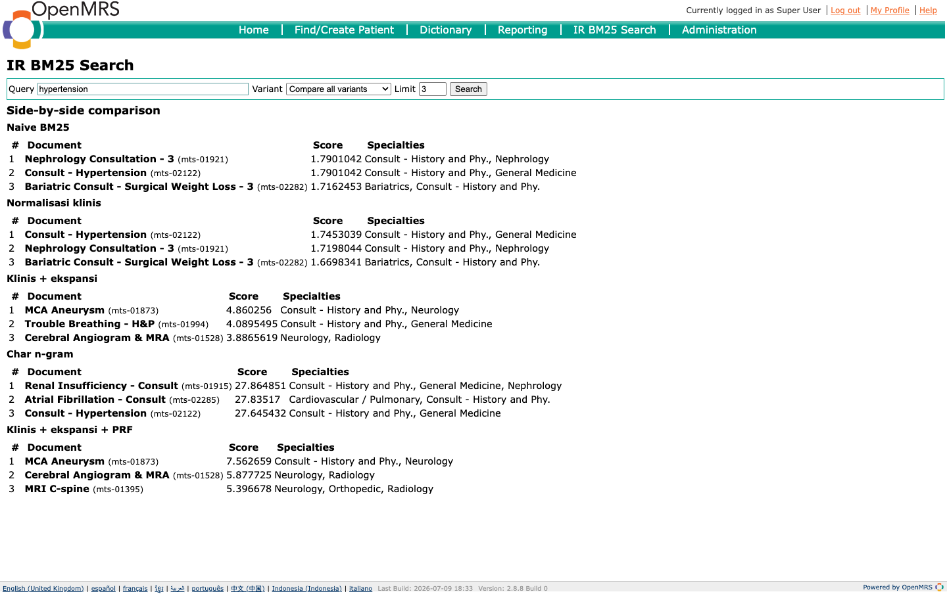
Fig. 3. “Compare all variants” mode showing all five variants side by side for the query “hypertension.”
TABLE V
ABLATION-STUDY EVALUATION RESULTS (50 QUERIES, K = 10)
Variant | P@10 | Recall@10 | nDCG@10
V0 · Naive BM25 | 0.5400 | 0.4312 | 0.6832
V1 · Clinical normalization | 0.5420 | 0.4284 | 0.6865
V2 · Clinical + expansion | 0.5120 | 0.4192 | 0.6509
V3 · Character n-gram | 0.5280 | 0.4055 | 0.6446
V4 · Clinical + expansion + PRF | 0.5020 | 0.4139 | 0.6186

B. Interpretation
Results show V1 (clinical normalization) is slightly above the naive baseline V0 on P@10 and nDCG@10. The magnitude of the gap must be read carefully. The P@10 difference of 0.0020 over 50 queries at K = 10 corresponds to exactly one document moving into the top ten (270 vs. 271 relevant documents out of 500 retrieved positions in total), while the nDCG@10 difference of 0.0033 corresponds to a 0.48% relative improvement. Recall@10 for V1 is actually slightly lower than V0 (0.4284 vs. 0.4312), so the improvement is not consistent across all three metrics. This evaluation also does not yet include a statistical significance test, such as a paired t-test or a randomization test over per-query scores. The defensible claim from this data is therefore that clinical normalization does not degrade ranking quality while substantially cutting response time (0.68 ms vs. 2.48 ms per query), not that it confers a confirmed improvement in ranking quality.
The Recall@10 values in Table V should also be read relative to their ceiling. With an average of 22.3 relevant documents per query (maximum 98), a cutoff of K = 10 caps the theoretically achievable recall at only 0.6762, not 1.0. Thus, V0's 0.4312 corresponds to about 64% of the ceiling achievable under this protocol.
Functionally, abbreviation expansion is verified to work: the query “CKD” successfully retrieves the document “Chronic Kidney Disease – Followup,” and the query “hypertension” retrieves documents containing the abbreviation “HTN.”

V. Discussion

A. Evaluation Limitations
The precision drop observed for V2, V3, and V4 should not be read as direct evidence that expansion is harmful. There is a structural limitation in the qrels used: relevance judgments were built from metadata columns (keywords, sample_name, description), while the field indexed and ranked by the IR engine is transcription. Direct measurement on the dataset reveals a large imbalance between the two, summarized in Table VI.
TABLE VI
IMBALANCE BETWEEN THE JUDGMENT DOMAIN AND THE INDEXING DOMAIN
Aspect | Value
Avg. length of judged fields (keywords + sample_name + description) | 44 tokens
Avg. length of indexed field (transcription) | 466 tokens
Imbalance ratio | 10.6×
Documents with no keywords at all | 526 (22.7%)
Documents ever judged relevant for some query | 841 (36.3%)

As a result, a document whose transcription genuinely discusses a clinical condition but whose metadata does not contain the matching term will be judged not relevant, even though the document is in fact relevant and was successfully retrieved by the system. This bias falls hardest precisely on the variants designed to look beneath the surface of the text — V2 (synonym expansion), V3 (character n-gram), and V4 (PRF) — because the additional documents they retrieve tend to be matches within the narrative body rather than the metadata. In other words, part of what is measured as a precision drop in Table V is potentially a protocol artifact rather than a genuine failure of those variants.
Consequently, the figures in Table V are more appropriately read as a comparison between variants under one fixed judgment protocol, rather than as an absolute estimate of system quality. Removing this limitation requires relevance judgments assessed directly on transcription content, ideally by clinically trained annotators.

B. Threats to Validity
Three further threats to validity are noted. First, no inferential statistics have been run on the results in Table V; the reported differences should be treated as descriptive, not confirmatory, until a paired significance test is applied [17]. Second, the clinical lexicon is manually curated and modest in size (13 negation markers, 28 multiword terms, 28 abbreviations, 15 synonym groups), with abbreviation coverage at only 28.8% of the corpus, so the ceiling on what V1–V4 can improve is itself bounded by lexicon coverage. Third, qrels were constructed semi-automatically from metadata rather than judged by clinically trained annotators, which compounds the domain mismatch discussed in Section V-A.

VI. Conclusion and Future Work
This project successfully implemented a BM25-based ranked retrieval engine with clinical normalization and expansion layers, integrated it into OpenMRS as an add-on module, and evaluated it through a five-variant ablation study on the MTSamples dataset. Dataset-based validation shows that negation markers, multiword terms, and medical abbreviations occur in a large share of documents, so clinical tokenization is grounded in evidence rather than assumption. Evaluation results show clinical normalization (V1) sits marginally above the naive baseline, but the gap lies within noise and has not been tested for significance, so the defensible conclusion is that the clinical tokenization layer does not degrade ranking quality while it speeds up response time. The limitation analysis in Section V-A shows that the precision drop in the expansion variants can largely be explained by a qrels protocol that judges relevance from metadata while the system ranks by transcription content. The module was verified to run on OpenMRS 2.8.8 and is ready for use as a prototype intelligent-search tool for clinicians.
Future development is directed at four items. First, constructing relevance judgments assessed directly on transcription content, ideally through manual annotation by clinically trained staff, so that expansion variants are judged in the same domain as the indexing domain. Second, adding per-query score output to EvalRunner so that statistical significance tests (a paired t-test or a randomization test) can be run, giving cross-variant comparisons an inferential basis. Third, extending the clinical lexicon from a manually curated dictionary toward standardized sources such as UMLS [16] or SNOMED CT, so that abbreviation coverage — currently only 28.8% — can be increased. Fourth, tuning the k1 and b parameters per variant and evaluating at larger cutoffs K so that Recall@K is not constrained by the low ceiling caused by the large number of relevant documents per query.

Acknowledgment
The authors thank the instructor and teaching staff of the Information Retrieval Systems (Sistem Temu Balik Informasi) course, Department of Computer Science and Electronics, Universitas Gadjah Mada, for their guidance throughout this project.

Appendix: Artifact Availability
The complete source code, processed dataset, and documentation are released at https://github.com/adedwi1808/stbi-openmrs-bm25, including:
• source code for the data pipeline, the Lucene-based IR engine, and the OpenMRS module (openmrs-module-ir-bm25/);
• the raw and processed MTSamples corpus, clinical lexicon, and qrels (dataset/, eval/);
• a step-by-step tutorial for building and running the system (README.md and the Makefile targets);
• an end-user manual for the search feature (docs/USER_MANUAL.md);
• a developer guide for extending and modifying the module, including how to add new retrieval variants (docs/DEVELOPMENT.md);
• the project's slide deck (presentasi/) and a link to the recorded system-demo video presented in class: [INSERT DEMO VIDEO LINK].

References
- [1] A. Syzdykova, K. Zieliński, and T. Jackowski, “Open-source electronic health record systems for low-resource settings: Systematic review,” JMIR Med. Inform., vol. 5, no. 4, p. e44, 2017.
- [2] S. Robertson and H. Zaragoza, “The probabilistic relevance framework: BM25 and beyond,” Found. Trends Inf. Retr., vol. 3, no. 4, pp. 333–389, 2009.
- [3] C. D. Manning, P. Raghavan, and H. Schütze, Introduction to Information Retrieval. Cambridge, U.K.: Cambridge Univ. Press, 2008.
- [4] Y. Mikkelsen, “Clinical context variables collectively rival model choice in embedding-based retrieval: Multi-corpus benchmark study,” JMIR Med. Inform., vol. 14, no. 1, p. e94241, 2026.
- [5] Z. Zhang, “An improved BM25 algorithm for clinical decision support in precision medicine based on co-word analysis and cuckoo search,” BMC Med. Inform. Decis. Mak., vol. 21, p. 81, 2021.
- [6] S. Gayen, D. Gupta, R. F. Loane, N. C. Ide, and D. Demner-Fushman, “Effects of porting Essie tokenization and normalization to Solr,” in Proc. AMIA Annu. Symp., 2023, pp. 369–378.
- [7] N. Griffon, W. Chebil, L. Rollin, G. Kerdelhué, B. Thirion, J.-F. Gehanno, and S. J. Darmoni, “Performance evaluation of Unified Medical Language System's synonyms expansion to query PubMed,” BMC Med. Inform. Decis. Mak., vol. 12, p. 12, 2012.
- [8] OpenMRS. Accessed: 2026. [Online]. Available: https://github.com/openmrs
- [9] MTSamples, “Medical transcription samples,” Kaggle, 2020. [Online]. Available: https://www.kaggle.com/datasets/tboyle10/medicaltranscriptions
- [10] Apache Lucene documentation. Accessed: 2026. [Online]. Available: https://lucene.apache.org/
- [11] S. E. Robertson, S. Walker, S. Jones, M. M. Hancock-Beaulieu, and M. Gatford, “Okapi at TREC-3,” in Proc. 3rd Text REtrieval Conf. (TREC-3), Gaithersburg, MD, USA, 1994, pp. 109–126.
- [12] K. Sparck Jones, “A statistical interpretation of term specificity and its application in retrieval,” J. Doc., vol. 28, no. 1, pp. 11–21, 1972.
- [13] K. Järvelin and J. Kekäläinen, “Cumulated gain-based evaluation of IR techniques,” ACM Trans. Inf. Syst., vol. 20, no. 4, pp. 422–446, 2002.
- [14] J. J. Rocchio, “Relevance feedback in information retrieval,” in The SMART Retrieval System: Experiments in Automatic Document Processing, G. Salton, Ed. Englewood Cliffs, NJ, USA: Prentice-Hall, 1971, pp. 313–323.
- [15] P. McNamee and J. Mayfield, “Character N-gram tokenization for European language text retrieval,” Inf. Retr., vol. 7, no. 1–2, pp. 73–97, 2004.
- [16] O. Bodenreider, “The Unified Medical Language System (UMLS): Integrating biomedical terminology,” Nucleic Acids Res., vol. 32, no. suppl_1, pp. D267–D270, 2004.
- [17] M. D. Smucker, J. Allan, and B. Carterette, “A comparison of statistical significance tests for information retrieval evaluation,” in Proc. 16th ACM Conf. Inf. Knowl. Manage. (CIKM), 2007, pp. 623–632.
- [18] D. Demner-Fushman, W. W. Chapman, and C. J. McDonald, “What can natural language processing do for clinical decision support?” J. Biomed. Inform., vol. 42, no. 5, pp. 760–772, 2009.
- [19] B. Mamlin, P. Biondich, B. Wolfe, H. Fraser, D. Jazayeri, C. Allen, J. Miranda, and W. Tierney, “Cooking up an open source EMR for developing countries: OpenMRS—a recipe for successful collaboration,” in Proc. AMIA Annu. Symp., 2006, pp. 529–533.

This paragraph of the first footnote will contain the date on which you submitted your paper for review, which is populated by IEEE. It is IEEE style to display support information, including sponsor and financial support acknowledgment, here and not in an acknowledgment section at the end of the article. For example, “This work was supported in part by the U.S. Department of Commerce under Grant 123456.” The name of the corresponding author appears after the financial information, e.g. (Corresponding author: M. Smith). Here you may also indicate if authors contributed equally or if there are co-first authors. The next few paragraphs should contain the authors’ current affiliations, including current address and e-mail. For example, First A. Author is with the National Institute of Standards and Technology, Boulder, CO 80305 USA (e-mail: author@ boulder.nist.gov). Second B. Author was with Rice University, Houston, TX 77005 USA. He is now with the Department of Physics, Colorado State University, Fort Collins, CO 80523 USA (e-mail: author@lamar.colostate.edu). Third C. Author Jr. is with the Electrical Engineering Department, University of Colorado, Boulder, CO 80309 USA, on leave from the National Research Institute for Metals, Tsukuba 305-0047, Japan (e-mail: author@nrim.go.jp). Mentions of supplemental materials and animal/human rights statements can be included here. Color versions of one or more of the figures in this article are available online at http://ieeexplore.ieee.org
It is recommended that footnotes be avoided (except for the unnumbered footnote with the receipt date on the first page). Instead, try to integrate the footnote information into the text.

