Patron : Prof. Pushpak Bhattacharyya, Director

Head C.S.E. Department : Dr. Jimson Mathew jimson@iitp.ac.in

Course Coordinator : Dr. Rajiv Misra rajivm@iitp.ac.in

Course TAs :

Yashwant Singh Patel yashwant.pcs17@iitp.ac.in

Anurag Choubey anurag.pcs17@iitp.ac.in

Sourajit Behera sourajit.pcs17@iitp.ac.in

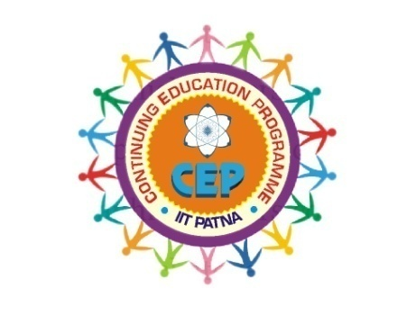

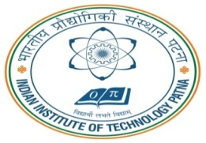

Travel : Reaching IITP

# By Rail: IIT Patna Campus is about 35kms from Patna Junction, 24kms from Danapur Station and 38kms from Rajendra Nagar Terminal. You can find direct trains to any one of these stations from all parts of the country such as Delhi, Mumbai, Kolkata, Chennai, Hyderabad, Bangalore, Lucknow, Kanpur, Guwahati, Puri, and Vasco-de-Gamma among many others.

**Certificate Course on**

**Big Data Computing: A Practical Approach**

**Dec 3-7, 2018**

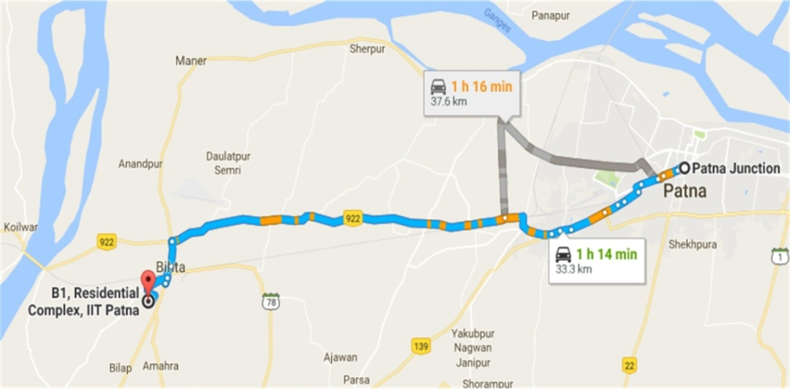

**Department of Computer Science and Engineering,**

**Indian Institute of Technology, Patna**

**Bihta, Bihar, India**

**Short Term Course CEP/FDP**

**IIT Patna**