**CSCE 5320 Scientific Data Visualization**

**Activity 6**

**Marks and Channels**

**Submission Guidelines for In- Person (Students who have attended to the class):**

1. Activity Submission is individual.
2. For each tutorial, please submit your dataset link (created through gist hub or GitHub) and Viz hub links of your code.
3. For every Question, make sure to submit the dataset link and viz hub link. You can only submit the final screenshot of visualization that you have generated. Every screenshot is not required.
4. Take screenshots of the entire screen including the date and time.
5. Explain the understanding of every question wherever it is asked. You can give a brief explanation of the entire question in one paragraph.
6. The similarity score for your document should be less than 15%.
7. Submission after the deadline is considered as late submission.

**Submission Guidelines for online (Students who have not attended to the class):**

1. Activity Submission is individual.
2. For each tutorial, please submit your dataset link (created through gist hub or GitHub) and Viz hub links of your code.
3. **You should also provide an explanation of understanding of each tutorial in one paragraph.**
4. For every Question, make sure to submit the dataset link and viz hub link. You can only submit the final screenshot of visualization that you have generated. Every screenshot is not required.
5. Explain the understanding of every question in detail wherever it is asked.
6. The similarity score for your document should be less than 15%.
7. Submission after the deadline is considered as late submission.

**TASK 1**

**Tutorial 1: Bar Chart**

Download the given dataset named “Activity6_population.csv” and create a dataset link by using gist.github.

Go to [*https://gist.github.com/*](https://gist.github.com/). Upload/copy the given csv file and create public gist.

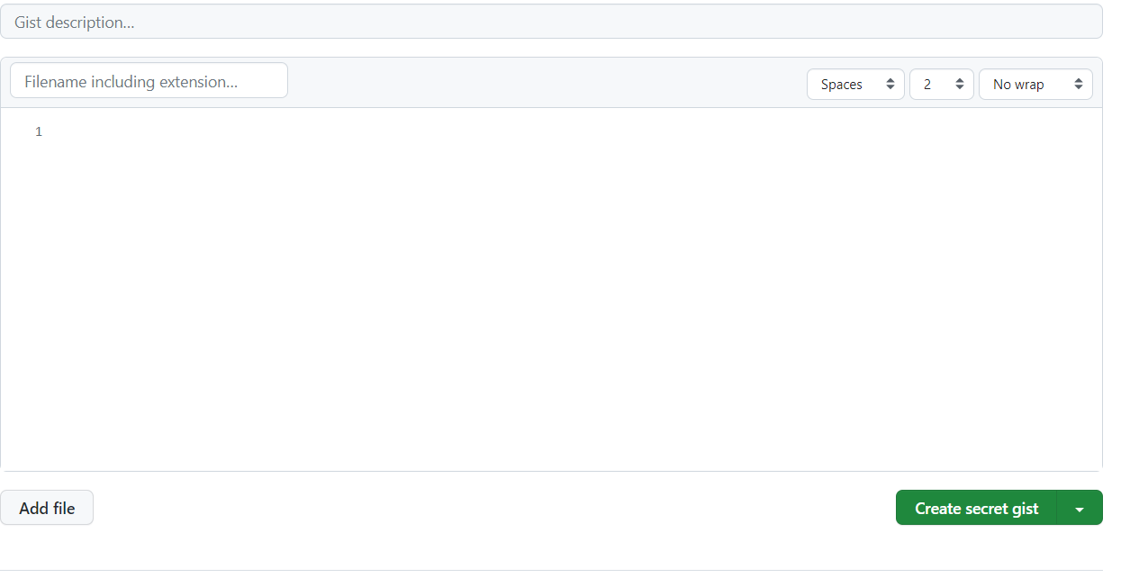

Select the entire data and copy it in gist hub workspace. Click on the downward arrow and select create public gist and click on it.

We are selecting as create public gist by default it will show as the secret gist. We need to select it as create as public gist once after clicking on it.

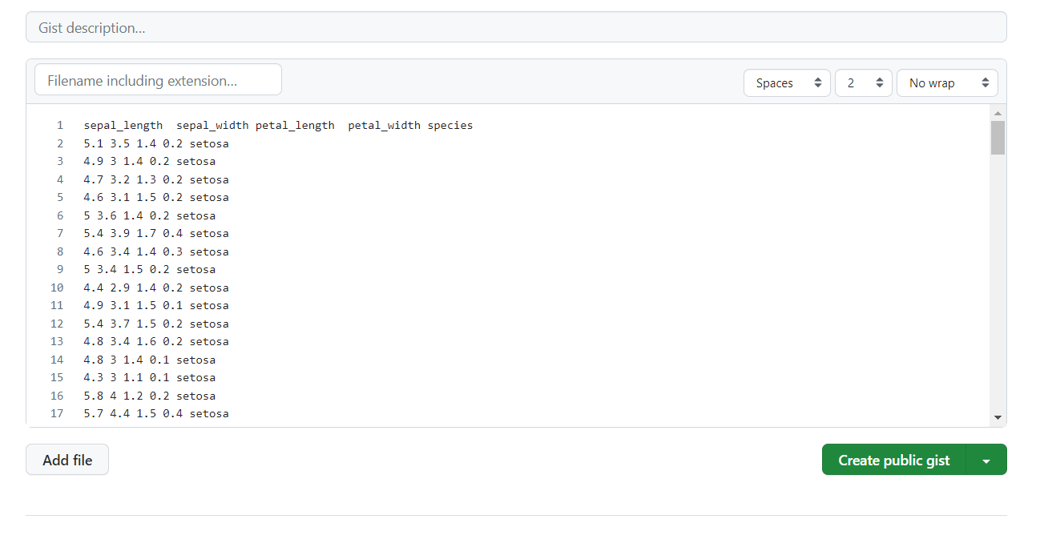

Once after creating the gist, we can be able to see a button as raw once if we click on the button raw we can able to see there a link will be created and in that link we can see the entire data that was present in the csv dataset.

Once after clicking on the raw button a link will be created that was the gist link that was been created once after the creation as below, we can be able to see that the data will be available as below. Here we can access the entire data by using the link.

Below is the data link that will be generated:

[**https://gist.githubusercontent.com/INDU1998-GIT/fb21d51514e846877e4de86e3ce2486b/raw/d530eff88e0d3ee1b733f03c632c86d260c154e1/Population.csv**](https://gist.githubusercontent.com/INDU1998-GIT/fb21d51514e846877e4de86e3ce2486b/raw/d530eff88e0d3ee1b733f03c632c86d260c154e1/Population.csv)

**Here you should create your own data link by using your own gist hub account with the given csv file.**

There is one more method to create the dataset link by using GitHub.

Here, we can create dataset link by creating a repository and by adding all the datasets in the repository.

Open your GitHub account and click on ‘+’ symbol and select new repository.

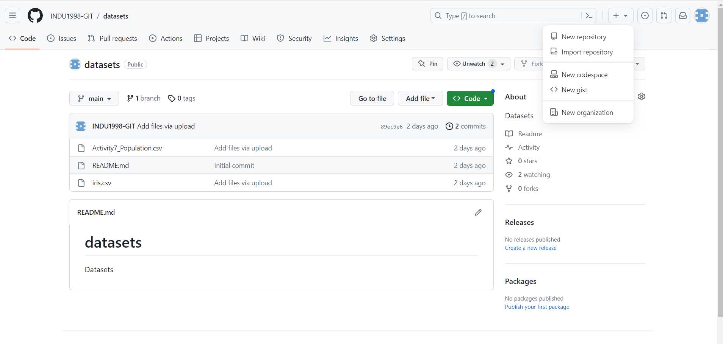

After selecting a new repository, give a repository name and add description to it and select public and select check box of add readme file and click on create repository. Then a new repository will be created.

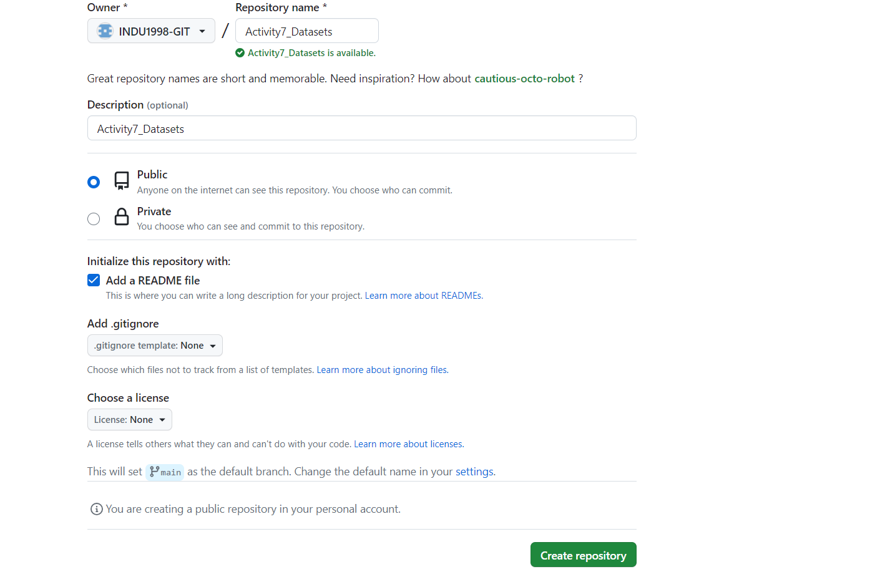

Click on add file and select upload files.

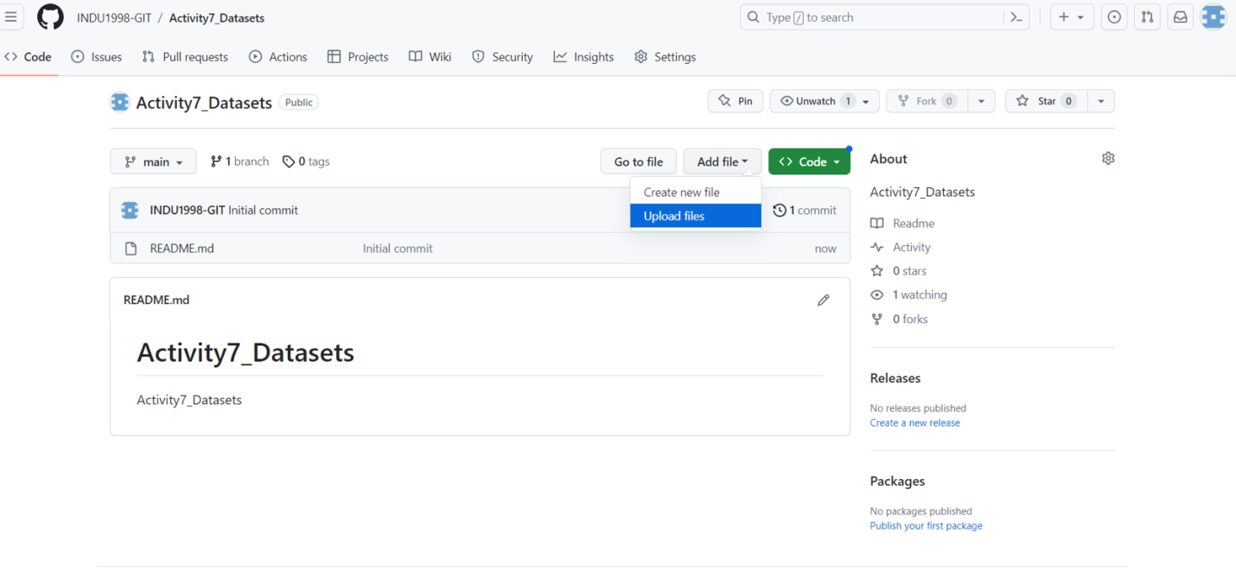

Click on choose your files and choose the downloaded datasets and add them into the repository. After adding the files, click on commit changes. Then you can see the files you have uploaded.

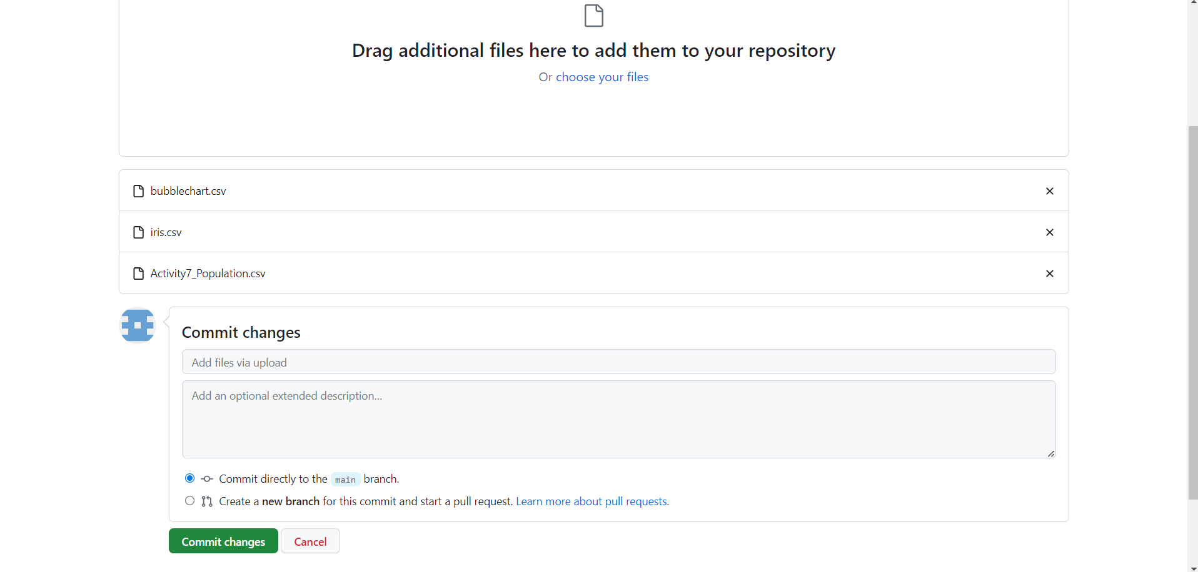

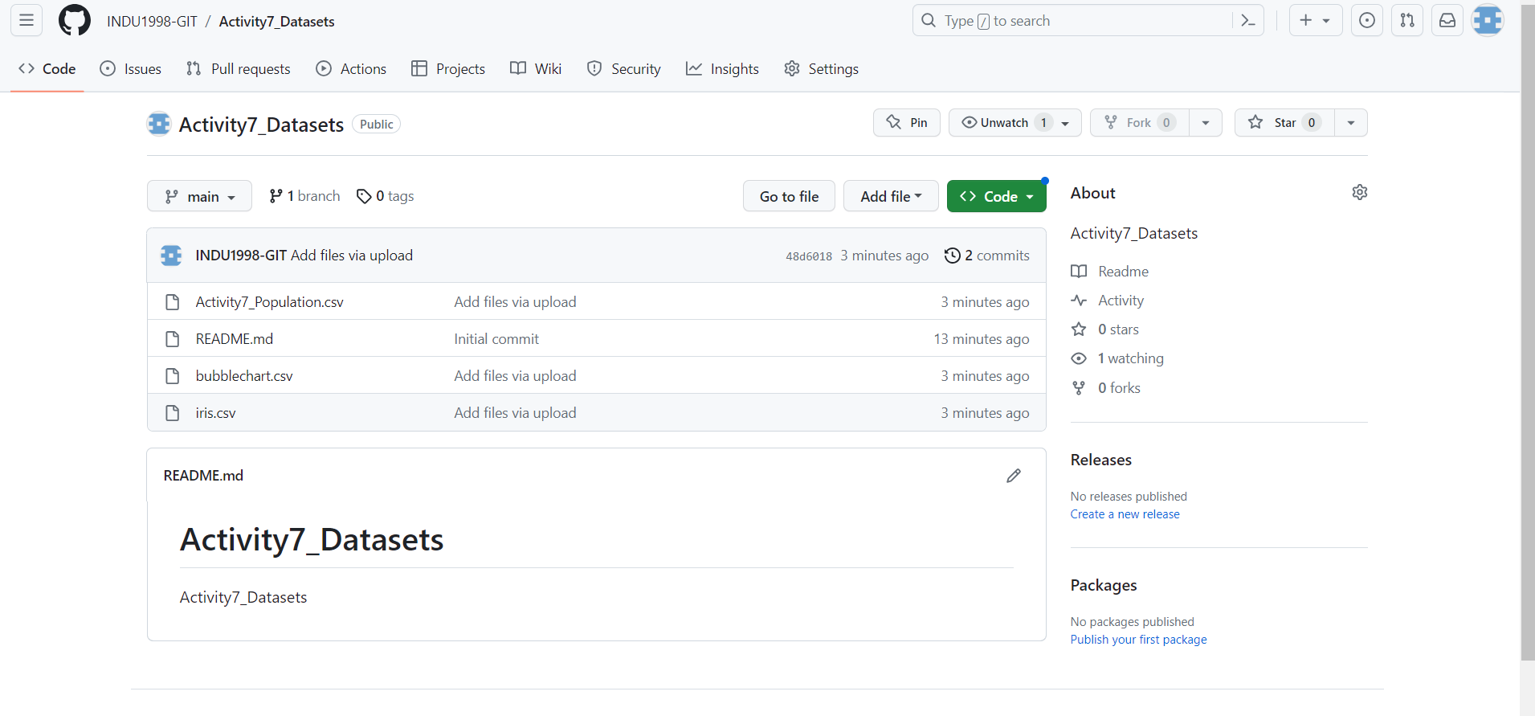

Then click on any dataset and click on raw.

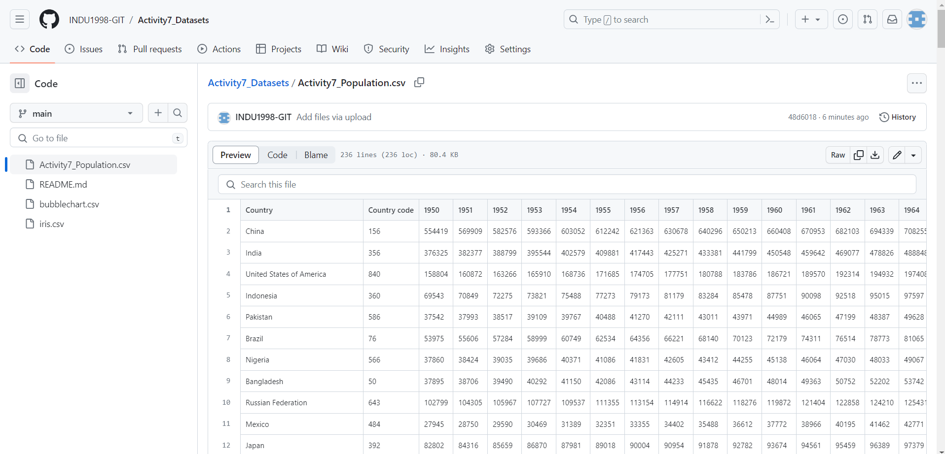

Once after clicking on the raw button a link will be created, once after creating as below we can able to see that the data will be available as below. Here we can access the entire data here by using the link.

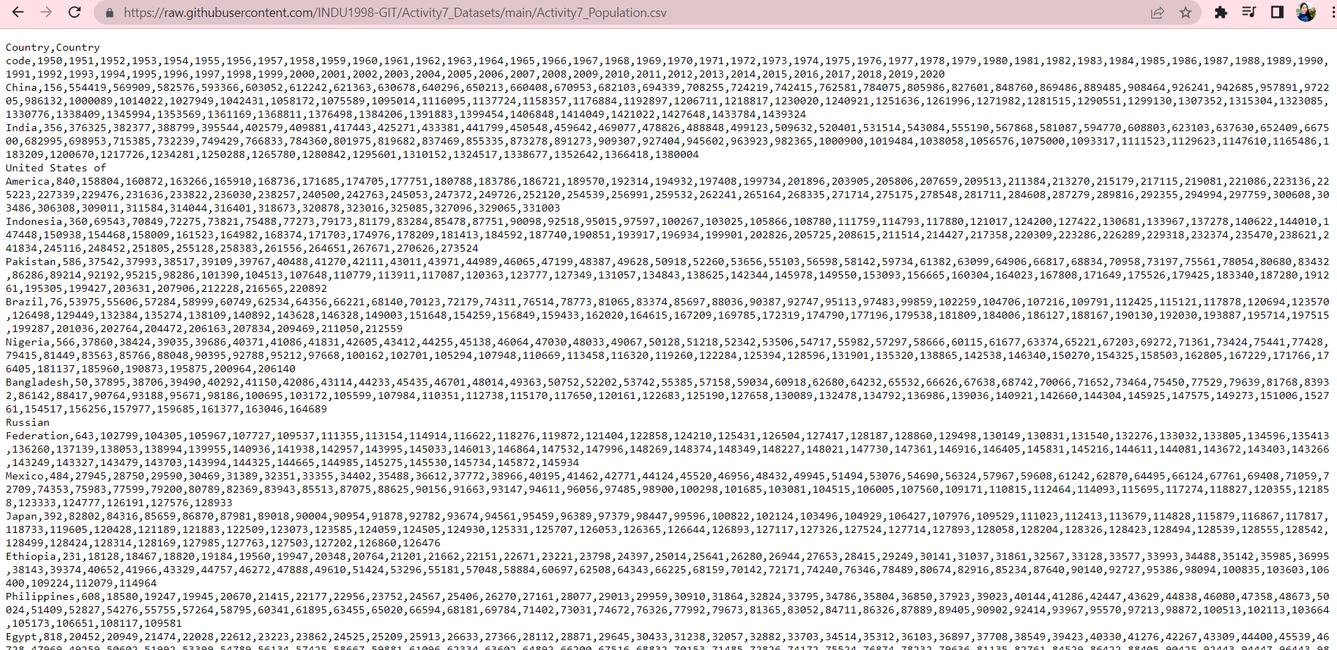

Below is the data link that will be generated:

<https://raw.githubusercontent.com/INDU1998-GIT/Activity7_Datasets/main/Activity7_Population.csv>

Here you can create your own data link by using your own GitHub account by creating repository and by uploading the given csv files into it. Then you can use that dataset link in your html or Java script code to generate the output.

Then create a bar chart by using the vizhub.

Now Click on <https://vizhub.com/>, log in to it and connect it with your GitHub. Then select a project from most forked/ most popular.

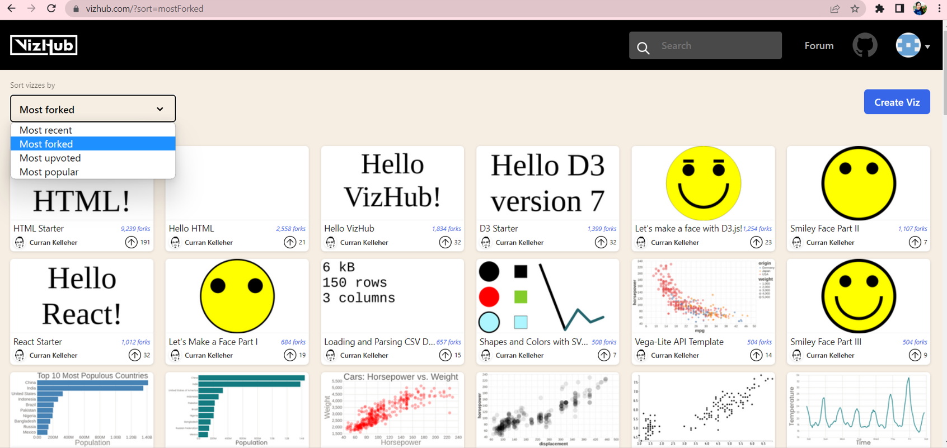

Select “Hello VizHub!” project or any other most forked project.

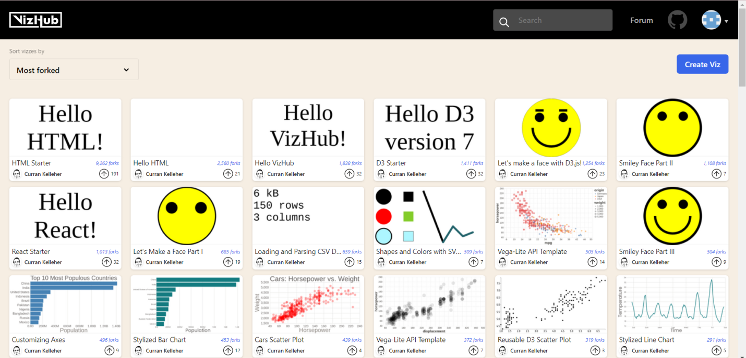

Click on fork symbol in order to save your changes.

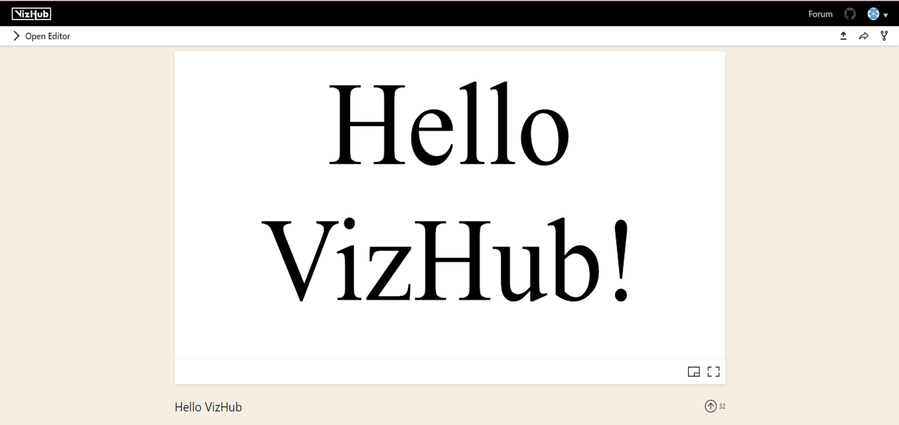

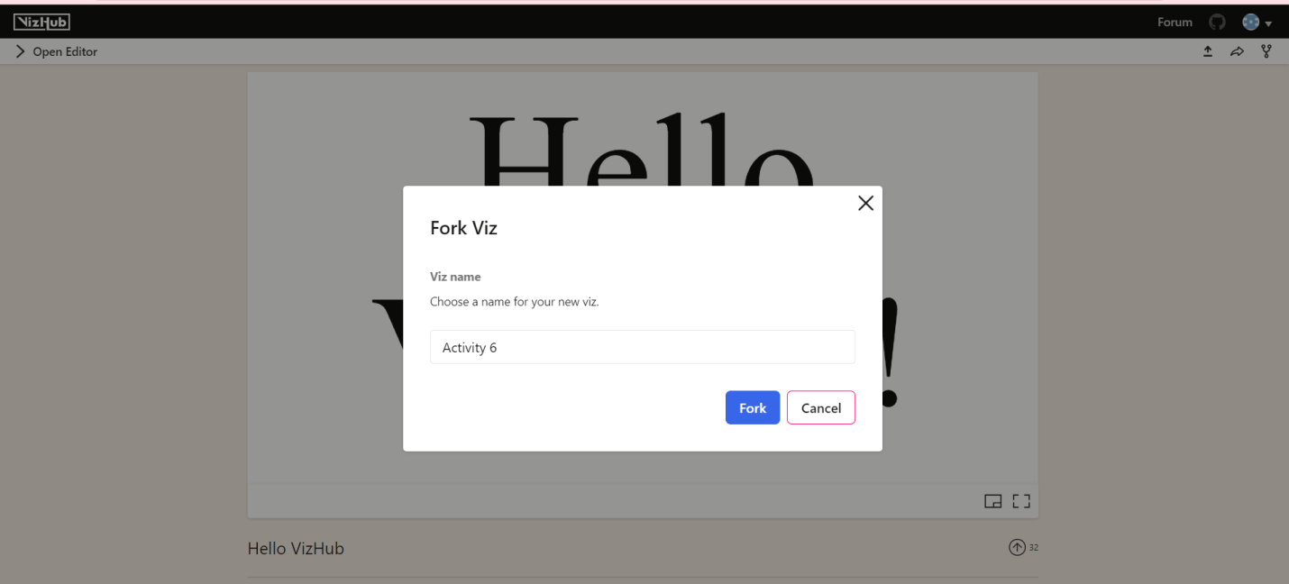

Give name as activity 6_Task 1 and click on fork.

Then click on open editor, and add index.html, index.js, Marks.js, AxisBottom.js, AxisLeft.js and useData.js and make the changes in the code such that it should display the bar chart with country names on y-axis and Population-2020 as X-axis.

Here in below bar chart we can see it displays the population of 30 countries of year 2020.

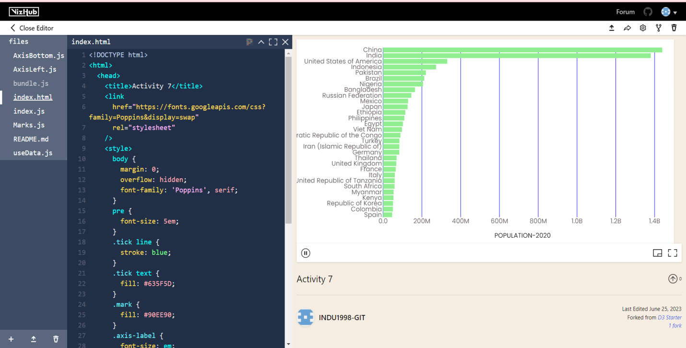

Please refer to the below vizhub link provided for any doubts.

<https://vizhub.com/INDU1998-GIT/5eb466b3aec44caaaa1870d78abe4643?edit=files&file=useData.js&tabs=index.js%7EuseData.js>

|  |  |
| --- | --- |
| **Question 1 (15%)** | Points |
| Follow Tutorial 1 and answer the below questions.   1. Create a bar chart by using the “**Activity6_population**” dataset such that it should display the population of 10 countries in the year 2000. Submit the final screenshot of the generated visualization and the viz hub link of your code. 2. Create a bar chart by using the “**Activity6_population**” for 20 countries in year 2010. Submit the final screenshot of the visualization and the viz hub links of your code.   For above bar chats. use population of particular year as X-axis and label it has “**POPULATION – Year name**” and country name as Y- axis | * Creation of 2 bar charts with label names– 0.5 Marks * Viz hub links-0.5 Marks * Submit 2 separate vizhub links for Q1.1 & Q1.2 |
| Explanation of understanding of the activity. | * Explanation – 0.5 Mark |
|  | Total 1.5 Marks |

**TASK-2**

**Tutorial 2: Stacked Bar chart with different colors:**

To perform this task, you have to again select a new project which is most forked.



Select “Hello VizHub!” project or any other most forked project.



Click on fork symbol to save your changes.





Give name as Activity6_Task2 or any other name and click on fork. Then click on open editor.

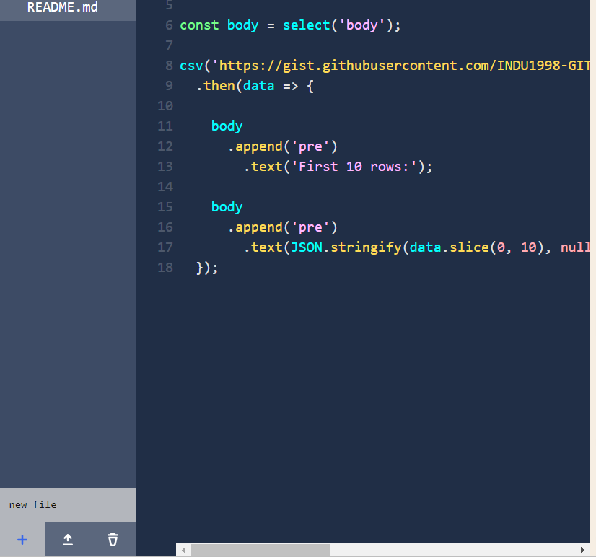

To add a new file, click on ‘+’ symbol which will be at bottom left of the screen and select new file.

First, you have to create the data.csv file. So, give file name as data.csv with csv extension.

Copy the data from the given csv file “**data.csv**” to newly created data.csv in vizhub.

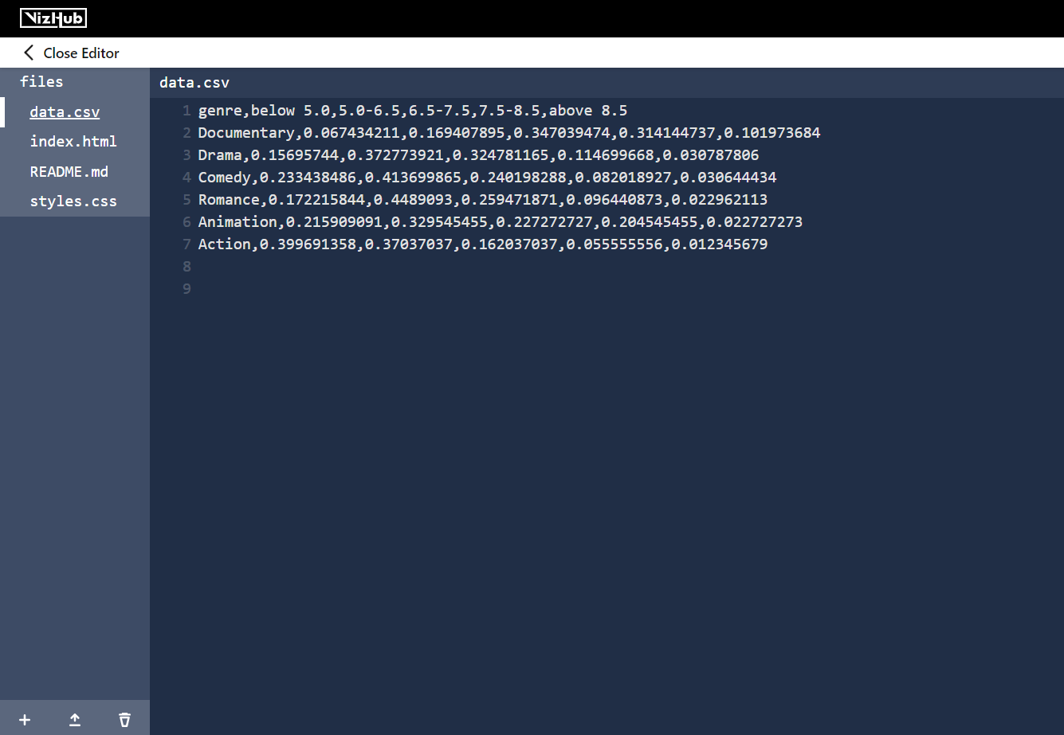

Create files index.html and style.css and include the code in such a way so that it should display the ratings of each genre. Percentage label should be added as x-axis and genre names on y-axis and each rating should be differentiated with different colors.

When you tap on the graph it should display the percentage of each rating.

Here in below stacked bar chart we can see it displays the rating of each genre with percentage of each rating in which each rating is differentiated with different colors.

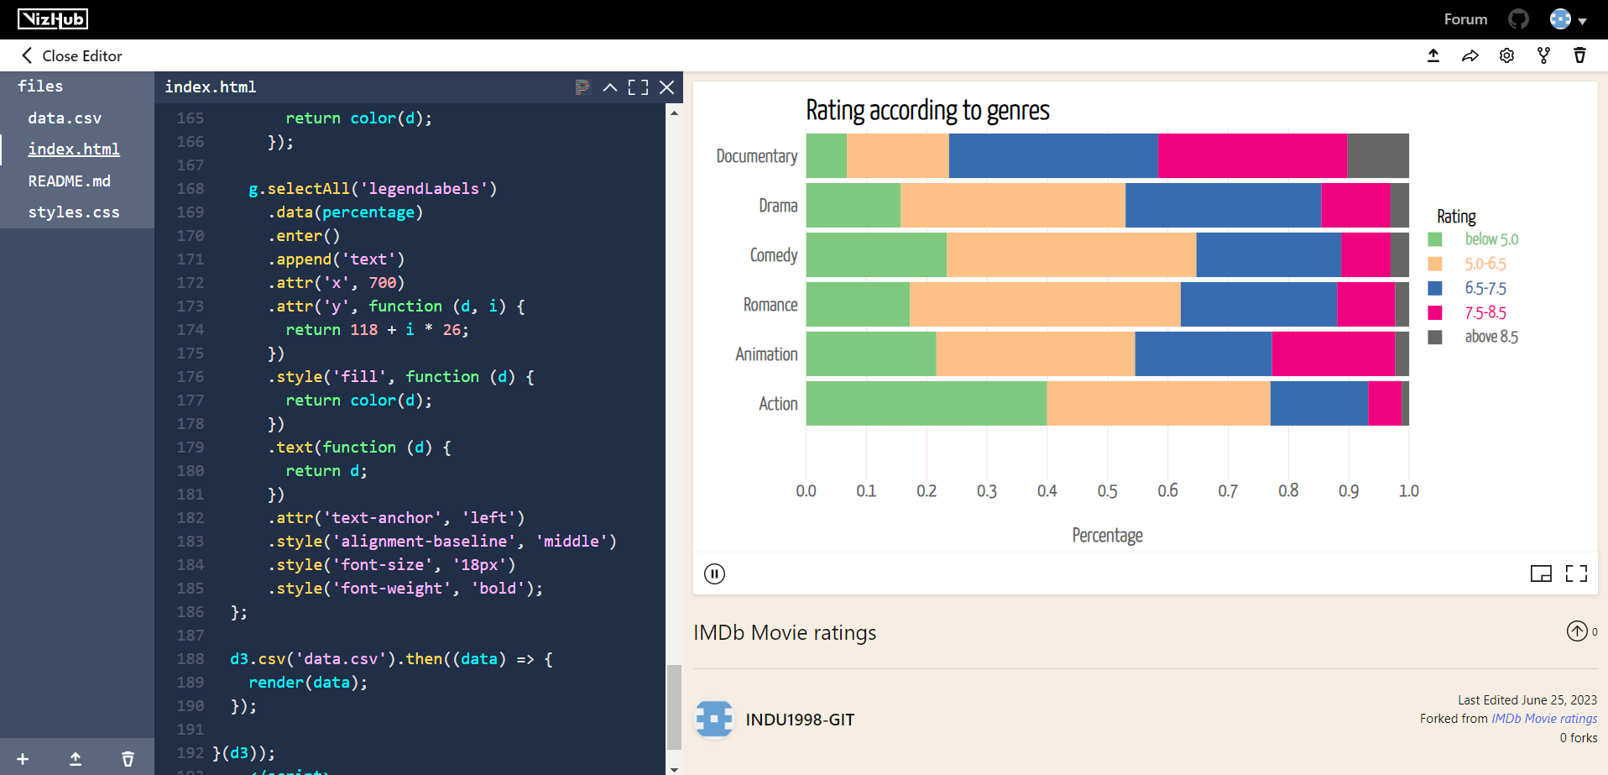

Please refer to the below vizhub link provided for any doubts.

[**https://vizhub.com/INDU1998-GIT/c4c6639cea404fe1988ad3dc04845727?edit=files&file=index.html**](https://vizhub.com/INDU1998-GIT/c4c6639cea404fe1988ad3dc04845727?edit=files&file=index.html)

|  |  |
| --- | --- |
| **Question 2 (25%)** | Points |
| Follow Tutorial 2 and answer the below questions.   1. Create a stacked bar chart by using any suitable dataset with d3.js.      1. Explain about the dataset you have chosen and submit the final screenshot of generated visualization and provide the VizHub link to your code. 2. Analyze the chart and provide an explanation on the visualization. | * Creation of stacked bar chart and vizhub link – 1.5 Marks * Explanation of dataset and visualization – 1 mark   **Note: Don’t use the same dataset that provide in tutorial to answer the questions. Use the different dataset for Questions.** |
|  |  |
|  | Total 2.5 Marks |

**TASK-3**

**Scatter Plot**

**Tutorial 3.1: Scatter Plot with Color:**

To perform this task, you must select again a new project which is most forked.



Similarly follow the above steps as mentioned in Task 1 & 2 and give name as Activity6_Task3 or any other name and click on fork. Then click on open editor.

Download **Iris.csv** dataset and create a dataset link by using gist.github or by github as shown above and use that dataset link in your html or js code to display the scatter plot.

Below is the data link that will be generated :

Link generated by github:

<https://raw.githubusercontent.com/INDU1998-GIT/datasets/main/iris.csv>

Link generated by gist.github:

[**https://gist.githubusercontent.com/INDU1998-GIT/27d356a6eb8513e0146a91a997d27aa6/raw/ba3c2ada2696991aacf6cb2323b97b8d2c40e46e/iris.csv**](https://gist.githubusercontent.com/INDU1998-GIT/27d356a6eb8513e0146a91a997d27aa6/raw/ba3c2ada2696991aacf6cb2323b97b8d2c40e46e/iris.csv)

**Here you should create your own data link by using your own gist hub or githhub account with the given csv file to display the scatter plot.**

In index.html write code in such a way to display the scatter plot with labels as Sepal_Length for x-axis and Petal_Length for y-axis and differentiate the 3 species with any 3 different colors.

Below we can see the scatter plot in which 3 species are differentiated with 3 different colors.

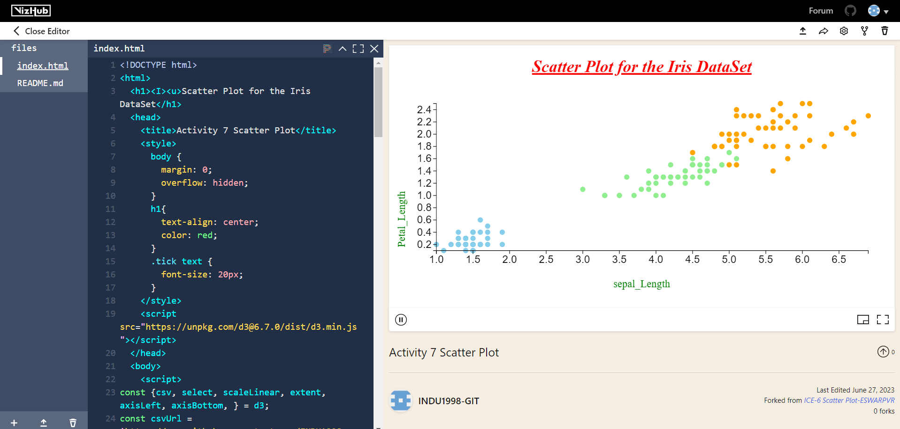

Please refer to the below vizhub link provided for any doubts.

[**https://vizhub.com/INDU1998-GIT/f9d6e606daf7415d969152475fff28a3?edit=files&file=index.html**](https://vizhub.com/INDU1998-GIT/f9d6e606daf7415d969152475fff28a3?edit=files&file=index.html)

**Tutorial 3.2 : Scatter plot with shape:**

To perform this task, you need to select again a new project which is most forked and continue the steps as shown in above tasks.

Use the same dataset link generated by using iris.csv dataset for the above question i.e. Task-3 to get a scatter plot which differentiates the 3 species with 3 different shapes.

Then click on open editor, and add index.html, axes.js ,index.js, scatterPlot.js and shapeLegend.js, styles.css, viz.js and make the changes in the code such that it should display the scatter plot with petal Length on y-axis and sepal Length as X-axis.

It should differentiate the 3 species named setosa, versicolor, virginica with 3 different shapes.

Here in the chart below, we can see the scatter plot with 3 different shapes.

Please refer to the below vizhub link provided for any doubts.

<https://vizhub.com/INDU1998-GIT/b2576853f04e412fadaa01d3c6affc34?edit=files&file=viz.js>

|  |  |
| --- | --- |
| **Question 3 (30%)** | Points |
| Follow Tutorial 3 and answer the below questions.   1. Create a scatter plot based on the any suitable dataset using d3.js. Add labels for x-axis and for y-axis to your scatter plot. Differentiate your generated scatter plot values with different colors or with different shapes. (You can work on anyone either differentiating the attributes with colors or shapes by referring through the tutorials 3.1 & 3.2 )      1. Explain about the dataset you have chosen and submit the final screenshot of generated visualization and provide the Viz Hub link to your code. 2. Analyze the chart and provide an explanation on the visualization. | * Creation of Scatter plot with colors and vizhub link – 2 Marks * Explanation of dataset and visualization – 1 mark   **Note: Don’t use the same dataset that is provided in tutorial to answer the questions. Use the different dataset for Questions.** |
|  |  |
|  | Total 3 Marks |

**TASK-4**

**Tutorial 4: Bubble Chart:**

To perform this task, you must select again a new project which is most forked.



Follow the same steps as mentioned in above tasks and give name as Activity6_Task4 or any other name and click on fork. Then click on open editor.



To add a new file, click on ‘+’ symbol which will be at bottom left of the screen and select new file.

First, you have to create the bubblechart.csv file. So, give file name as bubblechart.csv with csv extension.

Copy the data from the given bubblechart.csv file to newly created bubblechart.csv in vizhub.

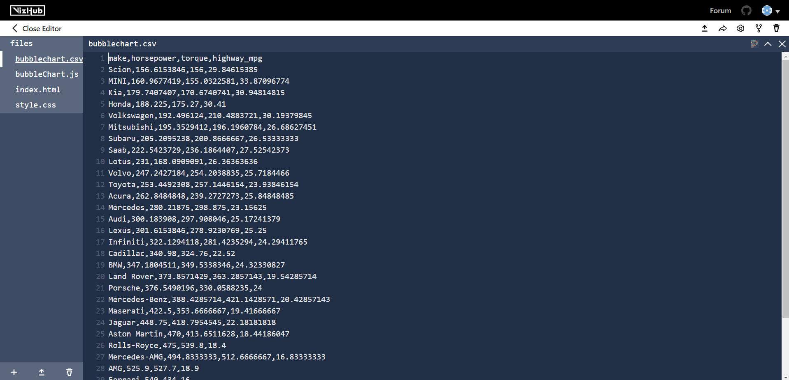

Create files index.html, bubblechart.js and style.css and include the code in such a way such that it should display the bubble chart in which add labels as Avg_horsepower for x-axis and Avg_Torque for y-axis and it should differentiate the make with different colors and it should display the all types of make.

Here in below graph we can see the bubble chart which displays the average torque and average horse power with different makes.

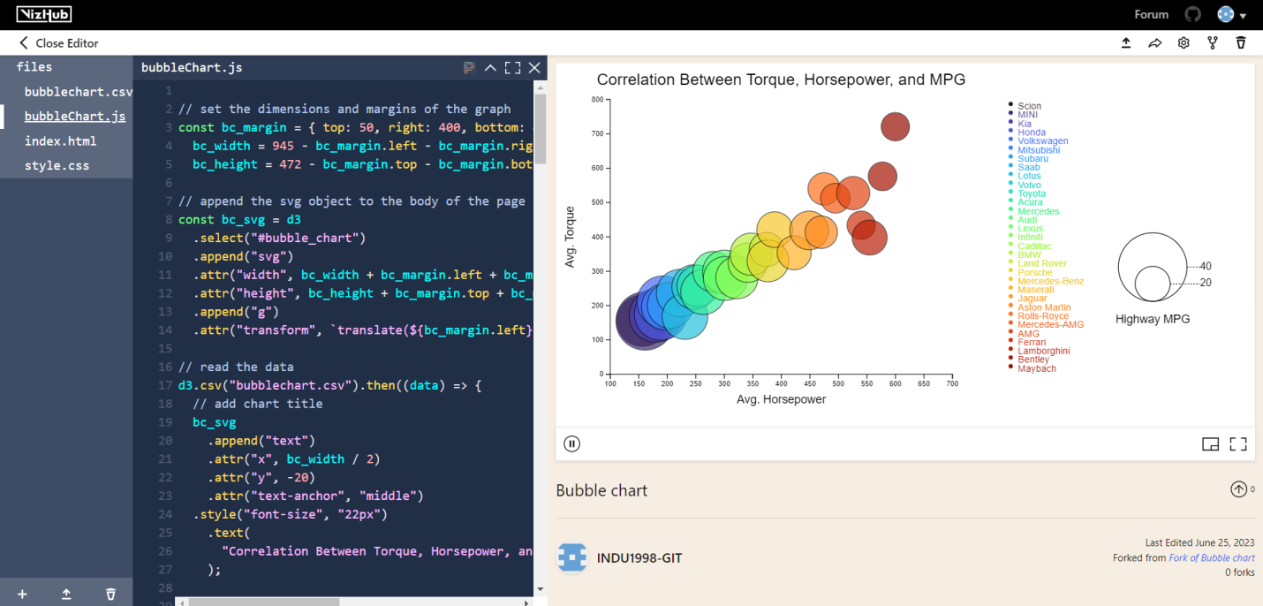

Please refer to the below vizhub link provided for any doubts.

<https://vizhub.com/INDU1998-GIT/a1a9f102b4464efca9dfde2548d6bf9c?edit=files&file=bubbleChart.js>

|  |  |
| --- | --- |
| **Question 4 (30%)** | Points |
| Follow Tutorial 3 and answer the below questions.   1. Create a Bubble Chart based on the any suitable dataset using d3.js. Add labels for x-axis and for y-axis on your Bubble Chart.      1. Explain about the dataset you have chosen and submit the final screenshot of generated visualization and provide the Viz Hub link to your code. 2. Analyze the chart and provide an explanation on the visualization. | * Creation of Bubble Chartand vizhub link – 2 Marks * Explanation of dataset and visualization – 1 mark   **Note: Don’t use the same dataset that is provided in tutorial to answer the questions. Use the different dataset for Questions.** |
|  |  |
|  | Total 3 Marks |