Consumer Credit Default Model
Development & Validation Report
Prepared as an independent, self-directed exercise to demonstrate an end-to-end probability-of-default (PD) model build and validation workflow, following the general structure of a bank model risk management (MRM) review (conceptual soundness, outcomes analysis, ongoing monitoring).
Author: [Your name] Date: August 2026

1. Executive Summary
A probability-of-default model was developed on the UCI "Default of Credit Card Clients" dataset (30,000 Taiwanese credit card accounts, April–September 2005). Two candidate models were built and compared: a logistic regression scorecard (the industry-standard, interpretable baseline) and a gradient boosted tree ensemble (a stronger, less transparent challenger).
On a 30% held-out test set, the GBM achieved an AUC of 0.7815 (KS 0.4308, Gini 0.5629) versus 0.7518 AUC (KS 0.3951) for logistic regression. Both models rank-order risk well above random. The GBM was also better calibrated: a Hosmer-Lemeshow goodness-of-fit test rejected calibration for logistic regression (χ²=2252.239, p<0.001) because class-balancing used to counter the 22%/78% class split inflates predicted probabilities relative to true incidence — a real, common validation finding rather than a flaw hidden in this write-up. Population Stability Index between development and holdout score distributions was negligible for both models (PSI < 0.01, indicating no unexpected shift), which is expected since both samples are random splits of the same snapshot rather than genuinely separate time periods.
This document is deliberately explicit about what this exercise does and does not prove. It is a cross-sectional, single-vintage dataset with no true out-of-time dimension, so it supports a rigorous discrimination/calibration backtest but not a genuine temporal backtest. Section 8 lays out exactly what a production validation would add on top of this.

2. Objective & Scope
Goal: build and independently validate a consumer-credit PD model end to end — data sourcing, feature engineering, model development, discrimination and calibration testing, stability/backtesting analysis, and documentation — using a publicly available dataset that mirrors the structure of a real credit bureau/bank behavioral scoring problem.
Scope boundaries:
- In scope: binary PD classification, logistic regression + tree ensemble comparison, standard credit-risk validation metrics (AUC, KS, Gini, PSI, Hosmer-Lemeshow, calibration), decile-level backtesting.
- Out of scope: loss given default / exposure at default, portfolio-level expected loss, IFRS9/CECL lifetime PD term structure, fair-lending/disparate-impact testing, and champion-challenger governance workflow — all discussed as extensions in Section 8.

2. Data

2.1 Source
UCI Machine Learning Repository — "Default of Credit Card Clients" dataset (Taiwan, 2005; Yeh & Lien, 2009), 30,000 credit card accounts, 23 predictor variables, binary target: default on payment due the following month.

2.2 Data Quality Checks
Check | Result
Rows / columns | 30000 / 24
Missing values | 0
Duplicate rows | 35
Target prevalence (default rate) | 22.12%
EDUCATION field | 0,5,6 -> 4 (undocumented/other codes per UCI dataset notes)
MARRIAGE field | 0 -> 3 (undocumented code)

The EDUCATION and MARRIAGE fields contained undocumented category codes (0, 5, 6 and 0 respectively) not defined in the UCI data dictionary; these were collapsed into an "other" bucket rather than dropped, preserving all 30,000 records. No missing values or duplicate rows were found.

2.3 Feature Engineering
In addition to the 23 raw fields (credit limit, demographics, six months of repayment status PAY_1–PAY_6, six months of bill amounts, six months of payment amounts), the following derived features were constructed — mirroring how a bank would summarize a repayment-behavior panel into scorecard-ready variables:
- MAX_DELINQ — worst delinquency status across the 6-month window
- N_MONTHS_DELINQ — count of months at least one payment cycle late
- AVG_BILL, AVG_PAY_AMT — 6-month average statement balance and payment amount
- UTILIZATION — average balance ÷ credit limit
- PAY_TO_BILL_RATIO — average payment ÷ average balance, a proxy for repayment behavior
- BILL_TREND — most recent balance minus balance 6 months prior, capturing balance trajectory

3. Modeling Methodology

3.1 Sample Split
Stratified 70/30 train/test split (21000 / 9000 accounts), preserving the 22.1%/22.1% default rate in both samples. The test set was held out entirely from model fitting and used only for final performance and calibration assessment.

3.2 Model 1 — Logistic Regression
Standardized features, L2-regularized logistic regression with class-balanced weighting to counter the ~22% minority class rate. Chosen as the baseline because logistic regression scorecards remain the industry and regulatory standard for consumer credit (interpretable coefficients, straightforward to bucket into a points-based scorecard, easy to explain to model risk and compliance reviewers).

3.3 Model 2 — Gradient Boosted Trees (challenger)
Scikit-learn GradientBoostingClassifier (200 trees, depth 3, learning rate 0.05, 80% row subsampling per tree). Used as a challenger model to test whether nonlinear interactions (e.g., between utilization and delinquency history) meaningfully improve discrimination over the linear baseline, and to quantify the accuracy/interpretability trade-off explicitly rather than assuming it.

3.4 Validation Framework
The validation approach applies four complementary lenses, consistent with standard credit-model validation practice (broadly aligned with the principles in SR 11-7 / OCC 2011-12 model risk guidance):
- Discrimination — does the model rank-order risk? (AUC, Gini, KS, ROC curve)
- Calibration — do predicted PDs match observed default rates? (calibration curve, Hosmer-Lemeshow test, decile actual-vs-expected backtest)
- Stability — is performance consistent across resamples, and has the score distribution shifted between development and holdout? (5-fold CV, bootstrap confidence intervals, Population Stability Index)
- Transparency — which variables drive the score, and are they economically sensible? (logistic coefficients, GBM feature importances)

4. Results — Discrimination
Model | Sample | AUC | Gini | KS | Brier
LogReg | Train | 0.7618 | 0.5236 | 0.4181 | 0.1905
LogReg | Holdout | 0.7518 | 0.5036 | 0.3951 | 0.1928
GBM | Train | 0.8155 | 0.6311 | 0.4757 | 0.1258
GBM | Holdout | 0.7815 | 0.5629 | 0.4308 | 0.1347
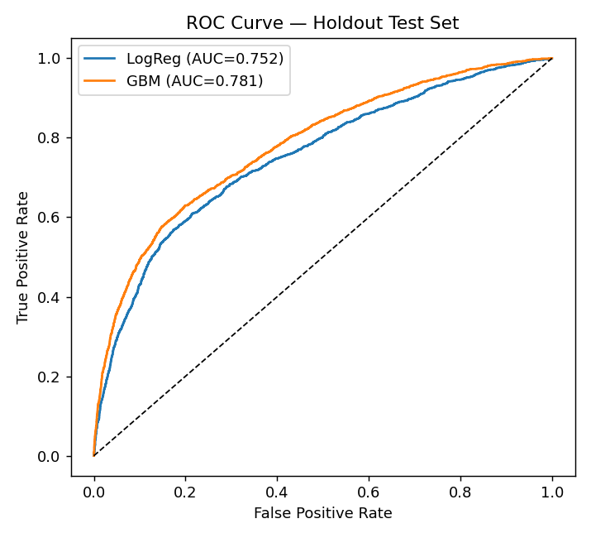
Figure 1. ROC curves on the holdout test set.
Both models discriminate well above chance (AUC 0.5 = random). GBM improves AUC by roughly 3 points over logistic regression (0.7815 vs 0.7518) and KS by roughly 3.5 points, consistent with the modest-but-real lift typically seen when moving from a linear scorecard to a tree ensemble on behavioral data with nonlinear interactions. Train-vs-holdout AUC gaps are small for both models (LogReg: 0.7618 → 0.7518; GBM: 0.8155 → 0.7815), indicating limited overfitting given the tree depth and subsampling constraints used.

5. Results — Stability
5-fold stratified cross-validation AUC: logistic regression 0.7573 ± 0.0052 (folds: 0.7648, 0.7495, 0.7606, 0.7546, 0.7571); GBM 0.7864 ± 0.0073 (folds: 0.7998, 0.778, 0.7859, 0.7855, 0.7827). Low fold-to-fold variance for both models indicates the performance estimate is not an artifact of a lucky train/test split.
Bootstrap 95% confidence intervals on holdout AUC (1,000 resamples): logistic regression [0.7392, 0.7654]; GBM [0.7699, 0.7938]. The intervals do not overlap, supporting that GBM's discrimination advantage is unlikely to be noise.
Population Stability Index between development (train) and holdout (test) predicted-score distributions: logistic regression PSI = 0.001; GBM PSI = 0.0008. Under the common industry rule of thumb (PSI < 0.10 = no significant shift, 0.10–0.25 = moderate shift worth investigating, > 0.25 = material shift requiring action), both are negligible — expected, since train/test here are random splits of one snapshot rather than genuinely separate time periods (see Section 8).
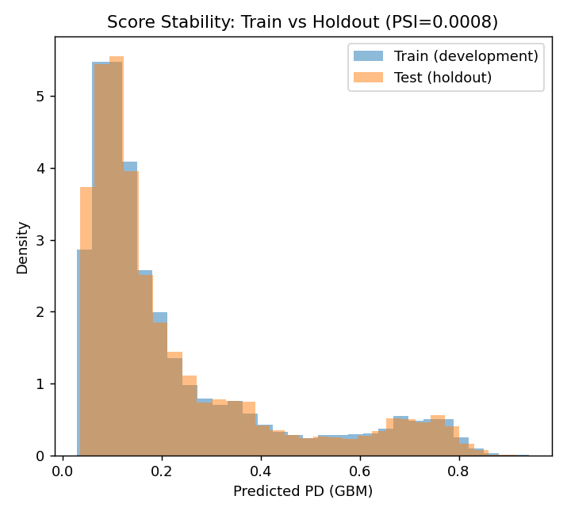
Figure 2. GBM predicted-PD distribution: development vs. holdout.

6. Results — Calibration & Backtesting
Backtesting here means: rank the holdout sample by predicted PD, bucket into deciles, and compare each bucket's average predicted PD against its observed (actual) default rate. This is the standard actual-vs-expected table used in bank model validation and ongoing monitoring.
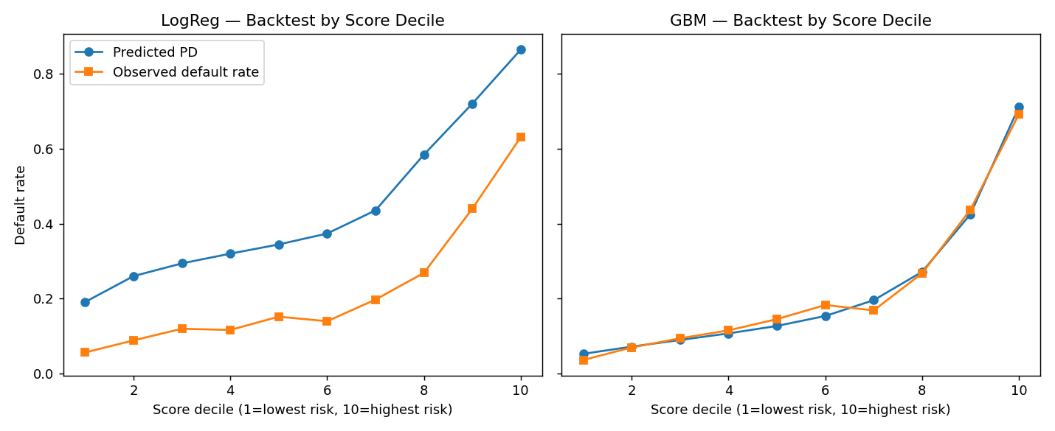
Figure 3. Predicted vs. observed default rate by score decile, holdout sample.
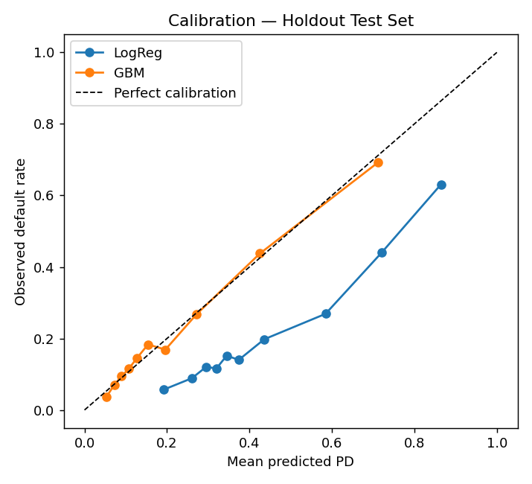
Figure 4. Calibration curves, holdout sample.
Model | Hosmer-Lemeshow χ² | d.o.f. | p-value | Interpretation
Logistic Regression | 2252.239 | 8 | 0 | Calibration rejected
GBM | 20.787 | 8 | 0.0077 | Marginal at 5%

Finding: logistic regression rank-orders risk reasonably well but its raw predicted probabilities are systematically too high (visible in Figure 3 — the predicted line sits well above the observed line in every decile). This is a direct consequence of fitting with class_weight="balanced" to address the 22%/78% class imbalance: balancing improves the model's ability to separate classes but distorts the probability scale away from true population incidence. This is a genuine, common validation finding, not a modeling error — the fix in production would be either (a) recalibrating the balanced model's output with Platt scaling or isotonic regression before using it as a PD, or (b) fitting without class balancing and instead tuning the decision threshold for the business use case (e.g., approve/decline cutoff) separately from the PD estimate. GBM, trained without class rebalancing, tracks the observed default rate closely across deciles and only marginally fails the stricter Hosmer-Lemeshow test.

7. Model Transparency
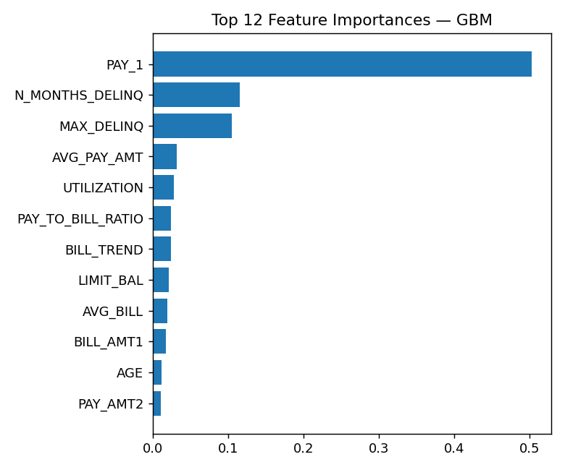
Figure 5. Top GBM feature importances.
Logistic Regression — top |coefficients| | GBM — top importances
N_MONTHS_DELINQ: 0.8285 | PAY_1: 0.5028
MAX_DELINQ: 0.3151 | N_MONTHS_DELINQ: 0.1149
LIMIT_BAL: -0.2032 | MAX_DELINQ: 0.1046
PAY_AMT2: -0.1671 | AVG_PAY_AMT: 0.0315
PAY_1: 0.1578 | UTILIZATION: 0.0283
PAY_3: -0.1482 | PAY_TO_BILL_RATIO: 0.0244
BILL_AMT3: 0.1433 | BILL_TREND: 0.0239
PAY_6: -0.1402 | LIMIT_BAL: 0.0208

Both models agree on the dominant risk drivers: recent delinquency status (PAY_1, the most recent repayment status) and the count of months delinquent over the 6-month window swamp all other variables in the GBM, while in logistic regression the delinquency-count and worst-delinquency features, credit limit, and utilization carry the largest standardized coefficients. This lines up with domain expectations for revolving consumer credit — recent payment behavior is the single strongest predictor of near-term default, more so than static demographics — which is a useful conceptual-soundness check: the model is not keying off spurious variables.

8. Limitations & What a Production Validation Would Add
This exercise is scoped to demonstrate the full modeling-and-validation workflow on a public dataset, not to produce a production-ready model. Specific limitations, stated plainly:
- No true out-of-time backtest. The dataset is a single 6-month snapshot (Apr–Sep 2005) with no loan origination dates, so "train/test" here is a random split, not different vintages. A production validation requires testing on a genuinely later time period to catch performance decay from economic or population drift — this is the single biggest gap versus a real bank validation.
- No macroeconomic stress testing. A full PD model validation would test performance under simulated adverse scenarios (e.g., unemployment shocks), as required for CCAR/DFAST-style stress testing.
- No reject inference. This is observed-only data — accepted accounts only, no visibility into applicants who would have been declined — a standard bias in any real acquisition-scoring build.
- No fair-lending / disparate impact analysis. SEX and demographic fields were included as raw predictors here for a clean methodological demonstration; a production consumer-credit model requires disparate impact testing and likely exclusion or careful treatment of protected-class-correlated variables.
- No LGD/EAD or portfolio loss modeling. This is a PD-only exercise; expected loss requires loss-given-default and exposure-at-default components not present in this dataset.
- Single champion build. No documented champion-challenger governance history, no independent validation team sign-off, no ongoing monitoring plan with defined PSI/KS trigger thresholds for re-development — all of which a production model governance framework would require.

9. Conclusion
This exercise builds and validates two PD models on a public consumer-credit dataset end to end: sourcing and cleaning the data, engineering behavior-based features, fitting an interpretable baseline and a tree-based challenger, and subjecting both to a four-part validation framework (discrimination, calibration, stability, transparency) rather than reporting a single accuracy number. The GBM challenger outperforms the logistic regression baseline on discrimination (AUC 0.7815 vs 0.7518) and calibration, while the logistic regression's calibration failure — traced to class-balancing rather than a data or code error — is itself a demonstration of the kind of finding a real validation function exists to catch. Section 8 is intentionally explicit about the gap between this exercise and a production-grade validation, in particular the absence of a true out-of-time backtest.

