# Sample conversation log for coursework stage 3

Let’s assume the chatbot topic is about astronomy. Here are the facts that we would like to be in the knowledgebase:

* The Sun is a star
* Planets are not stars.
* A planet orbits a star.
* A satellite orbits a planet.
* The Moon orbits the Earth.
* Mercury orbits the Sun.
* The Earth orbits the Sun.
* Mars orbits the Sun.
* Jupiter orbits the Sun.
* Ganymede orbits Jupiter.

A knowledgebase is made in NLTK syntax as a CSV file, as follows:

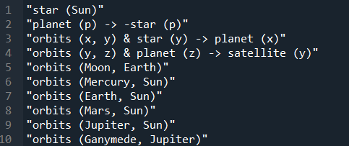

After the system checks for knowledgebase integrity (the above KB has passed the check, otherwise an error message had to be displayed), the chatbot can have the following sample conversations:

