STUDENT ASSESSMENT SUBMISSION AND

DECLARATION

Student name: Gaith AlRahahleh ID: 18110069 |  |  | Assessor name: Eng.Ahmad Azzam
Issue date: |  | Submission date: |  | Submitted on:
Programme: Energy Engineering
BTEC Course name: - |  |  | BTEC Course Code: -
HTU Course Name: STEM I |  |  | HTU Course Code : 10303130

Assignment number and title: Assignment II

Plagiarism

Plagiarism is a particular form of cheating. Plagiarism must be avoided at all costs and students who break the rules, however innocently, may be penalised. It is your responsibility to ensure that you understand correct referencing practices. As a university level student, you are expected to use appropriate references throughout and keep carefully detailed notes of all your sources of materials for material you have used in your work, including any material downloaded from the Internet. Please consult the relevant unit lecturer or your course tutor if you need any further advice.

Student declaration

I certify that the assignment submission is entirely my own work and I fully understand the consequences of plagiarism. I understand that making a false declaration is a form of malpractice.

Student signature: Date:



Task I:

%To plot this equation on the matlab, we should make the (y) alone on the
%left side of the equation by taking (1/y) as a common factor
%(1/y)*(x^3-1)= x^3+x^2+x
%(x^3-1)/y=x^3+x^2+x
%now we will make y alone y=(x^3-1)/(x^3+x^2+x)
x=-10:1/100:10;
y=(x.^3-1)./(x.^3+x.^2+x);
plot(x,y)
axis square
grid on


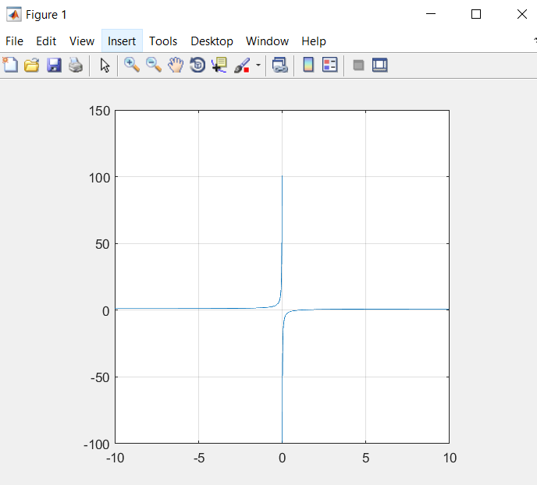

2- t=-pi:1/10:pi;
S=7*sin(t);
L=7*cos(t);
plot(S, L ,'o b ')
hold on
S2=5*sin(t);
L2=5*cos(t);
plot(S2,L2,'y')
hold on
S3=t.^2;
plot(t, S3, '* r')
hold on
S4=cos(t);
S5=sin(t);
plot(t,S4,'m', t,S5,'g')
hold off
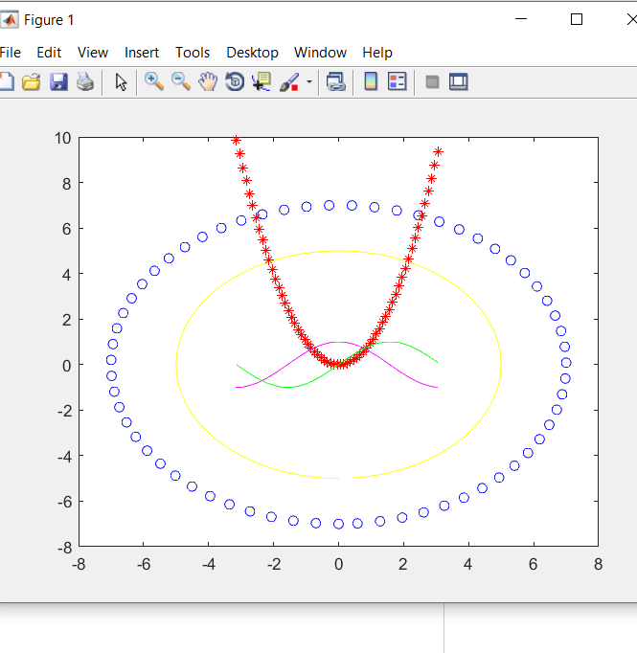
3-
xlabel('X axis');
ylabel('y axis');
title('Graphs');
legend('Capital Circle', ' Smaller circle', 'quadratic graph' ,'cos(t)', 'sin(t)')
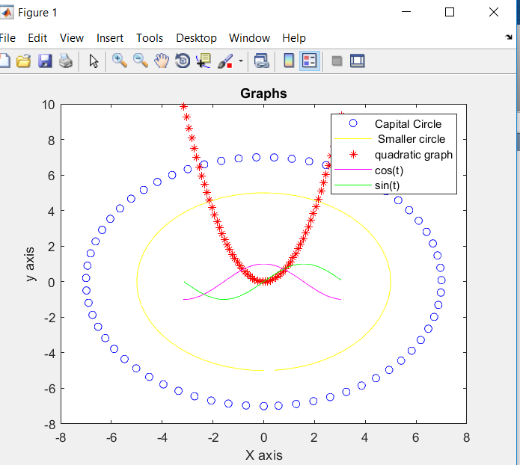

Task II:

a=[10 12 13 25 ;14 4 14 32; 5 7 12 24 ; 7 8 10 25 ; 4 20 11 35; 10 18 11 39; 20 14 11 45; 13 15 9 37; 15 10 9 34 ; 14 10 8 32; 12 3 5 20 ;13 6 5 24]
aa=max(a);%calculates the maximum value along the columns, It represents the first row in the matrix (answer)

bb=min(a);%calculates the minimum value along the columns, It represents the 2nd row in the matrix (answer)
cc=mode(a);%calculates the mode value along the columns, It represents the 3rd row in the matrix (answer)

dd=median(a); %calculates the median value along the columns, It represents the 4th row in the matrix (answer)
ee=mean(a); %calculates the mean value along the columns, It represents the 5th row in the matrix (answer)
ff=std(a);%calculates the standard deviation value along the columns, It represents the 6th row in the matrix (answer)

gg=var(a); %calculates the variance along the columns, It represents the 7th row in the matrix (answer)

answer=[aa; bb; cc; dd; ee; ff; gg] %to make the answers in a single matrix, The 1st column represents the column (First)in task II, The 2nd column represents the column (Second) in Task II, the 3rd column represents the column (Third) in Task II, and the last column represents the column (total)in Task II.

a =

10 12 13 25
14 4 14 32
5 7 12 24
7 8 10 25
4 20 11 35
10 18 11 39
20 14 11 45
13 15 9 37
15 10 9 34
14 10 8 32
12 3 5 20
13 6 5 24

answer =

20.0000 20.0000 14.0000 45.0000
4.0000 3.0000 5.0000 20.0000
10.0000 10.0000 11.0000 24.0000
12.5000 10.0000 10.5000 32.0000
11.4167 10.5833 9.8333 31.0000
4.5218 5.3845 2.8231 7.4712
20.4470 28.9924 7.9697 55.8182

Task III:

1- y=[-3.2000 -3.0000 -2.8000 -2.6000 -2.4000 -2.2000 -2.0000 -1.8000 -1.6000 -1.4000 -1.2000 -1.0000 -0.8000 -0.6000 -0.4000 -0.2000 0.0000 0.2000 0.4000 0.6000 0.8000 1.0000 1.2000 1.4000 1.6000 1.8000 2.0000 2.2000 2.4000 2.6000 2.8000 3.0000 3.2000];
x=[4.0000 0.0000 -2.0000 -2.0000 -1.6000 -0.8000 0.0000 0.4000 0.5000 0.4000 0.2000 0.0000 -0.2000 -0.3000 -0.2000 -0.1000 0.0000 0.1000 0.2000 0.3000 0.2000 0.0000 -0.2000 -0.4000 -0.5000 -0.4000 0.0000 0.6000 1.4000 2.0000 1.8000 0.0000 -4.0000];
plot(y,x)
S1=polyfit(y,x,7)
D=-3.2:1/100:3.2;
H=polyval(S1, D);
plot (D, H)
grid on
axis square

Task IV:

t=(1/16:1/8:1)*2*pi;
x1=cos(t);
y1=sin(t)+2.75;
x2=cos(t);
y2=sin(t)-2.75;
x3=cos(t)-2;
y3=sin(t)+1.9;
x4=cos(t)-2.75;
y4=sin(t);
x5=cos(t)+1.9;
y5=sin(t)-2;
x6=cos(t)+2;
y6=sin(t)+1.9;
x7=cos(t)+2.75;
y7=sin(t);
x8=cos(t)-2;
y8=sin(t)-1.9;
x=4*cos(t);
y=4*sin(t);
plot(x,y,x1,y1,x2,y2,x3,y3,x4,y4,x5,y5,x6,y6,x7,y7,x8,y8)
axis square
fill(x,y,'p',x1,y1,'b',x2,y2,'b',x3,y3,'b',x4,y4,'b',x5,y5,'b',x6,y6,'b',x7,y7,'b',x8,y8,'b')
r=rectangle('Position',[-1 -1 2 2]')
plot (r)

Task VI:

Player=input('choose between rock or paper or scissors: ','s');
if strcmpi(Player,'rock')
PN=2; % the number that corresponds to rock
elseif strcmpi(Player,'paper')
PN=1; % the number that corresponds to paper
elseif strcmpi(Player,'scissors')
PN=0; % the number that corresponds to scissors
else
termination[break]
disp('Wrong input')
break
end
if CN==0
CM='Scissors';
elseif CN==1
CM='Paper';
else
CM='Rock';
end
if PN>CN % if PN is more than CN
disp('Player Wins')
elseif PN<CN %if PN is less than CN
disp('Computer Wins')
else %if PN equals CN
disp('Draw')
end

