

DEPARTEMENT OF COMPUTER SCIENCE

A PROJECT WORK OF ARITIFICAL INTELLEGENCE ON THE TOPIC PERSONAL ASSITANT

SUBMITTED TO

MR SAGAR PANDE

SUBMITTED BY:

AMANDEEP(38)

ASHWINI VERMA(54)

CONTENT

1.ABSTRACT

2.INTRODUCTION:

3.AIM

4.APPLICABILITY

5.IMPLEMENTATION

6.CONCLUSION

7.BIBLIOGRAPHY

ABSTRACT

A voice assistant is a digital assistant that uses voice recognition, [natural language processing](https://searchbusinessanalytics.techtarget.com/definition/natural-language-processing-NLP) and speech synthesis to provide aid to users through phones and [voice recognition](https://searchcustomerexperience.techtarget.com/definition/voice-recognition-speaker-recognition) applications.

oice assistants are used in help and service phone lines, smartphones and other places to assist users with tasks, including:

Listening to an audiobook.

Requesting information, similarly to inputting a search query.

Making reservations.

Adding items to a shopping list.

Performing mathematical calculations.

Playing music.

Voice assistants are built on artificial intelligence ([AI](https://searchenterpriseai.techtarget.com/definition/AI-Artificial-Intelligence)), [machine learning](https://searchenterpriseai.techtarget.com/definition/machine-learning-ML) and voice recognition technology. As the end user interacts with the digital assistant, the AI programming uses sophisticated algorithms to learn from data input and better itself at predicting the user's needs. Some assistants are built with more advanced [cognitive computing](https://searchenterpriseai.techtarget.com/definition/cognitive-computing) technologies which will allow a digital assistant to understand and carry out multi-step requests with numerous interactions and perform more complex tasks, such as booking seats at a movie theater

Digital assistants can be contrasted with another application of consumer-facing AI called smart advisors. Smart advisor programs are knowledge-oriented, while digital assistants are task-oriented, although some perform both roles. Popular voice assistants currently include Apple's [Siri](https://searchmobilecomputing.techtarget.com/definition/Siri), Amazon's [Alexa](https://whatis.techtarget.com/definition/Alexa-Voice-Services-AVS), Google [Now](https://whatis.techtarget.com/definition/Google-Now), Google Assistant and Microsoft's [Cortana](https://searchenterprisedesktop.techtarget.com/definition/Cortana).

**INTRODUCTION**

As we know python is suitable language for Aritifical intelligence projects therefore we decided to make project named Personal voice assitant with python.

This project can be manipulated as per user need and do some of the basic task such search google,Wikipedia and Youtube.

We can process data as per need or can add the functionality depends upon how we code things.

We are using Microsoft Speech recognition API and google speech to text to speech for Voice input and output respectively

We have selected this topic because voice assistant has become one of the most common thing in human life and slowly becoming integral part of our lives therefore we did no wanted to miss oppurtinity to work on latest piece of technology so consequently we have chosen this project to work on.

**AIM**

The Aim of this project is to create a project that can communicate with human and do basic tasks such as sending Email,searching youtube ,Google etc with the help of sapi5 api provided to take command from the user and provide basic functionality to user of ease of doing things through voice.

**APPLICATION**

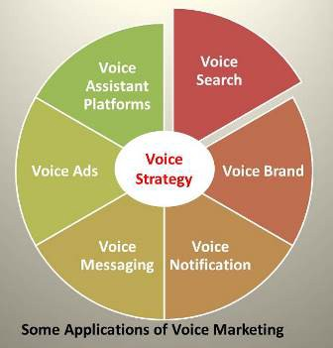As we know voice assistant has become parft of our daily lives from alexa to google assistant we find them everywhere and they have made a great ease in our lives.

Voice assistants come in somewhat small packages and can perform a variety of actions after hearing a wake word or command. They can turn on lights, answer questions, playmusic, place online orders, etc.

Voice assitants are getting famous day by day they are part of natural language processing and pocessess great scope to change our daily and bring ease to the lives of the indiviual

As a matter of factOne in three U.S. homes now has a smart speaker and 81% of us have helpers like the Google voice assistant in our smartphones [1,2]. Yet less than half of us actually use them [3].

SOME OF THE USES OF VOICE

ASSITANT

## Play music

Voice-activated assistants can be personal DJs that give instant access to nearly every piece of music you would want to hear. The Google Home voice-activated speaker, the Amazon voice assistant Alexa, and Apple’s Siri all play music natively.

## Keep a shopping list

Who knew shopping lists were such a pain? Once you start using voice-activated home assistants, you’ll wonder how you ever muddled through with pen and paper.

## Manage timers and productivity

Want to save time in the home and kitchen? One of the best voice assistant uses is setting multiple timers. During meal prep, it’s handy to set a pizza timer and a broccoli timer.

## Drive hands-free

One in every four car crashes in the U.S. is caused by a smartphone [18]. Make your world a safer place with hands-free voice assistant functions in your phone. Siri, the Google voice assistant, and Cortana can give you directions and send calls and messages without you ever touching a handset.

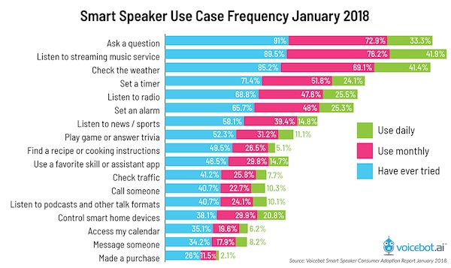

Get news, weather, and traffic

Why turn on the TV or peck around on the web for top-line news and weather info when your voice assistant has your back? The Google voice assistant and its brethren come pre-programmed to deliver key points about your world and town.

**IMPLEMENTATION**

In this project we have used Microsoft API for basic “text to speech” conversion and speech recognition.We have increased the functionality of the assistant.

In this project we have included selenium to control web related operation which can be later used to connect the browser and it can send commands to different browser despite variation in there browser design

We have also included wikipedia library for which can used to directly fetch data from wikipedia without using browser

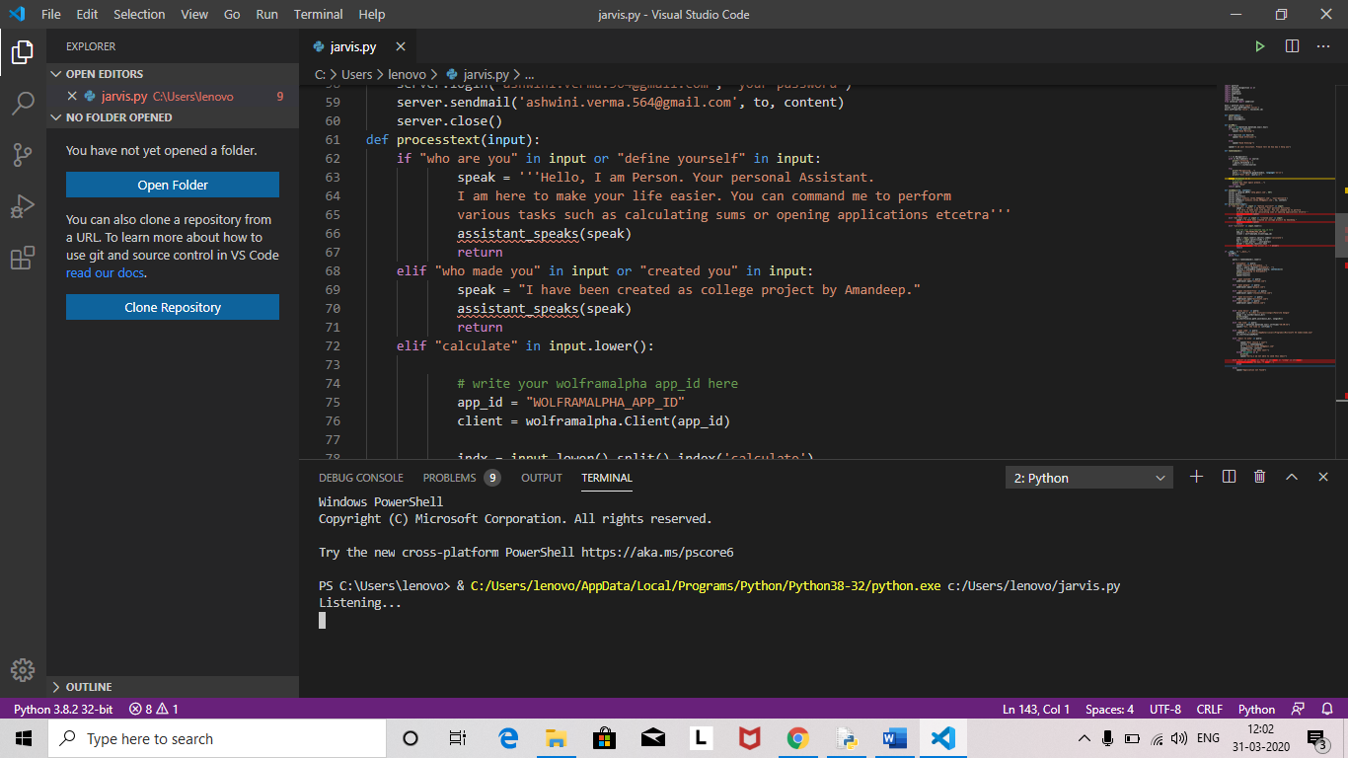

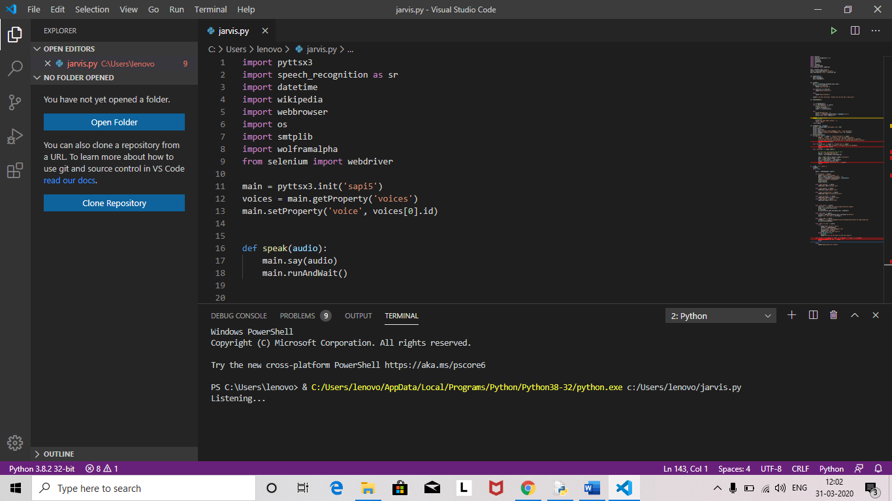

**CONCLUSION**

After completing this project on the topic voice assitant using python. I can concluded that we have made significant progress and made our concept clear about aritifical intelligence and made our concept clear.

This project includes Microsoft API which increases its realibility.Now we are able to talk any issue related with the topic.

The whole credit goes to my subject teacher and my , my friends,they refined my ideas and make this project wonderful..

**BIBLIOGRAPHY**

This was a wholesome task to complete and we took it as a challenge and completed it on time however some of the help from outside help was required so we would like to mention the help and thank them

1.www.pythonspot.com

2.www.actistate.com

2.www.tutorialpoint.com