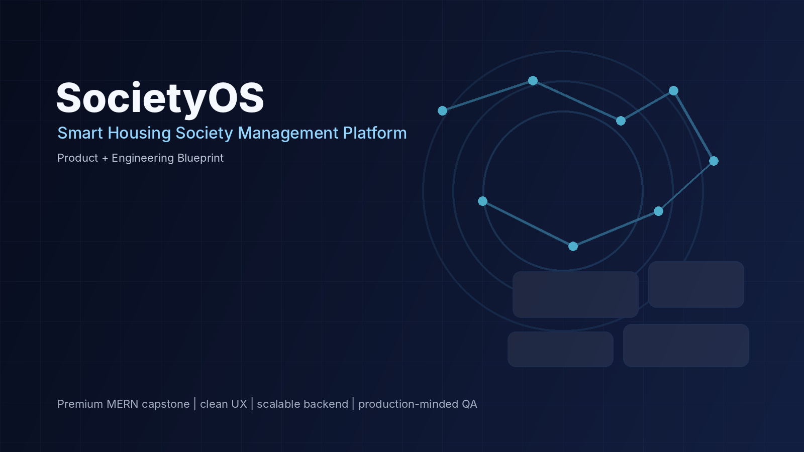
01

Startup Proposal
SocietyOS — Smart Housing Society & Community Operations Platform
PRODUCT / BUSINESS PITCH
Prepared for startup pitching, product planning and engineering execution.

Project | SocietyOS
Category | PropTech / Community Operations SaaS
Initial Market | Pakistan — pilot-first, Peshawar/KP focused
Primary Buyers | Housing society management, apartment/community operators, property administrators
Primary Users | Residents, security staff, maintenance teams, administrators
Version | 1.0 • September 2026

Executive Summary
SocietyOS is a premium, multi-tenant digital operating system for housing societies, apartment communities and gated residential developments. It brings resident services, visitor control, complaints, maintenance work orders, billing records, notices, notifications, auditability and AI-assisted workflows into one coherent product.
The product thesis is not “another dashboard”. SocietyOS is designed around operational workflows: a resident creates a visitor pass, a security guard verifies it, management sees the event, maintenance receives structured work orders, and the resident receives transparent status updates. The result is a system that reduces operational fragmentation while making community service more visible and accountable.
Pitch thesis
The opportunity is not limited to digitizing registers. It is to create a trusted operating layer between residents, management, security and maintenance—starting with a focused premium product and expanding through integrations.

1. Problem
Residential communities often coordinate important daily work across disconnected channels: paper gate registers, spreadsheets, personal calls, WhatsApp groups, manual bill records and informal complaint follow-up. This creates four recurring problems:
- Fragmentation: the same event may be entered or communicated multiple times across different places.
- Low traceability: residents and managers struggle to see who acted, when the status changed, and what remains pending.
- Security and service gaps: visitor access, maintenance requests and incidents can depend on informal communication.
- Poor operational visibility: management lacks a single, trustworthy view of open complaints, dues, work orders, service performance and audit history.

2. Proposed Solution
Area | SocietyOS capability | Outcome
Resident services | Visitor passes, complaints, bills, notices, profile and service requests | Less chasing; clear status and self-service
Security | Visitor approval, gate check-in/out, incident logging | Structured access records
Maintenance | Work orders, assignment, progress, evidence and verification | Visible service lifecycle
Management | Dashboards, billing records, announcements, reports and audit log | Operational control
AI assistance | Complaint classification, summaries and authorized Q&A | Faster information handling without autonomous high-impact decisions
Notifications | Email + WhatsApp adapter layer | Timely resident and staff communication

3. Target Customer & Personas
Persona | Primary needs | Success signal
Society / property manager | Visibility, collection tracking, complaints, staff/work orders, notices | Fewer manual follow-ups; consistent records
Resident | Convenience, visitor approval, complaint status, billing history | Can complete common tasks without calling the office
Security guard | Fast identity/visitor verification with minimal typing | Gate actions are quick and auditable
Maintenance supervisor | Assignment, priority, SLA/status and proof of completion | Work backlog is visible and actionable
Platform admin | Tenant onboarding, role management, audit and system health | Safe multi-tenant administration

4. Product Scope
- Authentication, secure sessions and role-based access control.
- Society, block/building, unit, resident and household/member management.
- Visitor pass lifecycle from request to approval, gate arrival and checkout.
- Complaint and maintenance workflow with assignment, status transitions, attachments and SLA-oriented visibility.
- Maintenance billing records, outstanding balances, receipts and payment evidence/adapters; no banking rails built from scratch in V1.
- Announcements, targeted notifications, email and WhatsApp integration through provider adapters.
- Admin dashboard, reporting, audit log, search/filter/pagination and export-ready data structures.
- AI assistant constrained by authorization, tool boundaries and human confirmation for consequential actions.

5. Product Differentiation Thesis
The market is already validating the category, so SocietyOS should not be pitched as “the first society management software”. Instead, the pitch should focus on product execution and a Pakistan-first operating experience.
Dimension | SocietyOS thesis
Pakistan-first workflows | Use PKR terminology, society/unit vocabulary, practical WhatsApp/email flows and bilingual-ready UI.
Workflow depth | State machines and audit history instead of disconnected CRUD screens.
Security by architecture | Every tenant-scoped record carries tenant context and backend authorization is authoritative.
AI with boundaries | AI assists classification, summaries and retrieval; it does not silently approve visitors, change financial records or bypass permissions.
Premium UX | Futuristic through restraint: clear hierarchy, fast actions, intentional mobile states, and real operational data.
Scalable engineering | Modular monolith first; explicit domain boundaries; adapter-based external integrations; testable services.

6. Business Model
Recommended initial model: B2B SaaS charged to the community/operator rather than residents. Pricing can be finalized after pilot interviews and should be based primarily on unit count and enabled modules.
Revenue stream | Mechanism | Purpose
Core SaaS subscription | Monthly/annual plan by occupied or registered units | Predictable recurring revenue
Onboarding / migration | One-time implementation fee | Data import, configuration and training
Premium modules | Optional advanced reporting, integrations or automation | Expansion revenue
Enterprise / portfolio | Custom commercial agreement for multi-property operators | Larger accounts and portfolio management
Commercial discipline
Do not publish a “market-leading” price before customer interviews. Validate willingness to pay, unit bands, onboarding effort and WhatsApp/payment-provider costs with real operators.

7. Go-To-Market & Pilot Strategy
- Start with 1–3 pilot communities where management can provide structured feedback and access to real workflows.
- Lead with one concrete operational problem—complaint tracking, visitor management or collections visibility—then expand into the full operating layer.
- Run a controlled onboarding: configure units, residents, roles, notification channels and demo data before go-live.
- Measure operational outcomes rather than vanity metrics: ticket response time, unresolved backlog, visitor approval turnaround, notification delivery and resident adoption.

8. Roadmap
Phase | Focus | Primary deliverable
0 | Discovery & domain mapping | Validated workflows, scope, data model and acceptance criteria
1 | Design system & UX | Premium UI foundation and role-based screen flows
2 | Architecture & foundation | Monorepo, CI, auth skeleton, API conventions, database setup
3 | Society & resident management | Tenant, unit, resident and role workflows
4 | Visitor & security | Pass lifecycle, gate workflow and audit trail
5 | Complaints & maintenance | Tickets, work orders, assignment, SLA-oriented tracking
6 | Billing & finance records | Bills, receipts, payment evidence and ledger-friendly history
7 | Notifications & AI | Email/WhatsApp adapters, AI assistant and safe tools
8 | Admin analytics & audit | Operational dashboards, audit review and reports
9 | Hardening & QA | Security, performance, accessibility, E2E and regression testing
10 | Deployment & pilot | Production release, monitoring, backup/restore test and controlled pilot
11+ | Expansion | Integrations, portfolio management and optional mobile/native experiences

9. Success Metrics
Metric | What it tells us | Pilot target approach
Resident activation rate | Whether the product is being adopted | Measure after onboarding; set target from baseline
Complaint first-response time | Operational responsiveness | Compare pre/post-pilot baseline
Open complaint aging | Backlog health | Track aging buckets weekly
Visitor approval turnaround | Security workflow speed | Measure median time during peak hours
Bill notification delivery rate | Communication reliability | Track provider delivery/failed events
Admin weekly active use | Management dependence on system | Track meaningful actions, not just logins

10. Risks & Mitigations
Risk | Why it matters | Mitigation
Low resident adoption | Management buys but residents do not use it | Keep high-frequency flows simple; support WhatsApp/email; pilot onboarding
Scope creep | Too many modules dilute quality | Protect V1 scope; ship workflows, not screen count
Security/privacy failure | Residential data is sensitive | Tenant isolation, least privilege, secure sessions, audit logs, validation and security testing
AI overreach | Incorrect automation can create operational risk | Use AI for assistance; require rules/confirmation for consequential actions
Provider dependency | WhatsApp/email/API outages affect workflows | Adapter interfaces, retry policies, fallback channels and observability
Unclear pricing | Feature completeness without a business model | Interview operators before locking tiers

11. Pitch Narrative
- Start with the operational reality: a society runs on people, but information is scattered.
- Show the resident-to-gate-to-management journey in one continuous workflow.
- Demonstrate the same event from different roles to prove role-aware product thinking.
- Use AI as a supporting layer, not the product itself.
- Close with measurable pilot outcomes, scalable architecture and the path from one community to a multi-property SaaS platform.

Sources & Research References
SBP — Annual Payment Systems Review FY2024-25 — Digital payment context for Pakistan; mobile banking apps processed 6.2B transactions in FY25 and Raast reached 1.9B transactions since launch through Jun-25. https://www.sbp.org.pk/PS/PDF/Annual-Payment-Systems-Review-FY25.pdf
PBS — Census 2023, KP tables — Population/urbanization context for KP and Peshawar Division; division-level figures should not be treated as Peshawar city totals. https://www.pbs.gov.pk/sites/default/files/population/2023/tables/kp/pcr/table_1.pdf
Mygate — Comparable community-management platform benchmark for security, dues, services and resident workflows. https://mygate.com/
ADDA — Comparable apartment/society management platform benchmark for maintenance, accounting, security and visitor workflows. https://ind.adda.io/apartment-management-system
BuildingLink — Comparable global resident/property operations benchmark. https://help-resident.buildinglink.com/en/support/solutions/articles/42000099088-buildinglink-features-for-residents

