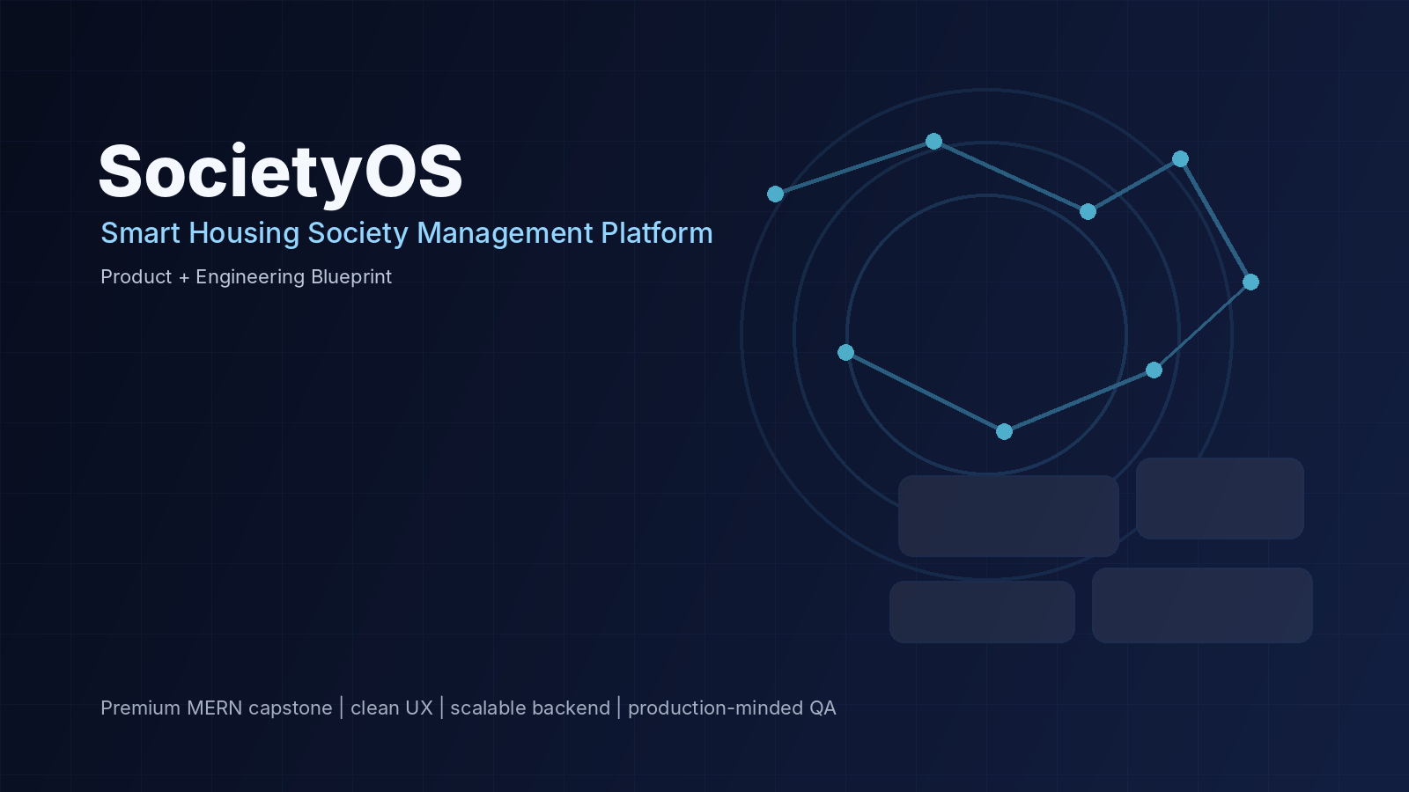
02

Market Research
SocietyOS — Pakistan Housing Community Management Market
EVIDENCE, COMPETITION, OPPORTUNITY AND VALIDATION PLAN
Prepared for startup pitching, product planning and engineering execution.

Research date | 17 September 2026
Primary geography | Pakistan; with Peshawar/KP as initial pilot lens
Category | Housing society / apartment / gated-community management software
Method | Secondary research + competitor scan + pilot validation framework
Important note | Market-size claims are not fabricated; where public data is limited, the report uses formulas and validation steps instead.

Executive Research Summary
The research supports three high-level conclusions. First, the category is real and commercially active: Pakistani vendors already market society-management products, while global and regional platforms demonstrate demand for visitor management, complaints, billing, communication and operations. Second, Pakistan’s payment infrastructure is increasingly digital, which supports electronic dues workflows. Third, the market should be treated as competitive rather than empty; SocietyOS needs a clear product thesis and pilot evidence.
Evidence boundary
Public websites are useful for feature benchmarking but are not sufficient to prove customer satisfaction, retention, revenue or market share. Those claims require direct interviews, product trials or audited third-party data.

1. Market Problem Signals
The target problem is operational fragmentation rather than a single missing feature. Society managers have to coordinate residents, visitors, security, staff, maintenance, billing and communication. Software products in this category increasingly combine these modules, indicating that buyers can understand the value of an integrated operating layer.
Signal | Evidence | Implication for SocietyOS
Digital payment readiness | SBP reports 6.2B mobile-app transactions in FY2024-25 and 1.9B Raast transactions from launch through Jun-25. | Residents and operators can increasingly support digital dues and receipts; payment adapters should be designed as a first-class integration boundary.
Large population base in KP | PBS 2023 census tables show Peshawar Division at about 10.0M people, including about 2.64M urban population. This is division-level, not city-only. | Peshawar/KP offers a meaningful pilot geography without claiming a precise city-level software market size from this table.
Local category activity | Pakistani products such as Manzhil, Nizam, SocioNest, Hayat Tech and others publicly market society-management capabilities. | The concept is not speculative; differentiation and execution matter.
International category maturity | Mygate, ADDA and BuildingLink combine resident services, security, complaints, finance and community operations. | There is established product precedent and a reference set for UX and workflow design.

2. Customer Segments
Segment | Pain intensity | Buying motion | SocietyOS fit
Gated housing societies | High | Management committee / operator decision | Strong
Apartment / condominium communities | High | Property manager / association | Strong
Private residential complexes | Medium-High | Developer or management operator | Strong
Small apartment buildings | Medium | Owner/manager-led; price sensitive | Possible later tier
Large multi-property operators | High | Enterprise / portfolio procurement | Expansion segment

3. Competitor & Category Scan
Competitors below are presented as documented category examples, not as a ranking. Feature descriptions are based on public product pages available during this research pass.
Player / category | Publicly described capabilities | Observed positioning signal | What SocietyOS should learn
Manzhil (Pakistan) | Maintenance collection, complaints, facility bookings, announcements, WhatsApp; English/Urdu positioning. | WhatsApp-first and Pakistan-specific workflows. | Adoption friction is a major product concern; resident communication should not depend on a new app alone.
Nizam (Pakistan) | PKR billing, visitor management, staff tracking, emergency alerts, accounting/reporting, English/Urdu. | Finance and society ERP depth. | Financial records and terminology need to feel locally credible.
SocioNest (Pakistan) | Billing, visitors, complaints, residents and notices. | All-in-one society platform. | Core workflows are table stakes; quality and trust become differentiators.
Hayat Tech (Pakistan) | Resident/unit management, maintenance, billing, amenity booking, communication, vendors, security, documents, accounting. | Enterprise-style ERP breadth. | Avoid competing on feature count alone; focus on workflow quality and maintainability.
Mygate (India/global benchmark) | Visitor/security, complaints, dues, services, broad community platform. | Large-scale community ecosystem. | Use as benchmark for end-to-end community workflows, not as a direct local market-size proxy.
ADDA (India/global benchmark) | Accounting, maintenance, resident management, security/visitor, communication, facility management. | Integrated apartment ERP. | Operational modules should share the same resident/unit model.
BuildingLink (global) | Resident dashboard, announcements, documents, deliveries and property services. | Property operations platform. | Resident-facing UX needs clear navigation and modular configuration.

4. Competitive White-Space Hypotheses
These are hypotheses to validate, not established facts.
- A premium but locally practical UX may help communities that find enterprise ERPs heavy or consumer apps insufficiently operational.
- A modular architecture can combine resident convenience with management-grade auditability without forcing every community to enable every module.
- An explicit “AI with permission boundaries” model can make AI useful without turning the system into an unreliable chatbot layer.
- A web-first responsive experience can reduce onboarding friction while retaining a path to mobile/native applications later.
- Bilingual-ready workflows (English + Urdu, with future Roman Urdu handling where useful) could improve usability for mixed user populations; the degree of demand should be validated with residents and guards.

5. Market Sizing Framework
Publicly available sources reviewed here do not provide a sufficiently reliable count of all Pakistani housing societies/apartment communities that should be multiplied into a precise TAM. Instead, use a transparent bottom-up model during the pitch and replace assumptions with verified numbers after interviews.
Layer | Formula | Example input to validate
TAM — communities | Number of addressable residential communities in chosen geography × annual contract value | Count of societies/communities by target city/region
TAM — units | Addressable units × annual revenue per unit | Unit count bands and expected ARPU
SAM | TAM subset matching product scope, geography and operational maturity | Peshawar/KP + selected major cities
SOM — 24 months | Realistic pilot-to-paid conversion × target sales capacity | Pilot communities, sales cycle, onboarding capacity
Pitch-safe sizing
Use ranges and label assumptions. A transparent “we need to validate X” is stronger than an invented billion-dollar TAM number.

6. Buyer & User Discovery Plan
Interview group | Sample | Questions to validate
Society management | 10–15 operators | Current tools, biggest recurring manual tasks, complaint load, collections process, staff workflow, willingness to pay.
Residents | 20–30 across 2–3 communities | Visitor friction, complaint experience, payment preferences, notification preferences, trust/privacy concerns.
Security staff | 8–12 guards/supervisors | Gate process, verification speed, device constraints, common failure cases, language needs.
Maintenance staff | 8–12 staff/supervisors | Assignment process, evidence collection, status reporting, SLA/escalation pain points.
Accountants/admins | 5–8 | Bill generation, payment reconciliation, adjustments, reporting and audit requirements.

7. Validation Experiments
Experiment | What it tests | Pass signal
Clickable UX test | Can residents/guards complete high-frequency actions quickly? | Most participants complete task without explanation.
Concierge pilot | Does structured ticket + visitor workflow reduce manual chasing? | Operators report measurable visibility improvement.
Notification trial | Do WhatsApp/email updates reduce follow-up calls? | Lower repeat follow-up for selected workflow.
AI triage shadow mode | Does classification save staff time without harmful errors? | Useful suggestions accepted/edited by staff; no unauthorized action.
Pricing interviews | Will operators pay and for what unit band? | Clear budget owner + credible willingness-to-pay range.

8. SWOT Snapshot
Strengths | Constraints | Opportunities | Threats
Full workflow product; modular architecture; strong security posture; AI boundaries; premium UX thesis | New product with no proven retention; onboarding and integrations require effort | Pakistan-focused pilots; multilingual UX; integrations; portfolio management; analytics | Established local ERP vendors; strong community platforms; low resident adoption; privacy/security incidents; provider dependency

9. Key Risks from the Research
- Category competition is real; “all-in-one society management” alone is not enough differentiation.
- Resident adoption can be harder than management procurement, particularly where communities rely heavily on existing WhatsApp habits.
- Financial modules create trust requirements beyond ordinary CRUD: adjustments, reversals, auditability and reconciliation matter.
- Security and privacy are central to visitor/household data and should be product requirements from day one.
- AI claims should remain narrow until real-world accuracy and usefulness are measured in shadow mode.

10. Strategic Positioning Statement
Proposed positioning
SocietyOS is a premium, Pakistan-ready operating platform for residential communities that want one trusted system for residents, security, maintenance and management—without sacrificing clean UX, auditability or controlled AI assistance.

Sources & Research References
SBP — Annual Payment Systems Review FY2024-25 — Primary source for FY25 digital payment figures. https://www.sbp.org.pk/PS/PDF/Annual-Payment-Systems-Review-FY25.pdf
PBS — 2023 Census KP table — Primary source for KP/Peshawar Division population context. https://www.pbs.gov.pk/sites/default/files/population/2023/tables/kp/pcr/table_1.pdf
Manzhil Pakistan — Publicly described Pakistan society-management features and WhatsApp/English/Urdu positioning. https://www.manzhil.com/pakistan
Nizam Pakistan — Publicly described Pakistan-focused billing, security, visitor and accounting features. https://www.nizamco.com/pk
SocioNest Pakistan — Publicly described society-management product features. https://socionest.pk/society-management-software-pakistan
Hayat Tech — Housing Society Management — Publicly described ERP feature breadth. https://hayattech.com/products/housing-society-management
Mygate — Community-management category benchmark. https://mygate.com/
ADDA — Apartment management category benchmark. https://ind.adda.io/apartment-management-system
BuildingLink resident features — Resident/property operations benchmark. https://help-resident.buildinglink.com/en/support/solutions/articles/42000099088-buildinglink-features-for-residents
Wasooli.Online — Peshawar — Example of locally targeted fee-collection positioning in Peshawar. https://wasooli.online/town-society-fee-collection-software-in-peshawar
Google Play — myABDALIANS — Example of a Pakistani society-specific resident app listing. https://play.google.com/store/apps/details?id=com.nmsolutions.ABDALINS
Google Play — AACHS — Example of another Pakistani housing society app listing. https://play.google.com/store/apps/details?hl=en&id=com.aachs.app

