**Adeel Amin – 2111627A**

**SzymonCzaja – 2107738C**

**Patrick Frempong – 21052928A**

**Daniel Girma – 2111133G**

Lab Group N

Tutor Name: Ronald Poet

19th January 2014

**Team ProgrammingProject**

MSc – Information Technology

1. **Status Report**

As a group, we believe the final state of our program meets the complete specification and functionalities highlighted in the assessment document. The Assigning Referees to JavaBall Matches program has been designed and implemented very closely to what has been stated.

The following assumptions/conditions influenced the design and implementation of the GUI and the logic of the program;

1. All referee details that will be displayed in the ‘Referees’ area of the GUI, will be extracted from a ‘RefereesIn.txt’ file, this will have always have the referee details in the correct format.
2. The program will always be directed to the correct input file ‘RefereesIn.txt’ and the file will always be in the same directory as the program with the specified name.
3. The data in the ‘RefereesIn.txt’ will be in the correct format, meaning all the details for each Referee will be on a new line.
4. Each Referee in the ‘RefereesIn.txt’ file will be unique.
5. The input file, ‘RefereesIn.txt’ can contain details of up to 12 referees, but no more than 12.
6. Each time the program is run and the GUI is created the 'RefereesIn.txt' is automatically read in.
7. The referees IDs in the ‘RefereesIn.txt’ file are not ordered in any form however when they are read into the program they are ordered first lexicographically on the first two characters and then numerically.
8. The referees’ data from the text file are displayed on the GUI in the same format as the input text file. This can be accessed by clicking on the ‘Referees’ tab on the GUI.
9. You can search for a referee by clicking on the ‘Manage’ tab, and by entering the first and last name.
10. When searching for an existing referee, the first and last name is case sensitive and must match exactly how it has been stored. Any whitespace in the text fields will be trimmed.
11. You can add a new referee by entering the referee’s first and last name (case sensitive), qualification held, the number of already allocated matches, the area he currently resides in, and the areas he can travel to. The referee ID is not required, however this is determined using the first initial of the referee’s first and last name followed by a sequential number.
12. You can only add a new referee if the current number of registered referees is less than 12.
13. You can only update the record of a referee that is already in the system.
14. You can only update the qualification, home area and the travel areas of a referee.
15. You can delete a referee from the system by first searching for the referee, if there is no referee within the system this cannot be done.
16. Referees are allocated to matches by accessing the ‘Matches’ tab, you can then select the week, area and type of match which can be either “Junior” or “Senior”. Once you click on Allocate, this will allocate the two most eligible referees. The following assumptions have been made when allocating referees;

* A new array is created within the program to contain the suitable referees based on suitable qualifications. Then the array is sorted with accordance to the preference rules from the specification document. Please note, it has been assumed that referees who are not willing to travel to the match area will also be excluded from the list of potential candidates.
* In first instance, if there are two or more referees with the required qualification for the match, the referees who are from the same area as the match and have the least number of allocations are selected.
* Otherwise, if there are no two referees who meet the above criteria, then the next suitable referee from an adjacent or non-adjacent area is selected provided he can travel to the area where the match is taking place
* Lastly, based on the new array created, the two selected referees along with all the possible candidate referees for the match are displayed on the right hand side of the GUI text area. The selected referees are those willing to travel to the match area and having the least number of allocations in this category.

1. Within the ‘Matches’ tab, when the two referees are allocated to a match, their details are displayed on the left hand side of the GUI in a text area under the selection boxes. Please note that the referee details displayed are the details prior to being allocated to the current match, hence the allocation number has not yet increased by 1.
2. Only weeks 1 to 52 are available within the GUI when allocating referees to a match.
3. Once referees have been allocated to a match in a particular week, no other matches can be selected again in that week unless the referee allocation for that week is removed first.
4. Following the allocation of the two referees to a match, the referee list is updated showing the updated number of allocations. This can be seen by accessing the ‘Referees’ tab of the GUI.
5. If there are any changes made to the qualification, home area or travel area, these will be reflected in all parts of the program regardless of which tab of the GUI you are viewing. Please read the developer comments in the n.models.Match class for the public void setAllocatedReferees(Referee[] registeredReferees) method.
6. Once all the above points have been performed by the program and all the matches have been allocated with referees, there should be an output text file produced named ‘MatchAllocs.txt’. It should contain details on each match with information such as week number, level and area along with the assigned referees. This file should be produced regardless when the program is terminated.
7. There is an ‘Exit’ button which when pressed, creates an output text file in the same format as the input text file. This text file is called ‘RefereesOut.txt’ and contains a list of an updated list of referees including any referees that may have been added, excluding any referees that may have been deleted.
8. By selecting the cross (X) cursor on the top right of the GUI, the program will terminate however no output files will be produced.

As a team, we believe that all the required functionality has been fully implemented using the best design possible. The selection of classes and packages have allowed us to break down the necessary code into manageable portions to ensure good programming practice and to allow any external personnel to review the program with ease.

On the following pages and sections are the required testing scenarios that were performed to demonstrate the basic functionality of the program. There has also been additional testing performed to demonstrate the robustness of the program.

1. **Testing**

**2.1 Required test scenarios**

The following tasks have been performed in sequential order during a single execution of the program. Therefore all changes made during this cycle will be reflected in the output files. The following tasks been carried out based on the input file ‘RefereesIn.txt’ being read into the program.

|  |  |  |  |
| --- | --- | --- | --- |
| **Task** | **Operation**  **Performed** | **Reference** | **Screen Dumps** |
| 1 | Allocate Referees | 2.3.1 | Figure 1, 2 |
| 2 | Add Referee | 2.3.2 | Figures 3 to 7 |
| 3 | Update Referee Details | 2.3.3 | Figures 8 to 14 |
| 4 | Display list of Referees | 2.3.4 | Figure 15 |
| 5 | Search for Referee | 2.3.5 | Figures 16 to 18 |
| 6 | Delete Referee | 2.3.6 | Figures 19 to 22 |
| 7 | Allocate Referees | 2.3.7 | Figure 23 to 255 |
| 8 | Display bar chart | 2.3.8 | Figure 26 |
| 9 | Display ‘RefereesOut.txt’ file | 2.3.9 | Figure 27 |
| 10 | Display ‘MatchAllocs.txt’ file | 2.3.10 | Figure 28 |

Where there are (x) indicated in the table this means that there were no matches allocated in that specific week.

* 1. **Additional test scenarios**

The following tasks have been performed again in one execution of the program reading in details from the ‘RefereesIn.txt’ which now contains 11 referees.

|  |  |  |  |  |
| --- | --- | --- | --- | --- |
| **Task** | **Operation**  **Performed** | **Additional Information** | **Reference** | **Screen Dumps** |
| 11 | Execute program to display referee list | Referee list shows all referees in ID order | 2.4.1 | Figures 29, 30 |
| 12 | Add Referee, Daniel Girma | Operation is successful | 2.4.2 | Figures 31, 32 |
| 13 | Add Referee, Ronald Poet | By adding another referee, warning message should appear | 2.4.3 | Figures 33, 34 |
| 14 | Search for Ronald Poet | Search for a referee that is not listed | 2.4.4 | Figure35 |
| 15 | Delete Referee, Daniel Girma | Operation is successful | 2.4.5 | Figures 36 to 38 |
| 15 | Add Referee of name, Albert Arthur | Adding referee with same initials as existing referee | 2.4.6 | Figures 39 to 41 |
| 16 | Allocate referee to match | Referees to be allocated to a Junior match in week 3 and in central area | 2.4.7 | Figures 42, 43 |
| 17 | Allocate referee to an existing match | Same as above | 2.4.8 | Figures 44 |

* 1. **Required Testing** 
     1. **Allocate referees to the following match;** Week 1 Junior Central

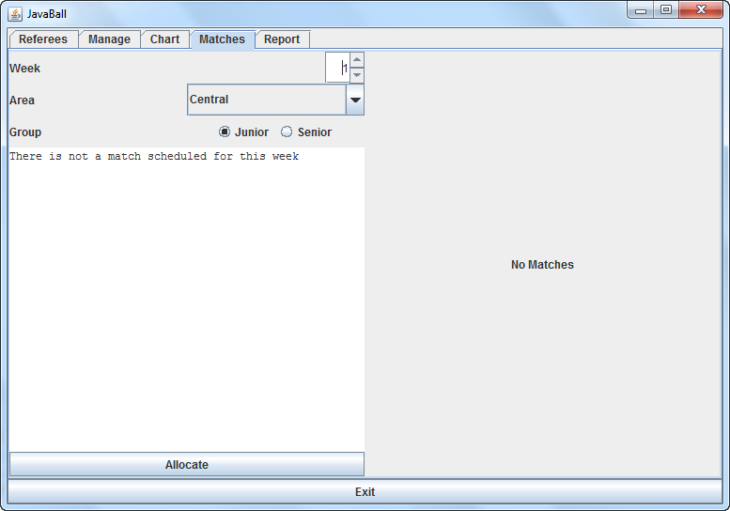

Figure : Click on the Matches tab to enter Match details

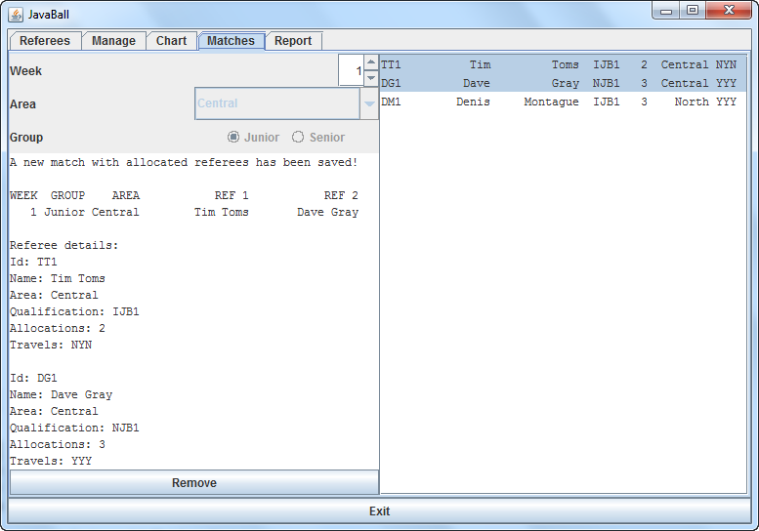

Figure : After entering the Match details, and selecting Allocate, the three possible referee candidates are shown on the RHS of the GUI with the two most suitable referees highlighted in blue

* + 1. **Add the following referee;**

Name: Peter Smith

Qualification: NJB1

Home locality: North

Prepared to visit: North only

Number of matches: 15

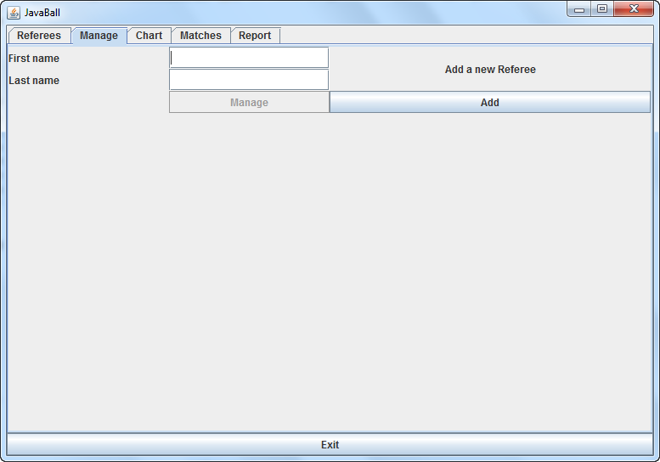

Figure 3: Select Manage tab to access and click on the ‘Add’ button

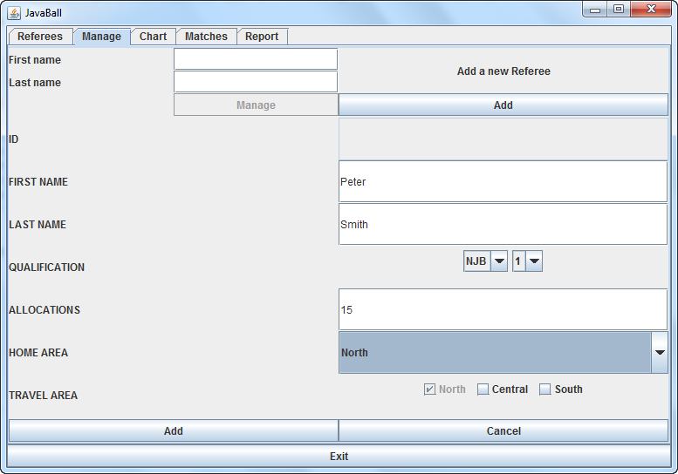

Figure 4: Enter the referee details and click on the ‘Add’ button at the bottom of the GUI

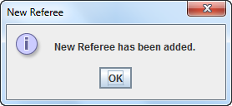

Figure 5: An Information pop-up message appears to inform user that Referee has been added

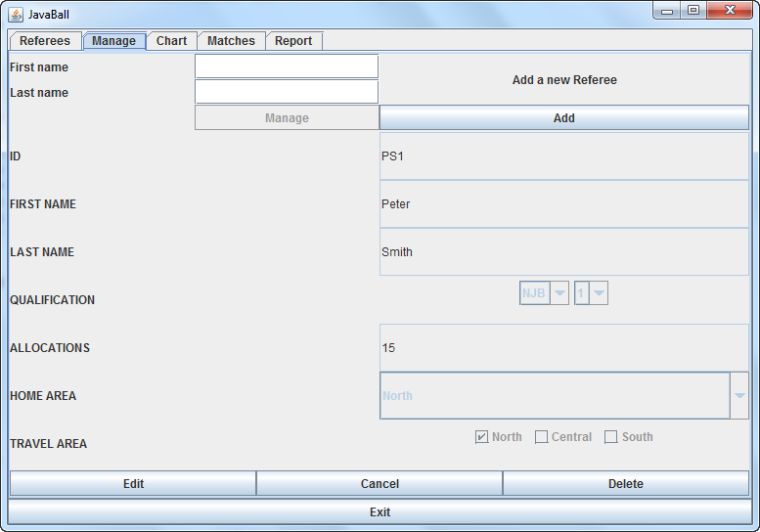

Figure 6: Once the referee has been added, the text fields cannot be edited

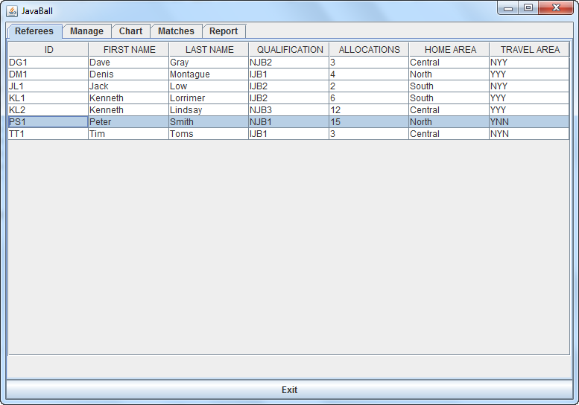

Figure7: By accessing the Referees tab you can view the newly added Referee in the table

* + 1. **Update the details of Peter Smith who was added in step 2.2.2 to the following;**

Qualification: IJB2

Home locality: Central

Prepared to visit: North and Central

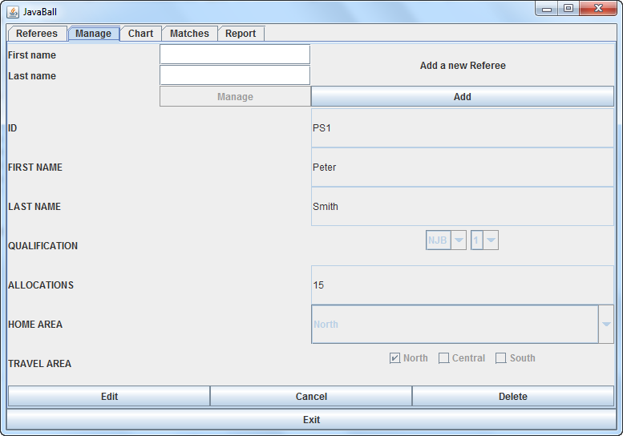

Figure 8: To update Referee details, press the ‘Edit’ Button

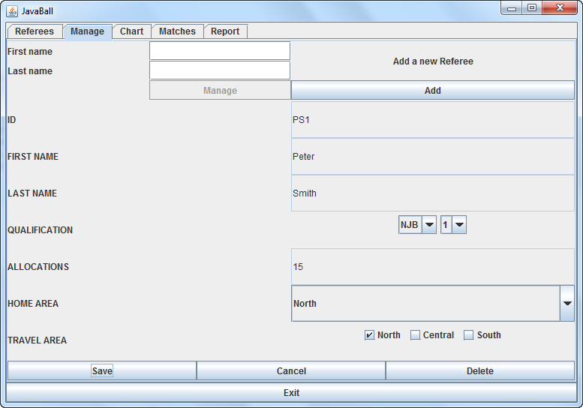

Figure 9: You can then edit, the Qualification, Home Area and Travel Areas of the selected Referee

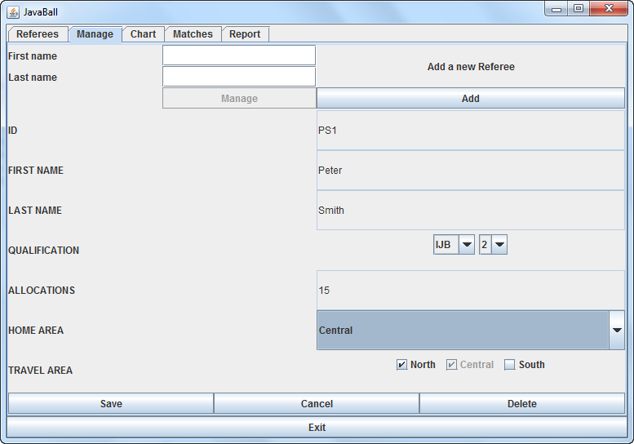

Figure 10: Make the required changes specified above and press Save

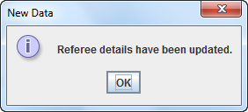

Figure 11: An Information message pop up message appears to inform you the details have been updated

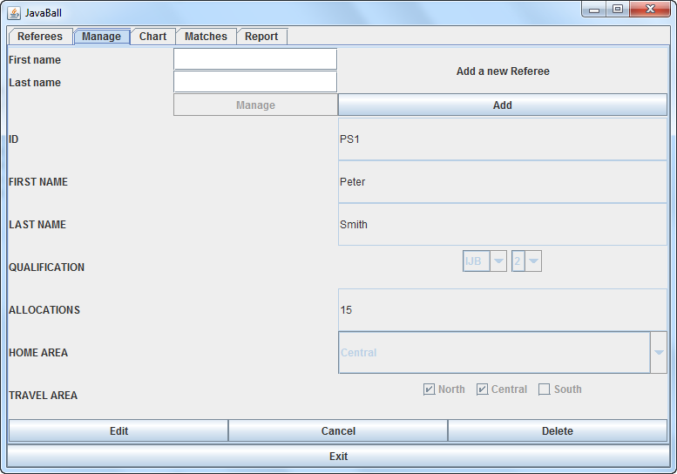

Figure 1: Once the referee details have been edited, the fields then become un-editable again

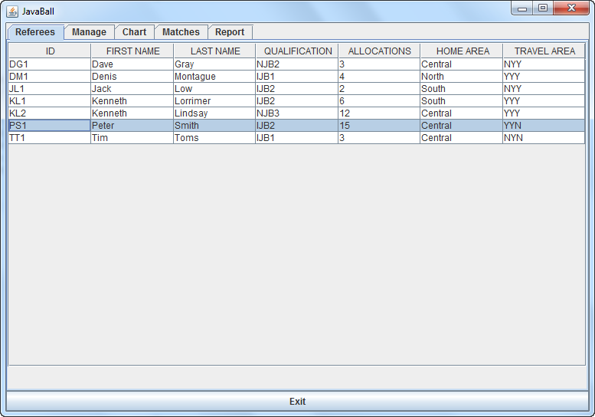

Figure 1: The updated referee details can be seen in the Referees tab

* + 1. **Display the list of all Referees**



Figure 1: The complete list all referees (this includes any added/updated referees during this program execution)

* + 1. **Search for Peter Smith**

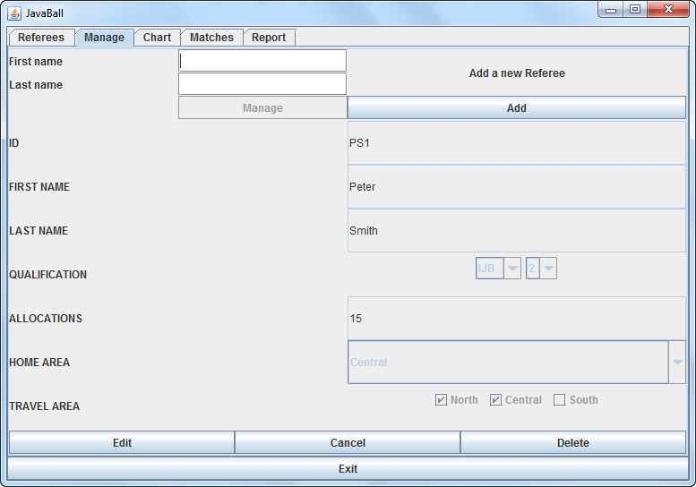

Figure 1: Click on the Manage tab on the GUI

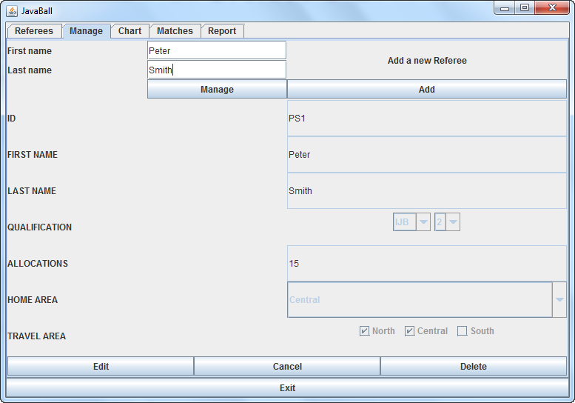

Figure17: Enter Peter Smith in the text fields at the top of the GUI

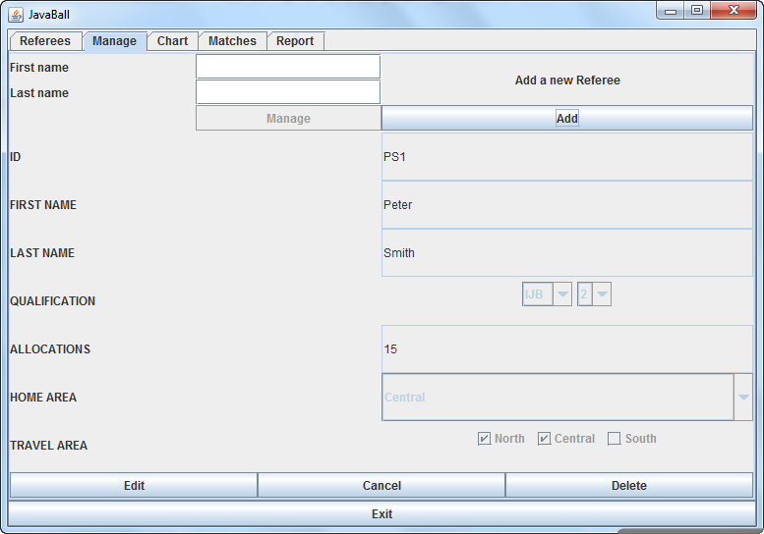

Figure 18: After selecting Manage, the details of Peter Smith are shown in the fields below

* + 1. **Delete Kenneth Lorrimer**

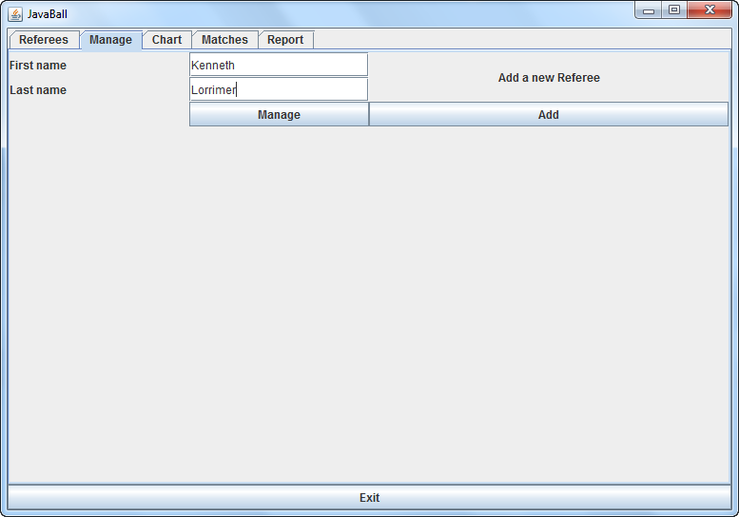

Figure 19: Enter Kenneth Lorrimer in the search fields

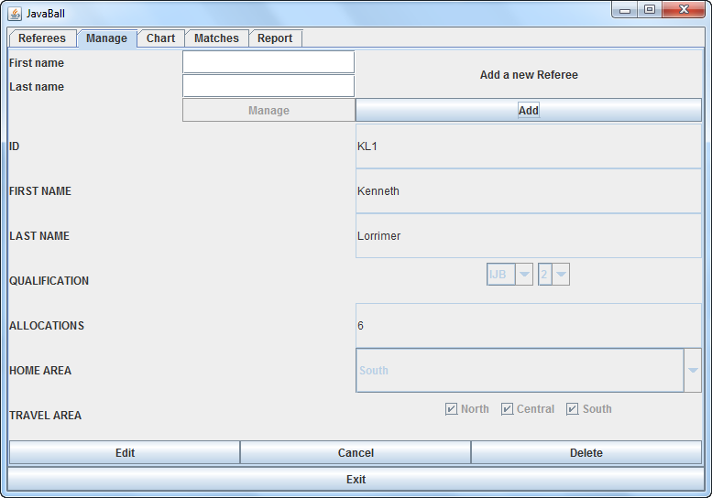

Figure 20: When you click onthe Manage button, the Referee details will be brought up

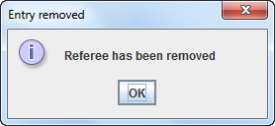

Figure 21: After clicking on the delete button, an information message box confirms removal

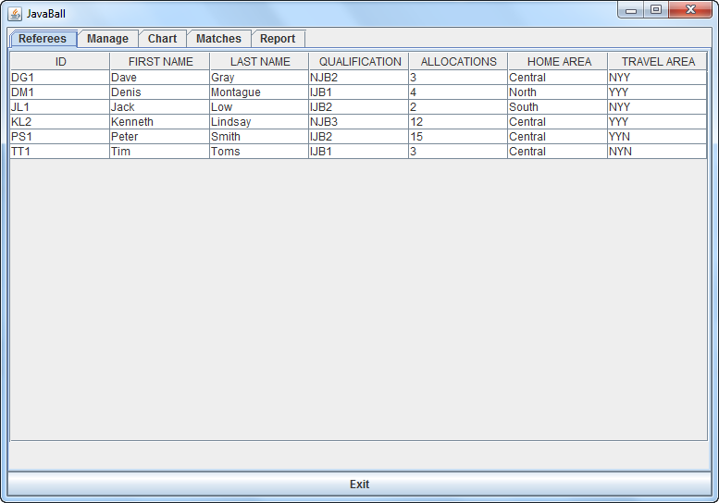

Figure 22: The updated list of referees can be seen by accessing the Referees tab

* + 1. **Allocate referees to the following match;** Week 2 Senior North

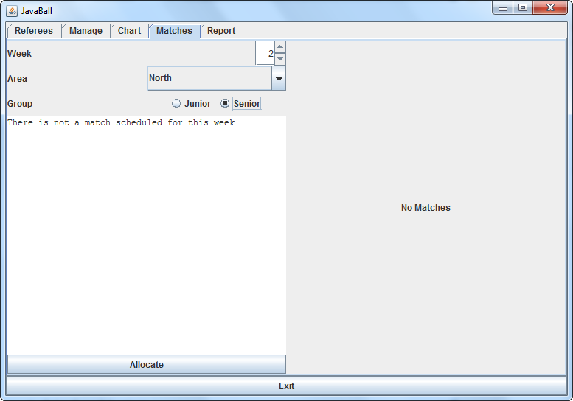

Figure 23: Click on the Matches tab and enter the details of the Match

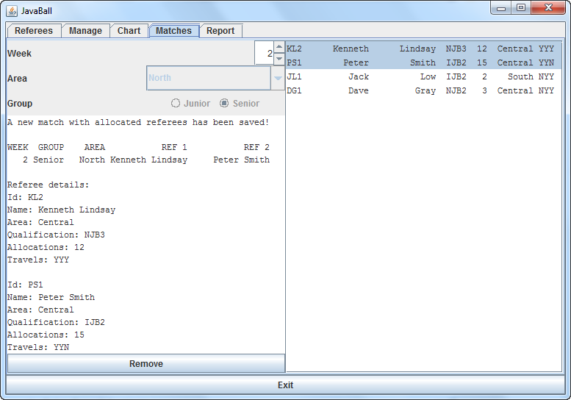

Figure24: When you click on Allocate, two Referees that are eligible are allocated to the Match

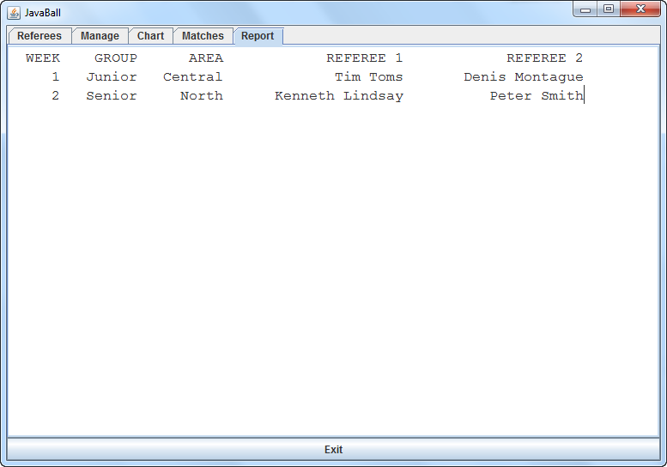

Figure 25: A list of the allocated matches with referees can be seen by clicking on the Report tab on the GUI

* + 1. **Display the bar chart**

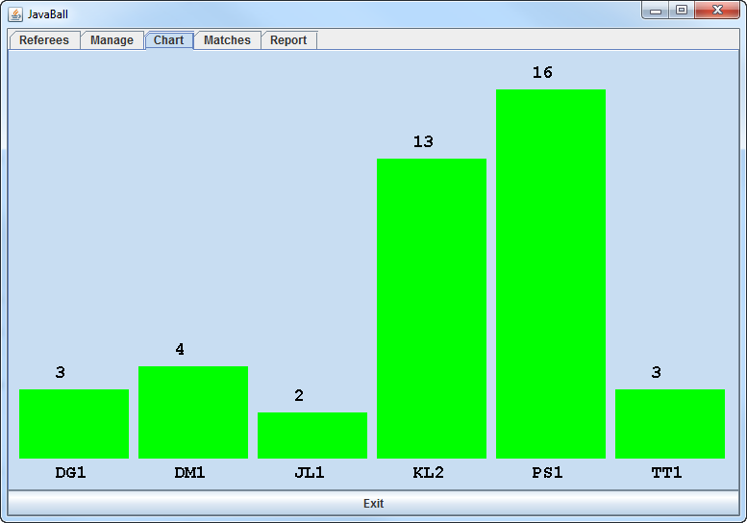

Figure 26: Bar Chart showing the number of Allocations of each Referee in alphabetic order of their ID. The allocation numbers shown take into account any Referees who have been recently allocated to a match.

* + 1. **Display the contents of RefereesOut.txt after exiting the program**

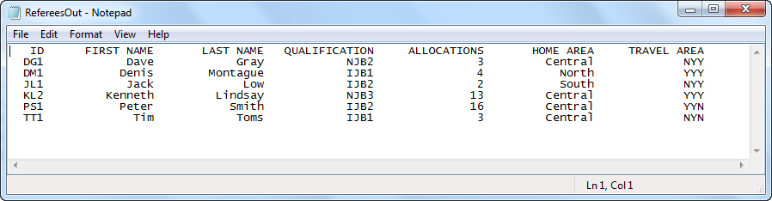

Figure 27: After the program is terminated, the updated list of Referees are displayed above

* + 1. **Display the contents of MatchAllocs.txt after exiting the program**

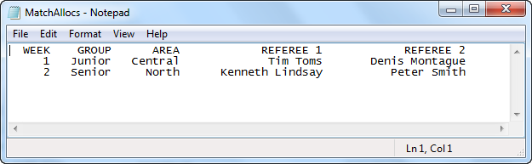

Figure 28: After the program is terminated, the matches that were allocated with referees are shown above

* 1. **Additional Testing Screen Dumps**

The below test cases are based on the RefereesIn text file containing 10 referees.

* + 1. **Execute program to display referee list**

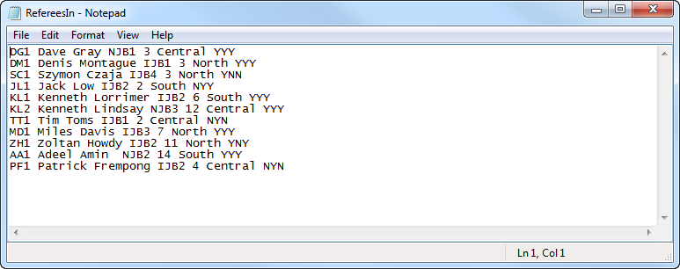

Figure 29: RefereesIn file showing a list of 10 Referees, these are not in any order

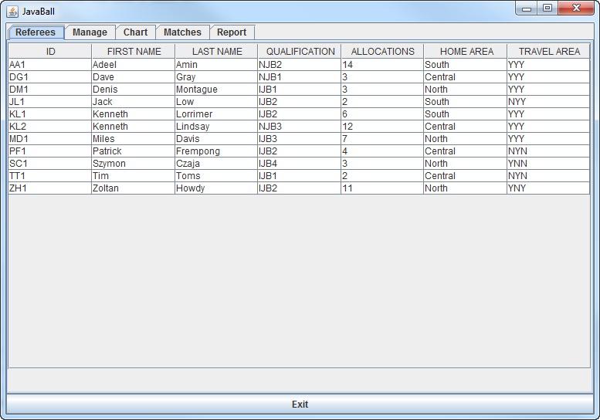

Figure 30: After the program is executed, the above Referee list is displayed with the referees read in from the text file but in order of ID

* + 1. **Add Referee, Daniel Girma**

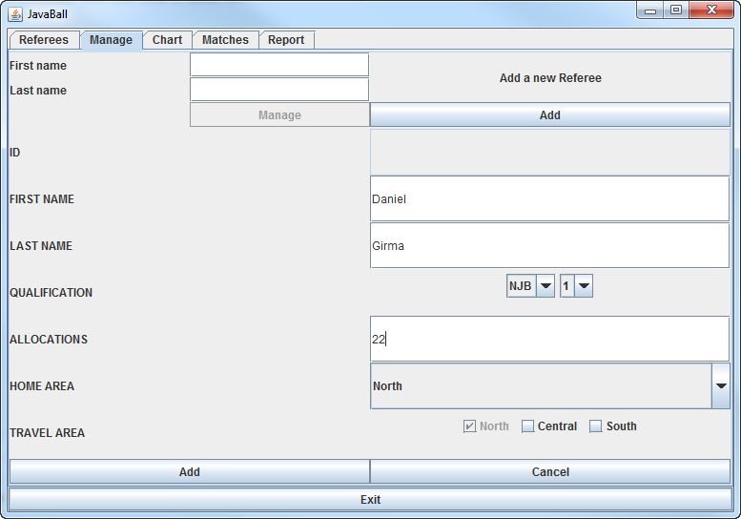

Figure 31: The referee Daniel Girma is being added

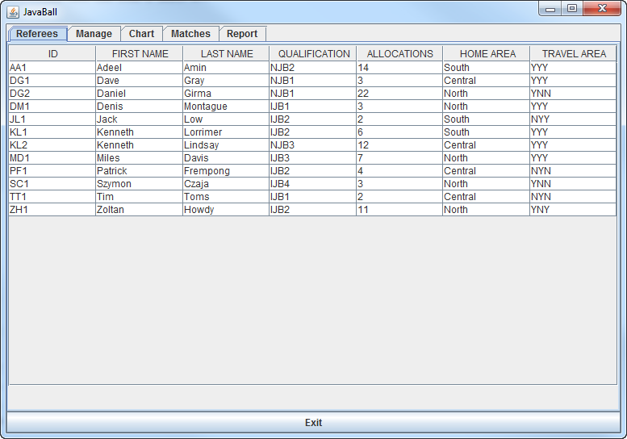

Figure 32: An updated referee list shows that Daniel Girma has now been added

* + 1. **Add Referee, Ronald Poet**

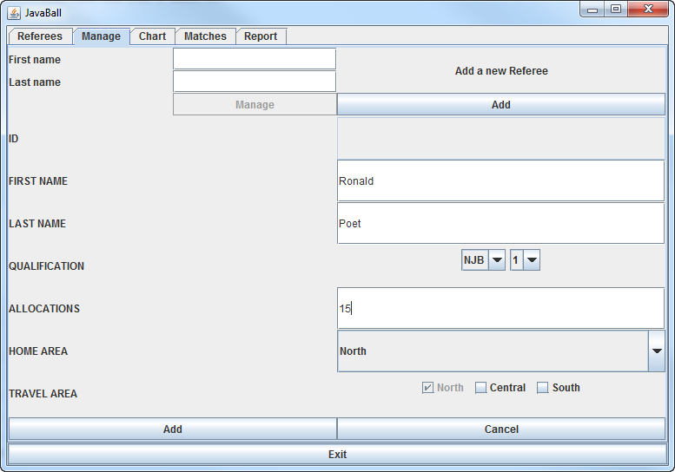

Figure 33: The referee Ronald Poet is being added

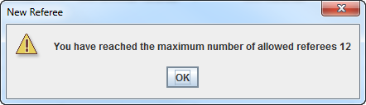

Figure 34: A warning message is shown as there are already 12 referees therefore Ronald Poet cannot be added

* + 1. **Search for Ronald Poet**

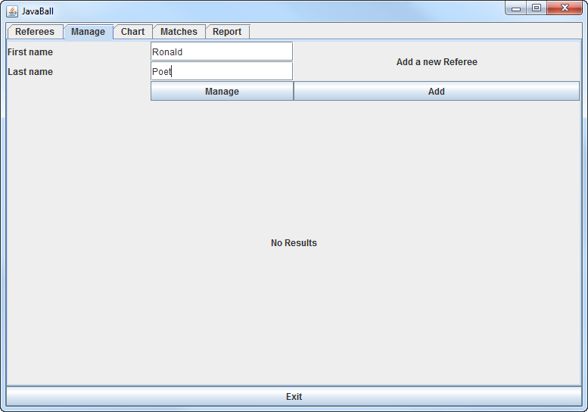

Figure 35: By searching for Ronald Poet, this brings back no results

* + 1. **Delete Referee, Daniel Girma**

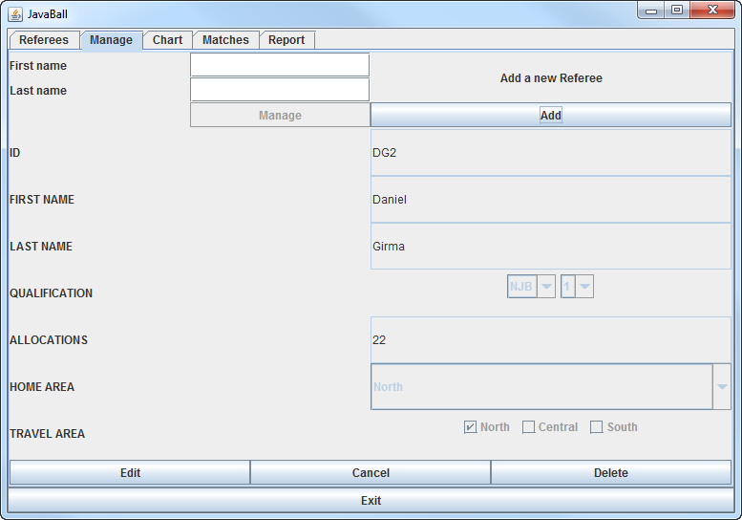

Figure 36: By searching for Daniel Girma, the following details are brought up

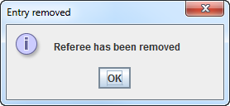

Figure 37: By clicking delete at the bottom of screen, Referee – Daniel Girma is removed

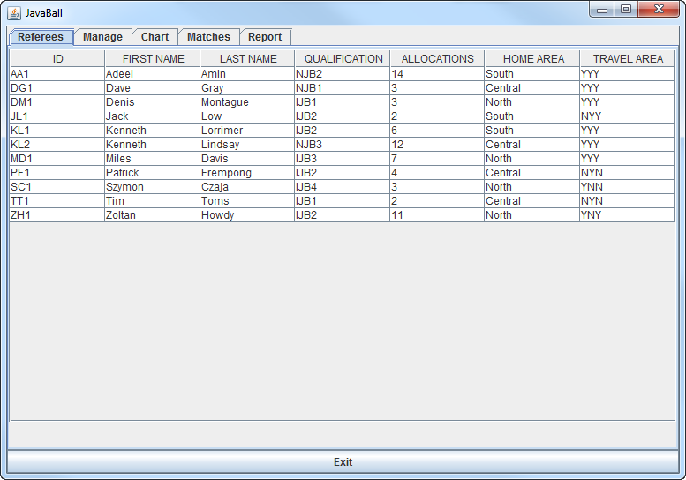

Figure 38: Updated Referees list showing without Daniel Girma

* + 1. **Add Referee of name, Albert Arthur**

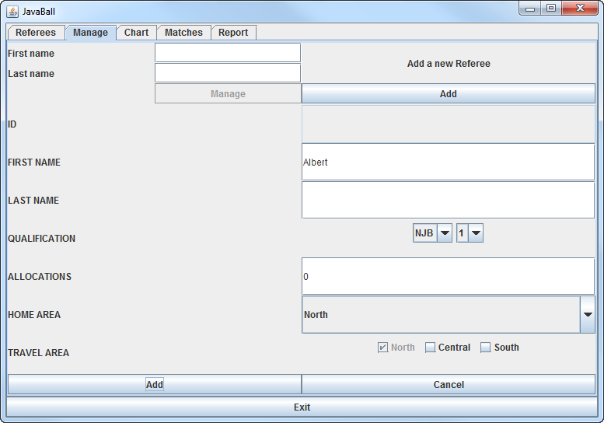

Figure 39: When referee is being added, there have been text fields left empty

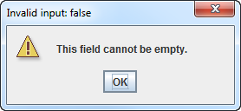

Figure 40: The above error message is displayed when required fields are left empty

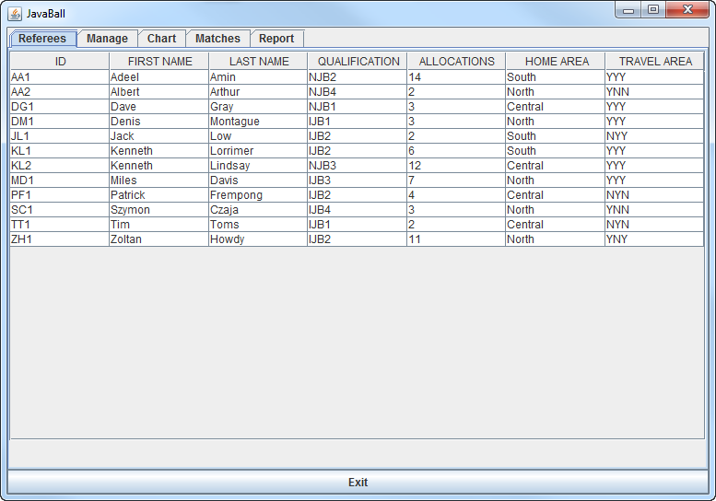

Figure 41: When correct details for Albert Arthur are entered, a new Referee is added to the list however the allocated ID is AA2 as there is already a referee with the same initials present

* + 1. **Allocate referees to a Match**

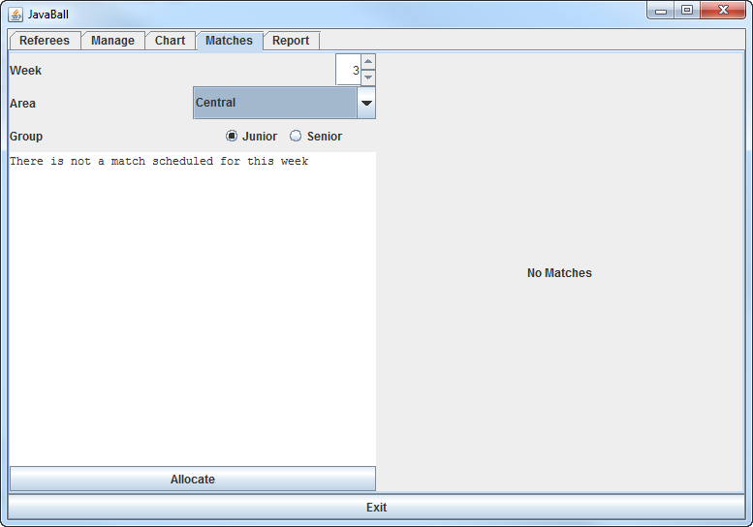

Figure 42: Select the details for the Match – Week 3, Central and Junior

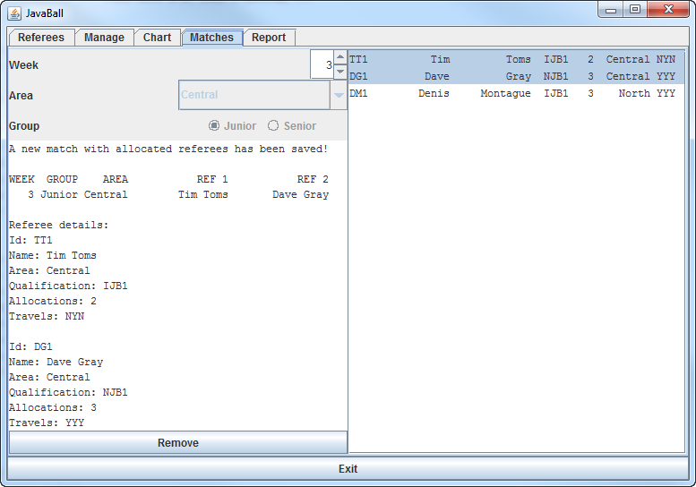

Figure 43: Once you click Allocate, two suitable referees are allocated to the match

* + 1. **Allocate referees to an existing Match**



Figure 44: As you can see from above, it is not possible to re-allocate referees to an existing match as the user fields are un-editable.