Tijara Suite Screenshot User Guide
Live local Odoo walkthrough for POS, kiosk, displays, inventory, back office, SaaS controls, analytics, and production evidence.

Live Verification Snapshot
- Database: tijara_dev
- Localization: Pakistan country, PKR currency, GST 18% sales tax verified
- Demo users: seeded from docs/TEST_CREDENTIALS.csv
- Screenshot source: docs/screenshots/INDEX.md

Demo Roles
Role | Login | Primary use
platform_superadmin | superadmin@demo.tijara-suite.local | Provision tenants, control SaaS plans, review protected release evidence, and manage platform configuration.
tenant_admin | tenant-admin@demo.tijara-suite.local | Configure company settings, feature flags, staff access, POS hardware, receipt templates, dashboards, and approvals.
cashier | cashier@demo.tijara-suite.local | Run B2C/B2B checkout, bill discounts, barcode refund scans, receipt print, and offline queue retry.
inventory_manager | inventory-manager@demo.tijara-suite.local | Maintain products, low-stock/expiry alerts, racks, shelves, bins, warehouses, and bulk import/export.
accountant | accountant@demo.tijara-suite.local | Review settlements, refunds, chargebacks, draft accounting moves, and FBR queue evidence.
restaurant_operator | restaurant@demo.tijara-suite.local | Operate dine-in, takeaway, pickup, kiosk orders, queue tickets, kitchen status, menu boards, and pickup screens.
public_display | public-display@demo.tijara-suite.local | Run public display routes for kiosk, customer display, queue, menu, deals, and promotions.

Screenshot Walkthrough

1. Login And Authenticated App Shell
Start from the Odoo login page, select the `tijara_dev` database when prompted, and sign in with the role account assigned to your workflow.
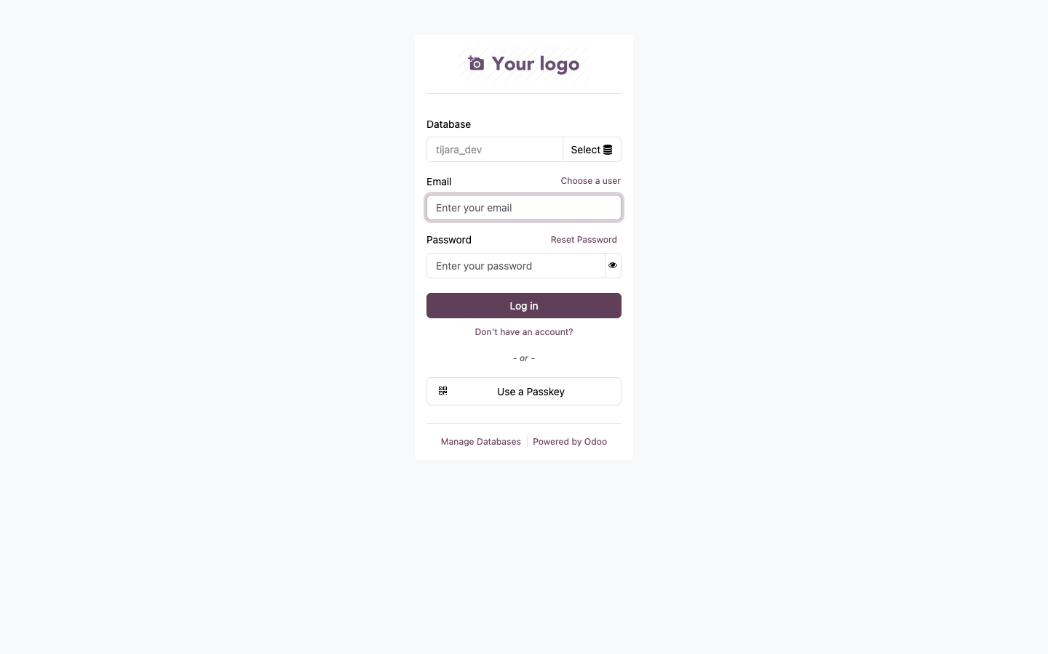
Figure 1: Login And Authenticated App Shell captured from live local Odoo.
- Open `http://localhost:8069/web/login?db=tijara_dev`.
- Use the role account from `docs/TEST_CREDENTIALS.csv`.
- After login, confirm the top Odoo navigation and company switcher are visible.

2. Back Office App Shell
The authenticated Odoo shell is the entry point for Apps, POS, Inventory, Sales, Purchases, Accounting, SaaS control, analytics, and configuration menus.
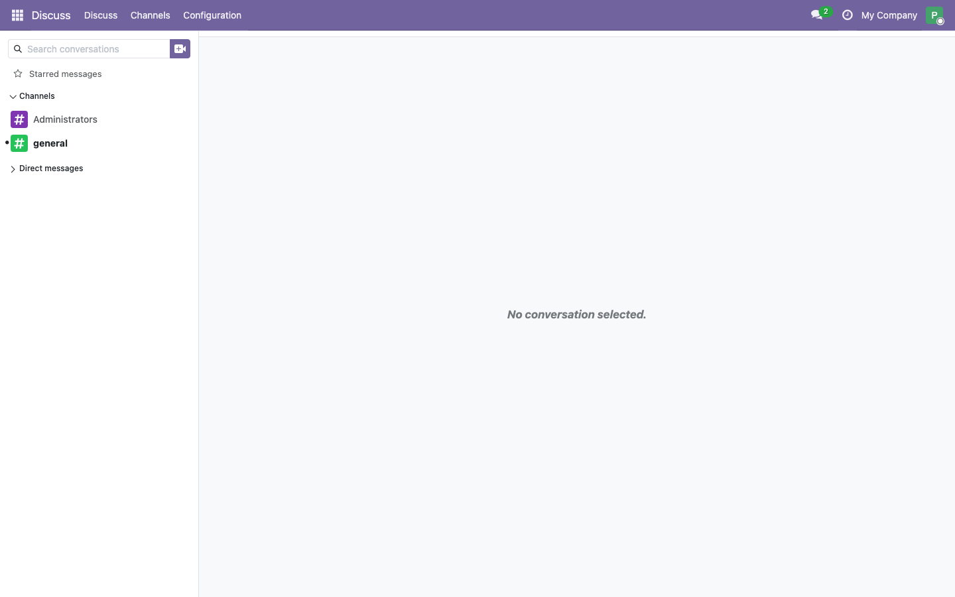
Figure 2: Back Office App Shell captured from live local Odoo.
- Use the app switcher to open the required module.
- Use role-specific menus for daily work and manager approvals.
- Keep demo operations in the local `tijara_dev` database.

3. Kiosk Self Ordering
The kiosk route supports dine-in, takeaway, pickup, B2C/B2B pricing, PKR prices, customer details, payment selection, and checkout.
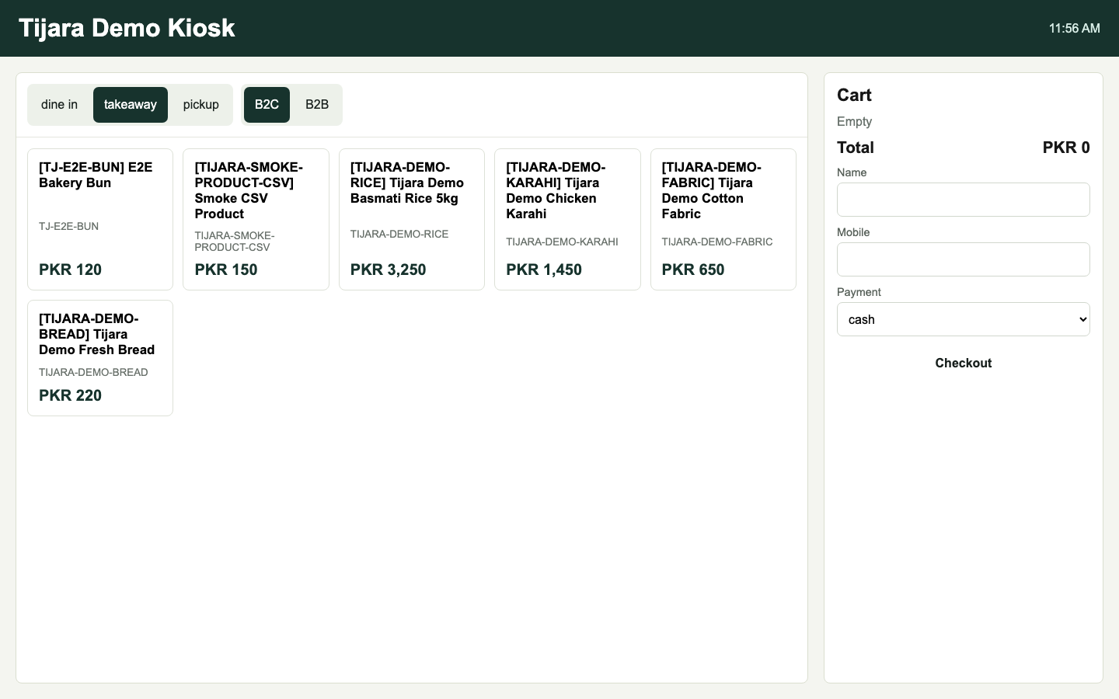
Figure 3: Kiosk Self Ordering captured from live local Odoo.
- Open `/tijara/display/tijara-demo-kiosk?db=tijara_dev` on a kiosk or tablet.
- Choose the service mode and customer type.
- Tap products to add them to the cart, enter customer details when needed, and press Checkout.

4. Customer Display
The customer-facing display shows the live order reference, item lines, quantities, PKR subtotal, discount, tax, and total.
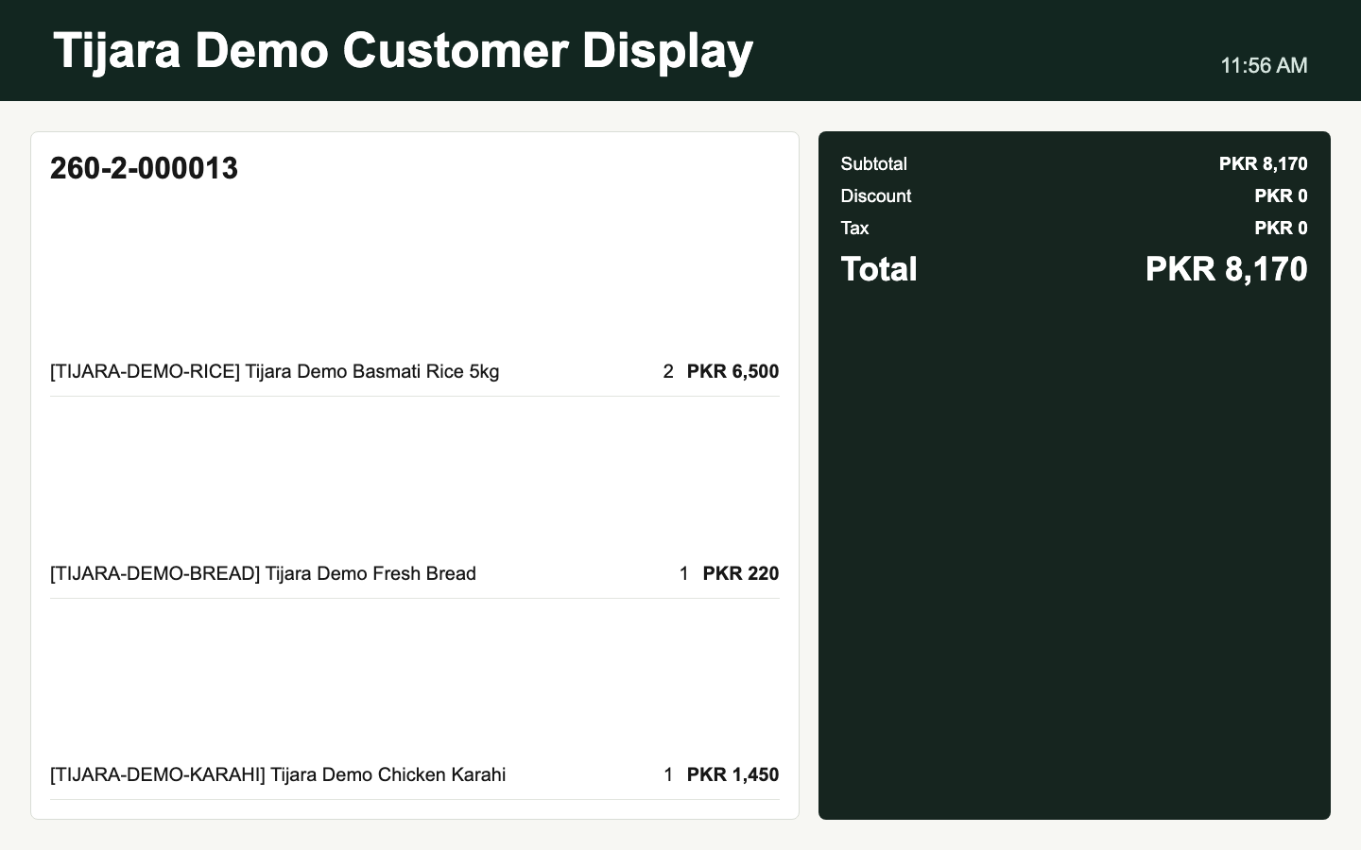
Figure 4: Customer Display captured from live local Odoo.
- Open `/tijara/display/tijara-demo-customer-display?db=tijara_dev` on the customer-side display.
- Keep it full screen near the POS counter.
- Use it to verify cart lines, discounts, GST, and totals with the customer before payment.

5. Queue Display
The queue display shows waiting, preparing, ready, and called tickets in large, readable cards for restaurant, bakery, and pickup counters.
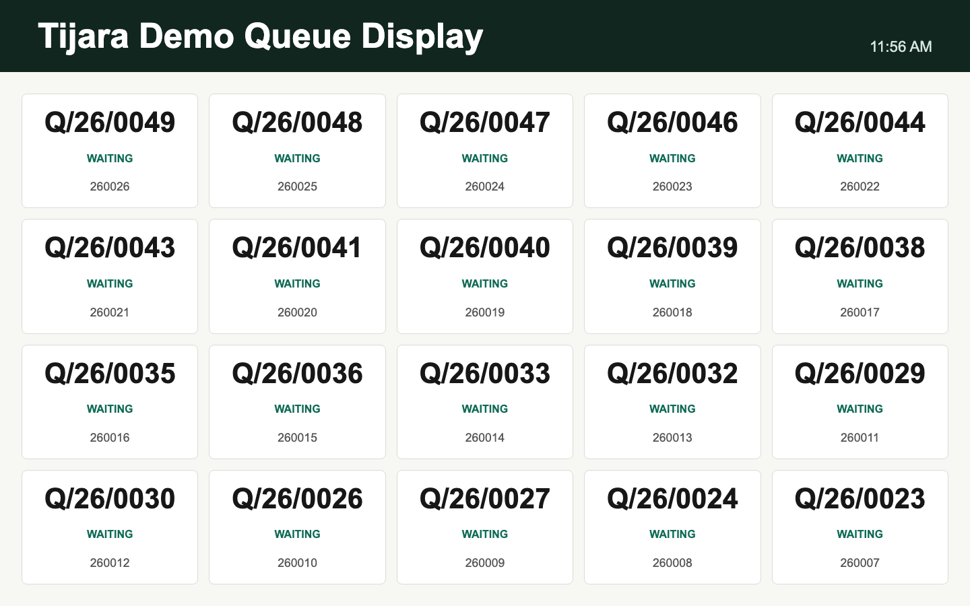
Figure 5: Queue Display captured from live local Odoo.
- Open `/tijara/display/tijara-demo-queue-display?db=tijara_dev` on a public screen.
- Use queue tickets from kiosk or POS orders.
- Advance ticket state from the operator workflow so the display reflects pickup readiness.

6. Menu Board
The menu board displays active menu items and promotions for restaurant, bakery, and food-service verticals.
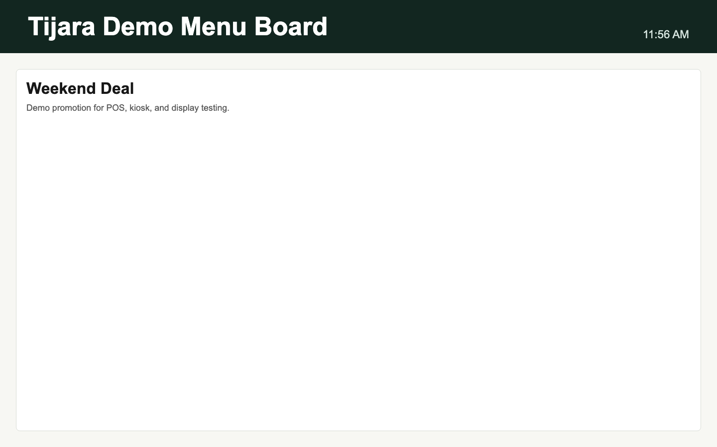
Figure 6: Menu Board captured from live local Odoo.
- Open `/tijara/display/tijara-demo-menu-board?db=tijara_dev`.
- Maintain menu items, Urdu/English names, and prices in display content or products.
- Use active start/end dates for timed menu or campaign changes.

7. Deals And Promotions Board
The deals board highlights discount campaigns and promotion messages for in-store screens.
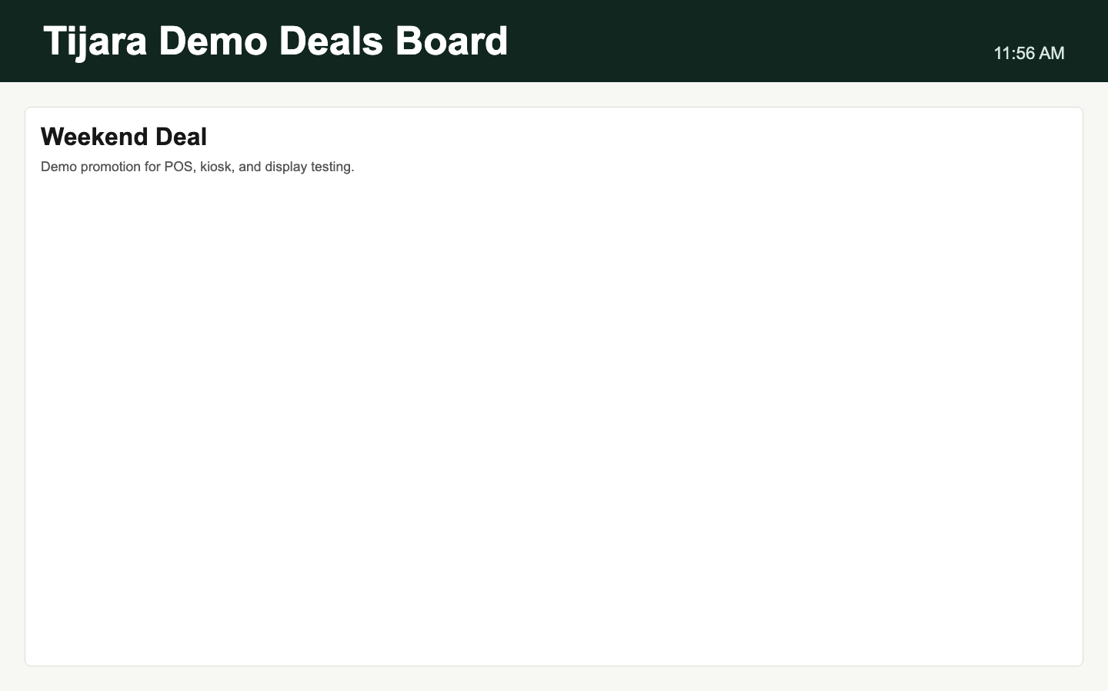
Figure 7: Deals And Promotions Board captured from live local Odoo.
- Open `/tijara/display/tijara-demo-deals-board?db=tijara_dev`.
- Create promotions with display visibility enabled.
- Review price, discount, and availability before running the campaign in store.

Workflow Checklist

POS Checkout, Discounts, Refunds, And Print
- Open POS from the app shell and select the active Tijara Demo POS session.
- Choose B2C or B2B when the feature is enabled for the tenant.
- Add products by search, barcode scanner, QR scanner, or touch product cards.
- Apply an overall bill discount by percentage or amount; the paired value recalculates automatically.
- Take payment, validate the sale, print the receipt, and use the receipt barcode for future refund/exchange lookup.

Inventory, Expiry, Shelves, And Bulk Data
- Use product forms for B2C/B2B prices, Urdu names, GST category, barcode aliases, and quick-sale flags.
- Use inventory intelligence for low-stock alerts, expiry alerts, warehouses, store rooms, racks, shelves, and bins.
- Use CSV import/export for products, prices, stock, contacts, hardware devices, receipt templates, storage positions, and promotions.
- Review import validation messages before applying data to a tenant database.

Restaurant, Bakery, And Pickup Operations
- Use dine-in, takeaway, and pickup modes on kiosk or POS flows.
- Send kiosk orders into queue tickets and linked POS payments when the profile has a POS register and payment method.
- Use queue display for public ticket status and kitchen/operator views for preparation stages.
- Use menu and deals boards for active promotions, food menus, bakery offers, and pickup announcements.

SaaS Controls And Tenant Operations
- Enable or disable B2B sales, queue display, promotion display, customer display, kiosk, and vertical packs by tenant plan.
- Use tenant provisioning manifests for DNS, ingress, admin bootstrap, backup, monitoring, and smoke evidence.
- Keep secrets in `secrets/.env.secrets`; keep non-secret runtime configuration in `.env` and deploy templates.

Payments, FBR, Analytics, And Production Evidence
- Use payment provider records for JazzCash, Easypaisa, Stripe, generic/manual webhooks, settlement imports, refunds, and chargebacks.
- Use FBR queue records for dry-run/live adapter evidence until certified-provider credentials are available.
- Use analytics dashboards for POS, inventory, queue, promotions, trends, history, KPI snapshots, charts, and report catalogs.
- Use protected release evidence, security scans, monitoring evidence, backups, restore drills, and load tests before production sign-off.

Production Readiness Notes
- Physical hardware certification still needs real printer, scanner, drawer, scale, and display evidence.
- FBR live operation still needs certified-provider credentials and compliance sign-off.
- Payment providers still need PSP certification, settlement reconciliation, refunds, and chargeback sign-off.
- Full staging browser E2E should run against seeded users and real staging URLs before customer deployment.
- Monitoring, alerting, restore drills, load tests, and security scans should be attached to release sign-off.

