**NBA DATABASE User Manual**

* Installation files with libraries
* Start Page
* Main Page (user input, what to enter how to use)
  + Adding Player
  + Deleting Player
  + Editing Player

**Installation**

To begin, you must first install the necessary libraries which can be done with a pip install command inside command prompt. The libraries we will be using are PyQt5(for UI) and pandas (for reading excel files).

* pip install pandas
* pip install PyQt5

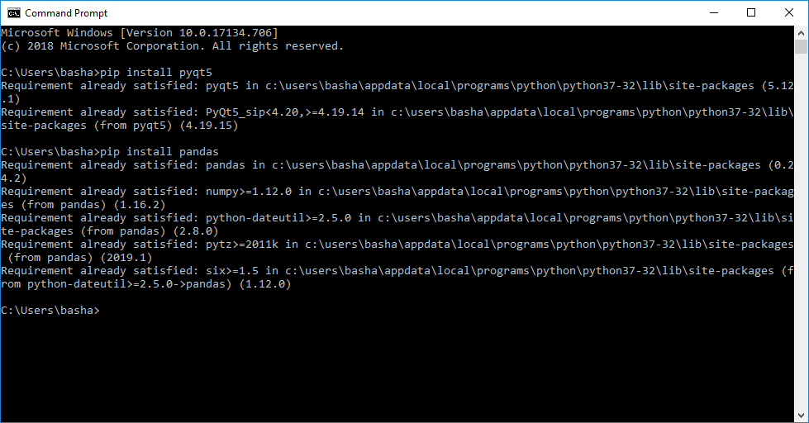

**Running the Project**

Once you have installed the necessary libraries, simply open up the NBA_Database.sln file and select Project>>Start without debugging from the toolbar options. The excel files that the project needs are already inside the folder and defined within the project.

**Start Page**

Enter in one of 30 NBA teams and then click submit. This will then take you to the main UI with the selected team’s full roster.

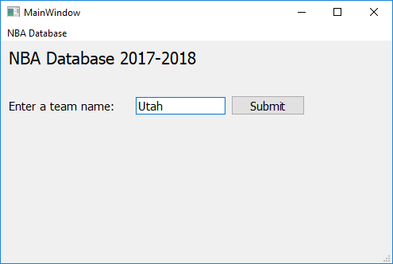

**Main Page**

This is the main UI. From here, you can add a player to the team, remove a player from a team, or a edit a player’s stats.

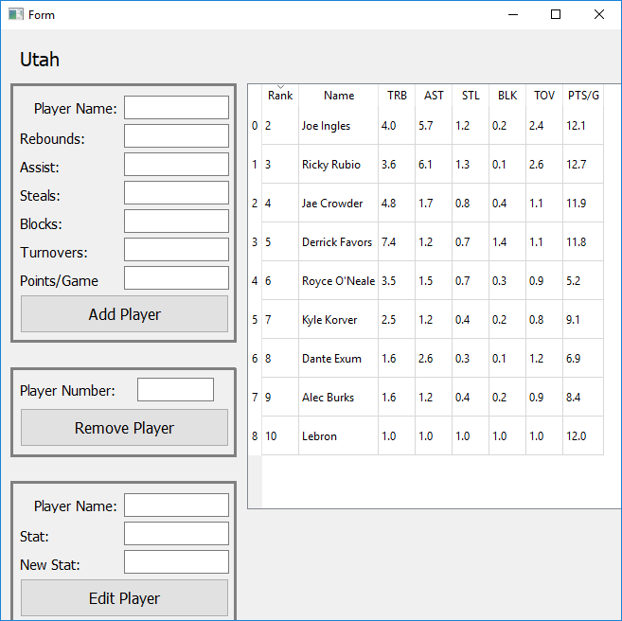

**Add Player**

Simply enter in a player’s name, and then their stats. Clicking Add Player will insert this player along with his stats into the bottom of the list.

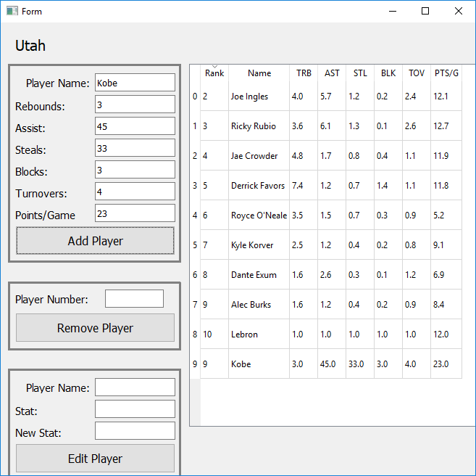

**Remove Player**

To remove a player, simply type in the number next to the rank (0-9) and click Remove Player. This will remove the selected player and shift the other cells accordingly. In this example, lets type in 9 to remove Kobe.

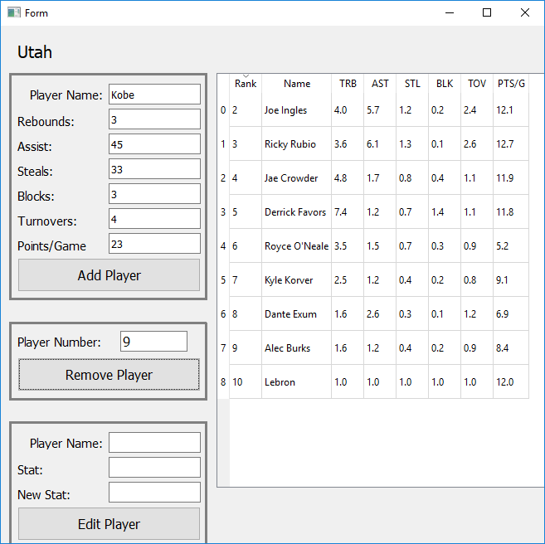

**Edit Player**

To edit a player’s stats, enter in the exact player name from the team, and one of the following stats to edit: TRB (Total Rebounds), AST (Assists), STL (Steals), BLK (Blocks), TOV (Turnovers), PTS/G (Points Per Game) and then enter in a new value for that stat.

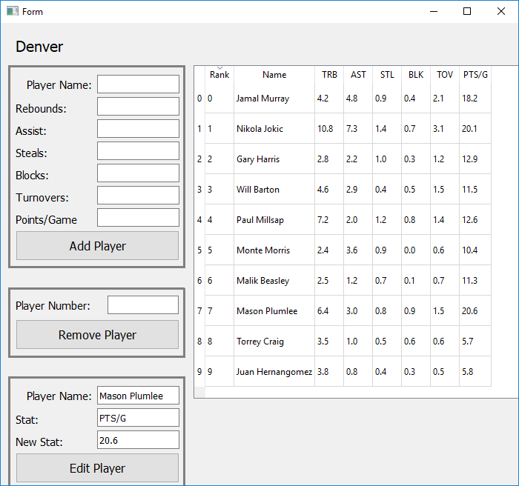

**Pre-project team review**

1. **Full name**

Adeel Asghar

1. **Access ID (two letters four digits)**

GA7177

1. **URL to GitLab or GitHub Account**

<https://github.com/adeelasghar1001>

1. **What is one goal you want to accomplish with this project?**

Learn how to implement Python in a group environment

1. **List the names of your team members that you have met and spoke personally**

Bashaar Shah and Michael Chen

1. **What is one goal your team want to accomplish with this project?**

Ensure our application doesn’t have any errors and has a GUI.

1. **Do you and your teammates have decided a project?**

A dynamic NBA Database.

1. **Have your teammates decided a project?**

Yes

1. **URL of GitLab or Github project. The repository should contain the team contract agreement on a folder named "management"**

https://github.com/adeelasghar1001/NBA-Database

**Updated Project Proposal**

**Team Name**: Aspire

Names: Access IDs:

1) Adeel Asghar ga7177

2) Michael Chen ev3024

3) Bashaar Shah gb2543

Project Proposal Questionnaire:

1. **Describe your project in one paragraph.**

CRUD Python application that will be able to access NBA statistics from a database and manipulate and output them.

1. **Did you include a prototype presentation file into your ‘Design’ folder in your project repository?**

Yes

1. **What type of project are you doing (CRUD – Game – Data science – etc )?**

CRUD Application

1. **What is the URL of your repository?**

https://github.com/adeelasghar1001/NBA-Database.git

1. **Did you include your instructor and TA in your repository?**

Yes

1. **Did you include the following files in a folder named ‘Management’ in your project repository?**

|  |
| --- |
| * **Team contract – YES** |
| * **Planning document - YES** |
| * **Gantt Chart (basic and advanced features clearly annotated) - YES** |

1. **Did you add your tasks to your project management tool? Which tool are you using? E.g. Project in Github**

Using project in GitHub.

1. **How familiar are your team members with OOP and UML diagrams?**

Team is familiar with UML diagrams.

**Updated Project Outline – Team Aspire**

1. GA7177 – Adeel Asghar
2. EV3024 – Michael Chen
3. GB2543 – Bashaar Shah
4. We have written basic code that accesses excel files and displays them in the command prompt. This is good start as we have all the values stored into variables that we can then show in a GUI interface that we will design using QT. We have not personally tested other Python projects.

We have not tried any specific framework besides PyCharm and Visual Studio

We have not done much work on the project due to time restrictions however, we did encounter Git errors which were resolved via group collaboration.

We have implemented a method to read in data from an excel file and displays the information in the command prompt.

1. 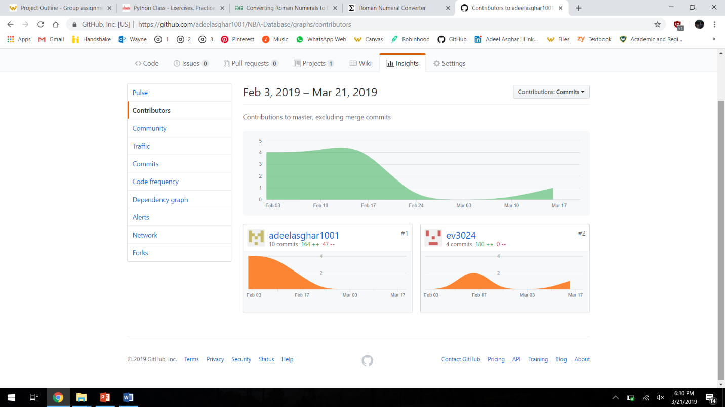
2. Overall, we realized that simply taking information from excel files and displaying it would be too little work for our project. We believe we can add team record predictions along with individual accolades as well. We have not been following the Gantt Chart but we will resume following it by simply pushing everyone’s objectives one week backwards. We have not been using a Kanban board. Adeel is the team lead but everyone is participating. The weekly reviews are useful for our team because it reminds us that we have a deadline and an objective.

Running on each computer

Adeel

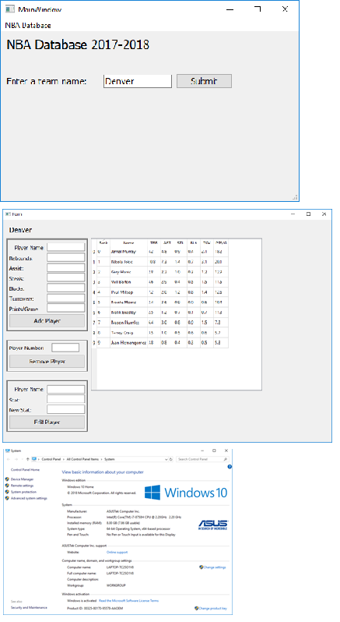

Michael



Bashaar