**NBA DATABASE User Manual**

* Installation files with libraries
* Start Page
* Main Page (user input, what to enter how to use)
  + Adding Player
  + Deleting Player
  + Editing Player

**Installation**

To begin, you must first install the necessary libraries which can be done with a pip install command inside command prompt. The libraries we will be using are PyQt5(for UI) and pandas (for reading excel files).

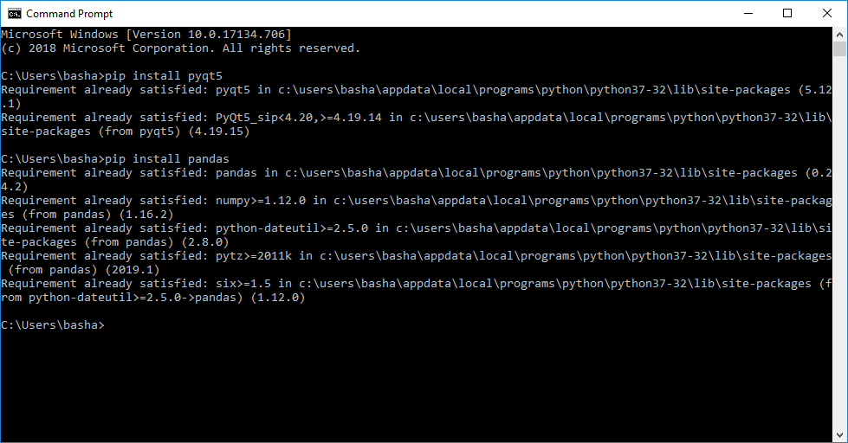

**Running the Project**

Once you have installed the necessary libraries, simply open up the NBA_Database.sln file and select Project>>Start without debugging from the toolbar options. The excel files that the project needs are already inside the folder and defined within the project.

**Start Page**

Enter in one of 30 NBA teams and then click submit. This will then take you to the main UI with the selected team’s full roster.

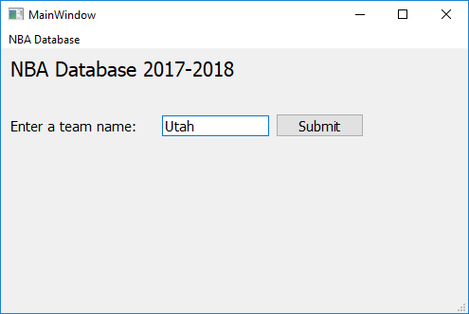

**Main Page**

This is the main UI. From here, you can add a player to the team, remove a player from a team, or a edit a player’s stats.

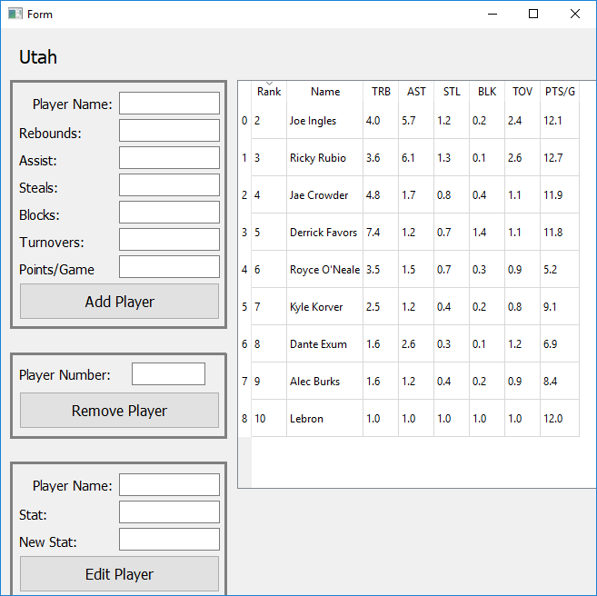

**Add Player**

Simply enter in a player’s name, and then their stats. Clicking Add Player will insert this player along with his stats into the bottom of the list.

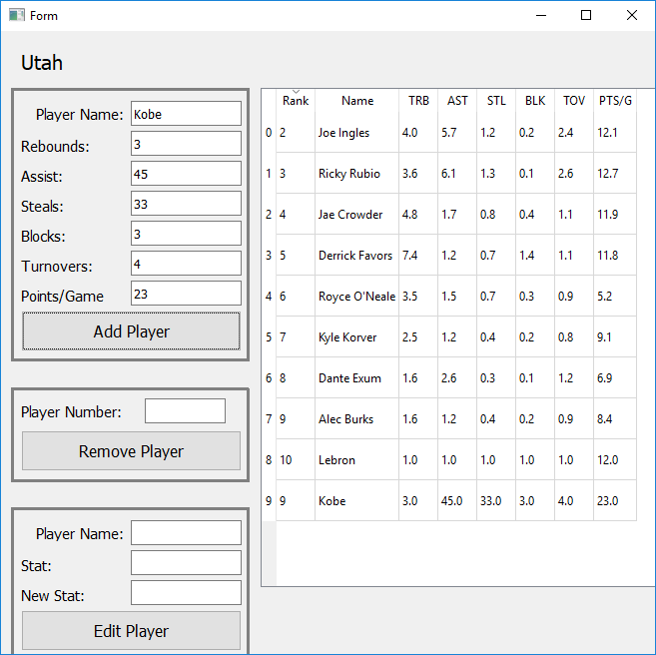

**Remove Player**

To remove a player, simply type in the number next to the rank (0-9) and click Remove Player. This will remove the selected player and shift the other cells accordingly. In this example, lets type in 9 to remove Kobe.

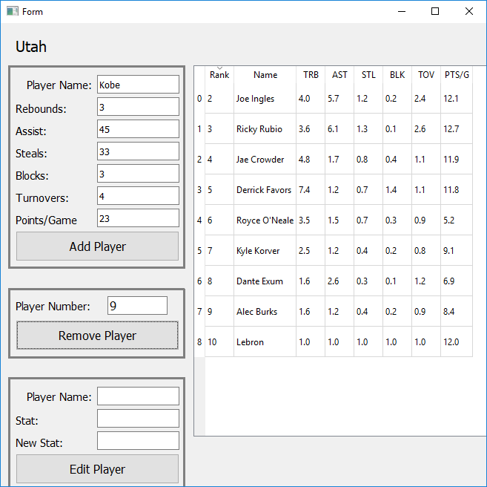

**Edit Player**

To edit a player’s stats, enter in the exact player name from the team, and one of the following stats to edit: TRB (Total Rebounds), AST (Assists), STL (Steals), BLK (Blocks), TOV (Turnovers), PTS/G (Points Per Game) and then enter in a new value for that stat.

