How much retrieval gain reaches the answer? Transfer ratios and cost of open embedding models in retrieval-augmented question answering
Abstract
Builders of retrieval-augmented generation (RAG) systems often pick an embedding model by its retrieval score. We measured how much retrieval gain reaches the answer, and at what cost, on free GPUs. We compared BM25 and six open embedding models (23–596M parameters) on Natural Questions (NQ, 2,255 queries) and HotpotQA (2,000 queries), with two quantised 7–8B readers. The transfer ratio $T$ divides the exact-match (EM) gain by the Hit@5 gain over a small baseline encoder on the same queries. We report bootstrap intervals and registered six predictions before the second phase. On NQ, $T$ for the dense encoders ranged from 0.16 to 0.27, and no upper 95% bound exceeded 0.45. On HotpotQA, $T$ was larger (0.49–0.93); with Llama, three of five upper bounds reached 1, so the prediction $T<1$ failed in one of four cells. Against BM25, NQ ratios were 0.29–0.35. A post hoc decomposition assigns 48%–70% of the HotpotQA transfer (44%–64% in a symmetric variant) to higher EM given a hit. With Both@5 as denominator, HotpotQA ratios were 0.29–0.35. On HotpotQA, bge-large gave higher EM than e5-base-v2 (+0.028 and +0.022, Holm-adjusted $p≤$ 0.040); on NQ, no difference was detected. Encoding throughput on one T4 differed 27-fold. Top-ranked non-gold passages lowered EM by 0.074 against random passages; gold position showed no detectable effect. An LLM faithfulness judge agreed poorly with annotator labels ($κ$ = 0.127) and was excluded. Within this setup, retrieval gains overstate answer gains on single-hop questions, and encoder cost should be weighed with retrieval scores.

Keywords
retrieval-augmented generation; dense retrieval; text embeddings; question answering; evaluation; reproducibility; computational cost

Introduction
Retrieval-augmented generation (RAG) answers a question in two steps. A retriever selects passages from a corpus, and a language model, the reader, writes an answer from them (Lewis et al. 2020; Izacard and Grave 2021; Ram et al. 2023). Teams that build such systems must choose the retriever. For dense retrieval this means choosing a text embedding model, and the usual guide is a retrieval benchmark such as BEIR (Thakur et al. 2021) or MTEB (Muennighoff et al. 2023). These benchmarks score ranked lists against relevance labels. They do not show how much of a retrieval gain survives the reader.
This question matters most for teams with limited compute. A larger encoder costs more to run over a corpus and adds latency to every query. If a retrieval gain turns into a much smaller answer gain, a cheaper encoder may serve as well. Several studies report that retrieval improvements do not reliably improve answers (Salemi and Zamani 2024; Mathur et al. 2026; Medrano, Verma, and Chhabra 2026; Ghosh, Mukhopadhyay, and Chatterjee 2026). Others find that retrieval metrics correlate well with generation quality when the two are aligned (Samuel et al. 2026). Readers are also sensitive to what else is in the context: passages that look relevant but lack the answer can lower accuracy (Cuconasu et al. 2024; Amiraz et al. 2025; Shi et al. 2023).
Earlier studies relate retrieval quality to answer quality through correlations across systems or topics (Salemi and Zamani 2024; Samuel et al. 2026; Trappolini et al. 2025), through a ratio of answer F1 to recall across RAG methods (Peng et al. 2026), or through manipulations of a single retriever (Leto et al. 2024). They do not report, for a set of interchangeable open encoders, the paired ratio of answer gain to retrieval gain with its uncertainty, per reader and dataset, next to the measured cost of each encoder. This study provides such estimates for one well-defined setting.
We define a transfer ratio $T\left(R\right)$: the gain in exact match (EM) of retriever $R$ over a small baseline encoder, divided by its gain in Hit@5, both measured on the same queries. A ratio of 1 means that EM rises by as many points as Hit@5; a ratio near 0 means that the retrieval gain does not reach the answer. The ratio compares averages; it does not track individual questions. We estimate $T\left(R\right)$ for BM25 and five dense encoders against MiniLM-L6, with two quantised 7–8B readers, on a single-hop dataset (Natural Questions) and a multi-hop dataset (HotpotQA). All runs used free Kaggle T4 GPUs.
We ask four research questions.
RQ1
How much of a Hit@5 gain over a small encoder reaches EM, and does this depend on the reader and the dataset?
RQ2
Do larger or newer encoders give higher EM than a mid-size encoder (e5-base-v2)?
RQ3
How do context choices change the answer: the number of passages, the kind of non-gold passages, the position of the gold passage, and reranking?
RQ4
What does each encoder cost on free hardware, and do our sub-corpus and exact search distort the comparison?
The study ran in two phases. Phase 1 covered one reader on NQ. Before Phase 2, we registered six predictions (P1–P6) in a dated design document and then ran the new cells and experiments. We report each prediction as it came out, including the three that failed in at least one condition.
The study makes four contributions.
- A paired estimate of retrieval-to-answer transfer for six retrievers, two readers and two datasets, with bootstrap intervals, a reporting rule fixed in advance and a check against a second baseline (Section 5.2).
- An exact decomposition of the ratio into the hit–miss gap of the baseline and the change in EM given a hit or a miss. It separates the NQ pattern (low transfer) from the HotpotQA pattern (larger transfer that goes with retrieving the second supporting passage) (Section 5.3).
- Controlled tests of context composition and position, a reranker, top-$k$, approximate search and a full-corpus check, all run in the same pipeline (Sections 5.5–5.6).
- Measured encoding cost of each encoder on a free GPU, with five repetitions, and a full record of every deviation and failed run (Sections 5.6 and 4.1).
Section 2 reviews related work. Sections 3 and 4 describe the method and setup. Section 5 reports the results, Section 6 discusses them, and Section 7 lists the limits of the study.

Related work

Retrieval quality and answer quality
Dense passage retrieval replaced sparse retrieval as the default initial stage for open-domain question answering (Karpukhin et al. 2020; Lee, Chang, and Toutanova 2019), and retrieval-augmented readers turned retrieved passages into answers (Lewis et al. 2020; Izacard and Grave 2021). Sentence encoders and general-purpose embedding models made dense retrieval cheap to adopt (Reimers and Gurevych 2019; L. Wang et al. 2022; Xiao et al. 2024; Zhang et al. 2025). Their quality is usually judged on retrieval benchmarks (Thakur et al. 2021; Muennighoff et al. 2023).
Earlier work relates retrieval scores to answer scores in three ways. One line of work correlates retrieval metrics with downstream metrics. Salemi and Zamani (2024) report that relevance-label metrics correlate weakly with downstream RAG performance and propose labels derived from the reader itself. Trappolini et al. (2025) argue that rank-discounted metrics fit a human reader, not a language model, and propose a utility- and distraction-aware gain. Samuel et al. (2026) find positive topic- and system-level correlations between coverage-based retrieval metrics and the coverage of generated reports, with weaker links for relevance-based nDCG. A second line builds ratios. Peng et al. (2026) define a recall conversion rate as answer F1 divided by Recall@5 and report that it falls as recall rises across RAG methods. Their ratio compares levels across different pipelines. Our ratio compares paired gains of interchangeable encoders against one baseline. A third line manipulates retrieval directly. Leto et al. (2024) vary the share of gold passages and the accuracy of approximate search for one dense retriever and find that gold-document recall matters far more than search recall. Hitl, Bagić Babac, and Mornar (2026) benchmark combinations of embedding models and 7–9B generators with recall, EM, F1 and latency, and conclude that retrieval quality remained the main determinant of end-to-end quality; their abstract reports no paired ratio of answer gain to retrieval gain. Domain studies report retrieval gains that did not improve answers (Mathur et al. 2026; Medrano, Verma, and Chhabra 2026; Muthyam 2026; Ghosh, Mukhopadhyay, and Chatterjee 2026). Bala (2026) show that recall of the retrieved set can differ from what reaches the reader once a context budget forces truncation.

Context composition
Readers are sensitive to the passages placed next to the gold passage. Shi et al. (2023) show that irrelevant context distracts language models. Cuconasu et al. (2024) find that high-scoring passages without the answer lower accuracy, while random passages placed before the gold passage can raise it. Amiraz et al. (2025) quantify a distracting effect per passage. Jin et al. (2024) attribute the drop in quality at large retrieval depth to hard negatives, and Repantis et al. (2026) isolate competition between passages from context length. Position effects were reported for long contexts (Liu et al. 2024), but Cuconasu et al. (2025) find them marginal in realistic retrieval settings. Hsia et al. (2025) report that the reader’s tolerance of noise shapes how a RAG system scales with retrieval depth, and Zhao et al. (2026) find that 5–10 documents work best for question answering across several models.

Encoder cost
Embedding benchmarks report quality; cost is rarely measured in the same study. Assadi, Muennighoff, and Lee (2026) compare the cost of embedding models and language models on embedding tasks, without a reader. Approximate nearest-neighbour search reduces query cost (Malkov and Yashunin 2020; Johnson, Douze, and Jegou 2021); Leto et al. (2024) find that it changes answer quality little. Efficient serving (Kwon et al. 2023) and weight quantisation (Lin et al. 2024) make 7–8B readers fit on one consumer-grade GPU.

Evaluation practice
RAG evaluation frameworks use language models as judges (Es et al. 2024; Saad-Falcon et al. 2024; Zheng et al. 2023), and benchmarks package many retrievers and readers (Rau et al. 2024; Petroni et al. 2021; Lyu et al. 2025). Lexical EM undercounts correct answers from language models (Kamalloo et al. 2023); we therefore also report token F1 and answer containment. For significance testing we follow advice from natural language processing and information retrieval: paired tests, multiplicity control and effect sizes with intervals (Dror et al. 2018; Smucker, Allan, and Carterette 2007; Sakai 2014).

Method
Fig. 1 shows the system under test. A question goes to one of seven retrievers, which searches a fixed corpus; the top $k$ passages go to one of two readers; the answer is scored against reference answers. Only the retriever changes between conditions within a reader–dataset cell.
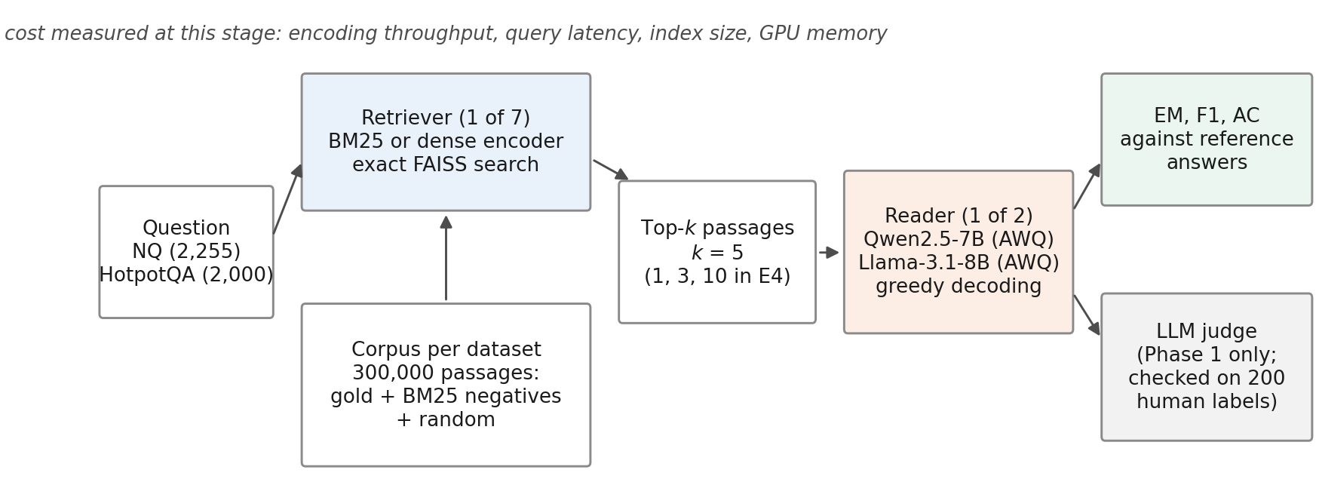
System under test. Within a reader–dataset cell only the retriever changes. Cost is measured at the retrieval stage. The LLM judge was used only in Phase 1 and was later excluded (Section 5.7).

Transfer ratio
Let $Q$ be a fixed set of generation queries. For retriever $R$ and query $q$, let $h_{R}\left(q\right)∈\{0,1\}$ indicate that at least one gold passage of $q$ is among the top five passages, and let $e_{R}\left(q\right)∈\{0,1\}$ be the exact match of the reader’s answer given those five passages. Write ${\overset{‾}{h}}_{R}$ and ${\overset{‾}{e}}_{R}$ for the means over $Q$. With MiniLM-L6 as the baseline $R_{1}$, the transfer ratio is
$$T\left(R\right)=\frac{{\overset{‾}{e}}_{R}−{\overset{‾}{e}}_{R_{1}}}{{\overset{‾}{h}}_{R}−{\overset{‾}{h}}_{R_{1}}}.$$
Both differences are paired: they use the same queries, the same reader, the same prompt and the same decoding. $T\left(R\right)$ is a ratio of mean differences. It is not the probability that one extra hit produces one extra correct answer, because the queries that gain a hit need not be the queries that gain an answer. We report $T\left(R\right)$ only if $\left|{\overset{‾}{h}}_{R}−{\overset{‾}{h}}_{R_{1}}\right|$ exceeds 2 percentage points and the Hit@5 difference is significant after Holm correction; otherwise the ratio is marked as not estimable. This rule was fixed in the Phase 1 design to avoid ratios with near-zero denominators. $T\left(R\right)$ depends on the choice of $R_{1}$. As a post hoc sensitivity analysis we therefore repeat every ratio with BM25 as the baseline, under the same rule.

Decomposition
Let $a_{R}=P\left(e_{R}=1∣h_{R}=1\right)$ and $b_{R}=P\left(e_{R}=1∣h_{R}=0\right)$ be the EM rates among hits and misses. Then ${\overset{‾}{e}}_{R}={\overset{‾}{h}}_{R}a_{R}+\left(1−{\overset{‾}{h}}_{R}\right)b_{R}$, and Eq. [eq:ratio] splits exactly into
$$T\left(R\right)=\underset{\text{baseline hit–miss gap}}{\underset{⏟}{\left(a_{R_{1}}−b_{R_{1}}\right)}}+\underset{\text{change in conditional EM}}{\underset{⏟}{\frac{{\overset{‾}{h}}_{R} \left(a_{R}−a_{R_{1}}\right)+\left(1−{\overset{‾}{h}}_{R}\right) \left(b_{R}−b_{R_{1}}\right)}{{\overset{‾}{h}}_{R}−{\overset{‾}{h}}_{R_{1}}}}}.$$
If a better encoder only turned misses into hits and left $a$ and $b$ unchanged, $T\left(R\right)$ would equal the baseline gap. The second term measures how far the encoder also changes the usefulness of its hits and misses. We report the share of the EM gain that the second term carries, $\left[{\overset{‾}{h}}_{R}\left(a_{R}−a_{R_{1}}\right)+\left(1−{\overset{‾}{h}}_{R}\right)\left(b_{R}−b_{R_{1}}\right)\right]/\left({\overset{‾}{e}}_{R}−{\overset{‾}{e}}_{R_{1}}\right)$, with a bootstrap interval over the same resamples as $T\left(R\right)$. The split is not unique. Eq. [eq:decomp] weights the change in hit rate by the baseline’s conditional rates; a symmetric form averages the two orderings of $R_{1}$ and $R$, and we report it alongside. Either form is an accounting identity, not a causal attribution: the queries that count as hits differ between encoders, so a change in $a$ can reflect which questions are hits as well as how useful a hit is. This decomposition was not part of the registered analysis; we report it as a post hoc description.

Data

Natural Questions
We used the BEIR version of Natural Questions (Kwiatkowski et al. 2019; Thakur et al. 2021): 3,452 judged test queries and a corpus of 2,681,468 Wikipedia passages. BEIR does not ship short answers, so we joined its queries to NQ-open (Lee, Chang, and Toutanova 2019) by normalised question text. The join matched 2,255 queries; 1,197 had no match and none had more than one. All 2,255 joined queries form the NQ generation set. Table 8 in the appendix summarises both datasets and sub-corpora.

HotpotQA
We used the BEIR version of HotpotQA (Yang et al. 2018; Thakur et al. 2021): 7,405 judged test queries, two gold passages per query, and a corpus of 5,233,329 passages. Answers come from the fullwiki validation release, joined by question id; all queries matched. The generation set is the leading 2,000 queries of a seeded order (1,616 bridge and 384 comparison questions).

Sub-corpus
Encoding millions of passages with six encoders exceeds a free GPU budget, so each dataset uses a 300,000-passage sub-corpus. It contains the gold passages of all judged queries, the top-$d$ BM25 passages of every judged query ($d$ = 42 for NQ and 19 for HotpotQA, set by a pre-registered formula), and a seeded random fill. All retrievers search the same sub-corpus. The NQ sub-corpus has 4,201 gold, 127,791 BM25 and 168,008 random passages; the HotpotQA sub-corpus has 13,783, 118,726 and 167,491. Because every gold passage is present, absolute retrieval scores are higher than on the full corpus. The construction also treats the retrievers unequally: it keeps BM25’s own strongest competitors for every judged query, but not those of the dense encoders, so it favours the dense encoders relative to BM25. The gold labels of the evaluation queries are used only to insert their gold passages; no model is trained on them. Section 5.6 checks whether the ordering of retrievers changes.

Retrievers
BM25 used the bm25s library (Lù 2024) with the Lucene variant, $k_{1}=1.2$, $b=0.75$, lower-casing and no stemming or stop-word removal (Robertson and Zaragoza 2009). The six dense encoders were all-MiniLM-L6-v2 (Reimers and Gurevych 2019; W. Wang et al. 2020), bge-small, bge-base and bge-large v1.5 (Xiao et al. 2024), e5-base-v2 (L. Wang et al. 2022) and Qwen3-Embedding-0.6B (Zhang et al. 2025). Each model ran at a pinned revision in half precision with a maximum of 256 tokens and its documented query and passage prefixes. Dense search used exact inner-product search in FAISS (Johnson, Douze, and Jegou 2021). Table [tab:models] in the appendix lists the models, revisions and prefixes.

Readers and prompts
The readers were Qwen2.5-7B-Instruct (Qwen et al. 2024) and Llama-3.1-8B-Instruct (Grattafiori et al. 2024), both in 4-bit AWQ form (Lin et al. 2024), served with vLLM (Kwon et al. 2023) on one T4 each. Decoding was greedy with at most 32 new tokens and a stop at a newline. The main prompt (A1) gives the top $k=5$ passages in rank order, each as “[i] title / text”, and asks for a short answer (Appendix 9). Two reference conditions bound each cell: closed book (no passages) and gold passages only.

Metrics
Hit@5 is 1 if at least one gold passage is in the top five. For HotpotQA we also report Both@5, which requires both gold passages. nDCG@10 uses binary gains. EM is 1 if the normalised answer equals a normalised reference answer. Normalisation follows SQuAD (lower case, no punctuation or articles, single spaces) and also removes typographic quotes, en and em dashes and the ellipsis; a plain SQuAD normaliser would change the score of 91 of 131,855 answers (0.07%). Token F1 and answer containment (AC; a normalised reference occurs in the normalised output) are secondary metrics, because lexical EM undercounts correct answers from language models (Kamalloo et al. 2023).

Statistical analysis
All comparisons are paired by query. Binary outcomes use the exact McNemar test (McNemar 1947). Within each reader–dataset cell, the 21 pairwise retriever comparisons of a metric form one family with Holm correction (Holm 1979). Intervals are 95% percentile bootstrap intervals over queries (Efron and Tibshirani 1993) with 10,000 resamples and seed 0; for $T\left(R\right)$ the numerator and denominator are resampled together. A secondary model pools the four cells: a logistic generalised estimating equation (Liang and Zeger 1986) for EM with retriever, dataset and reader as factors, an exchangeable working correlation within query, and empirical (sandwich) standard errors. The cluster is the query, which carries all retrievers and both readers of its dataset. This registered model assumes one retriever effect for both datasets. Post hoc, we test that assumption with a Wald test of retriever $×$ dataset interaction terms (and of retriever $×$ reader terms) and report dataset-specific odds ratios from the interaction model. Agreement between the LLM judge and human labels uses Cohen’s $κ$ (Cohen 1960; Landis and Koch 1977). A non-significant test is reported as “no difference detected”, not as equivalence.

Pre-registered predictions
Phase 1 (Qwen reader, NQ) was designed and committed before any data were generated. Before Phase 2 we registered six predictions (Table [tab:predictions]):
P1
In each new cell, every reportable $T\left(R\right)$ of a dense encoder has an upper 95% bound below 1.
P2
In each new cell, bge-large and Qwen3-Embedding-0.6B show no Holm-significant EM gain over e5-base-v2.
P3
The nDCG@10 ordering of BM25, MiniLM-L6, bge-small and e5-base-v2 on the sub-corpus holds on the full corpus.
P4
For every retriever, EM at $k=1$ is lower than at $k=5$.
P5
Gold plus four hard negatives gives lower EM than gold plus four random passages.
P6
The position of the gold passage (1, 3 or 5) changes EM.
Fig. 2 shows the sessions of both phases. The Qwen–NQ cell and the $k$ ablation for BM25, MiniLM-L6 and bge-large existed before registration. Their P1, P2 and P4 verdicts are therefore not confirmatory, and Table [tab:predictions] marks them. All other analyses are descriptive or secondary. Appendix 12 lists the design documents and their dates.
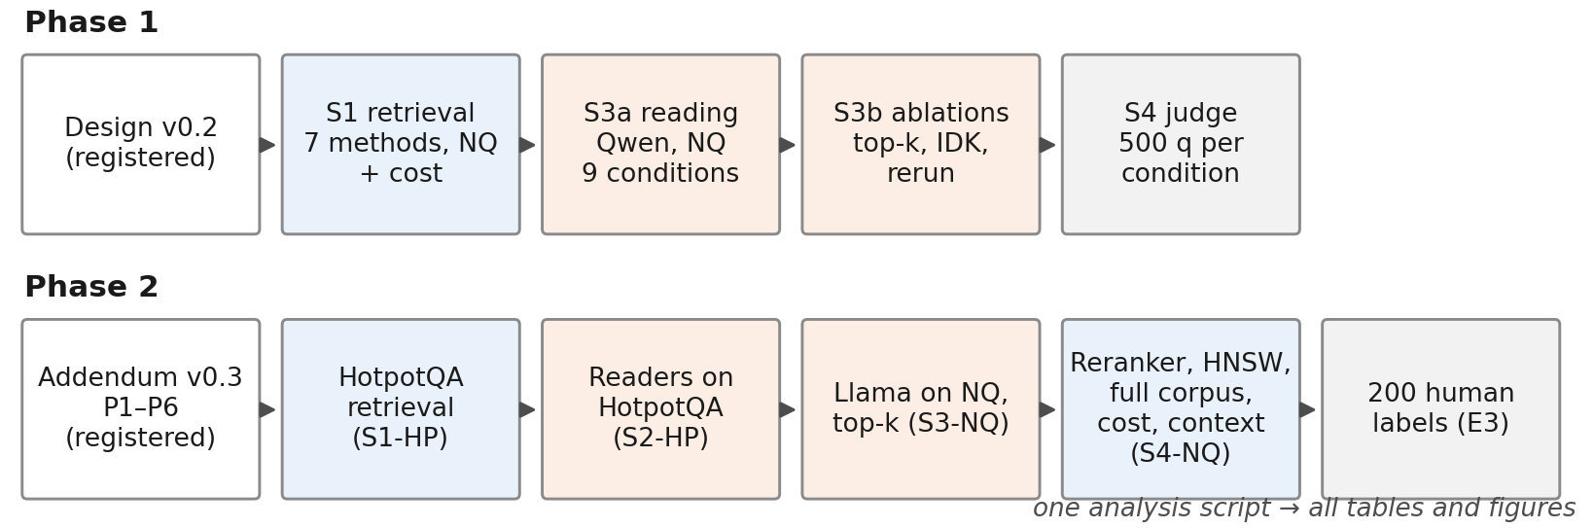
Study phases and Kaggle sessions. Each phase started with a dated design document; Phase 2 added the second dataset, the second reader and the additional experiments.

Additional experiments

Top-$k$ (E4)
The Qwen reader answered all NQ queries with $k∈\{1,3,5,10\}$ for all seven retrievers.

Context composition (E12)
On the leading 500 NQ generation queries of the seeded order, the Qwen reader always saw five passages: gold at position 1 plus four hard negatives (M1); gold at position 3 or 5 among the same negatives (M3, M5); gold at position 1 plus four random passages (MR); and the gold passage alone (MG). Hard negatives are the top-ranked BM25 passages that are not labelled gold.

Reranking (E5)
A cross-encoder, bge-reranker-base, reranked the top 50 passages of BM25 and of e5-base-v2 (Nogueira and Cho 2019; Xiao et al. 2024); the Qwen reader then answered NQ from the reranked top five.

Approximate search (E6)
HNSW indexes (Malkov and Yashunin 2020) ($M=32$, efConstruction 200, efSearch 64 and 128) replaced exact search for MiniLM-L6, bge-small and e5-base-v2 on the NQ sub-corpus.

Full corpus (E9)
BM25, MiniLM-L6, bge-small and e5-base-v2 retrieved from the full NQ corpus for all judged queries.

Cost (E7)
For each encoder we measured passage-encoding throughput on 20,000 passages (batch 128, after warm-up, with GPU synchronisation) and batch-1 query-encoding latency on 500 queries, five times in one session.

Judge validation (E3)
In Phase 1, an LLM judge (Mistral-7B-Instruct-v0.3; (Jiang et al. 2023)) labelled whether each answer was supported by its passages, for 500 NQ queries per retriever. The author labelled a stratified sample of 200 items without seeing the judge’s verdicts. The registered rule was: use the judge if $κ≥0.4$, use it only with a sensitivity analysis if $0.2≤κ<0.4$, and exclude it if $κ<0.2$.

Experimental setup

Hardware and software
All runs used free Kaggle notebook sessions with two NVIDIA Tesla T4 GPUs (15 GB each), four virtual CPUs and 31 GB of memory. Each process used one GPU; two processes could run in parallel. The code of every session was embedded in its notebook and checked against a fixed version-control tree hash before it ran. Every session recorded its Python version, package versions and model revisions. The readers ran with the same stack in every session (PyTorch 2.13.0 with CUDA 13.0, vLLM 0.30.0, Transformers 5.17.0). Between the two phases the Kaggle image changed from Python 3.12.13 to 3.13.15, and NumPy from 2.0.2 to 2.1.3.

Determinism across phases
Some comparisons cross the two phases: the Qwen–NQ cell against the new cells in the pooled model, $k=5$ against the new $k$ values, and the reranker runs against the Phase 1 runs. To check that the software change does not alter the reader, we compared the two phases on inputs that were identical by construction: the gold-only context of Phase 1 and the gold-only condition of the context experiment. Of 397 identical prompts, 396 produced identical outputs; the one difference was a shorter answer to the same question. A rerun of 100 prompts within one session gave 100/100 identical outputs.

Seeds and repetitions
The query order (seed 20260926), bootstrap (seed 0), decoding (greedy, seed 0) and the random passages of the context experiment were fixed. Retrieval and greedy decoding are deterministic within a session, so we ran each answer condition once. The cost measurements were repeated five times.

Analysis and verification
One analysis script reads only the committed raw outputs and writes all statistics, tables and figures. The author reran it on a second computer and obtained identical output. A separate script, written without the project code and using only the Python standard library, re-scored all 131,855 answers from the raw reader outputs, recomputed every Hit@5 and EM mean, every transfer ratio point estimate, all 84 pairwise EM tests with their Holm adjustment, and Cohen’s $κ$. It found no disagreement. Bootstrap intervals, F1, answer containment and the pooled model were not re-implemented independently.

Deviations and failed runs
We list every departure from the registered design.
- NQ join gate. The original design required a join rate of at least 0.70 between BEIR-NQ and NQ-open; the observed rate was 0.653. Before any outcome was observed, we replaced the gate with a minimum of 1,000 joined queries, because the two resources are independently filtered subsets of Natural Questions. Retrieval results on all 3,452 judged queries are reported where they matter (Table 5).
- Software image. The initial Phase 2 session stopped at the environment check because the Kaggle image had moved to Python 3.13, for which the pinned NumPy had no wheel. We unpinned NumPy and recorded all version differences; no data were produced by the stopped run.
- Failed reader start. The initial HotpotQA reader session stopped before generating anything because the image’s torchaudio build did not match the CUDA version of PyTorch. Later sessions reinstalled the matching build and checked the stack before any other step.
- Reduced scope of E6. Approximate search was planned for all six encoders. To stay within the GPU quota it ran for MiniLM-L6, bge-small and e5-base-v2, using the sub-corpus rows of the full-corpus embeddings.
- E7 scope. The repeated cost measurement covered encoding throughput and query-encoding latency; search latency was measured separately in E6 and is not repeated.
- Phase 1 deviations. We dropped the planned RAGAS cross-check, because its local deployment needed infrastructure that was untested on our hardware. We did not run the planned Matryoshka dimension ablation for Qwen3-Embedding-0.6B, so dimension and model are confounded in our cost comparison. The design planned two annotators for the judge validation; one took part. One gold-passage output reached the token limit, so the judge scored 499 instead of 500 gold items. The initial Phase 1 reading session stopped before generating because a notebook cell ran before the restore step; it was rerun with unchanged code. We estimated the Phase 1 CPU benchmark at one hour; it took eight hours and 24 minutes. This used free quota but changed no data.
- Failure log. The design promised one machine-readable failure log. Failures were recorded instead in two dated design addenda and in the session logs.
No run was repeated to obtain a different result, and no result was discarded.

Results

Retrieval
Table [tab:retrieval] gives retrieval quality on the generation queries, and Table [tab:ci] gives the intervals. On NQ, the dense encoders differed widely. MiniLM-L6 reached 0.664 and e5-base-v2 0.816; bge-large (0.796) came second. Qwen3-Embedding-0.6B (0.744) placed between bge-small and bge-base. BM25 reached 0.363. On HotpotQA, Hit@5 nearly saturated: all dense encoders except MiniLM-L6 scored between 0.945 and 0.961, against 0.817 for MiniLM-L6 and 0.833 for BM25. The stricter Both@5 separated them more clearly: bge-large found both supporting passages for 0.621 of the questions, e5-base-v2 for 0.544, Qwen3-Embedding-0.6B for 0.444 and MiniLM-L6 for 0.230. Table [tab:retrieval] also gives Hit@1, Hit@10, nDCG@10 and MRR@10, and Fig. 3 shows the main metrics with their intervals. On NQ, nDCG@10 ordered the retrievers as Hit@5 did, from 0.277 for BM25 and 0.520 for MiniLM-L6 to 0.667 for e5-base-v2. On HotpotQA, nDCG@10 ranged from 0.549 (MiniLM-L6) to 0.797 (bge-large).
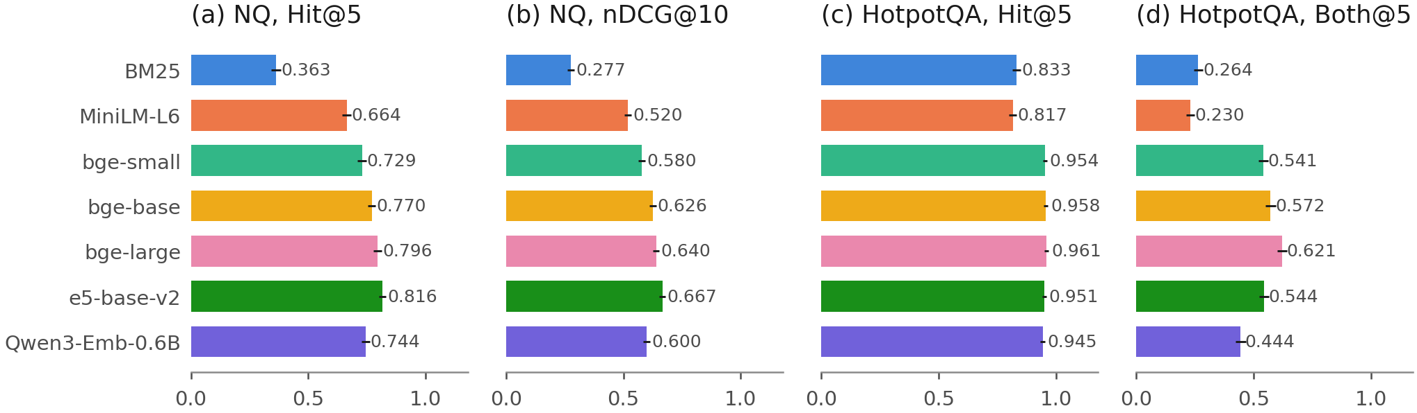
Retrieval quality on the generation queries with 95% bootstrap intervals: NQ Hit@5 and nDCG@10 (2,255 queries), HotpotQA Hit@5 and Both@5 (2,000 queries).
 | NQ (2,255 queries) |  |  |  |  | HotpotQA (2,000 queries)
2-6(lr)7-11 Retriever | Hit@1 | Hit@5 | Hit@10 | nDCG@10 | MRR@10 | Hit@1 | Hit@5 | Both@5 | nDCG@10 | MRR@10
BM25 | 0.150 | 0.363 | 0.472 | 0.277 | 0.243 | 0.666 | 0.833 | 0.264 | 0.578 | 0.740
MiniLM-L6 | 0.316 | 0.664 | 0.792 | 0.520 | 0.462 | 0.623 | 0.817 | 0.230 | 0.549 | 0.708
bge-small | 0.375 | 0.729 | 0.843 | 0.580 | 0.526 | 0.812 | 0.954 | 0.541 | 0.756 | 0.874
bge-base | 0.421 | 0.770 | 0.882 | 0.626 | 0.570 | 0.836 | 0.958 | 0.572 | 0.777 | 0.888
bge-large | 0.430 | 0.796 | 0.888 | 0.640 | 0.584 | 0.846 | 0.961 | 0.621 | 0.797 | 0.897
e5-base-v2 | 0.458 | 0.816 | 0.906 | 0.667 | 0.612 | 0.799 | 0.951 | 0.544 | 0.751 | 0.864
Qwen3-Emb-0.6B | 0.400 | 0.744 | 0.843 | 0.600 | 0.547 | 0.810 | 0.945 | 0.444 | 0.717 | 0.868
NQ intervals for Hit@5 and nDCG@10 are in Table [tab:ci] and Fig. 3. Both@5: both gold passages in the top five.

Answers and transfer (RQ1)
Table [tab:main] gives EM for every cell with its two bounds, and Fig. 4 plots EM against Hit@5. Retrieval closed only part of the gap between the closed-book and gold-passage conditions. With Qwen on NQ, closed-book EM was 0.149, gold passages gave 0.653, and the best retriever, e5-base-v2, gave 0.510. With Llama on NQ the best retriever was bge-base (0.477) against a gold bound of 0.613. On HotpotQA, bge-large gave the highest EM for both readers (0.424 and 0.430), against gold bounds of 0.628 and 0.624.
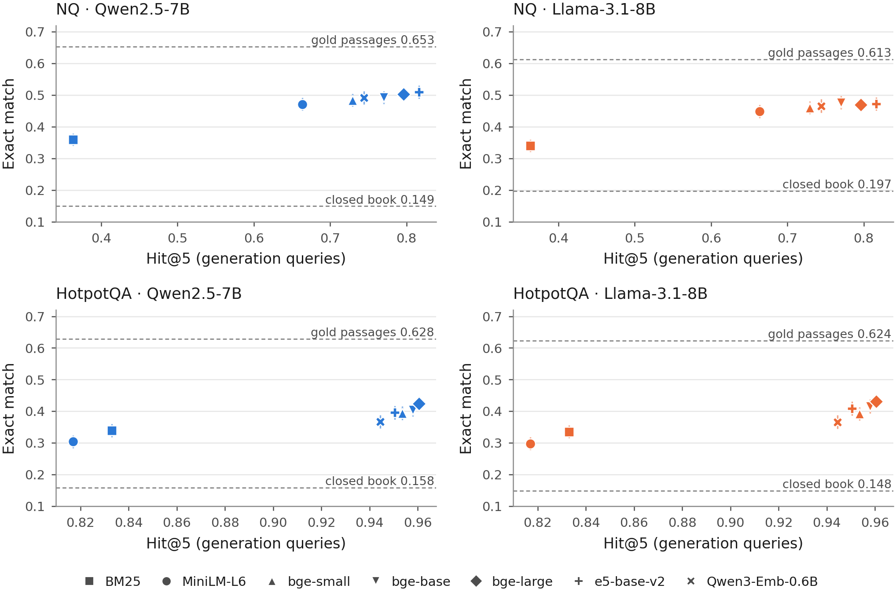
Exact match against Hit@5 for each retriever in the four reader–dataset cells. Vertical bars are 95% bootstrap intervals for EM. Dashed lines mark the closed-book and gold-passage conditions. Note the different Hit@5 ranges of the two datasets.
Table [tab:transfer] and Fig. 5 give the transfer ratios. On NQ, the dense encoders had ratios between 0.16 (bge-large and e5-base-v2 with Llama) and 0.27 (bge-base with Llama). With Qwen, e5-base-v2 gained +0.153 in Hit@5 over MiniLM-L6 but only +0.038 in EM, a ratio of 0.25 [0.15, 0.36]. The intervals for bge-small included zero in both NQ cells (Qwen [−0.07, 0.44], Llama [−0.08, 0.43]), so its NQ ratio is uncertain in sign. No upper bound on NQ exceeded 0.45. BM25 retrieved worse than MiniLM-L6 on NQ, so its ratio (0.37 with Qwen) describes how much of the retrieval loss reached the answer.
With Hit@5 as the denominator, the HotpotQA ratios were larger for every encoder and reader (Section 5.3 repeats them with Both@5). They ranged from 0.49 (Qwen3-Embedding-0.6B with Qwen) to 0.93 (bge-large with Llama). With Qwen, every upper bound stayed below 1, the largest being 0.996 for bge-large. With Llama, the bounds were 1.000 for bge-base, 1.000 for e5-base-v2 and 1.096 for bge-large; three of five bounds reached or exceeded 1. Prediction P1 therefore held in the two new NQ and Qwen–HotpotQA cells and failed in the Llama–HotpotQA cell (Table [tab:predictions]). The BM25 ratio was not estimable on HotpotQA, because BM25 and MiniLM-L6 differed by only +0.016 in Hit@5.
The ratios depend on the baseline (Table [tab:altbase]; post hoc). Against BM25 instead of MiniLM-L6, the NQ ratios of the dense encoders ranged from 0.29 to 0.35 and the HotpotQA ratios from 0.25 to 0.75. The HotpotQA ratio exceeded the NQ ratio in 8 of 10 encoder–reader pairs. The exceptions were Qwen3-Embedding-0.6B, with 0.25 and 0.27 on HotpotQA against 0.35 and 0.33 on NQ.
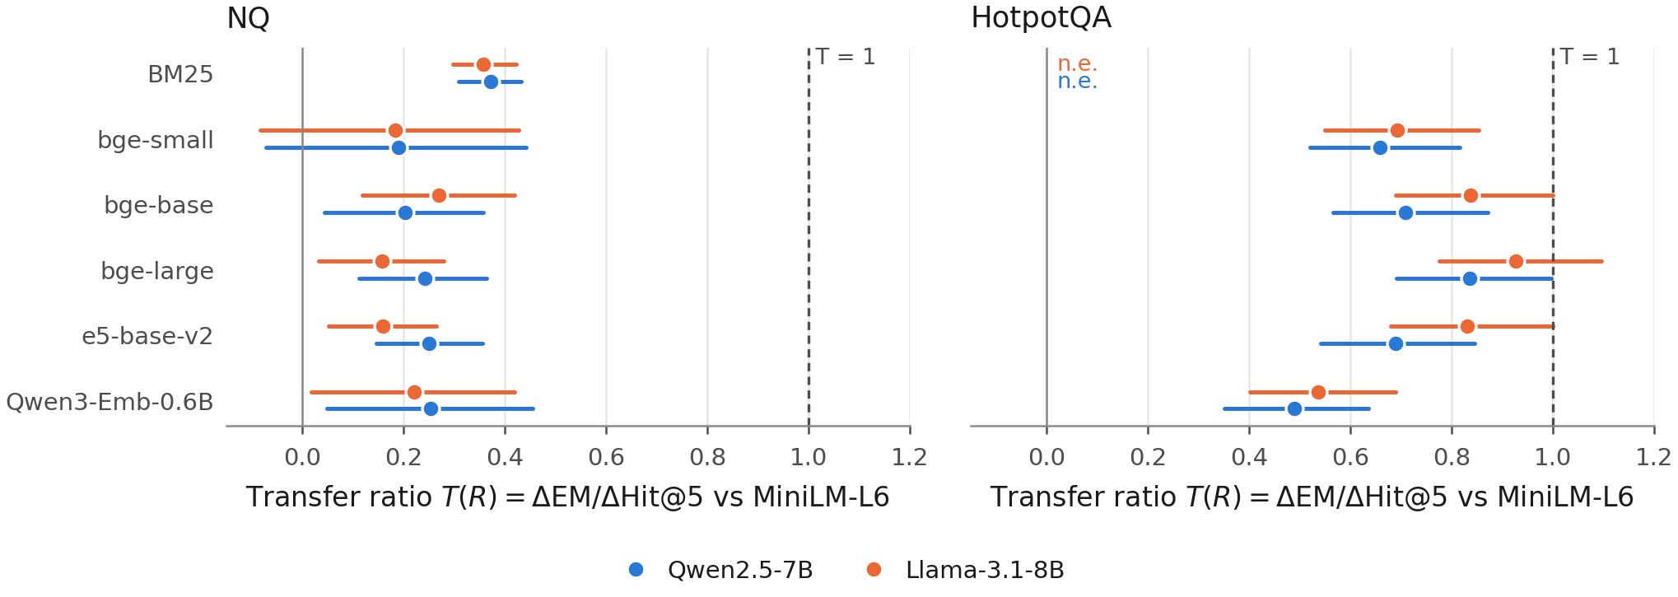
Transfer ratio $T\left(R\right)=ΔEM/ΔHit@5$ against MiniLM-L6 with 95% bootstrap intervals. The dashed line marks $T=1$. n.e.: not estimable under the reporting rule.
 | NQ (2,255 queries) |  |  |  | HotpotQA (2,000 queries)
2-5(lr)6-9 | Qwen |  | Llama |  | Qwen |  | Llama
2-3(lr)4-5(lr)6-7(lr)8-9 Retriever | Hit@5 | EM | Hit@5 | EM | Hit@5 | EM | Hit@5 | EM
BM25 | 0.363 | 0.360 | 0.363 | 0.340 | 0.833 | 0.339 | 0.833 | 0.336
MiniLM-L6 | 0.664 | 0.471 | 0.664 | 0.448 | 0.817 | 0.304 | 0.817 | 0.297
bge-small | 0.729 | 0.484 | 0.729 | 0.460 | 0.954 | 0.394 | 0.954 | 0.392
bge-base | 0.770 | 0.493 | 0.770 | 0.477 | 0.958 | 0.404 | 0.958 | 0.415
bge-large | 0.796 | 0.503 | 0.796 | 0.469 | 0.961 | 0.424 | 0.961 | 0.430
e5-base-v2 | 0.816 | 0.510 | 0.816 | 0.472 | 0.951 | 0.396 | 0.951 | 0.408
Qwen3-Emb-0.6B | 0.744 | 0.492 | 0.744 | 0.466 | 0.945 | 0.366 | 0.945 | 0.366
Closed book | – | 0.149 | – | 0.197 | – | 0.158 | – | 0.148
Gold passages | – | 0.653 | – | 0.613 | – | 0.628 | – | 0.624
Retriever | NQ Qwen | NQ Llama | HotpotQA Qwen | HotpotQA Llama
BM25 | 0.37 [0.31, 0.43] | 0.36 [0.30, 0.42] | n.e. | n.e.
bge-small | 0.19 [$−$0.07, 0.44] | 0.18 [$−$0.08, 0.43] | 0.66 [0.52, 0.82] | 0.69 [0.55, 0.85]
bge-base | 0.20 [0.04, 0.36] | 0.27 [0.12, 0.42] | 0.71 [0.57, 0.87] | 0.84 [0.69, 1.00]
bge-large | 0.24 [0.11, 0.36] | 0.16 [0.03, 0.28] | 0.84 [0.69, 1.00] | 0.93 [0.78, 1.10]
e5-base-v2 | 0.25 [0.15, 0.36] | 0.16 [0.05, 0.26] | 0.69 [0.54, 0.85] | 0.83 [0.68, 1.00]
Qwen3-Emb-0.6B | 0.25 [0.05, 0.45] | 0.22 [0.02, 0.42] | 0.49 [0.35, 0.64] | 0.54 [0.40, 0.69]
n.e.: not estimable under the pre-registered rule ($\left|ΔHit@5\right|≤2$ points or not significant after Holm). BM25 on NQ retrieves worse than MiniLM-L6, so its ratio describes a loss.
The lenient answer metrics moved the ratios up but did not change the pattern (Table [tab:transferalt]). With token F1, the NQ ratios of the dense encoders stayed between 0.23 and 0.33. On HotpotQA with Llama, the F1 ratio of bge-large was 1.10 [0.95, 1.28], so under F1 a full transfer cannot be ruled out for that encoder.

Where the transfer comes from
The decomposition in Eq. [eq:decomp] separates two effects (Table [tab:decomp] and Fig. 6). One term, the hit–miss gap of MiniLM-L6, was similar in all cells: 0.33 and 0.32 on NQ, 0.25 and 0.28 on HotpotQA. The other term differed in sign between the datasets.
On NQ it was negative for every dense encoder (from −0.16 to −0.05 with Llama; from −0.14 to −0.08 with Qwen). Better encoders found gold passages for more questions, but EM given a hit fell slightly (Qwen: 0.584 for MiniLM-L6, 0.569 for e5-base-v2). EM given a miss stayed near 0.244, well above closed-book EM (0.149). A “miss” under the sparse NQ labels thus often still produced a correct answer.
On HotpotQA the second term was positive and large, from +0.24 (Qwen3-Embedding-0.6B with Qwen) to +0.65 (bge-large with Llama). In the baseline-conditioned form of Eq. [eq:decomp] it made up 48% to 70% of the ratio; in the symmetric form, 44% to 64% (Table 9). The bootstrap intervals of these shares lay between 26% and 76%. On NQ we report only the two terms, because the EM gains there are small and the shares are unstable: every dense encoder’s share interval was at least 1.4 wide, where 1 is the whole EM gain. EM given a hit rose with the encoder (Qwen: 0.350 for MiniLM-L6, 0.438 for bge-large), while EM given a miss was lower for the stronger encoders (Qwen: 0.098 for MiniLM-L6, 0.030 to 0.090 for the others). The rise matches the Both@5 results: better encoders more often retrieved the second supporting passage, which Hit@5 does not count. In a post hoc check, the EM ranking of the seven retrievers equalled their Both@5 ranking in both HotpotQA cells (Spearman $ρ$ = 1.00 and 1.00); against Hit@5 it was 0.96 and 0.96. With Both@5 instead of Hit@5 as the denominator (post hoc; Table [tab:altbase]), the HotpotQA ratios of the dense encoders were 0.29 to 0.35 for both readers, and Qwen3-Embedding-0.6B no longer stood apart. The pattern came mainly from bridge questions. With Qwen, bridge EM rose from 0.248 (MiniLM-L6) to 0.384 (bge-large), while comparison EM moved from 0.539 to 0.594, close to its gold bound of 0.654.
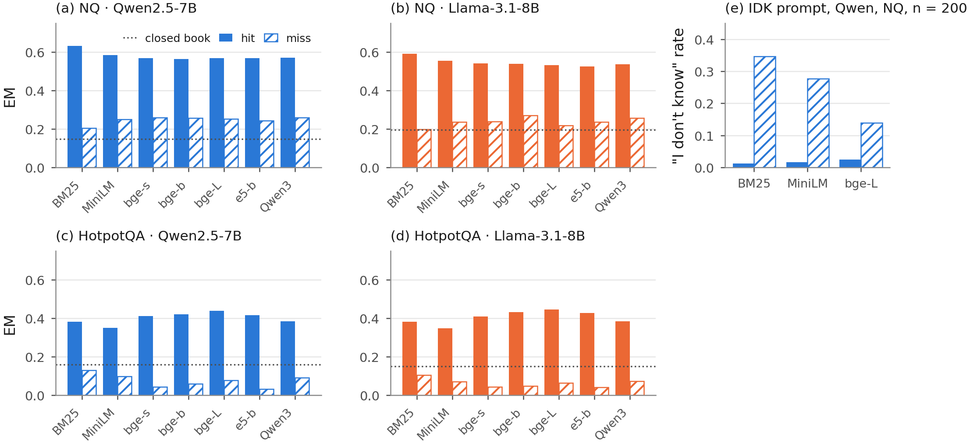
(a)–(d) Exact match given a hit (solid) and given a miss (hatched) at Hit@5, per reader–dataset cell; dotted line: closed-book EM. (e) Share of “I don’t know” answers on hits and misses under the abstention prompt A3 (Phase 1, Qwen reader, NQ, 200 queries).

Abstention prompt
A Phase 1 check (Table 10) is consistent with the reading that NQ “misses” often still contain usable evidence. When the prompt allowed “I don’t know” (A3), the reader abstained mostly on misses: 0.347 of BM25 misses, 0.276 of MiniLM-L6 misses and 0.139 of bge-large misses, against 0.013 to 0.024 of hits. Most misses were still answered. EM under A3 did not differ detectably from the main prompt (−0.010, −0.015 and −0.030; $p≥$ 0.07).

Encoder comparisons (RQ2)
Prediction P2 held on NQ and failed on HotpotQA (Table [tab:predictions]). On NQ, neither bge-large nor Qwen3-Embedding-0.6B differed detectably from e5-base-v2 in EM with either reader. On HotpotQA, bge-large gave higher EM than e5-base-v2 with both readers (+0.028, Holm-adjusted $p$ = 0.0055; +0.022, $p$ = 0.040), in line with its higher Both@5. Qwen3-Embedding-0.6B gave lower EM than e5-base-v2 on HotpotQA (−0.030, $p$ = 0.0031; −0.042, $p$ = $8.5×{10}^{−6}$). The registered pooled model over all four cells (Table [tab:gee]; 59,570 answers in 4,255 query clusters) gave odds ratios of 1.038 [1.001, 1.076] for bge-large and 0.909 [0.875, 0.943] for Qwen3-Embedding-0.6B, each against e5-base-v2. This main-effects model assumes the same retriever effect on both datasets, and the data do not support that assumption: the retriever $×$ dataset terms were jointly significant (Wald $χ_{6}^{2}$ = 179, $p$ = $5.2×{10}^{−36}$), while retriever $×$ reader terms were not ($p$ = 0.55). In the interaction model (post hoc), bge-large had an odds ratio of 0.981 [0.936, 1.028] on NQ and 1.109 [1.049, 1.172] on HotpotQA; Qwen3-Embedding-0.6B had 0.952 [0.906, 1.001] and 0.859 [0.811, 0.909]. The small pooled advantage of bge-large thus averages no detected effect on NQ with a gain on HotpotQA, in line with the per-cell tests. Both models mix the two study phases and are secondary.
 | Pooled (main effects) | With retriever $×$ dataset interaction
3-4 Contrast | both datasets | NQ | HotpotQA
bge-large vs e5-base-v2 | 1.038 [1.001, 1.076] | 0.981 [0.936, 1.028] | 1.109 [1.049, 1.172]
Qwen3-Emb-0.6B vs e5-base-v2 | 0.909 [0.875, 0.943] | 0.952 [0.906, 1.001] | 0.859 [0.811, 0.909]
Pooled: EM $∼$ retriever + dataset + reader (registered secondary model). Interaction model: EM $∼$ retriever $×$ dataset + reader (post hoc). Retriever $×$ dataset: Wald $χ_{6}^{2}$ = 179, $p$ = $5.2×{10}^{−36}$; adding retriever $×$ reader: $χ_{6}^{2}$ = 5.0, $p$ = 0.55. Exchangeable working correlation (0.60) within query; 59,570 answers in 4,255 query clusters; empirical (sandwich) standard errors. All models converged without warnings.

Context choices (RQ3)

Number of passages
Table 1 and Fig. 7 show EM for $k∈\{1,3,5,10\}$ with Qwen on NQ. One passage gave lower EM than five for every retriever (P4 held; differences from −0.126 for BM25 to −0.078 for e5-base-v2, all Holm-adjusted $p<0.001$). From five to ten passages, EM rose for six retrievers and stayed flat for e5-base-v2 (0.510 and 0.508). The gap between retrievers shrank with $k$: at $k=10$ all dense encoders gave EM between 0.502 and 0.520. In an exploratory check (Table [tab:transferk]), we matched Hit@$k$ to the $k$ passages the reader saw. The transfer ratio then fell with $k$; for bge-large it was 0.61 [0.47, 0.77] at $k=1$, 0.33 at $k=3$, 0.24 at $k=5$ and 0.19 [0.02, 0.35] at $k=10$. The NQ ratios of Section 5.2 therefore describe $k=5$ only. More passages also cost more reading: the mean prompt grew from 210 tokens at $k=1$ to 738 at $k=5$ and 1,414 at $k=10$ for bge-large. In a second exploratory comparison, bge-large with one passage gave higher EM than BM25 with ten passages (+0.022 [0.001, 0.042]; exact McNemar $p$ = 0.044, uncorrected).
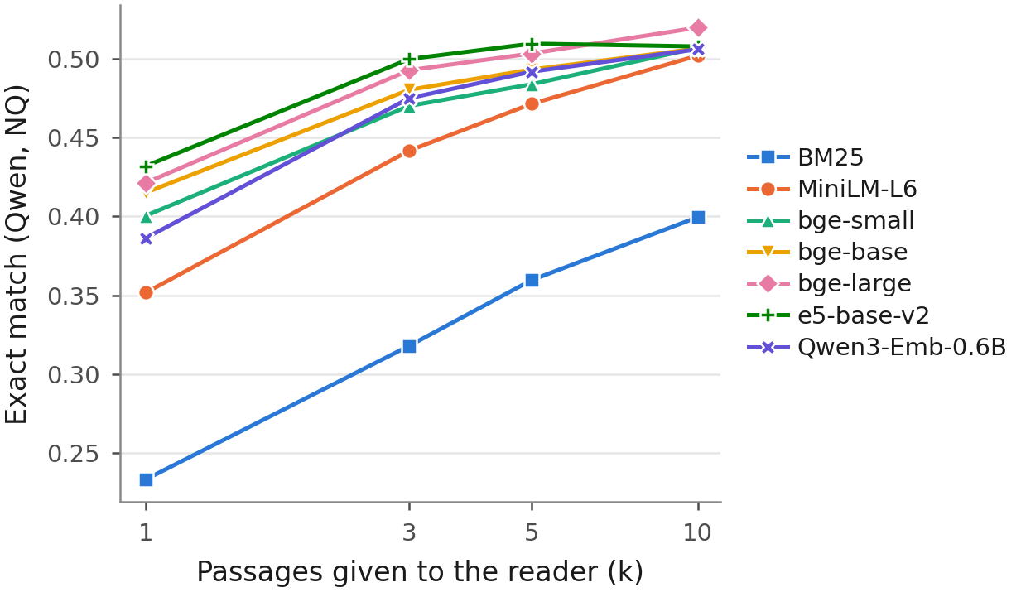
Exact match by number of passages $k$, Qwen reader on NQ (2,255 queries).

Passage composition and position
Table 2 and Fig. 8 give the controlled context test on 500 NQ questions. With the gold passage at position 1, four top-ranked non-gold BM25 passages gave EM 0.580, and four random passages gave 0.654: a drop of 0.074 (exact McNemar $p$ = $2.2×{10}^{−5}$; P5 held). Adding four random passages to the gold passage changed EM by no detectable amount: gold at position 1 plus four random passages gave 0.654, and the gold passage alone gave 0.648 (difference +0.006, 95% CI [−0.016, 0.026]; $p$ = 0.71). No equivalence margin was registered, so this interval is not evidence that random passages have no effect; it only bounds the effect in this sample of 500 questions. The position of the gold passage among the hard negatives showed no detectable effect (EM 0.580, 0.564 and 0.578 at positions 1, 3 and 5; all Holm-adjusted $p≥$ 0.94; P6 failed).
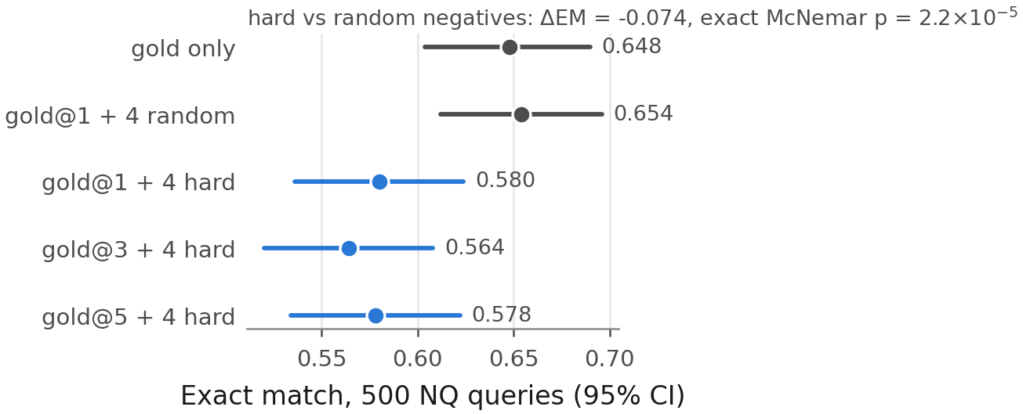
Exact match for five controlled contexts of five passages (Qwen reader, 500 NQ generation queries) with 95% bootstrap intervals.
Exact match by number of passages $k$ (Qwen reader, NQ, 2,255 queries).
Retriever | $k=1$ | $k=3$ | $k=5$ | $k=10$ | $Δ_{1−5}$ | $p_{\text{Holm}}$
BM25 | 0.233 | 0.318 | 0.360 | 0.400 | $−$0.126 | $<$0.001
MiniLM-L6 | 0.352 | 0.442 | 0.471 | 0.502 | $−$0.120 | $<$0.001
bge-small | 0.400 | 0.470 | 0.484 | 0.507 | $−$0.083 | $<$0.001
bge-base | 0.415 | 0.480 | 0.493 | 0.506 | $−$0.078 | $<$0.001
bge-large | 0.421 | 0.493 | 0.503 | 0.520 | $−$0.082 | $<$0.001
e5-base-v2 | 0.432 | 0.500 | 0.510 | 0.508 | $−$0.078 | $<$0.001
Qwen3-Emb-0.6B | 0.386 | 0.475 | 0.492 | 0.506 | $−$0.106 | $<$0.001
Exact McNemar test of $k=1$ vs $k=5$, Holm over seven retrievers.
Distraction and position tests (Qwen reader, 500 NQ generation queries).
Context (5 passages) | EM [95% CI] | F1 | AC
Gold only | 0.648 [0.604, 0.690] | 0.772 | 0.770
Gold@1 + 4 random | 0.654 [0.612, 0.696] | 0.777 | 0.764
Gold@1 + 4 hard | 0.580 [0.536, 0.624] | 0.696 | 0.686
Gold@3 + 4 hard | 0.564 [0.520, 0.608] | 0.684 | 0.672
Gold@5 + 4 hard | 0.578 [0.534, 0.622] | 0.698 | 0.682
Hard vs random negatives: $Δ$EM = $−$0.074, exact McNemar $p$ = $2.2×{10}^{−​5}$. Position: no pair differs after Holm.

Reranking
The cross-encoder helped BM25 and hurt e5-base-v2 (Table 3). On the NQ generation queries, reranking the BM25 top 50 raised Hit@5 by +0.304 and EM by +0.097 (both $p<0.001$). Reranking the e5-base-v2 top 50 changed Hit@5 by −0.067 ($p$ = $2.6×{10}^{−12}$); for EM the change was −0.016 ($p$ = 0.069), and no difference was detected. Reranking cost a median of 208 to 249 ms per query on a T4. These results come from one reranker at one depth.
Cross-encoder reranking (bge-reranker-base, top 50) on NQ.
System | Hit@5 | nDCG@10 | EM | ms/query
BM25 | 0.373 | 0.284 | 0.360 | –
BM25 + reranker | 0.658 | 0.542 | 0.456 | 208
e5-base-v2 | 0.817 | 0.665 | 0.510 | –
e5-base-v2 + reranker | 0.742 | 0.601 | 0.494 | 249
Retrieval on all 3,452 judged queries; EM on the 2,255 generation queries (Qwen). Latency: median per query, 50 pairs, one T4.

Cost and checks of the setup (RQ4)

Encoding cost
Table 4 gives the measured cost. Throughput fell from 1,807 passages per second for MiniLM-L6 to 66 for Qwen3-Embedding-0.6B, a factor of 27. e5-base-v2 encoded 2.9 times faster than bge-large. The five repetitions varied little (Table 4): no two encoders had overlapping throughput ranges. The closest pair, bge-base and e5-base-v2, share the same architecture size, and bge-base was 1.8% faster at the median. Query encoding took 6.0 to 52.2 ms per query; BM25 took 25.7 ms on the CPU. Fig. 9 relates throughput to EM averaged over the four cells. bge-large had the highest average EM (0.457), bge-base and e5-base-v2 followed at 0.447 with 2.9 times its throughput, and Qwen3-Embedding-0.6B (0.422) was both the slowest and below bge-small (0.432).
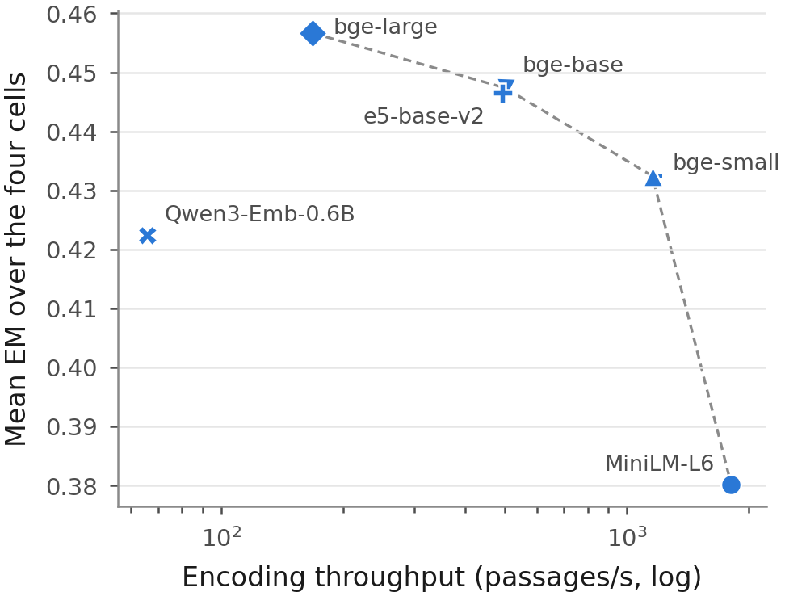
Encoding throughput on one T4 GPU (median of five repetitions, log scale) against EM averaged over the four reader–dataset cells. The dashed line joins encoders that no other encoder beats on both axes.
Encoding cost on one Tesla T4, median (range) over five repetitions.
Encoder | Params (M) | Dim | Passages/s | Query ms
MiniLM-L6 | 23 | 384 | 1807 (1768–1863) | 6.0 (6.0–6.1)
bge-small | 33 | 384 | 1155 (1136–1207) | 10.3 (10.1–10.3)
bge-base | 109 | 768 | 502 (501–503) | 10.0 (9.9–10.1)
e5-base-v2 | 109 | 768 | 493 (491–496) | 10.0 (9.9–10.1)
bge-large | 335 | 1024 | 168 (168–169) | 18.3 (18.3–18.6)
Qwen3-Emb-0.6B | 596 | 1024 | 66 (66–66) | 52.2 (51.8–54.9)
BM25 batch-1 query latency on CPU: 25.7 ms (23.7–27.7).

Deployment cost on a CPU
Phase 1 also measured the cost of serving queries without a GPU (Table [tab:deploy]; single measurements). Encoding the 300,000-passage sub-corpus on the T4 took 158 s with MiniLM-L6, 592 s with e5-base-v2, 1,753 s with bge-large and 4,431 s with Qwen3-Embedding-0.6B. On the CPU alone, one query (encoding plus exact search) took 21.9 ms with BM25, 53.7 ms with MiniLM-L6, 149.3 ms with e5-base-v2, 402.5 ms with bge-large and 861.7 ms with Qwen3-Embedding-0.6B. The flat index took 439, 879 and 1,172 MB at 384, 768 and 1,024 dimensions. Fig. 10 places each retriever by CPU latency and EM in every cell. bge-large and Qwen3-Embedding-0.6B were dominated on NQ for both readers: a cheaper retriever gave at least the same EM. On HotpotQA, bge-large was on the frontier with both readers, and its step over the next retriever was significant only with Qwen. Fig. 12 in the appendix gives the same view for NQ nDCG@10. In an exploratory check that treats costs within 5% as equal, only one frontier changed, on both cost axes: with Qwen on NQ, bge-base left the frontier, because its cost is within 5% of e5-base-v2 and its EM is lower.
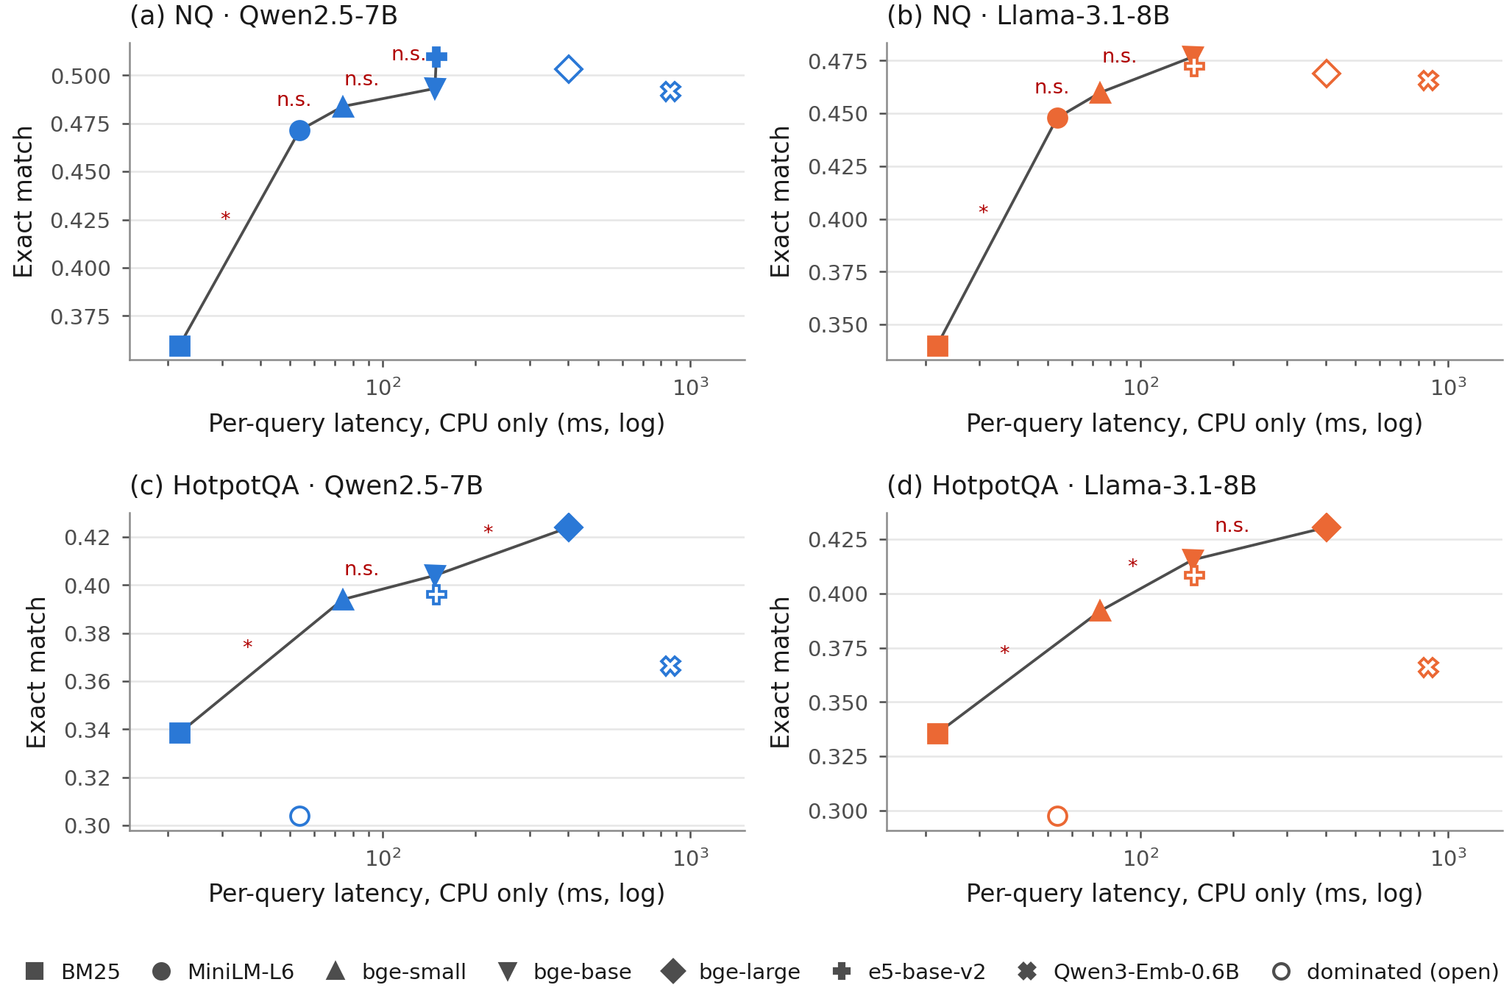
Exact match against per-query latency with query encoding and exact search on the CPU (Phase 1 cost measurements, log scale). The line joins retrievers that no other retriever beats on both axes; open markers are dominated. Step labels: $​^{*}$ EM difference significant after Holm correction over the 21 pairs of the cell; n.s. not significant.
Retriever | Enc. 300k (s) | GPU MiB | CPU pass./s | Q-enc GPU | Q-enc CPU | Search | Query CPU | Index MB
BM25 | – | – | – | – | – | 21.9 | 21.9 | –
MiniLM-L6 | 158 | 352 | 38.7 | 5.6 | 14.3 | 39.3 | 53.7 | 439
bge-small | 250 | 374 | 20.0 | 9.7 | 35.3 | 38.8 | 74.1 | 439
bge-base | 584 | 818 | 6.4 | 9.6 | 66.5 | 81.2 | 147.7 | 879
bge-large | 1,753 | 1,427 | 1.9 | 17.4 | 259.4 | 143.1 | 402.5 | 1,172
e5-base-v2 | 592 | 818 | 6.2 | 9.6 | 67.8 | 81.5 | 149.3 | 879
Qwen3-Emb-0.6B | 4,431 | 7,548 | 0.3 | 46.9 | 719.7 | 142.0 | 861.7 | 1,172
Enc. 300k: T4 wall time to encode the 300,000-passage sub-corpus. Q-enc: batch-1 query encoding (ms, median). Search: batch-1 exact inner-product search on the CPU (ms, median). Query CPU: query encoding plus search, all on the CPU. Index: flat float32 FAISS index. Encoding throughput repeated five times in Phase 2 is in Table 4.

Approximate search
HNSW search kept the exact top five almost unchanged (Table [tab:hnsw]). At efSearch 128 the top-5 overlap with exact search was 0.9956 or higher, Hit@5 changed by at most 0.0023, and the median query latency on the CPU fell from 36–78 ms to 0.84–1.45 ms. We did not run the readers on HNSW results, so this check covers retrieval and latency only.
Encoder | Exact |  | HNSW ef=64 |  |  | HNSW ef=128
 | Hit@5 | ms | Overlap | Hit@5 | ms | Overlap | Hit@5 | ms
MiniLM-L6 | 0.673 | 35.9 | 0.946 | 0.672 | 0.50 | 0.984 | 0.673 | 0.84
bge-small | 0.729 | 36.3 | 0.904 | 0.726 | 0.49 | 0.964 | 0.727 | 0.89
e5-base-v2 | 0.817 | 77.7 | 0.915 | 0.815 | 0.80 | 0.970 | 0.817 | 1.45
Overlap: mean share of the exact top 100 recovered. ms: median batch-1 query latency on 4 vCPUs.

Sub-corpus versus full corpus
On the full NQ corpus the four tested retrievers kept their nDCG@10 order (Kendall’s $τ$ = 1.00; P3 held; Table 5 and Fig. 11). The dense retrievers lost 0.083 to 0.086 in nDCG@10, and BM25 lost almost nothing (0.002). The sub-corpus therefore inflates absolute dense scores but not the order of these four retrievers. The drops also agree with the bias that the construction implies: the sub-corpus keeps BM25’s own top-ranked passages for every judged query but not those of the dense encoders, so it favours the dense encoders relative to BM25. We did not run the readers on the full corpus, and this check covers NQ only.
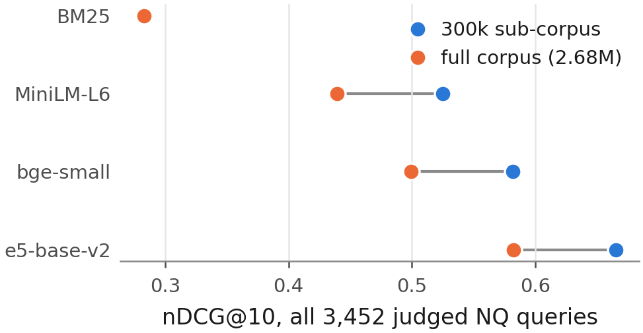
nDCG@10 on the 300,000-passage sub-corpus and on the full NQ corpus (all 3,452 judged queries).
Sub-corpus (300k) vs full NQ corpus (2.68M), all 3,452 judged queries.
Retriever | nDCG@10 sub | nDCG@10 full | Hit@5 sub | Hit@5 full
BM25 | 0.284 | 0.283 | 0.373 | 0.373
MiniLM-L6 | 0.525 | 0.439 | 0.673 | 0.571
bge-small | 0.582 | 0.499 | 0.729 | 0.630
e5-base-v2 | 0.665 | 0.582 | 0.817 | 0.727
Kendall’s $τ$ between the two orderings = 1.00.

LLM judge validation
The LLM judge agreed poorly with the author’s labels (Table 6). Cohen’s $κ$ was 0.127 [−0.006, 0.261], with raw agreement 0.565. Weighted to the population, the judge labelled 0.886 of answers as supported, against 0.620 for the author, and its precision for the label supported was 0.636. Under the registered rule ($κ<0.2$) we excluded the judge’s faithfulness labels from all conclusions. For completeness, Table 11 in the appendix lists the share of answers the judge labelled as supported, and Appendix 10 gives the judge prompt and the annotation instructions.
Agreement between the author’s labels and the LLM judge on 200 stratified items.
 | Judge SUPPORTED | Judge NOT_SUPPORTED
Human SUPPORTED | 65 | 50
Human NOT_SUPPORTED | 37 | 48
Cohen’s $κ$ = 0.127 [$−$0.006, 0.261]; raw agreement 0.565. Under the pre-registered rule ($κ<0.2$) the judge results are excluded from the conclusions.

Summary of the predictions
Table [tab:predictions] lists all six predictions. P3, P4 and P5 held. P1 failed in one of three new cells, P2 failed in both HotpotQA cells, and P6 failed. Where a verdict is not confirmatory, the table marks it.
ID | Scope | Result | Evidence
P1 | NQ, Qwen$​^{†}$ | holds | 6 ratios; largest upper bound 0.455 (Qwen3-Emb-0.6B)
P1 | NQ, Llama | holds | 6 ratios; largest upper bound 0.427 (bge-small)
P1 | HotpotQA, Qwen | holds | 5 ratios; largest upper bound 0.996 (bge-large)
P1 | HotpotQA, Llama | fails | 5 ratios; largest upper bound 1.096 (bge-large)
P2 | NQ, Qwen$​^{†}$ | holds | bge-large $−$ e5: $−$0.006 ($p_{\text{Holm}}$ 1.000); Qwen3-Emb-0.6B $−$ e5: $−$0.018 ($p_{\text{Holm}}$ 0.271)
P2 | NQ, Llama | holds | bge-large $−$ e5: $−$0.004 ($p_{\text{Holm}}$ 1.000); Qwen3-Emb-0.6B $−$ e5: $−$0.007 ($p_{\text{Holm}}$ 1.000)
P2 | HotpotQA, Qwen | fails | bge-large $−$ e5: +0.028 ($p_{\text{Holm}}$ 0.005); Qwen3-Emb-0.6B $−$ e5: $−$0.030 ($p_{\text{Holm}}$ 0.003)
P2 | HotpotQA, Llama | fails | bge-large $−$ e5: +0.022 ($p_{\text{Holm}}$ 0.040); Qwen3-Emb-0.6B $−$ e5: $−$0.042 ($p_{\text{Holm}}$ $<$0.001)
P3 | NQ, 4 retrievers | holds | Kendall’s $τ$ = 1.00
P4 | NQ, Qwen | holds | $k=1$ below $k=5$ for all 7 retrievers$​^{‡}$; $Δ$EM $−$0.126 to $−$0.078; all $p_{\text{Holm}}$ $<$0.001
P5 | NQ, Qwen, 500 q. | holds | hard vs random negatives: $Δ$EM $−$0.074, $p$ $<$0.001
P6 | NQ, Qwen, 500 q. | fails | gold at position 1/3/5: largest $|Δ$EM$|$ 0.016; smallest $p_{\text{Holm}}$ 0.94
P1: every reportable EM transfer ratio has an upper 95% bound below 1. P2: no Holm-significant EM gain of bge-large or Qwen3-Emb-0.6B over e5-base-v2. P3: the full corpus keeps the nDCG@10 ordering. P4: EM at $k=1$ below $k=5$. P5: hard negatives lower EM. P6: gold position changes EM. $​^{†}$Not confirmatory: this cell was observed in Phase 1 of the study, before the predictions were registered. $​^{‡}$Confirmatory for bge-small, bge-base, e5-base-v2 and Qwen3-Emb-0.6B only; the other three were observed before registration.

Discussion

What the transfer ratio shows
On single-hop NQ, a retrieval gain of a dense encoder over a small encoder reached the answer at a rate of 0.16 to 0.27 EM points per Hit@5 point, with both readers. Three observations within our setup are consistent with this. (i) The readers fell well short of their gold-passage bound even with good retrieval, so part of the loss lies in reading, not retrieval. (ii) EM given a miss stayed far above closed-book EM. The NQ relevance labels are sparse, so many “misses” likely still contained an answer-bearing passage that was not labelled gold, or the reader knew the answer. Hit@5 may therefore overstate the difference between encoders that matters for the reader. (iii) EM given a hit fell slightly as encoders improved, which suggests that the questions that a better encoder newly solves at the retrieval stage are harder to answer. This last point is a hypothesis; we did not test which questions changed status.
On multi-hop HotpotQA, Hit@5 saturated while Both@5 did not. In the baseline-conditioned decomposition, between 48% and 70% of the transfer came from higher EM given a hit (44%–64% in the symmetric form), and the EM ranking of retrievers followed Both@5 exactly. Both are descriptions of the data, not causal attributions. A reasonable reading is that, for bridge questions, the second supporting passage carries the answer, and Hit@5 does not count it. A post hoc check supports this reading: with Both@5 as the denominator, the HotpotQA ratios fell to 0.29–0.35, much closer to the NQ range. The large Hit@5-based ratios on HotpotQA therefore largely reflect the denominator: the retrieval gain that matters is larger than Hit@5 shows. The comparison questions, where both entities are named in the question, were close to their gold bound for every dense encoder. Teams that build multi-hop systems may therefore prefer to measure retrieval with a metric that requires all needed evidence.
Measured with Hit@5, the two datasets thus support different conclusions about the same encoders. A team that judges encoders by single-hop retrieval benchmarks may overrate the answer value of the strongest ones. A team with multi-hop questions may underrate it if it uses Hit@k.

Comparison with earlier work
Our NQ results agree with reports that retrieval gains do not carry over fully to answers (Salemi and Zamani 2024; Mathur et al. 2026; Ghosh, Mukhopadhyay, and Chatterjee 2026) and with the falling recall conversion rate reported by Peng et al. (2026). They do not contradict the strong correlations reported by Samuel et al. (2026): the EM ranking of retrievers followed their Hit@5 ranking closely in every cell (Spearman $ρ$ between 0.89 and 1.00). Correlation concerns the order of systems; the transfer ratio concerns the size of the gain. A metric can rank encoders correctly and still overstate how much answers improve.
The context experiment agrees with earlier findings on distraction. Top-ranked non-gold passages lowered EM compared with random passages (Cuconasu et al. 2024; Amiraz et al. 2025; Repantis et al. 2026), and adding random passages to the gold passage changed EM by no detectable amount. Gold position showed no detectable effect among five passages, in line with Cuconasu et al. (2025); with five short passages our setting is far from the long contexts in which position effects were originally shown (Liu et al. 2024). The near-identical retrieval results of exact and approximate search agree with Leto et al. (2024), who also measured answers; we measured retrieval only.

Practical implications
Within our setup, the choice of encoder mattered less for answers than for retrieval, while its cost differed by more than an order of magnitude. For single-hop questions, a base-size encoder such as e5-base-v2 or bge-base gave answers that no larger encoder improved detectably, while encoding 2.9 times faster than bge-large. For multi-hop questions, bge-large gave a small but detectable gain. Qwen3-Embedding-0.6B was the most expensive encoder and gave lower EM than e5-base-v2 on HotpotQA; its instruction and length settings may not suit this task, and we did not tune them. Retrieving ten passages instead of five raised EM for most retrievers and narrowed their differences, which is another lever when the reader’s context allows it, although it nearly doubles the prompt the reader must process. A cross-encoder helped the weak BM25 retrieval stage but not a strong dense one. Approximate search returned nearly the same top five passages as exact search at a small fraction of the latency; we did not measure its effect on answers.

Alternative explanations
Several features of the design could produce low NQ transfer without a property of the encoders. EM undercounts correct answers (Kamalloo et al. 2023); the F1 and containment ratios were higher but showed the same contrast between datasets. The sub-corpus inflates dense retrieval scores, but the full-corpus check kept the order of four retrievers, and the inflation was similar for the three dense encoders tested (0.083 to 0.086 in nDCG@10). The construction favours the dense encoders relative to BM25, so the comparisons that involve BM25 depend most on it. The readers were 4-bit quantised 7–8B models with one prompt; stronger readers may convert hits into answers at a different rate. The baseline encoder also matters: $T\left(R\right)$ against MiniLM-L6 measures gains above a fairly strong small encoder. Against BM25 the NQ ratios were higher (0.29–0.35), and the contrast between datasets held for four of the five dense encoders but reversed for Qwen3-Embedding-0.6B (Table [tab:altbase]). The ratio therefore describes a pair of retrievers, not a single encoder, and the dataset contrast is clearest against the small dense baseline.

Limitations

Scope
The study covers two English Wikipedia question-answering datasets, six open encoders up to 0.6B parameters, two 4-bit 7–8B readers, one prompt and $k=5$ for the transfer ratios. Results may differ for other domains, longer answers, larger or proprietary readers, other prompts or agentic pipelines. All timings come from one GPU type (Tesla T4) and one CPU configuration.

Corpus and labels
Retrieval ran on 300,000-passage sub-corpora that contain every gold passage. The full-corpus check covers retrieval for four retrievers on NQ only; we did not rerun the readers on the full corpus or check HotpotQA. The sub-corpus keeps BM25’s strongest competitors but not those of the dense encoders, which favours the dense encoders relative to BM25. NQ relevance labels are sparse, so some “misses” contain the answer. The joined NQ set covers 2,255 of 3,452 judged queries and may differ in difficulty from the excluded queries. A Phase 1 check found Hit@5 differences between joined and unjoined queries from −0.028 to +0.005 across the seven retrievers, and every 95% interval included zero.

Metrics and statistics
EM is strict. We report F1 and answer containment, but did not judge correctness by hand. The transfer ratio is a ratio of means and becomes unstable when the retrieval gain is small; our reporting rule removes the worst cases, but the bge-small intervals on NQ still include zero. The ratio depends on the baseline encoder, and the share of the gain assigned to conditional EM depends on how the decomposition is ordered (Tables [tab:altbase] and 9). The decomposition, the Both@5 ranking and ratios, the BM25 baseline and the GEE interaction model are post hoc. The registered pooled GEE model assumed one retriever effect across datasets, which the interaction test did not support. Answer quality under approximate search was not measured. Multiplicity is controlled within each family, not across all tests in the paper. Bootstrap intervals, F1, answer containment and the pooled model were checked by a rerun on a second computer, not by an independent implementation.

Context experiment
The hard negatives are top-ranked BM25 passages without a gold label. Some may contain the answer; that would raise EM in the hard-negative condition and shrink the measured drop. We could not check this because the passage text is not stored with the outputs. The experiment used one reader and 500 questions. The random-passage control found no detected difference from the gold passage alone; it does not establish equivalence.

Judge and annotation
The LLM judge was validated against one annotator, the author. With $κ$ = 0.127 the judge was excluded under the registered rule, so this limitation does not affect the conclusions, but no faithfulness result is reported.

Two study phases
The predictions were registered in dated, version-controlled design documents in our own repository, not in a public registry. The Qwen–NQ cell and part of the $k$ ablation were run before the predictions were registered, and the software image changed between phases. Within-cell comparisons share one environment. For comparisons across phases, 396 of 397 identical prompts gave identical outputs.

Conclusion
We measured how much of a retrieval gain reaches the answer when a RAG system swaps one open embedding model for another. On single-hop NQ, between 0.16 and 0.27 EM points followed each Hit@5 point that a dense encoder gained over MiniLM-L6, for both readers (RQ1); against BM25 the ratios were 0.29 to 0.35. On multi-hop HotpotQA the Hit@5-based ratio was larger; in a post hoc decomposition, 48% to 70% of it came from higher EM given a hit, in line with better encoders retrieving the second supporting passage more often, which Hit@5 does not count; with Both@5 as the denominator, the HotpotQA ratios were 0.29 to 0.35. Among dense encoders, bge-large gave a small EM gain over e5-base-v2 on HotpotQA and none detectable on NQ, and Qwen3-Embedding-0.6B gave lower EM on HotpotQA (RQ2). Top-ranked non-gold passages lowered EM, gold position did not change it detectably, a reranker helped only the weak BM25 retrieval stage, and ten passages narrowed the gaps between retrievers (RQ3). Encoding throughput differed 27-fold, while approximate search returned nearly the same top passages and the four retrievers tested on the full NQ corpus kept their order (RQ4).
Within this setup, retrieval gains overstated answer gains on single-hop questions, and on multi-hop questions once retrieval was scored by Both@5; Hit@5 hid much of the multi-hop retrieval gain. We recommend that RAG studies report answer gains next to retrieval gains, with paired intervals and the baseline stated, and use retrieval metrics that require all evidence a question needs. Future work should test larger readers and other domains, run the readers on the full corpus and on approximate-search results, and replace EM with validated human or model judgements.

Ethics statement

Data and licences
We used public resources under their licences, as listed on their Hugging Face cards (accessed 17 October 2026): the BEIR versions of Natural Questions and HotpotQA (CC BY-SA 4.0), NQ-open (CC BY-SA 3.0) and HotpotQA (CC BY-SA 4.0). The encoders are released under Apache-2.0 (all-MiniLM-L6-v2, Qwen3-Embedding-0.6B) or MIT (bge, e5 and bge-reranker-base); Qwen2.5-7B-Instruct-AWQ and Mistral-7B-Instruct-v0.3 under Apache-2.0; and the Llama-3.1-8B-Instruct AWQ build under the Llama 3.1 Community License. We used each for research evaluation. The questions are public benchmark questions over Wikipedia; we collected no personal data.

Human annotation
The 200 judge-validation items were labelled by one member of the study team, with the same instructions the judge received and without seeing its verdicts. No external participants were involved.

Risks
The study compares existing models and creates no new model. Readers may over-generalise the comparison to other readers, corpora or languages; we scope each claim to the tested setup. The excluded LLM judge should not be used as evidence that a system gives faithful answers.

Compute
All experiments ran on free Kaggle sessions with Tesla T4 GPUs; the study had no monetary cost.

Data and code availability
All code, prompts, design documents with their registration dates, raw reader outputs, scored answers and analysis scripts are kept in one version-controlled repository. To preserve double-anonymised review, its link is given to the editor on the separate title page; it will be made public, with an archived DOI, on acceptance. The datasets and models are public under their own licences; the exact revisions are listed in Appendix 11. Every number in this paper is generated from the committed analysis output.

Declaration of generative AI and AI-assisted technologies in the manuscript preparation process
During the preparation of this work the author used Claude (Anthropic) to write and test analysis and experiment code, to check references against bibliographic databases, and to draft and edit text. After using this tool, the author reviewed and edited the content as needed and takes full responsibility for the content of the published article. Figures and tables were generated by scripts from the experimental data.

Reader prompts
Each prompt was rendered with the reader’s own chat template. Passages appear in rank order as “[$i$] title” followed by the passage text on the next line, separated by blank lines.

A1 (with passages)
System: “You are a question answering assistant. Answer the question using the passages provided. If the passages do not contain the answer, give your best short answer anyway. Reply with the answer only, as a short phrase of a few words, with no explanation.” User: “Passages: … Question: {question} Answer:”

A2 (closed book)
System: “You are a question answering assistant. Reply with the answer only, as a short phrase of a few words, with no explanation.” User: “Question: {question} Answer:”
The gold-passage condition uses A1 with the gold passages only.

Judge prompt and annotation instructions
The LLM judge (Mistral-7B-Instruct-v0.3, greedy decoding, at most 8 new tokens) received one user message:
You will be given PASSAGES, a QUESTION, and an ANSWER. Decide whether the ANSWER is fully supported by the PASSAGES. An answer is SUPPORTED only if the passages state it or directly imply it. Do not use outside knowledge. Do not judge whether the answer is true in the real world.
PASSAGES: [the same five passages the reader saw, formatted as in Appendix 9]
QUESTION: {question} ANSWER: {answer}
Reply with exactly one word: SUPPORTED or NOT_SUPPORTED.
The verdict was the label SUPPORTED or NOT_SUPPORTED found at the start of the output; there were no parse failures. The human annotator saw the same text, without the judge’s verdict, plus the instruction: “Label each item SUPPORTED or NOT_SUPPORTED. If unsure, choose NOT_SUPPORTED and add a note.” The 200 items were drawn by a seeded, stratified sampler that over-represents NOT_SUPPORTED verdicts; population-weighted statistics use the inverse inclusion probabilities.

Models, data and software
Pinned revisions (leading eight characters of the Hugging Face commit).
Resource | Revision
sentence-transformers/all-MiniLM-L6-v2 | 1110a243
BAAI/bge-small-en-v1.5 | 5c38ec7c
BAAI/bge-base-en-v1.5 | a5beb1e3
BAAI/bge-large-en-v1.5 | d4aa6901
intfloat/e5-base-v2 | f52bf8ec
Qwen/Qwen3-Embedding-0.6B | 97b0c614
Qwen/Qwen2.5-7B-Instruct-AWQ | b2503754
hugging-quants/Meta-Llama-3.1-8B-Instruct-AWQ-INT4 | db1f81ad
BAAI/bge-reranker-base | 2cfc18c9
mistralai/Mistral-7B-Instruct-v0.3 (judge) | c170c708
BeIR/nq | b7253e6c
BeIR/nq-qrels | 519acd4e
google-research-datasets/nq_open | 5dd9790a
BeIR/hotpotqa | a7e8bab2
BeIR/hotpotqa-qrels | b15429e9
hotpotqa/hotpot_qa | 1908d6af
Retrieval used bm25s 0.3.11 and faiss-cpu 1.15.1; readers used vLLM 0.30.0 with PyTorch 2.13.0 (CUDA 13.0) and Transformers 5.17.0, in half precision with a maximum model length of 4,096 tokens.
Retriever | Model | Revision | Params (M) | Dim | Query prefix
BM25 | bm25s 0.3.11, Lucene variant, $k_{1}=1.2$, $b=0.75$ | – | – | – | –
MiniLM-L6 | sentence-transformers/all-MiniLM-L6-v2 | 1110a243 | 23 | 384 | none
bge-small | BAAI/bge-small-en-v1.5 | 5c38ec7c | 33 | 384 | BGE instruction
bge-base | BAAI/bge-base-en-v1.5 | a5beb1e3 | 109 | 768 | BGE instruction
bge-large | BAAI/bge-large-en-v1.5 | d4aa6901 | 335 | 1024 | BGE instruction
e5-base-v2 | intfloat/e5-base-v2 | f52bf8ec | 109 | 768 | “query: ”
Qwen3-Emb-0.6B | Qwen/Qwen3-Embedding-0.6B | 97b0c614 | 596 | 1024 | task instruction
BGE instruction: Represent this sentence for searching relevant passages:. e5-base-v2 also prefixes passages with “passage: ”. Qwen3-Embedding uses a task instruction per dataset.
Data and sub-corpora.
Item | NQ | HotpotQA
Full corpus (passages) | 2,681,468 | 5,233,329
Judged test queries | 3,452 | 7,405
Queries joined to reference answers | 2,255 | 7,405
Generation queries | 2,255 | 2,000 (1,616 bridge, 384 comparison)
Unique gold passages per judged query | 1.22 | 1.86
Sub-corpus size | 300,000 | 300,000
gold passages | 4,201 | 13,783
BM25 non-gold passages (depth $d$) | 127,791 ($d$ = 42) | 118,726 ($d$ = 19)
random passages | 168,008 | 167,491
Reference answers | NQ-open (validation) | HotpotQA fullwiki (validation)
Corpus sizes as distributed by BEIR. Joins: NQ by normalised question text, HotpotQA by question id.

Design documents
The design document and its addenda are dated and versioned in the study repository. Each was written before the stage it governs.
- v0.2 (26 September 2026). Research questions, retrievers, reader, judge, metrics, statistical tests, the transfer-ratio reporting rule and the pilot plan.
- v0.2.1–v0.2.2 (26 September 2026). Follow-up rules (abstention-prompt check, judge fallback, GPU stopping rules) and the change of the NQ join gate (deviation 1).
- v0.2.3 (27 September 2026). Pilot verification; the sub-corpus membership rule for all judged queries; dropping the RAGAS cross-check.
- v0.2.4 (27–29 September 2026). Execution records of Phase 1, the failed initial reading session, the cost-estimate error and the cut dimension ablation.
- v0.3 (12 October 2026). Phase 2 experiments E1–E12 and predictions P1–P6, written before any Phase 2 run.
- v0.3.1 (12 and 14 October 2026). The Python 3.13 image change and the torchaudio fix.
- v0.3.2 (15 October 2026). Implementation of E5, E6, E7, E9 and E12 before the session that ran them, including the reduced scope of E6.
Pilot numbers were used only for planning and are not reported as results.

Additional tables
Table [tab:ci] gives the bootstrap intervals for Table [tab:main]. Table [tab:transferalt] repeats the transfer ratios with token F1 and answer containment. Table [tab:decomp] gives EM given a hit and given a miss, which enter Eq. [eq:decomp]. Table 10 gives the abstention-prompt check, Table [tab:transferk] the exploratory transfer ratios at each $k$, Table [tab:pairwise] all pairwise EM tests, and Table 11 the excluded judge labels. Table 9 gives the decomposition shares for HotpotQA under both orderings, and Table [tab:altbase] the transfer ratios against BM25.
Condition | NQ Qwen | NQ Llama | HotpotQA Qwen | HotpotQA Llama
BM25 | [0.340, 0.380] | [0.321, 0.360] | [0.318, 0.359] | [0.315, 0.356]
MiniLM-L6 | [0.451, 0.492] | [0.427, 0.469] | [0.284, 0.325] | [0.278, 0.318]
bge-small | [0.463, 0.505] | [0.439, 0.481] | [0.372, 0.415] | [0.370, 0.413]
bge-base | [0.473, 0.513] | [0.456, 0.497] | [0.383, 0.426] | [0.394, 0.438]
bge-large | [0.482, 0.524] | [0.448, 0.489] | [0.402, 0.446] | [0.408, 0.453]
e5-base-v2 | [0.489, 0.530] | [0.452, 0.493] | [0.374, 0.417] | [0.387, 0.430]
Qwen3-Emb-0.6B | [0.471, 0.512] | [0.445, 0.487] | [0.345, 0.388] | [0.345, 0.388]
Closed book | [0.135, 0.164] | [0.180, 0.213] | [0.143, 0.174] | [0.133, 0.165]
Gold passages | [0.633, 0.673] | [0.593, 0.633] | [0.607, 0.649] | [0.602, 0.645]
Retrieval | NQ Hit@5 |  | HotpotQA Hit@5 | HotpotQA Both@5
BM25 | [0.343, 0.383] |  | [0.816, 0.849] | [0.244, 0.283]
MiniLM-L6 | [0.645, 0.683] |  | [0.799, 0.834] | [0.212, 0.248]
bge-small | [0.710, 0.747] |  | [0.944, 0.963] | [0.519, 0.563]
bge-base | [0.753, 0.788] |  | [0.949, 0.967] | [0.550, 0.594]
bge-large | [0.779, 0.812] |  | [0.952, 0.969] | [0.599, 0.642]
e5-base-v2 | [0.800, 0.832] |  | [0.941, 0.960] | [0.522, 0.567]
Qwen3-Emb-0.6B | [0.726, 0.762] |  | [0.934, 0.955] | [0.422, 0.467]
Share of the HotpotQA EM gain over MiniLM-L6 that comes from changed conditional EM (percent), under the baseline-conditioned decomposition of Eq. [eq:decomp] with a 95% bootstrap interval, and under the symmetric decomposition. Post hoc.
 | Qwen reader |  | Llama reader
2-3(lr)4-5 Encoder | Baseline-cond. | Symmetric | Baseline-cond. | Symmetric
bge-small | 62 [49, 71] | 53 | 60 [47, 69] | 54
bge-base | 64 [53, 73] | 57 | 67 [58, 74] | 60
bge-large | 70 [62, 76] | 63 | 70 [63, 76] | 64
e5-base-v2 | 64 [51, 72] | 54 | 67 [57, 74] | 60
Qwen3-Emb-0.6B | 49 [26, 63] | 44 | 48 [28, 62] | 45
Baseline-conditioned: $ΔEM=Δh \left(a_{R_{1}}−b_{R_{1}}\right)+h_{R} Δa+\left(1−h_{R}\right) Δb$. Symmetric: each term averages the two orderings of the baseline and the encoder. Both identities hold exactly (residual $<{10}^{−12}$). The intervals resample queries ($B=10,000$, seed 0).
Encoder | NQ Qwen | NQ Llama | HotpotQA Qwen | HotpotQA Llama
Baseline BM25, denominator Hit@5
bge-small | 0.34 [0.29, 0.39] | 0.33 [0.28, 0.38] | 0.46 [0.31, 0.62] | 0.47 [0.31, 0.64]
bge-base | 0.33 [0.28, 0.37] | 0.34 [0.29, 0.38] | 0.52 [0.37, 0.69] | 0.64 [0.49, 0.81]
bge-large | 0.33 [0.29, 0.37] | 0.30 [0.25, 0.34] | 0.67 [0.51, 0.84] | 0.75 [0.59, 0.92]
e5-base-v2 | 0.33 [0.29, 0.37] | 0.29 [0.25, 0.33] | 0.49 [0.33, 0.66] | 0.62 [0.46, 0.80]
Qwen3-Emb-0.6B | 0.35 [0.30, 0.40] | 0.33 [0.28, 0.38] | 0.25 [0.09, 0.42] | 0.27 [0.12, 0.44]
Baseline MiniLM-L6, denominator Both@5
bge-small | – | – | 0.29 [0.23, 0.35] | 0.30 [0.24, 0.36]
bge-base | – | – | 0.29 [0.24, 0.35] | 0.34 [0.29, 0.40]
bge-large | – | – | 0.31 [0.26, 0.35] | 0.34 [0.29, 0.39]
e5-base-v2 | – | – | 0.29 [0.24, 0.35] | 0.35 [0.30, 0.41]
Qwen3-Emb-0.6B | – | – | 0.29 [0.21, 0.37] | 0.32 [0.24, 0.40]
BM25 with Both@5 is omitted: its Both@5 gain over MiniLM-L6 is 0.034 and its ratio is unstable (Qwen: 1.0 [0.5, 2.5]).
Retriever | NQ Qwen | NQ Llama | HotpotQA Qwen | HotpotQA Llama
Token F1
BM25 | 0.43 [0.37, 0.48] | 0.43 [0.37, 0.49] | n.e. | n.e.
bge-small | 0.26 [0.02, 0.49] | 0.23 [0.00, 0.45] | 0.76 [0.62, 0.92] | 0.85 [0.70, 1.01]
bge-base | 0.26 [0.11, 0.40] | 0.33 [0.19, 0.47] | 0.79 [0.65, 0.95] | 0.95 [0.80, 1.11]
bge-large | 0.27 [0.15, 0.39] | 0.25 [0.13, 0.36] | 0.97 [0.82, 1.14] | 1.10 [0.95, 1.28]
e5-base-v2 | 0.30 [0.20, 0.39] | 0.26 [0.17, 0.36] | 0.77 [0.62, 0.92] | 0.97 [0.82, 1.13]
Qwen3-Emb-0.6B | 0.26 [0.07, 0.45] | 0.29 [0.11, 0.47] | 0.52 [0.38, 0.66] | 0.66 [0.52, 0.81]
Answer containment
BM25 | 0.45 [0.39, 0.52] | 0.46 [0.39, 0.52] | n.e. | n.e.
bge-small | 0.27 [0.01, 0.52] | 0.32 [0.07, 0.57] | 0.68 [0.53, 0.84] | 0.75 [0.61, 0.92]
bge-base | 0.34 [0.18, 0.49] | 0.38 [0.23, 0.53] | 0.72 [0.57, 0.88] | 0.90 [0.75, 1.07]
bge-large | 0.34 [0.21, 0.46] | 0.33 [0.21, 0.46] | 0.88 [0.73, 1.04] | 1.01 [0.86, 1.18]
e5-base-v2 | 0.36 [0.26, 0.47] | 0.33 [0.23, 0.43] | 0.71 [0.57, 0.87] | 0.91 [0.75, 1.07]
Qwen3-Emb-0.6B | 0.28 [0.08, 0.48] | 0.39 [0.20, 0.60] | 0.49 [0.35, 0.64] | 0.58 [0.45, 0.74]
Retriever | NQ Qwen | NQ Llama | HotpotQA Qwen | HotpotQA Llama
BM25 | 0.632 / 0.204 | 0.591 / 0.197 | 0.381 / 0.129 | 0.382 / 0.105
MiniLM-L6 | 0.584 / 0.249 | 0.554 / 0.237 | 0.350 / 0.098 | 0.348 / 0.071
bge-small | 0.568 / 0.259 | 0.542 / 0.239 | 0.411 / 0.043 | 0.409 / 0.043
bge-base | 0.564 / 0.257 | 0.538 / 0.270 | 0.419 / 0.060 | 0.432 / 0.048
bge-large | 0.568 / 0.252 | 0.533 / 0.220 | 0.438 / 0.076 | 0.446 / 0.063
e5-base-v2 | 0.569 / 0.244 | 0.525 / 0.237 | 0.415 / 0.030 | 0.428 / 0.040
Qwen3-Emb-0.6B | 0.572 / 0.260 | 0.538 / 0.256 | 0.383 / 0.090 | 0.383 / 0.072
Closed-book EM for comparison: NQ 0.149 (Qwen), 0.197 (Llama); HotpotQA 0.158 (Qwen), 0.148 (Llama).
Abstention prompt A3 (“I don’t know” allowed), Qwen reader, NQ, leading 200 queries of the seeded order (Phase 1).
Context | $n$ | IDK rate | IDK $∣$ hit ($n$) | IDK $∣$ miss ($n$) | EM (A1) | EM (A3) | $p$
BM25 | 200 | 0.215 | 0.013 (79) | 0.347 (121) | 0.390 | 0.380 | 0.69
MiniLM-L6 | 200 | 0.115 | 0.016 (124) | 0.276 (76) | 0.470 | 0.455 | 0.45
bge-large | 200 | 0.045 | 0.024 (164) | 0.139 (36) | 0.495 | 0.465 | 0.07
Gold passages | 200 | 0.060 | – | – | – | – | –
$p$: exact McNemar test of EM under A3 against the main prompt A1, unadjusted.
Retriever | $k=1$ | $k=3$ | $k=5$ | $k=10$
BM25 | 0.71 [0.61, 0.83] | 0.48 [0.41, 0.55] | 0.37 [0.31, 0.43] | 0.32 [0.26, 0.38]
bge-small | 0.83 [0.56, 1.22] | 0.37 [0.16, 0.59] | 0.19 [$−$0.07, 0.44] | 0.10 [$−$0.24, 0.42]
bge-base | 0.61 [0.45, 0.78] | 0.32 [0.19, 0.46] | 0.20 [0.04, 0.36] | 0.05 [$−$0.13, 0.22]
bge-large | 0.61 [0.47, 0.77] | 0.33 [0.22, 0.44] | 0.24 [0.11, 0.36] | 0.19 [0.02, 0.35]
e5-base-v2 | 0.57 [0.45, 0.69] | 0.32 [0.23, 0.41] | 0.25 [0.15, 0.36] | 0.05 [$−$0.09, 0.19]
Qwen3-Emb-0.6B | 0.41 [0.21, 0.60] | 0.35 [0.17, 0.53] | 0.25 [0.05, 0.45] | 0.08 [$−$0.27, 0.38]
Post hoc; the reporting rule of Section 3.1 is not applied. For BM25 the ratio describes a retrieval loss.
Row $−$ column | BM25 | MiniLM-L6 | bge-small | bge-base | bge-large | e5-base-v2
NQ, Qwen
MiniLM-L6 | +0.112$​^{*}$
bge-small | +0.124$​^{*}$ | +0.012
bge-base | +0.133$​^{*}$ | +0.022 | +0.009
bge-large | +0.144$​^{*}$ | +0.032$​^{*}$ | +0.020 | +0.010
e5-base-v2 | +0.150$​^{*}$ | +0.038$​^{*}$ | +0.026$​^{*}$ | +0.016 | +0.006
Qwen3-Emb-0.6B | +0.132$​^{*}$ | +0.020 | +0.008 | $−$0.001 | $−$0.012 | $−$0.018
NQ, Llama
MiniLM-L6 | +0.108$​^{*}$
bge-small | +0.120$​^{*}$ | +0.012
bge-base | +0.137$​^{*}$ | +0.029$​^{*}$ | +0.017
bge-large | +0.129$​^{*}$ | +0.021 | +0.009 | $−$0.008
e5-base-v2 | +0.132$​^{*}$ | +0.024 | +0.012 | $−$0.004 | +0.004
Qwen3-Emb-0.6B | +0.125$​^{*}$ | +0.018 | +0.006 | $−$0.011 | $−$0.003 | $−$0.007
HotpotQA, Qwen
MiniLM-L6 | $−$0.035$​^{*}$
bge-small | +0.056$​^{*}$ | +0.090$​^{*}$
bge-base | +0.066$​^{*}$ | +0.100$​^{*}$ | +0.010
bge-large | +0.086$​^{*}$ | +0.120$​^{*}$ | +0.030$​^{*}$ | +0.020$​^{*}$
e5-base-v2 | +0.058$​^{*}$ | +0.092$​^{*}$ | +0.002 | $−$0.008 | $−$0.028$​^{*}$
Qwen3-Emb-0.6B | +0.028$​^{*}$ | +0.062$​^{*}$ | $−$0.028$​^{*}$ | $−$0.037$​^{*}$ | $−$0.058$​^{*}$ | $−$0.029$​^{*}$
HotpotQA, Llama
MiniLM-L6 | $−$0.038$​^{*}$
bge-small | +0.057$​^{*}$ | +0.095$​^{*}$
bge-base | +0.080$​^{*}$ | +0.118$​^{*}$ | +0.024$​^{*}$
bge-large | +0.095$​^{*}$ | +0.133$​^{*}$ | +0.038$​^{*}$ | +0.015
e5-base-v2 | +0.073$​^{*}$ | +0.111$​^{*}$ | +0.017 | $−$0.007 | $−$0.022$​^{*}$
Qwen3-Emb-0.6B | +0.030$​^{*}$ | +0.069$​^{*}$ | $−$0.026$​^{*}$ | $−$0.050$​^{*}$ | $−$0.065$​^{*}$ | $−$0.043$​^{*}$
$​^{*}$: exact McNemar test significant after Holm correction over the 21 pairs of the cell ($p<0.05$).
Phase 1 LLM-judge labels (Mistral-7B-Instruct-v0.3, zero-shot prompt of Appendix 10), Qwen reader, NQ. Excluded from all conclusions because agreement with human labels was slight ($κ$ = 0.127).
Context | $n$ | Share judged SUPPORTED [95% CI]
BM25 | 500 | 0.790 [0.754, 0.826]
MiniLM-L6 | 500 | 0.886 [0.858, 0.914]
bge-small | 500 | 0.898 [0.870, 0.924]
bge-base | 500 | 0.902 [0.876, 0.928]
bge-large | 500 | 0.912 [0.886, 0.936]
e5-base-v2 | 500 | 0.916 [0.890, 0.940]
Qwen3-Emb-0.6B | 500 | 0.896 [0.870, 0.922]
Gold passages | 499 | 0.966 [0.950, 0.980]
3,999 judgements; one gold-passage output reached the token limit, so the gold row has 499 items.
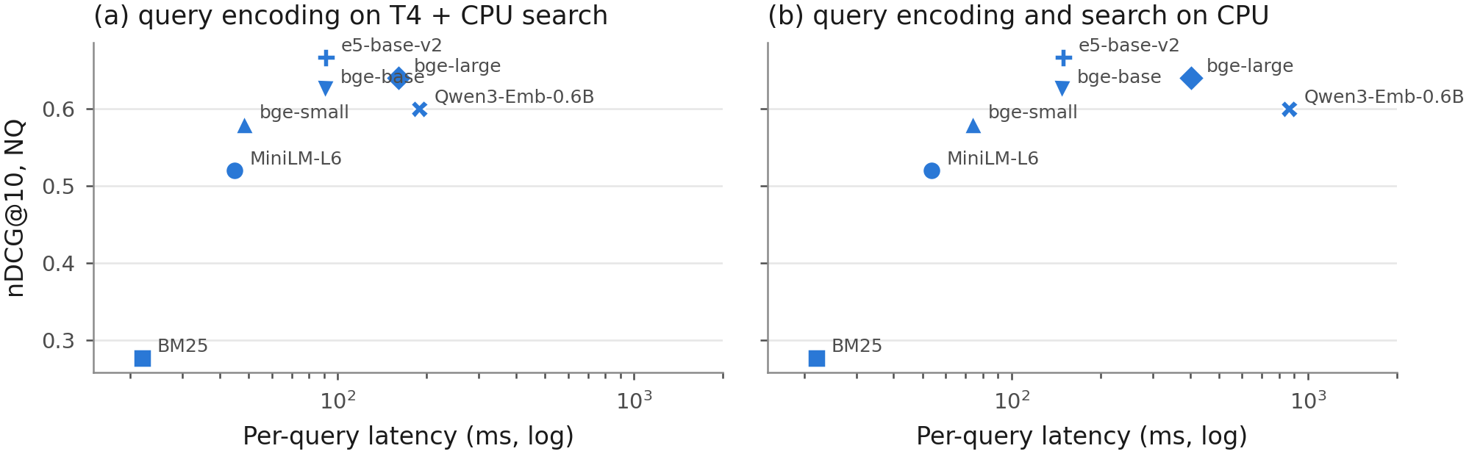
NQ nDCG@10 against per-query latency (Phase 1 batch-1 medians, log scale): (a) query encoding on the T4 and exact search on the CPU; (b) both on the CPU.
Amiraz, Chen, Florin Cuconasu, Simone Filice, and Zohar Karnin. 2025. “The Distracting Effect: Understanding Irrelevant Passages in RAG.” In Proceedings of the 63rd Annual Meeting of the Association for Computational Linguistics (ACL 2025). https://doi.org/10.18653/v1/2025.acl-long.892.
Assadi, Adnan El, Niklas Muennighoff, and Jinhyuk Lee. 2026. “The Embedder’s Dilemma: LLMs Are Better, but at What Cost?” arXiv preprint arXiv:2608.12875.
Bala, Ananto Nayan. 2026. “Recall Is Not Enough: A Reader-Context Diagnostic for Budget-Constrained Retrieval-Augmented Generation.” arXiv preprint arXiv:2607.00725.
Cohen, Jacob. 1960. “A Coefficient of Agreement for Nominal Scales.” Educational and Psychological Measurement 20 (1): 37–46. https://doi.org/10.1177/001316446002000104.
Cuconasu, Florin, Simone Filice, Guy Horowitz, Yoelle Maarek, and Fabrizio Silvestri. 2025. “Do RAG Systems Really Suffer From Positional Bias?” In Proceedings of the 2025 Conference on Empirical Methods in Natural Language Processing, 28022–36. https://doi.org/10.18653/v1/2025.emnlp-main.1422.
Cuconasu, Florin, Giovanni Trappolini, Federico Siciliano, Simone Filice, Cesare Campagnano, Yoelle Maarek, Nicola Tonellotto, and Fabrizio Silvestri. 2024. “The Power of Noise: Redefining Retrieval for RAG Systems.” In Proceedings of the 47th International ACM SIGIR Conference on Research and Development in Information Retrieval, 719–29. ACM. https://doi.org/10.1145/3626772.3657834.
Dror, Rotem, Gili Baumer, Segev Shlomov, and Roi Reichart. 2018. “The Hitchhiker’s Guide to Testing Statistical Significance in Natural Language Processing.” In Proceedings of the 56th Annual Meeting of the Association for Computational Linguistics (Volume 1: Long Papers), 1383–92. Association for Computational Linguistics. https://doi.org/10.18653/v1/p18-1128.
Efron, Bradley, and Robert J. Tibshirani. 1993. An Introduction to the Bootstrap. Springer US. https://doi.org/10.1007/978-1-4899-4541-9.
Es, Shahul, Jithin James, Luis Espinosa Anke, and Steven Schockaert. 2024. “RAGAs: Automated Evaluation of Retrieval Augmented Generation.” In Proceedings of the 18th Conference of the European Chapter of the Association for Computational Linguistics: System Demonstrations, 150–58. Association for Computational Linguistics. https://doi.org/10.18653/v1/2024.eacl-demo.16.
Ghosh, Utshab Kumar, Debayan Mukhopadhyay, and Shubham Chatterjee. 2026. “Assessing the Downstream Utility of Evidence-Aware Retrieval in RAG.” arXiv preprint arXiv:2608.26379.
Grattafiori, Aaron, Abhimanyu Dubey, Abhinav Jauhri, Abhinav Pandey, Abhishek Kadian, Ahmad Al-Dahle, Aiesha Letman, et al. 2024. “The Llama 3 Herd of Models.” arXiv preprint arXiv:2407.21783.
Hitl, Mateo, Marina Bagić Babac, and Vedran Mornar. 2026. “Comparative evaluation of embedding and generative model combinations in retrieval-augmented generation pipelines.” Data Technologies and Applications. https://doi.org/10.1108/DTA-07-2025-0609.
Holm, Sture. 1979. “A Simple Sequentially Rejective Multiple Test Procedure.” Scandinavian Journal of Statistics 6 (2): 65–70. https://www.jstor.org/stable/4615733.
Hsia, Jennifer, Afreen Shaikh, Zhiruo Wang, and Graham Neubig. 2025. “RAGGED: Towards Informed Design of Scalable and Stable RAG Systems.” In Proceedings of the 42nd International Conference on Machine Learning (ICML 2025).
Izacard, Gautier, and Edouard Grave. 2021. “Leveraging Passage Retrieval with Generative Models for Open Domain Question Answering.” In Proceedings of the 16th Conference of the European Chapter of the Association for Computational Linguistics: Main Volume, 874–80. Association for Computational Linguistics. https://doi.org/10.18653/v1/2021.eacl-main.74.
Jiang, Albert Q., Alexandre Sablayrolles, Arthur Mensch, Chris Bamford, Devendra Singh Chaplot, Diego de las Casas, Florian Bressand, et al. 2023. “Mistral 7B.” arXiv preprint arXiv:2310.06825.
Jin, Bowen, Jinsung Yoon, Jiawei Han, and Sercan O. Arik. 2024. “Long-Context LLMs Meet RAG: Overcoming Challenges for Long Inputs in RAG.” arXiv preprint arXiv:2410.05983.
Johnson, Jeff, Matthijs Douze, and Herve Jegou. 2021. “Billion-Scale Similarity Search with GPUs.” IEEE Transactions on Big Data 7 (3): 535–47. https://doi.org/10.1109/tbdata.2019.2921572.
Kamalloo, Ehsan, Nouha Dziri, Charles Clarke, and Davood Rafiei. 2023. “Evaluating Open-Domain Question Answering in the Era of Large Language Models.” In Proceedings of the 61st Annual Meeting of the Association for Computational Linguistics (Volume 1: Long Papers), 5591–5606. Association for Computational Linguistics. https://doi.org/10.18653/v1/2023.acl-long.307.
Karpukhin, Vladimir, Barlas Oguz, Sewon Min, Patrick Lewis, Ledell Wu, Sergey Edunov, Danqi Chen, and Wen-tau Yih. 2020. “Dense Passage Retrieval for Open-Domain Question Answering.” In Proceedings of the 2020 Conference on Empirical Methods in Natural Language Processing (EMNLP), 6769–81. Association for Computational Linguistics. https://doi.org/10.18653/v1/2020.emnlp-main.550.
Kwiatkowski, Tom, Jennimaria Palomaki, Olivia Redfield, Michael Collins, Ankur Parikh, Chris Alberti, Danielle Epstein, et al. 2019. “Natural Questions: A Benchmark for Question Answering Research.” Transactions of the Association for Computational Linguistics 7: 453–66. https://doi.org/10.1162/tacl_a_00276.
Kwon, Woosuk, Zhuohan Li, Siyuan Zhuang, Ying Sheng, Lianmin Zheng, Cody Hao Yu, Joseph Gonzalez, Hao Zhang, and Ion Stoica. 2023. “Efficient Memory Management for Large Language Model Serving with PagedAttention.” In Proceedings of the 29th Symposium on Operating Systems Principles, 611–26. ACM. https://doi.org/10.1145/3600006.3613165.
Landis, J. Richard, and Gary G. Koch. 1977. “The Measurement of Observer Agreement for Categorical Data.” Biometrics 33 (1): 159. https://doi.org/10.2307/2529310.
Lee, Kenton, Ming-Wei Chang, and Kristina Toutanova. 2019. “Latent Retrieval for Weakly Supervised Open Domain Question Answering.” In Proceedings of the 57th Annual Meeting of the Association for Computational Linguistics, 6086–96. Association for Computational Linguistics. https://doi.org/10.18653/v1/p19-1612.
Leto, Alexandria, Cecilia Aguerrebere, Ishwar Bhati, Ted Willke, Mariano Tepper, and Vy Ai Vo. 2024. “Toward Optimal Search and Retrieval for RAG.” arXiv preprint arXiv:2411.07396.
Lewis, Patrick, Ethan Perez, Aleksandra Piktus, Fabio Petroni, Vladimir Karpukhin, Naman Goyal, Heinrich Küttler, et al. 2020. “Retrieval-Augmented Generation for Knowledge-Intensive NLP Tasks.” In Advances in Neural Information Processing Systems 33 (NeurIPS 2020).
Liang, Kung-Yee, and Scott L. Zeger. 1986. “Longitudinal data analysis using generalized linear models.” Biometrika 73 (1): 13–22. https://doi.org/10.1093/biomet/73.1.13.
Lin, Ji, Jiaming Tang, Haotian Tang, Shang Yang, Wei-Ming Chen, Wei-Chen Wang, Guangxuan Xiao, Xingyu Dang, Chuang Gan, and Song Han. 2024. “AWQ: Activation-aware Weight Quantization for LLM Compression and Acceleration.” In Proceedings of Machine Learning and Systems 6 (MLSys 2024).
Liu, Nelson F., Kevin Lin, John Hewitt, Ashwin Paranjape, Michele Bevilacqua, Fabio Petroni, and Percy Liang. 2024. “Lost in the Middle: How Language Models Use Long Contexts.” Transactions of the Association for Computational Linguistics 12: 157–73. https://doi.org/10.1162/tacl_a_00638.
Lù, Xing Han. 2024. “BM25S: Orders of magnitude faster lexical search via eager sparse scoring.” arXiv preprint arXiv:2407.03618.
Lyu, Yuanjie, Zhiyu Li, Simin Niu, Feiyu Xiong, Bo Tang, Wenjin Wang, Hao Wu, Huanyong Liu, Tong Xu, and Enhong Chen. 2025. “CRUD-RAG: A Comprehensive Chinese Benchmark for Retrieval-Augmented Generation of Large Language Models.” ACM Transactions on Information Systems 43 (2): 1–32. https://doi.org/10.1145/3701228.
Malkov, Yu A., and D. A. Yashunin. 2020. “Efficient and Robust Approximate Nearest Neighbor Search Using Hierarchical Navigable Small World Graphs.” IEEE Transactions on Pattern Analysis and Machine Intelligence 42 (4): 824–36. https://doi.org/10.1109/tpami.2018.2889473.
Mathur, Saahil, Ryan David Rittner, Vedant Ajit Thakur, Daniel Stuart Schiff, and Tunazzina Islam. 2026. “Retrieval Improvements Do Not Guarantee Better Answers: A Study of RAG for AI Policy QA.” arXiv preprint arXiv:2603.24580.
McNemar, Quinn. 1947. “Note on the Sampling Error of the Difference Between Correlated Proportions or Percentages.” Psychometrika 12 (2): 153–57. https://doi.org/10.1007/bf02295996.
Medrano, Luigi, Arush Verma, and Mukul Chhabra. 2026. “Scaling Retrieval Augmented Generation with RAG Fusion: Lessons from an Industry Deployment.” arXiv preprint arXiv:2603.02153.
Muennighoff, Niklas, Nouamane Tazi, Loic Magne, and Nils Reimers. 2023. “MTEB: Massive Text Embedding Benchmark.” In Proceedings of the 17th Conference of the European Chapter of the Association for Computational Linguistics, 2014–37. Association for Computational Linguistics. https://doi.org/10.18653/v1/2023.eacl-main.148.
Muthyam, Bharath Simha Reddy. 2026. “A Systems-Level Analysis of Sensitivity, Robustness, and Stability in Retrieval-Augmented Generation.” arXiv preprint arXiv:2606.28337.
Nogueira, Rodrigo, and Kyunghyun Cho. 2019. “Passage Re-ranking with BERT.” arXiv preprint arXiv:1901.04085.
Peng, Shiyao, Qianhe Zheng, Zhuodi Hao, Zichen Tang, Rongjin Li, Qing Huang, Jiayu Huang, Jiacheng Liu, Yifan Zhu, and Haihong E. 2026. “NeocorRAG: Less Irrelevant Information, More Explicit Evidence, and More Effective Recall via Evidence Chains.” In Proceedings of the ACM Web Conference 2026 (WWW ’26), 1899–1910. https://doi.org/10.1145/3774904.3792093.
Petroni, Fabio, Aleksandra Piktus, Angela Fan, Patrick Lewis, Majid Yazdani, Nicola De Cao, James Thorne, et al. 2021. “KILT: a Benchmark for Knowledge Intensive Language Tasks.” In Proceedings of the 2021 Conference of the North American Chapter of the Association for Computational Linguistics: Human Language Technologies, 2523–44. Association for Computational Linguistics. https://doi.org/10.18653/v1/2021.naacl-main.200.
Qwen, An Yang, Baosong Yang, Beichen Zhang, Binyuan Hui, Bo Zheng, Bowen Yu, et al. 2024. “Qwen2.5 Technical Report.” arXiv preprint arXiv:2412.15115.
Ram, Ori, Yoav Levine, Itay Dalmedigos, Dor Muhlgay, Amnon Shashua, Kevin Leyton-Brown, and Yoav Shoham. 2023. “In-Context Retrieval-Augmented Language Models.” Transactions of the Association for Computational Linguistics 11: 1316–31. https://doi.org/10.1162/tacl_a_00605.
Rau, David, Hervé Déjean, Nadezhda Chirkova, Thibault Formal, Shuai Wang, Stéphane Clinchant, and Vassilina Nikoulina. 2024. “BERGEN: A Benchmarking Library for Retrieval-Augmented Generation.” In Findings of the Association for Computational Linguistics: EMNLP 2024, 7640–63. Association for Computational Linguistics. https://doi.org/10.18653/v1/2024.findings-emnlp.449.
Reimers, Nils, and Iryna Gurevych. 2019. “Sentence-BERT: Sentence Embeddings using Siamese BERT-Networks.” In Proceedings of the 2019 Conference on Empirical Methods in Natural Language Processing and the 9th International Joint Conference on Natural Language Processing (EMNLP-IJCNLP), 3980–90. Association for Computational Linguistics. https://doi.org/10.18653/v1/d19-1410.
Repantis, Vyzantinos, Ameya Gawde, Harshvardhan Singh, Rohit Alekar, Cien Zhang, Svetlana Karslioglu, and Akash Vishwakarma. 2026. “Separating Semantic Competition from Context Length in RAG Reading.” arXiv preprint arXiv:2605.27294.
Robertson, Stephen, and Hugo Zaragoza. 2009. “The Probabilistic Relevance Framework: BM25 and Beyond.” Foundations and Trends in Information Retrieval 4 (1-2): 1–174. https://doi.org/10.1561/1500000019.
Saad-Falcon, Jon, Omar Khattab, Christopher Potts, and Matei Zaharia. 2024. “ARES: An Automated Evaluation Framework for Retrieval-Augmented Generation Systems.” In Proceedings of the 2024 Conference of the North American Chapter of the Association for Computational Linguistics: Human Language Technologies (Volume 1: Long Papers), 338–54. Association for Computational Linguistics. https://doi.org/10.18653/v1/2024.naacl-long.20.
Sakai, Tetsuya. 2014. “Statistical reform in information retrieval?” ACM SIGIR Forum 48 (1): 3–12. https://doi.org/10.1145/2641383.2641385.
Salemi, Alireza, and Hamed Zamani. 2024. “Evaluating Retrieval Quality in Retrieval-Augmented Generation.” In Proceedings of the 47th International ACM SIGIR Conference on Research and Development in Information Retrieval, 2395–2400. ACM. https://doi.org/10.1145/3626772.3657957.
Samuel, Saron, Alexander Martin, Eugene Yang, Andrew Yates, Dawn Lawrie, Ian Soboroff, Laura Dietz, and Benjamin Van Durme. 2026. “Beyond Relevance: On the Relationship Between Retrieval and RAG Information Coverage.” In Proceedings of the 2026 ACM SIGIR International Conference on Innovative Concepts and Theories in Information Retrieval (ICTIR ’26). https://doi.org/10.1145/3805713.3820424.
Shi, Freda, Xinyun Chen, Kanishka Misra, Nathan Scales, David Dohan, Ed Chi, Nathanael Schärli, and Denny Zhou. 2023. “Large Language Models Can Be Easily Distracted by Irrelevant Context.” In Proceedings of the 40th International Conference on Machine Learning (ICML 2023), 202:31210–27. PMLR.
Smucker, Mark D., James Allan, and Ben Carterette. 2007. “A comparison of statistical significance tests for information retrieval evaluation.” In Proceedings of the Sixteenth ACM Conference on Conference on Information and Knowledge Management, 623–32. ACM. https://doi.org/10.1145/1321440.1321528.
Thakur, Nandan, Nils Reimers, Andreas Rücklé, Abhishek Srivastava, and Iryna Gurevych. 2021. “BEIR: A Heterogenous Benchmark for Zero-shot Evaluation of Information Retrieval Models.” arXiv preprint arXiv:2104.08663.
Trappolini, Giovanni, Florin Cuconasu, Simone Filice, Yoelle Maarek, and Fabrizio Silvestri. 2025. “Redefining Retrieval Evaluation in the Era of LLMs.” arXiv preprint arXiv:2510.21440.
Wang, Liang, Nan Yang, Xiaolong Huang, Binxing Jiao, Linjun Yang, Daxin Jiang, Rangan Majumder, and Furu Wei. 2022. “Text Embeddings by Weakly-Supervised Contrastive Pre-training.” arXiv preprint arXiv:2212.03533.
Wang, Wenhui, Furu Wei, Li Dong, Hangbo Bao, Nan Yang, and Ming Zhou. 2020. “MiniLM: Deep Self-Attention Distillation for Task-Agnostic Compression of Pre-Trained Transformers.” In Advances in Neural Information Processing Systems 33 (NeurIPS 2020).
Xiao, Shitao, Zheng Liu, Peitian Zhang, Niklas Muennighoff, Defu Lian, and Jian-Yun Nie. 2024. “C-Pack: Packed Resources For General Chinese Embeddings.” In Proceedings of the 47th International ACM SIGIR Conference on Research and Development in Information Retrieval, 641–49. ACM. https://doi.org/10.1145/3626772.3657878.
Yang, Zhilin, Peng Qi, Saizheng Zhang, Yoshua Bengio, William Cohen, Ruslan Salakhutdinov, and Christopher D. Manning. 2018. “HotpotQA: A Dataset for Diverse, Explainable Multi-hop Question Answering.” In Proceedings of the 2018 Conference on Empirical Methods in Natural Language Processing, 2369–80. Association for Computational Linguistics. https://doi.org/10.18653/v1/d18-1259.
Zhang, Yanzhao, Mingxin Li, Dingkun Long, Xin Zhang, Huan Lin, Baosong Yang, Pengjun Xie, et al. 2025. “Qwen3 Embedding: Advancing Text Embedding and Reranking Through Foundation Models.” arXiv preprint arXiv:2506.05176.
Zhao, Shengming, Yuchen Shao, Yuheng Huang, Jiayang Song, Zhijie Wang, Chengcheng Wan, and Lei Ma. 2026. “Understanding the Fundamental Design Decisions of Retrieval-Augmented Generation Systems.” ACM Transactions on Software Engineering and Methodology. https://doi.org/10.1145/3802824.
Zheng, Lianmin, Wei-Lin Chiang, Ying Sheng, Siyuan Zhuang, Zhanghao Wu, Yonghao Zhuang, Zi Lin, et al. 2023. “Judging LLM-as-a-Judge with MT-Bench and Chatbot Arena.” In Advances in Neural Information Processing Systems 36 (NeurIPS 2023), Datasets and Benchmarks Track.

