How much retrieval gain reaches the answer? Transfer ratios and retrieval-stage cost of open embedding models in retrieval-augmented question answering
Abstract
Retrieval-augmented generation (RAG) systems are often built around the embedding model with the best retrieval score. We asked how much of a paired retrieval gain reaches the answer. On Natural Questions (NQ, 2,255 queries) and HotpotQA (2,000 queries), we compared BM25 and six open embedding models (23–596M parameters) under two quantised 7–8B readers, with corpus, prompt and decoding fixed, and registered predictions before the second and third study phases. The transfer ratio $T$ divides the exact-match (EM) gain over a small baseline encoder by the Hit@5 gain on the same queries. On NQ, $T$ of the five dense encoders was 0.16–0.27 (largest upper 95% bound 0.455). Rerun on the full 2.68-million-passage corpus with both readers, the dense ratios were 0.15–0.23, and the ratio of e5-base-v2 lay inside its sub-corpus interval. $T$ stayed well below 1 under F1, answer containment and a BM25 baseline, but was higher when the reader saw one passage. Queries that newly retrieved a gold passage gained EM, queries that kept or lost a hit gave some back, and 0.41–0.55 of dense-encoder Hit@5 misses still contained an answer string. On HotpotQA, $T$ was 0.49–0.93 with Hit@5 but 0.29–0.35 with Both@5, which requires both supporting passages; queries that gained supporting passages carried the whole EM gain. Retrieval-stage throughput on one T4 GPU differed 27-fold across encoders, and larger encoders gave no detected EM gain over e5-base-v2 on NQ. In this setting, retrieval gains overstate answer gains, and multi-hop retrieval should be scored by complete evidence.

Keywords
retrieval-augmented generation; dense retrieval; text embeddings; question answering; evaluation; reproducibility; computational cost

Introduction
Retrieval-augmented generation (RAG) answers a question in two steps. A retriever selects passages from a corpus, and a language model, the reader, writes an answer from them (Lewis et al. 2020; Izacard and Grave 2021; Ram et al. 2023). Teams that build such systems must choose the retriever. For dense retrieval this means choosing a text embedding model, and the usual guide is a retrieval benchmark such as BEIR (Thakur et al. 2021) or MTEB (Muennighoff et al. 2023). These benchmarks score ranked lists against relevance labels. They do not show how much of a retrieval gain survives the reader.
This question matters most for teams with limited compute. A larger encoder costs more to run over a corpus and adds latency to every query. If a retrieval gain turns into a much smaller answer gain, a cheaper encoder may serve as well. It is already known that better retrieval does not reliably give better answers (Salemi and Zamani 2024; Mathur et al. 2026; Medrano, Verma, and Chhabra 2026; Ghosh, Mukhopadhyay, and Chatterjee 2026), that retrieval metrics can still track generation quality when the two are aligned (Samuel et al. 2026; Hitl, Bagić Babac, and Mornar 2026), and that passages which look relevant but lack the answer can lower accuracy (Cuconasu et al. 2024; Amiraz et al. 2025; Shi et al. 2023). What is less clear is how large the answer gain is, relative to the retrieval gain, when one interchangeable encoder replaces another, and where in the query set that gain appears.
Earlier studies relate retrieval quality to answer quality through correlations across systems or topics (Salemi and Zamani 2024; Samuel et al. 2026; Trappolini et al. 2025), through a ratio of answer F1 to recall across RAG methods (Peng et al. 2026), or through manipulations of a single retriever (Leto et al. 2024). Correlations describe whether systems are ranked in the same order; they do not say how many answer points one retrieval point buys. Two encoders can be ranked correctly by Hit@5 while the answer gain between them is a quarter of the retrieval gain. We found no study that reports, for a set of interchangeable open encoders, the paired ratio of answer gain to retrieval gain with its uncertainty, per reader and dataset, next to the measured retrieval-stage cost of each encoder. This study provides such estimates for one controlled setting.
We define a transfer ratio $T\left(R\right)$: the gain in exact match (EM) of retriever $R$ over a small baseline encoder, divided by its gain in Hit@5, both measured on the same queries. A ratio of 1 means that EM rises by as many points as Hit@5, and a ratio near 0 means that the retrieval gain does not reach the answer. $T\left(R\right)$ is a descriptive ratio of paired mean gains. It is not a probability, not a causal conversion efficiency, and not the share of newly retrieved passages that the reader uses; it depends on the baseline and on the retrieval metric, so it describes a pair of retrievers rather than one encoder; and 1 is a reference point, not a target. We therefore also account for the gain query by query. We estimate $T\left(R\right)$ for BM25 and five dense encoders against MiniLM-L6, with two quantised 7–8B readers, on a single-hop dataset (Natural Questions) and a multi-hop dataset (HotpotQA). All runs used free Kaggle T4 GPUs.
We ask four research questions.
RQ1
How much of a Hit@5 gain over a small encoder reaches EM, and does this depend on the reader and the dataset?
RQ2
Do larger or newer encoders give higher EM than a mid-size encoder (e5-base-v2)?
RQ3
How do context choices change the answer: the number of passages, the kind of non-gold passages, the position of the gold passage, and reranking?
RQ4
What is each encoder’s retrieval-stage cost on free hardware, and do our sub-corpus and exact search distort the comparison?
The study ran in three phases. Phase 1 covered one reader on NQ. Before Phase 2, we registered six predictions (P1–P6) in a dated design document and then ran the new cells and experiments. Before Phase 3, we registered two more (P7, P8) and ran both readers on retrieval from the full NQ corpus, to test whether the 300,000-passage sub-corpus that all other answer results use had changed the NQ ratios. We report whether each stated criterion was met, including the three that were not met in at least one condition.
The study makes four contributions.
- Paired estimates of the answer gain per unit of retrieval gain for six retrievers, two readers and two datasets, with bootstrap intervals and a reporting rule fixed in advance, their sensitivity to the answer metric, the baseline, the retrieval metric and the number of passages read, and a registered replication of the NQ ratios on the full corpus (Sections 5.2–5.4).
- Evidence that, for multi-hop questions, the size of the transfer depends on whether retrieval is scored by complete evidence: with Both@5 instead of Hit@5 the HotpotQA ratios fall to the NQ range (Section 5.3).
- A query-level accounting that splits each EM gain exactly into queries that gained, kept or lost labelled evidence, which shows where the NQ and HotpotQA gains sit, and an answer-string check of the passages behind NQ retrieval misses (Section 5.5).
- Measured retrieval-stage cost of each encoder on a free GPU, controlled checks of context composition, reranking, approximate search and the sub-corpus, and a full record of every deviation and failed run (Sections 5.7–5.8 and 4.1).
Section 2 reviews related work. Sections 3 and 4 describe the method and setup. Section 5 reports the results, Section 6 discusses them, and Section 7 lists the limits of the study.

Related work

Retrieval quality and answer quality
Dense passage retrieval replaced sparse retrieval as the default initial stage for open-domain question answering (Karpukhin et al. 2020; Lee, Chang, and Toutanova 2019), and retrieval-augmented readers turned retrieved passages into answers (Lewis et al. 2020; Izacard and Grave 2021). Sentence encoders and general-purpose embedding models made dense retrieval cheap to adopt (Reimers and Gurevych 2019; L. Wang et al. 2022; Xiao et al. 2024; Zhang et al. 2025). Their quality is usually judged on retrieval benchmarks (Thakur et al. 2021; Muennighoff et al. 2023).
Earlier work relates retrieval scores to answer scores in three ways. One line of work correlates retrieval metrics with downstream metrics. Salemi and Zamani (2024) report that relevance-label metrics correlate weakly with downstream RAG performance and propose labels derived from the reader itself. Trappolini et al. (2025) argue that rank-discounted metrics fit a human reader, not a language model, and propose a utility- and distraction-aware gain. Samuel et al. (2026) find positive topic- and system-level correlations between coverage-based retrieval metrics and the coverage of generated reports, with weaker links for relevance-based nDCG. A second line builds ratios. Peng et al. (2026) define a recall conversion rate as answer F1 divided by Recall@5 and report that it falls as recall rises across RAG methods. Their ratio compares levels across different pipelines. Our ratio compares paired gains of interchangeable encoders against one baseline. A third line manipulates retrieval directly. Leto et al. (2024) vary the share of gold passages and the accuracy of approximate search for one dense retriever and find that gold-document recall matters far more than search recall. Hitl, Bagić Babac, and Mornar (2026) benchmark combinations of embedding models and 7–9B generators with recall, EM, F1 and latency, and conclude that retrieval quality remained the main determinant of end-to-end quality; their abstract reports no paired ratio of answer gain to retrieval gain. Domain studies report retrieval gains that did not improve answers (Mathur et al. 2026; Medrano, Verma, and Chhabra 2026; Muthyam 2026; Ghosh, Mukhopadhyay, and Chatterjee 2026). Bala (2026) show that recall of the retrieved set can differ from what reaches the reader once a context budget forces truncation.

Context composition
Readers are sensitive to the passages placed next to the gold passage. Shi et al. (2023) show that irrelevant context distracts language models. Cuconasu et al. (2024) find that high-scoring passages without the answer lower accuracy, while random passages placed before the gold passage can raise it. Amiraz et al. (2025) quantify a distracting effect per passage. Jin et al. (2024) attribute the drop in quality at large retrieval depth to hard negatives, and Repantis et al. (2026) isolate competition between passages from context length. Position effects were reported for long contexts (Liu et al. 2024), but Cuconasu et al. (2025) find them marginal in realistic retrieval settings. Hsia et al. (2025) report that the reader’s tolerance of noise shapes how a RAG system scales with retrieval depth, and Zhao et al. (2026) find that 5–10 documents work best for question answering across several models.

Encoder cost
Embedding benchmarks report quality; cost is rarely measured in the same study. Assadi, Muennighoff, and Lee (2026) compare the cost of embedding models and language models on embedding tasks, without a reader. Approximate nearest-neighbour search reduces query cost (Malkov and Yashunin 2020; Johnson, Douze, and Jegou 2021); Leto et al. (2024) find that it changes answer quality little. Efficient serving (Kwon et al. 2023) and weight quantisation (Lin et al. 2024) make 7–8B readers fit on one consumer-grade GPU.

Evaluation practice
RAG evaluation frameworks use language models as judges (Es et al. 2024; Saad-Falcon et al. 2024; Zheng et al. 2023), and benchmarks package many retrievers and readers (Rau et al. 2024; Petroni et al. 2021; Lyu et al. 2025). Lexical EM undercounts correct answers from language models (Kamalloo et al. 2023); we therefore also report token F1 and answer containment. For significance testing we follow advice from natural language processing and information retrieval: paired tests, multiplicity control and effect sizes with intervals (Dror et al. 2018; Smucker, Allan, and Carterette 2007; Sakai 2014).

Method
Fig. 1 shows the system under test. A question goes to one of seven retrievers, which searches a fixed corpus; the top $k$ passages go to one of two readers; the answer is scored against reference answers. Only the retriever changes between conditions within a reader–dataset cell.
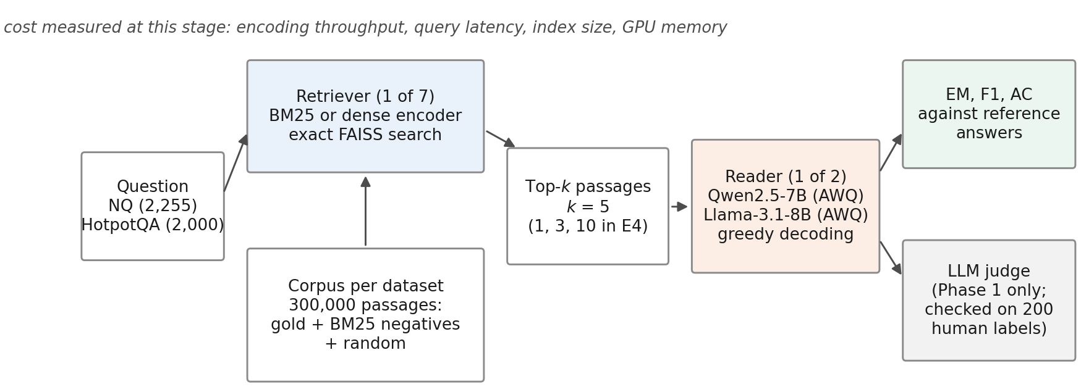
System under test. Within a reader–dataset cell only the retriever changes. Cost is measured at the retrieval stage. The LLM judge was used only in Phase 1 and was later excluded (Section 5.9).

Transfer ratio
Let $Q$ be a fixed set of generation queries. For retriever $R$ and query $q$, let $h_{R}\left(q\right)∈\{0,1\}$ indicate that at least one gold passage of $q$ is among the top five passages, and let $e_{R}\left(q\right)∈\{0,1\}$ be the exact match of the reader’s answer given those five passages. Write ${\overset{‾}{h}}_{R}$ and ${\overset{‾}{e}}_{R}$ for the means over $Q$. With MiniLM-L6 as the baseline $R_{1}$, the transfer ratio is
$$T\left(R\right)=\frac{{\overset{‾}{e}}_{R}−{\overset{‾}{e}}_{R_{1}}}{{\overset{‾}{h}}_{R}−{\overset{‾}{h}}_{R_{1}}}.$$
Both differences are paired: they use the same queries, the same reader, the same prompt and the same decoding. $T\left(R\right)$ is a ratio of mean differences. It is not the probability that one extra hit produces one extra correct answer, because the queries that gain a hit need not be the queries that gain an answer. Ratios are compared with the unrounded bootstrap bounds; a bound of exactly 1 counts as reaching 1. We report $T\left(R\right)$ only if $\left|{\overset{‾}{h}}_{R}−{\overset{‾}{h}}_{R_{1}}\right|$ exceeds 2 percentage points and the Hit@5 difference is significant after Holm correction; otherwise the ratio is marked as not estimable. This rule was fixed in the Phase 1 design to avoid ratios with near-zero denominators. $T\left(R\right)$ depends on the choice of $R_{1}$. As post hoc sensitivity analyses we therefore repeat every ratio with BM25 as the baseline and, for HotpotQA, with Both@5 instead of Hit@5 in the denominator, under the same rule.

Decomposition
Let $a_{R}=P\left(e_{R}=1∣h_{R}=1\right)$ and $b_{R}=P\left(e_{R}=1∣h_{R}=0\right)$ be the EM rates among hits and misses. Then ${\overset{‾}{e}}_{R}={\overset{‾}{h}}_{R}a_{R}+\left(1−{\overset{‾}{h}}_{R}\right)b_{R}$, and Eq. [eq:ratio] splits exactly into
$$T\left(R\right)=\underset{\text{baseline hit–miss gap}}{\underset{⏟}{\left(a_{R_{1}}−b_{R_{1}}\right)}}+\underset{\text{change in conditional EM}}{\underset{⏟}{\frac{{\overset{‾}{h}}_{R} \left(a_{R}−a_{R_{1}}\right)+\left(1−{\overset{‾}{h}}_{R}\right) \left(b_{R}−b_{R_{1}}\right)}{{\overset{‾}{h}}_{R}−{\overset{‾}{h}}_{R_{1}}}}}.$$
Multiplied by ${\overset{‾}{h}}_{R}−{\overset{‾}{h}}_{R_{1}}$, Eq. [eq:decomp] splits the EM gain into three terms: a hit-prevalence term $\left({\overset{‾}{h}}_{R}−{\overset{‾}{h}}_{R_{1}}\right)\left(a_{R_{1}}−b_{R_{1}}\right)$, an EM-among-hits term ${\overset{‾}{h}}_{R} \left(a_{R}−a_{R_{1}}\right)$ and an EM-among-misses term $\left(1−{\overset{‾}{h}}_{R}\right) \left(b_{R}−b_{R_{1}}\right)$. If a better encoder only turned misses into hits and left $a$ and $b$ unchanged, $T\left(R\right)$ would equal the baseline gap. We report the three terms with bootstrap intervals over the same resamples as $T\left(R\right)$, and the share of the EM gain carried by the last two together. The split is not unique. Eq. [eq:decomp] weights the change in hit rate by the baseline’s conditional rates; a symmetric form averages the two orderings of $R_{1}$ and $R$, and we report it alongside. Either form is an accounting identity, not a causal attribution: the queries that count as hits differ between encoders, so a change in $a$ can reflect which questions are hits as well as how useful a hit is. This decomposition was not part of the registered analysis; we report it as a post hoc description.

Query-level accounting
The decomposition works with rates. To see where the gain sits, we also group the queries of a cell by their Hit@5 under MiniLM-L6 and under encoder $R$: miss$→$hit, hit$→$hit, hit$→$miss and miss$→$miss. For each group we report its size, the EM of both retrievers within it, the numbers of answers that turned from wrong to right and from right to wrong, and its contribution to the EM gain, q∈G​eRq−eR1q/Q. The four contributions add up to ${\overset{‾}{e}}_{R}−{\overset{‾}{e}}_{R_{1}}$ exactly. For HotpotQA we group the queries in the same way by the number of supporting passages (0, 1 or 2) in the top five. The groups are defined by retrieval outcomes, so they describe where the EM difference sits, not what caused it. This analysis is post hoc.

Data

Natural Questions
We used the BEIR version of Natural Questions (Kwiatkowski et al. 2019; Thakur et al. 2021): 3,452 judged test queries and a corpus of 2,681,468 Wikipedia passages. BEIR does not ship short answers, so we joined its queries to NQ-open (Lee, Chang, and Toutanova 2019) by normalised question text. The join matched 2,255 queries; 1,197 had no match and none had more than one. All 2,255 joined queries form the NQ generation set. Table 10 in the appendix summarises both datasets and sub-corpora.

HotpotQA
We used the BEIR version of HotpotQA (Yang et al. 2018; Thakur et al. 2021): 7,405 judged test queries, two gold passages per query, and a corpus of 5,233,329 passages. Answers come from the fullwiki validation release, joined by question id; all queries matched. The generation set is the leading 2,000 queries of a seeded order (1,616 bridge and 384 comparison questions).

Sub-corpus
Encoding millions of passages with six encoders exceeds a free GPU budget, so each dataset uses a 300,000-passage sub-corpus. It contains the gold passages of all judged queries, the top-$d$ BM25 passages of every judged query ($d$ = 42 for NQ and 19 for HotpotQA, set by a pre-registered formula), and a seeded random fill. All retrievers search the same sub-corpus. The NQ sub-corpus has 4,201 gold, 127,791 BM25 and 168,008 random passages; the HotpotQA sub-corpus has 13,783, 118,726 and 167,491. Because every gold passage is present, absolute retrieval scores are higher than on the full corpus. The construction also treats the retrievers unequally: it keeps BM25’s own strongest competitors for every judged query, but not those of the dense encoders, so it favours the dense encoders relative to BM25. The gold labels of the evaluation queries are used only to insert their gold passages; no model is trained on them. Section 5.4 checks whether the NQ transfer ratios change on the full corpus, and Section 5.8 whether the ordering of retrievers changes.

Retrievers
BM25 used the bm25s library (Lù 2024) with the Lucene variant, $k_{1}=1.2$, $b=0.75$, lower-casing and no stemming or stop-word removal (Robertson and Zaragoza 2009). The six dense encoders were all-MiniLM-L6-v2 (Reimers and Gurevych 2019; W. Wang et al. 2020), bge-small, bge-base and bge-large v1.5 (Xiao et al. 2024), e5-base-v2 (L. Wang et al. 2022) and Qwen3-Embedding-0.6B (Zhang et al. 2025). Each model ran at a pinned revision in half precision with a maximum of 256 tokens and its documented query and passage prefixes. Dense search used exact inner-product search in FAISS (Johnson, Douze, and Jegou 2021). Table [tab:models] in the appendix lists the models, revisions and prefixes.

Readers and prompts
The readers were Qwen2.5-7B-Instruct (Qwen et al. 2024) and Llama-3.1-8B-Instruct (Grattafiori et al. 2024), both in 4-bit AWQ form (Lin et al. 2024), served with vLLM (Kwon et al. 2023) on one T4 each. Decoding was greedy with at most 32 new tokens and a stop at a newline. The main prompt (A1) gives the top $k=5$ passages in rank order, each as “[i] title / text”, and asks for a short answer (Appendix 9). Two reference conditions frame each cell: closed book (no passages) and gold passages only. They are references, not hard bounds: a retrieved context can in principle beat the gold-only context.

Metrics
Hit@5 is 1 if at least one gold passage is in the top five. Every HotpotQA query has exactly two distinct gold passages; Both@5 is 1 if both are in the top five. nDCG@10 uses binary gains. EM is 1 if the normalised answer equals a normalised reference answer. Normalisation follows SQuAD (lower case, no punctuation or articles, single spaces) and also removes typographic quotes, en and em dashes and the ellipsis; a plain SQuAD normaliser would change the score of 91 of 131,855 answers (0.07%). Token F1 and answer containment (AC; a normalised reference occurs in the normalised output) are secondary metrics, because lexical EM undercounts correct answers from language models (Kamalloo et al. 2023).

Statistical analysis
All comparisons are paired by query. Binary outcomes use the exact McNemar test (McNemar 1947). Within each reader–dataset cell, the 21 pairwise retriever comparisons of a metric form one family with Holm correction (Holm 1979); on the full NQ corpus the family is the six pairs among the four retrievers run there. Intervals are 95% percentile bootstrap intervals over queries (Efron and Tibshirani 1993) with 10,000 resamples and seed 0; for $T\left(R\right)$ the numerator and denominator are resampled together, and no resample produced a zero or reversed Hit@5 difference. For the query-level accounting each query keeps its group, so group sizes vary across resamples and the interval is for the group’s contribution to the population EM gain. A secondary model pools the four cells: a logistic generalised estimating equation (Liang and Zeger 1986) for EM with retriever, dataset and reader as factors, an exchangeable working correlation within query, and empirical (sandwich) standard errors. The cluster is the query, which carries all retrievers and both readers of its dataset. This registered model assumes one retriever effect for both datasets. Post hoc, we test that assumption with a Wald test of retriever $×$ dataset interaction terms (and of retriever $×$ reader terms) and report dataset-specific odds ratios from the interaction model. Agreement between the LLM judge and human labels uses Cohen’s $κ$ (Cohen 1960; Landis and Koch 1977). A non-significant test is reported as “no difference detected”, not as equivalence.

Pre-registered predictions
Phase 1 (Qwen reader, NQ) was designed and committed before any data were generated. Before Phase 2 we registered six predictions (Table [tab:predictions]):
P1
In each new cell, every reportable $T\left(R\right)$ of a dense encoder has an upper 95% bound below 1.
P2
In each new cell, bge-large and Qwen3-Embedding-0.6B show no Holm-significant EM gain over e5-base-v2.
P3
The nDCG@10 ordering of BM25, MiniLM-L6, bge-small and e5-base-v2 on the sub-corpus holds on the full corpus.
P4
For every retriever, EM at $k=1$ is lower than at $k=5$.
P5
Gold plus four hard negatives gives lower EM than gold plus four random passages.
P6
The position of the gold passage (1, 3 or 5) changes EM.
Before Phase 3 we registered two predictions for the readers on the full NQ corpus, together with the analysis of Section 5.4:
P7
For each reader, every reportable full-corpus $T\left(R\right)$ of a dense encoder has an upper 95% bound below 1.
P8
For each reader, the full-corpus $T$ of e5-base-v2 lies inside its sub-corpus 95% interval.
Fig. 2 shows the sessions of the three phases. The Qwen–NQ cell and the $k$ ablation for BM25, MiniLM-L6 and bge-large existed before registration. Their P1, P2 and P4 verdicts are therefore not confirmatory, and Table [tab:predictions] marks them. All other analyses are descriptive or secondary. Appendix 12 lists the design documents and their dates.
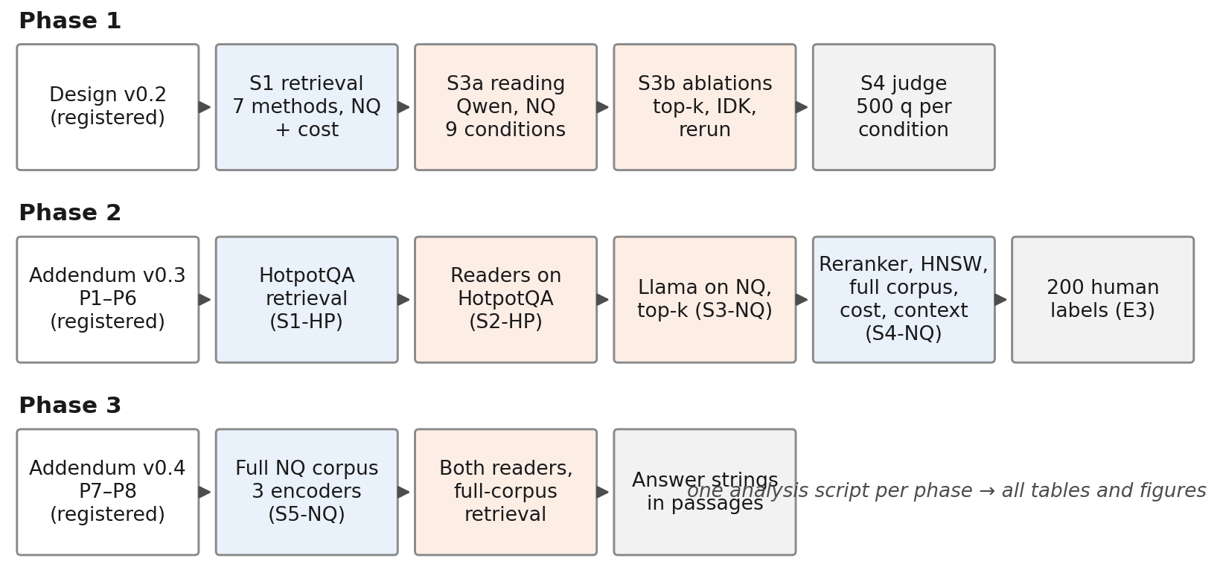
Study phases and Kaggle sessions. Each phase started with a dated design document; Phase 2 added the second dataset, the second reader and the additional experiments, and Phase 3 the readers on full-corpus NQ retrieval.

Additional experiments

Top-$k$ (E4)
The Qwen reader answered all NQ queries with $k∈\{1,3,5,10\}$ for all seven retrievers.

Context composition (E12)
On the leading 500 NQ generation queries of the seeded order, the Qwen reader always saw five passages: gold at position 1 plus four hard negatives (M1); gold at position 3 or 5 among the same negatives (M3, M5); gold at position 1 plus four random passages (MR); and the gold passage alone (MG). Hard negatives are the top-ranked BM25 passages that are not labelled gold.

Reranking (E5)
A cross-encoder, bge-reranker-base, reranked the top 50 passages of BM25 and of e5-base-v2 (Nogueira and Cho 2019; Xiao et al. 2024); the Qwen reader then answered NQ from the reranked top five.

Approximate search (E6)
HNSW indexes (Malkov and Yashunin 2020) ($M=32$, efConstruction 200, efSearch 64 and 128) replaced exact search for MiniLM-L6, bge-small and e5-base-v2 on the NQ sub-corpus.

Full corpus (E9)
BM25, MiniLM-L6, bge-small and e5-base-v2 retrieved from the full NQ corpus for all judged queries.

Full-corpus readers (Phase 3)
MiniLM-L6, bge-small and e5-base-v2 encoded all 2,681,468 NQ passages again, with the same revisions and settings, and exact search returned the top 100 passages for every judged query; the BM25 full-corpus run of Phase 1 was reused. Both readers then answered the 2,255 NQ generation queries from the top five passages of these four retrievers with prompt A1 and greedy decoding (18,040 answers). The ranked lists, reader outputs and scores were all stored.

Answer strings in passages
For each run and query we checked whether any of the top five passages contains a reference answer: a normalised reference occurs as a whole-token span of the normalised passage title and text, the rule of answer containment. The same check covered the gold passages and, for the context experiment, the four hard negatives of each question. This is a lexical check; it was registered with Phase 3 and is descriptive.

Retrieval-stage cost (E7)
For each encoder we measured passage-encoding throughput on 20,000 passages (batch 128, after warm-up, with GPU synchronisation) and batch-1 query-encoding latency on 500 queries, five times in one session.

Judge validation (E3)
In Phase 1, an LLM judge (Mistral-7B-Instruct-v0.3; (Jiang et al. 2023)) labelled whether each answer was supported by its passages, for 500 NQ queries per retriever. The author labelled a stratified sample of 200 items without seeing the judge’s verdicts. The registered rule was: use the judge if $κ≥0.4$, use it only with a sensitivity analysis if $0.2≤κ<0.4$, and exclude it if $κ<0.2$.

Experimental setup

Hardware and software
All runs used free Kaggle notebook sessions with two NVIDIA Tesla T4 GPUs (15 GB each), four virtual CPUs and 31.3 GiB of memory. Each process used one GPU; two processes could run in parallel. The code of every session was embedded in its notebook and checked against a fixed version-control tree hash before it ran. Every session recorded its Python version, package versions and model revisions. The readers ran with the same stack in every session (PyTorch 2.13.0 with CUDA 13.0, vLLM 0.30.0, Transformers 5.17.0). Between Phases 1 and 2 the Kaggle image changed from Python 3.12.13 to 3.13.15, and NumPy from 2.0.2 to 2.1.3; Phase 3 used the same image and package versions as Phase 2. The two sessions that encoded the NQ and HotpotQA sub-corpora used older images (PyTorch 2.10.0 and 2.11.0 with CUDA 12.8, Transformers 5.0.0); Table [tab:env] lists the software of every session as its environment log recorded it.

Determinism across phases
Some comparisons cross the software change between Phase 1 and the later phases: the Qwen–NQ cell against the new cells in the pooled model, $k=5$ against the new $k$ values, the reranker runs against the Phase 1 runs, and the Phase 3 full-corpus runs of the Qwen reader against its Phase 1 sub-corpus runs. To check that the software change does not alter the reader, we compared Phases 1 and 2 on inputs that were identical by construction: the gold-only context of Phase 1 and the gold-only condition of the context experiment. Of 397 identical prompts, 396 produced identical outputs; the one difference was a shorter answer to the same question. A rerun of 100 prompts within one session gave 100/100 identical outputs.

Seeds and repetitions
The query order (seed 20260926), bootstrap (seed 0), decoding (greedy, seed 0) and the random passages of the context experiment were fixed. Retrieval and greedy decoding are deterministic within a session, so we ran each answer condition once. The cost measurements were repeated five times.

Analysis and verification
One analysis script reads only the committed raw outputs and writes all statistics, tables and figures. The author reran it on a second computer and obtained identical output. A separate script, written without the project code and using only the Python standard library, re-scored all 131,855 answers from the raw reader outputs, recomputed every Hit@5 and EM mean, every transfer ratio point estimate, all 84 pairwise EM tests with their Holm adjustment, and Cohen’s $κ$. It found no disagreement. Bootstrap intervals, F1, answer containment and the pooled model were not re-implemented independently. Phase 3 has its own analysis script, which also reads only committed outputs. It checks that the passages each reader saw equal the top five of the stored ranked lists, and that the sub-corpus intervals it recomputes equal the committed ones. Re-encoding the full corpus gave Hit@5 and nDCG@10 values identical to those of the earlier full-corpus check (E9) for all four retrievers. A second script, again written without the project code, re-scored all 18,040 Phase 3 answers from the raw reader outputs and recomputed the means, ratios with their intervals, McNemar tests, query-level contributions and the answer-string shares of MiniLM-L6 and e5-base-v2; it found no disagreement.

Deviations and failed runs
We list every departure from the registered design.
- NQ join gate. The original design required a join rate of at least 0.70 between BEIR-NQ and NQ-open; the observed rate was 0.653. Before any outcome was observed, we replaced the gate with a minimum of 1,000 joined queries, because the two resources are independently filtered subsets of Natural Questions. Retrieval results on all 3,452 judged queries are reported where they matter (Table 7).
- Software image. The initial Phase 2 session stopped at the environment check because the Kaggle image had moved to Python 3.13, for which the pinned NumPy had no wheel. We unpinned NumPy and recorded all version differences; no data were produced by the stopped run.
- Failed reader start. The initial HotpotQA reader session stopped before generating anything because the image’s torchaudio build did not match the CUDA version of PyTorch. Later sessions reinstalled the matching build and checked the stack before any other step.
- Reduced scope of E6. Approximate search was planned for all six encoders. To stay within the GPU quota it ran for MiniLM-L6, bge-small and e5-base-v2, using the sub-corpus rows of the full-corpus embeddings.
- E7 scope. The repeated cost measurement covered encoding throughput and query-encoding latency; search latency was measured separately in E6 and is not repeated.
- Phase 1 deviations. We dropped the planned RAGAS cross-check, because its local deployment needed infrastructure that was untested on our hardware. We did not run the planned Matryoshka dimension ablation for Qwen3-Embedding-0.6B, so dimension and model are confounded in our cost comparison. The design planned two annotators for the judge validation; one took part. One gold-passage output reached the token limit, so the judge scored 499 instead of 500 gold items. The initial Phase 1 reading session stopped before generating because a notebook cell ran before the restore step; it was rerun with unchanged code. We estimated the Phase 1 CPU benchmark at one hour; it took eight hours and 24 minutes. This used free quota but changed no data.
- Failure log. The design promised one machine-readable failure log. Failures were recorded instead in two dated design addenda and in the session logs.
- Phase 3 human audit. The Phase 3 design adds a blinded audit of 100 seeded e5-base-v2 retrieval misses by the author. Its labels were not complete when this version was written, so it is not reported. The Phase 3 session itself ran as registered, with no failed run.
No run was repeated to obtain a different result, and no result was discarded.

Results

Retrieval
Table [tab:retrieval] gives retrieval quality on the generation queries, and Table [tab:ci] gives the intervals. On NQ, the dense encoders differed widely. MiniLM-L6 reached 0.664 and e5-base-v2 0.816; bge-large (0.796) came second. Qwen3-Embedding-0.6B (0.744) placed between bge-small and bge-base. BM25 reached 0.363. On HotpotQA, Hit@5 nearly saturated: all dense encoders except MiniLM-L6 scored between 0.945 and 0.961, against 0.817 for MiniLM-L6 and 0.833 for BM25. The stricter Both@5 separated them more clearly: bge-large found both supporting passages for 0.621 of the questions, e5-base-v2 for 0.544, Qwen3-Embedding-0.6B for 0.444 and MiniLM-L6 for 0.230. Table [tab:retrieval] also gives Hit@1, Hit@10, nDCG@10 and MRR@10, and Fig. 3 shows the main metrics with their intervals. On NQ, nDCG@10 ordered the retrievers as Hit@5 did, from 0.277 for BM25 and 0.520 for MiniLM-L6 to 0.667 for e5-base-v2. On HotpotQA, nDCG@10 ranged from 0.549 (MiniLM-L6) to 0.797 (bge-large).
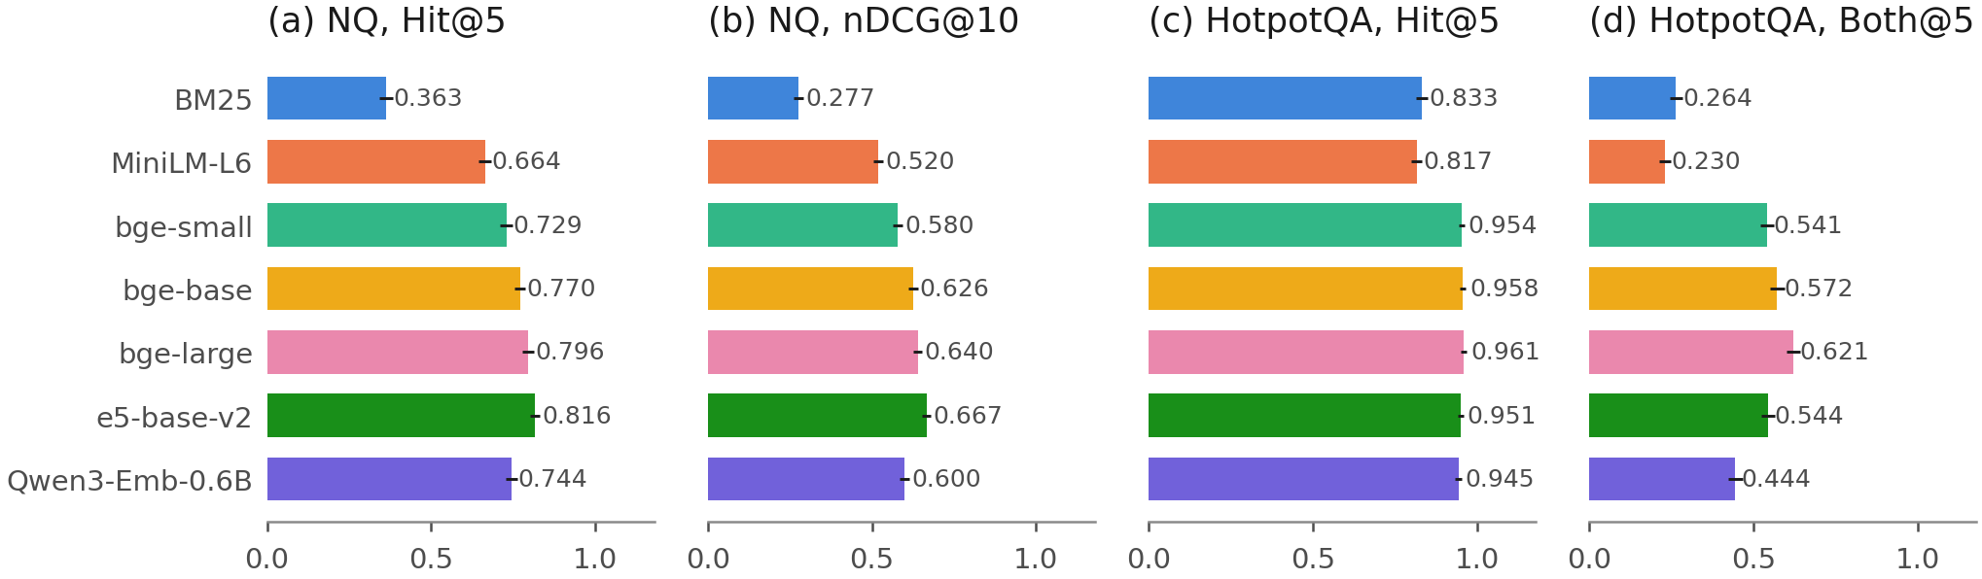
Retrieval quality on the generation queries with 95% bootstrap intervals: NQ Hit@5 and nDCG@10 (2,255 queries), HotpotQA Hit@5 and Both@5 (2,000 queries).
 | NQ (2,255 queries) |  |  |  |  | HotpotQA (2,000 queries)
2-6(lr)7-11 Retriever | Hit@1 | Hit@5 | Hit@10 | nDCG@10 | MRR@10 | Hit@1 | Hit@5 | Both@5 | nDCG@10 | MRR@10
BM25 | 0.150 | 0.363 | 0.472 | 0.277 | 0.243 | 0.666 | 0.833 | 0.264 | 0.578 | 0.740
MiniLM-L6 | 0.316 | 0.664 | 0.792 | 0.520 | 0.462 | 0.623 | 0.817 | 0.230 | 0.549 | 0.708
bge-small | 0.375 | 0.729 | 0.843 | 0.580 | 0.526 | 0.812 | 0.954 | 0.541 | 0.756 | 0.874
bge-base | 0.421 | 0.770 | 0.882 | 0.626 | 0.570 | 0.836 | 0.958 | 0.572 | 0.777 | 0.888
bge-large | 0.430 | 0.796 | 0.888 | 0.640 | 0.584 | 0.846 | 0.961 | 0.621 | 0.797 | 0.897
e5-base-v2 | 0.458 | 0.816 | 0.906 | 0.667 | 0.612 | 0.799 | 0.951 | 0.544 | 0.751 | 0.864
Qwen3-Emb-0.6B | 0.400 | 0.744 | 0.843 | 0.600 | 0.547 | 0.810 | 0.945 | 0.444 | 0.717 | 0.868
NQ intervals for Hit@5 and nDCG@10 are in Table [tab:ci] and Fig. 3. Both@5: both gold passages in the top five.

Answer gains and transfer ratios (RQ1)
Table [tab:main] gives EM for every cell with its two reference conditions, and Fig. 4 plots EM against Hit@5. Retrieval closed only part of the gap between the closed-book and gold-passage conditions. With Qwen on NQ, closed-book EM was 0.149, gold passages gave 0.653, and the best retriever, e5-base-v2, gave 0.510. With Llama on NQ the best retriever was bge-base (0.477) against a gold-passage reference of 0.613. On HotpotQA, bge-large gave the highest EM for both readers (0.424 and 0.430), against gold-passage references of 0.628 and 0.624.
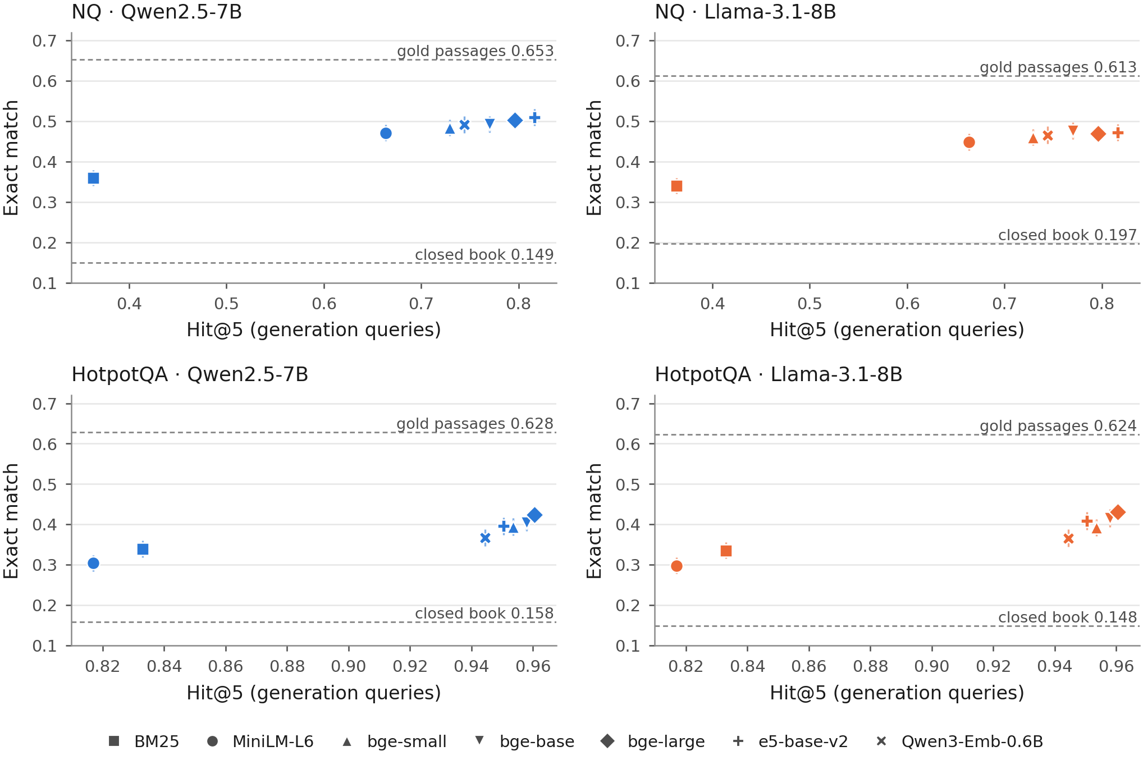
Exact match against Hit@5 for each retriever in the four reader–dataset cells. Vertical bars are 95% bootstrap intervals for EM. Dashed lines mark the closed-book and gold-passage reference conditions. Note the different Hit@5 ranges of the two datasets.
Table [tab:transfer] and Fig. 5 give the transfer ratios. On NQ, the five dense encoders had ratios between 0.16 (bge-large and e5-base-v2 with Llama) and 0.27 (bge-base with Llama). With Qwen, e5-base-v2 gained +0.153 in Hit@5 over MiniLM-L6 but only +0.038 in EM, a ratio of 0.25 [0.15, 0.36]. The intervals for bge-small included zero in both NQ cells (Qwen [−0.07, 0.44], Llama [−0.08, 0.43]), so its NQ ratio is uncertain in sign. The largest NQ upper bound was 0.455 (Qwen3-Embedding-0.6B with Qwen). BM25 retrieved worse than MiniLM-L6 on NQ, so its ratio (0.37 with Qwen) relates an EM loss to a Hit@5 loss.
With Hit@5 as the denominator, the HotpotQA ratios were larger for every encoder and reader, from 0.49 (Qwen3-Embedding-0.6B with Qwen) to 0.93 (bge-large with Llama). With Qwen, every upper bound stayed below 1, the largest being 0.996 for bge-large. With Llama, the bounds were 1.000 for bge-base, 1.000 for e5-base-v2 and 1.096 for bge-large, so the P1 criterion (every upper bound below 1) was met in the two new NQ and Qwen–HotpotQA cells and not met in the Llama–HotpotQA cell (Table [tab:predictions]). The BM25 ratio was not estimable on HotpotQA, because BM25 and MiniLM-L6 differed by only +0.016 in Hit@5.
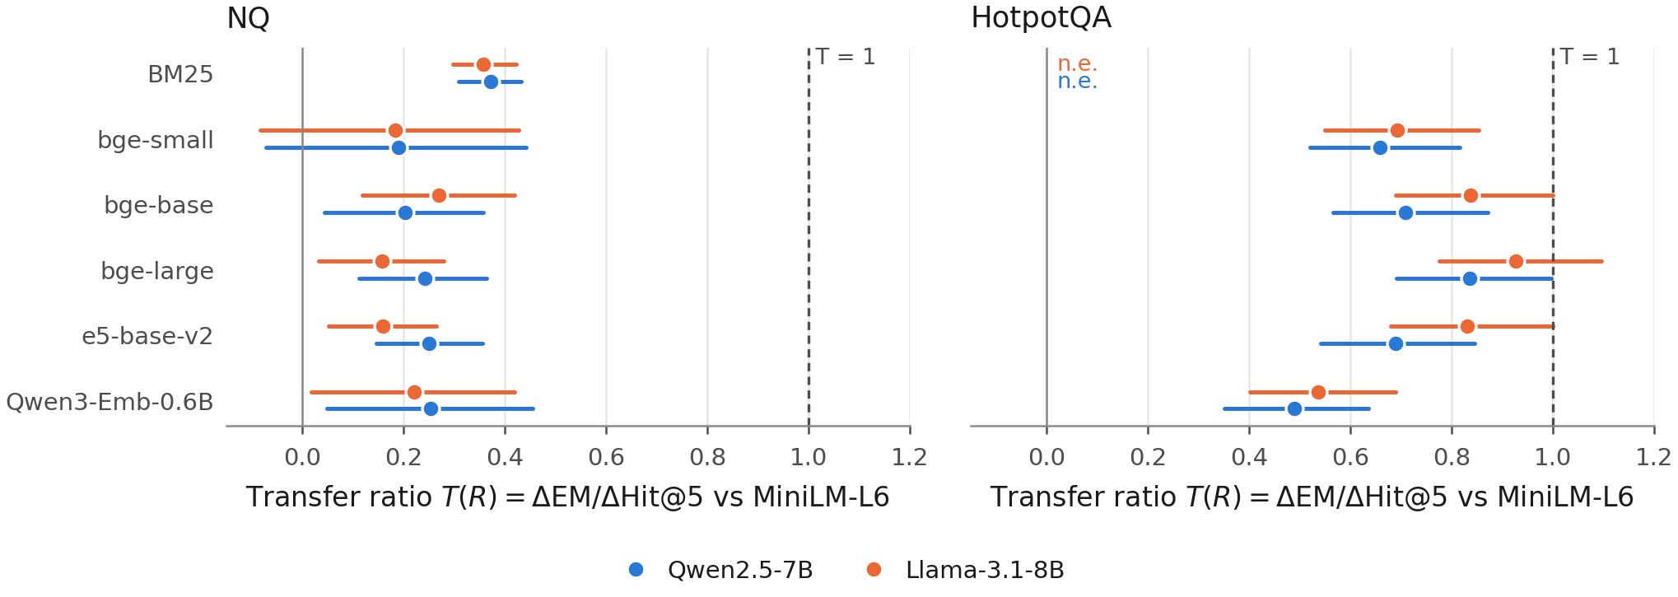
Transfer ratio $T\left(R\right)=ΔEM/ΔHit@5$ against MiniLM-L6 with 95% bootstrap intervals. The dashed line marks $T=1$, a reference point. n.e.: not estimable under the reporting rule.
 | NQ (2,255 queries) |  |  |  | HotpotQA (2,000 queries)
2-5(lr)6-9 | Qwen |  | Llama |  | Qwen |  | Llama
2-3(lr)4-5(lr)6-7(lr)8-9 Retriever | Hit@5 | EM | Hit@5 | EM | Hit@5 | EM | Hit@5 | EM
BM25 | 0.363 | 0.360 | 0.363 | 0.340 | 0.833 | 0.339 | 0.833 | 0.336
MiniLM-L6 | 0.664 | 0.471 | 0.664 | 0.448 | 0.817 | 0.304 | 0.817 | 0.297
bge-small | 0.729 | 0.484 | 0.729 | 0.460 | 0.954 | 0.394 | 0.954 | 0.392
bge-base | 0.770 | 0.493 | 0.770 | 0.477 | 0.958 | 0.404 | 0.958 | 0.415
bge-large | 0.796 | 0.503 | 0.796 | 0.469 | 0.961 | 0.424 | 0.961 | 0.430
e5-base-v2 | 0.816 | 0.510 | 0.816 | 0.472 | 0.951 | 0.396 | 0.951 | 0.408
Qwen3-Emb-0.6B | 0.744 | 0.492 | 0.744 | 0.466 | 0.945 | 0.366 | 0.945 | 0.366
Closed book | – | 0.149 | – | 0.197 | – | 0.158 | – | 0.148
Gold passages | – | 0.653 | – | 0.613 | – | 0.628 | – | 0.624
Retriever | NQ Qwen | NQ Llama | HotpotQA Qwen | HotpotQA Llama
BM25 | 0.37 [0.31, 0.43] | 0.36 [0.30, 0.42] | n.e. | n.e.
bge-small | 0.19 [$−$0.07, 0.44] | 0.18 [$−$0.08, 0.43] | 0.66 [0.52, 0.82] | 0.69 [0.55, 0.85]
bge-base | 0.20 [0.04, 0.36] | 0.27 [0.12, 0.42] | 0.71 [0.57, 0.87] | 0.84 [0.69, 1.00]
bge-large | 0.24 [0.11, 0.36] | 0.16 [0.03, 0.28] | 0.84 [0.69, 1.00] | 0.93 [0.78, 1.10]
e5-base-v2 | 0.25 [0.15, 0.36] | 0.16 [0.05, 0.26] | 0.69 [0.54, 0.85] | 0.83 [0.68, 1.00]
Qwen3-Emb-0.6B | 0.25 [0.05, 0.45] | 0.22 [0.02, 0.42] | 0.49 [0.35, 0.64] | 0.54 [0.40, 0.69]
n.e.: not estimable under the pre-registered rule ($\left|ΔHit@5\right|≤2$ points or not significant after Holm). BM25 on NQ retrieves worse than MiniLM-L6, so its ratio describes a loss.

How stable are the ratios?
Table [tab:sensitivity] repeats the dense-encoder ratios under other answer metrics, another baseline, another retrieval metric and other numbers of passages. Only the top row is the registered analysis.
On NQ, one pattern held in every row read at $k≥3$: each ratio and each upper bound stayed well below 1. With token F1 the NQ ratios were 0.23–0.33, with answer containment 0.27–0.39, and against BM25 instead of MiniLM-L6 0.29–0.35; the largest upper bound over these rows was 0.60. The size of the ratio was not stable, however. It fell with the number of passages read: 0.41–0.83 at $k=1$, 0.32–0.37 at $k=3$ and 0.05–0.19 at $k=10$ (Qwen; exploratory, Hit@$k$ matched to $k$). At $k=1$ the largest upper bound was 1.22.
On HotpotQA, the size of the ratio depended mainly on the retrieval metric. With Both@5 instead of Hit@5 as the denominator, the dense-encoder ratios were 0.29–0.35 for both readers, close to the NQ ratios against BM25, and Qwen3-Embedding-0.6B no longer stood apart. Against BM25 with Hit@5, the HotpotQA ratios were 0.25–0.75; they exceeded the NQ ratios in 8 of 10 encoder–reader pairs, the exceptions being Qwen3-Embedding-0.6B (0.25 and 0.27 against 0.35 and 0.33). Under F1, the Llama ratio of bge-large was 1.10 [0.95, 1.28], so full transfer cannot be ruled out for that encoder when it is measured with Hit@5.
The stable finding is therefore that, with three to ten passages read ($k$ = 3, 5 and 10), a Hit@5 gain over a small encoder bought a much smaller EM gain on NQ. The exact ratio depends on the baseline, the answer metric and $k$, and the larger HotpotQA ratios depend on scoring retrieval by any rather than all supporting passages.
Answer metric, retrieval metric, baseline | NQ ratios | NQ max. upper | HotpotQA ratios | HotpotQA max. upper
EM (primary), Hit@5, MiniLM-L6 | 0.16–0.27 | 0.45 | 0.49–0.93 | 1.10
token F1, Hit@5, MiniLM-L6 | 0.23–0.33 | 0.49 | 0.52–1.10 | 1.28
answer containment, Hit@5, MiniLM-L6 | 0.27–0.39 | 0.60 | 0.49–1.01 | 1.18
EM, Hit@5, BM25 | 0.29–0.35 | 0.40 | 0.25–0.75 | 0.92
EM, Both@5, MiniLM-L6 | – | – | 0.29–0.35 | 0.41
EM, Hit@$k$ at $k=1$, MiniLM-L6 (Qwen) | 0.41–0.83 | 1.22 | – | –
EM, Hit@$k$ at $k=3$, MiniLM-L6 (Qwen) | 0.32–0.37 | 0.59 | – | –
EM, Hit@$k$ at $k=10$, MiniLM-L6 (Qwen) | 0.05–0.19 | 0.42 | – | –
Max. upper: largest upper 95% bootstrap bound in the row. The $k$ rows match Hit@$k$ to the $k$ passages read (Qwen reader, NQ only; exploratory, without the reporting rule).

Do the NQ ratios hold on the full corpus?
All results so far use the 300,000-passage sub-corpus, which favours the dense encoders relative to BM25. In Phase 3 both readers answered the NQ generation queries from retrieval on the full corpus of 2,681,468 passages (Table [tab:fullreader] and Fig. 6). On the full corpus the dense encoders lost 0.089–0.100 in Hit@5 and 0.018–0.028 in EM (all Holm-adjusted $p≤$ 0.014). BM25 kept its Hit@5, and its EM changed by no detectable amount (−0.005 to −0.001; $p≥$ 0.16).
The transfer ratios hardly moved. With e5-base-v2, $T$ was 0.233 [0.13, 0.33] with Qwen, inside its sub-corpus interval [0.147, 0.356], and 0.195 [0.09, 0.30] with Llama, inside [0.053, 0.265]. The paired differences from the sub-corpus ratios were −0.02 [−0.12, +0.09] and +0.04 [−0.06, +0.14]. The bge-small ratios were 0.15 [−0.12, 0.40] and 0.22 [−0.05, 0.48]; as on the sub-corpus, their intervals included zero. Every dense upper bound stayed below 1 (largest 0.483), so P7 and P8 were met for both readers. Against BM25, the ratios of bge-small and e5-base-v2 were 0.33–0.38 on the full corpus and 0.29–0.34 on the sub-corpus.
The query-level accounting also kept its shape. Queries that moved from miss to hit contributed +0.043 to +0.062 to the EM gain, those that hit under both retrievers −0.020 to −0.011 (interval below zero in 3 of 4 encoder–reader pairs) and those that lost their hit −0.022 to −0.010. In a comparison that was not pre-specified, the full corpus cost the three dense encoders 0.20–0.28 EM points per Hit@5 point lost, about the size of the transfer ratios themselves. At most 1.0% of the full-corpus outputs could not be parsed.
NQ transfer ratios against MiniLM-L6 on the sub-corpus (open circles) and on the full corpus (filled squares), with 95% bootstrap intervals; 2,255 queries, $k=5$. The dashed line marks $T=1$.
 | Hit@5 |  | EM |  |  |  | $T$ vs MiniLM-L6 [95% CI]
2-3(lr)4-5(lr)8-9 Retriever | sub | full | sub | full | $Δ$EM full$−$sub | $p_{\text{Holm}}$ | sub | full
Qwen2.5-7B
BM25 | 0.363 | 0.364 | 0.360 | 0.358 | −0.001 | 0.798 | 0.37 [0.31, 0.43] | 0.44 [0.35, 0.53]
MiniLM-L6 | 0.664 | 0.564 | 0.471 | 0.446 | −0.025 | $<$0.001 | – | –
bge-small | 0.729 | 0.630 | 0.484 | 0.456 | −0.028 | $<$0.001 | 0.19 [−0.07, 0.44] | 0.15 [−0.12, 0.40]
e5-base-v2 | 0.816 | 0.728 | 0.510 | 0.484 | −0.025 | $<$0.001 | 0.25 [0.15, 0.36] | 0.23 [0.13, 0.33]
Llama-3.1-8B
BM25 | 0.363 | 0.364 | 0.340 | 0.335 | −0.005 | 0.155 | 0.36 [0.30, 0.42] | 0.44 [0.34, 0.54]
MiniLM-L6 | 0.664 | 0.564 | 0.448 | 0.423 | −0.025 | $<$0.001 | – | –
bge-small | 0.729 | 0.630 | 0.460 | 0.437 | −0.023 | 0.002 | 0.18 [−0.08, 0.43] | 0.22 [−0.05, 0.48]
e5-base-v2 | 0.816 | 0.728 | 0.472 | 0.455 | −0.018 | 0.014 | 0.16 [0.05, 0.26] | 0.20 [0.09, 0.30]
Sub-corpus values are those of Table [tab:transfer]. $Δ$EM: paired difference full $−$ sub (intervals in the repository), exact McNemar test, Holm over the four retrievers per reader. Full-corpus ratios use the reporting rule with Holm over the six pairs among the four retrievers. BM25’s ratio relates an EM loss to a Hit@5 loss.

Where the gain sits

Query-level accounting
Table [tab:transitions] groups the queries by their Hit@5 under MiniLM-L6 and under each dense encoder (per-encoder values with intervals in Table [tab:transdetail]). On NQ, 14–19% of the queries moved from miss to hit. Their EM rose by +0.26 to +0.34 within the group, from a MiniLM-L6 level of 0.23–0.30: many of these “misses” had already been answered correctly. This group contributed +0.040 to +0.055 to the EM gain. Two groups gave part of it back. The 59–62% of queries that hit under both retrievers contributed −0.021 to −0.007 (interval below zero in 7 of 10 encoder–reader pairs), and the 4–7% that lost their hit contributed −0.019 to −0.006 (below zero in 10 of 10). Queries that missed under both contributed −0.002 to +0.007, an interval that contained zero in 9 of 10 pairs. The net NQ gain was 29–72% of the gain from new hits alone.
On HotpotQA, 81% of the queries hit under both retrievers, and this group made the largest contribution in every encoder–reader pair (+0.035 to +0.084, all 10 intervals above zero). Table 1 shows where this gain sits: grouped by the number of supporting passages in the top five, the queries for which the encoder retrieved more supporting passages (34–48%) carried 100–130% of the EM gain, most of it from queries that went from one supporting passage to two (62–81%). Queries with the same number of supporting passages contributed −0.011 to +0.002, and those with fewer −0.012 to −0.002.
These groups are defined by retrieval outcomes and are not randomised, so they describe where the EM gain sits, not why. The NQ pattern is consistent with sparse relevance labels and with answers the reader already knew, and the HotpotQA pattern with the second supporting passage being the useful one.

Answer strings in NQ misses
Table 2 checks the label-sparsity reading for NQ. Among the Hit@5 misses of the dense encoders, 0.41–0.55 had a reference answer string in their top five passages on the sub-corpus (e5-base-v2: 0.50 [0.45, 0.55] of 414 misses) and 0.44–0.58 on the full corpus; for BM25 the share was 0.33. Among hits it was 0.92–0.94. The check is lexical and incomplete in both directions. A passage can mention the answer without supporting it, and the gold passages themselves contained an answer string for only 0.93 [0.92, 0.94] of the queries. Even so, a large part of what Hit@5 counts as a miss gave the reader a passage with the answer in it.
 | NQ |  |  | HotpotQA
2-4(lr)5-7 Hit@5 (MiniLM-L6 $→$ encoder) | % queries | $Δ$EM within | Contribution | % queries | $Δ$EM within | Contribution
miss $→$ hit | 14–19 | +0.26 to +0.34 | +0.040 to +0.055 | 14–15 | +0.22 to +0.34 | +0.030 to +0.050
hit $→$ hit | 59–62 | −0.03 to −0.01 | −0.021 to −0.007 | 81 | +0.04 to +0.10 | +0.035 to +0.084
hit $→$ miss | 4–7 | −0.30 to −0.15 | −0.019 to −0.006 | 1 | −0.33 to +0.00 | −0.003 to +0.000
miss $→$ miss | 14–20 | −0.01 to +0.04 | −0.002 to +0.007 | 3–5 | −0.03 to +0.02 | −0.001 to +0.001
all queries | 100 |  | +0.012 to +0.038 | 100 |  | +0.062 to +0.133
$Δ$EM within: EM of the encoder minus EM of MiniLM-L6 among the queries of the group. Contribution: the group’s share of the overall EM difference, (sum of paired EM differences in the group) / all queries; the four contributions add up to the overall $Δ$EM exactly. Groups are defined by retrieval outcomes and describe where the EM difference sits, not why. Per-encoder values with 95% bootstrap intervals: Table [tab:transdetail].
HotpotQA: EM gain over MiniLM-L6 by change in the number of supporting passages (0, 1 or 2) in the top five. Ranges over five dense encoders and two readers. Post hoc, descriptive.
Supporting passages in top 5 (encoder vs MiniLM-L6) | % queries | Contribution to $Δ$EM | % of $Δ$EM
more supporting passages | 34–48 | +0.081 to +0.134 | 100–130
same number | 50–62 | −0.011 to +0.002 | −11 to 1
fewer supporting passages | 2–4 | −0.012 to −0.002 | −18 to −2
The three contributions add up to $Δ$EM exactly. Shares above 100% occur because the other two groups contribute small losses.
Share of Hit@5 misses and hits whose top five passages contain a reference answer string (NQ, 2,255 generation queries).
 | Misses, sub-corpus |  | Misses, full corpus |  | Hits, sub
2-3(lr)4-5 Retriever | with answer | $n$ | with answer | $n$ | with answer
BM25 | 0.33 [0.31, 0.36] | 1,436 | 0.33 [0.30, 0.35] | 1,435 | 0.93
MiniLM-L6 | 0.41 [0.37, 0.44] | 758 | 0.44 [0.41, 0.47] | 983 | 0.92
bge-small | 0.48 [0.44, 0.52] | 611 | 0.51 [0.48, 0.55] | 834 | 0.93
bge-base | 0.51 [0.46, 0.55] | 518 | – | – | 0.93
bge-large | 0.55 [0.50, 0.59] | 460 | – | – | 0.93
e5-base-v2 | 0.50 [0.45, 0.55] | 414 | 0.58 [0.54, 0.62] | 614 | 0.94
Qwen3-Emb-0.6B | 0.46 [0.42, 0.50] | 577 | – | – | 0.93
Automatic, lexical check: a normalised reference answer occurs as a whole-token span of a normalised passage (title and text), the rule of answer containment. Under this rule the gold passages contain an answer for 0.93 of the queries. A match does not show that the passage supports the answer.

Decomposition
The rate-based decomposition of Eq. [eq:decomp] agrees with this accounting (Tables [tab:components], [tab:decomp] and Fig. 7). The baseline hit–miss gap of MiniLM-L6 was similar in all cells: 0.33 and 0.32 on NQ, 0.25 and 0.28 on HotpotQA. On NQ, the hit-prevalence term was +0.021 to +0.051, the EM-among-hits term −0.024 to −0.009 (interval below zero for 2 of 10 pairs) and the EM-among-misses term −0.004 to +0.007 (interval containing zero for 10 of 10). EM given a miss stayed near 0.244, well above closed-book EM (0.149). On HotpotQA, the EM-among-hits term was +0.031 to +0.093, with every interval above zero, while the EM-among-misses term was −0.003 to +0.000. The two conditional terms together made up 48% to 70% of the HotpotQA gain in the baseline-conditioned form and 44% to 64% in the symmetric form (Table 11); the hits term alone made up 48% to 71%. On NQ we do not report shares: the EM gains are small and every dense encoder’s share interval was at least 1.4 wide, where 1 is the whole gain.
In a post hoc check, the EM ranking of the seven retrievers equalled their Both@5 ranking in both HotpotQA cells (Spearman $ρ$ = 1.00 and 1.00); against Hit@5 it was 0.96 and 0.96. The gains came mainly from bridge questions. With Qwen, bridge EM rose from 0.248 (MiniLM-L6) to 0.384 (bge-large), while comparison EM moved from 0.539 to 0.594, close to its gold-passage reference of 0.654.
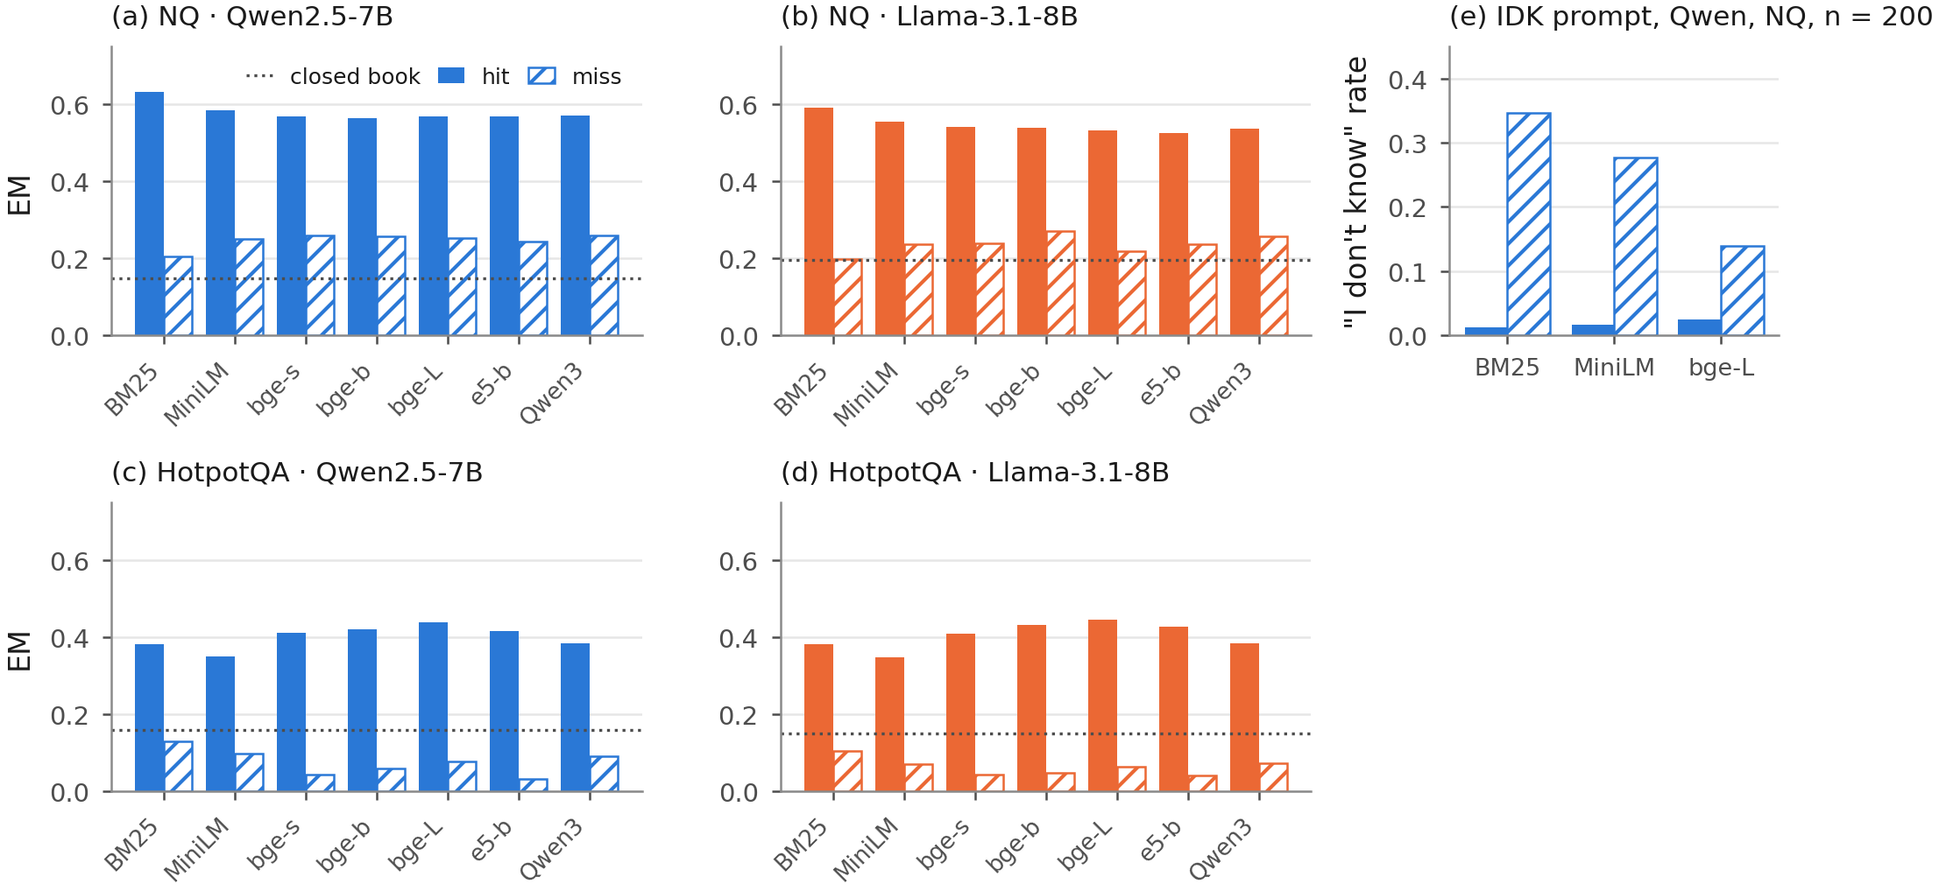
(a)–(d) Exact match given a hit (solid) and given a miss (hatched) at Hit@5, per reader–dataset cell; dotted line: closed-book EM. (e) Share of “I don’t know” answers on hits and misses under the abstention prompt A3 (Phase 1, Qwen reader, NQ, 200 queries).

Abstention prompt
A Phase 1 check (Table 12) is consistent with the reading that NQ “misses” often still contain usable evidence. When the prompt allowed “I don’t know” (A3, Appendix 9), the reader abstained mostly on misses: 0.347 of BM25 misses, 0.276 of MiniLM-L6 misses and 0.139 of bge-large misses, against 0.013 to 0.024 of hits. Most misses were still answered. EM under A3 did not differ detectably from the main prompt (−0.010, −0.015 and −0.030; $p≥$ 0.07).

Encoder comparisons (RQ2)
The P2 criterion was met on NQ and not met on HotpotQA (Table [tab:predictions]). On NQ, neither bge-large nor Qwen3-Embedding-0.6B differed detectably from e5-base-v2 in EM with either reader. On HotpotQA, bge-large gave higher EM than e5-base-v2 with both readers (+0.028, Holm-adjusted $p$ = 0.0055; +0.022, $p$ = 0.040), in line with its higher Both@5. Qwen3-Embedding-0.6B gave lower EM than e5-base-v2 on HotpotQA (−0.030, $p$ = 0.0031; −0.042, $p$ = $8.5×{10}^{−6}$). The registered pooled model over all four cells (Table [tab:gee]; 59,570 answers in 4,255 query clusters) gave odds ratios of 1.038 [1.001, 1.076] for bge-large and 0.909 [0.875, 0.943] for Qwen3-Embedding-0.6B, each against e5-base-v2. This main-effects model assumes the same retriever effect on both datasets, and the data do not support that assumption: the retriever $×$ dataset terms were jointly significant (Wald $χ_{6}^{2}$ = 179, $p$ = $5.2×{10}^{−36}$), while retriever $×$ reader terms were not ($p$ = 0.55). In the interaction model (post hoc), bge-large had an odds ratio of 0.981 [0.936, 1.028] on NQ and 1.109 [1.049, 1.172] on HotpotQA; Qwen3-Embedding-0.6B had 0.952 [0.906, 1.001] and 0.859 [0.811, 0.909]. The small pooled advantage of bge-large thus averages no detected effect on NQ with a gain on HotpotQA, in line with the per-cell tests. Both models mix the two study phases and are secondary.
 | Pooled (main effects) | With retriever $×$ dataset interaction
3-4 Contrast | both datasets | NQ | HotpotQA
bge-large vs e5-base-v2 | 1.038 [1.001, 1.076] | 0.981 [0.936, 1.028] | 1.109 [1.049, 1.172]
Qwen3-Emb-0.6B vs e5-base-v2 | 0.909 [0.875, 0.943] | 0.952 [0.906, 1.001] | 0.859 [0.811, 0.909]
Pooled: EM $∼$ retriever + dataset + reader (registered secondary model). Interaction model: EM $∼$ retriever $×$ dataset + reader (post hoc). Retriever $×$ dataset: Wald $χ_{6}^{2}$ = 179, $p$ = $5.2×{10}^{−36}$; adding retriever $×$ reader: $χ_{6}^{2}$ = 5.0, $p$ = 0.55. Exchangeable working correlation (0.60) within query; 59,570 answers in 4,255 query clusters; empirical (sandwich) standard errors. All models converged without warnings.

Context choices (RQ3)

Number of passages
Table 3 and Fig. 8 show EM for $k∈\{1,3,5,10\}$ with Qwen on NQ. One passage gave lower EM than five for every retriever (P4 criterion met; differences from −0.126 for BM25 to −0.078 for e5-base-v2, all Holm-adjusted $p<0.001$). From five to ten passages, EM rose for six retrievers and stayed flat for e5-base-v2 (0.510 and 0.508). The gap between retrievers shrank with $k$: at $k=10$ all dense encoders gave EM between 0.502 and 0.520. In an exploratory check (Table [tab:transferk]), we matched Hit@$k$ to the $k$ passages the reader saw. The transfer ratio then fell with $k$; for bge-large it was 0.61 [0.47, 0.77] at $k=1$, 0.33 at $k=3$, 0.24 at $k=5$ and 0.19 [0.02, 0.35] at $k=10$. The NQ ratios of Section 5.2 therefore describe $k=5$ only. More passages also cost more reading: the mean prompt grew from 210 tokens at $k=1$ to 738 at $k=5$ and 1,414 at $k=10$ for bge-large. In a second exploratory comparison, bge-large with one passage gave higher EM than BM25 with ten passages (+0.022 [0.001, 0.042]; exact McNemar $p$ = 0.044, uncorrected).
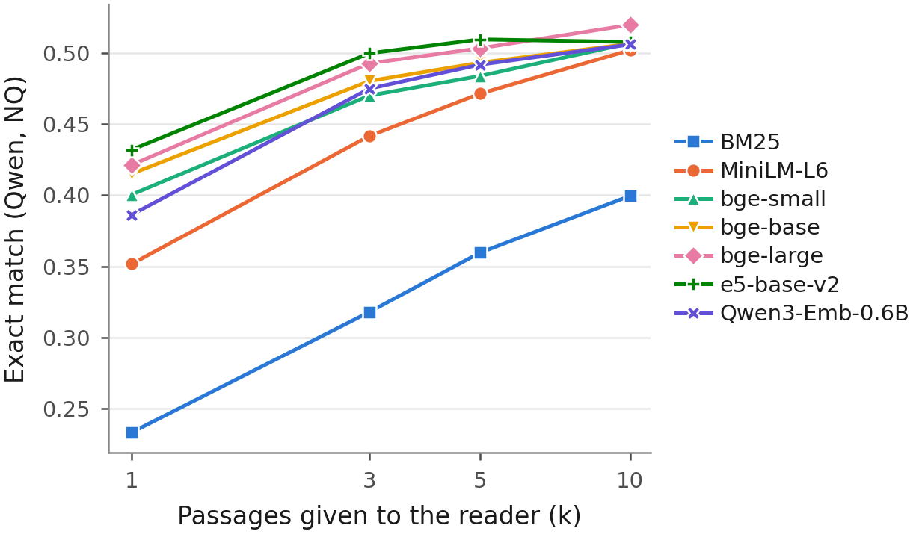
Exact match by number of passages $k$, Qwen reader on NQ (2,255 queries).

Passage composition and position
Table 4 and Fig. 9 give the controlled context test on 500 NQ questions. With the gold passage at position 1, four top-ranked non-gold BM25 passages gave EM 0.580, and four random passages gave 0.654: a drop of 0.074 (exact McNemar $p$ = $2.2×{10}^{−5}$; P5 criterion met). Adding four random passages to the gold passage changed EM by no detectable amount: gold at position 1 plus four random passages gave 0.654, and the gold passage alone gave 0.648 (difference +0.006, 95% CI [−0.016, 0.026]; $p$ = 0.71). No equivalence margin was registered, so this interval is not evidence that random passages have no effect; it only bounds the effect in this sample of 500 questions. Under the answer-string rule, at least one hard negative contained an answer for 167 of the 500 questions (0.33, Wilson interval [0.29, 0.38]). On the 333 questions without such a passage, the drop was larger: EM 0.535 with hard negatives against 0.637 with random passages (−0.102, 95% CI [−0.144, −0.060]; $p$ $<$0.001). On the other questions the two contexts gave 0.671 and 0.689 (not pre-specified). Answer-bearing hard negatives therefore made the registered P5 effect smaller, not larger. The position of the gold passage among the hard negatives showed no detectable effect (EM 0.580, 0.564 and 0.578 at positions 1, 3 and 5; all Holm-adjusted $p≥$ 0.94; P6 criterion not met).
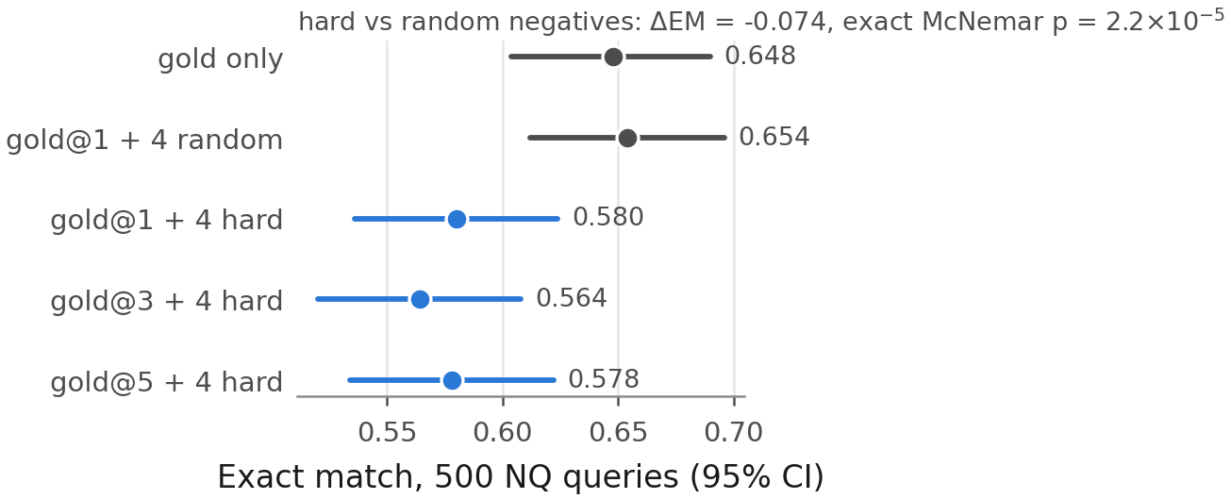
Exact match for five controlled contexts of five passages (Qwen reader, 500 NQ generation queries) with 95% bootstrap intervals.
Exact match by number of passages $k$ (Qwen reader, NQ, 2,255 queries).
Retriever | $k=1$ | $k=3$ | $k=5$ | $k=10$ | $Δ_{1−5}$ | $p_{\text{Holm}}$
BM25 | 0.233 | 0.318 | 0.360 | 0.400 | $−$0.126 | $<$0.001
MiniLM-L6 | 0.352 | 0.442 | 0.471 | 0.502 | $−$0.120 | $<$0.001
bge-small | 0.400 | 0.470 | 0.484 | 0.507 | $−$0.083 | $<$0.001
bge-base | 0.415 | 0.480 | 0.493 | 0.506 | $−$0.078 | $<$0.001
bge-large | 0.421 | 0.493 | 0.503 | 0.520 | $−$0.082 | $<$0.001
e5-base-v2 | 0.432 | 0.500 | 0.510 | 0.508 | $−$0.078 | $<$0.001
Qwen3-Emb-0.6B | 0.386 | 0.475 | 0.492 | 0.506 | $−$0.106 | $<$0.001
Exact McNemar test of $k=1$ vs $k=5$, Holm over seven retrievers.
Distraction and position tests (Qwen reader, 500 NQ generation queries).
Context (5 passages) | EM [95% CI] | F1 | AC
Gold only | 0.648 [0.604, 0.690] | 0.772 | 0.770
Gold@1 + 4 random | 0.654 [0.612, 0.696] | 0.777 | 0.764
Gold@1 + 4 hard | 0.580 [0.536, 0.624] | 0.696 | 0.686
Gold@3 + 4 hard | 0.564 [0.520, 0.608] | 0.684 | 0.672
Gold@5 + 4 hard | 0.578 [0.534, 0.622] | 0.698 | 0.682
Hard vs random negatives: $Δ$EM = $−$0.074, exact McNemar $p$ = $2.2×{10}^{−​5}$. Position: no pair differs after Holm.

Reranking
The cross-encoder raised the Hit@5 and EM of BM25 and lowered the Hit@5 of e5-base-v2 (Table 5). On the NQ generation queries, reranking the BM25 top 50 raised Hit@5 by +0.304 and EM by +0.097 (both $p<0.001$). Reranking the e5-base-v2 top 50 changed Hit@5 by −0.067 ($p$ = $2.6×{10}^{−12}$); for EM the change was −0.016 ($p$ = 0.069), and no difference was detected. Reranking cost a median of 208 to 249 ms per query on a T4. These results come from one reranker at one depth.
Cross-encoder reranking (bge-reranker-base, top 50) on NQ.
System | Hit@5 | nDCG@10 | EM | ms/query
BM25 | 0.373 | 0.284 | 0.360 | –
BM25 + reranker | 0.658 | 0.542 | 0.456 | 208
e5-base-v2 | 0.817 | 0.665 | 0.510 | –
e5-base-v2 + reranker | 0.742 | 0.601 | 0.494 | 249
Retrieval on all 3,452 judged queries; EM on the 2,255 generation queries (Qwen). Latency: median per query, 50 pairs, one T4.

Retrieval-stage cost and checks of the setup (RQ4)

Encoding cost
Table 6 gives the measured retrieval-stage cost; reader cost was not part of this measurement. Throughput fell from 1,807 passages per second for MiniLM-L6 to 66 for Qwen3-Embedding-0.6B, a factor of 27. e5-base-v2 encoded 2.9 times faster than bge-large. The five repetitions varied little (Table 6): no two encoders had overlapping throughput ranges. The closest pair, bge-base and e5-base-v2, share the same architecture size, and bge-base was 1.8% faster at the median. Query encoding took 6.0 to 52.2 ms per query; BM25 took 25.7 ms on the CPU. Fig. 10 relates throughput to EM averaged over the four cells. bge-large had the highest average EM (0.457), bge-base and e5-base-v2 followed at 0.447 with 2.9 times its throughput, and Qwen3-Embedding-0.6B (0.422) was both the slowest and below bge-small (0.432).
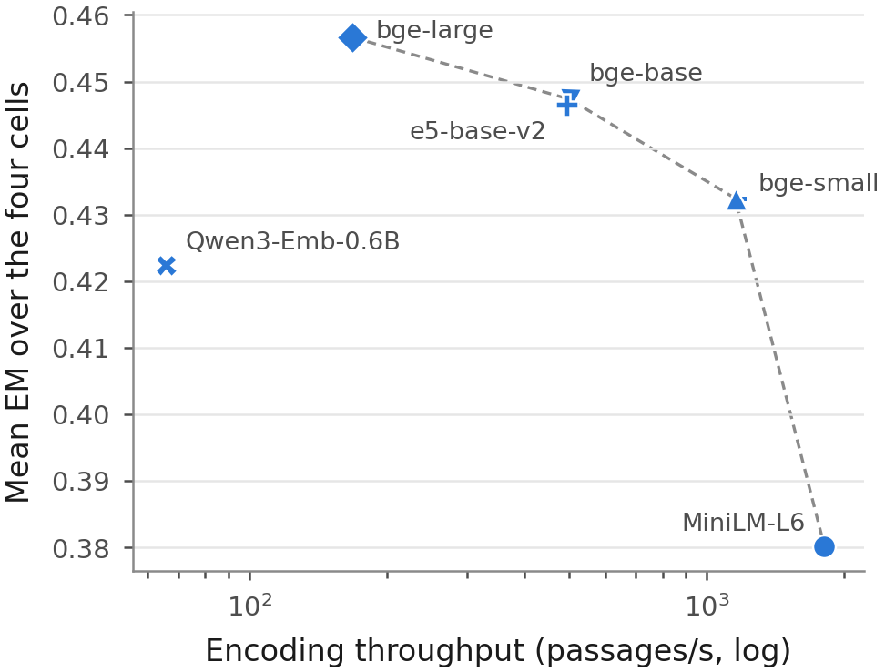
Encoding throughput on one T4 GPU (median of five repetitions, log scale) against EM averaged over the four reader–dataset cells. The dashed line joins encoders that no other encoder beats on both axes.
Encoding cost on one Tesla T4, median (range) over five repetitions.
Encoder | Params (M) | Dim | Passages/s | Query ms
MiniLM-L6 | 23 | 384 | 1807 (1768–1863) | 6.0 (6.0–6.1)
bge-small | 33 | 384 | 1155 (1136–1207) | 10.3 (10.1–10.3)
bge-base | 109 | 768 | 502 (501–503) | 10.0 (9.9–10.1)
e5-base-v2 | 109 | 768 | 493 (491–496) | 10.0 (9.9–10.1)
bge-large | 335 | 1024 | 168 (168–169) | 18.3 (18.3–18.6)
Qwen3-Emb-0.6B | 596 | 1024 | 66 (66–66) | 52.2 (51.8–54.9)
BM25 batch-1 query latency on CPU: 25.7 ms (23.7–27.7).

CPU deployment
Phase 1 also measured single-query latency with encoding and exact search on the CPU, index size and full sub-corpus encoding time (single measurements). These operational details, with the CPU quality–latency frontier, are in Appendix 13.

Approximate search
HNSW search kept the exact top five almost unchanged (Table [tab:hnsw]). At efSearch 128, HNSW returned at least 0.996 of the exact top five and 0.964 of the exact top 100 (mean shares over all 3,452 judged queries), Hit@5 changed by at most 0.0023, and the median query latency on the CPU fell from 36–78 ms to 0.84–1.45 ms. We did not run the readers on HNSW results, so this check covers retrieval and latency only.
 | Exact |  | HNSW efSearch 64 |  |  |  | HNSW efSearch 128
2-3(lr)4-7(lr)8-11 Encoder | Hit@5 | ms | Ov@5 | Ov@100 | Hit@5 | ms | Ov@5 | Ov@100 | Hit@5 | ms
MiniLM-L6 | 0.673 | 35.9 | 0.998 | 0.946 | 0.672 | 0.50 | 0.999 | 0.984 | 0.673 | 0.84
bge-small | 0.729 | 36.3 | 0.992 | 0.904 | 0.726 | 0.49 | 0.996 | 0.964 | 0.727 | 0.89
e5-base-v2 | 0.817 | 77.7 | 0.995 | 0.915 | 0.815 | 0.80 | 0.997 | 0.970 | 0.817 | 1.45
Ov@5 / Ov@100: mean share of the exact top 5 / top 100 that HNSW also returns. Hit@5 here is over all judged queries, not the 2,255 generation queries. ms: median batch-1 query latency on 4 vCPUs. No reader was run on HNSW results.

Sub-corpus versus full corpus
On the full NQ corpus the four tested retrievers kept their nDCG@10 order (Kendall’s $τ$ = 1.00; P3 criterion met; Table 7 and Fig. 11). The dense retrievers lost 0.083 to 0.086 in nDCG@10, and BM25 lost almost nothing (0.002). The sub-corpus therefore inflates absolute dense scores but not the order of these four retrievers. The drops also agree with the bias that the construction implies: the sub-corpus keeps BM25’s own top-ranked passages for every judged query but not those of the dense encoders, so it favours the dense encoders relative to BM25. Section 5.4 gives the readers on full-corpus retrieval; HotpotQA was not run on its full corpus.
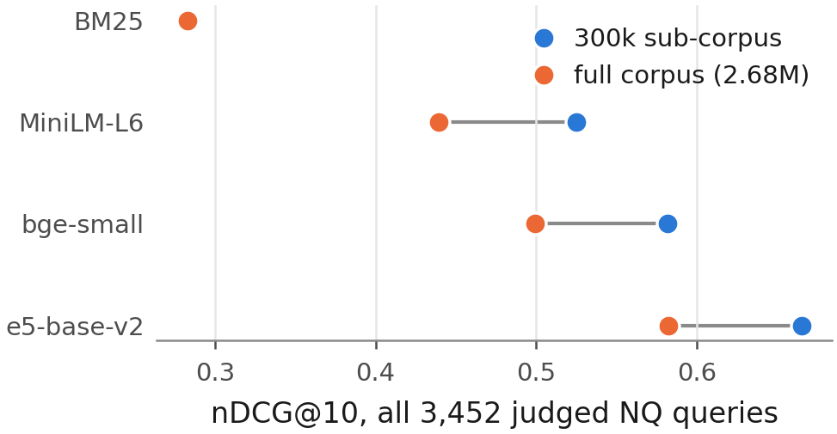
nDCG@10 on the 300,000-passage sub-corpus and on the full NQ corpus (all 3,452 judged queries).
Sub-corpus (300k) vs full NQ corpus (2.68M), all 3,452 judged queries.
Retriever | nDCG@10 sub | nDCG@10 full | Hit@5 sub | Hit@5 full
BM25 | 0.284 | 0.283 | 0.373 | 0.373
MiniLM-L6 | 0.525 | 0.439 | 0.673 | 0.571
bge-small | 0.582 | 0.499 | 0.729 | 0.630
e5-base-v2 | 0.665 | 0.582 | 0.817 | 0.727
Kendall’s $τ$ between the two orderings = 1.00.

LLM judge validation
The LLM judge agreed poorly with the author’s labels (Table 8). Cohen’s $κ$ was 0.127 [−0.006, 0.261], with raw agreement 0.565. Weighted to the population, the judge labelled 0.886 of answers as supported, against 0.620 for the author, and its precision for the label supported was 0.636. Under the registered rule ($κ<0.2$) we excluded the judge’s faithfulness labels from all conclusions. For completeness, Table 13 in the appendix lists the share of answers the judge labelled as supported, and Appendix 10 gives the judge prompt and the annotation instructions.
Agreement between the author’s labels and the LLM judge on 200 stratified items.
 | Judge SUPPORTED | Judge NOT_SUPPORTED
Human SUPPORTED | 65 | 50
Human NOT_SUPPORTED | 37 | 48
Cohen’s $κ$ = 0.127 [$−$0.006, 0.261]; raw agreement 0.565. Under the pre-registered rule ($κ<0.2$) the judge results are excluded from the conclusions.

Summary of the predictions
Table [tab:predictions] lists all eight registered criteria. P3, P4, P5, P7 and P8 were met. P1 was not met in one of three new cells (an upper bound of 1.000 or more), P2 was not met in either HotpotQA cell, and P6 was not met. Where a verdict is not confirmatory, the table marks it.
ID | Scope | Criterion | Evidence
P1 | NQ, Qwen$​^{†}$ | met | 5 dense-encoder ratios; largest upper bound 0.455 (Qwen3-Emb-0.6B)
P1 | NQ, Llama | met | 5 dense-encoder ratios; largest upper bound 0.427 (bge-small)
P1 | HotpotQA, Qwen | met | 5 dense-encoder ratios; largest upper bound 0.996 (bge-large)
P1 | HotpotQA, Llama | not met | 5 dense-encoder ratios; largest upper bound 1.096 (bge-large)
P2 | NQ, Qwen$​^{†}$ | met | bge-large $−$ e5: $−$0.006 ($p_{\text{Holm}}$ 1.000); Qwen3-Emb-0.6B $−$ e5: $−$0.018 ($p_{\text{Holm}}$ 0.271)
P2 | NQ, Llama | met | bge-large $−$ e5: $−$0.004 ($p_{\text{Holm}}$ 1.000); Qwen3-Emb-0.6B $−$ e5: $−$0.007 ($p_{\text{Holm}}$ 1.000)
P2 | HotpotQA, Qwen | not met | bge-large $−$ e5: +0.028 ($p_{\text{Holm}}$ 0.005); Qwen3-Emb-0.6B $−$ e5: $−$0.030 ($p_{\text{Holm}}$ 0.003)
P2 | HotpotQA, Llama | not met | bge-large $−$ e5: +0.022 ($p_{\text{Holm}}$ 0.040); Qwen3-Emb-0.6B $−$ e5: $−$0.042 ($p_{\text{Holm}}$ $<$0.001)
P3 | NQ, 4 retrievers | met | Kendall’s $τ$ = 1.00 (retrieval only)
P4 | NQ, Qwen | met | $k=1$ below $k=5$ for all 7 retrievers$​^{‡}$; $Δ$EM $−$0.126 to $−$0.078; all $p_{\text{Holm}}$ $<$0.001
P5 | NQ, Qwen, 500 q. | met | hard vs random negatives: $Δ$EM $−$0.074, $p$ $<$0.001
P6 | NQ, Qwen, 500 q. | not met | gold at position 1/3/5: largest $|Δ$EM$|$ 0.016; smallest $p_{\text{Holm}}$ 0.94
P7 | NQ full corpus, Qwen | met | 2 dense-encoder ratios; largest upper bound 0.399 (bge-small)
P7 | NQ full corpus, Llama | met | 2 dense-encoder ratios; largest upper bound 0.483 (bge-small)
P8 | NQ full corpus, Qwen | met | e5-base-v2: $T_{\text{full}}$ 0.233 in [0.147, 0.356]; $T_{\text{full}}−T_{\text{sub}}$ $−$0.017 [$−$0.123, +0.087]
P8 | NQ full corpus, Llama | met | e5-base-v2: $T_{\text{full}}$ 0.195 in [0.053, 0.265]; $T_{\text{full}}−T_{\text{sub}}$ +0.035 [$−$0.065, +0.137]
P1: every reportable EM transfer ratio of a dense encoder has an upper 95% bound below 1 (unrounded; a bound of exactly 1.000 does not meet it). P2: no Holm-significant EM gain of bge-large or Qwen3-Emb-0.6B over e5-base-v2. P3: the full corpus keeps the nDCG@10 ordering. P4: EM at $k=1$ below $k=5$. P5: hard negatives lower EM. P6: gold position changes EM. P7 (registered before Phase 3): every reportable full-corpus EM ratio of a dense encoder has an upper 95% bound below 1. P8: the full-corpus ratio of e5-base-v2 lies inside its sub-corpus 95% interval. $​^{†}$Not confirmatory: observed in Phase 1, before registration. $​^{‡}$Confirmatory for bge-small, bge-base, e5-base-v2 and Qwen3-Emb-0.6B only. The v0.3 analysis code also counted BM25 in the NQ P1 checks (six ratios); the registered criterion covers dense encoders, and the verdict is the same either way.

Discussion

What the transfer ratio shows
On single-hop NQ, a Hit@5 gain of a dense encoder over a small encoder came with an EM gain of 0.16 to 0.27 points per point, with both readers, and the ratio stayed well below 1 under every answer metric and baseline we tried at $k≥3$. The registered full-corpus run agreed for the encoders it covered: the ratio of e5-base-v2 moved by −0.02 and +0.04, and both values lay inside the sub-corpus intervals. The query-level accounting shows where the difference between the two gains sits. Queries that newly retrieved a gold passage did gain EM, but 0.23–0.30 of them had already been answered correctly under MiniLM-L6, and queries that kept or lost their hit gave back part of the gain. Three observations within our setup are consistent with this. (i) The readers fell well short of the gold-passage reference even with good retrieval, so part of the loss lies in reading, not retrieval. (ii) EM given a miss stayed far above closed-book EM, and the abstention prompt showed that the reader still answered most misses. The NQ relevance labels are sparse: 0.41–0.55 of dense-encoder misses had an answer string in their top five passages, and the readers may also have known some answers. Hit@5 therefore overstates the difference between encoders that matters for the reader. The full corpus showed the same effect from the other side: it removed about a tenth of the hits of each dense encoder but only 0.20–0.28 EM points per lost hit. (iii) Queries that hit under both retrievers lost a little EM with the stronger encoder, so a change of context can cost answers even when a gold passage stays in the top five. We did not inspect these contexts; this point is a hypothesis.
On multi-hop HotpotQA, Hit@5 saturated while Both@5 did not. The EM gain sat almost entirely in queries for which the stronger encoder retrieved more supporting passages, mostly the second of two, and the EM ranking of retrievers followed Both@5 exactly. With Both@5 as the denominator, the HotpotQA ratios fell to 0.29–0.35, close to the NQ ratios against BM25. The large Hit@5-based ratios on HotpotQA therefore largely reflect the denominator: the retrieval gain that matters is larger than Hit@5 shows. The comparison questions, where both entities are named in the question, were close to their gold-passage reference for every dense encoder. These are descriptions of the data, not causal attributions, but they point the same way: for multi-hop questions, a retrieval metric that requires all needed evidence tracks the answer far better than Hit@k.
Measured with Hit@5, the two datasets would support different conclusions about the same encoders. Measured with metrics that count the evidence the question needs, both show an answer gain that is a fraction of the retrieval gain.

Comparison with earlier work
That better retrieval need not give proportionally better answers is not new (Salemi and Zamani 2024; Mathur et al. 2026; Ghosh, Mukhopadhyay, and Chatterjee 2026), and our NQ results agree with the falling recall conversion rate reported by Peng et al. (2026). Our results do not contradict the strong correlations reported by Samuel et al. (2026) or the conclusion of Hitl, Bagić Babac, and Mornar (2026) that retrieval quality is the main determinant of end-to-end quality: the EM ranking of retrievers followed their Hit@5 ranking closely in every cell (Spearman $ρ$ between 0.89 and 1.00). Correlation concerns the order of systems; the transfer ratio concerns the size of the gain. A metric can rank encoders correctly and still overstate how much answers improve, and that size is what decides whether a more expensive encoder is worth its cost. What this study adds is the paired size with its uncertainty, its sensitivity to the baseline, the answer metric, $k$ and evidence completeness, and an accounting of where in the query set the gain appears.
The context experiment agrees with earlier findings on distraction. Top-ranked non-gold passages lowered EM compared with random passages (Cuconasu et al. 2024; Amiraz et al. 2025; Repantis et al. 2026), and adding random passages to the gold passage changed EM by no detectable amount. Gold position showed no detectable effect among five passages, in line with Cuconasu et al. (2025); with five short passages our setting is far from the long contexts in which position effects were originally shown (Liu et al. 2024). The near-identical retrieval results of exact and approximate search agree with Leto et al. (2024), who also measured answers; we measured retrieval only.

Practical implications
Within our setup, the choice of encoder mattered less for answers than for retrieval, while its retrieval-stage cost differed by more than an order of magnitude. For single-hop questions, no larger encoder gave a detectably higher EM than a base-size encoder such as e5-base-v2 or bge-base, which encoded 2.9 times faster than bge-large. For multi-hop questions, bge-large gave a small but detectable gain. Qwen3-Embedding-0.6B had the highest retrieval-stage cost and gave lower EM than e5-base-v2 on HotpotQA; its instruction and length settings may not suit this task, and we did not tune them. Retrieving ten passages instead of five raised EM for most retrievers and narrowed their differences, which is another option when the reader’s context allows it, although it nearly doubles the prompt the reader must process. The cross-encoder raised the Hit@5 and EM of the weak BM25 retrieval stage; for e5-base-v2 it lowered Hit@5, and no EM difference was detected. Approximate search returned nearly the same top passages as exact search at a small fraction of the latency; we did not measure its effect on answers.

Alternative explanations
Several features of the design could produce low NQ transfer without a property of the encoders. EM undercounts correct answers (Kamalloo et al. 2023); the F1 and containment ratios were higher but still well below 1. The sub-corpus inflates dense retrieval scores, but on the full corpus the order of four retrievers was kept, the e5-base-v2 ratios stayed inside their sub-corpus intervals for both readers, and the ratios of bge-small and e5-base-v2 against BM25 rose only from 0.29–0.34 to 0.33–0.38. This check covers three dense encoders on NQ; the larger encoders and HotpotQA were not run on a full corpus. Answer-bearing hard negatives did not explain the context effect either: P5 held, with a larger drop, on the questions whose hard negatives contained no answer string. The readers were 4-bit quantised 7–8B models with one prompt; stronger readers may convert hits into answers at a different rate. The ratio also depends on the baseline and on $k$. Against BM25 the NQ ratios were higher (0.29–0.35), and with one passage read they were higher still. The ratio therefore describes a pair of retrievers at a given reading depth, not a single encoder.

Limitations

Scope
The study covers two English Wikipedia question-answering datasets, six open encoders up to 0.6B parameters, two 4-bit 7–8B readers, one prompt and $k=5$ for the registered transfer ratios; the exploratory ratios at other $k$ show that the size of the ratio depends on how many passages the reader sees. Results may differ for other domains, longer answers, larger or proprietary readers, other prompts or agentic pipelines. All timings come from one GPU type (Tesla T4) and one CPU configuration.

Corpus and labels
Except for Phase 3, retrieval ran on 300,000-passage sub-corpora that contain every gold passage and favour the dense encoders relative to BM25. Phase 3 tested the NQ ratios on the full corpus for BM25, MiniLM-L6, bge-small and e5-base-v2 only; bge-base, bge-large, Qwen3-Embedding-0.6B and all of HotpotQA rest on the sub-corpus. NQ relevance labels are sparse. The answer-string check measures how often a miss still holds an answer, but it is lexical: it can count a passage that mentions the answer without supporting it, and it misses paraphrases. The registered blinded human audit of misses was not complete for this version. The joined NQ set covers 2,255 of 3,452 judged queries and may differ in difficulty from the excluded queries. A Phase 1 check found Hit@5 differences between joined and unjoined queries from −0.028 to +0.005 across the seven retrievers, and every 95% interval included zero.

Metrics and statistics
EM is strict. We report F1 and answer containment, but did not judge correctness by hand. The transfer ratio is a ratio of means and becomes unstable when the retrieval gain is small; our reporting rule removes the worst cases, but the bge-small intervals on NQ still include zero. The ratio depends on the baseline encoder, and the share of the gain assigned to conditional EM depends on how the decomposition is ordered (Tables [tab:altbase] and 11). The decomposition, the query-level accounting, the Both@5 ranking and ratios, the BM25 baseline and the GEE interaction model are post hoc. The accounting groups are defined by retrieval outcomes, so they locate the EM difference but do not explain it. The registered pooled GEE model assumed one retriever effect across datasets, which the interaction test did not support. Answer quality under approximate search was not measured. Multiplicity is controlled within each family, not across all tests in the paper. Bootstrap intervals, F1, answer containment and the pooled model were checked by a rerun on a second computer, not by an independent implementation.

Context experiment
The hard negatives are top-ranked BM25 passages without a gold label, and a third of the questions had at least one that contained an answer string. Excluding those questions made the measured drop larger, so this does not weaken P5, but the subset analysis is a sensitivity check on 333 questions. The experiment used one reader and 500 questions. The random-passage control found no detected difference from the gold passage alone; it does not establish equivalence.

Judge and annotation
The LLM judge was validated against one annotator, the author. With $κ$ = 0.127 the judge was excluded under the registered rule, so this limitation does not affect the conclusions, but no faithfulness result is reported.

Three study phases
The predictions were registered in dated, version-controlled design documents in our own repository, not in a public registry. The Qwen–NQ cell and part of the $k$ ablation were run before the predictions were registered, and the software image changed between Phases 1 and 2. P7 and P8 were registered after the sub-corpus results were known; they test whether those results replicate, not a new hypothesis. Within-cell comparisons share one environment. For comparisons across phases, 396 of 397 identical prompts gave identical outputs.

Conclusion
We measured how much of a paired retrieval gain reaches the answer when a RAG system swaps one open embedding model for another. On single-hop NQ, between 0.16 and 0.27 EM points followed each Hit@5 point that a dense encoder gained over MiniLM-L6, for both readers; the ratio stayed well below 1 under other answer metrics and a BM25 baseline, held on the full NQ corpus in a registered rerun (0.15–0.23), and its size depended on the number of passages read (RQ1). The gain came from queries that newly retrieved a gold passage, partly offset by queries that kept or lost one, and many retrieval misses still contained the answer. On multi-hop HotpotQA, the Hit@5-based ratios were larger, but with Both@5 as the denominator they were 0.29 to 0.35, and the EM gain sat in queries for which the encoder retrieved more supporting passages. Among dense encoders, bge-large gave a small EM gain over e5-base-v2 on HotpotQA and none detectable on NQ, and Qwen3-Embedding-0.6B gave lower EM on HotpotQA (RQ2). Top-ranked non-gold passages lowered EM, gold position did not change it detectably, and ten passages narrowed the gaps between retrievers (RQ3). Retrieval-stage throughput differed 27-fold, approximate search returned nearly the same top passages, and on the full NQ corpus the four retrievers tested kept their order and their transfer ratios (RQ4).
Within this setup, retrieval gains overstated answer gains, and Hit@5 hid much of the multi-hop retrieval gain. We recommend that RAG studies report answer gains next to retrieval gains, with paired intervals, the baseline and the reading depth stated, and that they score multi-hop retrieval by complete evidence. Future work should test larger readers, other domains and the multi-hop setting on a full corpus, run the readers on approximate-search results, and judge by hand whether the answer-bearing passages behind retrieval misses support the answer.

Ethics statement

Data and licences
We used public resources under their licences, as listed on their Hugging Face cards (accessed 17 October 2026): the BEIR versions of Natural Questions and HotpotQA (CC BY-SA 4.0), NQ-open (CC BY-SA 3.0) and HotpotQA (CC BY-SA 4.0). The encoders are released under Apache-2.0 (all-MiniLM-L6-v2, Qwen3-Embedding-0.6B) or MIT (bge, e5 and bge-reranker-base); Qwen2.5-7B-Instruct-AWQ and Mistral-7B-Instruct-v0.3 under Apache-2.0; and the Llama-3.1-8B-Instruct AWQ build under the Llama 3.1 Community License. We used each for research evaluation. The questions are public benchmark questions over Wikipedia; we collected no personal data.

Human annotation
The 200 judge-validation items were labelled by one member of the study team, with the same instructions the judge received and without seeing its verdicts. No external participants were involved.

Risks
The study compares existing models and creates no new model. Readers may over-generalise the comparison to other readers, corpora or languages; we scope each claim to the tested setup. The excluded LLM judge should not be used as evidence that a system gives faithful answers.

Compute
All experiments ran on free Kaggle sessions with Tesla T4 GPUs; the study had no monetary cost.

Data and code availability
All code, prompts, design documents with their registration dates, raw reader outputs, scored answers and analysis scripts are kept in one version-controlled repository. To preserve double-anonymised review, its link is given to the editor on the separate title page; it will be made public, with an archived DOI, on acceptance. The datasets and models are public under their own licences; the exact revisions are listed in Appendix 11. Every number in this paper is generated by script from the committed outputs, including the post hoc analyses, whose scripts are in the same repository.

Declaration of generative AI and AI-assisted technologies in the manuscript preparation process
During the preparation of this work the author used Claude (Anthropic) to write and test analysis and experiment code, to check references against bibliographic databases, and to draft and edit text. After using this tool, the author reviewed and edited the content as needed and takes full responsibility for the content of the published article. Figures and tables were generated by scripts from the experimental data.

Reader prompts
The prompts below are copied from the code that ran the readers (src/generation/prompts.py). Every generation record stores a hash of the system prompt; all 131,855 scored answers carry the hash of the prompt printed here (A1: 122,545, A2: 8,510, A3: 800 records). Each prompt was rendered with the reader’s own chat template.

User message (A1 and A3)
Passages appear in rank order, each as “[$i$] title”, a line break and the passage text, separated by blank lines:
Passages:
[1] {title 1}
{text 1}
[2] {title 2}
{text 2}
…
Question: {question}
Answer:

A1 (main prompt, with passages)
System: “You are a question answering assistant. Answer the question using the passages provided. If the passages do not contain the answer, give your best short answer anyway. Reply with the answer only, as a short phrase of a few words, with no explanation.”

A2 (closed book)
System: “You are a question answering assistant. Reply with the answer only, as a short phrase of a few words, with no explanation.” User: Question: {question} followed by a line break and Answer:.

A3 (abstention check, Phase 1 only)
System: “You are a question answering assistant. Answer the question using only the passages provided. If the passages do not contain the answer, reply exactly: I don’t know. Otherwise reply with the answer only, as a short phrase of a few words, with no explanation.” User message as for A1.
The gold-passage condition uses A1 with the gold passages only.

Judge prompt and annotation instructions
The LLM judge (Mistral-7B-Instruct-v0.3, greedy decoding, at most 8 new tokens) received one user message:
You will be given PASSAGES, a QUESTION, and an ANSWER. Decide whether the ANSWER is fully supported by the PASSAGES. An answer is SUPPORTED only if the passages state it or directly imply it. Do not use outside knowledge. Do not judge whether the answer is true in the real world.
PASSAGES: [the same five passages the reader saw, formatted as in Appendix 9]
QUESTION: {question} ANSWER: {answer}
Reply with exactly one word: SUPPORTED or NOT_SUPPORTED.
The verdict was the label SUPPORTED or NOT_SUPPORTED found at the start of the output; there were no parse failures. The human annotator saw the same text, without the judge’s verdict, plus the instruction: “Label each item SUPPORTED or NOT_SUPPORTED. If unsure, choose NOT_SUPPORTED and add a note.” The 200 items were drawn by a seeded, stratified sampler that over-represents NOT_SUPPORTED verdicts; population-weighted statistics use the inverse inclusion probabilities.

Models, data and software
Pinned revisions (leading eight characters of the Hugging Face commit).
Resource | Revision
sentence-transformers/all-MiniLM-L6-v2 | 1110a243
BAAI/bge-small-en-v1.5 | 5c38ec7c
BAAI/bge-base-en-v1.5 | a5beb1e3
BAAI/bge-large-en-v1.5 | d4aa6901
intfloat/e5-base-v2 | f52bf8ec
Qwen/Qwen3-Embedding-0.6B | 97b0c614
Qwen/Qwen2.5-7B-Instruct-AWQ | b2503754
hugging-quants/Meta-Llama-3.1-8B-Instruct-AWQ-INT4 | db1f81ad
BAAI/bge-reranker-base | 2cfc18c9
mistralai/Mistral-7B-Instruct-v0.3 (judge) | c170c708
BeIR/nq | b7253e6c
BeIR/nq-qrels | 519acd4e
google-research-datasets/nq_open | 5dd9790a
BeIR/hotpotqa | a7e8bab2
BeIR/hotpotqa-qrels | b15429e9
hotpotqa/hotpot_qa | 1908d6af
Retrieval used bm25s 0.3.11 and faiss-cpu 1.15.1; readers used vLLM 0.30.0 with PyTorch 2.13.0 (CUDA 13.0) and Transformers 5.17.0, in half precision with a maximum model length of 4,096 tokens. Table [tab:env] lists the software of every session.
Session | Python | PyTorch | CUDA | Transformers | vLLM | NumPy
Phase 1, NQ retrieval and encoding | 3.12.13 | 2.10.0 | 12.8 | 5.0.0 | – | 2.0.2
Phase 1, Qwen reader (NQ) | 3.12.13 | 2.13.0 | 13.0 | 5.17.0 | 0.30.0 | 2.0.2
Phase 1, judge and CPU cost | 3.12.13 | 2.13.0 | 13.0 | 5.17.0 | 0.30.0 | 2.0.2
Phase 2, HotpotQA retrieval | 3.13.15 | 2.11.0 | 12.8 | 5.0.0 | – | 2.1.3
Phase 2, HotpotQA readers | 3.13.15 | 2.13.0 | 13.0 | 5.17.0 | 0.30.0 | 2.1.3
Phase 2, Llama reader (NQ), top-$k$ | 3.13.15 | 2.13.0 | 13.0 | 5.17.0 | 0.30.0 | 2.1.3
Phase 2, E5, E6, E7, E9, E12 | 3.13.15 | 2.13.0 | 13.0 | 5.17.0 | 0.30.0 | 2.1.3
Phase 3, full-corpus NQ readers (S5) | 3.13.15 | 2.13.0 | 13.0 | 5.17.0 | 0.30.0 | 2.1.3
All sessions: bm25s 0.3.11, faiss 1.15.1, sentence-transformers 5.4.1, 4 vCPUs, 31.3 GiB memory, 2 Tesla T4 (14,911 MiB each).
Retriever | Model | Revision | Params (M) | Dim | Query prefix
BM25 | bm25s 0.3.11, Lucene variant, $k_{1}=1.2$, $b=0.75$ | – | – | – | –
MiniLM-L6 | sentence-transformers/all-MiniLM-L6-v2 | 1110a243 | 23 | 384 | none
bge-small | BAAI/bge-small-en-v1.5 | 5c38ec7c | 33 | 384 | BGE instruction
bge-base | BAAI/bge-base-en-v1.5 | a5beb1e3 | 109 | 768 | BGE instruction
bge-large | BAAI/bge-large-en-v1.5 | d4aa6901 | 335 | 1024 | BGE instruction
e5-base-v2 | intfloat/e5-base-v2 | f52bf8ec | 109 | 768 | “query: ”
Qwen3-Emb-0.6B | Qwen/Qwen3-Embedding-0.6B | 97b0c614 | 596 | 1024 | task instruction
BGE instruction: Represent this sentence for searching relevant passages:. e5-base-v2 also prefixes passages with “passage: ”. Qwen3-Embedding uses a task instruction per dataset.
Data and sub-corpora.
Item | NQ | HotpotQA
Full corpus (passages) | 2,681,468 | 5,233,329
Judged test queries | 3,452 | 7,405
Queries joined to reference answers | 2,255 | 7,405
Generation queries | 2,255 | 2,000 (1,616 bridge, 384 comparison)
Gold passages per judged query | 1.22 (range 1–4) | 2 (every query)
Distinct gold passages in the corpus | 4,201 | 13,783 (shared across queries)
Sub-corpus size | 300,000 | 300,000
gold passages | 4,201 | 13,783
top-$d$ BM25 passages, non-gold (depth $d$) | 127,791 ($d$ = 42) | 118,726 ($d$ = 19)
random passages | 168,008 | 167,491
Reference answers | NQ-open (validation) | HotpotQA fullwiki (validation)
Corpus sizes as distributed by BEIR. Joins: NQ by normalised question text, HotpotQA by question id. Each HotpotQA query has exactly two distinct gold passages; 14,810 gold references point to 13,783 distinct passages because some passages support several questions. Both@5 requires both gold passages of the query in the top five.

Design documents
The design document and its addenda are dated and versioned in the study repository. Each was written before the stage it governs.
- v0.2 (26 September 2026). Research questions, retrievers, reader, judge, metrics, statistical tests, the transfer-ratio reporting rule and the pilot plan.
- v0.2.1–v0.2.2 (26 September 2026). Follow-up rules (abstention-prompt check, judge fallback, GPU stopping rules) and the change of the NQ join gate (deviation 1).
- v0.2.3 (27 September 2026). Pilot verification; the sub-corpus membership rule for all judged queries; dropping the RAGAS cross-check.
- v0.2.4 (27–29 September 2026). Execution records of Phase 1, the failed initial reading session, the cost-estimate error and the cut dimension ablation.
- v0.3 (12 October 2026). Phase 2 experiments E1–E12 and predictions P1–P6, written before any Phase 2 run.
- v0.3.1 (12 and 14 October 2026). The Python 3.13 image change and the torchaudio fix.
- v0.3.2 (15 October 2026). Implementation of E5, E6, E7, E9 and E12 before the session that ran them, including the reduced scope of E6.
- v0.4 (17 October 2026). Phase 3: readers on full-corpus NQ retrieval, predictions P7 and P8, the answer-string checks and the human audit of misses, written and committed before the Phase 3 session.
Pilot numbers were used only for planning and are not reported as results.

Retrieval-stage cost on a CPU
Phase 1 also measured the cost of serving queries without a GPU (Table [tab:deploy]; single measurements). Encoding the 300,000-passage sub-corpus on the T4 took 158 s with MiniLM-L6, 592 s with e5-base-v2, 1,753 s with bge-large and 4,431 s with Qwen3-Embedding-0.6B. On the CPU alone, one query (encoding plus exact search) took 21.9 ms with BM25, 53.7 ms with MiniLM-L6, 149.3 ms with e5-base-v2, 402.5 ms with bge-large and 861.7 ms with Qwen3-Embedding-0.6B. The flat index took 439, 879 and 1,172 MB at 384, 768 and 1,024 dimensions. Fig. 12 places each retriever by CPU latency and EM in every cell. bge-large and Qwen3-Embedding-0.6B were dominated on NQ for both readers: a cheaper retriever gave at least the same EM. On HotpotQA, bge-large was on the frontier with both readers, and its step over the next retriever was significant only with Qwen. Fig. 13 in the appendix gives the same view for NQ nDCG@10. In an exploratory check that treats costs within 5% as equal, only one frontier changed, on both cost axes: with Qwen on NQ, bge-base left the frontier, because its cost is within 5% of e5-base-v2 and its EM is lower.
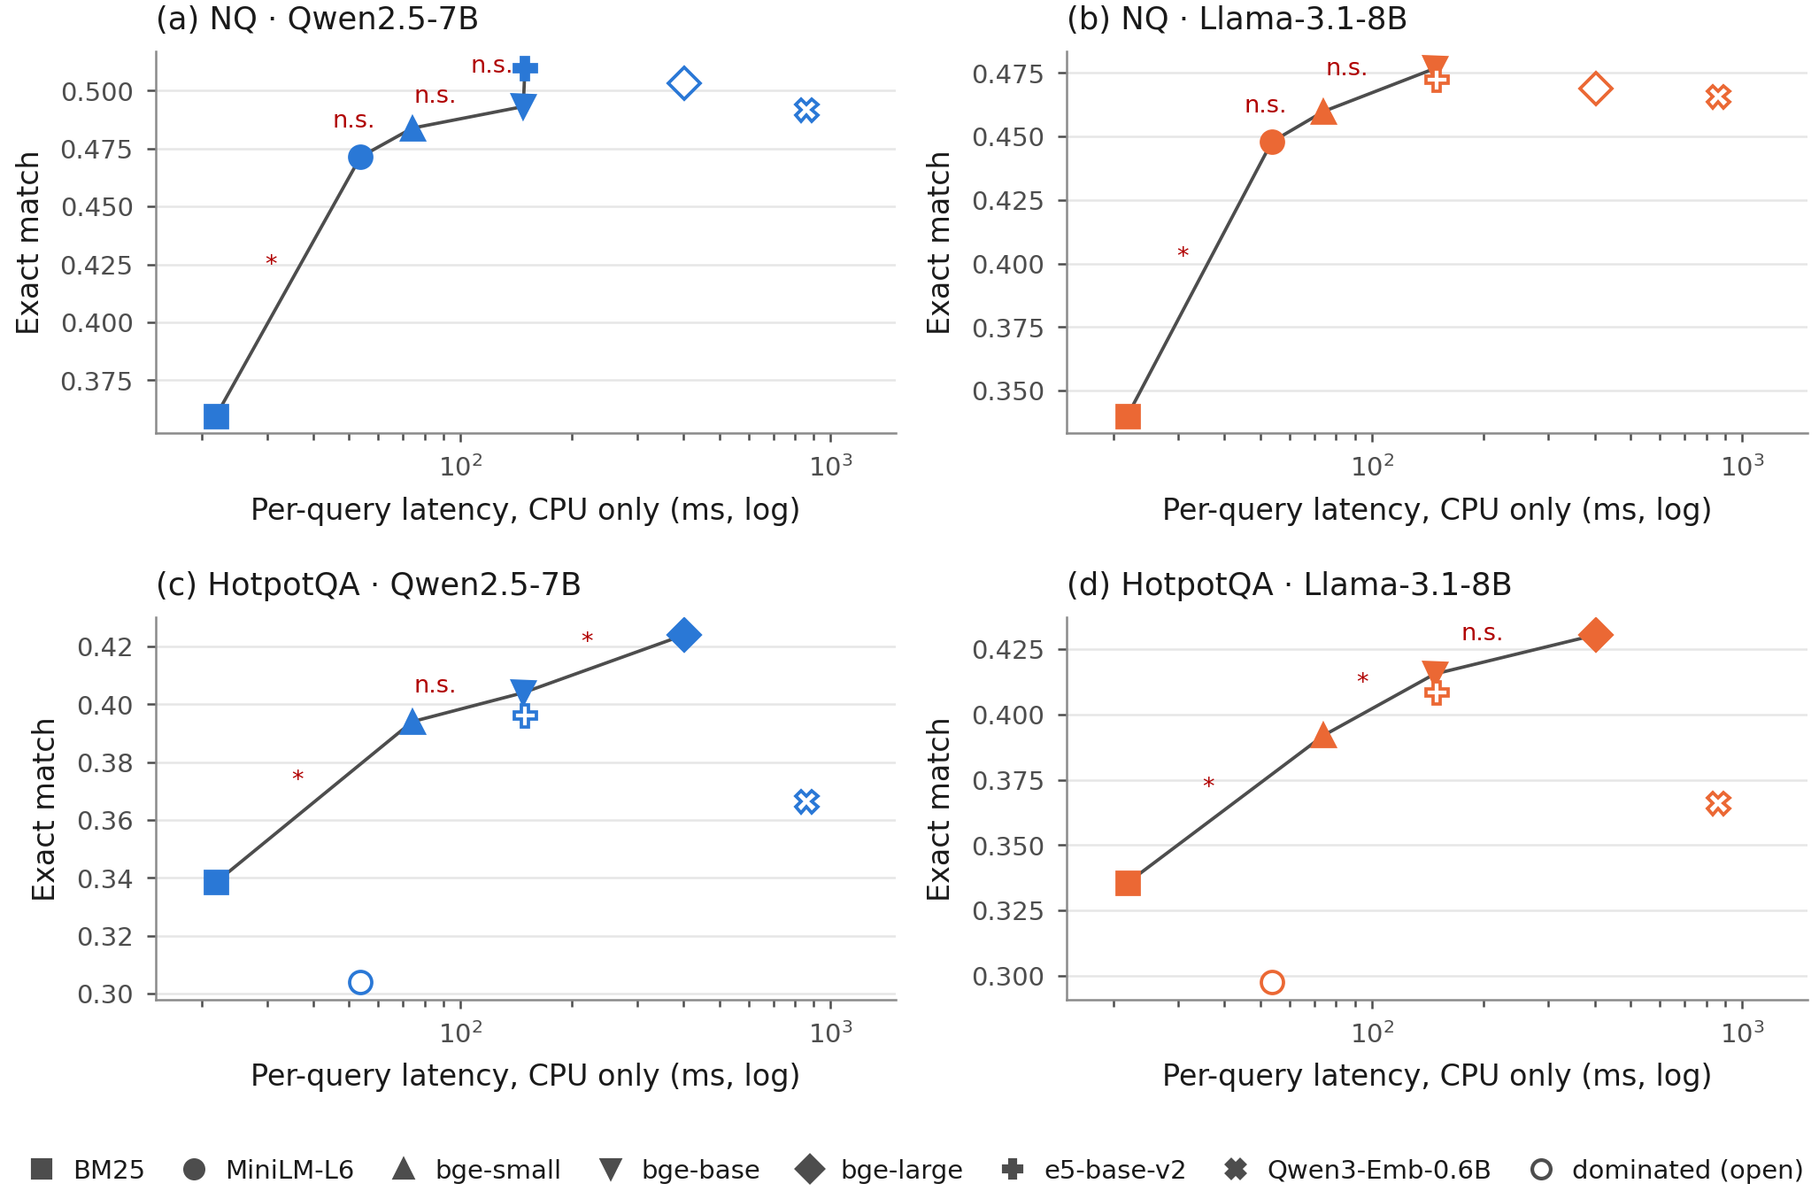
Exact match against per-query latency with query encoding and exact search on the CPU (Phase 1 cost measurements, log scale). The line joins retrievers that no other retriever beats on both axes; open markers are dominated. Step labels: $​^{*}$ EM difference significant after Holm correction over the 21 pairs of the cell; n.s. not significant.
Retriever | Enc. 300k (s) | GPU MiB | CPU pass./s | Q-enc GPU | Q-enc CPU | Search | Query CPU | Index MB
BM25 | – | – | – | – | – | 21.9 | 21.9 | –
MiniLM-L6 | 158 | 352 | 38.7 | 5.6 | 14.3 | 39.3 | 53.7 | 439
bge-small | 250 | 374 | 20.0 | 9.7 | 35.3 | 38.8 | 74.1 | 439
bge-base | 584 | 818 | 6.4 | 9.6 | 66.5 | 81.2 | 147.7 | 879
bge-large | 1,753 | 1,427 | 1.9 | 17.4 | 259.4 | 143.1 | 402.5 | 1,172
e5-base-v2 | 592 | 818 | 6.2 | 9.6 | 67.8 | 81.5 | 149.3 | 879
Qwen3-Emb-0.6B | 4,431 | 7,548 | 0.3 | 46.9 | 719.7 | 142.0 | 861.7 | 1,172
Enc. 300k: T4 wall time to encode the 300,000-passage sub-corpus. Q-enc: batch-1 query encoding (ms, median). Search: batch-1 exact inner-product search on the CPU (ms, median). Query CPU: query encoding plus search, all on the CPU. Index: flat float32 FAISS index. Encoding throughput repeated five times in Phase 2 is in Table 6.

Additional tables
Table [tab:ci] gives the bootstrap intervals for Table [tab:main]. Table [tab:transferalt] repeats the transfer ratios with token F1 and answer containment. Table [tab:decomp] gives EM given a hit and given a miss, which enter Eq. [eq:decomp]. Table 12 gives the abstention-prompt check, Table [tab:transferk] the exploratory transfer ratios at each $k$, Table [tab:pairwise] all pairwise EM tests, and Table 13 the excluded judge labels. Table [tab:components] gives the three decomposition terms with intervals, Table [tab:transdetail] the query-level transitions for two encoders, Table 11 the HotpotQA shares under both orderings, and Table [tab:altbase] the ratios against BM25 and with Both@5.
Condition | NQ Qwen | NQ Llama | HotpotQA Qwen | HotpotQA Llama
BM25 | [0.340, 0.380] | [0.321, 0.360] | [0.318, 0.359] | [0.315, 0.356]
MiniLM-L6 | [0.451, 0.492] | [0.427, 0.469] | [0.284, 0.325] | [0.278, 0.318]
bge-small | [0.463, 0.505] | [0.439, 0.481] | [0.372, 0.415] | [0.370, 0.413]
bge-base | [0.473, 0.513] | [0.456, 0.497] | [0.383, 0.426] | [0.394, 0.438]
bge-large | [0.482, 0.524] | [0.448, 0.489] | [0.402, 0.446] | [0.408, 0.453]
e5-base-v2 | [0.489, 0.530] | [0.452, 0.493] | [0.374, 0.417] | [0.387, 0.430]
Qwen3-Emb-0.6B | [0.471, 0.512] | [0.445, 0.487] | [0.345, 0.388] | [0.345, 0.388]
Closed book | [0.135, 0.164] | [0.180, 0.213] | [0.143, 0.174] | [0.133, 0.165]
Gold passages | [0.633, 0.673] | [0.593, 0.633] | [0.607, 0.649] | [0.602, 0.645]
Retrieval | NQ Hit@5 |  | HotpotQA Hit@5 | HotpotQA Both@5
BM25 | [0.343, 0.383] |  | [0.816, 0.849] | [0.244, 0.283]
MiniLM-L6 | [0.645, 0.683] |  | [0.799, 0.834] | [0.212, 0.248]
bge-small | [0.710, 0.747] |  | [0.944, 0.963] | [0.519, 0.563]
bge-base | [0.753, 0.788] |  | [0.949, 0.967] | [0.550, 0.594]
bge-large | [0.779, 0.812] |  | [0.952, 0.969] | [0.599, 0.642]
e5-base-v2 | [0.800, 0.832] |  | [0.941, 0.960] | [0.522, 0.567]
Qwen3-Emb-0.6B | [0.726, 0.762] |  | [0.934, 0.955] | [0.422, 0.467]
Encoder | $Δ$EM | Hit prevalence | EM among hits | EM among misses
NQ Qwen
bge-small | +0.012 | +0.022 [0.015, 0.029] | −0.012 [−0.026, 0.003] | +0.003 [−0.007, 0.012]
bge-base | +0.022 | +0.036 [0.028, 0.043] | −0.016 [−0.031, 0.000] | +0.002 [−0.007, 0.011]
bge-large | +0.032 | +0.044 [0.036, 0.052] | −0.013 [−0.029, 0.004] | +0.001 [−0.008, 0.009]
e5-base-v2 | +0.038 | +0.051 [0.043, 0.060] | −0.012 [−0.028, 0.005] | −0.001 [−0.009, 0.007]
Qwen3-Emb-0.6B | +0.020 | +0.027 [0.020, 0.034] | −0.009 [−0.024, 0.006] | +0.003 [−0.007, 0.012]
NQ Llama
bge-small | +0.012 | +0.021 [0.014, 0.027] | −0.009 [−0.024, 0.006] | +0.000 [−0.009, 0.009]
bge-base | +0.029 | +0.034 [0.027, 0.041] | −0.012 [−0.028, 0.003] | +0.007 [−0.001, 0.016]
bge-large | +0.021 | +0.042 [0.034, 0.050] | −0.017 [−0.034, −0.002] | −0.004 [−0.012, 0.004]
e5-base-v2 | +0.024 | +0.048 [0.040, 0.057] | −0.024 [−0.040, −0.008] | −0.000 [−0.008, 0.008]
Qwen3-Emb-0.6B | +0.018 | +0.025 [0.019, 0.032] | −0.013 [−0.028, 0.003] | +0.005 [−0.004, 0.014]
HotpotQA Qwen
bge-small | +0.090 | +0.034 [0.028, 0.041] | +0.058 [0.038, 0.078] | −0.003 [−0.005, −0.000]
bge-base | +0.100 | +0.035 [0.029, 0.042] | +0.066 [0.046, 0.087] | −0.002 [−0.004, 0.001]
bge-large | +0.120 | +0.036 [0.029, 0.043] | +0.085 [0.065, 0.105] | −0.001 [−0.003, 0.001]
e5-base-v2 | +0.092 | +0.034 [0.027, 0.040] | +0.062 [0.042, 0.082] | −0.003 [−0.005, −0.001]
Qwen3-Emb-0.6B | +0.062 | +0.032 [0.026, 0.039] | +0.031 [0.013, 0.050] | −0.001 [−0.003, 0.002]
HotpotQA Llama
bge-small | +0.095 | +0.038 [0.031, 0.045] | +0.058 [0.038, 0.078] | −0.001 [−0.003, 0.001]
bge-base | +0.118 | +0.039 [0.033, 0.046] | +0.080 [0.059, 0.100] | −0.001 [−0.003, 0.001]
bge-large | +0.133 | +0.040 [0.033, 0.047] | +0.093 [0.073, 0.114] | −0.000 [−0.002, 0.002]
e5-base-v2 | +0.111 | +0.037 [0.031, 0.044] | +0.075 [0.056, 0.096] | −0.002 [−0.004, 0.001]
Qwen3-Emb-0.6B | +0.069 | +0.035 [0.029, 0.042] | +0.033 [0.015, 0.052] | +0.000 [−0.002, 0.003]
Hit prevalence: $Δ\overset{‾}{h} \left(a_{R_{1}}−b_{R_{1}}\right)$; EM among hits: ${\overset{‾}{h}}_{R} Δa$; EM among misses: $\left(1−{\overset{‾}{h}}_{R}\right) Δb$. The three terms add up to $Δ$EM exactly. Intervals recompute every term in each resample.
Group | $n$ | EM MiniLM-L6 | EM encoder | wrong$→$right / right$→$wrong | Contribution | 95% CI
NQ Qwen, bge-large
miss $→$ hit | 406 | 0.264 | 0.569 | 138 / 14 | +0.0550 | [0.0443, 0.0656]
hit $→$ hit | 1,389 | 0.588 | 0.567 | 71 / 99 | −0.0124 | [−0.0239, −0.0009]
hit $→$ miss | 108 | 0.537 | 0.333 | 5 / 27 | −0.0098 | [−0.0146, −0.0049]
miss $→$ miss | 352 | 0.233 | 0.227 | 21 / 23 | −0.0009 | [−0.0067, 0.0049]
NQ Qwen, e5-base-v2
miss $→$ hit | 436 | 0.296 | 0.569 | 139 / 20 | +0.0528 | [0.0421, 0.0634]
hit $→$ hit | 1,405 | 0.588 | 0.569 | 66 / 92 | −0.0115 | [−0.0222, −0.0009]
hit $→$ miss | 92 | 0.522 | 0.370 | 3 / 17 | −0.0062 | [−0.0102, −0.0022]
miss $→$ miss | 322 | 0.186 | 0.208 | 20 / 13 | +0.0031 | [−0.0018, 0.0080]
NQ Llama, bge-large
miss $→$ hit | 406 | 0.264 | 0.527 | 125 / 18 | +0.0475 | [0.0373, 0.0576]
hit $→$ hit | 1,389 | 0.552 | 0.534 | 64 / 89 | −0.0111 | [−0.0217, −0.0004]
hit $→$ miss | 108 | 0.583 | 0.287 | 4 / 36 | −0.0142 | [−0.0195, −0.0089]
miss $→$ miss | 352 | 0.207 | 0.199 | 20 / 23 | −0.0013 | [−0.0071, 0.0044]
NQ Llama, e5-base-v2
miss $→$ hit | 436 | 0.268 | 0.525 | 133 / 21 | +0.0497 | [0.0390, 0.0603]
hit $→$ hit | 1,405 | 0.559 | 0.525 | 52 / 100 | −0.0213 | [−0.0319, −0.0111]
hit $→$ miss | 92 | 0.478 | 0.315 | 5 / 20 | −0.0067 | [−0.0111, −0.0022]
miss $→$ miss | 322 | 0.196 | 0.214 | 22 / 16 | +0.0027 | [−0.0027, 0.0080]
HotpotQA Qwen, bge-large
miss $→$ hit | 307 | 0.098 | 0.414 | 106 / 9 | +0.0485 | [0.0385, 0.0590]
hit $→$ hit | 1,614 | 0.352 | 0.443 | 225 / 79 | +0.0730 | [0.0565, 0.0900]
hit $→$ miss | 20 | 0.150 | 0.000 | 0 / 3 | −0.0015 | [−0.0035, 0.0000]
miss $→$ miss | 59 | 0.102 | 0.102 | 1 / 1 | +0.0000 | [−0.0015, 0.0015]
HotpotQA Qwen, e5-base-v2
miss $→$ hit | 290 | 0.107 | 0.383 | 85 / 5 | +0.0400 | [0.0310, 0.0495]
hit $→$ hit | 1,611 | 0.354 | 0.421 | 196 / 88 | +0.0540 | [0.0375, 0.0710]
hit $→$ miss | 23 | 0.087 | 0.000 | 0 / 2 | −0.0010 | [−0.0025, 0.0000]
miss $→$ miss | 76 | 0.066 | 0.040 | 0 / 2 | −0.0010 | [−0.0025, 0.0000]
HotpotQA Llama, bge-large
miss $→$ hit | 307 | 0.072 | 0.397 | 107 / 7 | +0.0500 | [0.0400, 0.0605]
hit $→$ hit | 1,614 | 0.351 | 0.455 | 239 / 72 | +0.0835 | [0.0665, 0.1005]
hit $→$ miss | 20 | 0.100 | 0.050 | 1 / 2 | −0.0005 | [−0.0025, 0.0010]
miss $→$ miss | 59 | 0.068 | 0.068 | 0 / 0 | +0.0000 | [0.0000, 0.0000]
HotpotQA Llama, e5-base-v2
miss $→$ hit | 290 | 0.079 | 0.417 | 105 / 7 | +0.0490 | [0.0390, 0.0590]
hit $→$ hit | 1,611 | 0.350 | 0.429 | 211 / 83 | +0.0640 | [0.0475, 0.0805]
hit $→$ miss | 23 | 0.217 | 0.043 | 1 / 5 | −0.0020 | [−0.0045, 0.0000]
miss $→$ miss | 76 | 0.040 | 0.040 | 0 / 0 | +0.0000 | [0.0000, 0.0000]
Intervals: percentile bootstrap over queries ($B=10,000$, seed 0); each query keeps its group, so group sizes vary across resamples and the interval is for the group’s contribution to the population EM difference.
Share of the HotpotQA EM gain over MiniLM-L6 carried by the two conditional terms together (EM among hits and EM among misses; percent), under the baseline-conditioned decomposition of Eq. [eq:decomp] with a 95% bootstrap interval, and under the symmetric decomposition. Post hoc.
 | Qwen reader |  | Llama reader
2-3(lr)4-5 Encoder | Baseline-cond. | Symmetric | Baseline-cond. | Symmetric
bge-small | 62 [49, 71] | 53 | 60 [47, 69] | 54
bge-base | 64 [53, 73] | 57 | 67 [58, 74] | 60
bge-large | 70 [62, 76] | 63 | 70 [63, 76] | 64
e5-base-v2 | 64 [51, 72] | 54 | 67 [57, 74] | 60
Qwen3-Emb-0.6B | 49 [26, 63] | 44 | 48 [28, 62] | 45
Baseline-conditioned: $ΔEM=Δh \left(a_{R_{1}}−b_{R_{1}}\right)+h_{R} Δa+\left(1−h_{R}\right) Δb$. Symmetric: each term averages the two orderings of the baseline and the encoder. Both identities hold exactly (residual $<{10}^{−12}$). The intervals resample queries ($B=10,000$, seed 0).
Encoder | NQ Qwen | NQ Llama | HotpotQA Qwen | HotpotQA Llama
Baseline BM25, denominator Hit@5
bge-small | 0.34 [0.29, 0.39] | 0.33 [0.28, 0.38] | 0.46 [0.31, 0.62] | 0.47 [0.31, 0.64]
bge-base | 0.33 [0.28, 0.37] | 0.34 [0.29, 0.38] | 0.52 [0.37, 0.69] | 0.64 [0.49, 0.81]
bge-large | 0.33 [0.29, 0.37] | 0.30 [0.25, 0.34] | 0.67 [0.51, 0.84] | 0.75 [0.59, 0.92]
e5-base-v2 | 0.33 [0.29, 0.37] | 0.29 [0.25, 0.33] | 0.49 [0.33, 0.66] | 0.62 [0.46, 0.80]
Qwen3-Emb-0.6B | 0.35 [0.30, 0.40] | 0.33 [0.28, 0.38] | 0.25 [0.09, 0.42] | 0.27 [0.12, 0.44]
Baseline MiniLM-L6, denominator Both@5
bge-small | – | – | 0.29 [0.23, 0.35] | 0.30 [0.24, 0.36]
bge-base | – | – | 0.29 [0.24, 0.35] | 0.34 [0.29, 0.40]
bge-large | – | – | 0.31 [0.26, 0.35] | 0.34 [0.29, 0.39]
e5-base-v2 | – | – | 0.29 [0.24, 0.35] | 0.35 [0.30, 0.41]
Qwen3-Emb-0.6B | – | – | 0.29 [0.21, 0.37] | 0.32 [0.24, 0.40]
BM25 with Both@5 is omitted: its Both@5 gain over MiniLM-L6 is 0.034 and its ratio is unstable (Qwen: 1.0 [0.5, 2.5]).
Retriever | NQ Qwen | NQ Llama | HotpotQA Qwen | HotpotQA Llama
Token F1
BM25 | 0.43 [0.37, 0.48] | 0.43 [0.37, 0.49] | n.e. | n.e.
bge-small | 0.26 [0.02, 0.49] | 0.23 [0.00, 0.45] | 0.76 [0.62, 0.92] | 0.85 [0.70, 1.01]
bge-base | 0.26 [0.11, 0.40] | 0.33 [0.19, 0.47] | 0.79 [0.65, 0.95] | 0.95 [0.80, 1.11]
bge-large | 0.27 [0.15, 0.39] | 0.25 [0.13, 0.36] | 0.97 [0.82, 1.14] | 1.10 [0.95, 1.28]
e5-base-v2 | 0.30 [0.20, 0.39] | 0.26 [0.17, 0.36] | 0.77 [0.62, 0.92] | 0.97 [0.82, 1.13]
Qwen3-Emb-0.6B | 0.26 [0.07, 0.45] | 0.29 [0.11, 0.47] | 0.52 [0.38, 0.66] | 0.66 [0.52, 0.81]
Answer containment
BM25 | 0.45 [0.39, 0.52] | 0.46 [0.39, 0.52] | n.e. | n.e.
bge-small | 0.27 [0.01, 0.52] | 0.32 [0.07, 0.57] | 0.68 [0.53, 0.84] | 0.75 [0.61, 0.92]
bge-base | 0.34 [0.18, 0.49] | 0.38 [0.23, 0.53] | 0.72 [0.57, 0.88] | 0.90 [0.75, 1.07]
bge-large | 0.34 [0.21, 0.46] | 0.33 [0.21, 0.46] | 0.88 [0.73, 1.04] | 1.01 [0.86, 1.18]
e5-base-v2 | 0.36 [0.26, 0.47] | 0.33 [0.23, 0.43] | 0.71 [0.57, 0.87] | 0.91 [0.75, 1.07]
Qwen3-Emb-0.6B | 0.28 [0.08, 0.48] | 0.39 [0.20, 0.60] | 0.49 [0.35, 0.64] | 0.58 [0.45, 0.74]
Retriever | NQ Qwen | NQ Llama | HotpotQA Qwen | HotpotQA Llama
BM25 | 0.632 / 0.204 | 0.591 / 0.197 | 0.381 / 0.129 | 0.382 / 0.105
MiniLM-L6 | 0.584 / 0.249 | 0.554 / 0.237 | 0.350 / 0.098 | 0.348 / 0.071
bge-small | 0.568 / 0.259 | 0.542 / 0.239 | 0.411 / 0.043 | 0.409 / 0.043
bge-base | 0.564 / 0.257 | 0.538 / 0.270 | 0.419 / 0.060 | 0.432 / 0.048
bge-large | 0.568 / 0.252 | 0.533 / 0.220 | 0.438 / 0.076 | 0.446 / 0.063
e5-base-v2 | 0.569 / 0.244 | 0.525 / 0.237 | 0.415 / 0.030 | 0.428 / 0.040
Qwen3-Emb-0.6B | 0.572 / 0.260 | 0.538 / 0.256 | 0.383 / 0.090 | 0.383 / 0.072
Closed-book EM for comparison: NQ 0.149 (Qwen), 0.197 (Llama); HotpotQA 0.158 (Qwen), 0.148 (Llama).
Abstention prompt A3 (“I don’t know” allowed), Qwen reader, NQ, leading 200 queries of the seeded order (Phase 1).
Context | $n$ | IDK rate | IDK $∣$ hit ($n$) | IDK $∣$ miss ($n$) | EM (A1) | EM (A3) | $p$
BM25 | 200 | 0.215 | 0.013 (79) | 0.347 (121) | 0.390 | 0.380 | 0.69
MiniLM-L6 | 200 | 0.115 | 0.016 (124) | 0.276 (76) | 0.470 | 0.455 | 0.45
bge-large | 200 | 0.045 | 0.024 (164) | 0.139 (36) | 0.495 | 0.465 | 0.07
Gold passages | 200 | 0.060 | – | – | – | – | –
$p$: exact McNemar test of EM under A3 against the main prompt A1, unadjusted.
Retriever | $k=1$ | $k=3$ | $k=5$ | $k=10$
BM25 | 0.71 [0.61, 0.83] | 0.48 [0.41, 0.55] | 0.37 [0.31, 0.43] | 0.32 [0.26, 0.38]
bge-small | 0.83 [0.56, 1.22] | 0.37 [0.16, 0.59] | 0.19 [$−$0.07, 0.44] | 0.10 [$−$0.24, 0.42]
bge-base | 0.61 [0.45, 0.78] | 0.32 [0.19, 0.46] | 0.20 [0.04, 0.36] | 0.05 [$−$0.13, 0.22]
bge-large | 0.61 [0.47, 0.77] | 0.33 [0.22, 0.44] | 0.24 [0.11, 0.36] | 0.19 [0.02, 0.35]
e5-base-v2 | 0.57 [0.45, 0.69] | 0.32 [0.23, 0.41] | 0.25 [0.15, 0.36] | 0.05 [$−$0.09, 0.19]
Qwen3-Emb-0.6B | 0.41 [0.21, 0.60] | 0.35 [0.17, 0.53] | 0.25 [0.05, 0.45] | 0.08 [$−$0.27, 0.38]
Post hoc; the reporting rule of Section 3.1 is not applied. For BM25 the ratio describes a retrieval loss.
Row $−$ column | BM25 | MiniLM-L6 | bge-small | bge-base | bge-large | e5-base-v2
NQ, Qwen
MiniLM-L6 | +0.112$​^{*}$
bge-small | +0.124$​^{*}$ | +0.012
bge-base | +0.133$​^{*}$ | +0.022 | +0.009
bge-large | +0.144$​^{*}$ | +0.032$​^{*}$ | +0.020 | +0.010
e5-base-v2 | +0.150$​^{*}$ | +0.038$​^{*}$ | +0.026$​^{*}$ | +0.016 | +0.006
Qwen3-Emb-0.6B | +0.132$​^{*}$ | +0.020 | +0.008 | $−$0.001 | $−$0.012 | $−$0.018
NQ, Llama
MiniLM-L6 | +0.108$​^{*}$
bge-small | +0.120$​^{*}$ | +0.012
bge-base | +0.137$​^{*}$ | +0.029$​^{*}$ | +0.017
bge-large | +0.129$​^{*}$ | +0.021 | +0.009 | $−$0.008
e5-base-v2 | +0.132$​^{*}$ | +0.024 | +0.012 | $−$0.004 | +0.004
Qwen3-Emb-0.6B | +0.125$​^{*}$ | +0.018 | +0.006 | $−$0.011 | $−$0.003 | $−$0.007
HotpotQA, Qwen
MiniLM-L6 | $−$0.035$​^{*}$
bge-small | +0.056$​^{*}$ | +0.090$​^{*}$
bge-base | +0.066$​^{*}$ | +0.100$​^{*}$ | +0.010
bge-large | +0.086$​^{*}$ | +0.120$​^{*}$ | +0.030$​^{*}$ | +0.020$​^{*}$
e5-base-v2 | +0.058$​^{*}$ | +0.092$​^{*}$ | +0.002 | $−$0.008 | $−$0.028$​^{*}$
Qwen3-Emb-0.6B | +0.028$​^{*}$ | +0.062$​^{*}$ | $−$0.028$​^{*}$ | $−$0.037$​^{*}$ | $−$0.058$​^{*}$ | $−$0.029$​^{*}$
HotpotQA, Llama
MiniLM-L6 | $−$0.038$​^{*}$
bge-small | +0.057$​^{*}$ | +0.095$​^{*}$
bge-base | +0.080$​^{*}$ | +0.118$​^{*}$ | +0.024$​^{*}$
bge-large | +0.095$​^{*}$ | +0.133$​^{*}$ | +0.038$​^{*}$ | +0.015
e5-base-v2 | +0.073$​^{*}$ | +0.111$​^{*}$ | +0.017 | $−$0.007 | $−$0.022$​^{*}$
Qwen3-Emb-0.6B | +0.030$​^{*}$ | +0.069$​^{*}$ | $−$0.026$​^{*}$ | $−$0.050$​^{*}$ | $−$0.065$​^{*}$ | $−$0.043$​^{*}$
$​^{*}$: exact McNemar test significant after Holm correction over the 21 pairs of the cell ($p<0.05$).
Phase 1 LLM-judge labels (Mistral-7B-Instruct-v0.3, zero-shot prompt of Appendix 10), Qwen reader, NQ. Excluded from all conclusions because agreement with human labels was slight ($κ$ = 0.127).
Context | $n$ | Share judged SUPPORTED [95% CI]
BM25 | 500 | 0.790 [0.754, 0.826]
MiniLM-L6 | 500 | 0.886 [0.858, 0.914]
bge-small | 500 | 0.898 [0.870, 0.924]
bge-base | 500 | 0.902 [0.876, 0.928]
bge-large | 500 | 0.912 [0.886, 0.936]
e5-base-v2 | 500 | 0.916 [0.890, 0.940]
Qwen3-Emb-0.6B | 500 | 0.896 [0.870, 0.922]
Gold passages | 499 | 0.966 [0.950, 0.980]
3,999 judgements; one gold-passage output reached the token limit, so the gold row has 499 items.
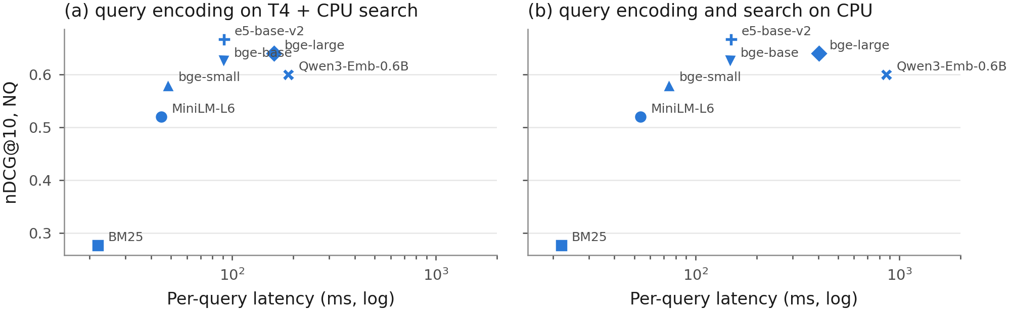
NQ nDCG@10 against per-query latency (Phase 1 batch-1 medians, log scale): (a) query encoding on the T4 and exact search on the CPU; (b) both on the CPU.
Amiraz, Chen, Florin Cuconasu, Simone Filice, and Zohar Karnin. 2025. “The Distracting Effect: Understanding Irrelevant Passages in RAG.” In Proceedings of the 63rd Annual Meeting of the Association for Computational Linguistics (ACL 2025). https://doi.org/10.18653/v1/2025.acl-long.892.
Assadi, Adnan El, Niklas Muennighoff, and Jinhyuk Lee. 2026. “The Embedder’s Dilemma: LLMs Are Better, but at What Cost?” arXiv preprint arXiv:2608.12875.
Bala, Ananto Nayan. 2026. “Recall Is Not Enough: A Reader-Context Diagnostic for Budget-Constrained Retrieval-Augmented Generation.” arXiv preprint arXiv:2607.00725.
Cohen, Jacob. 1960. “A Coefficient of Agreement for Nominal Scales.” Educational and Psychological Measurement 20 (1): 37–46. https://doi.org/10.1177/001316446002000104.
Cuconasu, Florin, Simone Filice, Guy Horowitz, Yoelle Maarek, and Fabrizio Silvestri. 2025. “Do RAG Systems Really Suffer From Positional Bias?” In Proceedings of the 2025 Conference on Empirical Methods in Natural Language Processing, 28022–36. https://doi.org/10.18653/v1/2025.emnlp-main.1422.
Cuconasu, Florin, Giovanni Trappolini, Federico Siciliano, Simone Filice, Cesare Campagnano, Yoelle Maarek, Nicola Tonellotto, and Fabrizio Silvestri. 2024. “The Power of Noise: Redefining Retrieval for RAG Systems.” In Proceedings of the 47th International ACM SIGIR Conference on Research and Development in Information Retrieval, 719–29. ACM. https://doi.org/10.1145/3626772.3657834.
Dror, Rotem, Gili Baumer, Segev Shlomov, and Roi Reichart. 2018. “The Hitchhiker’s Guide to Testing Statistical Significance in Natural Language Processing.” In Proceedings of the 56th Annual Meeting of the Association for Computational Linguistics (Volume 1: Long Papers), 1383–92. Association for Computational Linguistics. https://doi.org/10.18653/v1/p18-1128.
Efron, Bradley, and Robert J. Tibshirani. 1993. An Introduction to the Bootstrap. Springer US. https://doi.org/10.1007/978-1-4899-4541-9.
Es, Shahul, Jithin James, Luis Espinosa Anke, and Steven Schockaert. 2024. “RAGAs: Automated Evaluation of Retrieval Augmented Generation.” In Proceedings of the 18th Conference of the European Chapter of the Association for Computational Linguistics: System Demonstrations, 150–58. Association for Computational Linguistics. https://doi.org/10.18653/v1/2024.eacl-demo.16.
Ghosh, Utshab Kumar, Debayan Mukhopadhyay, and Shubham Chatterjee. 2026. “Assessing the Downstream Utility of Evidence-Aware Retrieval in RAG.” arXiv preprint arXiv:2608.26379.
Grattafiori, Aaron, Abhimanyu Dubey, Abhinav Jauhri, Abhinav Pandey, Abhishek Kadian, Ahmad Al-Dahle, Aiesha Letman, et al. 2024. “The Llama 3 Herd of Models.” arXiv preprint arXiv:2407.21783.
Hitl, Mateo, Marina Bagić Babac, and Vedran Mornar. 2026. “Comparative evaluation of embedding and generative model combinations in retrieval-augmented generation pipelines.” Data Technologies and Applications. https://doi.org/10.1108/DTA-07-2025-0609.
Holm, Sture. 1979. “A Simple Sequentially Rejective Multiple Test Procedure.” Scandinavian Journal of Statistics 6 (2): 65–70. https://www.jstor.org/stable/4615733.
Hsia, Jennifer, Afreen Shaikh, Zhiruo Wang, and Graham Neubig. 2025. “RAGGED: Towards Informed Design of Scalable and Stable RAG Systems.” In Proceedings of the 42nd International Conference on Machine Learning (ICML 2025).
Izacard, Gautier, and Edouard Grave. 2021. “Leveraging Passage Retrieval with Generative Models for Open Domain Question Answering.” In Proceedings of the 16th Conference of the European Chapter of the Association for Computational Linguistics: Main Volume, 874–80. Association for Computational Linguistics. https://doi.org/10.18653/v1/2021.eacl-main.74.
Jiang, Albert Q., Alexandre Sablayrolles, Arthur Mensch, Chris Bamford, Devendra Singh Chaplot, Diego de las Casas, Florian Bressand, et al. 2023. “Mistral 7B.” arXiv preprint arXiv:2310.06825.
Jin, Bowen, Jinsung Yoon, Jiawei Han, and Sercan O. Arik. 2024. “Long-Context LLMs Meet RAG: Overcoming Challenges for Long Inputs in RAG.” arXiv preprint arXiv:2410.05983.
Johnson, Jeff, Matthijs Douze, and Herve Jegou. 2021. “Billion-Scale Similarity Search with GPUs.” IEEE Transactions on Big Data 7 (3): 535–47. https://doi.org/10.1109/tbdata.2019.2921572.
Kamalloo, Ehsan, Nouha Dziri, Charles Clarke, and Davood Rafiei. 2023. “Evaluating Open-Domain Question Answering in the Era of Large Language Models.” In Proceedings of the 61st Annual Meeting of the Association for Computational Linguistics (Volume 1: Long Papers), 5591–5606. Association for Computational Linguistics. https://doi.org/10.18653/v1/2023.acl-long.307.
Karpukhin, Vladimir, Barlas Oguz, Sewon Min, Patrick Lewis, Ledell Wu, Sergey Edunov, Danqi Chen, and Wen-tau Yih. 2020. “Dense Passage Retrieval for Open-Domain Question Answering.” In Proceedings of the 2020 Conference on Empirical Methods in Natural Language Processing (EMNLP), 6769–81. Association for Computational Linguistics. https://doi.org/10.18653/v1/2020.emnlp-main.550.
Kwiatkowski, Tom, Jennimaria Palomaki, Olivia Redfield, Michael Collins, Ankur Parikh, Chris Alberti, Danielle Epstein, et al. 2019. “Natural Questions: A Benchmark for Question Answering Research.” Transactions of the Association for Computational Linguistics 7: 453–66. https://doi.org/10.1162/tacl_a_00276.
Kwon, Woosuk, Zhuohan Li, Siyuan Zhuang, Ying Sheng, Lianmin Zheng, Cody Hao Yu, Joseph Gonzalez, Hao Zhang, and Ion Stoica. 2023. “Efficient Memory Management for Large Language Model Serving with PagedAttention.” In Proceedings of the 29th Symposium on Operating Systems Principles, 611–26. ACM. https://doi.org/10.1145/3600006.3613165.
Landis, J. Richard, and Gary G. Koch. 1977. “The Measurement of Observer Agreement for Categorical Data.” Biometrics 33 (1): 159. https://doi.org/10.2307/2529310.
Lee, Kenton, Ming-Wei Chang, and Kristina Toutanova. 2019. “Latent Retrieval for Weakly Supervised Open Domain Question Answering.” In Proceedings of the 57th Annual Meeting of the Association for Computational Linguistics, 6086–96. Association for Computational Linguistics. https://doi.org/10.18653/v1/p19-1612.
Leto, Alexandria, Cecilia Aguerrebere, Ishwar Bhati, Ted Willke, Mariano Tepper, and Vy Ai Vo. 2024. “Toward Optimal Search and Retrieval for RAG.” arXiv preprint arXiv:2411.07396.
Lewis, Patrick, Ethan Perez, Aleksandra Piktus, Fabio Petroni, Vladimir Karpukhin, Naman Goyal, Heinrich Küttler, et al. 2020. “Retrieval-Augmented Generation for Knowledge-Intensive NLP Tasks.” In Advances in Neural Information Processing Systems 33 (NeurIPS 2020).
Liang, Kung-Yee, and Scott L. Zeger. 1986. “Longitudinal data analysis using generalized linear models.” Biometrika 73 (1): 13–22. https://doi.org/10.1093/biomet/73.1.13.
Lin, Ji, Jiaming Tang, Haotian Tang, Shang Yang, Wei-Ming Chen, Wei-Chen Wang, Guangxuan Xiao, Xingyu Dang, Chuang Gan, and Song Han. 2024. “AWQ: Activation-aware Weight Quantization for LLM Compression and Acceleration.” In Proceedings of Machine Learning and Systems 6 (MLSys 2024).
Liu, Nelson F., Kevin Lin, John Hewitt, Ashwin Paranjape, Michele Bevilacqua, Fabio Petroni, and Percy Liang. 2024. “Lost in the Middle: How Language Models Use Long Contexts.” Transactions of the Association for Computational Linguistics 12: 157–73. https://doi.org/10.1162/tacl_a_00638.
Lù, Xing Han. 2024. “BM25S: Orders of magnitude faster lexical search via eager sparse scoring.” arXiv preprint arXiv:2407.03618.
Lyu, Yuanjie, Zhiyu Li, Simin Niu, Feiyu Xiong, Bo Tang, Wenjin Wang, Hao Wu, Huanyong Liu, Tong Xu, and Enhong Chen. 2025. “CRUD-RAG: A Comprehensive Chinese Benchmark for Retrieval-Augmented Generation of Large Language Models.” ACM Transactions on Information Systems 43 (2): 1–32. https://doi.org/10.1145/3701228.
Malkov, Yu A., and D. A. Yashunin. 2020. “Efficient and Robust Approximate Nearest Neighbor Search Using Hierarchical Navigable Small World Graphs.” IEEE Transactions on Pattern Analysis and Machine Intelligence 42 (4): 824–36. https://doi.org/10.1109/tpami.2018.2889473.
Mathur, Saahil, Ryan David Rittner, Vedant Ajit Thakur, Daniel Stuart Schiff, and Tunazzina Islam. 2026. “Retrieval Improvements Do Not Guarantee Better Answers: A Study of RAG for AI Policy QA.” arXiv preprint arXiv:2603.24580.
McNemar, Quinn. 1947. “Note on the Sampling Error of the Difference Between Correlated Proportions or Percentages.” Psychometrika 12 (2): 153–57. https://doi.org/10.1007/bf02295996.
Medrano, Luigi, Arush Verma, and Mukul Chhabra. 2026. “Scaling Retrieval Augmented Generation with RAG Fusion: Lessons from an Industry Deployment.” arXiv preprint arXiv:2603.02153.
Muennighoff, Niklas, Nouamane Tazi, Loic Magne, and Nils Reimers. 2023. “MTEB: Massive Text Embedding Benchmark.” In Proceedings of the 17th Conference of the European Chapter of the Association for Computational Linguistics, 2014–37. Association for Computational Linguistics. https://doi.org/10.18653/v1/2023.eacl-main.148.
Muthyam, Bharath Simha Reddy. 2026. “A Systems-Level Analysis of Sensitivity, Robustness, and Stability in Retrieval-Augmented Generation.” arXiv preprint arXiv:2606.28337.
Nogueira, Rodrigo, and Kyunghyun Cho. 2019. “Passage Re-ranking with BERT.” arXiv preprint arXiv:1901.04085.
Peng, Shiyao, Qianhe Zheng, Zhuodi Hao, Zichen Tang, Rongjin Li, Qing Huang, Jiayu Huang, Jiacheng Liu, Yifan Zhu, and Haihong E. 2026. “NeocorRAG: Less Irrelevant Information, More Explicit Evidence, and More Effective Recall via Evidence Chains.” In Proceedings of the ACM Web Conference 2026 (WWW ’26), 1899–1910. https://doi.org/10.1145/3774904.3792093.
Petroni, Fabio, Aleksandra Piktus, Angela Fan, Patrick Lewis, Majid Yazdani, Nicola De Cao, James Thorne, et al. 2021. “KILT: a Benchmark for Knowledge Intensive Language Tasks.” In Proceedings of the 2021 Conference of the North American Chapter of the Association for Computational Linguistics: Human Language Technologies, 2523–44. Association for Computational Linguistics. https://doi.org/10.18653/v1/2021.naacl-main.200.
Qwen, An Yang, Baosong Yang, Beichen Zhang, Binyuan Hui, Bo Zheng, Bowen Yu, et al. 2024. “Qwen2.5 Technical Report.” arXiv preprint arXiv:2412.15115.
Ram, Ori, Yoav Levine, Itay Dalmedigos, Dor Muhlgay, Amnon Shashua, Kevin Leyton-Brown, and Yoav Shoham. 2023. “In-Context Retrieval-Augmented Language Models.” Transactions of the Association for Computational Linguistics 11: 1316–31. https://doi.org/10.1162/tacl_a_00605.
Rau, David, Hervé Déjean, Nadezhda Chirkova, Thibault Formal, Shuai Wang, Stéphane Clinchant, and Vassilina Nikoulina. 2024. “BERGEN: A Benchmarking Library for Retrieval-Augmented Generation.” In Findings of the Association for Computational Linguistics: EMNLP 2024, 7640–63. Association for Computational Linguistics. https://doi.org/10.18653/v1/2024.findings-emnlp.449.
Reimers, Nils, and Iryna Gurevych. 2019. “Sentence-BERT: Sentence Embeddings using Siamese BERT-Networks.” In Proceedings of the 2019 Conference on Empirical Methods in Natural Language Processing and the 9th International Joint Conference on Natural Language Processing (EMNLP-IJCNLP), 3980–90. Association for Computational Linguistics. https://doi.org/10.18653/v1/d19-1410.
Repantis, Vyzantinos, Ameya Gawde, Harshvardhan Singh, Rohit Alekar, Cien Zhang, Svetlana Karslioglu, and Akash Vishwakarma. 2026. “Separating Semantic Competition from Context Length in RAG Reading.” arXiv preprint arXiv:2605.27294.
Robertson, Stephen, and Hugo Zaragoza. 2009. “The Probabilistic Relevance Framework: BM25 and Beyond.” Foundations and Trends in Information Retrieval 4 (1-2): 1–174. https://doi.org/10.1561/1500000019.
Saad-Falcon, Jon, Omar Khattab, Christopher Potts, and Matei Zaharia. 2024. “ARES: An Automated Evaluation Framework for Retrieval-Augmented Generation Systems.” In Proceedings of the 2024 Conference of the North American Chapter of the Association for Computational Linguistics: Human Language Technologies (Volume 1: Long Papers), 338–54. Association for Computational Linguistics. https://doi.org/10.18653/v1/2024.naacl-long.20.
Sakai, Tetsuya. 2014. “Statistical reform in information retrieval?” ACM SIGIR Forum 48 (1): 3–12. https://doi.org/10.1145/2641383.2641385.
Salemi, Alireza, and Hamed Zamani. 2024. “Evaluating Retrieval Quality in Retrieval-Augmented Generation.” In Proceedings of the 47th International ACM SIGIR Conference on Research and Development in Information Retrieval, 2395–2400. ACM. https://doi.org/10.1145/3626772.3657957.
Samuel, Saron, Alexander Martin, Eugene Yang, Andrew Yates, Dawn Lawrie, Ian Soboroff, Laura Dietz, and Benjamin Van Durme. 2026. “Beyond Relevance: On the Relationship Between Retrieval and RAG Information Coverage.” In Proceedings of the 2026 ACM SIGIR International Conference on Innovative Concepts and Theories in Information Retrieval (ICTIR ’26). https://doi.org/10.1145/3805713.3820424.
Shi, Freda, Xinyun Chen, Kanishka Misra, Nathan Scales, David Dohan, Ed Chi, Nathanael Schärli, and Denny Zhou. 2023. “Large Language Models Can Be Easily Distracted by Irrelevant Context.” In Proceedings of the 40th International Conference on Machine Learning (ICML 2023), 202:31210–27. PMLR.
Smucker, Mark D., James Allan, and Ben Carterette. 2007. “A comparison of statistical significance tests for information retrieval evaluation.” In Proceedings of the Sixteenth ACM Conference on Conference on Information and Knowledge Management, 623–32. ACM. https://doi.org/10.1145/1321440.1321528.
Thakur, Nandan, Nils Reimers, Andreas Rücklé, Abhishek Srivastava, and Iryna Gurevych. 2021. “BEIR: A Heterogeneous Benchmark for Zero-shot Evaluation of Information Retrieval Models.” In Proceedings of the Neural Information Processing Systems Track on Datasets and Benchmarks.
Trappolini, Giovanni, Florin Cuconasu, Simone Filice, Yoelle Maarek, and Fabrizio Silvestri. 2025. “Redefining Retrieval Evaluation in the Era of LLMs.” arXiv preprint arXiv:2510.21440.
Wang, Liang, Nan Yang, Xiaolong Huang, Binxing Jiao, Linjun Yang, Daxin Jiang, Rangan Majumder, and Furu Wei. 2022. “Text Embeddings by Weakly-Supervised Contrastive Pre-training.” arXiv preprint arXiv:2212.03533.
Wang, Wenhui, Furu Wei, Li Dong, Hangbo Bao, Nan Yang, and Ming Zhou. 2020. “MiniLM: Deep Self-Attention Distillation for Task-Agnostic Compression of Pre-Trained Transformers.” In Advances in Neural Information Processing Systems 33 (NeurIPS 2020).
Xiao, Shitao, Zheng Liu, Peitian Zhang, Niklas Muennighoff, Defu Lian, and Jian-Yun Nie. 2024. “C-Pack: Packed Resources For General Chinese Embeddings.” In Proceedings of the 47th International ACM SIGIR Conference on Research and Development in Information Retrieval, 641–49. ACM. https://doi.org/10.1145/3626772.3657878.
Yang, Zhilin, Peng Qi, Saizheng Zhang, Yoshua Bengio, William Cohen, Ruslan Salakhutdinov, and Christopher D. Manning. 2018. “HotpotQA: A Dataset for Diverse, Explainable Multi-hop Question Answering.” In Proceedings of the 2018 Conference on Empirical Methods in Natural Language Processing, 2369–80. Association for Computational Linguistics. https://doi.org/10.18653/v1/d18-1259.
Zhang, Yanzhao, Mingxin Li, Dingkun Long, Xin Zhang, Huan Lin, Baosong Yang, Pengjun Xie, et al. 2025. “Qwen3 Embedding: Advancing Text Embedding and Reranking Through Foundation Models.” arXiv preprint arXiv:2506.05176.
Zhao, Shengming, Yuchen Shao, Yuheng Huang, Jiayang Song, Zhijie Wang, Chengcheng Wan, and Lei Ma. 2026. “Understanding the Fundamental Design Decisions of Retrieval-Augmented Generation Systems.” ACM Transactions on Software Engineering and Methodology. https://doi.org/10.1145/3802824.
Zheng, Lianmin, Wei-Lin Chiang, Ying Sheng, Siyuan Zhuang, Zhanghao Wu, Yonghao Zhuang, Zi Lin, et al. 2023. “Judging LLM-as-a-Judge with MT-Bench and Chatbot Arena.” In Advances in Neural Information Processing Systems 36 (NeurIPS 2023), Datasets and Benchmarks Track.

