<https://dizziness-and-balance.com/disorders/central/cerebellar/index.htm>

This page is meant to provide a general outline of cerebellar disorders. More specific and detailed material is found in links.

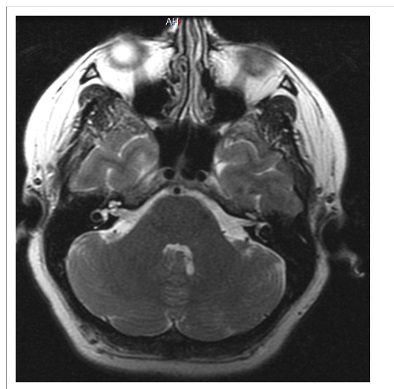

The cerebellum with surrounding skull and spinal fluid occupies the bottom 1/3 of this axial MRI image. This is an axial view, through the middle of the cerebellum above, also showing some of the temporal lobe.

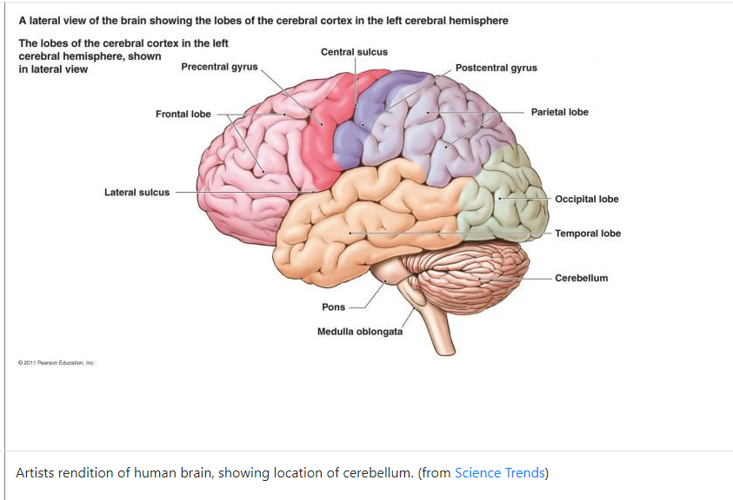

Artists rendition of human brain, showing location of cerebellum.

