**What is astrocytoma, and how is it different from glioblastoma?**

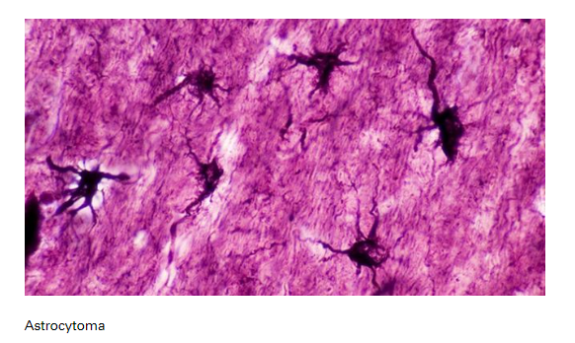

BY CAROLINE BRENNAN

[Astrocytoma](https://www.mdanderson.org/cancer-types/brain-tumor.html) and [glioblastoma](https://www.mdanderson.org/cancer-types/glioblastoma.html) are two types of brain tumors. Recently, the World Health Organization (WHO) changed how these tumors are classified.

We asked neurosurgeon [Chibawanye Ene, M.D., Ph.D.](http://faculty.mdanderson.org/profiles/chibawanye_ene.html), to explain the different types of astrocytoma brain tumors, as well as how astrocytoma differs from glioblastoma.

**What is an astrocytoma?**

Astrocytoma is a type of [brain tumor](https://www.mdanderson.org/cancer-types/brain-tumor.html). Astrocytoma brain tumors grow from astrocytes. An astrocyte is a type of cell in the nervous system. These cells get their name from their shape: they look like stars. Astrocytes help nerves work properly.

Astrocytoma develops when astrocytes grow abnormally. It’s not known exactly what causes an astrocytoma to form. Certain genetic mutations are associated with astrocytes growing out of control and becoming tumors. Still, scientists are not sure exactly what causes abnormal astrocyte growth.

Astrocytes are glial cells. Glial cells support the functions of the nervous system. Glial cells are found in the brain, spinal cord and elsewhere throughout the nervous system. Astrocytoma is a type of glioma (brain tumor).

**What are the types of astrocytoma?**

Astrocytomas are classified by the WHO from Grade 1 to Grade 4. Astrocytoma Grade 1 and astrocytoma Grade 2 are considered low-grade astrocytomas.

Low-grade astrocytoma includes pilocytic astrocytoma (WHO Grade 1). Pilocytic astrocytoma usually occurs in children. It is not considered cancerous because it does not spread in the brain. Pilocytic astrocytoma is rare in adults.

WHO Grade 2 astrocytoma tumors are also considered low-grade astrocytomas. But they grow faster than Grade 1 tumors and can affect more parts of the brain than Grade 1 astrocytomas. Grade 2 astrocytomas are more common among young adults.

**What’s a Grade 3 astrocytoma?**

Some low-grade astrocytomas progress to high-grade tumors (WHO Grade 3 or 4). Astrocytoma Grade 3 and astrocytoma Grade 4 are considered high-grade astrocytomas. High-grade tumors are fast-growing and aggressive.

WHO Grade 3 astrocytoma usually affects adults. Previously, Grade 3 astrocytoma was called anaplastic astrocytoma. Recently, the WHO revised its terminology. The term “anaplastic” is no longer used. Instead, these tumors are simply called Grade 3 astrocytomas.

**Is Grade 4 astrocytoma the same as glioblastoma?**

Until recently, glioblastoma was considered a Grade 4 astrocytoma brain tumor—the most aggressive astrocytoma.

Today, however, glioblastoma and astrocytoma are classified based on the presence or absence of a mutation in an enzyme called isocitrate dehydrogenase (IDH).

* Astrocytomas are all IDH-mutant tumors. This means they have a mutation in their IDH enzyme.
* Glioblastomas are all IDH-wild-type because they do not have IDH mutations.

Glioblastoma has a different molecular profile than Grade 4 IDH-mutant astrocytoma. Therefore, glioblastoma is no longer believed to evolve from a lower-grade astrocytoma. Still, both glioblastoma and Grade 4 astrocytoma are aggressive, cancerous tumors.

**How do doctors know if a tumor is IDH-wild-type or IDH-mutant?**

A doctor removes the tumor to biopsy it. Then, scientists run lab tests to determine whether the tumor is IDH-wild-type or IDH-mutant.

**What are the signs and symptoms of astrocytoma?**

Signs and symptoms of astrocytoma include headaches, blurry or double vision, seizures, trouble with balance and coordination, and mood changes.

**What causes astrocytomas?**

The precise causes are not known. Astrocytoma may be associated with certain genetic risk factors. Some hereditary syndromes, like Li-Fraumeni syndrome, Turcot syndrome, and von Hippel-Landau disease, may be connected to astrocytoma.

**How is astrocytoma treated?**

Astrocytoma is difficult to treat because the tumors are mixed with healthy tissue in the brain. The higher the grade of the tumor, the more likely that surgery will be accompanied by medication and radiation.

Grade 1 astrocytoma brain tumors, if completely removed by surgery, do not need additional treatments. Grade 2 astrocytoma may be treated with both surgery and chemotherapy. Whether radiation is used depends on factors such as age and how much tumor is left after surgery.

Grade 3 astrocytoma and Grade 4 astrocytoma brain tumors usually require surgery, radiation, and chemotherapy. That’s because these high-grade tumors spread within the brain and cannot be completely removed by surgery. Therefore, after surgery, chemotherapy and radiation are used to kill the tumor cells that spread outside of the area of surgery.

Today, we have more treatment options than ever before to manage astrocytoma. Modern surgical procedures enable surgeons to be more precise and effective when they remove tumors. Techniques like fluorescence-guided surgery and brain mapping also allow surgeons to more precisely target areas of the brain during surgery, minimizing impact on healthy areas.

In some cases, we can use radiation therapy instead to treat tumors without surgically opening the skull. For patients who don’t respond to radiation therapy, we can use laser interstitial thermal therapy (LITT) to kill the tumor.

MD Anderson is also testing next-generation brain tumor treatments through [clinical trials](https://www.mdanderson.org/patients-family/diagnosis-treatment/clinical-trials.html). These treatments include using viruses or natural killer T-cells to destroy cancer cells. Results from these clinical trials will help determine whether these therapies can become part of the standard treatment for brain tumors.