Forehead Reconstruction Treatment & Management

Surgical Therapy

Secondary intention healing

Healing by secondary intent is the simplest option. For adequate granulation tissue to develop, vascularized tissue must remain in the defect bed. If bone is exposed, the pericranium provides an adequate substrate for the proliferation of granulation tissue. However, if bare cortical bone is present, the outer cortex must be drilled away to expose the diploë layer for secondary healing to occur.

Frequent dressing changes with wet-to-damp saline dressings or with nonadherent bandages with antibacterial ointment provide the proper environment for healing. The defect bed gradually fills with granulation tissue to ablate the depression. Reepithelialization can occur on its own, or it can be hastened with secondary application of a skin graft. Centripetal wound contracture also gradually reduces the size of the defect.

Primary closure

Small defects with wound edges that are easily approximated can be closed primarily. Designing a horizontal closure to place the scar parallel to the relaxed skin-tension lines (RSTL) is best. The skin may need to be excised on either side of the defect, converting the closure to a fusiform shape (as seen in the image below). As an alternative, M-plasties may be performed to reduce the length of tissue to be excised (as seen in the image below).

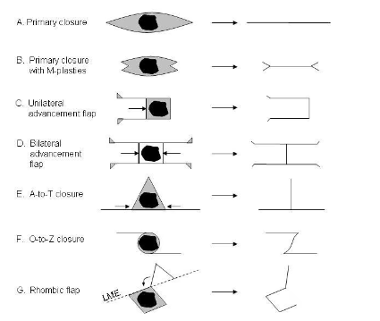

Closures and local flaps.

The closure should be performed in layers to specifically bring the galeal layers together to prevent depression and widen the scar. Midline defects may be closed in a vertical fashion with an acceptable result. Because a net deficit of tissue results from primary closure, care must be taken not to distort the brow.

Skin grafting

Large defects that are too extensive for local flaps can be closed with skin grafts. Skin grafts are free grafts which rely on the exchange of nutrients from the recipient site for their survival. [Split-thickness skin grafts](https://emedicine.medscape.com/article/876290-overview), which are composed of epithelium and a variable amount of dermis, have a survival rate better than that of [full-thickness skin grafts](https://emedicine.medscape.com/article/876379-overview). The thinner the graft, the lower its metabolic demands. The graft must be applied to a vascularized bed; pericranium is acceptable. Bare cortical bone must be burred down to expose the diploë if the skin graft is to survive. A bolster is typically placed over the graft for approximately 1 week to prevent movement of the graft and accumulation of fluid beneath it.

Skin grafts, especially split-thickness grafts, do not have the same characteristics as those of the surrounding forehead. Donor supply for split-thickness grafts is abundant, but color and texture match is poor (as seen in the image below). The grafts are usually thinner than the defect depth, causing the reconstructed area to appear depressed. This depression is especially noticeable when the bone or pericranium is covered. Allowing the area to fill in with granulation tissue before grafting can minimize the contour discrepancy.

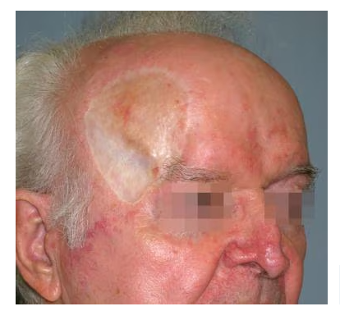

Split-thickness skin graft used for temple reconstruction. The skin color and texture match are not optimal.

Full-thickness grafts are useful, but large quantities cannot be easily harvested without creating the problem of donor-site closure. Full-thickness skin grafts have better texture and volume than their split-thickness counterparts. However, color match again is usually poor. Whichever grafting method is used, the reconstructed result tends to have a "patch-like" appearance. As an alternative, grafting can be used for temporary coverage while [tissue expansion](https://emedicine.medscape.com/article/880686-overview) is taking place. Once expansion is complete, the grafted portion can be excised and covered with the expanded skin.

Transfer of adjacent tissue

Local flaps can be designed to recruit adjacent tissue. Advancement flaps borrow skin from the lateral forehead to close more centrally located defects in a unilateral or bilateral manner. Horizontal incisions, which allow the skin to advance toward the defect, are well camouflaged as horizontal rhytides.

The length-to-width ratio of a randomly vascularized flap should not exceed 4:1 to prevent vascular compromise. For small defects on the temple, skin from the upper midface region can be advanced upward to aid in closure. If a circular defect lies adjacent to a horizontal subunit boundary such as the hairline or brow line, its shape can be converted to a triangle, and an A-to-T closure can be performed (as seen in the image below). This broad-based variation of the bilateral advancement flap involves the use of 2 relaxing incisions located either tangentially inferior or superior to the defect.

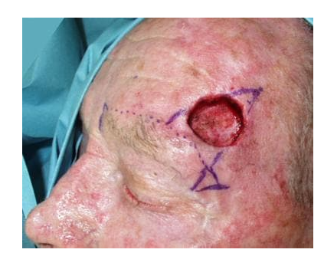

to-T closure adjacent to the brow. The initial defect, as shown, lies close to the brow.

The similar O-to-Z closure rotates and advances skin by using 2 horizontal relaxing incisions on opposite sides of the defect.

Large V-to-Y musculocutaneous island flaps could also be used to advance adjacent tissue to the defect site. Based upon either the supratrochlear or supraorbital vessels, the flap is raised with a sheet of underlying frontalis muscle, bridging the cutaneous island with its vascular supply.[[2](javascript:void(0);),[3](javascript:void(0);)]

The thickness of the flap depends on the depth of the defect. Small, shallow defects may be closed by using flaps undermined in the subcutaneous plane. Large flaps covering deep defects should be undermined in the subgaleal plane to preserve the musculocutaneous blood supply.

A study by Hussain indicated that large defects of the temple and lateral forehead can effectively be repaired with contralateral subgaleal sliding flaps. In the study, 16 patients (average defect size 2.8 x 3.1 cm) underwent the single-stage surgery, with all of them rating the results as good or excellent.[[4](javascript:void(0);)]

Transposition flaps

By definition, transposition flaps involve donor-site tissue, which must be transferred over or under intervening tissue. The classic Limberg rhombic flap and its variants (eg, Webster, Defourmentel) involve the rotation of skin to close defects that have been converted to rhombic shapes.

Each defect has 4 possible rhombic flap designs. The best design is one that orients the lines of maximum extensibility (LME) to facilitate donor-site closure. The incision lines in rhombic flaps unfortunately occur in different directions and are difficult to camouflage. The rhombic flap is most suitable for temple defects, where increased tissue laxity can be found and where RSTL are not strictly horizontal.

Regional flaps

Large defects require more creative solutions. A preauricular island flap that consists of skin and underlying superficial musculoaponeurotic system (SMAS) can be based on a reversed temporal artery system. The island of tissue can then passed beneath the temporal forehead to a lateral defect site.[[5](javascript:void(0);)]Hair-bearing tissue from the scalp can be used to reconstruct the eyebrow by using an island flap based on the posterofrontal branch of the superficial temporal artery. Superficial temporoparietal fascia or pericranium can be rotated into defects not only to provide a vascularized bed for skin grafting, but also volume restoration.

Tissue expansion may be required to increase the amount of local tissue available for recruitment. Tissue expanders are inflatable silicone reservoirs that are implanted under the galea. Over several weeks, saline is added to the expander through an injection port. The surface area of the overlying skin is gradually increased through a process of "biologic creep," providing increased tissue to reconstruct adjacent defects. Because this is a time-consuming process, the initial defect is often closed with a temporizing technique such as skin grafting. The expander base should be 2.5 times as large as the defect to be closed when a rectangular expander is used. Infection, extrusion, and mechanical failure of the expander are potential stumbling blocks with this procedure.[[6](javascript:void(0);)]

After adequate inflation has occurred, the expander is removed and the defect is reconstructed (as seen in the images below). Careful planning is required to anticipate the final flap design to avoid causing damage with expander implantation.

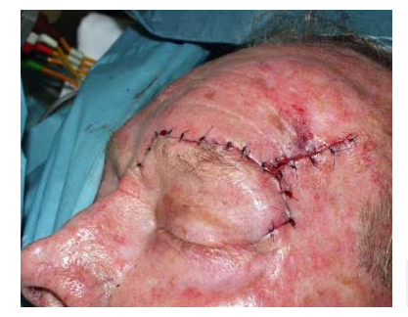

closure adjacent to the brow. Completion of the closure.

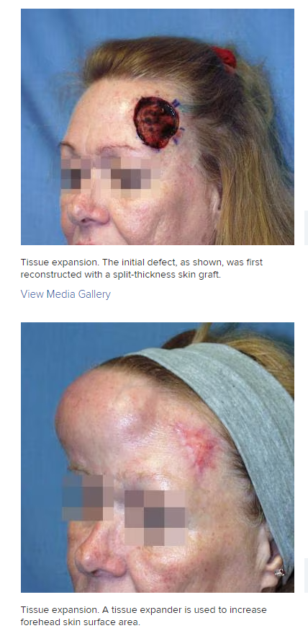

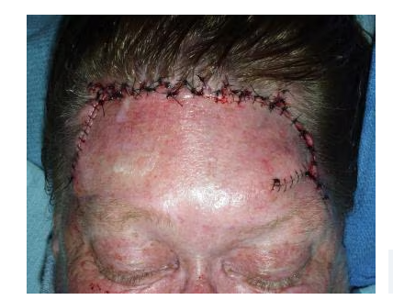

Tissue expansion. The expander has been removed, the skin grafted area excised, and the skin advanced to cover the former defect.

As an alternative, intraoperative tissue expansion can be attempted to immediately increase the availability of tissue. The reservoir is expanded until tissue pallor and firmness is achieved for 3 minutes. The balloon is then deflated for a few minutes then reinflated for 2 or 3 more cycles. The amount of tissue gained is not considerable.

Free tissue transfer

Gigantic defects that require closure and are not amenable to other reconstructive options may require the free transfer of tissue. In the forehead region, consideration for free flap reconstruction should be given for lesions that expose bone greater than 50 cm2 in size.[[7](javascript:void(0);)]Donor tissue is available in segments of tissue known as angiosomes. An angiosome is a 3-dimensional block of tissue supplied by a source artery and concomitant veins. Angiosomes may be transferred by connecting its arterial and vascular pedicle to the systemic circulation at the recipient site.

The radial forearm fasciocutaneous flap provides thin, pliable tissue that may improve replication of forehead skin. Large areas of scalp and forehead can be covered with a muscle-only free flap of the latissimus dorsi combined with a skin graft. This provides a thinner reconstruction result than that achieved by using a latissimus dorsi musculocutaneous flap with its native skin. Other free-flap donor options include scapula and [rectus abdominus flaps](https://emedicine.medscape.com/article/880615-overview). However, the thickness match is not optimal.

Repair of bone defects

The underlying frontal bone determines much of the contour of the forehead. When the defect violates the integrity of the bone, the native architecture may require restoration. In trauma cases, bone fragments can be pieced together by using internal fixation. However, bone may have been destroyed after tumor extirpation and may need to be replaced with autologous or alloplastic material. Split-calvarial bone grafts can be used, but potential donor-site morbidity must be considered. Use of costal cartilage has also been described to bridge a calvarial defect, but the propensity for graft absorption is problematic.

Alloplastic grafts have become increasingly popular because of the abundance of material and lack of donor-site morbidity. Polymethylmethacrylate (PMMA) is probably the most frequently used alloplast for cranioplasty. The material is stronger than the adjacent skull bone in compression and torsion testing. However, PMMA does not integrate with bone; it can loosen over time if used as an onlay, and it may induce a foreign-body giant-cell reaction during its exothermic polymerization process.

Hydroxyapatite cement is another promising substitute. Made of calcium phosphate salts, the material can integrate into native bone, it is easy to mold and shape, and it hardens with an isothermic reaction. However, hydroxyapatite is brittle, it does not provide good structural strength, and it may induce a delayed inflammatory reaction.

Porous polyethylene is a semirigid implantable material that can provide structural support to replace missing bone. The material comes manufactured in a variety of shapes or can be custom designed to fit a particular defect. Its porous nature allows ingrowth of vascularized tissue, which is thought to improve resistance to infection and prevent migration of the implant. Porous polyethylene is used widely for all types of craniofacial reconstruction, including the forehead.[[8](javascript:void(0);)]

If reconstruction of the calvaria over the frontal sinus is performed, take care to avoid future mucocele formation. Therefore, all mucosal surfaces should continue to have outflow access to the nasofrontal duct. Sequestered areas must be stripped of mucosa and obliterated. If the posterior table is violated, cranialization of the sinus should be considered to prevent inward mucocele growth. Alloplastic materials should not contact the mucosa because this leads to a high rate of infection.