elastic search issue

>>>>>>>>>>>>>>>>>>>>>>>>>>

Catalog Search index process unknown error:

{"error":{"root_cause":[{"type":"cluster_block_exception","reason":"index [magento2_product_1_v144] blocked by: [FORBIDDEN/12/index read-only / allow delete (api)];"}],"type":"cluster_block_exception","reason":"index [magento2_product_1_v144] blocked by: [FORBIDDEN/12/index read-only / allow delete (api)];"},"status":403}

curl -XPUT -H "Content-Type: application/json" http://localhost:9200/_all/_settings -d '{"index.blocks.read_only_allow_delete": null}'

curl -XPUT -H "Content-Type: application/json" http://localhost:9200/_all/_settings -d '{"index.blocks.read_only_allow_delete": null}'

curl -XPUT -H "Content-Type: application/json" http://localhost:9200/_all/_settings -d '{"index.blocks.read_only_allow_delete": null}'

>>>>>>>>>>>>>>>>>>>>>>>>>>

show indexes

curl --silent -X GET localhost:9200/_cat/indices?v

>>>>>>>>>>>>>>

curl -X GET "localhost:9200/_cluster/health?pretty"

remove all indexer

curl -X DELETE 'http://localhost:9200/_all'

https://mirasvit.com/blog/magento-2-and-elasticsearch.html

https://firebearstudio.com/blog/how-to-restore-green-elasticsearch-index-status-in-magento-2.html

get view contents by index

curl --silent -X GET localhost:9200/_cat/indices?v

curl -H 'Content-Type: application/json' -X GET http://localhost:9200/mg243_product_1_v2?pretty

======================================

filter product collection in category page

https://webkul.com/blog/add-non-product-attribute-to-magento2-elastic-documents/

E:\PHP\magento243\vendor\magento\module-catalog\Model\ResourceModel\Product\Collection.php

:: 787 :: addIdFilter

E:\PHP\magento243\vendor\magento\module-catalog-search\Model\ResourceModel\Fulltext\Collection.php

:: 451 :: _renderFiltersBefore

E:\PHP\magento243\vendor\magento\framework\Search\Search.php

:: 59 :: search

E:\PHP\magento243\vendor\magento\framework\Search\Request\Builder.php

:: 147 :: create

$data = $this->config->get($requestName); // catalog_view_container

E:\PHP\magento243\vendor\magento\module-catalog-search\etc\search_request.xml

E:\PHP\magento243\vendor\magento\module-elasticsearch-7\etc\di.xml

E:\PHP\magento243\vendor\magento\framework\Search\Request\Binder.php

:: 82 :: processData

E:\PHP\magento243\vendor\magento\module-advanced-search\Model\Adapter\DataMapper\AdditionalFieldsProvider.php

=========================================

How to add product field to elasticsearch

https://webkul.com/blog/add-non-product-attribute-to-magento2-elastic-documents/

1. 1.First of all you need to create a class which is going to be the provider for the data that you want to index while Magento indexer runs:

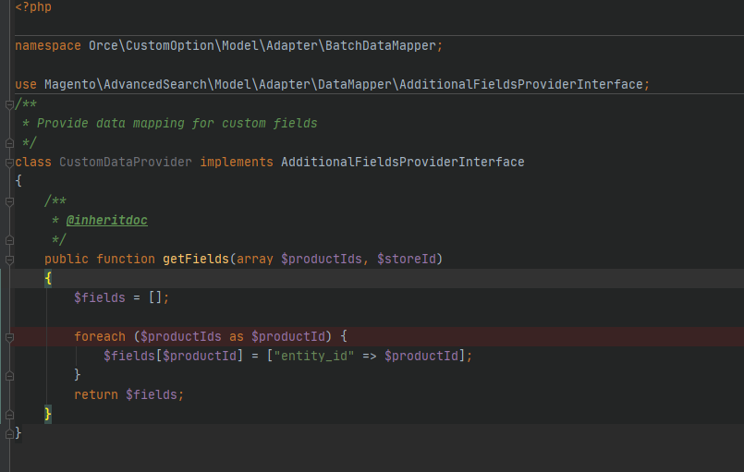

1. 2.Now we have to add this class in the di.xml file of the module so that Magento can know at the time of indexing to add this field:

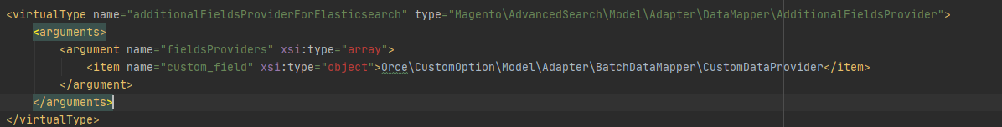

1. php bin/magento indexer:reindex
2. etc/search_request.xml

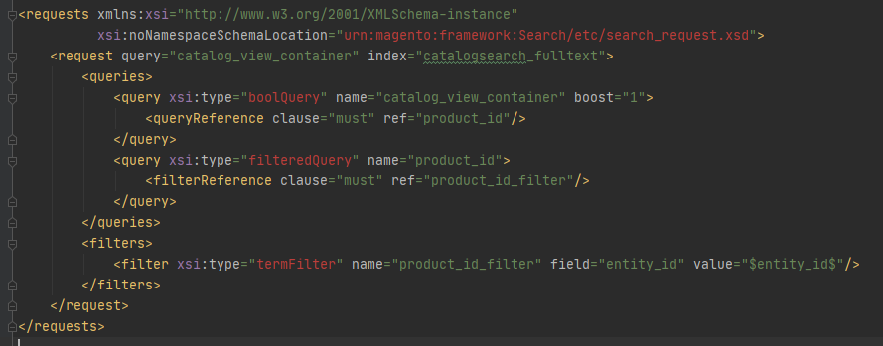

1. create observer etc/events.xml



