SQL CONNECTIVITY ISSUE

STEP 1:
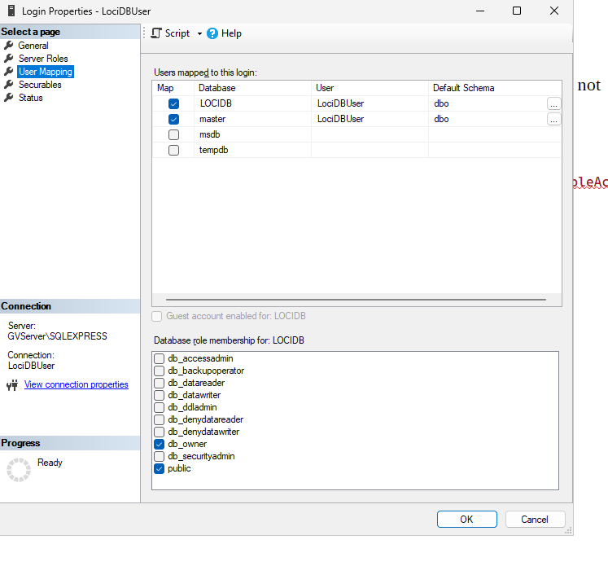
Create a new login if already exist in my case lociDBuser is already created so delete it ,if it is not deleting go to user mapping and un check db owner for lociDBuser and then delete it

and again create with SQL AUTHENTICATION according to your connection string.

connection string:
"IbrakCon":
"Server=tcp:127.0.0.1,1433;Database=LOCIDB;User Id=LociDBUser;Password=Lsj4Sh3#@4j2087;Encrypt=False;TrustServerCertificate=True;MultipleActiv
eResultSets=True;"
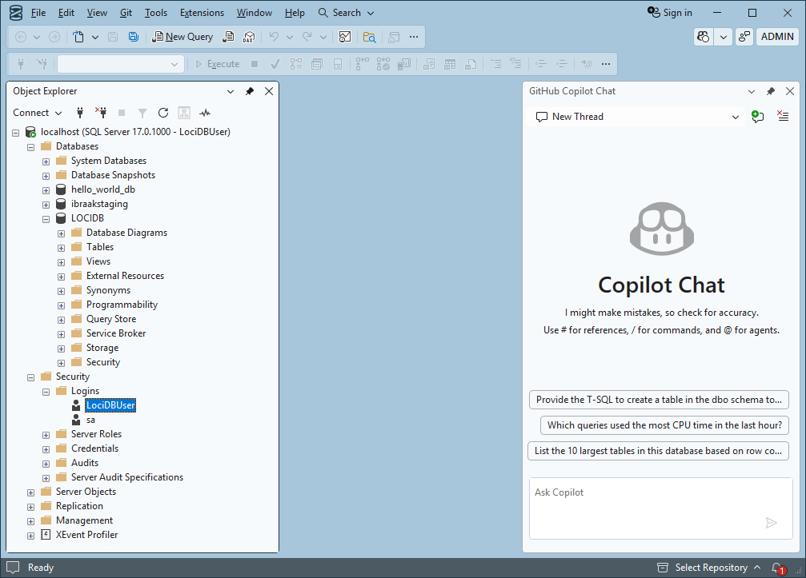

STEP 2:
Giving permission

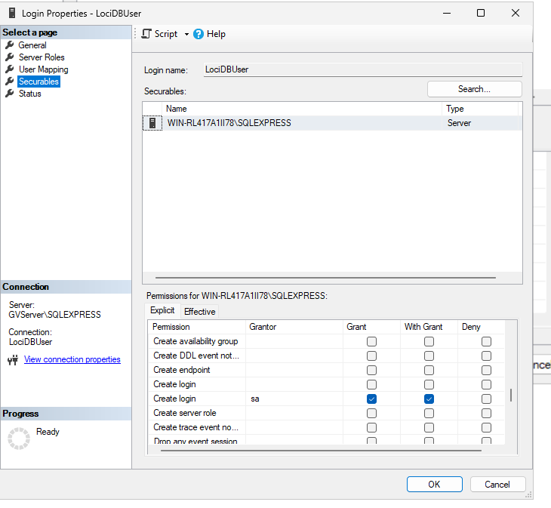

CREATE LOGIN
CONNECT SQL

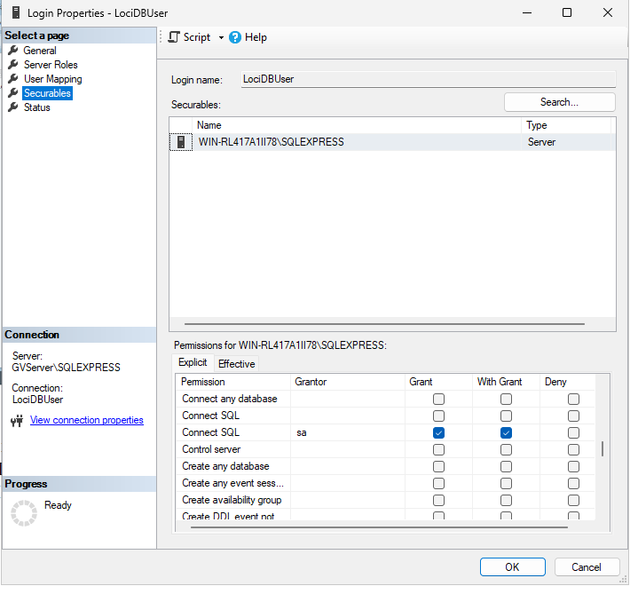

STEP 3:
login in SQL SEVER MANAGEMENT STUDIO
if log in successful website will work

