A Job Simulation Report
Of
Data Analytics Job Simulation
Submitted
To
School of Computer Science and Engineering
IILM University, Greater Noida, U.P.
In partial fulfilment of the requirement of degree of
B-Tech (CSE)

By
Roll Number of Student:- 2410031158
Name of Student: ADEEL KHAN
Batch: 2026-27

CANDIDATE'S DECLARATION
I, ADEEL KHAN, do hereby declare that the job simulation report titled “Data Analytics Job Simulation”, undertaken with Deloitte through the Forage virtual experience platform, has been completed by me to fulfil the requirement for the award of the degree of Bachelor of Technology in Computer Science and Engineering. All the references have been quoted and I have not taken as such any material from any other source. I affirm that this report is my own and has not been submitted to any other institute for any degree/diploma requirement, and further I shall be solely responsible for any kind of copyright violation in this regard.
Signature:-
Student Name: ADEEL KHAN
Roll No.: 2410031158

ACKNOWLEDGEMENT
I am using this opportunity to express my gratitude to everyone who supported me throughout the Job Simulation Program. I am thankful for their aspiring guidance, invaluably constructive criticism and friendly advice during this work. I am sincerely grateful to them for sharing their truthful and illuminating views on a number of issues related to this work.
I would like to thank Deloitte and the Forage virtual experience platform for providing me the opportunity and the structured platform to learn and gain hands-on exposure in the domain of Data Analytics and Forensic Technology. I am also thankful to my institute, IILM University, Greater Noida, and the faculty of the School of Computer Science and Engineering for their continuous support and encouragement.
I express my gratitude to my parents for their blessings.
Signature:
Student Name: ADEEL KHAN
Roll No.: 2410031158

TABLE OF CONTENTS
1. Candidate's Declaration i
2. Acknowledgement ii
3. Job Simulation Completion Certificate -
4. Project Description 1
4.1 Introduction 1
4.2 Organization Profile 2
4.3 Problem Statement 3
4.4 Project Objectives 3
4.5 Scope of the Project 4
4.6 Technologies and Tools Used 4
4.7 Task Architecture 5
4.8 Methodology 6
4.9 Expected Outcomes 7
4.10 Certificate of Completion 8
5. Bibliography/References 9

3. JOB SIMULATION COMPLETION CERTIFICATE
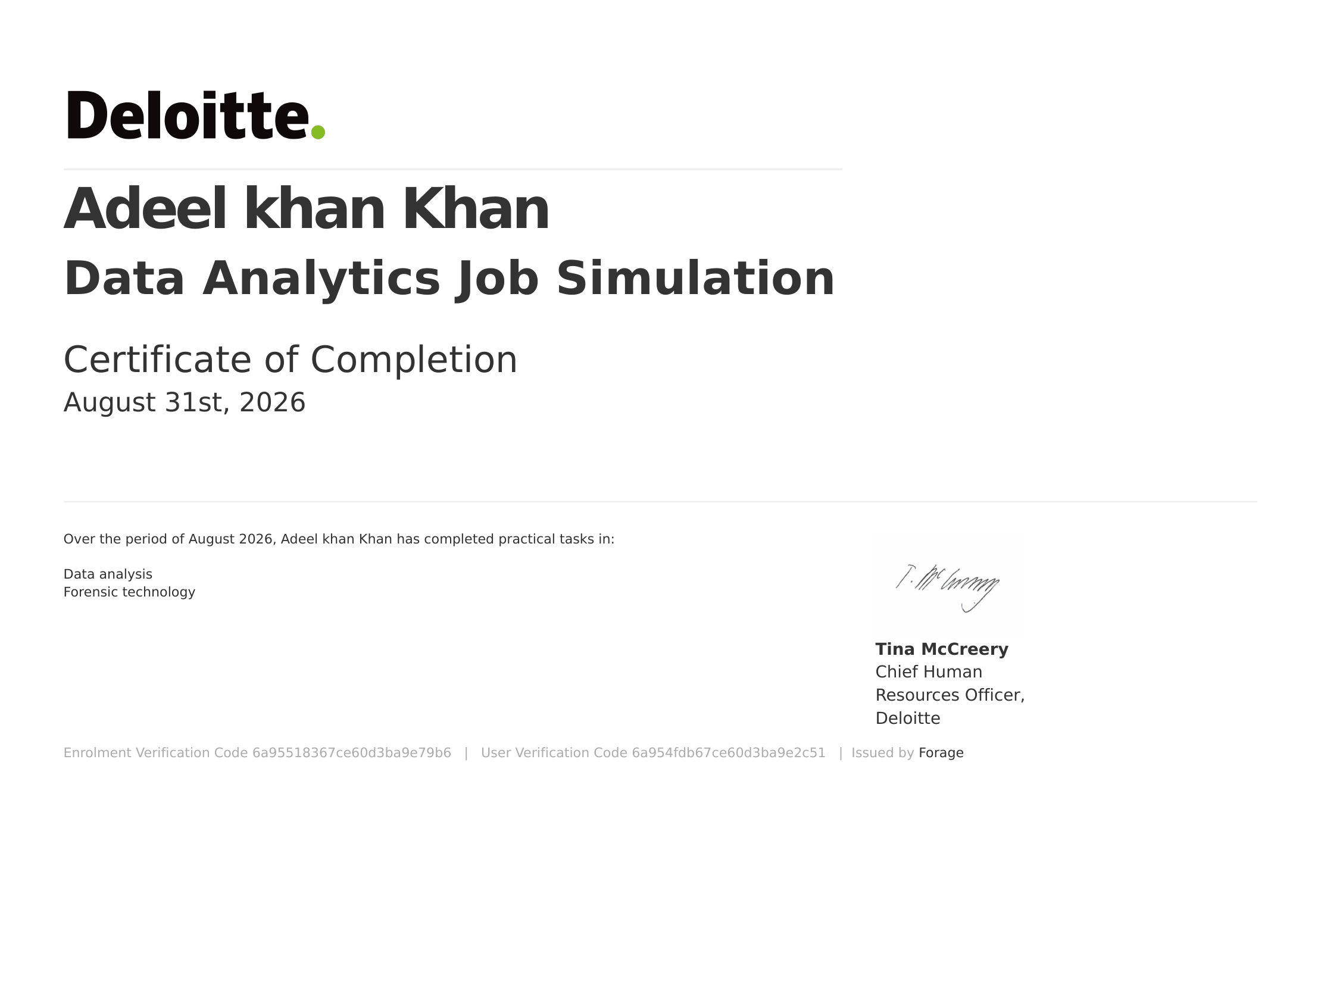

4. PROJECT DESCRIPTION

4.1 Introduction
This report presents a detailed account of the Data Analytics Job Simulation undertaken with Deloitte through the Forage virtual experience platform. The simulation was carried out in August 2026 as part of the requirement of the Bachelor of Technology (Computer Science and Engineering) programme at IILM University, Greater Noida. The primary aim of this job simulation was to provide practical, industry-relevant exposure to the kind of data analytics and forensic technology work carried out by analysts within Deloitte's advisory practice, allowing the learner to apply classroom knowledge of data analysis to realistic, client-style business tasks.
The job simulation followed a self-paced, task-based structure that combined a realistic business scenario with hands-on practical exercises in data analysis and forensic technology. On successful completion of all the required tasks, a Certificate of Completion was issued by Deloitte through Forage.

4.2 Organization Profile
Deloitte is one of the world's largest professional services networks, providing audit and assurance, consulting, financial advisory, risk advisory, tax, and legal services to clients across industries worldwide. Its forensic and financial advisory practice assists organizations in identifying, investigating, and mitigating financial risk, fraud, and irregularities through the application of data analytics and technology-driven investigative techniques.
Forage is a virtual work experience platform that partners with leading global organizations, including Deloitte, to design job simulations that replicate real day-to-day tasks performed by employees in specific roles. These simulations give students practical exposure to industry workflows and help them build job-relevant skills outside of a traditional classroom setting.

4.3 Problem Statement
Although engineering students are commonly taught the theoretical foundations of data analysis during their academic coursework, very few get exposure to how such analysis is actually applied within a real corporate advisory setting, particularly in the context of identifying suspicious transactions or supporting forensic investigations. The problem addressed by this job simulation was to understand and practically apply core data analysis techniques -- identifying relevant data sources, cleaning and structuring data, building visualizations, and communicating findings -- within the context of a forensic technology engagement.

4.4 Project Objectives
- To understand the role of data analytics within Deloitte's forensic technology practice.
- To identify appropriate data sources and data types relevant to a forensic business scenario.
- To organize, clean, and structure raw data for meaningful analysis.
- To build a data dashboard/visualization to highlight patterns and anomalies within the dataset.
- To interpret analytical findings and translate them into clear, actionable business insights.
- To prepare a professional presentation summarizing the analysis and recommendations for a client-style audience.
- To apply all the above concepts in a realistic, end-to-end forensic data analysis task.

4.5 Scope of the Project
The scope of this job simulation covers the initial stages of a forensic technology engagement -- starting from understanding a business problem, identifying and organizing relevant data sources, and progressing to data analysis, visualization, and presentation of insights. The job simulation was limited to a virtual, self-paced environment provided by Forage on behalf of Deloitte and did not involve work on any live client engagement or organizational data.

4.6 Technologies and Tools Used
- Data Analysis & Visualization: Microsoft Excel / Tableau
- Data Organization: Spreadsheet-based data cleaning and structuring techniques
- Presentation: Microsoft PowerPoint / business communication techniques
- Domain Concepts: Forensic technology, data analytics, fraud and risk indicators

4.7 Task Architecture
The general workflow followed during the job simulation for approaching a forensic data analysis task can be summarized in the following stages:
- Business Understanding Stage: Reviewing the client scenario/brief provided by Deloitte to understand the business problem and objective.
- Data Identification Stage: Identifying the data sources and data types relevant to the scenario for forensic review.
- Data Preparation Stage: Cleaning, organizing, and structuring the raw data into an analysis-ready format.
- Analysis & Visualization Stage: Building a dashboard/visualization to identify trends, patterns, and anomalies within the data.
- Insight & Reporting Stage: Interpreting the results and preparing a clear, client-ready summary of findings and recommendations.

4.8 Methodology
The job simulation followed a structured, task-based methodology combining a realistic business brief, hands-on practical exercises, and self-assessment, as summarized in the table below.
Task | Module | Description
1 | Data Analysis | Reviewing the business scenario, identifying relevant data sources and data types, and understanding how data analytics supports forensic investigations.
2 | Forensic Technology | Organizing and analyzing a real-world style dataset, building a dashboard to visualize patterns and anomalies, and presenting findings and recommendations in a clear, client-ready format.

Each task concluded with a practical deliverable that was reviewed against Deloitte's model answers, allowing self-assessment of conceptual understanding and analytical skill. On successful completion of both tasks, a Certificate of Completion was issued.

4.9 Expected Outcomes
- Ability to identify data sources relevant to a real-world forensic business problem.
- Practical understanding of organizing and structuring data for analysis.
- Hands-on exposure to building dashboards/visualizations to detect patterns and anomalies.
- Capability to translate analytical findings into clear, actionable business insights.
- Understanding of how data analytics supports forensic technology and risk advisory work.
- A completed, task-based project demonstrating end-to-end data analysis within a forensic context.

4.10 Certificate of Completion
The Certificate of Completion issued by Deloitte through Forage, confirming successful completion of the Data Analytics Job Simulation covering Data Analysis and Forensic Technology, is attached in Chapter 3 of this report.

5. BIBLIOGRAPHY/REFERENCES
1. Deloitte, “Data Analytics Job Simulation,” Certificate of Completion, issued via Forage, August 31, 2026.
2. Forage, “Virtual Work Experience Programs,” https://www.theforage.com/
3. Deloitte, official website, https://www2.deloitte.com/
4. Microsoft Excel Documentation, https://support.microsoft.com/excel
5. Tableau Documentation, https://help.tableau.com/

