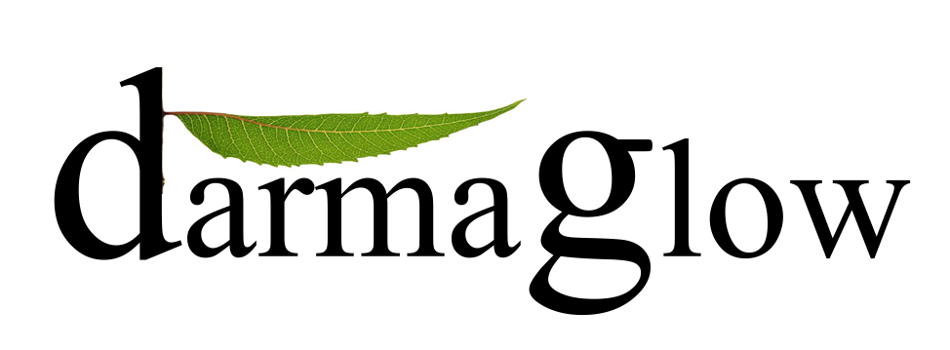
IMC
Marketing Compaing
Submitted To : Sir Waqar
Submitted By : Adeel Nasir
Irfan Alvi
Arslan Shahzad
Abu Bakar

Table of content

Executive Summary------------------------------------------------------------------------3
Industry --------------------------------------------------------------------------------------4
Cosmetics Industry ---------------------------------------------------------------------4
Gluten Free Product --------------------------------------------------------------------5
Gluten-Free Cosmetics. ----------------------------------------------------------------5
Ayurvedic Products-.--------------------------------------------------------------------5

Darma glow Cosmetics
Background ---------------------------------------------------------------------------------6
Mission & Vision. --------------------------------------------------------------------------7
Product Range ------------------------------------------------------------------------------7
Value propositions .-------------------------------------------------------------------------8
Barriers to Entry..---------------------------------------------------------------------------8
Keys to Success .----------------------------------------------------------------------------8

Market Analysis
Customer …………………………………………………………………………..9
Market Research……………………………………………….…………………..9
Market Size and Trends……………………………………………………………10
Differentiation…………………………………………………………….….……10
Competitors………………………………………………………………………..11

Marketing Plan
Positioning …………………………..………………………………………….…..12
Promotions Mix …………………………………………………..………………... 12
On the spot Advertisement ……………………………………………..…….…..…13
Sales & Distribution………………………………………………………….….…..13
Pricing Strategy……………………………………………………………….……..14
.
Operational Plan
Operational Model………………………………………………………….………..15

Darma glow Cosmetics solves the growing need for gluten-free cosmetics by manufacturing and distributing gluten-free, organic makeup and personal care products.
Gluten is a protein in wheat, barley, and rye which causes severe health problems for individuals with Celiac Disease. Celiac disease is linked to long term problems such as osteoporosis, infertility and cancer .Individuals who are gluten-intolerant can improve their quality of life by eliminating all traces of gluten from their diet. Darma glow products offer peace of mind. We give our customers freedom to enjoy the luxuries of quality makeup worry-free. Unlike competitors, we focus on the gluten-free claim. Our products are certified gluten-free by a third party and backed with scientific consumer education which competitors do not offer.
Our primary customers are natural and organic grocery stores and distributors, reached through trade shows and sales programs. Our end users are women ages 16-60 who suffer from food allergies, especially gluten-intolerance. We will reach them through web marketing, consumer events, grocery stores where they shop. We believe that DGC Clean Cosmetics will meet the read and growing need for gluten-free makeup and personal care products. We will break even in our first year of operations, and grow in profitability as DGC becomes a household name in the brand-loyal gluten-free community.

Industry

Darma glow is part of a young niche industry providing cosmetic products to individuals who struggle with gluten intolerance and wheat allergies. This niche is currently underserved and growing, providing serendipitous opportunities for Darma glow.

Cosmetics Industry
Darma glow Cosmetics participates in the growing gluten-free cosmetics industry. The cosmetics industry struggled during the recession, but has rebounded, with growth in 2011. the industry shows especially strong growth in the high-tech and organic sectors.

Gluten- Free Products.
While the cosmetics industry is mature and stable, the gluten-free products industry is relatively new and volatile. Since 2009, public awareness of gluten-intolerance has grown significantly. Gluten is a protein found in wheat, barley, and rye which frequently triggers adverse reaction ranging from headaches and nausea to debilitating fatigue. Gluten exposure in women with Celiac disease has been linked to long term problems like osteoporosis, infertility and cancer. Individuals who are gluten-intolerant can substantially improve their quality of life by eliminating all traces of gluten from their diet.

Today, 10% of the US population eats gluten-free. (That’s more than the entire population of Texas)
In response to burgeoning consumer demand, the natural and specialty food industry has created an impressive array of gluten-free food products. SPINs, a market research service for the natural food industry, says that gluten-free food is a $6.3 Billion industry, up 33% since 2009.
Darma glow all products line are gluten free products.

Gluten - Free Cosmetics
Darma rising demand for gluten-free foods, there is a notable lack of attention to gluten in cosmetics. Gluten intolerant individuals spend hours of time to ensuring that their diets are completely gluten-free, yet fail to realize that gluten is hiding in their makeup bags, causing breakouts or even more serious symptoms.
A popular gluten-free blog lists over 20 common personal care product ingredients which contain gluten and an additional 10 which may be cross-contaminated. One of the most ubiquitous of these ingredients is Vitamin E oil, which may be derived from wheat, soy, or rice. If Vitamin E oil is derived from wheat, gluten contamination is inevitable.
Ayurvedic & Sulphide Free Products
If someone was sick in ancient India they have a doctor to treat them. The medicine was use in that time is ayurvedic medicine. Darma glow use ayurvedic products which are allergic free.
Darma glow products are Sulphide free products that provide the customer wide range of allergic free cosmetic creams , lotion and other products.
7Fact about Celiac disease

Celiac diseases are condition that is caused by gluten. Gluten is a protein composite found in a wheat, barley and rye.
The only treatment for celiac disease is the gluten free products
Celiac disease is more common in women than men by a ratio of 3:1
Genetics and ancestry are important in the incidience of celiac disease.
5 million people in Pakistan have celiac disease . Its prevalence will rise with greater awareness.
Celiac disease affects every organ in the human body.
A Gluten-free Lifestyle affects the ability to socialize, travel and dine in restaurants.
Darma Glow (DC) manufactures and distributes organic, gluten-free, top-8 allergen free makeup and personal care products. Our high-quality products are distributed online and through natural and specialty grocery stores carrying gluten-free products.
Awareness of the benefits of organic products has grown dramatically in recent years, and is more than just a trend. In addition, many individuals are diagnosed with food allergies each year, and the rate of diagnosis for gluten intolerance is rising. Research in the gluten-free and food-allergy communities reveals that these individuals are confused and dissatisfied with current cosmetic offerings.
In addition, our target market is growing. We identify our primary market as females ages 16-60 who suffer from a food allergy, especially gluten-intolerance. These customers have high purchasing power and are accustomed to spending more than average on allergen-free foods. Darma glow
We offer consumers full peace of mind through gluten-free and organic and Halal.

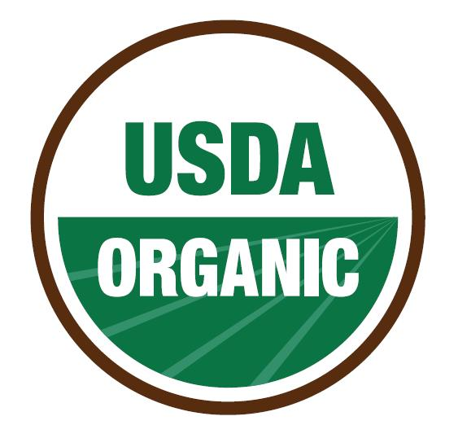

Background
Darma glow cosmetics are a new startup, which we are serious about launching in 2010.
As a founder of Darma glow we believe that our skill and passions are relevant to DC mission.
Nasir Mahmood the Owner of the DC has nearly 10 year experience of Marketing and 20 year experience of Auditing.
Waheed Shah the partner DC has experience in biology which will enable him to understand the formulation and scientific basis for our products and also have knowledge and contacts in the Gluten free natural products industry.
Nasir mahmood, Waheed Shah and Adeel Nasir are interested in working together to launch DC cosmetics.
To date, we have completed this business plan, prototyped products, built a website, and conducted beta testing and interviews with our target market.
Mission Statement
The company’s Mission Statement is to become the recognized leader in its target Market for developing, producing, and branding a diverse line in demand Organic products including perfume, makeup and other accessories.

Products Range

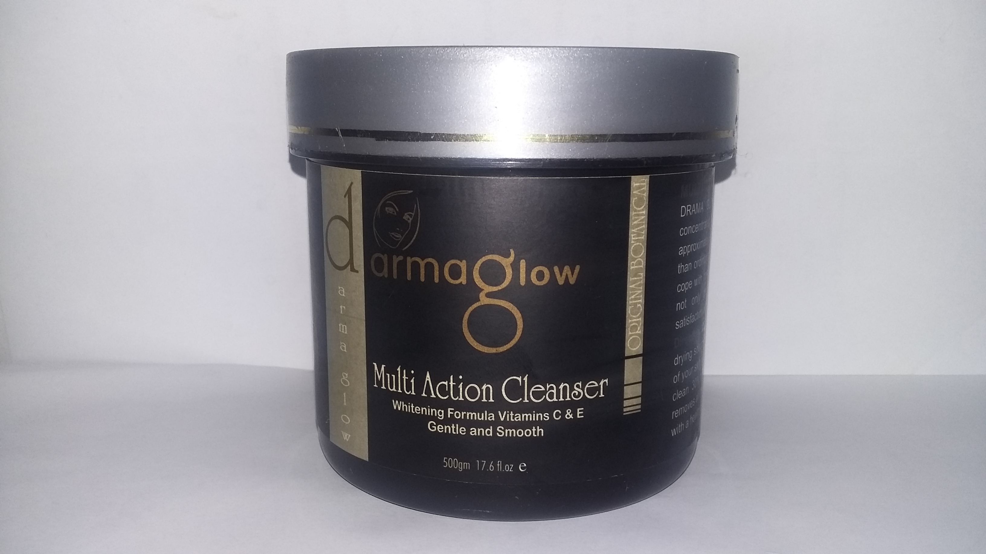
- Skin Care
- Ayurvedic Facial
- Botanical Facial
- Herbal Facial
- Skin Lifting treatment
- Cosmetic surgery

- Personal & Hair
- Hair treatment
- Hair Extension
- Hair color

- Colour Cosmetics
- The world of color cosmetics is not only about colors. DC approach is to enhance every woman’s natural beauty. Our portfolio offers a wide and sophisticated range of products with enhanced formulations and trendy packaging. We have products t0 suit every woman, every mood and every style.

- Accessories
From hair brushes to handbags, sunglasses to sandals, toothbrushes to teddy bears, make up bags to manicure sets, sarongs to scarves, candles to combs, not to mention belts, pedicure sets, towels, bracelets, necklaces, earrings, toilet bags and seasonal gifts, DC has them all and much, much more

Value Proposition
DC products offer consumers Peace of Mind. DC‟s value proposition encompasses the following key elements:

1. Peace of Mind – assuring consumers that DGC products are safe
2. Quality – creating products that are effective and luxurious
3. Consumer Education – providing materials to inform consumers of the harmful ingredients in mainstream cosmetics
4. Honesty – fully disclosing the ingredients in our products
5. Purity – sourcing high-quality, organic ingredients for a pure end product

Barriers to Entry
The gluten-free cosmetics industry is made up of a fragmented group of small companies. Barriers to entry exist, but can be overcome by smart and determined entrepreneurs.
The greatest barrier to entry for DC is developing and retaining strong wholesale accounts in natural & specialty grocery.
The costs of sourcing raw materials from certified organic and gluten-free suppliers are substantial, relative to generic ingredients. This forms a second barrier to entry in the gluten-free cosmetics market.

Keys to Success
3.4 Keys to Success
Based on our extensive reading and networking in the gluten-free industry, we believe successful gluten-free cosmetics companies must:
• Educate consumers about the need for gluten-free cosmetics
• Provide 100% gluten-free products
• Create high quality, enjoyable products
• Offer a reasonable price-point
• Engage consumers through social media and consumer events
Market Analysis

Customers
We identify our primary market as females ages 16-60 who suffer from a food allergy, especially gluten- Intolerance. These customers have high purchasing power and are accustomed to spending more than average on allergen-free foods. Women have an intense need to feel beautiful. In our high-pressure culture of supermodels and TV stars, most women struggle with deep-seated feelings of inadequacy. Like all other women, our customers wear makeup to feel beautiful, young, and healthy. Our target market is segmented into two subgroups:

 | Primary Target Market | Secondary Target Market
Age | 16-30 | 30-60
Family | Single | Married with 2-3 Child
Affluence | Upper / Middle Class | Upper / Middle Class
Frequency Of Makeup  Purchase | 3-6 Months | 3-6 Months
Purchase Behavior | Buy Makeup for beauty | Buy for anti-aging

Market Research
Recently we gave a brief presentation on DC Cosmetics to a group of faculty and students. We asked participants to describe DC. They responded with words like “clean, simple, honest, natural, fresh, and wholesome.” One participant said “„DC‟ is a name that immediately captures me.” Design-specific words included “girlie, bright, pink and green.” One evaluator wrote “your website was comfortable and agreeable to me.”
Participants also included terms pertaining to DC viability such as “start-up, market share, opportunity for sound investment and growth.” The idea of healthy, “clean cosmetics” resonated
With many participants, as seen from words like “healthy, pure, no allergens, organic, gluten free,
All natural, cosmetics for a health conscious generation.”

Market Size and Trends
The gluten-free industry is growing. Over 18 million Americans have some form of gluten sensitivity and a study by the Mayo Clinic found a dramatic increase in the number of Celiac cases over the last ten years. Young people are five times more likely to have Celiac disease than youth in the 1950.With greater awareness of Celiac disease and related gastrointestinal disorders, the demand for gluten-free cosmetics has increased.

Over 96% of gluten-free customers are brand loyal . Once DC wins the support of Celiac cosmetic users, it will enjoy long-lasting support from this core customer base. Consumer awareness of the need for gluten-free cosmetics is rising rapidly and will lead to significant growth in this sector during the next 3-5 years.
The gluten-free cosmetics industry is made up of a large number of small companies. DC Clean Cosmetics has an opportunity to dominate this fragmented market with superior cosmetics and a focused message.

Differentiation
Darma glow is differentiated from competitors on the basis of :

- Full disclosure of ingredients

- Lower Price than many competitors

- Scientific consumer Education

- Gluten – Free products

- Sulphide free products

- Ayurvedic formulas

Competitors
There are several small and medium sized players in this market. Of the 16 companies which produce gluten-free cosmetics, only 4 are formally tested and certified gluten-free. The remainder of the market is commanded by mainstream products which happen to be gluten-free.

Our key competitors are as follow, each of these companies has their products tested for gluten by a
Professional lab.
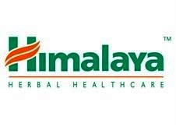
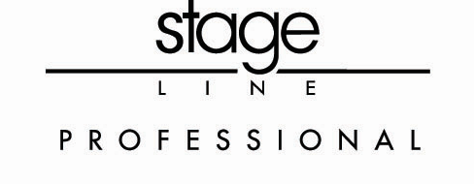

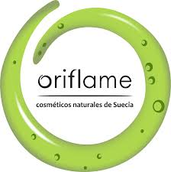
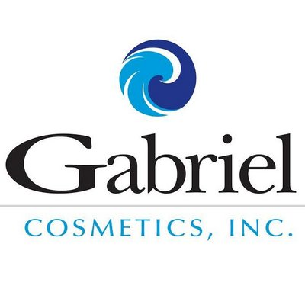

Himalaya Herbal
Low-cost products with gluten-free label. However, their selection focuses more on personal hygiene items and lacks quality makeup.
Gabriel Cosmetics
Offer a limited number of gluten-free products. High prices.

Stage line Professional
Offer high-quality lipstick with a clear gluten free claim. It does not offer any other items.
Gabriel Cosmetics
Offers a wide range of products which are gluten free. However, the gluten-free claim is not prominently displayed on their website and packaging.
Marketing Plan
Positioning
Darma glow sells peace of mind to the consumer through gluten free products. Our cosmetics are
Positioned based on their high-quality, pure ingredients, and our honesty about what is in them.
Our brand personality is simple, friendly, and relaxed.

Promotions Mix
- Internal Marketing
We will pursue an integrated strategy of internet marketing to drive customers to our website. These efforts will be segmented by age group:
- 16-30 Group: These young consumers use social media and search heavily, and are
Likely to use a smart phone or other mobile device. We will reach the younger portion of our target market through a campaign to create internet buzz. This will include Facebook ads, Google ad Words, excellent SEO, and free giveaway contests.
- 30-50 Groups: Middle-aged women are the largest group of social media users. This age group has become remarkably interested in blogging and related outlet. Our social media and SEO efforts will effectively reach this group.

- Consumer Events
The Celiac community is robust and growing, with a network of support groups and events.
DC will reach consumers on the grassroots level by participating in and sampling at consumer events.
- Provide Celiac support groups with free samples and product information.
- Distribute information and samples at consumer events.

On the spot Advertisement
- Class in big cities and invites best beauticians
- User Trail
- Leaflet
- Posters
- Giveaway
- Special offer
- Gifts
- Samples
Sales and Distributions
For distribution purpose we invite distributer and arrange a Demo classes.
We also invite
- Retailer
- Whole salers
- Broker
- Commission Agent
- And other interested parties

Our Target areas are:


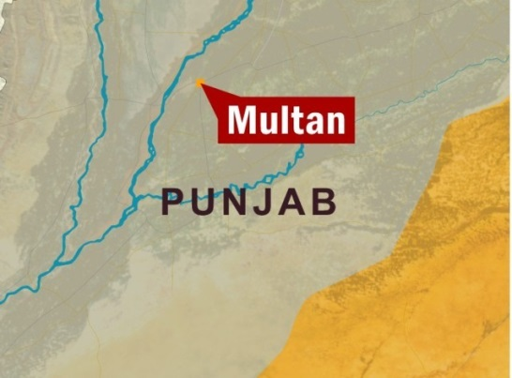




We will also call directly on gluten-free independent grocery stores to promote our products. Some consumers will discover our products on the shelves of their local store.
After startup, our communication with consumers and customers will remain essentially the
same: internet marketing, consumer events, trade shows, and distribution
Pricing Strategy
Darma glow products will command a mid-to-high price point relative to competitors, as shown here:

Products | Price in Rs
 | Cost | Retail
Ayurvedic Facial | 3000 | 7999 /-
Botanical Facial | 2500 | 6000
Skin lifting treatment | 3500 | 9000
Herbal Facial | 2000 | 4500
Hair treatment | 2700 | 7500

Product cost for Wholesalers
We sale the product to our wholesaler at a fixed discount rate. Which is 20 %?

Product | Price in Rs
 | Cost | Whole sale Rate @ 20%
Ayurvedic Facial | 3000 | 6400/-
Botanical Facial | 2500 | 4800
Skin lifting treatment | 3500 | 7200
Herbal Facial | 2000 | 3600
Hair treatment | 2700 | 6000

Operational Plan

Darma glow will manufacture, market, and distribute high-quality, gluten-free cosmetic products. Our operating model and procedures are explained in the following sections.

Operations Model
Below is a diagram highlighting the workflow of tasks at Darma glow the tasks outlined in purple will be the primary responsibilities of Rachel. Sharon will be responsible for tasks outlined in green.

Manufacturing
Packing Product
Direct sales
Marketing
Demo Class
Fill Wholesale
Order
Fill Retail Order
Receiving Order
Receiving Order

Follow Up
Follow Up
Follow Up
Creating Customized Event

Sponsors of the Event
Distributer’s of Area

Location Of Event

Well reputed Hall or Marci

Invitation To.
Beautician , Wholesaler, Retailer, Consumers
Objective

Awareness of Brand and products
Training program or short course Certificate

Budget Of Event Full Summary
In Lahore

Expenses | Rs
Rent of Hall (As per head) | 1500
Sampling Cost | 250 Per Pack
Model cost | 10000 per model
U trus | 5000 per set
Dj | 5000
Projector | 10000
NOC | 20000
Celebrity Musarrat Misbah | 150000
Best Beautician for teaching | 20000 per
Skin Specialist | 20000
Guard | 10000 per
Certificates | 15000
Worker | Basic Salary

