16

**Aspose Build & Deployment Guide**

**Adeel Umar Usmani**

Table of Contents

Purpose: 3

Required Softwares: 3

*Prerequisites* 3

Aspose Maven Installation: 3

Build Project: 4

Issues & Resolution: 11

Deployment (Production): 12

**Aspose Rest API Build & Deployment Guide**

# Purpose:

This document is meant for guiding the end user regarding build & deployment of Apsose Rest API.

# Required Softwares:

Following softwares are required for build & deployment procedure:

* Eclipse Mars.2 Release(4.5.2)
* Jdk (1.7)
* Apache Tomcat (8.0.33)
* Apache Maven (3.3.9)

Under aspose-dev directory, you will find two projects folder:

* Aspose (Containing required Java Rest API)
* Asposeclient(Containing Spring MVC web client to consume the aspose Rest API)

In this document, we will guide you through build & deployment process for both of these applications.

Prerequisites:

* All required softwares are already installed on machine
* All java & maven related environment variables are already configured on system.

# Aspose Maven Installation:

* Due to some technical issues, which I discussed on aspose support forum as well, I was unable to download aspose maven repository. So as a work around I installed maven to my local repository by issuing following maven command:

mvn install:install-file -Dfile=<Jar Physical Location>\aspose-words-16.5.0-jdk16.jar -DgroupId=com.asposelocal -DartifactId=aspose-words -Dversion=16.5.0 -Dpackaging=jar -DgeneratePom=true

**Note: aspose library is available in GitHub under aspose-assignment repository in aspose-maven-lib directory**

Workspace Creation:

* Open Eclipse & on WorkSpace Selector screen, click Browse

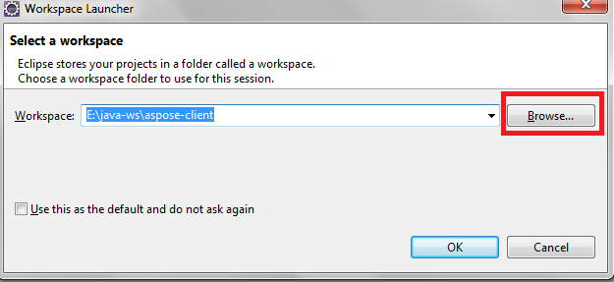

* Select a location where you want to create workspace for aspose & asposeclient projects.
* Add external maven installation (maven 3.3.9) to workspace to use with the project through Window->Preferences->Maven->Installations -> Add.

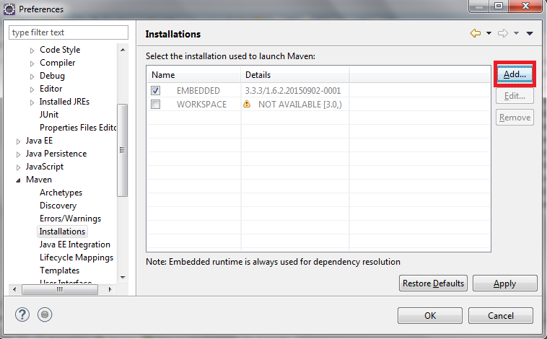

After adding required maven, select the maven installation to use with the project & then click OK button.

# Build Project:

Please follow these steps to build the projet:

* Go to File -> Import -> Maven -> Existing Maven Projects & click Next

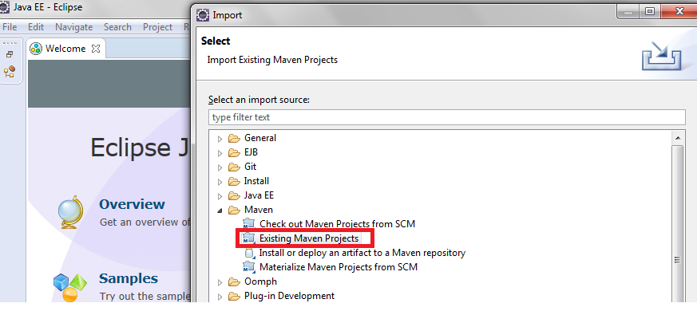

* On next screen, browse the root directory where you have extracted aspose project. After selecting the directory, your screen should appear something like this:

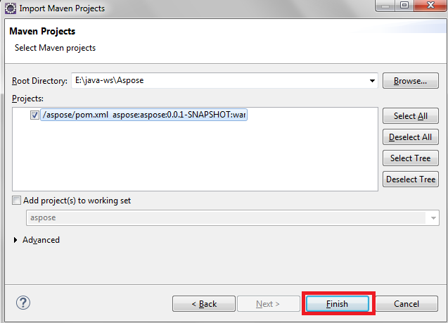

* Now click Finish.
* Right click Aspose project -> Properties -> Java Build Path -> Libraries, & select proper jdk7 version by selecting JRE System Library & then click edit. Click Apply & then Ok in the end.

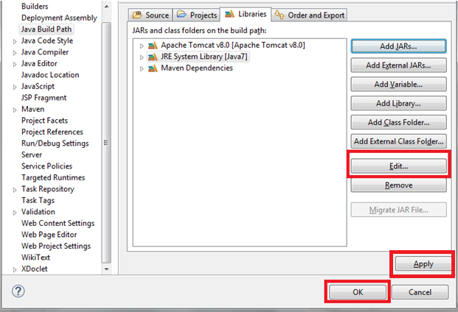

* Build the Project
* Now you have to add Apache Tomcat8 to project workspace. In order to add targeted runtime, Click Server tab & then click New Server Creation Link

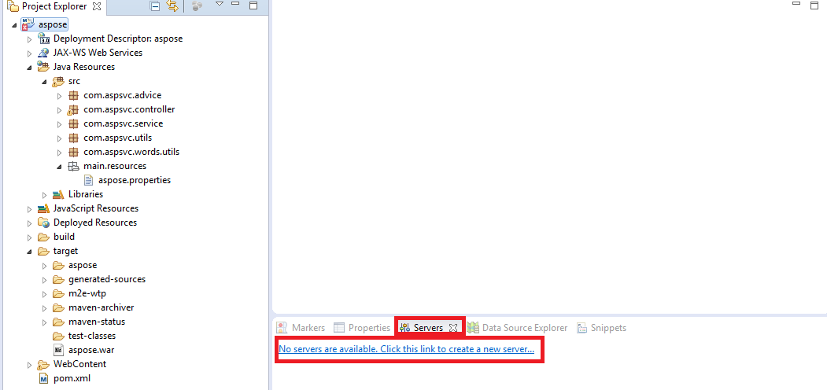

* On next window, select Tomcat v8.0 server under Apache directory & click Next

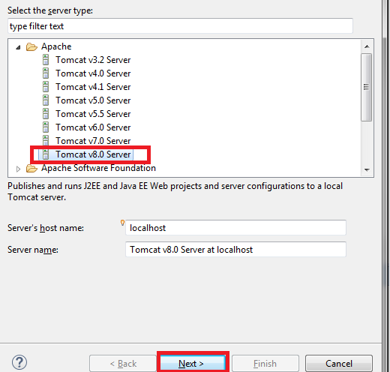

* On next screen, select Tomcat installation directory & jre7 & then click finish.

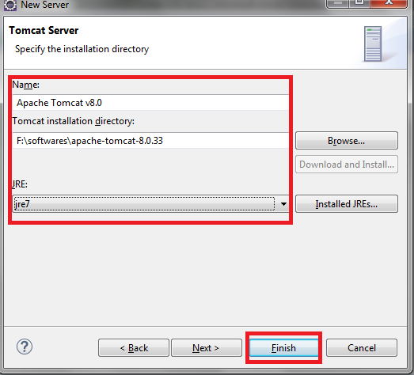

Note: If jre7 is not appearing in jre list, then select it by clicking Installed JREs button.

* Open aspose.properties file. It contains a property save_path. It is being used by the application to upload files to server storage. Create a suitable directory for file storage on the server & edit the save_path information in properties file in accordance with directory path.
* Right click Aspose project -> Run as -> Maven build. Specify **clean install** in Goal field & click Run

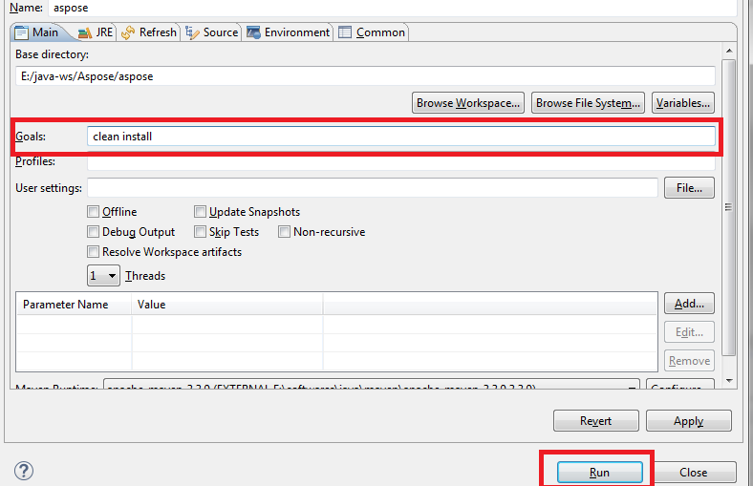

On successful build completion, you should see Build Success message in console.

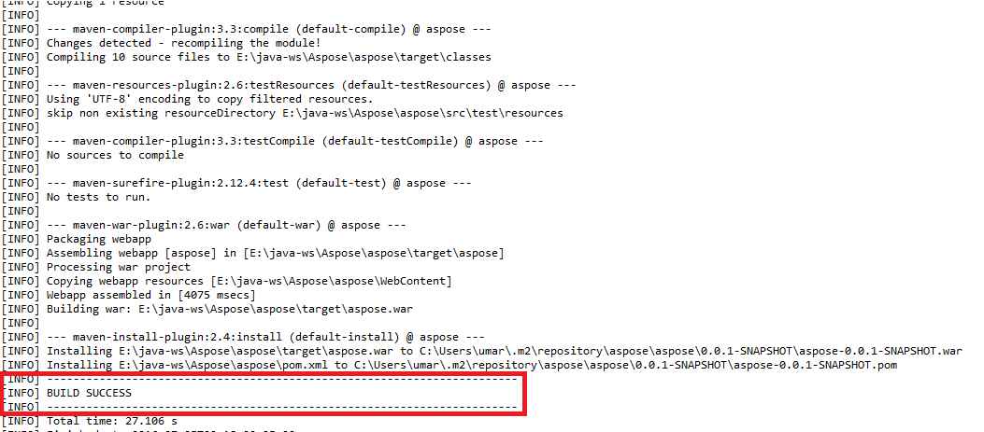

* You can see aspose.war file under target folder in your project pane

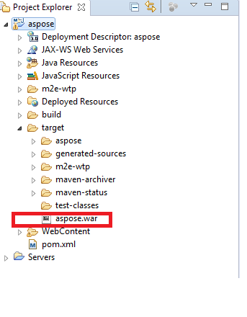

Now aspose rest API is successfully configured.

Next task is to configure asposeclient project. Perform all of the above steps listed under Build Project section except the following:

* + Tomcat is already configured for the workspace, so there is no need to reconfigure it while configuring asposeclient project. Anyhow, just make sure build path that you are using same jdk7 version for asposeclient as well.
  + There isn’t any properties file needed for asposeclient, so just skip property setting step.

At this point, both the projects are configured successfully & ready to deploy. Now we will go through deploying these two applications using eclipse.

* Righ Click Tomcat -> Add and Remove
* Select both aspose & asposeclient -> Add ->Finish

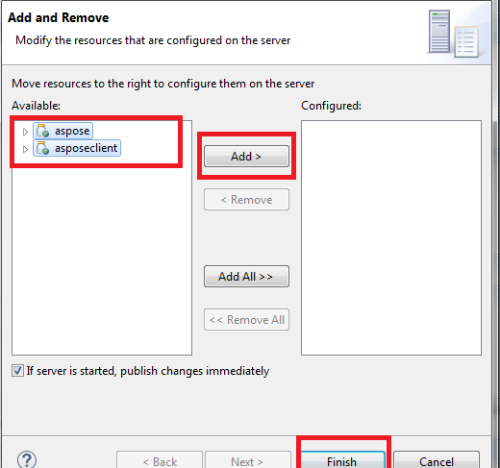

* Now start the tomcat server & in order to access Rest API features, type following URL in browser:

<http://localhost:8080/asposeclient>

You will get following interface from where you can access different JAVA Rest API features for Aspose.

IssyueI

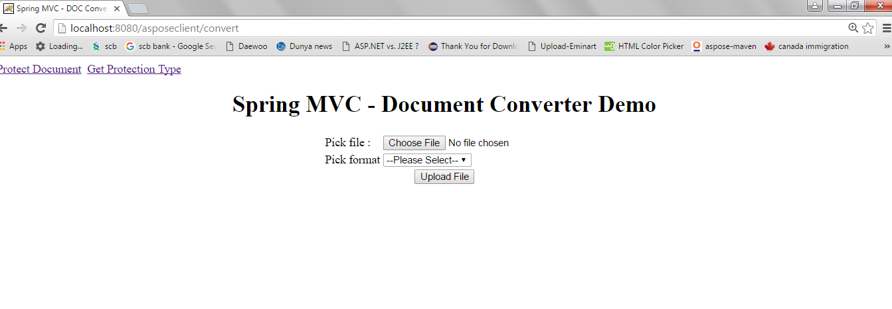

# Issues & Resolution:

While building application, you might face few issues. Below are the issues along with their resolution

* If you see errors like in below snapshot

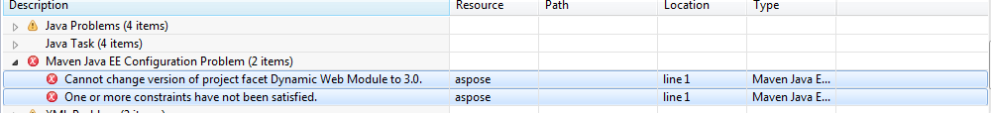

First Right Click Project -> Properties->Project Facets to make sure that dynamic web module 3.1 is selected

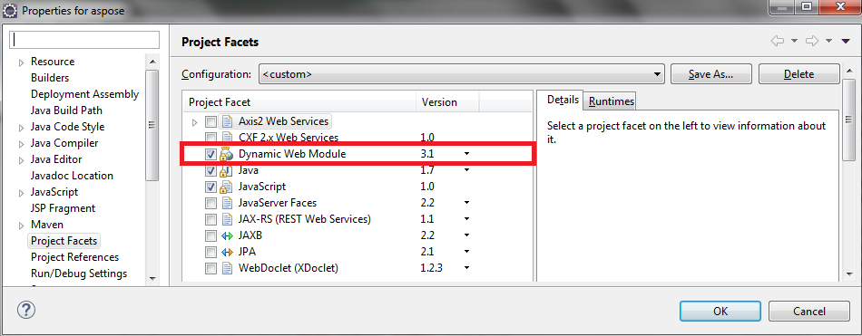

If so, then these errors actually occur because of a bug in eclipse. Just simply delete these two errors & clean your project again. Errors will be gone.

* While starting/stopping Tomcat server, you may face timeout error. You can fix this issue by increasing server start & stop time. If needed to do so then Click Server Tab & then double click previously configured Tomcat 8 server & then click timeout tab

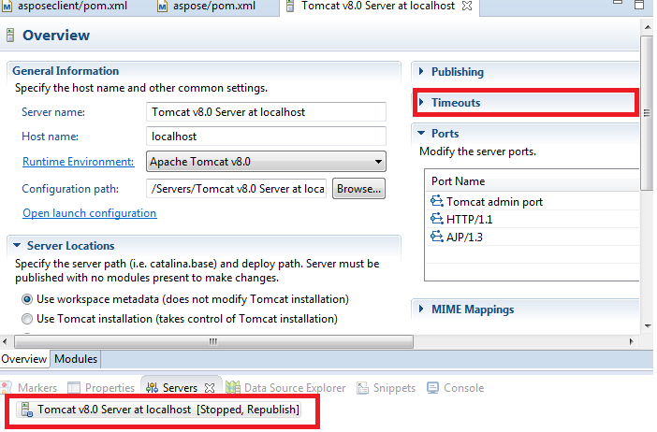

* Set appropriate start & stop time & save your settings.

# Deployment (Production):

In Build Project section, we learned how to build & run application in development environment. Now we will see how to deploy application on Tomcat in production environment.

Prerequisites:

* Required Versions of jre, maven & tomcat as per Required Softwares section, must be installed on server.
* All java & maven related environment variables are already configured on system.
* Install aspose-words to local repository following instructions from Aspose Maven Installation section.

Procedure:

1. Place the war files, created during Build Project Section, for both projects to some location on server.
2. Add Role manager-gui & user admin with the same role in tomcat-users.xml located in <Tomcat root directory>\conf

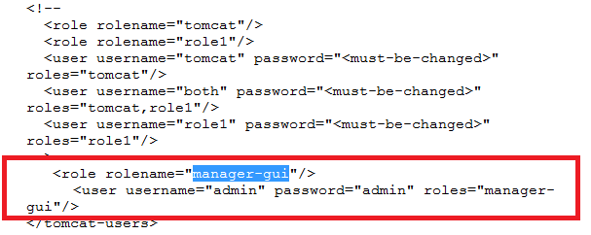

1. Double click startup.bat located in <Tomcat root directory>\bin to start the server.
2. Once the server gets started, access the admin panel by typing following URL in browser:

<http://localhost:8080>

1. Click Manager App button & provide user name/password for manager-gui role (admin/admin in my case)
2. Once you got logged-in to admin panel, click on Choose File under War File to deploy section & after selecting aspose.war, click Deploy.

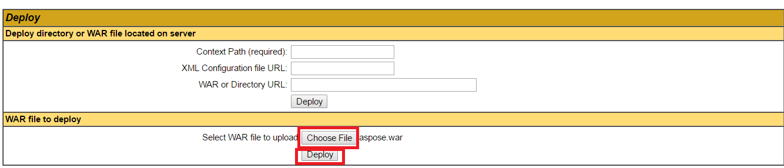

1. Execute step 6 again to deploy asposeclient as well.
2. Now both Rest API & client application are deployed in production environment. You can access the application using the following link:

http://<server-ip>:8080/asposeclient/