Contents

Purpose: 2

Required Softwares: 2

Procedure: 2

Build Website: 2

Deployment: 3

Issues & Resolution: 7

**Build & Deployment .Net Client**

# Purpose:

Purpose of this document is to guide you throw the process of building & deploying .net client for Aspose Rest API.

# Required Softwares:

* VS 2008
* .Net Framework 3.5
* IIS 7.5
* Win 7

# Procedure:

Under aspose-assignment at github, you will find a folder named netrestclient. This folder contains two directories:

* AsposeRestClient
* Published

AsposeRestClient contains the website source to build & execute through VC 2008 whereas published directory contains the published website to be deployed on IIS.

# Build Website:

* Open website in Visual Studio 2008 through Filke->Open->Website
* Open web.config file, under <appsettings> tag, edit restURL value as per Aspose Rest API URL

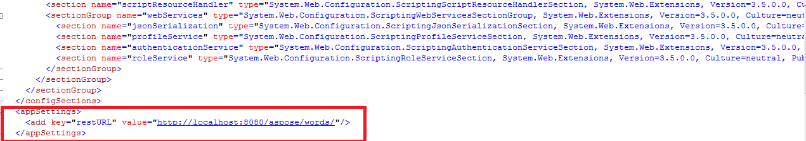

* Build the solution
* In solution Explorer, right click website -> publish Website

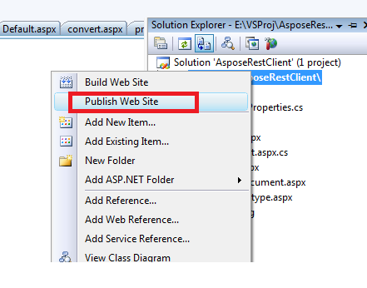

* In resulting window, specify the folder where you want to publish site and press OK.

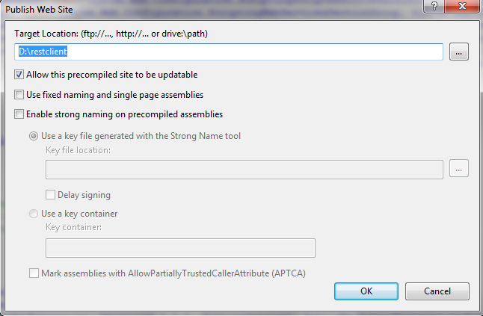

By now, .net rest client is ready for deployment.

# Deployment:

You can deploy application either using the published website which was created during Website build process or directly through the published directory under netrestclient folder.

In order to follow the deployment procedure, please follow these instructions:

* To open/access the IIS web server, go to Run window and type “**inetmgr** “
* Right click on the left side Default Web Site under Sites and click again Add application in the menu to add the application build in IIS web server.

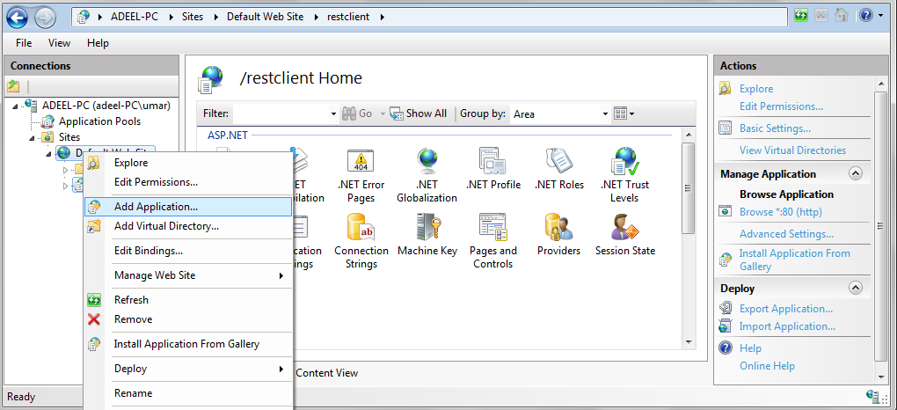

* Once you clicks Add application, you will get Add application windows as shown below and provide application Alias name and map the physical location of build where we placed the application build and click OK.

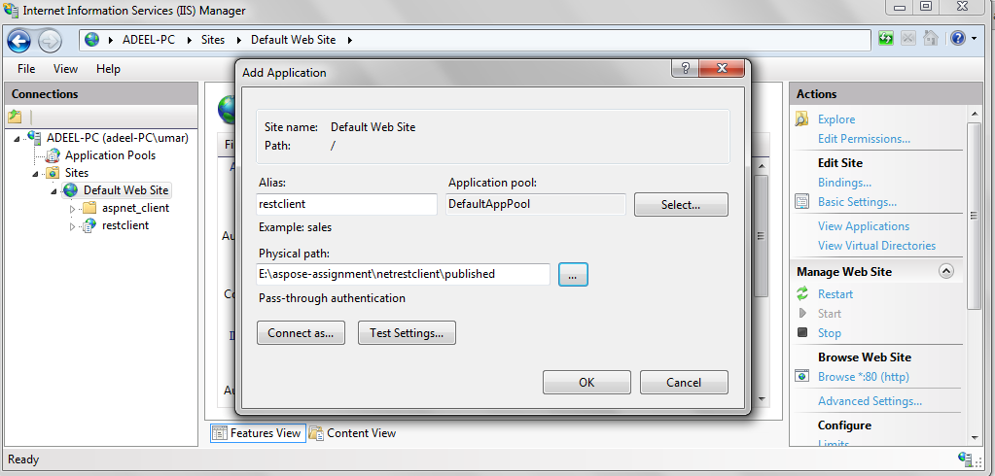

* After added the application, you will see the application name under Default Web Site. Now we have to configure Application pool for the application. So click Application pool as shown below and click Add Application Pool in the menu

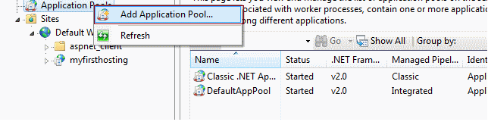

* Specify pool name, select the options as shown in figure below & press OK

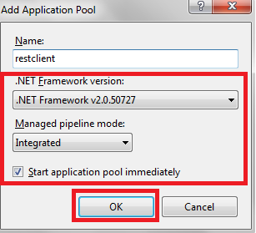

* Once done the above and go to Default Web site and right click on “restclient” application Manage Application à Advanced Settings,  you will get new window. Click in Application Pool value field, you will get a button there, click it (See figure below )

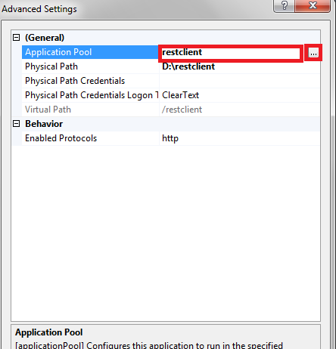

* You will get Select Application pool window and select existing Application pool name which we created earlier in the application pool section and click Ok, that’s it now we have configured the Application pool

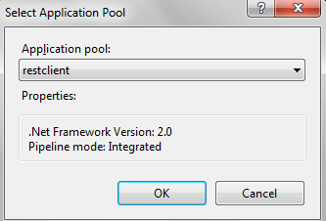

* All setup is ready now and need to browse the application from IIS, for that right click on application name in IIS and click Manage Application in the menu and click Browse option as shown below.

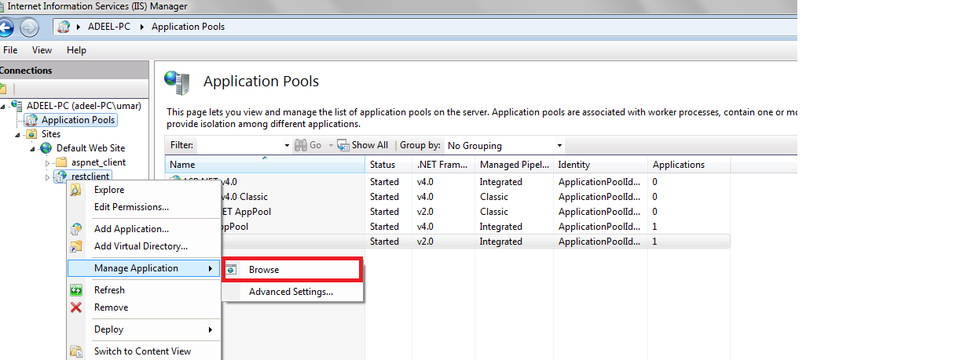

* You will see the application running as browser:

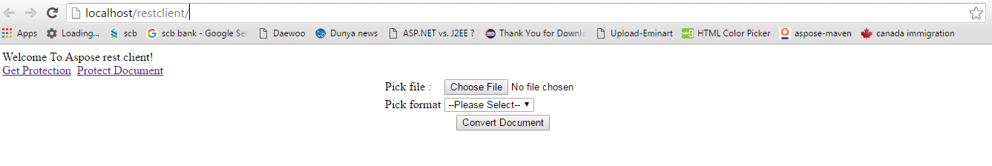

Now, you .net client is ready to use Aspose Rest API provided that Rest API is running & you have made required changes in web.config file.

# Issues & Resolution:

While browsing the site, you may face following error:

**"HTTP Error 404.17 - Not Found  
The requested content appears to be script and will not be served by the static file handler."**

To resolve this issue lease follow these instructions:

1. Run Command Prompt as Administrator.
2. Type **cd C:\Windows\Microsoft.NET**
3. For 32-bit installations, type **cd Framework** and press Enter.  For 64-bit installations, type **cd Framework64** and press Enter.
4. Type **cd v2.0.50727** and press Enter.
5. Type **aspnet_regiis -i** and press Enter.
6. Once ASP.NET has finished installing, restart the IIS service through the **iisreset** command or right-click on the top-level node in the IIS Manager and click **Stop**, then right-click again and click **Start**.