**Lab#01**

**Student name: Adina Faraz**

**Student id: 23k-0008**

**Task 01: The setup**

**Step01:**

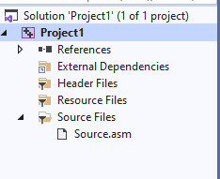

**Step02:**

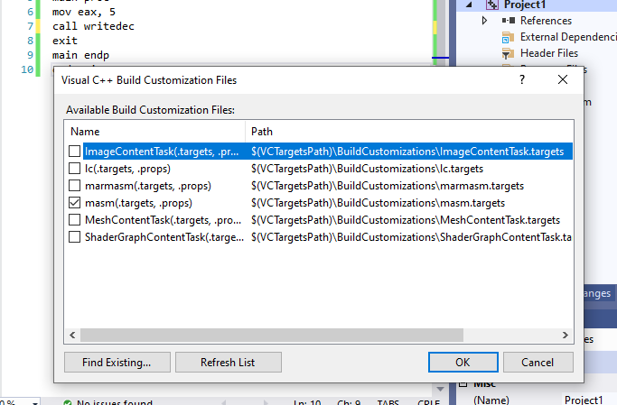

**Step03:**

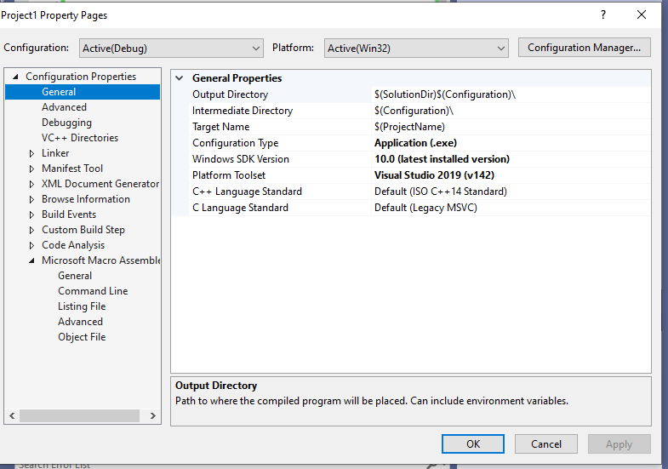

**Step04:**

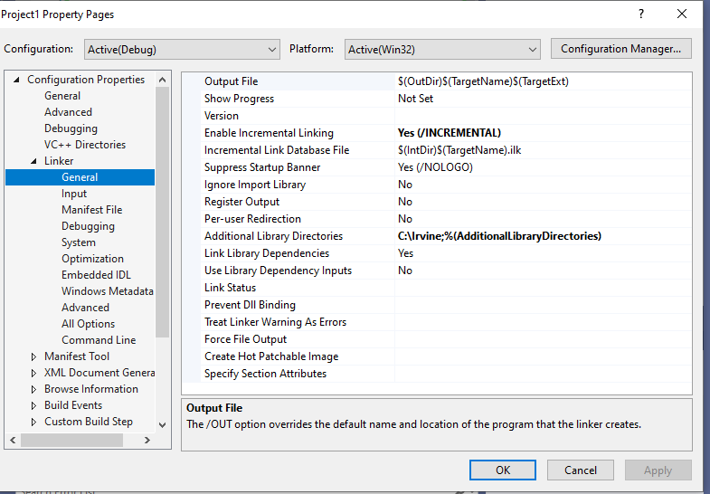

**Step05:**

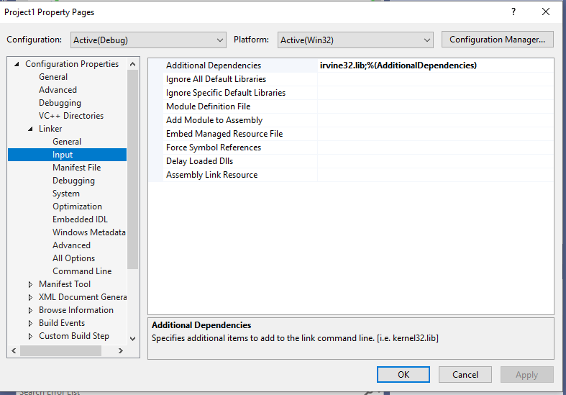

**Step06:**

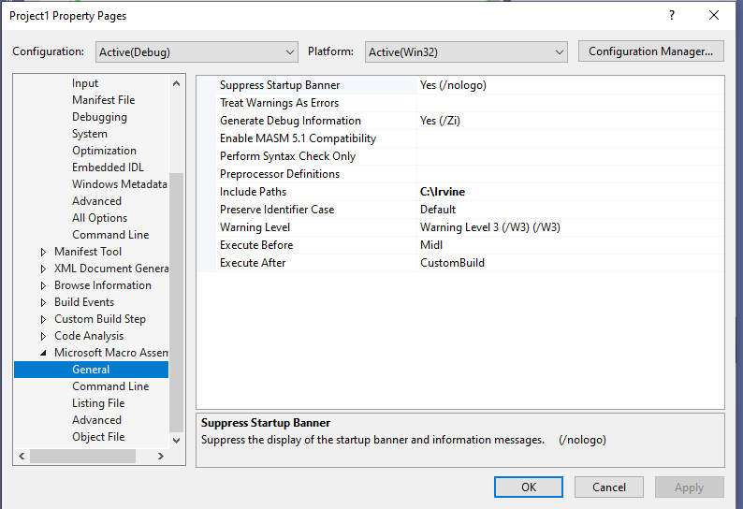

**Task 02: Running a sample code:**

**Code:**

include irvine32.inc

.data

.code

main proc

mov eax, 5

call writedec

exit

main endp

end main

**Output:**



