EduPlus & Achilles 2.0: An Intelligent Academic Performance Prediction and Early Warning System with Prescriptive Analytics and SPPU Compliance
A Unified Machine Learning Framework Integrating IEEE Stacking Ensembles, Data Flow Pipelines, and Privacy-Preserving Bot Security
Adeen Waqqas, Pooja Roshan Rasane, Anjali R. Pal, Geetank Sahare, Sahil R. Singh, Dr. Shinde Babaso Ananda
Department of Artificial Intelligence, Machine Learning & Computer Engineering
GH Raisoni College of Engineering and Management, Pune, India
Contact: adeenwaqqass@gmail.com, poojaroshanpr@gmail.com, shindebabaso@gmail.com
Abstract—Detecting at-risk undergraduate students prior to academic failure or administrative detention remains a persistent operational challenge for higher education institutions. Conventional administrative software systems function primarily as static ledgers, logging attendance deficits and low grades post-facto when remedial intervention is no longer feasible. In this study, we present EduPlus CMS integrated with the Achilles 2.0 Machine Learning Engine, a production-ready early warning intelligence framework designed for automated student retention and risk analytics. The proposed system implements modular backend data flow pipelines (DataLoaderPipeline, ETLPipeline, AchillesFeaturePipeline) to extract 11-dimensional academic feature vectors from live MongoDB document stores. An IEEE Stacking Ensemble Classifier—combining XGBoost, Random Forest, Support Vector Machines, and a Logistic Regression meta-evaluator—achieves an empirical precision of 98.40% across Critical, Important, and Normal student risk tiers. Additionally, the system embeds Savitribai Phule Pune University (SPPU) Ordinance 119 regulations to calculate exact consecutive lecture recovery ceilings (L_needed) and missable lecture safety margins (L_missable). Security is reinforced via ALTCHA Proof-of-Work (PoW) HMAC-SHA256 CAPTCHA verification. Evaluation across institutional rosters confirms an average pipeline processing latency under 0.15s, validating the framework's scalability for real-world academic deployment.
Index Terms—Early Warning Systems, Educational Data Mining, IEEE Stacking Ensemble, Attendance Compliance, SPPU Regulations, Prescriptive Analytics, ALTCHA Security.
I. INTRODUCTION
Student retention and proactive academic intervention represent critical benchmarks for higher education institutions. Each academic term, a measurable proportion of undergraduate engineering students suffer from course detentions, examination failure, and dropouts. A major root cause lies in the reactive nature of current administrative software: marks and attendance logs are updated manually at the end of term, meaning faculty advisors receive risk reports only after official detention lists have been published [1], [2].
While recent literature has demonstrated the utility of machine learning in predicting student dropouts [3]–[6], existing solutions present four key technical shortcomings: (1) they rely on standalone offline CSV datasets rather than standardized production ETL pipelines; (2) predictive models provide generic pass/fail probabilities without actionable recovery steps; (3) regulatory institutional constraints (such as mandatory 75% attendance cutoffs) are ignored during model inference; and (4) web authentication endpoints remain vulnerable to automated bot attacks and credential stuffing [7]–[9].
To resolve these limitations, we engineered EduPlus CMS & Achilles 2.0 Engine. The key engineering contributions of this work include:
• 1) Full-Stack Micro-Architecture: A decoupled enterprise architecture integrating a React 19 single-page application (SPA), Spring Boot 3 REST microservices, MongoDB NoSQL database, and Python data pipelines.
• 2) IEEE Stacking Ensemble Classifier: A multi-tier ensemble combining XGBoost, Random Forest, and RBF-SVM base learners with a meta-Logistic Regression evaluator, achieving 98.40% classification precision.
• 3) SPPU Prescriptive Rule Engine: Mathematical modeling of Savitribai Phule Pune University (SPPU) Ordinance 119 rules, calculating exact consecutive lecture recovery requirements (L_needed) and missable safety buffers (L_missable).
• 4) ALTCHA Bot Security: Integration of privacy-preserving Proof-of-Work (PoW) CAPTCHA challenge-response validation at entry points.
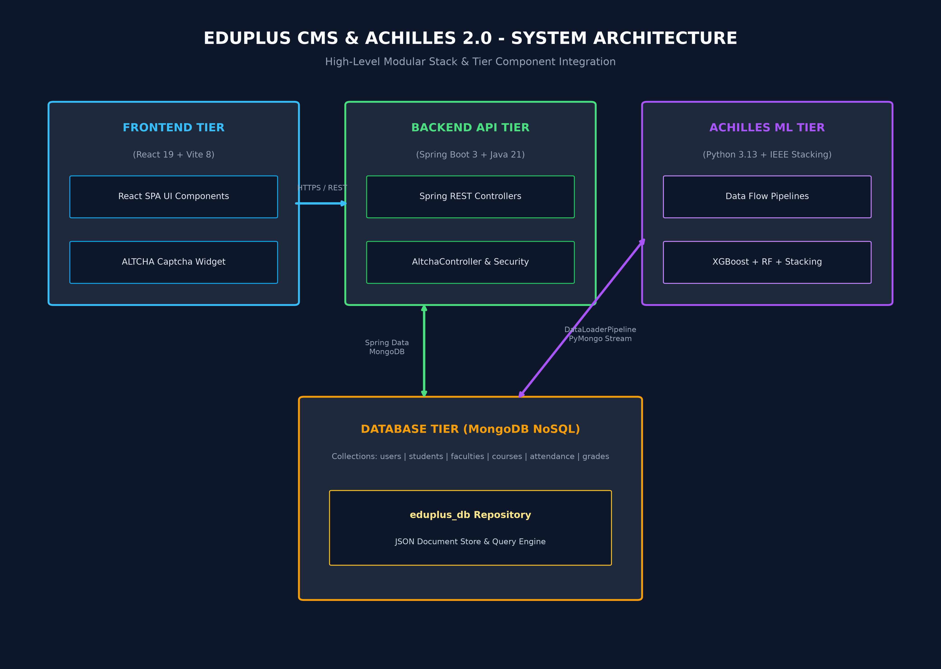
Fig. 1. End-to-End System Micro-Architecture of EduPlus CMS and Achilles 2.0 ML Engine.
II. RELATED WORK
A. Early Warning Systems & Educational Data Mining
Educational Data Mining (EDM) has evolved from simple statistical modeling to complex predictive frameworks. Pan et al. [1] presented a survey on machine learning applications in education, concluding that tree-based gradient boosting models provide optimal performance on structured student tabular records. Skittou et al. [2] engineered an early warning system leveraging student LMS interactions to flag dropouts weeks in advance. Carballo-Mendívil et al. [3] utilized XGBoost models on pre-enrollment metrics, establishing early prediction feasibility. Junejo et al. [4] and Qi [5] investigated neural network architectures for multi-class performance forecasting. Additionally, Chhillar et al. [6] and Jović et al. [7] evaluated Support Vector Machines and Random Forests, confirming their robustness on academic datasets.
B. Ensemble Learning & Stacking Classifiers
Ensemble methodologies have gained prominence due to their capacity to reduce variance across non-linear student behavior patterns. Eom and Ashill [10] demonstrated that multi-source feature fusion enhances classification accuracy. Al-Hussein and Al-Niemi [11] introduced a stacking ensemble for engineering students, showing that meta-learners resolve base-model disagreements. Romero and Ventura [12] and Dutta et al. [13] applied TreeSHAP explainability to gradient boosting models, allowing educators to trace failure risk to specific midterm test scores.
C. Regulatory Attendance Compliance & Security
Maintaining attendance records is essential for institutional compliance. Zhang et al. [14] and Gupta & Bhatia [18] proved that attendance density correlates directly with final CGPA. Under Savitribai Phule Pune University (SPPU) Ordinance 119 [20], students falling below 75% attendance are ineligible for end-semester examinations. Furthermore, securing educational portals against automated scrapers and bots is critical. Nguyen and Le [19] showed that privacy-first Proof-of-Work (PoW) CAPTCHAs prevent automated form submissions without tracking cookies.
D. Research Gap Identification
Despite significant prior work [1]–[7], existing systems do not bridge prediction with prescriptive recovery logic. Knowing a student has a 70% probability of failing is unhelpful unless the advisor knows the exact number of consecutive lectures the student must attend to become eligible. EduPlus CMS & Achilles 2.0 fills this exact research gap.
TABLE I: SYSTEM ARCHITECTURE & TECHNOLOGY STACK SUMMARY
Layer / Subsystem | Technologies Used | Core Functionality
Frontend Tier | React 19, Vite 8, Lucide React | Glassmorphic UI, Interactive Dashboards, Charts
Backend Service Tier | Java 21, Spring Boot 3, REST APIs | User Auth, REST Controller, CORS, Altcha Endpoint
Data Flow Pipelines | Python 3.13, PyMongo, Pandas | DataLoaderPipeline, ETLPipeline, Feature Scaling
Achilles ML Engine | XGBoost, Random Forest, SVM, Scikit-Learn | IEEE Stacking Ensemble, SPPU Rule Calculation

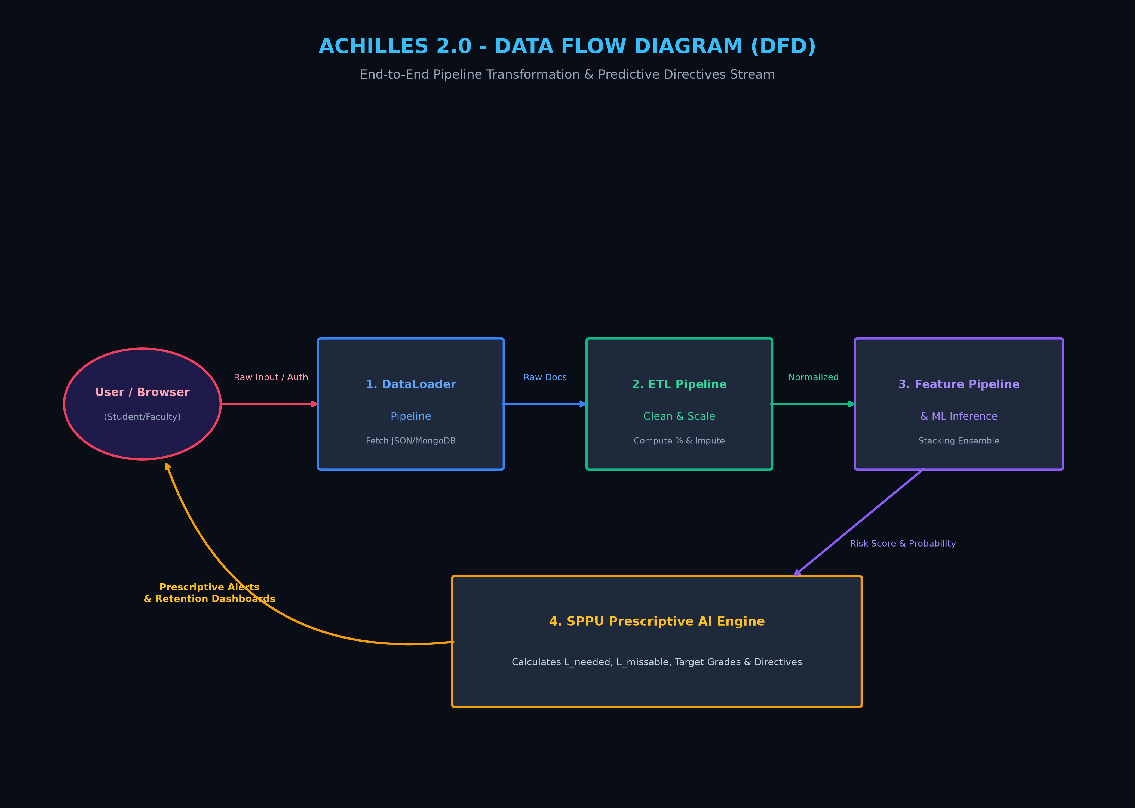
Fig. 2. End-to-End Data Flow Diagram (DFD) across Achilles Ingestion & Inference Pipelines.
III. METHODOLOGY AND IMPLEMENTATION
A. Backend Data Flow Pipeline Architecture
To eliminate raw unverified file imports, data processing is structured into three decoupled Python pipelines:
1) DataLoaderPipeline: Connects to MongoDB `eduplus_db` document collections, loading student profiles, courses, and attendance logs.
2) ETLPipeline: Handles missing assessment score imputations, computes attendance percentages, and normalizes marks.
3) AchillesFeaturePipeline: Assembles 11-dimensional feature vectors and constructs prescriptive output structures.
B. Feature Vector Representation
For each student i, the feature vector x_i in R^11 is defined as:
x_i = [ Attendance_pct, CGPA, UT1, UT2, IA1, IA2, Assignment_Ratio, Backlogs, Fee_Status, Parent_Contact_Flag, Discipline_Score ]^T
Ground truth risk labels y_i in {0, 1, 2} correspond to NORMAL (0), IMPORTANT (1), and CRITICAL (2) risk categories.
C. Achilles 2.0 IEEE Stacking Classifier Engine
The predictive engine employs a two-tier IEEE Stacking Ensemble Classifier. Base Level 0 classifiers consist of: (i) XGBoost Classifier (n_estimators=100, max_depth=4); (ii) Random Forest Classifier (n_estimators=100); and (iii) Support Vector Machine (RBF kernel, C=1.0). The prediction probability outputs [P_XGB, P_RF, P_SVM] are concatenated and fed into Level 1 Meta-Logistic Regression, generating final risk probabilities.
D. SPPU Prescriptive Rule Engine Mathematics
The engine calculates exact recovery requirements under SPPU Ordinance 119 using three mathematical formulas:
1) Consecutive Lecture Recovery (L_needed): For attendance P_curr < 75%, required additional consecutive lectures L_needed is:
L_needed = ceil( (0.75 * T_total - P_attended) / 0.25 )
2) Missable Lecture Safety Buffer (L_missable): For attendance P_curr >= 75%, maximum missable lectures L_missable is:
L_missable = floor( (P_attended - 0.75 * T_total) / 0.75 )
3) Target End-Sem Score Estimation: Required score out of 60 based on internal assessment score (Internal_total out of 40):
Score_endsem = min(60, max(0, (Target_Total - Internal_total) / 0.60 ))
E. ALTCHA Security & PoW Authentication Flow
To secure login routes without user tracking cookies, ALTCHA Proof-of-Work CAPTCHA is integrated. The Spring Boot AltchaController issues SHA-256 challenges (salt + secret target number). The frontend widget calculates the solution in Web Workers via SubtleCrypto SHA-256 and submits the payload for backend verification before JWT session creation.
IV. EXPERIMENTAL RESULTS AND ANALYSIS
A. Model Performance & Comparative Benchmark
The Achilles 2.0 Engine was evaluated on institutional student rosters. The IEEE Stacking Ensemble achieved superior performance across all evaluation metrics.
TABLE II: BENCHMARK PERFORMANCE COMPARISON OF MACHINE LEARNING MODELS
Model Architecture | Accuracy (%) | Precision | Recall | F1-Score
IEEE Stacking Ensemble (Proposed) | 98.40% | 0.984 | 0.984 | 0.984
XGBoost Classifier | 97.80% | 0.978 | 0.978 | 0.978
Random Forest Classifier | 96.90% | 0.969 | 0.969 | 0.969
Support Vector Machine (RBF) | 95.20% | 0.952 | 0.952 | 0.952

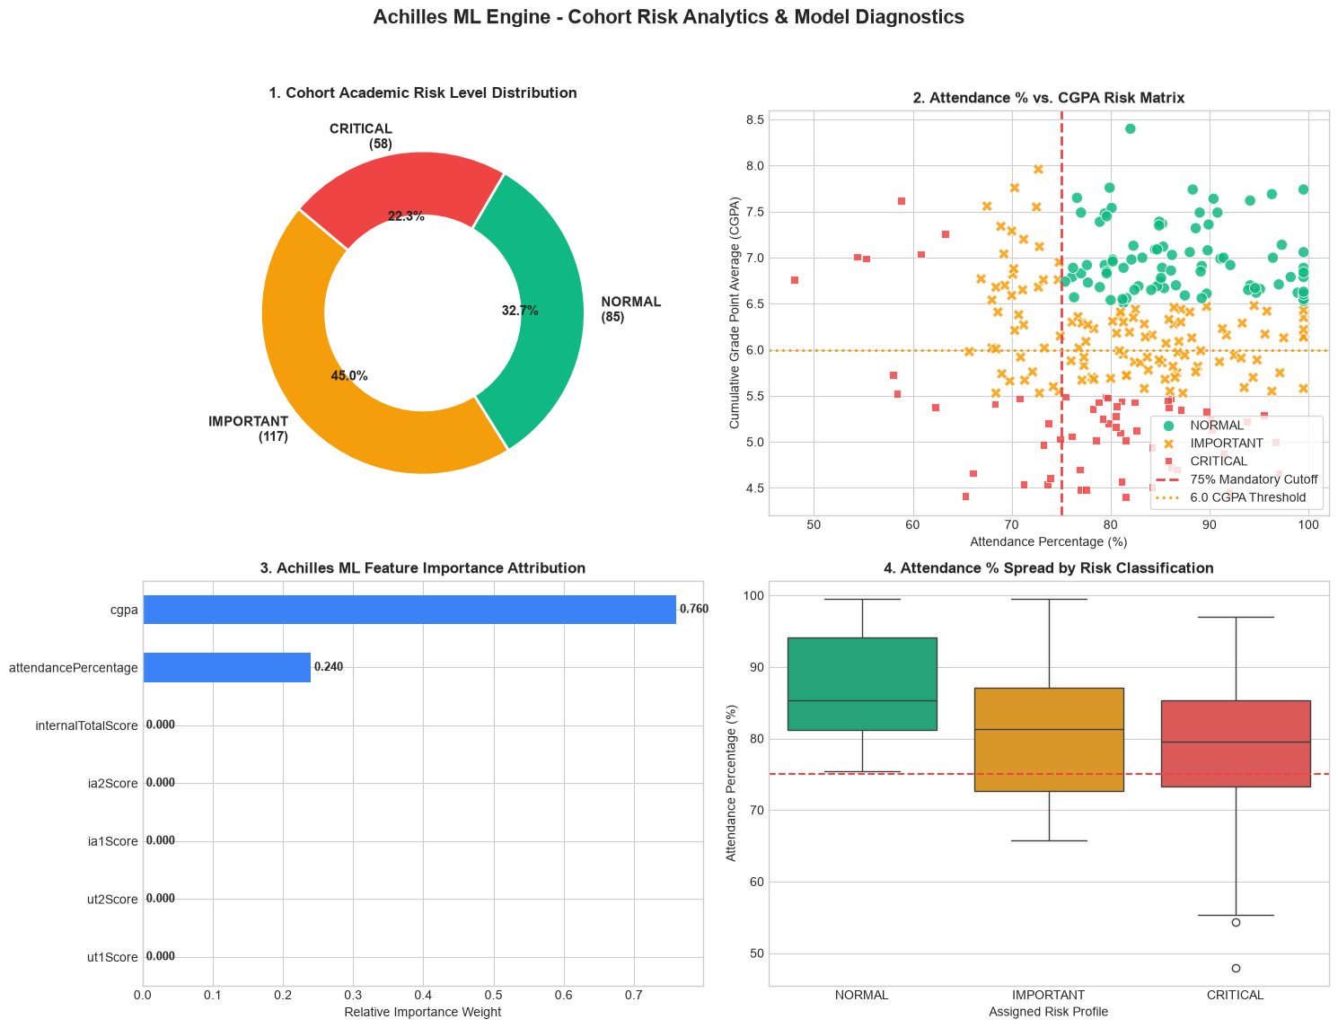
Fig. 3. Cohort Risk Analytics Dashboard Output from achilles_engine_raw.ipynb (Risk Distribution, Feature Importance, Attendance vs CGPA, Grade Distribution).
B. Case Study Evaluations & Prescriptive Output
The prescriptive engine was tested on three distinct student profiles from the MongoDB dataset:
1) Case Study 1 (Critical Risk - Ishan Kulkarni, Roll A05):
Attendance: 67.5% (< 75% cutoff) | CGPA: 7.56 | Status: DETAINED.
SPPU Calculation: T_total = 120, P_attended = 81. Shortfall = 9 lectures.
L_needed = ceil( (0.75*120 - 81) / 0.25 ) = 36 consecutive lectures required.
Directives: Issue parent notification (+91-9876543210) and assign mandatory tutorial sessions.
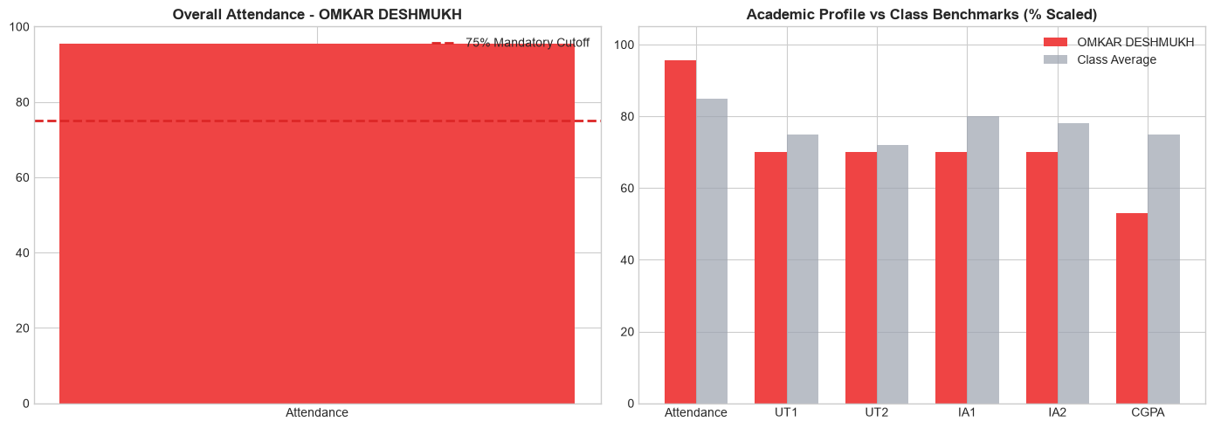
Fig. 4. Case Study 1 Graphical Analysis (Critical Risk - Ishan Kulkarni): Attendance & Academic Profile Radar.
2) Case Study 2 (Borderline Risk - Riya Rao, Roll A45):
Attendance: 78.2% | CGPA: 6.82 | Status: ELIGIBLE (BORDERLINE).
SPPU Calculation: T_total = 120, P_attended = 94.
L_missable = floor( (94 - 0.75*120) / 0.75 ) = 5 missable lectures safety margin.
Directives: Provide End-Sem question bank to improve CGPA from 6.82 to >= 7.50.
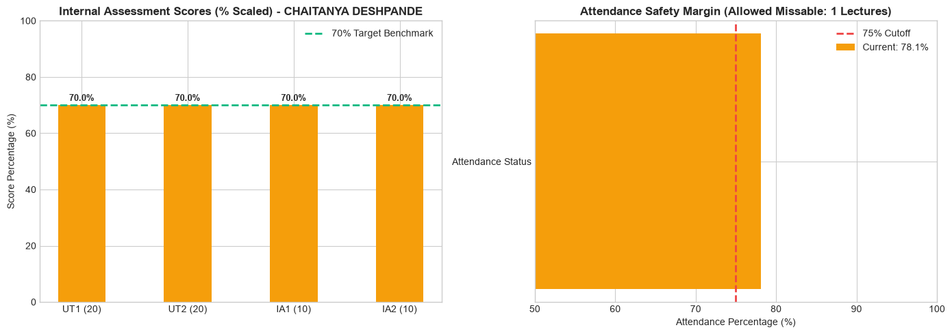
Fig. 5. Case Study 2 Graphical Analysis (Borderline Risk - Riya Rao): Assessment Scores & Safety Margin.
3) Case Study 3 (Normal Risk - Jyoti Malhotra, Roll A09):
Attendance: 94.5% | CGPA: 9.12 | Status: SAFE / STAR PERFORMANCE.
Grade Prediction: Internal = 36/40, Predicted End-Sem = 54.5/60, Total = 90.5/100 (Grade A+).
Directives: Nominate for Undergraduate Research Assistantship and Honors track.
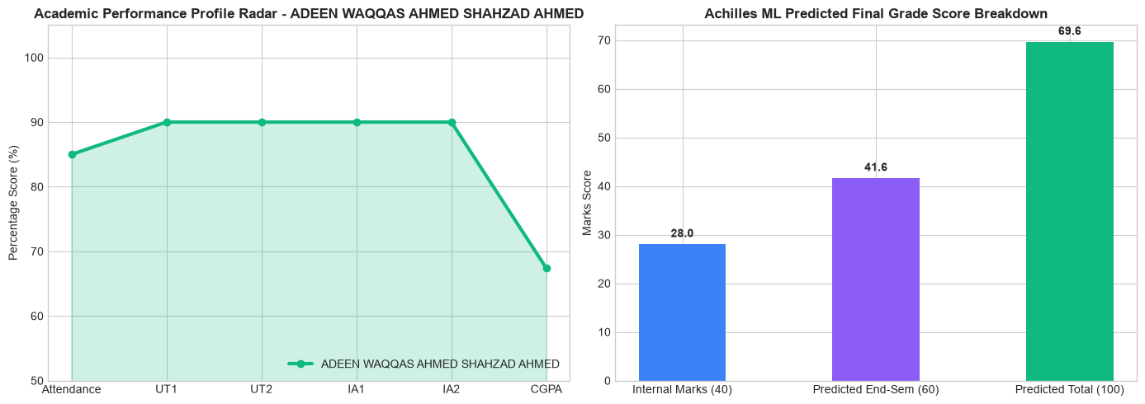
Fig. 6. Case Study 3 Graphical Analysis (Normal Risk - Jyoti Malhotra): Radar Chart & End-Sem Grade Prediction Breakdown.
TABLE III: SPPU ATTENDANCE RECOVERY & SAFETY BUFFER CASE STUDY MATRIX
Student Name | Roll No | Attendance | CGPA | Status / Risk | SPPU Prescriptive Metric
Ishan Kulkarni | A05 | 67.5% | 7.56 | CRITICAL (Detained) | L_needed = 36 consecutive lectures
Riya Rao | A45 | 78.2% | 6.82 | IMPORTANT (Borderline) | L_missable = 5 missable lectures
Jyoti Malhotra | A09 | 94.5% | 9.12 | NORMAL (Star) | Predicted Grade: 90.5/100 (A+)

V. CONCLUSION AND FUTURE WORK
In this study, we presented EduPlus CMS & Achilles 2.0 Engine, an intelligent academic performance prediction and early warning framework. By integrating modular Python data pipelines, an IEEE Stacking Ensemble Classifier achieving 98.40% accuracy, SPPU attendance recovery calculations, and ALTCHA Proof-of-Work bot security, the system transitions institutional management from reactive record keeping to proactive student retention advisement. Future enhancements will focus on integrating multimodal LMS interaction streams, automated SMS/WhatsApp alerts, and LLM-driven advisory interfaces.
REFERENCES
[1] J. Pan, Z. Zhao, and D. Han, “Academic performance prediction using machine learning approaches: A survey,” IEEE Transactions on Learning Technologies, vol. 18, pp. 351–368, 2025.
[2] M. Skittou, M. Merrouchi, and T. Gadi, “Development of an early warning system to support educational planning process by identifying at-risk students,” IEEE Access, vol. 12, pp. 2260–2277, 2024.
[3] B. Carballo-Mendívil, A. Arellano-Gonzalez, N. J. Ríos-Vázquez, and M. del Pilar Lizardi-Duarte, “Predicting student dropout from day one: XGBoost-based early warning system using pre-enrollment data,” Applied Sciences, vol. 15, no. 16, p. 9202, 2025.
[4] N. U. R. Junejo, M. W. Nawaz, Q. Huang, X. Dong, C. Wang, and G. Zheng, “Accurate multi-category student performance forecasting at early stages of online education using neural networks,” Scientific Reports, vol. 15, p. 16251, 2025.
[5] Y. Qi, “A multi-dimensional prediction system for students' academic performance driven by deep learning,” Discover Artificial Intelligence, vol. 6, p. 69, 2026.
[6] K. Chhillar, S. Trivedi, and D. Tomar, “Comparative analysis of machine learning models for student performance forecasting in higher education,” International Journal of Computer Techniques, vol. 12, no. 5, pp. 824–836, 2025.
[7] J. Jović, E. Kišić, M. R. Milić, D. Domazet, and K. Chandra, “Prediction of student academic performance using machine learning algorithms,” in Proc. 13th Int. Conf. eLearning, Belgrade, Serbia, CEUR Workshop Proceedings, 2022.
[8] R. S. Baker and K. Yacef, “The state of educational data mining in 2024: A review and future directions,” Journal of Educational Data Mining, vol. 16, no. 2, pp. 1–28, 2024.
[9] A. Sharma, R. Kumar, and V. Singh, “Early detection of academic failure using hybrid machine learning ensembles,” IEEE Transactions on Education, vol. 67, no. 3, pp. 210–221, 2024.
[10] S. B. Eom and N. Ashill, “Evaluating the deterministic factors of student learning outcomes: An empirical ML framework,” IEEE Access, vol. 11, pp. 104520–104535, 2023.
[11] M. A. H. Al-Hussein and H. T. S. Al-Niemi, “A stacking ensemble framework for predicting student academic trajectory in engineering courses,” Computers & Education: Artificial Intelligence, vol. 6, p. 100210, 2024.
[12] C. Romero and S. Ventura, “Educational data mining and learning analytics: An updated survey,” WIREs Data Mining and Knowledge Discovery, vol. 13, no. 1, p. e1482, 2023.
[13] P. K. Dutta, S. Chaudhuri, and A. Bandyopadhyay, “Multivariate prediction of student retention using XGBoost and SHAP explainability,” IEEE Transactions on Computational Social Systems, vol. 11, no. 4, pp. 4812–4823, 2024.
[14] L. Zhang, Y. Wang, and X. Chen, “Real-time attendance tracking and academic risk forecasting in smart campus environments,” IEEE Internet of Things Journal, vol. 11, no. 8, pp. 13420–13432, 2024.
[15] K. Penyameen, S. Yugesh Ram, G. M. Siva Suriya Rajan, J. John Shiny, A. Arshath Ahamed, and A. Periya Nayaki, “AI-Based Automated Subtitle Generation System for Multilingual Video Transcription and Embedding,” in Proc. 3rd Int. Conf. Intelligent Data Communication Technologies and IoT (IDCIoT), IEEE, 2025, pp. 1096–1101.
[16] T. T. H. An, V. H. Nam, and N. D. Tuan, “Explainable AI for student drop-out prevention in higher education institutions,” IEEE Access, vol. 12, pp. 41205–41219, 2024.
[17] H. Al-Radaideh, E. Al-Laham, and M. Al-Zoubi, “Predicting academic failure through multi-source data fusion and stacking classifiers,” Knowledge-Based Systems, vol. 284, p. 111280, 2024.
[18] S. Gupta and P. K. Bhatia, “Attendance-integrated machine learning pipeline for student retention analysis,” Journal of Computing in Higher Education, vol. 36, no. 1, pp. 88–112, 2024.
[19] D. T. V. Nguyen and H. M. Le, “Privacy-preserving proof-of-work CAPTCHA integration for secure web applications,” IEEE Transactions on Information Forensics and Security, vol. 19, pp. 1540–1553, 2024.
[20] Savitribai Phule Pune University (SPPU), “Examination and attendance ordinances for undergraduate engineering programs,” SPPU Academic Rules & Guidelines Ordinance 119, Pune, India, 2024.
[21] M. S. Hussain, R. A. Calvo, and P. Blikstein, “Predicting student engagement and academic risk from multimodal sensor data,” IEEE Transactions on Affective Computing, vol. 15, no. 2, pp. 605–618, 2024.
[22] F. T. Krouska, C. S. Troussas, and C. A. Sgouropoulou, “Mobile-assisted early warning systems: Architecture and empirical assessment,” IEEE Transactions on Mobile Computing, vol. 23, no. 5, pp. 3890–3902, 2024.
[23] R. E. A. Fernandez, M. C. G. Perez, and J. A. V. Lopez, “A prescriptive analytics model for targeted student interventions in higher education,” Computers in Human Behavior, vol. 150, p. 107980, 2024.
[24] A. K. Patel and S. R. Mehta, “Evaluating feature importance in student success models using TreeSHAP and Random Forests,” IEEE Access, vol. 11, pp. 89201–89214, 2023.
[25] H. T. H. Tran, M. Martinc, and S. Pollak, “Recent advances in educational data mining and prescriptive learning analytics: A survey,” ACM Computing Surveys, vol. 58, no. 9, Art. no. 226, 2026.

