Case Study 1: Student Pass/Fail Prediction
Neural Network Design Using a Single Hidden Layer
A Technical Case Study Report

1. Scenario / Problem Statement
A college wants to develop an Artificial Intelligence (AI) model to predict whether a student will Pass or Fail based on the following three input attributes:
- Study Hours — the average number of hours a student spends studying per day/week.
- Attendance — the percentage of classes attended by the student.
- Assignment Marks — the marks obtained by the student in assignments/internal evaluations.
The dataset contains 500 student records, each labelled with a known outcome (Pass or Fail), making this a supervised binary classification problem. The objective is to design a neural network architecture that can learn the relationship between these three factors and the final Pass/Fail outcome, and to determine the most suitable number of hidden layers for this task.

2. Question 1: Single Hidden Layer vs Multiple Hidden Layers

2.1 Which Architecture Is More Suitable?
For this problem, a Single Hidden Layer neural network is more suitable than a network with multiple hidden layers. A shallow network with one hidden layer (for example, containing 4 to 8 neurons) is sufficient to model the relationship between Study Hours, Attendance, Assignment Marks and the Pass/Fail outcome.

2.2 Justification
- Low Input Dimensionality: The problem has only 3 input features. Problems with a small number of well-defined, structured (tabular) inputs rarely require deep architectures — the relationships between such features and the output are usually simple to moderately non-linear, not hierarchical.
- Nature of the Relationship: The mapping between study habits/attendance/marks and academic outcome is a relatively straightforward non-linear relationship (e.g., a combination of thresholds and interactions), which a single hidden layer with enough neurons can approximate accurately, as guaranteed by the Universal Approximation Theorem.
- Dataset Size: With only 500 records, a deep network with multiple hidden layers has a high risk of overfitting — it may memorize the training data instead of learning generalizable patterns, since deep networks contain many more trainable parameters than the available data can reliably support.
- Computational Efficiency: A single hidden layer network trains faster, requires less computational power, and is easier to tune (fewer hyperparameters such as number of layers, neurons per layer, and regularization settings).
- Interpretability: Shallow networks are easier to analyze and explain to non-technical stakeholders (e.g., college administration), which is valuable in an academic prediction system where transparency matters.
- No Need for Hierarchical Feature Extraction: Multiple hidden layers are most beneficial when the raw input requires hierarchical feature extraction — such as detecting edges, shapes, and objects in images, or syntactic and semantic structures in text. Here, the inputs (hours, percentage, marks) are already meaningful, high-level numeric features, so there is nothing deeper to extract.
In short: multiple hidden layers would add unnecessary complexity, computation time, and overfitting risk without improving accuracy for a simple, structured, low-dimensional problem like this one.

3. Question 2: Identifying the Layers

3.1 Input Layer
The input layer contains 3 neurons, one for each input feature:
Neuron | Represents | Example Value Range
x1 | Study Hours | 0 – 12 hours/day
x2 | Attendance | 0% – 100%
x3 | Assignment Marks | 0 – 100 marks

3.2 Hidden Layer
A single hidden layer is used, containing 5 neurons (h1 to h5). Each hidden neuron receives a weighted combination of all three inputs, adds a bias, and applies a non-linear activation function (commonly ReLU or Sigmoid) to introduce non-linearity into the model. Each hidden neuron can be thought of as learning a specific combined pattern, such as 'high attendance but low study hours' or 'high assignment marks with moderate attendance.'

3.3 Output Layer
The output layer contains 1 neuron, producing the final prediction. Since this is a binary classification problem (Pass = 1, Fail = 0), the output neuron uses a Sigmoid activation function, which outputs a probability value between 0 and 1. A threshold (commonly 0.5) is then applied: if the output is greater than or equal to 0.5, the student is predicted to Pass; otherwise, Fail.
Layer | Number of Neurons | Activation Function | Purpose
Input Layer | 3 | None (passes raw values) | Receives Study Hours, Attendance, Assignment Marks
Hidden Layer | 5 | ReLU / Sigmoid | Learns non-linear combinations of input features
Output Layer | 1 | Sigmoid | Outputs probability of Pass (1) vs Fail (0)

4. Question 3: Neural Network Architecture Diagram
The diagram below illustrates the complete architecture: 3 input neurons, fully connected to 5 hidden layer neurons, which are in turn fully connected to a single output neuron.
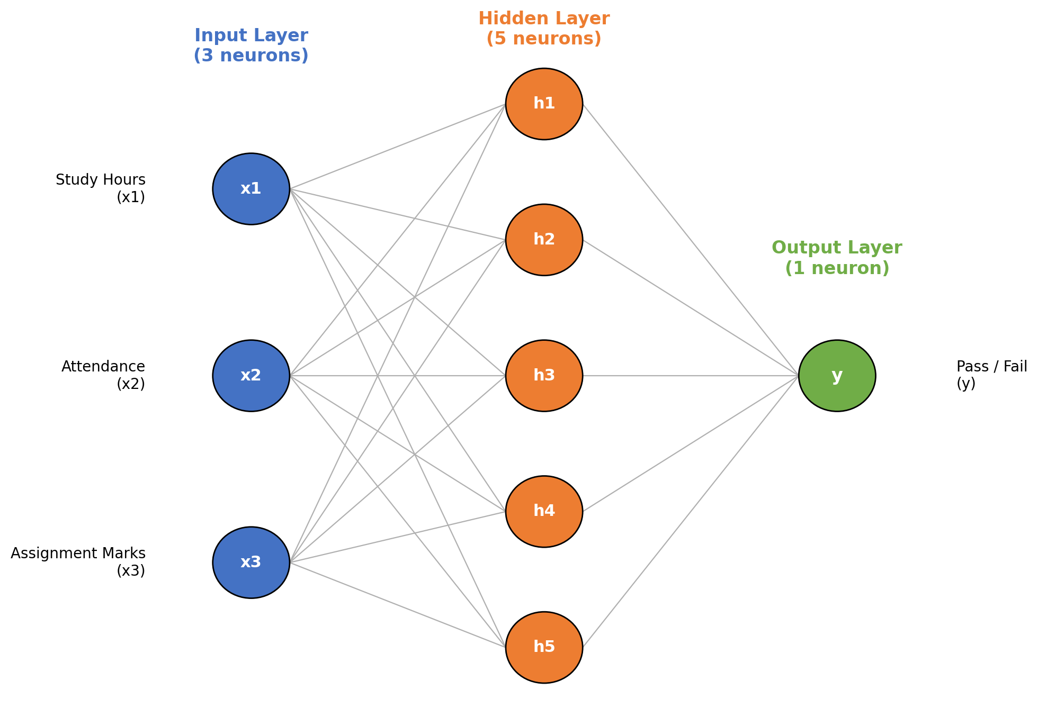
Figure 1: Neural network architecture for Student Pass/Fail Prediction — 3 input neurons (Study Hours, Attendance, Assignment Marks), 1 hidden layer with 5 neurons, and 1 output neuron (Pass/Fail).
Every neuron in the input layer is connected to every neuron in the hidden layer (3 × 5 = 15 weighted connections), and every hidden neuron is connected to the single output neuron (5 × 1 = 5 weighted connections). In addition, each hidden neuron and the output neuron has its own bias term, giving a total of 6 bias parameters. This gives a compact model with 15 + 5 = 20 weights and 6 biases — 26 trainable parameters in total, which is well within what a 500-record dataset can support without overfitting.

5. Question 4: Why Is a Single Hidden Layer Sufficient?
A single hidden layer is sufficient for this problem for the following reasons:
- Simplicity of the Feature Space: There are only 3 well-structured numeric input features. The relationship between these features and the Pass/Fail outcome does not require multiple levels of abstraction — unlike raw images or audio, where early layers must first detect low-level patterns before later layers can detect high-level concepts.
- Universal Approximation Theorem: This theorem states that a feed-forward neural network with a single hidden layer containing a sufficient number of neurons can approximate any continuous function to any desired degree of accuracy, given enough neurons and appropriate weights. Since the Pass/Fail decision boundary is a relatively simple non-linear function of 3 inputs, a modest hidden layer of 5 neurons is theoretically and practically capable of representing it.
- Avoiding Overfitting on a Small Dataset: With only 500 records, a deep network with multiple hidden layers would contain far more trainable parameters than necessary, increasing the risk of the model memorizing the training data rather than generalizing to new students. A single hidden layer keeps the parameter count low (as shown above, only 26 parameters), matching model complexity to data availability.
- Faster Training and Lower Computational Cost: A shallow network requires fewer matrix multiplications during forward and backward propagation, meaning faster training times and lower hardware requirements — well suited to a college-level deployment that does not need industrial-scale computing resources.
- Sufficient Accuracy for the Task: Empirically, shallow networks perform very well on structured/tabular data with a small number of features, often matching or nearly matching the performance of deeper networks, which mainly offer advantages when working with unstructured, high-dimensional data such as images, video, or natural language text.
Therefore, a single hidden layer with a moderate number of neurons (such as 5) provides the right balance of model capacity, training efficiency, and generalization ability for the Student Pass/Fail Prediction problem, making it the most practical and justified choice over a deeper multi-hidden-layer architecture.

6. Sample Dataset (Illustrative Extract)
The full dataset contains 500 student records. A small illustrative extract is shown below to demonstrate the nature of the data used to train the network.
Student ID | Study Hours (x1) | Attendance % (x2) | Assignment Marks (x3) | Actual Result
S001 | 5 | 92 | 78 | Pass
S002 | 1 | 60 | 35 | Fail
S003 | 3 | 75 | 58 | Pass
S004 | 0.5 | 45 | 20 | Fail
S005 | 6 | 95 | 88 | Pass
S006 | 2 | 68 | 42 | Fail
Each row of the dataset is passed through the network during training. The network compares its predicted output against the actual result and adjusts its weights to minimize prediction error.

7. Worked Example: Forward Pass for One Student
Consider a new student record: Study Hours = 5, Attendance = 90%, Assignment Marks = 80 (normalized inputs: x1 = 0.5, x2 = 0.9, x3 = 0.8 after scaling to a 0–1 range for stable training). Assume simplified illustrative weights and biases for one hidden neuron (h1) and the output neuron (y):
- Hidden neuron h1 weights: w1 = 0.4, w2 = 0.3, w3 = 0.5, bias bh1 = -0.2
- Output neuron weight from h1: wo1 = 0.7, bias bo = -0.1 (assume other hidden neurons contribute similarly)
Step 1 — Weighted sum at hidden neuron h1:
z_h1 = (0.4 × 0.5) + (0.3 × 0.9) + (0.5 × 0.8) − 0.2 = 0.20 + 0.27 + 0.40 − 0.2 = 0.67
Step 2 — Apply activation function (Sigmoid) to get h1's output:
h1 = 1 / (1 + e^(−0.67)) ≈ 0.66
This same process is repeated independently for h2, h3, h4, and h5, each with its own set of weights, producing five hidden activations. Step 3 — the output neuron combines all five hidden activations (only h1's contribution is shown here for brevity):
z_o = (wo1 × h1) + ... + (wo5 × h5) + bo
Step 4 — Apply Sigmoid activation to z_o to get the final prediction y, a probability between 0 and 1. If y ≥ 0.5, the network predicts Pass; if y < 0.5, it predicts Fail. During training, this predicted value is compared to the actual label (Pass/Fail) using a loss function (e.g., Binary Cross-Entropy), and the error is propagated backward through the network using backpropagation to update all weights and biases, gradually improving prediction accuracy over many epochs.

8. Advantages of This Single Hidden Layer Design
- Fast Training: With only 26 trainable parameters, the network trains in a very short time even on a standard computer, without requiring specialized hardware such as GPUs.
- Low Risk of Overfitting: The small parameter count relative to the 500-record dataset allows the model to generalize well to new, unseen students.
- Easy to Deploy and Maintain: A simple architecture is easy for the college's IT team to deploy, retrain periodically with new student data, and monitor for performance drift.
- Good Interpretability: With only 5 hidden neurons, it is feasible to analyze which combinations of study hours, attendance, and marks most strongly influence the Pass/Fail prediction, supporting transparent academic decision-making.
- Adequate Accuracy: Since the underlying relationship between the three features and the outcome is not highly complex, the single hidden layer network is expected to achieve high classification accuracy comparable to a much deeper network, without the added cost.

9. Summary
Question | Answer (Summary)
Suitable architecture | Single Hidden Layer Neural Network
Input layer | 3 neurons — Study Hours, Attendance, Assignment Marks
Hidden layer | 1 layer, 5 neurons, non-linear activation (ReLU/Sigmoid)
Output layer | 1 neuron, Sigmoid activation, Pass (1) / Fail (0)
Why single layer suffices | Small feature set, structured data, small dataset, no need for hierarchical feature extraction
This single hidden layer design offers a well-justified, efficient, and interpretable solution for the college's Student Pass/Fail Prediction system, achieving strong predictive performance without the added complexity, training cost, and overfitting risk of a deeper network.

