CprE 381, Computer Organization and

Assembly-Level Programming

Lab 2 Report

Student Name _________________ John Brose _________________________

Submit a typeset pdf version of this on Canvas by the due date. Refer to the highlighted language in the lab document for the context of the following questions.

[Part 2 (a)]
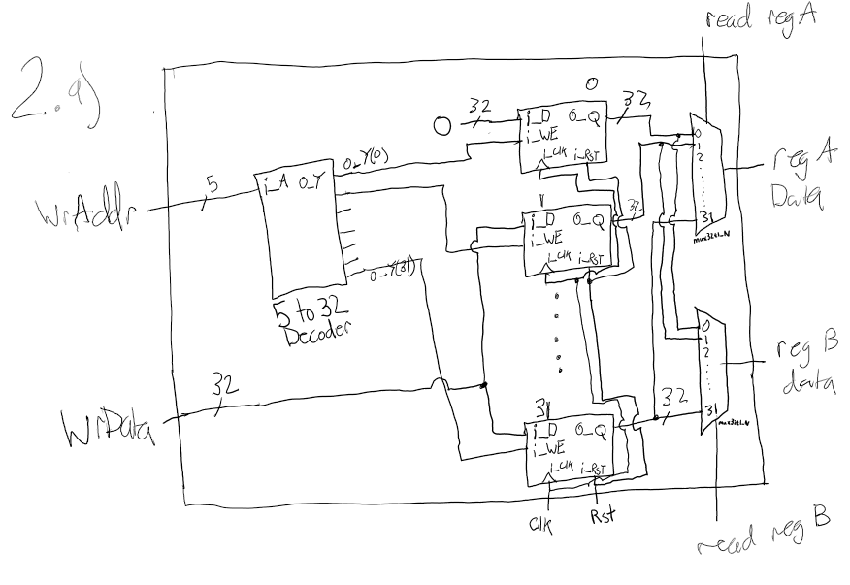
Two read ports are necessary both of 32 bits wide for the output data, thus 5 bit select lines. One write port with WrAddr at 5 bits long, WrData at 32 bits long. Clock and reset both of 1 bit.

[Part 2 (b)] Create an N-bit register using this flip-flop as your basis.
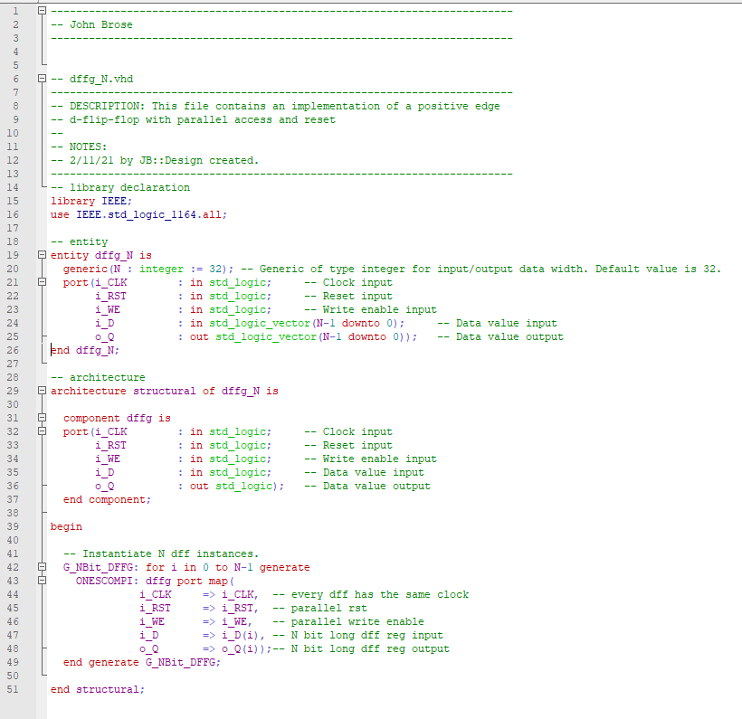

[Part 2 (c)] Waveform.
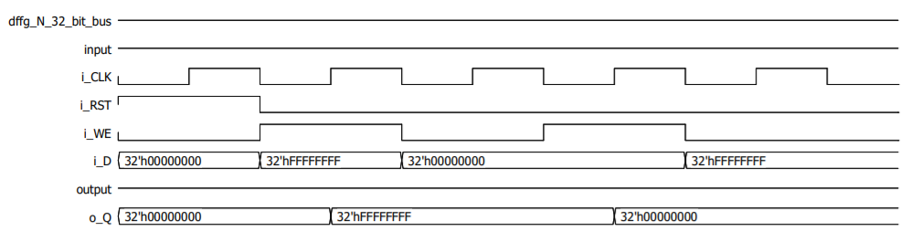

[Part 2 (d)] What type of decoder would be required by the MIPS register file and why?
5 to 32 decoder because the MIPS register has 32 registers and the decoder needs a select bit for each register thus log2(32) = 5.
[Part 2 (e)] Waveform.
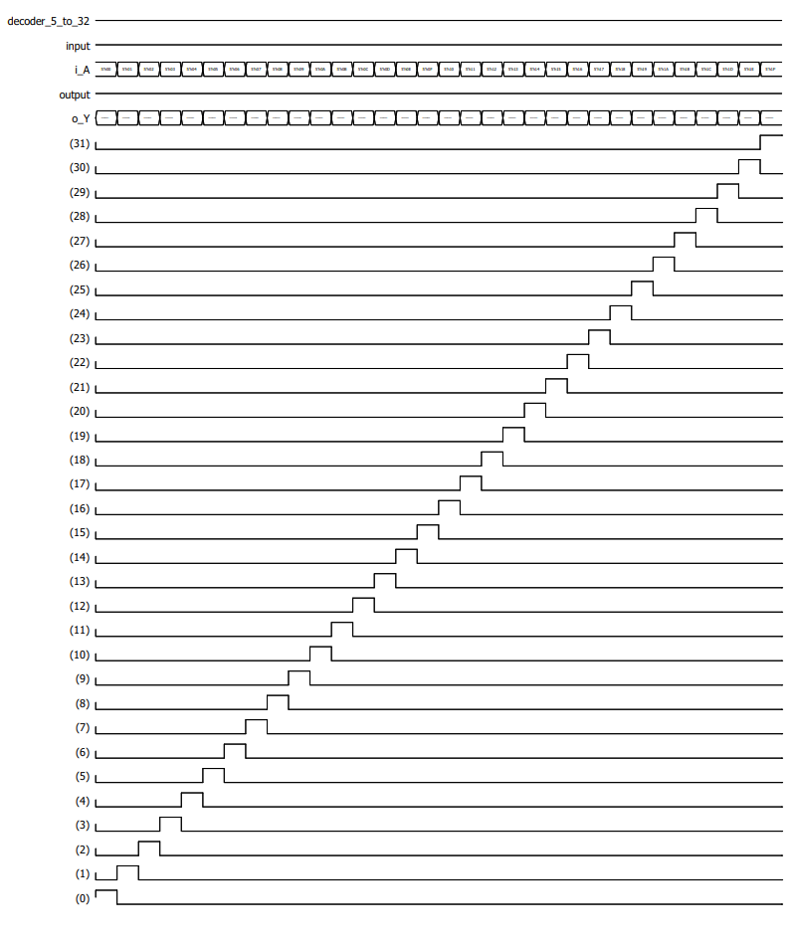
I_A iterates from 00000 to 11111 and i_Y responds accordingly.

[Part 2 (f)] In your write-up, describe and defend the design you intend on implementing for the next part.
I intend on implementing a 32 to 1 32-bit multiplexer by first creating a single 32 to 1 multiplexer using a dataflow approach. Then, use structural vhdl with the generate function to create a 32-bit 32 to 1 multiplexer.

[Part 2 (g)] Waveform.
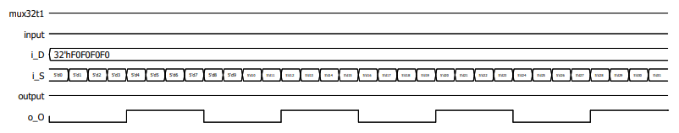
I_S iterates from 0 to 31. The output follows i_D(i_S) as shown below in the following two pages.
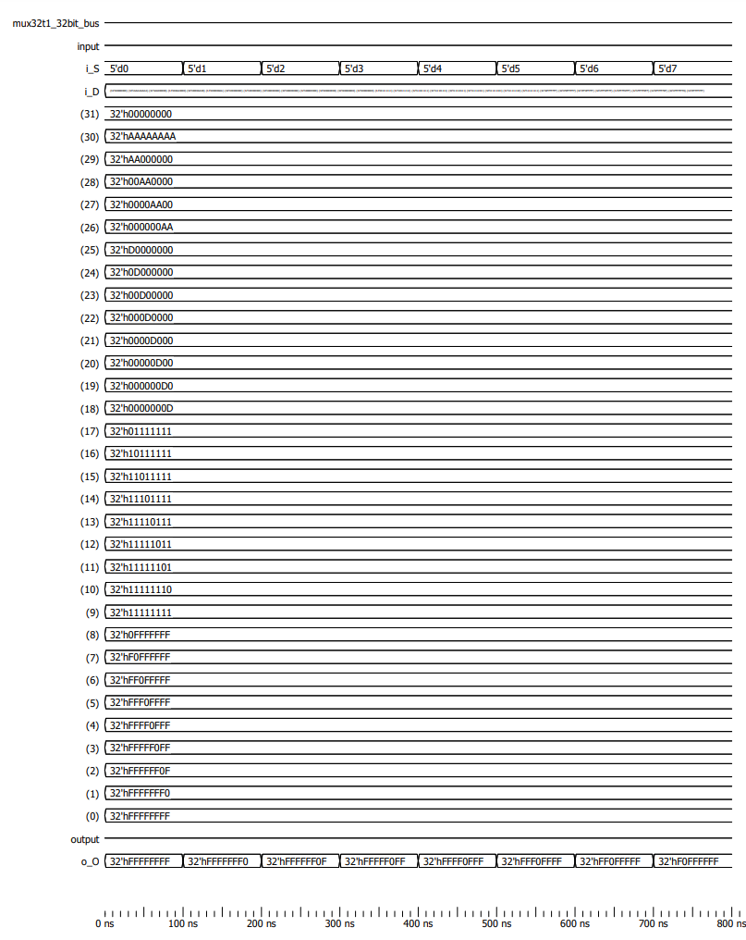
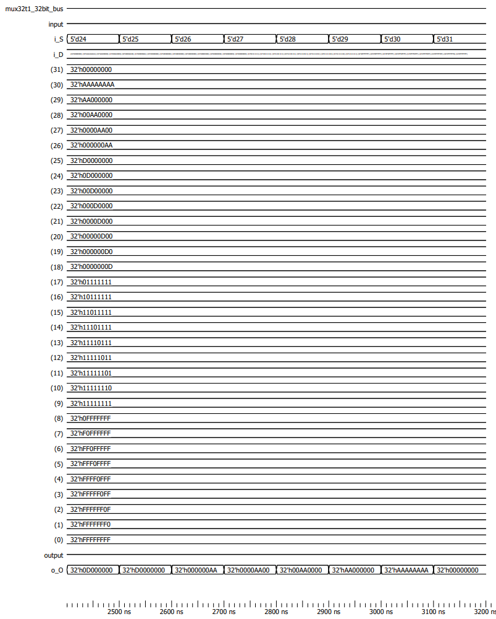

[Part 2 (h)] Draw a (simplified) schematic for the MIPS register file, using the same top-level interface ports as in your solution describe above and using only the register, decoder, and mux VHDL components you have created.
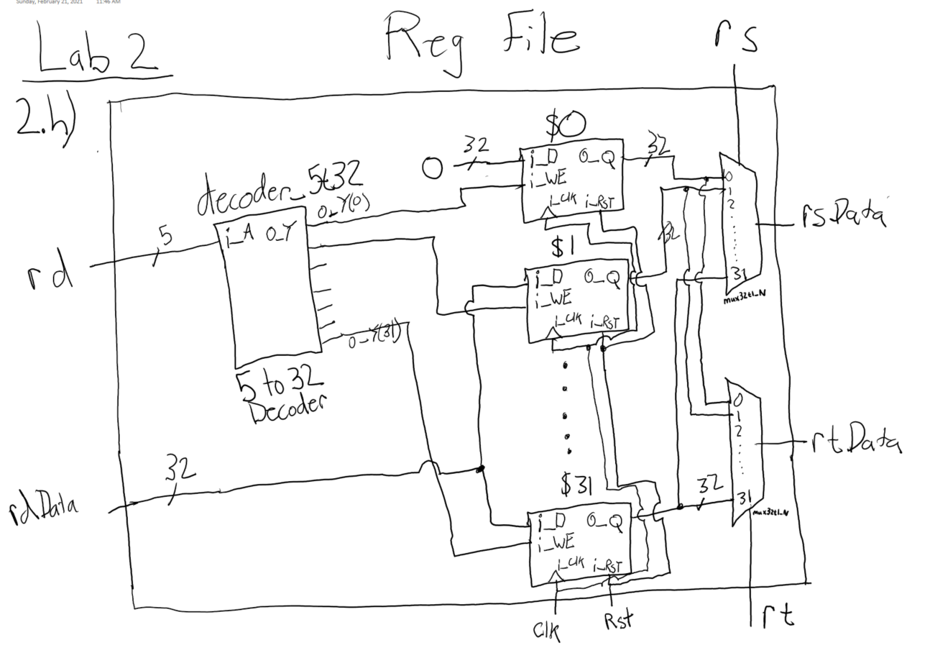
[Part 2 (i)] Waveform.
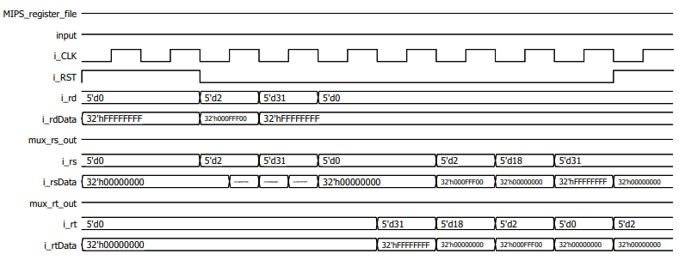
Test Case: set i_rdData = 0xFFFFFFFF, attempt to load into $0,$31. Set i_rdData to 0x000FFF00 and attempt to load into $s2. Read outputs of $0, $2, $31, and $18

Expected out: $0 and $18 should be 0, $31 should be all Fs, and $2 should be 0x000FFF00 after the first rising edge of the clock.
[Part 3 (b)] Draw a symbol for this MIPS-like datapath.
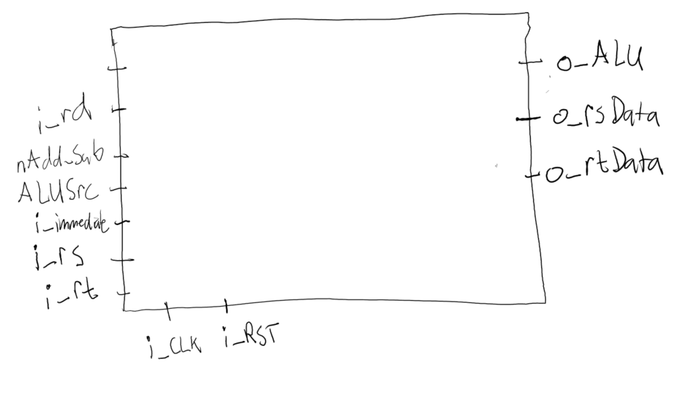
O_rsData and o_rtData are not strictly needed as outputs but they help to clearly show the correct implementation of the datapath when testing.

[Part 3 (c)] Draw a schematic of the simplified MIPS processor datapath consisting only of the component described in part (a) and the register file from problem (1).
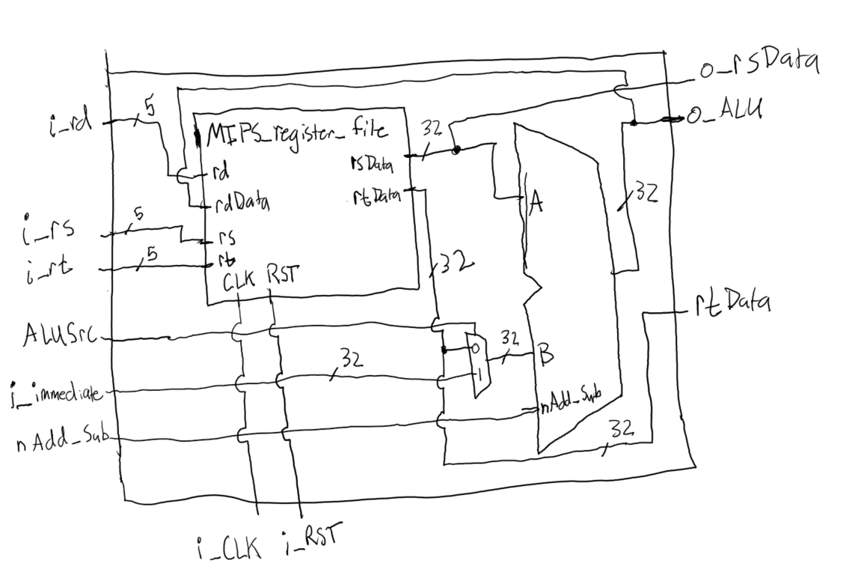

[Part 3 (d)] Include in your report waveform screenshots that demonstrate your properly functioning design. Annotate what the final register file state should be.
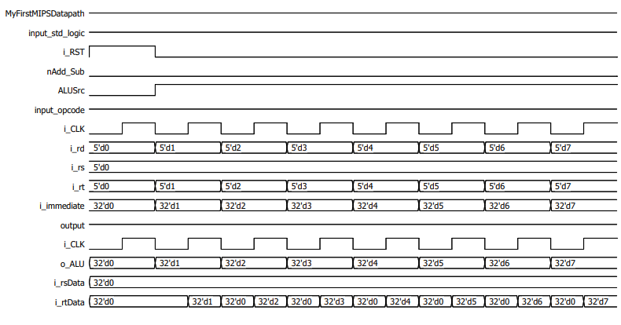
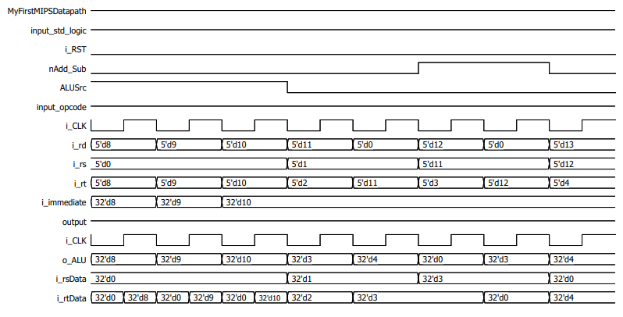
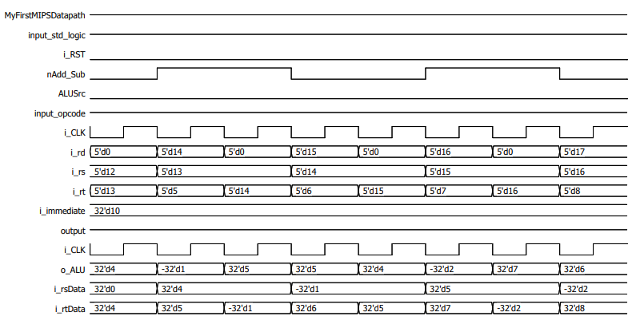
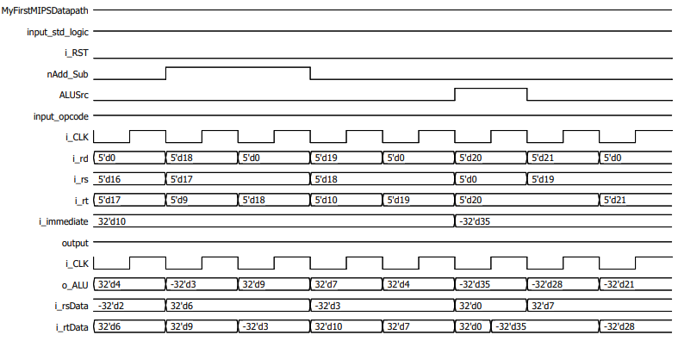
The expected output is -28 which is shown in i_rtData. A buffer step that lasted a full clock cycle in between each MIPS instruction was added in which i_rtData was set to the output of the register that was just updated by the previous MIPS instruction for easy error checking and confirmation of working MIPS dataflow.

[Part 4 (a)] Read through the mem.vhd file, and based on your understanding of the VHDL implementation, provide a 2-3 sentence description of each of the individual ports (both generic and regular).
DATA_WIDTH: This is the size of each register in bits. The normal value of this is 32 which matches the MIPS architecture which states that each address in memory is 32 bits wide.

ADDR_WIDTH: This helps define the amount of memory elements of size DATA_WIDTH in the memory storage space. The actual size of the ram is 2^(ADDR_WIDTH-1) as shown in line 31 of mem.vhd. Generic size is 2^10 = 1024 address’s.

clk: defines the process of the memory space by allowing an update to the memory on the rising edge of clk. In most implementations of mem.vhd I would assume clk is set to a constant frequency, thus writes can happen at set intervals of the rising edge.

addr: addr size is defined as a vector of bits of size ADDR_WIDTH. addr is used to indicate which memory address should be written to or read from. The default length is 10 bits long meaning it can select from 1024 addresses which matches the amount of memory declared by ADDR_WIDTH in line 31.

data: data is a standard logic vector of size DATA_WIDTH with a default value of 32 bits long. The data element can be used to set an address(indicated by addr) in ram to whatever value data holds as defined by line 43 of mem.vhd when we = ‘1’. Data can only update ram on the rising edge of the clock.

we: we is the right enable bit and has a default value of 1. The we line dictates whether or not data can update a ram address. If we is ‘1’ it allows data to update ram and when ‘0’ ram does not change.

q: The q port is an output of length DATA_WIDTH(default 32). It allows holds the value of one address’s value in ram. The address is specified by addr and updates constantly, not just on the rising edge of the clock.

[Part 4 (c)] Waveforms.
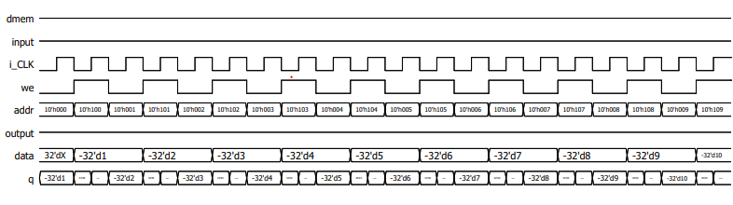
Addr is iterated from 0x000 to 0x009 and the consecutive memory locations starting at 0x100 are updated in parallel. For example, when 0x001 is read from, 0x101 is updated and then read from on the next positive edge.

[Part 5 (a)] What are the MIPS instructions that require some value to be sign extended? What are the MIPS instructions that require some value to be zero extended?
Load, stores, addiu, and addi’s need to be sign extended. Andi, ori, xori, noti or anything gate logic needs to be zero extended.

[Part 5 (b)] what are the different 16-bit to 32-bit “extender” components that would be required by a MIPS processor implementation?
One 16 to 32 0 extender is needed, where bits 16 to 31 are set to 0 and one 16 to 32 sign extender is needed, where bits 16 to 31 are set to whatever bit 15 is equal to.

[Part 5 (d)] Waveform.
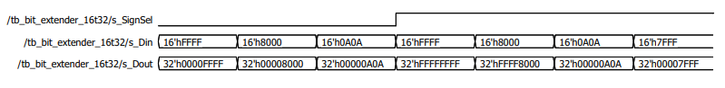

[Part 6 (a)] what control signals will need to be added to the simple processor from part 2? How do these control signals correspond to the ports on the mem.vhd component analyzed in part 3?
Write enable which corresponds to we in mem.vhd needs to be added to control writing to memory. i_rdDataSel needs to be added to switch between loading into regs from alu or mem, no correspondence to mem.vhd. i_SignSel needs to be added to change the i_immediate from 16 bits to 32 bits using zero extension or sign extension, again no correspondence to mem.vhd.

[Part 6 (b)] Draw a schematic of a simplified MIPS processor consisting only of the base components used in part 2, the extender component described in part 4, and the data memory from part 3.
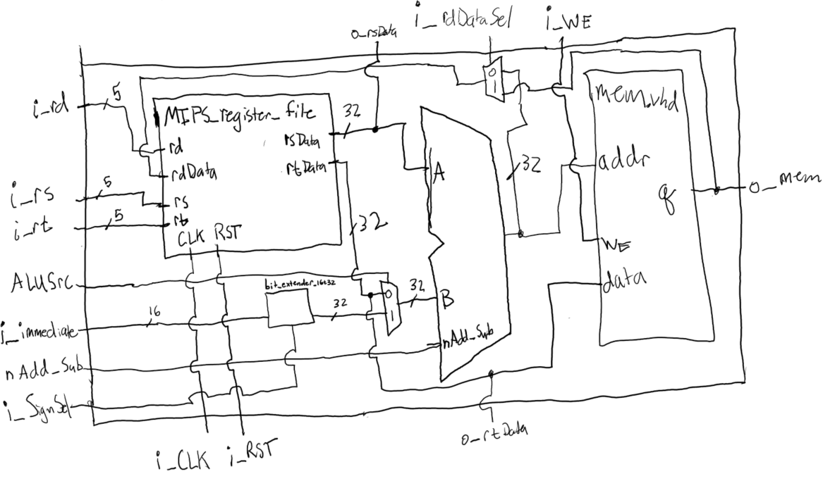

[Part 6 (c)] Waveform.
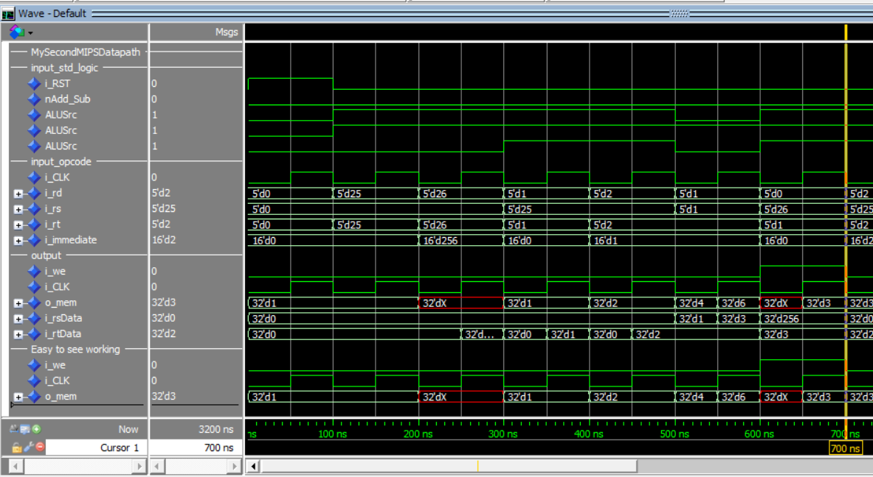
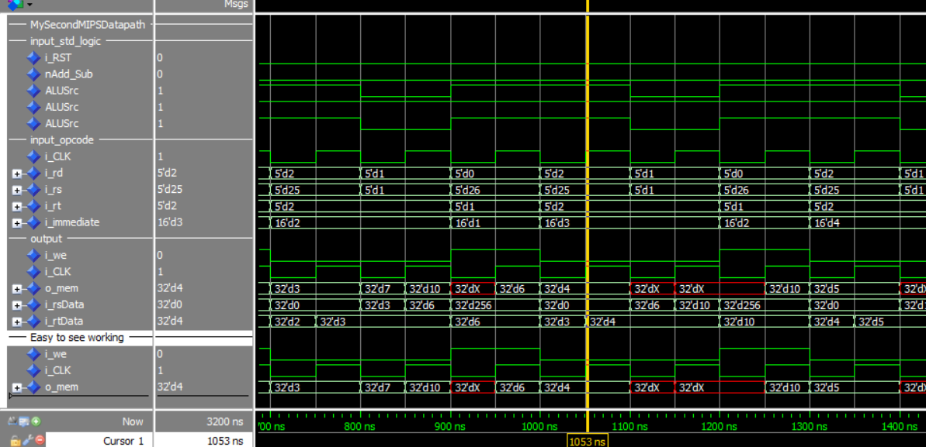
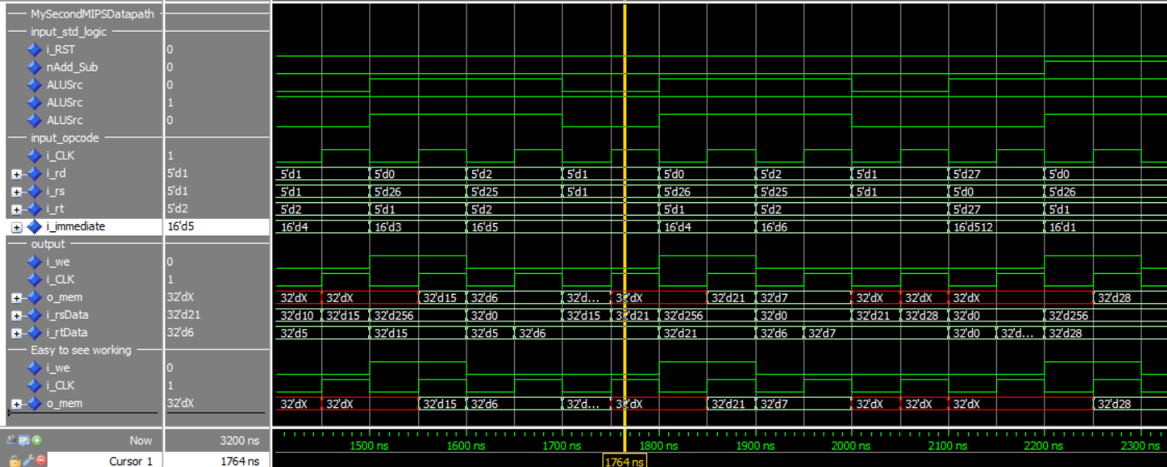
Expected output is 28, which matches the value in B[255] shown by o_mem a 2250 ns.

