**CHAPTER THREE**

**METHODOLOGY**

**3.1 Introduction**

This chapter presents the research methodology for this study. The methodology, therefore, comprises all the adopted methods and materials used for the implementation of this work. In this chapter, each adopted method for this work is presented and fully explained under a separate subheading, and each process follows a systematic order of research report.The proposed system utilizes the power of genetic algorithms to find an optimal or near-optimal solution for generating timetables. This methodology outlines the key steps involved in implementing the web-based automatic timetable generator, including problem formulation, representation, fitness evaluation, genetic operators, and the web interface.

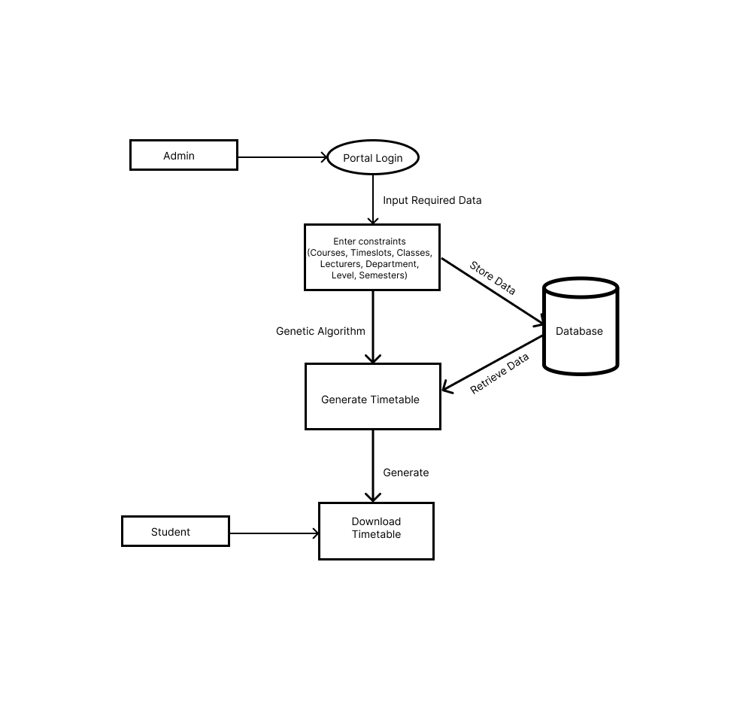**Figure 3.1: Diagrammatic Illustration of the Proposed Computer Aided Learning System**

**3.2 Problem Formulation**

The problem of timetable generation in educational institutions is multifaceted and encompasses several critical aspects. At its core, it involves the allocation of courses to specific time slots, classrooms, lecturers, level and department withn a particular semester while also taking into account various constraints and objectives. The primary challenges and considerations include:

**3.2.1 Input Parameters**

To construct the timetable, the system must consider a set of input parameters. These include:

* **Courses:** The list of courses offered by the institution, each with its own unique requirements and constraints.
* **Professors:** The availability and preferences of professors who will be teaching the courses.
* **Classrooms:** Information about available classrooms, their capacity, and any specific requirements.
* **Time Slots:** The time periods during which classes can be scheduled.
* **Program:** The programs available in each departments.
* **Department:** The infomation about each department in the school.
* **Level:** The information about the levels available in each department.
* **Semester:** The semester available in each year.

**3.2.2 Constraints**

The timetable must adhere to a number of constraints, in order to be deemed efficient.

These constraints include:

* **Course Prerequisites:** Ensuring that students meet the prerequisites for courses.
* **Professor Availability:** Scheduling classes when professors are available to teach.
* **Classroom Capacity:** Assigning classrooms that can accommodate the expected number of students.
* **Avoiding Conflicts:** Preventing timetable conflicts for students who may have overlapping course schedules.
* **Optimizing Resource Usage:** Efficiently using available classrooms and professors' time.
* **Student Preferences:** Considering student preferences for specific class times, if applicable.

**3.2.3 Considerations and Objectives**

In addition to complying with constraints and conditions, the development of a well-constructed timetable should aim to meet several objectives:

* **Conflict Minimization:** Prioritizing timetables that minimize scheduling conflicts for students, allowing them to attend all necessary classes.
* **Room Allocation Optimization:** Efficiently assigning classrooms to courses, optimizing resource utilization and reducing the need for additional facilities.
* **Lecturer Workload Balance:** Ensuring lecturers' teaching schedules are balanced, avoiding scenarios of overload or underutilization.
* **Preference Satisfaction:** Whenever possible, accommodating student preferences for class timings to enhance the overall learning experience.
* **Student Access:** A well-designed timetable ensures that students can attend the courses they need without facing scheduling conflicts. This, in turn, enhances their learning experience and academic success.

**3.3 Genetic Algorithm Overview**

Genetic algorithms (GAs), a class of evolutionary algorithms inspired by the process of natural selection, present a powerful and versatile approach to tackle complex scheduling problems. This section provides an overview of genetic algorithms and their suitability in the context of timetable generation.

**3.3.1 Key Components**

* **Chromosomes:** In a genetic algorithm, a solution to a problem is represented as a chromosome. In the context of timetable generation, a chromosome encapsulates the schedule of classes for a particular course timetable. It specifies which courses are assigned to which time slots and classrooms, which professors are teaching them, and other relevant information. Each chromosome represents a potential timetable.
* **Population:** A population consists of a group of individual solutions (chromosomes). In timetable generation, a population represents a collection of potential timetables. These timetables are subjected to evolutionary operations (crossover and mutation) to produce new, potentially improved timetables.
* **Fitness Evaluation:**The fitness function is a crucial component of a genetic algorithm. It quantifies how well a chromosome (timetable) satisfies the desired objectives and constraints. In the context of timetable generation, the fitness function assesses the quality of a timetable based on factors like conflict avoidance, room allocation, and preference satisfaction.

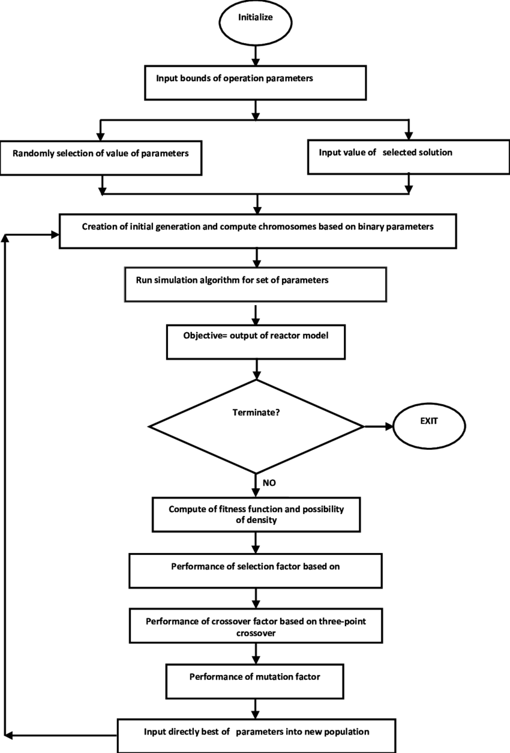**Figure 3.2: Genetic Algorithm Overview**

**3.3.2 The Genetic Algorithm Workflow**

* **Initialization:** The algorithm begins by creating an initial population of potential timetables (chromosomes). These timetables are often generated randomly or using some heuristic methods.
* **Selection:** In the selection phase, chromosomes from the current population are chosen to serve as parents for the next generation. The selection process is typically biased towards selecting better-performing timetables (those with higher fitness).
* **Crossover:** Crossover (recombination) involves taking two parent timetables and combining them to create one or more offspring timetables. In timetable generation, this means taking two existing timetables and creating new timetables by mixing elements of the parent timetables (e.g., class assignments).
* **Mutation:** Mutation introduces small, random changes into individual timetables. In the context of timetable generation, mutation might involve swapping the time slots of two classes or reassigning a course to a different classroom.
* **Fitness Evaluation:** After creating the next generation of timetables, the fitness function is applied to each timetable to assess its quality. Timetables that better satisfy constraints and objectives receive higher fitness scores.
* **Termination:** The algorithm continues to iterate through selection, crossover, mutation, and fitness evaluation steps for multiple generations or until a termination criterion is met. The termination criterion could be a specified number of generations, a time limit, or reaching a satisfactory timetable solution.

**3.4 Chromosome Representation**

Chromosome representation is a foundational aspect of the genetic algorithm-based timetable generation system. It serves as the blueprint for encoding and decoding potential timetables, allowing the algorithm to explore and optimize scheduling solutions efficiently. Whether using binary or integer-based representations, the structure of the chromosome must capture all relevant elements, including courses, professors, classrooms, and time slots.

* **Chromosome Structure:** A chromosome in the context of timetable generation encapsulates a potential timetable, representing the assignment of courses to specific time slots and classrooms. The structure of a chromosome is a critical aspect of the genetic algorithm, and it should efficiently encode the information required to generate a complete timetable.
* **Binary Representation:** One commonly used approach is a binary representation. In this scheme, each bit within the chromosome corresponds to a specific time slot and classroom combination. For example, if an institution has 10 time slots and 20 classrooms, each chromosome might consist of 200 binary bits.
* **Integer-Based Representation:** Another approach involves using integers to represent various elements. For instance, each gene within the chromosome could be an integer corresponding to a course ID. Professors, classrooms, and time slots can also be represented as integers. The chromosome is then a sequence of integers that represent the assignment of courses to specific time slots, classrooms, and professors.
* **Encoding Elements:** To create a chromosome that represents a complete timetable, several elements need to be encoded within it:
  + Courses: Each course offered by the institution needs to be represented in the chromosome. Courses can be assigned unique integer identifiers, and these identifiers are used within the chromosome to denote which courses are scheduled at specific times.
  + Lecturers: Lecturers responsible for teaching courses are also encoded in the chromosome. Similar to courses, each lecturer can be assigned a unique integer identifier. This allows the algorithm to track which lecturers are assigned to which courses.
  + Classrooms: Classrooms available for scheduling are encoded in the chromosome as well. Like courses and professors, each classroom can have a unique integer identifier. The chromosome will specify which classrooms are used for each course.
  + Time Slots: Time slots represent specific time periods during which classes can be scheduled. These can be encoded using integers or binary values within the chromosome. Each time slot corresponds to a segment of the day when a class can occur.
  + Decoding the Chromosome: Once a chromosome is created, it must be decoded to generate an actual timetable. Decoding involves mapping the information encoded within the chromosome back to real-world elements, such as courses, professors, classrooms, and time slots.
  + Course Assignment: The chromosome specifies which courses are assigned to which time slots and classrooms. By decoding this information, the algorithm generates a list of courses and their corresponding schedules.
  + Lecturer Allocation: The lecturer assignments encoded in the chromosome are used to determine which professors are responsible for teaching each course. This information is crucial for ensuring that lecturer's availability and expertise match the assigned courses.
  + Classroom Assignment: Classroom assignments within the chromosome dictate where each course takes place. Decoding this information results in a list of classrooms and their schedules.
  + Time Slot Mapping: The time slots encoded in the chromosome are mapped back to specific time periods during the day. This step creates a schedule that aligns with the institution's daily timetable.

**3.5 Fitness Evaluation**

In the genetic algorithm framework, the primary objective of the fitness function is to find optimal or near-optimal solutions to a given problem. In the context of timetable generation, the goal is to discover timetables that satisfy various constraints and objectives while minimizing conflicts and resource wastage. Fitness evaluation serves as the guiding mechanism within the genetic algorithm. In each generation, the algorithm selects and evolves timetables based on their fitness scores. Timetables with higher fitness scores are more likely to be chosen as parents for crossover and mutation operations, allowing their favorable traits to be inherited by the next generation. Over successive generations, the algorithm converges towards solutions that better satisfy constraints and objectives.

**Designing the Fitness Function**

The fitness function is the cornerstone of fitness evaluation. It quantifies how well a potential timetable aligns with the desired objectives and constraints. In the context of timetable generation, the fitness function must be carefully designed to capture key aspects of scheduling quality. Let's explore some of the critical criteria that the fitness function typically considers:

**Conflict Avoidance**

One of the paramount objectives is to minimize scheduling conflicts for students. Conflicts occur when a student is required to attend multiple classes that overlap in time or location. The fitness function assesses the extent to which conflicts are avoided in a timetable. It assigns higher fitness scores to timetables with fewer conflicts.

**Room Allocation Optimization**

Efficient room allocation is another essential criterion. The fitness function evaluates how well classrooms are assigned to courses, aiming to minimize resource wastage. Timetables that optimize room allocation receive higher fitness scores.

**Lecturer Workload Balance**

To ensure fairness and efficiency, the fitness function considers the workload of lecturers. It evaluates how evenly teaching responsibilities are distributed among faculty members. Timetables that achieve a balanced workload for lecturers receive higher fitness scores.

**Constraint Adherence**

Timetables must adhere to various constraints, such as course prerequisites, professor availability, classroom capacity, and institutional policies. The fitness function penalizes timetables that violate these constraints, ensuring compliance.

**Objective Weighting**

Assigning appropriate weights to each of these criteria is crucial. The relative importance of minimizing conflicts, optimizing room allocation, and other objectives can vary depending on institutional priorities. The fitness function should allow for flexible weighting to reflect these priorities.

**Calculating Fitness Scores**

Once the fitness function is defined, it is applied to each potential timetable to calculate a fitness score. This score quantifies how well the timetable satisfies the specified criteria and objectives. Timetables with higher fitness scores are considered better solutions.

**3.6 Implementation Details**

The development of a web-based automatic timetable generator represents a fusion of cutting-edge technology and educational administration. In this section, we delve into the technical underpinnings of our system, highlighting the choice of technologies, the architecture of the system, and the database schema. Our implementation leverages HTML, CSS, and JavaScript for the frontend, PHP for the backend, and MySQL for the database, ensuring a robust and efficient platform for timetable generation.

**3.6.1 Frontend Technologies**

* **HTML (HyperText Markup Language)**

HTML serves as the foundation of our web-based system. It provides the structure and semantics for the user interface, defining elements like forms for input, tables for displaying timetables, and buttons for user interactions. HTML5 features are utilized to create a modern and responsive user interface.

* **CSS (Cascading Style Sheets)**

CSS is employed for styling and layout, ensuring an aesthetically pleasing and user-friendly interface. Stylesheets define the appearance of elements, including fonts, colors, spacing, and responsiveness to different screen sizes. CSS frameworks may also be used to streamline the styling process.

* **JavaScript**

JavaScript adds interactivity to the frontend, enabling dynamic behaviors such as real-time validation of user inputs, asynchronous data retrieval (AJAX), and the ability to visualize generated timetables. Popular libraries and frameworks like jQuery and React can be utilized to simplify development.

* Java: For the development of the mobile app, i opted for Java, a widely used and versatile programming language for Android app development. Java allows the creation of a mobile application that complements the web-based system, offering users flexibility and convenience.

**3.6.2 Backend Technologies**

* **PHP (Hypertext Preprocessor)**

PHP serves as the backend scripting language for our system. It handles the core logic of the timetable generation process, including parsing user inputs, executing the genetic algorithm, and generating timetables. PHP also communicates with the database to retrieve and store data.

* **Genetic Algorithm Implementation**

Within the PHP backend, the genetic algorithm is implemented to generate timetables. This includes the selection mechanism, crossover and mutation operations, fitness evaluation, and the management of the population of potential timetables. The algorithm iteratively refines timetables until satisfactory solutions are achieved.

**3.6.3 Database Technology**

* **MySQL**

MySQL is employed as the relational database management system (RDBMS) for our system. It stores and manages data related to courses, professors, classrooms, time slots, generated timetables, and user preferences. The use of a relational database ensures data integrity and efficient querying.

* **Database Schema**

The database schema defines the structure and relationships between tables. Key tables in the schema may include:

* 1. Courses: Storing information about courses, including course codes, names, departments, levels, and associated professors.
  2. Professors: Holding data about lecturers, including their names, expertise, and availability.
  3. Classrooms: Storing details about available classrooms, including capacities and equipment.
  4. Time Slots: Defining time slots, including start and end times and days of the week.
  5. Timetables: Storing generated timetables, including course assignments, professor allocations, classroom assignments, and fitness scores.
  6. User Preferences: Capturing student preferences for class timings and other constraints.

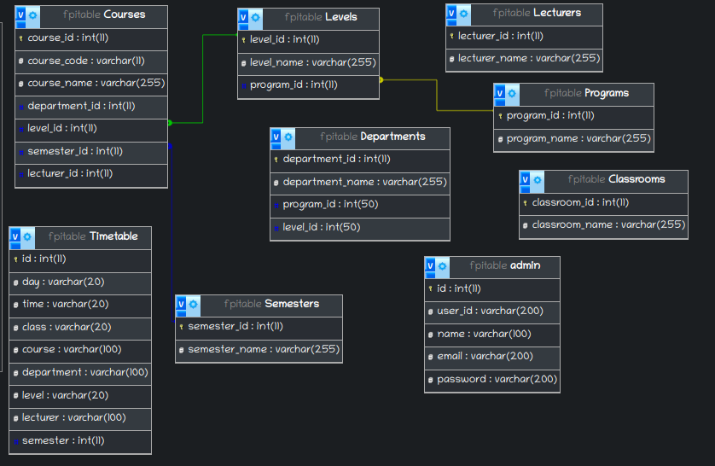**Figure 3.3: Database Entity Relationship Diagram (ERD)**

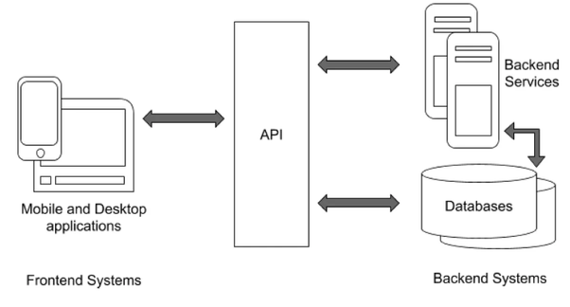**Figure 3.4: Software Dataflow Design**

**3.6.4 System Architecture**

* Presentation Layer (Frontend)

The presentation layer, implemented using HTML, CSS, and JavaScript, provides the user interface through which users interact with the system. It captures user inputs, displays timetables, and communicates with the backend.

* Application Layer (Backend)

The application layer, powered by PHP, houses the core logic of the system. It processes user inputs, executes the genetic algorithm, and communicates with the database to retrieve and store data. This layer orchestrates the timetable generation process.

* Data Layer (Database)

The data layer, built on MySQL, stores and manages all data related to courses, professors, classrooms, time slots, generated timetables, and user preferences. It ensures data consistency and provides efficient data retrieval for the application layer.

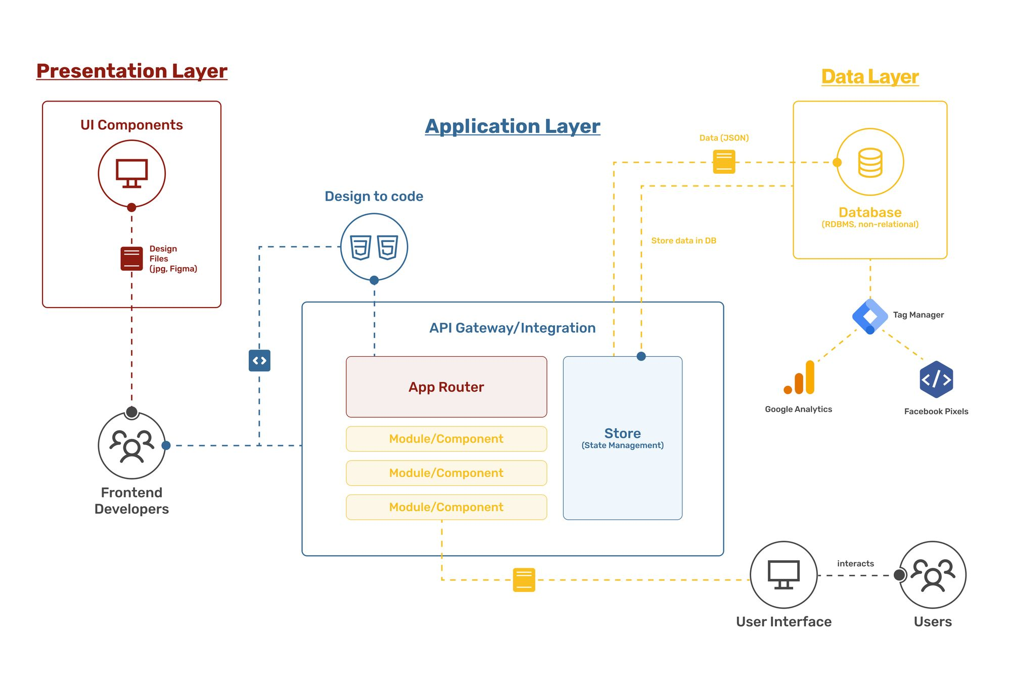**Figure 3.5 System Architecture**

**3.7 Timetable Generation Algorithm**

The core of the web-based timetable generator is the algorithm responsible for creating optimal or near-optimal timetables. I employed a genetic algorithm, as previously discussed, to address the complexities of this scheduling problem.The genetic algorithm works iteratively to evolve a population of potential timetables toward more optimal solutions. Here's an overview of the algorithm's steps:

**Step 1: Initialization**

The process begins with the initialization of the genetic algorithm. Key parameters, such as population size and the maximum number of generations, are set. An initial population of potential timetables is generated. Each timetable adheres to the initial constraints and conditions, ensuring that class assignments, room allocations, and time slots meet the basic requirements.

**Step 2: Fitness Evaluation**

In this step, the fitness of each timetable in the population is evaluated. The fitness function takes into account multiple criteria, including conflict avoidance, room allocation optimization, lecturer workload balance, preference satisfaction, and constraint adherence. Each timetable receives a fitness score that quantifies how well it satisfies these criteria.

**Step 3: Selection of Parents**

The genetic algorithm selects individuals (timetables) from the current population to serve as parents for the next generation. The selection process is biased toward timetables with higher fitness scores, increasing their chances of being chosen as parents. Various selection mechanisms, such as roulette wheel selection, tournament selection, or rank-based selection, can be employed.

**Step 4: Crossover (Recombination)**

Crossover is performed to create offspring timetables. Two parent timetables are chosen, and their genetic material is combined to produce one or more offspring timetables. This operation mimics genetic recombination in nature. The choice of crossover method, such as one-point crossover, two-point crossover, or uniform crossover, influences how genetic material is exchanged.

**Step 5: Mutation**

Mutation introduces small, random changes into individual timetables. It helps maintain diversity in the population and prevents the algorithm from getting stuck in local optima. Mutation operations can include reassigning courses, swapping time slots, or reassigning classrooms. The mutation rate determines the probability of introducing changes.

**Step 6: Evaluation of Offspring**

The fitness of the offspring population, which includes newly created timetables, is evaluated using the same fitness function as in step 2. This step ensures that the newly generated timetables conform to the defined criteria and objectives.

**Step 7: Selection of the Next Generation**

The next generation of timetables is selected from a combination of the parent and offspring populations. Selection mechanisms are employed to choose individuals for the next generation. Timetables with higher fitness scores are more likely to be selected, but there is also an element of randomness to promote diversity.

**Step 8: Termination Criterion**

The genetic algorithm continues to iterate through steps 3 to 7 for multiple generations or until a termination criterion is met. Termination criteria can include reaching a specified number of generations, reaching a time limit, or achieving a satisfactory timetable solution. Once the criterion is met, the algorithm terminates.

**Step 9: Best Timetable**

After the algorithm terminates, the best timetable found during the process is selected. This timetable has the highest fitness score among all timetables in the final population.

The psuedocode for the algorithm is shown below:

# Initialize the Genetic Algorithm for Timetable Generation

function initializeGeneticAlgorithm():

populationSize = definePopulationSize() # Determine the size of the population

generationCount = 0

population = createInitialPopulation(populationSize) # Create an initial population of timetables

while generationCount < maxGenerations and not terminationCriterionMet():

fitnessScores = evaluateFitness(population) # Evaluate the fitness of each timetable

# Select parents for the next generation

parents = selectParents(population, fitnessScores)

# Initialize an empty offspring population

offspringPopulation = []

# Perform crossover to create offspring timetables

while offspringPopulation is not full:

parent1, parent2 = selectTwoParents(parents)

offspring1, offspring2 = performCrossover(parent1, parent2)

offspringPopulation.add(offspring1)

offspringPopulation.add(offspring2)

# Apply mutation to the offspring population

offspringPopulation = applyMutation(offspringPopulation)

# Evaluate the fitness of the offspring population

offspringFitnessScores = evaluateFitness(offspringPopulation)

# Select individuals for the next generation

nextGeneration = selectNextGeneration(population, offspringPopulation, fitnessScores, offspringFitnessScores)

population = nextGeneration

generationCount += 1

bestTimetable = findBestTimetable(population, fitnessScores)

return bestTimetable

# Define Population Size

function definePopulationSize():

# Determine an appropriate population size based on the problem complexity

# and available computational resources.

populationSize = calculatePopulationSize()

return populationSize

# Create an Initial Population

function createInitialPopulation(populationSize):

# Generate an initial population of timetables, adhering to constraints and conditions.

initialPopulation = []

for i in range(populationSize):

timetable = generateRandomTimetable() # Create a random timetable

initialPopulation.add(timetable)

return initialPopulation

# Evaluate the Fitness of Timetables

function evaluateFitness(population):

# Calculate the fitness score for each timetable in the population.

fitnessScores = []

for timetable in population:

fitness = calculateFitness(timetable) # Use the defined fitness function

fitnessScores.add(fitness)

return fitnessScores

# Select Parents for the Next Generation

function selectParents(population, fitnessScores):

# Implement a selection method to choose parents based on their fitness scores.

parents = selectBasedOnFitness(population, fitnessScores)

return parents

# Perform Crossover to Create Offspring Timetables

function performCrossover(parent1, parent2):

# Implement a crossover operation to combine genetic material from two parents.

offspring1, offspring2 = singlePointCrossover(parent1, parent2) # Example: Single-point crossover

return offspring1, offspring2

# Apply Mutation to the Offspring Population

function applyMutation(offspringPopulation):

# Implement mutation to introduce small, random changes into timetables.

mutatedOffspring = []

for timetable in offspringPopulation:

mutatedTimetable = introduceMutation(timetable) # Apply mutation to the timetable

mutatedOffspring.add(mutatedTimetable)

return mutatedOffspring

# Select Individuals for the Next Generation

function selectNextGeneration(parentPopulation, offspringPopulation, parentFitness, offspringFitness):

# Implement a selection mechanism to choose the next generation.

combinedPopulation = parentPopulation + offspringPopulation

combinedFitness = parentFitness + offspringFitness

nextGeneration = selectBasedOnFitness(combinedPopulation, combinedFitness)

return nextGeneration

# Find the Best Timetable

function findBestTimetable(population, fitnessScores):

# Determine the best timetable in the final population based on fitness scores.

bestIndex = indexWithHighestFitness(fitnessScores)

bestTimetable = population[bestIndex]

return bestTimetable

# Termination Criterion

function terminationCriterionMet():

# Check if the termination criterion has been met (e.g., maximum generations reached).

if generationCount >= maxGenerations:

return True

else:

return False

**3.8 Web Interface and Mobile App Integration**

The success of a web-based automatic timetable generator heavily depends on the quality and usability of its user interfaces. In this section, we will explore in detail how the web interface and mobile app interface have been designed and integrated to provide a seamless experience for users.

**3.8.1 Web Interface**

**User Interface Design**

The web interface serves as the primary means for users to interact with the timetable generator. The design of the user interface is critical to ensure that users, including administrators, professors, and students, can easily input scheduling constraints, view generated timetables, and make scheduling requests.

* Dashboard: The dashboard serves as the central hub of the web application. It provides an overview of the current semester's timetable, upcoming events, and important notifications. The dashboard is designed to be user-friendly and informative.
* Input Forms: Input forms are essential for users to specify scheduling constraints and preferences. These forms include options to select courses, professors, classrooms, and other constraints. Input validation ensures that users provide accurate and complete information.
* Timetable Display: Timetables are displayed in an organized and visually appealing manner. Each timetable view includes day-by-day schedules with color-coded entries for different courses and events. Users can easily navigate through weeks and semesters.
* Search and Filter: Timetables can be searched and filtered based on specific criteria. Users can search for a particular course, professor, or classroom, making it convenient to locate specific information within a complex schedule.
* Preferences: Students may have preferences for class timings. The interface allows students to indicate their preferences, which are considered during the timetable generation process. These preferences are given weight in the fitness function.
* Conflict Resolution: In cases where conflicts arise, the interface provides clear indications of conflicts and suggestions for resolution. Users are notified of overlapping class timings and are presented with alternative options.

**User Experience (UX)**

The user experience plays a vital role in the effectiveness of the web interface. To enhance UX, several principles are applied:

* Responsiveness: The web interface is designed to be responsive, ensuring a consistent experience across devices, including desktops, tablets, and smartphones. This responsiveness accommodates the diverse needs of users.
* Intuitiveness: The interface is intuitive and user-friendly, with clear navigation menus and well-labeled buttons. Users should be able to complete tasks without encountering confusion.
* Accessibility: Accessibility features are implemented to ensure that the interface is usable by individuals with disabilities. This includes support for screen readers and keyboard navigation.
* Feedback: Users receive timely feedback when interacting with the interface. For example, when submitting scheduling requests or preferences, users are informed of the successful submission.
* Performance: The interface is optimized for performance, with efficient data retrieval and rendering. Users experience minimal lag or delays when accessing timetables or making requests.

**3.8.2 Mobile App Integration**

In addition to the web interface, a mobile app has been developed to provide students with on-the-go access to their timetables and also allows them report technical issues. The mobile app complements the web-based system by offering flexibility and convenience, particularly for students and professors. The mobile app is built using Java, a versatile and widely used programming language for Android app development. The choice of Java allows for compatibility with a wide range of Android devices and ensures a robust and stable mobile app experience.

**Mobile App Features**

* Timetable Access: Users can view their timetables, including class schedules, room assignments, and other relevant information. The mobile app synchronizes data with the web-based system, ensuring real-time updates.
* Notifications: The mobile app sends push notifications for important events, such as class cancellations, room changes, or scheduling conflicts. Users receive timely alerts to stay informed.
* Scheduling Requests: Students can submit scheduling requests or preferences directly through the mobile app. This feature streamlines the process of making requests and ensures that students can quickly communicate their scheduling needs.
* Offline Access: The mobile app provides offline access to timetables. Users can access their schedules even when they are not connected to the internet, ensuring uninterrupted usability.

**Integration with Web-Based System**

To ensure data consistency and seamless user experience, the mobile app interfaces with the web-based system through Application Programming Interfaces (APIs). This integration allows data to be synchronized between the web and mobile platforms.

* API for Data Retrieval: The mobile app queries the web-based system's APIs to retrieve timetable data, user preferences, and notifications. This ensures that the data displayed on the mobile app is up-to-date.
* API for Scheduling Requests: When users submit scheduling requests or preferences through the mobile app, the data is sent to the web-based system via APIs. This enables the scheduling algorithm to consider mobile app submissions in the timetable generation process.
* Notification Integration: Push notifications are sent to the mobile app when important events or updates occur within the web-based system. These notifications are triggered by events such as class changes, room assignments, or scheduling conflicts.

**Security Considerations**

Security is paramount in both the web interface and mobile app to protect sensitive scheduling data and user information. The following security measures are implemented:

* Authentication: Users are required to log in with their credentials to access their timetables and submit scheduling requests. Strong authentication mechanisms, such as password hashing and session management, are employed.
* Data Encryption: Data transmission between the web-based system, mobile app, and server is encrypted using industry-standard protocols (e.g., HTTPS). This ensures that data exchanged over the network is secure and confidential.
* Authorization: Users are granted access permissions based on their roles (e.g., student, professor, administrator). Role-based access control ensures that users can only perform actions authorized for their role.
* Data Privacy: User data, including personal information and scheduling preferences, is stored securely and is accessible only to authorized personnel. Data privacy regulations, if applicable, are strictly adhered to.
* Mobile App Security: The mobile app undergoes security testing to identify vulnerabilities. Measures are taken to prevent unauthorized access, data leakage, and other security risks commonly associated with mobile apps.