**TABLE OF CONTENT**

**CHAPTER ONE…………………………………………………………………………..1**

* 1. Introduction……………..……………………………………………………....2

**CHAPTER TWO……………………………………………………...……………..……3**

2.1 Literature Review…………………………………….……………………..…3

2.2 Artificial Intelligence…………………………………………………………...3

2.3 Machine Learning………………………………………………………………4

2.4 Supervised Machine Learning………………………………….………………4

2.5 Unsupervised Machine Learning…………………………………………….…4

2.6 Deep Learning………………………...………………………….……………..5

2.7 Natural Language Processing..………………………….………………………5

2.8 Conversational Chatbot………………………………..………………………..5

2.8.1 Chat-bot Efficiency…………………………………....………………6

2.8.2 Conversational Chat-bot Architecture………………..……………….6

**CHAPTER THREE………………………………………………………………………..7**

3.1 Design and Analysis…………………………………………………………….7

3.2 Overall System Design………………………………………………………….7

**CHAPTER FOUR…………………………………………………………………………13**

4.1 Implementation………………………………………………………………….13

4.2 Website Development Procedure……………………………………………….14

4.2.1 Authentication System………………………………………………...15

4.2.2 Profile Management…………………………………………………..16

4.2.3 Therapy Session Scheduling………………………………………….16

4.2.4 Conversational Chat-bot Development……………………………….17

4.2.5 Forum System………………………………………………………...18

**CHAPTER FIVE…………………………………………………………………………..19**

5.1 Testing and Discussion………………………………………………………….19

5.2 Testing…………………………………………………………………………..19

5.3 Discussion………………………………………………………………………19

**CHAPTER SIX…………………………………………………………………………….21**

6.1 Conclusion………………………………………………………………………21

**LIST OF FIGURES**

Figure 1: Web communication System…………………………………………………………..7

Figure 2: Use case Diagram For The Proposed System………………………………………….9

Figure 3: Block Diagram Of The System………………………………………………………..10

Figure 4: Database Entity Relationship Diagram of the Proposed System……………………...11

Figure 5: Wireframe for the website……………………………………………………………..13

Figure 6: Code snippet showing the user signup algorithm……………………………………...14

Figure 7: Code snippet showing user access control using session variable…………………….14

Figure 8: Code Snippet for profile management…………………………………………………15

Figure 9: Code snippet for the chatbot session…………………………………………………..16

Figure 10: Code snippet for forum post creation………………………………………………...17

**ABSTRACT**

Mental health is a growing concern in our society, with millions of people around the world suffering from various mental health conditions. Unfortunately, seeking mental health therapy is still stigmatized and often inaccessible due to the cost or availability of qualified therapists. This study aims to correct this by developing a mental health therapy services website that provides accessible and affordable therapy services, a peer support forum and a chat-bot interactive for self-help and guidance. The motivation behind this research is to provide a platform for people who may be hesitant or unable to seek therapy for various reasons such as stigma, lack of accessibility or affordability. The site will provide people with an easy and convenient way to schedule and attend therapy sessions from the comfort of their own homes. The forum will also provide a space for individuals to connect with others who may be experiencing similar difficulties, providing support and empathy. The site will also incorporate an interactive chat-bot session that can provide users with immediate feedback, advice and self-help tools. The chat-bot will be designed using natural language processing and prompt engineering to recognize and respond to various mental health issues, providing users with personalized resources and directing them to the right support channels. The site will address issues of accessibility, affordability, and stigma that have long been associated with mental health therapy.

**CHAPTER ONE**

**1.0 INTRODUCTION**

The term mental illness or unsettling influence alludes to all identifiable mental disorders well being conditions characterized by alterations in considering, temperament, or behavior related to trouble or impaired working. Because it is characterized by the absence of psychopathologies like depression and anxiety, mental health has long been established. In the modern society, depression may affect everyone and is a major problem. The illness of depression is very challenging. Nobody is particularly aware of what causes it. The solvable causes might include significant illnesses, relationships, deadlines, heredity, abuse, disagreements, and loneliness. (Kapoor, Agrawal, and Ahmad, 2021). A report was created in 2017 and according to this report, 792 million individuals worldwide had a mental health problem in 2017. This translates to 10.7% of the world's population and as at 2019 15% of the population in United Kingdom have mental disorder. (Saloni Dattani, Ritchie, and Roser, 2021).

A growing corpus of pre-pandemic research has revealed that internet treatment and in-person therapy can be as beneficial and are equivalent in terms of the working alliance quality. Nevertheless, therapists' worries about online therapy continued and had slowed the adoption of online therapy via videoconferencing in spite of these empirical findings. (Simpson, 2009). No matter their age or therapeutic orientation, many therapists were hesitant to offer internet therapy in the pre-pandemic era and to include online therapy work into their daily practices. Prior to the pandemic, the majority of psychotherapists had limited training and experience in offering online psychotherapy, but they still had many reservations about this type of treatment.(Backhaus, 2012).

Online therapy can be defined as a certified mental health care service provided through online chat, email, video conferencing, virtual reality, artificial intelligence or any combination of any of these. Psychotherapeutic services provided in person (face-to-face) by mental health professionals now have a substitute thanks to the Internet. In fact, a lot of psychoanalysts and psychotherapists have taken advantage of the opportunities provided by the Internet, leading to changes in several aspects of the psychotherapeutic world.( Fishkin, 2011). According to the survery carried out by Békés et al. ( 2021), at the beginning of COVID-19, when many therapists transitioned to offering online therapy instead of in-person therapy, and three months later, when they had had time to get used to the online therapy format. At both timepoints, therapists provided information on perceived difficulties, the nature of the therapeutic alliance and the genuineness of the relationship, attitudes toward online therapy, and opinions on the effectiveness of online therapy in comparison to in-person therapy. The emotional connection (feeling connected to patients, reading emotions, expressing or feeling empathy), distraction during sessions (therapist or patient), patients' privacy (private space, confidentiality), and therapists' boundaries (professional space, boundary setting) are four different types of challenges that this therapist sample faces. Older, more seasoned therapists found the online sessions to be less challenging. At the outset, all four challenges were linked to lower perceptions of the therapeutic alliance's and real relationship's quality, as well as more unfavorable views of the effectiveness of online therapy. After three months, perceived difficulties in three domains—emotional connection, patients' privacy, and therapists' boundaries—significantly diminished, but difficulties in a fourth domain—distraction—rose. The study also found that, above and beyond the influence of therapists' age and clinical experience, concerns about being able to connect with patients online appeared to have the greatest influence, as they predicted negative views about online therapy and its perceived efficacy 3 months later. There is discussion of the clinical and educational ramifications. (Békés et al., 2021). Convenience and improved accessibility for both clients and therapists are two of the most commonly mentioned advantages of online therapy. People with limited mobility, time constraints, and access to mental health services may benefit from online therapy as well. People who work, travel, and relocate in nations where they would not seek the advice of a mental health professional due to language barriers are another group that includes those who live in remote areas or regions without access to a suitable therapist. Another group that faces substantial obstacles to seeing a therapist is those who are physically disabled or who are responsible for caring for them. Additionally, if potential clients believe their initial shame reduces when they are not in the therapist’s presence physically, they may be more likely to seek help online. (Rochlen, Zack, and Speyer, 2004).

Continuous developments in artificial intelligence (AI) technologies are expected to bring innovations to the future of health care. Machine learning, a subfield of AI, is the study of computer algorithm that is automatically improved through experience by applying mathematical approaches.1 Deep learning, a subset of machine learning, refers to an algorithm that learns by processing input data through artificial neural networks that mimic neurons in the biologic brain. (Park et al., 2020). The detection and treatment of diseases will be significantly simpler and less expensive thanks to artificial intelligence and additional technological advancement. Artificial intelligence is being used by many digital businesses to identify diseases before they become life-threatening so that they can be quickly and effectively treated.Through machine learning and artificial intelligence, many companies are working to diagnose fatal diseases like cancer early on. A hospital creates a clinical plan for the patient in order to enhance patient health quickly, but occasionally these plans do not work out as expected. In these situations, artificial intelligence will be very beneficial as a better plan will be carried out through machine learning. (Sharma, 2021). Also, artificial intelligence will make it simple to diagnose patients’ physical and mental well-being. Through machine learning and artificial intelligence, it will be simple to determine whether a patient is receiving a drug that is helping them fight their disease.

**CHAPTER TWO**

**LITERATURE REVIEW**

Currently, AI is used to help with early disease detection, improve understanding of disease progression, optimize medication/treatment dosages, and find new treatments. Rapid pattern analysis of massive datasets is one of AI's key advantages. The medical fields that have benefited the most from pattern recognition are ophthalmology, cancer detection, and radiology, where AI algorithms can evaluate images for abnormalities or subtleties invisible to the human eye (such as gender from the retina) as well as experienced clinicians.In the last few years, there has been a sharp increase in the clinical use of artificial intelligence (AI) in the field of mental health treatment. Significant medical therapies that were previously exclusively available from skilled and knowledgeable healthcare personnel are now being administered by AI-enabled chatbot software and applications. Such programs, which encompass everything from "virtual psychiatrists" to "social robots" in mental health, aim to increase nursing productivity and cost control while also addressing the mental health needs of underserved and vulnerable populations. However, there is still a sizable gap between recent developments in AI mental health and the widespread application of these tools by medical professionals in clinical settings. (Omarov, Narynov, and Zhumanov, 2023). A revival in AI technologies is driving the resurgence of digital mental health treatments. Conversational agents, often known as Chatbots, are AI-enabled software systems that can engage with people via text or speech while using natural language. Digital assistants like Apple's Siri, Yandex's Alice, Amazon's Alexa, and other virtual assistants, as well as user interfaces for online banking and shopping, all make use of this continuously evolving technology. (K. Nirala, N. Singh and V. Purani, 2022). Other uses of the technology include the creation of mental health chatbots, a brand-new category of online mental health services that may have a lasting impact on psychotherapy. The automated chatbots can address issues like low commitment, insufficient physician availability, and stigma in mental health care by imitating social contact in a lighthearted and unprejudiced way.

**2.2 Artificial Intelligence**

The detection and treatment of diseases will be significantly simpler and less expensive thanks to artificial intelligence and additional technological advancement. Artificial intelligence is being used by many digital businesses to identify ailments before they become life-threatening so that they can be quickly treated. This indicates that artificial intelligence (AI) is making significant strides in the prognosis and diagnosis of mental illnesses. With varying degrees of success, researchers have trained models to predict or assist in the diagnosis using visual, auditory, linguistic, and physiological characteristics. (Yan et al., 2022). Every year, hundreds of publications are written about the use of machine learning to forecast depression. In recent years, accuracy rates have generally been found to be over 80%, and many studies have shown accuracy rates of over 90%.(Gao et al., 2018). The growing capacity of artificial intelligence (AI) in the area of natural language processing (NLP), which permits the creation, comprehension, and classification of clinical documentation and published studies (which, among other things, makes it easier to compare the analyzed case with other ones whose data is already in AI resources). NLP systems can conduct discussion, create reports (for research, for example), transcribe patient encounters, and evaluate unstructured clinical notes about patients. (Gieruszyńskaa, 2022).

**2.3 Machine Learning**

AI has a branch called machine learning (ML). Due to the fact that ML algorithms create models based on training data, the models can make predictions (or decisions) about new data without having to be explicitly told how to do so (Dua and Do, 2016). Sai (2021) states that ML uses statistical algorithms to comprehend huge amounts of data and discover patterns that I can use to get a better understanding of the data as a whole. Any digital information can be considered data, and a machine learning algorithm can be used to extract these insights from that data. A lot of the products I use today, such as Netflix, YouTube, Spotify, Facebook, and even voice assistants like Siri and Alexa, have some sort of machine learning pipeline integrated into their workflow (Sai, 2021). The special feature of ML is our capacity to impart knowledge to the computer without using explicit, pre-programmed instructions. The machine learns from the data.

**2.4 Supervised Machine Learning**

In supervised machine learning, the algorithm learns to correlate input features collected from several data streams (e.g., sociodemographic, biological, and clinical variables) to best predict the labels from pre-labeled data (e.g., diagnosis of major depressive disorder (MDD) vs. no depression). Labels may be continuous (along a severity continuum) or categorical (whether an individual has MDD or not). (Bzdok, Krzywinski, and Altman, 2018). Because the labels serve as the "teacher" (i.e., instructing the algorithm on how to label the data) and the "learner" (i.e., learning to associate features with a particular label), the machine encounters SML. (Fabris, Magalhães, and Freitas, 2017).

**2.5 Unsupervised Machine Learning**

In unsupervised machine learning, algorithms are not given labels; as a result, they are unable to correlate input features with existing labels. Instead, they can find similarities between input features and learn the underlying structure of the data. To classify and categorize data into groups or patterns or to determine the most salient aspects of a dataset, UML employs clustering techniques (such as k-means, hierarchical, and principal component analysis) [44]. To establish the usefulness of the data output, subject-matter specialists must interpret it. UML is more difficult since it lacks labels, but it can show the underlying structure of a dataset with less a priori bias. (Bzdok, Krzywinski, and Altman, 2018)

**2.6 Deep Learning**

Deep learning (DL) is a branch of machine learning. Though they use the same methods and tasks, machine learning and deep learning have different capacities. DL algorithms are modeled after the human brain to support logical and analytical thought. According to Kamran et al. (2020), convolutional neural networks and deep belief networks are the two main research areas in deep learning (DL). Over the past ten years, these areas have drawn attention from the research and academic communities (Bengio, 2019). Modern-day DL is demonstrated by automatic driving. There are numerous studies in the literature using DL models to enhance cyber security, including Maimó, Gómez, Clemente, and Perez (2018).

**2.7 Natural Language Processing (NLP)**

NLP specifically refers to how computers process and analyze human language in the form of unstructured text and involves language translation, semantic understanding, and information extraction. NLP is a subfield of AI that uses the aforementioned algorithmic methods. Prior to performing other AI techniques, mental health practice will heavily rely on NLP since there is a large amount of raw input data in the form of text (for example, clinical notes; other written language) and talk (for example, counseling sessions).( Hirschberg and Manning, 2015). Despite the complexity of human language, the ability of computer algorithms to automatically understand the meanings of underlying words is a significant technological advancement and is crucial for applications in the field of mental healthcare.Despite the generativity of human language, an algorithm to automatically understand meanings of underlying words is a significant technological advance and is crucial for applications in mental healthcare.

**2.8 Conversational Chatbot**Chatbots refers to a software application that is able to converse with a human being, using natural language and artificial intelligence (Bharti et al., 2020). The use of chatbots as human-computer interfaces is essential. It's a piece of software that mimics typing conversations in an effort to deceive the user into thinking they're speaking with someone else. Chatbots are conversational agents that employ Natural Language Processing to have conversations with any user, anywhere. The chatbot aspires to provide a less scripted and more conversational environment in response to the rising demand for assistance. The chatbot provides advice and encouraging feedback as a result, assisting you in overcoming your tension.( Hasim, Irshadahmad and Khalil, 2021).

Raij et.al (2007) carried out two separate studies in which they contrasted interactions between a virtual human and a real human in the context of a medical consultation. Their findings indicate a correlation between virtual and actual interactions. They carried out two separate studies in which they contrasted interactions between a virtual human and a real human in the context of a medical consultation. Their findings indicate a correlation between virtual and actual interactions. Fadhil (2008) demonstrates how intelligent conversational systems can interact with elderly populations to gather information and conduct ongoing health condition monitoring, particularly after hospital discharge.

Bharti et al. (2020) propose a conversational chatbot that offers users healthcare consultation, counseling, and information with multilingual support (for now, English and Hindi). This will help to improve the healthcare and well-being of India's expanding population and continue to provide easy access to healthcare even after the lockdown.

**2.8.1 Chat-bot Efficiency**

The effectiveness of the chatbot can vary depending on how the discussion is handled. There are text-based chatbots and chatbots that use speech-based, natural language interfaces in dialogue systems. Technically speaking, voice-based chatbots are text-based chatbots having the ability to read aloud text using speech synthesis and recognition. The more fundamental chatbots depend on knowing particular key words to steer a discussion. More effective chatbots may assess user feedback and contact patterns in greater detail, enabling the extraction of contextual data like users' emotions and more precise responses. (Hasim, Irshadahmad and Khalil, 2021). Contextual chatbots, sometimes referred to as relational chatbots, imitate human abilities such as social, cognitive, and relational components of normal dialogues. Computer-generated personas, or avatars, are widely used to create chatbot identities; these emulate the key elements of human discussions and are frequently investigated under the moniker embodied conversational agent. The more human-like a chatbot is, the more mental capabilities it possesses (anthropomorphism). A chatbot's capacity to emulate the behavior of a therapist is known as anthropomorphism. A strong basis for the enhancement of mental wellbeing in the psychotherapeutic sense is typically created by social traits and the chatbot's capacity to convey empathy.

**2.8.2 Conversational Chat-bot Architecture**

Serverless architectures, also known as functions-as-a-service, have gained popularity in recent years as an alternate method of delivering backend services without the need for a dedicated infrastructure. Users of serverless can integrate their stateless functions into platform infrastructures. Because of this stateless characteristic, every invocation is independent of earlier runs. Our backend infrastructure is provided by Google Cloud Platform and Firebase Cloud Functions for our application. (Bharti et al., 2019)

It incorporates both natural language understanding (NLU) and natural language processing (NLP) to recognize the user's inquiry and provide the appropriate answers. Reading, decoding, comprehending, and making sense of human languages are made easier by NLP. Audio I/O is handled at the first level of processing in our system.

Speech-to-Text is the process that converts user queries from audio input into text when a user submits one. The generated text is subjected to Natural Language Understanding in the second level of processing in order to decode the semantic meaning of the user input and identify morphemes. (Bharti et al., 2020)

**CHAPTER THREE**

**DESIGN AND ANALYSIS**

Artificial intelligence (AI) and natural language processing (NLP) have become increasingly popular in the healthcare industry in recent years. This technology is being used, among other things, in the field of mental health, specifically in the creation of chatbots for online therapy. These chatbots are made to offer users a private and practical way to get therapy and support for their mental health. The objective of this chapter is to discuss the creation and analysis of an artificial intelligence-powered chatbot for online therapy. The chatbot's design process, including the choice of AI technology and the development of the conversational flow, will then be discussed. The use of a web-based therapy chatbot will also be discussed in the chapter's ethical issues and potential difficulties.

The website is basically divided into two section; the front-end and the back-end. The front-end is the part that allows the user interact with the system. It usually runs in the browser and is composed of the user interface and various triggers to perform tasks or manipulate data. The back-end is more of the logical section of the website, it runs independently on the server. The backend helps to perform logical operation, file storage and connection with the database.

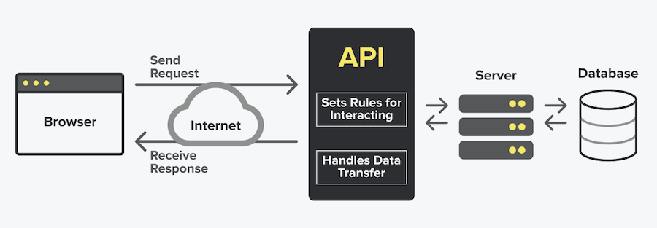

Figure 1: Web communication System

Source: Snipcart

**3.2 Overall System Design**

The design of an online mental health therapy website is a complex process that involves several components, including the user interface, database, and security measures.

* **User Interface:** The visual element of a website that a user interacts with is called the user interface. The user interface is simple to use, intuitive, and open to users with various levels of technical proficiency. The branding and mission of the website is also be reflected in the design, giving users a seamless and interesting experience. A homepage, login page, sign up page, profile page, chat-bot session, chat-bot session history page, appointment scheduling system, and forum should all be included in the user interface design of an online mental health therapy website. Users are given a summary of the website's goals on the homepage. Users are able to register for an account or sign in to an existing account via the login page and sign up page respectively. Users should be able to update their personal information on their profile page. The appointment scheduling system should allow users to schedule therapy appointments. The chat-bot session allows users have an interactive text based session with the therapy chat-bot. The chat-bot session history allows user view their previous sessions with the therapy chat-bot. The forum allows user interact with other users by creating forum posts and commenting on the posts.
* **Database:** The database is an essential component for the proposed online mental health therapy website. The database contains data on users, therapists, therapy histories, and appointment scheduling. User information should be safeguarded from unauthorized access and cyber-attacks by a scalable and secure database design. The database includes several tables such as the user table which is used to store each user details, the forum table which is used to forum posts, the chatbot session table which is used to store previous chatbot sessions. The database schema is created using the entity-relationship (ER) model, which is a graphical depiction of the database structure. The user account entity, the chatbot dialogue entity, and the user preferences entity are just a few of the important entities included in the ER model. Fields like the user ID, name, password, email address, and other user data are included in the user account entity. This entity is in charge of handling user authentication and authorization, making sure that only people who have been given permission can use the system. Fields like the discussion ID, user ID, chatbot answer, and conversation timestamp are all included in the chatbot conversation entity. This organization is in charge of keeping the chatbot's conversation history, allowing users to examine earlier exchanges, and providing useful information for enhancing the chatbot's performance. There are several connections between the entities in the database design as well. For example, the user account entity and the chatbot conversation entity have a one-to-many relationship since each user can have several chats with the chatbot. Since each user can only have a single set of preferences, there is also a one-to-one relationship between the user account entity and the user preferences entity.
* **Security Measures:** The security measures includes user session/access management, secure server communication system and password encryption using secure hashing algorithms.

Below is the use case diagram, block diagram

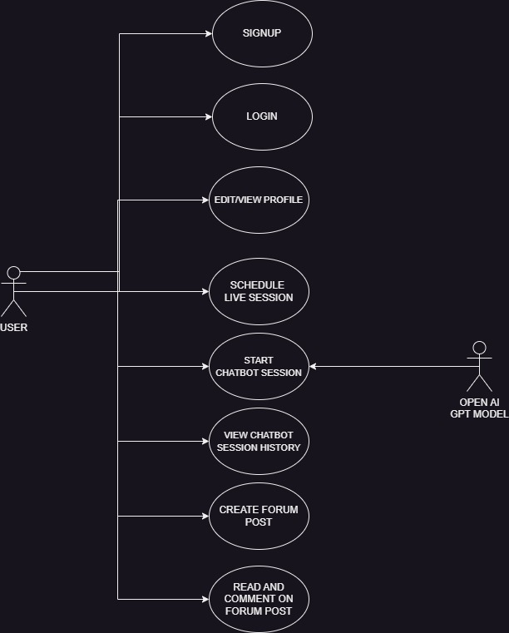

Figure 2: Use case Diagram For The Proposed System.

SIGNUP

LOGIN

SCHEDULE LIVE SESSION

START CHATBOT SESSION

EDIT PROFILE DETAILS

FORUM

VIEW CHATBOT SESSION HISTORY

CREATE FORUM POST

VIEW FORUM POST

LOGIN

Figure 3: Block Diagram Of The System

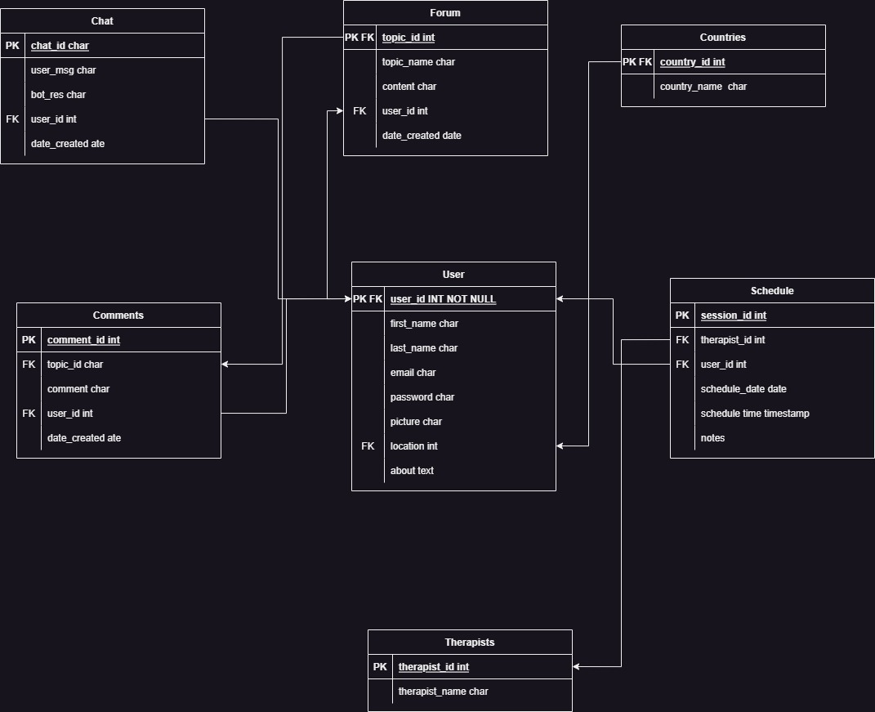

Figure 4: Database Entity Relationship Diagram of the Proposed System

**CHAPTER FOUR**

**IMPLEMENTATION**

This chapter presents the various strategy used and the various web technology used to develop the proposed system. The following technologies and languages were used to build the system.

* **HTML:** The structure and content of a website are created using HyperText Markup Language (HTML). HTML is a markup language that establishes the website's structure and gives its content semantic meaning.
* **CSS:** The visual structure of the website is defined using Cascading Style Sheets (CSS). The presentation of the website is determined by CSS, which is used to style the HTML elements.
* **Javascript:** The website is made interactive using JavaScript. A programming language called JavaScript is used to build dynamic, interactive websites. Animations, validation, and other interactive features are added to the website using JavaScript.
* **Jquery:** Jquery is a lightweight JavaScript library that can be found in a single.js file. It has a lot of built-in features. They can be used to quickly and easily finish a variety of tasks.  Jquery was created using JavaScript functions. As a result, you can use every function as well as any other functions that JavaScript offers. Jquery makes it easier to navigate the HTML DOM tree, develop Ajax-based applications, create simple, concise, and reusable code, handle events, add animation, and support Ajax in web applications.
* **Bootstrap:** Bootstrap makes responsive site design a possibility. It enables a website or app to recognize the size and orientation of the visitor's screen and automatically adjust the display. The mobile-first strategy presupposes that employees' main tools for accomplishing their work are smartphones, tablets, and task-specific mobile apps. Bootstrap offers UI components, layouts, and other elements to address the design requirements of such technologies.
* **PHP:** PHP is a server-side scripting language that is embedded in HTML in its most basic form. It can be utilized to create interactive and dynamic web pages, programs, and eCommerce platforms. Creating dynamic web pages, sending emails, collecting web forms, and even sending and receiving cookies are all web tasks that PHP is well suited for.
* **MYSQL:** MySQL is the most popular free and open-source database management system in the world. Data is stored, accessed, and processed using databases, which are structured collections of data. Structured Query Language, the most popular, standardized language used to access databases, is what the SQL component of MySQL stands for. It is a multi-platform, open-source relational database management system.
* **IDE:** IDEs are integrated development environments that provide a variety of web development tools. Version control, code profiling, and code debugging are functions offered by IDEs. Tools like Visual Studio Code, Eclipse, and NetBeans are examples of IDEs. The IDE used for this project is the Visual Studio Code IDE from Microsoft.
* **Apache Server:** The free and open-source web server software Apache Server, sometimes referred to as Apache HTTP Server, is frequently used to host websites and web applications. The Apache Software Foundation created and maintains Apache Server, which can run on a variety of hardware platforms and is compatible with all popular operating systems.

**4.2 Website Development Procedure**

1. **Planning:** Website planning is the first stage of website creation. Identifying the website's objectives, target market, and features is part of the planning process. Making a website wireframe, which is a graphic depiction of the website's layout, is another aspect of website planning.
2. **Design:** Website design is the second stage of website development. Designing the website's aesthetic aspects, such as its colors, fonts, and graphics, is known as website design. The layout of the website should be flexible, which implies that it should work well on desktop, tablet, and mobile devices. The website wireframe was built using the Adobe Figma tool an example of the wireframe is shown below.

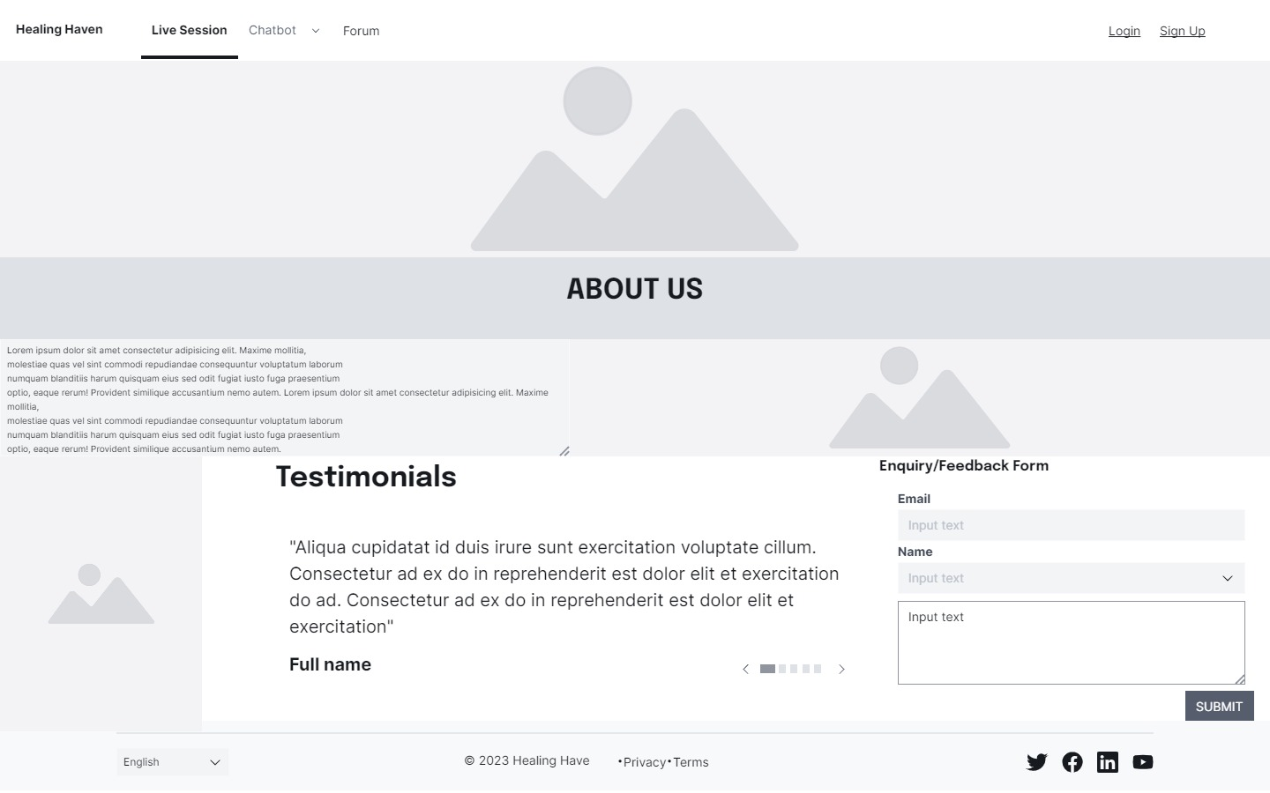

Figure 5: Wireframe for the website.

1. **Development:** The third step in website development is website development. Website development involves coding the website using the programming languages and web development tools listed above.

**4.2.1 Authentication System**

The user signup process involves gathering simple data like name, email, and password. The PHP password_hash() function is used to encrypt the user’s password. The password_hash() function uses the bcrypt encryption to implement a one way password hashing, which ensures the security of users' passwords. The user’s details including the hashed password is then stored in the database

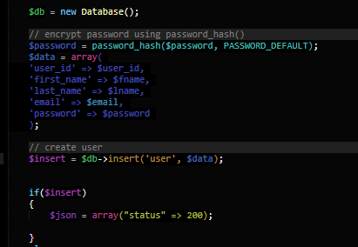

Figure 6: Code snippet showing the user signup algorithm

To authenticate users, a session variable is created for each user on the server. A conditional statement is then written on each webpage to allow or reject access to a user based on the given condition.

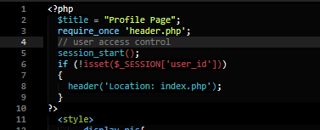

Figure 7: Code snippet showing user access control using session variable.

**4.2.2 Profile Management**

The profile section allow the users to edit their profile details such as name, e-mail address, pictures and location. To implement this a post request is sent to the back end after the user clicks submit form in the profile page the data sent alongside the post request is the form object created in the profile page. In the back end the form object is accepted and processed and all necessary details are extracted from the form object . The details are then sent to the database using the UPDATE query. After the details are saved successfully in the database the response is sent back to the front end which then displays a message to the user that’s the profile has been updated successfully. In order to save users picture on the server, the picture is processed and then saved in a designated folder on the server while the name of the picture he sends to the database for reference purposes.

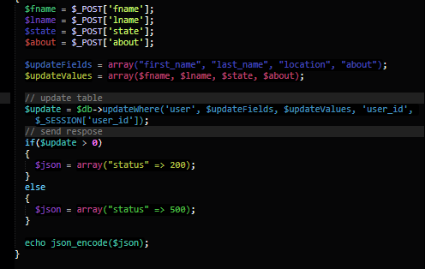

Figure 8: Code Snippet for profile management

**4.2.3 Therapy Session Scheduling**In this section, a form is created containing a dropdown list of all therapists, a date input, a time input and a text input for notes. After user clicks on the submit form, the form object is sent as a post request to the backend. In the backend, the form details are extracted and sent to the database alongside the user ID.

**4.2.4 Conversational Chatbot Development**

The chatbot was developed using the openai gpt-3.5 turbo model. When the page for the chat interface loads, a chat_id is generated this chat_id would be used to recognize the particular session and the chat_id is stored in the database. Using and already generated chatbot key the website is connected to the openai API server and the particular model is selected for this project the GPT 3.5 turbo model is used. After you model has been connected the chat bots is giving a rule to play this rule determines what kind of response it would give and what kind of questions it’s good accept from the user. In this case the chatbot is said to respond as a professional mental health therapist and the chatbot is said to respond as professional as possible and as human as possible, the chat bots is also set to ask questions in order to perform a diagnosis and reach a conclusion about the mental state of the user this means the chat bots would act or mimic professional mental health therapistt. The chatbot would not answer questions that are not related to mental health and the I would try to direct the part of the conversation towards mental health therapy this is to avoid unnecessary conversation with the chatbot which results in waste of time and resources. The communication between the user and the AI is is made possible through the interaction of the front end API request functions using Jquery Ajax and the back end openai PHP API functions which communicates with the open chatbot this communication is made possible through HTTP requests. Each time a message is either sent or received between the user and the chat bot the particular message is saved into the database which the chat ID which was initially generated at the beginning of the session alongside the user ID and the timestamp which indicates the time which the message was sent this made it possible to retrieve the session details when the user wants to view the session history.

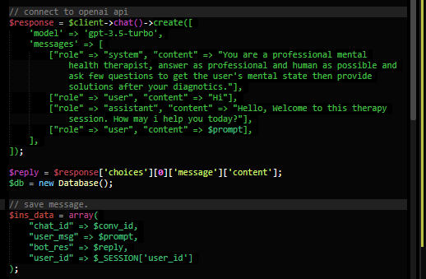

Figure 9: Code snippet for the chatbot session

This process was particularly quite challenging as I needed to review and understand the open AI API system, retrieving the chat bots response demands filtering each response gotten from the server.

In order to view the session history for a particular session , an API request is meat to the PHP server using live chat_id for that session as a condition . The server then queries the database using the chat_id as a condition to get all chats relating to that particular chat_id. The query response is then processed and sent back to the front end for presentation.

**4.2.5 Forum System**

The forum room section of the website involves the creation of forum posts view and comments on each post. To create a forum post in the front end a What You See Is What You Get (WYSIWYG) editor is used to write the post content. This editor allows the user to perform busy text formatting such as bold italics underline and also to add color to text . The content of the editor is then converted to HTML elements in order to keep the various formats applied to the content.The is then sent to the back end to process. In the back end an ID is created to represent the posts then The ID, post contents, user ID and the dates is then stored in the database.

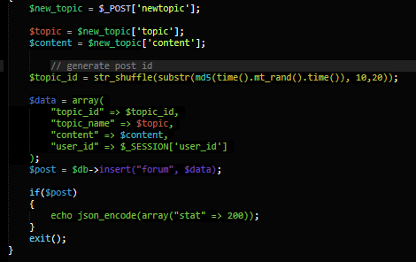

Figure 10: Code snippet for forum post creation

In order to comment on the post an API request is made to the server using the posts ID as a data alongside with the particular comments. In the back end the post ID and the comment is collected and saved to the database alongside the user ID and the time which the comment was made this will help with presentation in the front end.

**CHAPTER FIVE**

**TESTING AND DISCUSSION**

**5.2 Testing**

Testing is an important part of the software development process that ensures the quality and reliability of the code. In this section, I will discuss the testing methodology used in the development of the proposed system and the results obtained from the testing process.

Combining manual and automated testing methods, the conversational chatbot system was put to the test. By modeling user interactions with the chatbot, numerous test scenarios were carried out manually. I were able to swiftly discover problems and errors thanks to automated testing, which involves the use of testing tools to automate the testing process. I carried out unit testing on the PHP code using the PHPUnit testing framework. A collection of assertion functions are offered by the PHPUnit framework to aid in confirming the validity of the code's behavior. To make sure that each function and method in the system behaved as anticipated, I built test cases to check their behavior.

I tested the API endpoints for integration using Postman. An effective tool for automating REST API testing is Postman. In order to cover all potential user interactions with the chatbot, I developed a set of API queries, including those for scheduling therapy sessions, messaging the chatbot, and looking up the user's session history.

**Discussion**

During the development process, I addressed a number of issues that were discovered during testing. The following are a few of the problems found during testing:

1. Response times were slower than anticipated when I tested the chatbot, as I discovered. I discovered that the reason for the delay was the lengthier processing time for the request during the OpenAI API call. I introduced caching of the OpenAI API response to remedy this issue and speed up response times.
2. Errors in session management: I found problems with how user sessions are managed. When a user attempted to view their session history, the chatbot in certain situations failed to keep track of their session history, leading to problems. By enhancing the session management code, I made sure that the system accurately monitored the user's session history and resolved these problems.
3. I discovered that the system did not gracefully handle errors. For instance, the chatbot provided an unhelpful error message when the OpenAI API did not respond. To give users more enlightening error messages, I modified the error handling code.
4. Chatbot Accuracy: I discovered the chatbot was not accurate in it’s response. To solve this I checked the API documentation and discovered that the accuracy can be improved using an option in the API request.

**CHAPTER SIX**

**CONCLUSION**

The web-based online therapy system, which uses artificial intelligence to facilitate online mental health therapy, is a useful resource for people looking to receive therapeutic services from the convenience of their homes. With the current COVID-19 pandemic, the system offers people a practical and affordable means to get mental health care and support. The testing procedure was essential to the system's development since it allowed for the early detection and correction of problems that would have hampered the system's functionality and dependability. The system's intended functionality was verified through the use of manual and automated testing methods, resulting in a seamless user experience. I discovered a number of problems with the system's response speeds, session management, and error handling during the testing process. By integrating caching of the OpenAI API answer, enhancing the session management code, and giving users more detailed error messages, I was able to resolve these problems. Despite the difficulties encountered during the testing and development phases, users can gain a lot from the conversational chatbot system developed in this project. It offers a platform for people to get mental health services and assistance without having to meet with therapists in person, which can be especially useful for those who want to maintain their anonymity.

**REFERENCES**

Backhaus, A., Agha, Z., Maglione, M. L., Repp, A., Ross, B., Zuest, D., Thorp, S. R. (2012). Videoconferencing psychotherapy: a systematic review. Psychological Services, 9(2), 111.

Bharti, U., Bajaj, D., Batra, H., Lalit, S., Lalit, S., & Gangwani, A. (2020). Medbot: Conversational Artificial Intelligence Powered Chatbot for Delivering Tele-Health after COVID-19. In 2020 5th International Conference on Communication and Electronics Systems (ICCES) (pp. 870-875). Coimbatore, India: IEEE. doi: 10.1109/ICCES48766.2020.9137944.

Békés, V., Aafjes-van Doorn, K., Luo, X., Prout, T. A., and Hoffman, L. (2021). Psychotherapists' Challenges With Online Therapy During COVID-19: Concerns About Connectedness Predict Therapists' Negative View of Online Therapy and Its Perceived Efficacy Over Time. Frontiers in psychology, 12, 705699. https://doi.org/10.3389/fpsyg.2021.705699

Bzdok, D., Krzywinski, M., & Altman, N. (2018). Machine learning: supervised methods. Nature Methods, 15(1), 5-6. https://doi.org/10.1038/nmeth.4551

Fabris, F., Magalhães, J. P. d., & Freitas, A. A. (2017). A review of supervised...

Fishkin, R., Fishkin, L., Leli, U., Katz, B., and Snyder, E. (2011). Psychodynamic treatment, training, and supervision using internet-based technologies. Journal of the American Academy of Psychoanalysis and Dynamic Psychiatry, 39(1), 155–168.

Gao, S., Calhoun, V. D., & Sui, J. (2018). Machine learning in major depression: From classification to treatment outcome prediction. CNS Neuroscience & Therapeutics, 24(11), 1037-1052.

Gieruszyńskaa, K. F. (2022) ‘The use of artificial intelligence in psychiatric treatment and the protection of patients’ privacy’, Procedia Computer Science, 207, pp. 3691–3702. doi: 10.1016/j.procs.2022.09.429.

Hasim P., Irshadahmad P., Khalil P. (2021) ‘AI Meets Mental Health’, International Research Journal of Engineering and Technology, 08(5), 3715-3717

Kapoor, P., Agrawal, P., and Ahmad, Z. (2021). Therapy Chatbot: A Relief From Mental Stress And Problems. International Journal of Scientific & Engineering Research, 12(5), 279–282. https://doi.org/10.14299/ijser.2021.05.08

Nirala, K., Singh, N. and Purani, V. (2022) ‘A survey on providing customer and public administration based services using AI: Chatbot’, Multimedia Tools and Applications, 81(1), pp. 22215-22246.

Omarov, B., Narynov, S., and Zhumanov, Z. (2023). Artificial Intelligence-Enabled Chatbots in Mental Health: A Systematic Review. Computers, Materials & Continua, 74, 5105–5122. <https://doi.org/10.32604/cmc.2023.034655>

Raij, A.B., Johnsen, K., Dickerson, R.F., Lok, B.C., Cohen, M.S., Duerson, M., Pauly, R.R., Stevens, A.O., Wagner, P. and Lind, D.S. (2007). Comparing interpersonal interactions with a virtual human to those with a real human. IEEE transactions on visualization and computer graphics, 13(3), 443-457.

Rochlen, A., Zack, J., and Speyer, C. (2004). Online Therapy: Review of Relevant Definitions, Debates, and Current Empirical Support. Journal of Clinical Psychology, 60(3), 269–283. https://doi.org/10.1002/jclp.10263

Saloni Dattani, Hannah Ritchie, & Max Roser. (2021). Mental Health. OurWorldInData.org. Retrieved May 1, 2023, from https://ourworldindata.org/mental-health

Sharma, A. (2021). ARTIFICIAL INTELLIGENCE IN HEALTH CARE. International Journal of Humanities, Arts, Medicine and Science, 5(2), 106–109.

Simpson, S. (2009). Psychotherapy via videoconferencing: a review. British Journal of Guidance & Counselling, 37(3), 271–286. <https://doi.org/10.1080/03069880902957007>

Yan, W. J., Ruan, Q. N., and Jiang, K. (2022). Challenges for Artificial Intelligence in Recognizing Mental Disorders. Diagnostics (Basel, Switzerland), 13(1), 2. <https://doi.org/10.3390/diagnostics13010002>