Eat-Out Restaurant Site Plan

Purpose

this website will serve as an upgraded version of Eat-Out Restaurant Meal Menu Platform. The upgraded design aims to provide a more visually appealing interface. By improving the menu's aesthetically and usability, the website will create a better customer experience, potentially increasing food sales.

Goals

**Enhance User Experience:** Create a visually appealing and user-friendly website that is easy to navigate and provides a seamless online dining experience.

**Boost Online Visibility:** Improve the website's search engine ranking to attract more potential customers through organic search.

**Increase Online Orders:** Implement a robust online ordering system that is easy to use and integrates with the restaurant's point-of-sale system.

**Build Brand Loyalty:** Develop a loyalty program and engage with customers through social media and email marketing to foster brand loyalty.

**Generate Increased Revenue:** Ultimately, the goal is to increase revenue by attracting new customers, encouraging repeat business, and maximizing average order value.

Target Audience

• Demographics: Adventure-seekers, outdoor enthusiasts, and nature lovers

• Psychographics: Individuals seeking excitement, challenge, and connection with nature

• User personas: First-time rafters, experienced rafters, families, and corporate groups.

Scenarios

The website should answer the following scenario questions:

• Information on trip levels and difficulty

• Detailed descriptions of what to expect during the trip

• Testimonials and reviews from previous customers

• Information on family-friendly trips and age restrictions

• Details on safety measures and equipment provided

• Options for booking a private guide or group trip

• Recommendations for nearby activities and attractions for non-rafters

• High-quality photos and videos showcasing the trip

• Options for customizing the trip (e.g., private guides, camping)

Sitemap

Branding

Logo

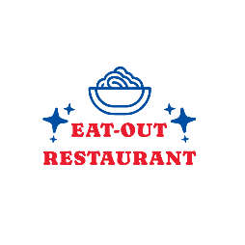

Style Guide

Color Schema

Color Palatte: https://coolors.co/5b5941-050505-024ea4-eb3644-ffffff

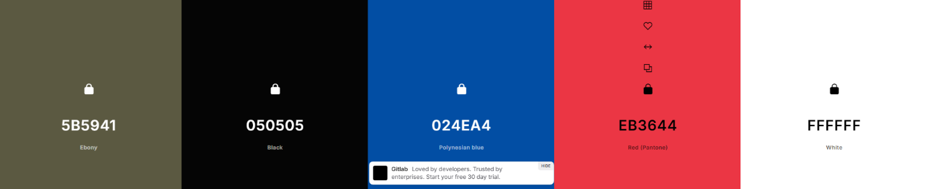

Typograohy

Headings

Body:

Wireframes

Homepage

Dishes and Drinks