CSE361 (UG2023) – Computer Networking

Mini-RFC
7/11/2025


Submitted by:
Ahmed Wail 23P0335
Omar Shaker 23P0188
Youssef George 23P0227
Youssef Ahmed 23P0054
Zeyad Ahmed 23P0082

Multiplayer Game State Synchronization
Phase 1

Section 1:

Introduction
The Violet Ascending Protocol (VAP-1) is a small and efficient network protocol built on UDP. It is designed to keep multiple players synchronized with a game server in real time. The main goal is to share player positions and short game events quickly, even if some packets are lost on the way.
VAP-1 focuses on speed and low latency, which are more important for real-time games than perfect reliability. It lets players see updates almost instantly instead of waiting for packet retransmissions like in TCP.

Use Case
This protocol is used for a simple multiplayer environment called Grid Clash. In this setup, several players connect to one central server and play on a shared 2D grid. The server keeps track of the full game state (like which cells are claimed and each player’s score) and sends frequent updates to all clients so that everyone sees the same grid.

Why a New Protocol Is Needed
Existing protocols don’t fit well for this kind of real-time communication.
- TCP is reliable but too slow for live updates because it waits for lost packets to be resent.
- UDP is faster but doesn’t define how to structure or manage messages for games.
VAP-1 uses UDP for speed but adds its own structure to make communication organized and consistent. It defines message types like JOIN, READY, and SNAPSHOT, includes small headers for each message, and adds simple reliability features such as sending the latest and previous snapshots together so the client can recover if one is lost.

Assumptions and Constraints
- All messages use UDP sockets.
- One server handles all connected clients.
- The maximum packet size is about 1200 bytes to avoid fragmentation.
- The server sends snapshots around every 50 milliseconds.
- The system can handle 5–10% packet loss without major issues.
- The game state is small enough to fit into a single packet.
- Clients assume the server is disconnected if no update is received for 2 seconds.

Section 2:

Protocol Architecture

Entities:
Server: authoritative game process that accepts joins, tracks players, and broadcasts snapshots. Implemented as the GameServer class with states WAITING_FOR_JOIN, WAITING_FOR_INIT, GAME_LOOP, GAME_OVER.
Client: a player instance that sends JOIN and READY messages and applies SNAPSHOT updates. A client runs a UDP socket and follows the handshake then listens for snapshots.
Sequence Flow:
Message Type Name | Direction
MSG_JOIN_REQ | Client → Server
MSG_JOIN_ACK | Server → Client
MSG_READY_REQ | Client → Server
MSG_READY_ACK | Server → Client
MSG_START_GAME | Server → Client
MSG_SNAPSHOT_FULL | Server → Client
MSG_SNAPSHOT_DELTA | Server → Client
MSG_SNAPSHOT_ACK | Client → Server
MSG_ACQUIRE_EVENT | Client → Server
MSG_END_GAME | Server → Client
MSG_TERMINATE | Server → Client
MSG_LEADERBOARD | Server → Client

Finite State Machine For Server:
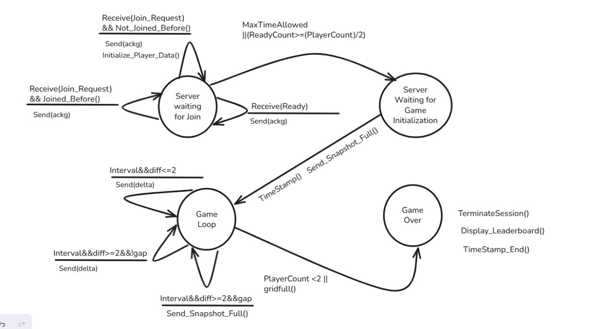

Finite State Machine For Client:
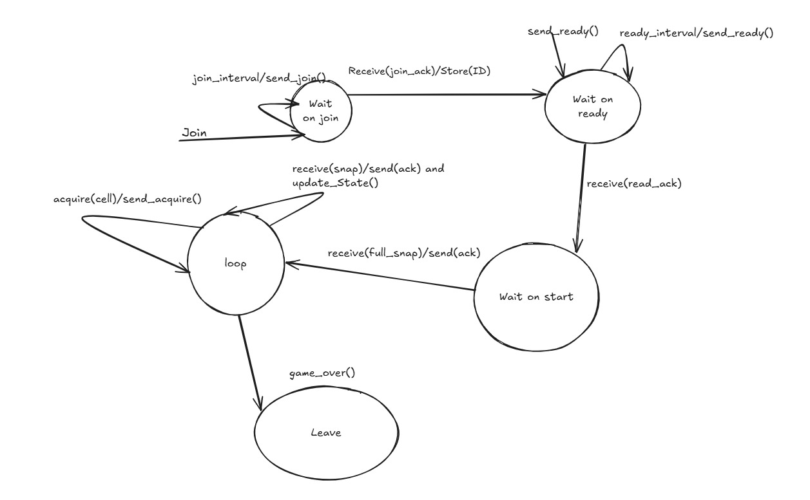

Section 3:

Message Formats:
Field | Size(Bits) | Description
protocol_id | 32 | 4-byte ASCII identifier unique to your protocol(VAP)
version | 8 | Protocol version
msg_type | 8 | Message type (JOIN, READY, SNAPSHOT
snapshot_id | 32
  Snapshot identifier used for ordering and redundancy
seq_num | 32
  Sequence number for tracking message order
timestamp | 64 | Server-side timestamp (seconds since start using monotonic clock)
payload_len | 16 | Length of the variable-size payload (in bytes)

Total Header Size: 24 Bytes or 192 Bits
The Header Format is: !4s B B I I d H
!: big-endian format
4s: array of char(String)
B: unsigned char
I: unsigned int
d: double
H: unsigned short

Message Type Name | Value | Description
MSG_JOIN_REQ | 1 | Client asks to join the game
MSG_JOIN_ACK | 2 | Server accepts the join and assigns player ID
MSG_READY_REQ | 3 | Client signals readiness
MSG_READY_ACK | 4 | Server confirms client is ready
MSG_START_GAME | 5 | Server announces game start
MSG_SNAPSHOT_FULL | 6 | Server sends full snapshot
MSG_SNAPSHOT_DELTA | 7 | Server sends delta snapshot
MSG_SNAPSHOT_ACK | 8 | Client returns the snapshot acknowledgement
MSG_ACQUIRE_EVENT | 9 | Client sends a game action (e.g., claiming a grid cell)
MSG_END_GAME | 10 | Server signals the end of the match
MSG_TERMINATE | 11 | Server closes the session
MSG_LEADERBOARD | 12 | Final scores and results broadcast

