Kavak Cinema: Performance Analysis
& Recovery Plan
A data-driven strategy to achieve +20% profit growth and operational excellence.

Prepared By: Adel Al-Khaldi
Tools: Excel & Python (Streamlit)

SECTION 01
Executive Summary
This report presents a comprehensive recovery plan for the Kavak cinema, addressing the mall management's requirement for a 20% increase in profitability. The analysis is structured across four phases: baseline business review, root cause diagnosis, strategic prescription, and a negotiation case for retaining the last cinema session.
Baseline Annual Profit | Target Profit (+20%) | Average CSAT Score | Hot Food Attach Rate
$ 501,887 | $ 602,264 | 4.3 / 10 | 15.5%
Full-Year Baseline | +$100,377 Gap | 7 months below 5.0 | vs. 55.5% Popcorn Rate

Summary: The cinema generates $501,887 annually but is operating well below its potential. The ~$100K gap to the 20% target is achievable with approaches discussed in section 4. Our modelled initiatives project $638,618 exceeding the target by $36,354.

SECTION 02
Business Review: Data Analysis & Trends
2.1 Profitability Analysis
Despite having three F&B revenue streams, ticket sales still account for 51.2% of total profit. The imbalance reveals a untapped revenue opportunity in food and beverage, particularly “Hot Food” which represents 9.5% of total profit despite the highest unit margin.
Item | Annual Profit | % of Total | Unit Profit Margin
Tickets | $256,890 | 51.2% | $5.00 / ticket
Popcorn | $121,238 | 24.2% | $4.25 / unit
Soda | $75,944 | 15.1% | $2.50 / unit
Hot Food | $47,815 | 9.5% | $6.00 / dish ← HIGHEST MARGIN
TOTAL | $501,887 | 100%

2.2 Correlation Analysis (Kendall's Tau)
A Kendall's Tau correlation matrix was computed across the seven primary variables as it’s the best method of identifying correlation among small datasets. Figure below showcases correlation figure:
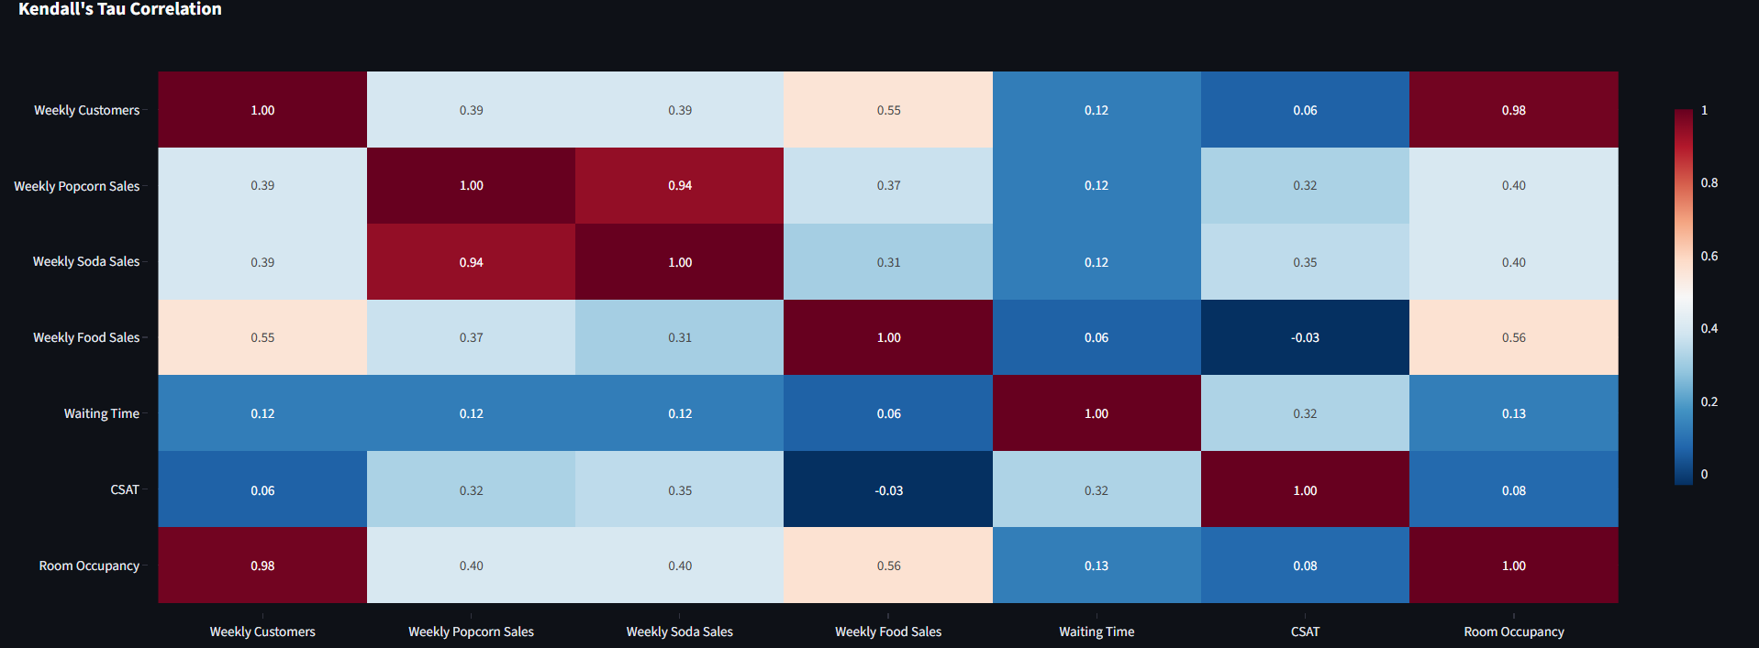

Key findings:
- Waiting Time has a positive correlation with CSAT (counterintuitively), suggesting that wait time is NOT the primary CSAT driver despite common assumption.
- Popcorn and Soda Sales are highly positively correlated.

SECTION 03
Discovery: Diagnosing Underperformance
3.1 Issue: Low F&B Attach Rates
The root cause of F&B underperformance is not a lack of product selection, but a failure to convert foot traffic into additional purchases. The table below shows the stark gap between popcorn/soda rates and hot food. Hot Food has lowest attach rate, which is explored in the next section with CSAT breakdown.
F&B Item | Annual Units Sold | Purchase Rate / Customer | Profit Margin
Popcorn | 28,526 | 55.5% | $4.25 / unit
Soda | 30,378 | 59.1% | $2.50 / unit
Hot Food | 7,969 | 15.5% | $6.00 / unit

3.2 Issue: CSAT Breakdown & Detractor Analysis
CSAT averaged 4.3/10 across the year, with 7 of 12 months scoring below 5.0. Decomposing by primary detractor category reveals a clear hierarchy of customer complaints:
Detractor Category | # Months as Primary Detractor | Avg CSAT When Primary | Impact Assessment
Food Quality | 4 months | 2.25 / 10 | CRITICAL direct link to low food revenue
Cinema Hygiene (incl. smell & ) | 5 months | 4.2 / 10 | Moderate affects repeat visits
Waiting Time | 3 months | 7.3 / 10 | LOW customers are forgiving of queues

Findings: Food Quality registers an average CSAT of 2.25 when it is the primary detractor.
3.3 Issue: Static Staffing vs. Variable Demand
The FTE count is fixed at 15 year-round, creating two distinct failure modes:
A. Understaffing during peaks leading to long waits.
B. Overstaffing during troughs generating unnecessary payroll cost.
The data below isolates the most striking examples:

Month | Monthly Customers | FTEs (Fixed) | Wait Time (Mins) | Diagnosis
May | 4,167 | 15 | 25 mins | Peak inefficiency, 4K customers yet 25-min wait
Jun | 6,209 | 15 | 10 mins | High demand, acceptable wait well managed
Sep | 1,338 | 15 | 6 mins | Low demand but full staff pure redundancy
Dec | 6,987 | 15 | 7 mins | Highest demand yet lowest wait best performance
Avg | 4,282 | 15 | 13 mins | Target benchmark for scheduling optimisation

SECTION 04
Recovery Plan: Achieving the +20% Target
Four targeted initiatives have been designed to address each identified issue. All projections assume a static customer base (no growth assumption) to remain conservative. The combined impact exceeds the $602,264 target.

Initiative | Assumption | Additional Profit | Cumulative Total
1. F&B Combo Promotions | 75% combo adoption, 12% discount | +$398,437 (promo) + $64,223 (tkt) | $462,660
2. Delivery App (Talabat/Noon/ etc.) Integration | +25% F&B delivery sales uplift | +$61,249 | $523,909
3. Food Quality Control | Purchase rate rises to 25% | +$77,067 | $600,976
4. Operational Efficiency Savings | 7.5% efficiency gain on profit base | +$37,642 | $638,618
TOTAL PROJECTED PROFIT |  | TARGET: $602,264 | $638,618 (+27.2%)

Initiative 1: F&B Combo Promotions

Concept: Bundle the three most-purchased items (Ticket + Popcorn + Soda) into a discounted combo, replacing individual purchases for most customers.
Parameters: 12% discount on the combined price ($11.75 to $10.34 combo price) with assumed 75% adoption rate.
Financial Logic: Even at a 12% discount, the guaranteed attachment of popcorn and soda for 75% of customers generates more total profit than the current fragmented purchase pattern customers buy tickets only or single items only.
- 75% of 51,378 annual customers → 38,534 combo customers × $10.34 = $398,437
- Remaining 25% ticket-only: 12,844 × $5.00 = $64,223
- Total Initiative 1 Contribution: $462,660

Of course, the rates and packages can be changed at will (higher discount, at wider adoption rate or to include Hot Foods with the combo but assuming lower adoption rate is another feasible option)
Initiative 2: Delivery App Integration (Talabat/Noon/etc.)
Concept: List cinema F&B items on delivery app for standalone purchases both for in-cinema delivery and external orders from cinema-adjacent customers.
Parameters: Assumed 25% incremental volume uplift applied to existing annual F&B sales quantities.
- Additional popcorn volume: 7,132 units × $4.25 = $30,309
- Additional soda volume: 7,594 units × $2.50 = $18,986
- Additional food volume: 1,992 units × $6.00 = $11,954
- Total Initiative 2 Contribution: $61,249

Case Study Reference: VOX Cinema (UAE) launched on Talabat and reported a measurable increase in F&B revenue within months, validating this as a proven revenue channel in the GCC market context.

Initiative 3: Food Quality Control
Concept: Implement strict quality control protocols on hot food preparation temperature standards, freshness windows, and presentation requirements to resolve the single biggest CSAT driver.
Parameters: Conservative assumption: resolving food quality increases the attach rate from 15.5% to 25% (still well below popcorn/soda rates).
- New food volume: 51,378 customers × 25% = 12,845 units annually
- Profit at $6.00/unit: $77,067
- This compares to current food profit of $47,815.
CSAT Impact: Resolving Food Quality (Avg CSAT 2.25) to acceptable levels should lift overall CSAT toward the 6.0+ target range, improving retention and repeat visit frequency beyond what the financial model captures.

Initiative 4: Operational Efficiency Savings
Concept: Train all 15 FTEs in demand-responsive service protocols and implement flexible scheduling (reduced hours in low-demand months like September, extended coverage in December) to eliminate the wait-time/staffing mismatch.
Parameters: 7.5% operational efficiency gain applied to total annual profit base.
- $501,887 × 7.5% = $37,642 in efficiency savings
- Additional KPI target: Average wait time reduced from 13 minutes to ≤10 minutes
- Employee/customer ratio normalised to ≥11.0 across all months (current average: 9.5)
Implementation Note: This initiative does can use headcount reduction, working hours reduction or part-time workers with proper training given to reduce costs during off-peak periods.

SECTION 05
Negotiation: Retaining The Cinema Session
Few operational & logistical changes can be more than enough to bring achieve profits 20% minimum assuming no additional customers to the cinema & conservative profit margins/estimates.
5.1 The Business Case for the Last Session
- Evening sessions (post-mall close) typically attract after-work adult demographics with higher disposable income and F&B spend per head.
- Retaining mall customers, as they are more likely to dine, shop and spend time in the mall prior to the late evening screening.
- Provided profit margins from reforms proposed are conservative estimation and already surpassed expected 20%

Solution: Proposing a 6-month trial period with bi-weekly reporting to mall management showing total profit and F&B spend.
SECTION 06
KPI Framework & Monitoring Plan
The following KPIs are recommended for ongoing performance management. Each maps directly to one of the identified issues or recovery initiatives and has a defined monitoring cadence.

KPI | Baseline | Target | Monitoring Cadence & Method
Monthly Total Profit | $41,824 | $50,189 | Monthly P&L review Excel dashboard
CSAT Score | 4.3 / 10 | ≥ 7.0 | Weekly survey aggregate, flag if below 6.0
Hot Food Attach Rate | 15.5% | ≥ 25% | Weekly POS report, split by session time
Combo Adoption Rate | 0% | ≥ 75% | Daily POS initiative launch week 1 KPI
Avg Wait Time | 13 mins | ≤ 10 mins | Daily manager log; escalate at >15 mins
Customers/FTE Daily Ratio | 9.51 | ≥ 11.0 | Weekly adjust flex scheduling if below
Food Quality Complaints | ~4 mo/yr | 0 | Real-time: manager review of every 1–2 star
Delivery App Profits | $0 | +25% Cinema F&B | Weekly app dashboard (Talabat partner portal)

SECTION 07
Analytical Methodology & Tools Used:
- Excel: Initial data discovery and exploration.
- Python (Streamlit + Plotly): Interactive web application built for the presentation layer, allows stakeholders to interact with the report and explore the data easily.

