1- Sequence Objective.

1.1 – What is diffusion?

Diffusion refers to the random, microscopic movement of water and other small molecules due to thermal collisions. Diffusion is also known as Brownian motion, named in honor of Scottish botanist Robert Brown who first observed spontaneous vibration of pollen particles under the microscope in 1827.

For reference, the diffusion coefficient of water molecules is 2.2 × 10−5 cm2/s at room temperature. That is, on average a water molecule moves and covers a patch of area 0.000022 cm2 every second (Fig. 1).

Water diffusion depends on the microscopic structural environment in the tissue, and measurement of it can provide valuable insights into the regional functional and structural changes occurring in disease states.

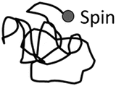  
Figure1

The greatest diffusion rate occurs in free water with no boundaries. In brain tissue, the boundaries of cell membranes restrict the motion of water to a degree which depends upon the mean free path of the water molecules. For example, in cerebral ventricles, water diffusion is relatively unimpeded and CSF has a high diffusion coefficient. Gray matter (GM) and white matter (WM) have lower diffusion coefficient than CSF because of their complex tissue structure.

1.2 – DWI objective

Water forms a large percentage of body weight composition as intra and extra cellular fluids in human body. In biological tissues, diffusion of water molecules follows a pattern according to tissue structure and properties. In some pathological conditions like acute stroke, this diffusion pattern is disturbed and the amount of diffusion changes in affected area. Through studying these changes in diffusion, the abnormalities can be detected.

This can be achieved using a specialized magnetic resonance imaging technique called Diffusion Weighted MRI (DW-MRI) or DWI, wherein the diffusion of the water molecules is exploited to visualize internal physiology. The image contrast in DWI reflects the difference in rate of diffusion between tissues.

The water diffusion can be detected or measured using the diffusion-weighted imaging (DWI) technology.

DWI is sensitized to the random molecular motion of water in tissue by applying magnetic field gradients (diffusion gradients) in the RF pulse sequence.

In a DWI sequence, the diffusion weighting is determined by a parameter called “b-value,” which is in the unit of second per square millimeter (s/mm2).

High “b-value” generates high diffusion weighting, and no diffusion weighting is generated when b = 0.

On a diffusion-weighted image, the tissue that contains high diffusing water generates hypointense signal. A map of apparent diffusion coefficient (ADC) of water molecules can be calculated from the diffusion-weighted image.

Diffusion-weighted imaging(DWI) has been continuously improved to probe ran-dom microscopic motion of water protons on a per pixelbasis.

Such DWI techniques haveadvanced far beyondthe experimental arena into routine clinical applicationsin ischemia and are also the subject of research in otherdiseases, such as multiple sclerosis, dyslexia, schizophre-nia, or trauma[1#/6].

Changes in proton self-diffusion are an early indicatorof alterations of cellular homeostasis in acute ischemicstroke[1].

An early detection of these alterations candramatically impact treatment decisions and the ther-apeutic outcome for strokevictims

2 – Basic pulse sequences for DWI

2.1 Spin echo- and stimulated echo-based

Merboldt et al. [10] placed one diffusion-encoding gradient between the first and the second 90° pulse and another one after the third 90° pulse of a stimulated echo sequence (Fig. 2) to generate diffusion-weighted images.

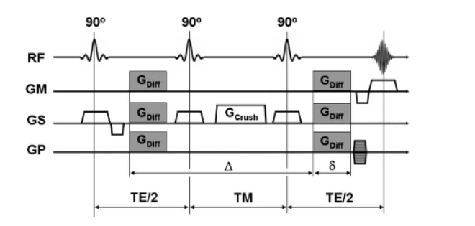  
Figure 2: Diffusion-weighted stimulated echo sequence

A stimulated echo can be formed by three RF-pulses (note that the RF-pulses must not necessarily be 90°-pulses to form a stimulated echo): Spins are tipped into the transverse plane by the first RF-pulse and lose their phase coherence.

The second RF- pulse brings half of the transverse magnetization (i.e. all vector components perpendicular to the phase of the second RF-pulse) from the transverse plane along the z-axis.

While the magnetization is ‘stored’ along the z-axis (TM), it is affected solely by the much slower T1-relaxation process. Ultimately, after the third RF-pulse, which tips spins back in to the transverse plane, and after the second precession interval (TE/2), a diffusion-weighted stimulated echo is formed at time TE+TM .

The diffusion-weighted stimulated echo sequence is of particular interest for tissues with short T2-relaxation times (e.g. liver) and can also be combined with different readout strategies, such as echo planar imaging (EPI) or spiral imaging.

The diffusion-weighting is mainly deter-mined by the T1-sensitive TM-interval and therefore allows one to choose short echo times with reasonable diffusion-weighting. However, it should be kept in mind that stimulated echoes theoretically provide only half the signal compared to spin echoes, whereby the corresponding signal equation is

$$M_{(TE)STE}=\frac{1}{2}M_{0}exp(\frac{-TE}{T_{1}})exp(\frac{-TM}{T_{1}})exp(-bD)$$

2.2 SSFP-diffusion-weighted imaging

If a train of equidistant RF pulses with flip anglea and TRB/T2is applied, a condition of steady-state free precession (SSFP) will develop; because of the very short TR SSFP imaging allows rapid image formation. SSFP imaging has long been known for its high sensitivity to flow and diffusion in the presence of magnetic field gradients (Fig. 3) and has therefore gotten some attention from several research groups.

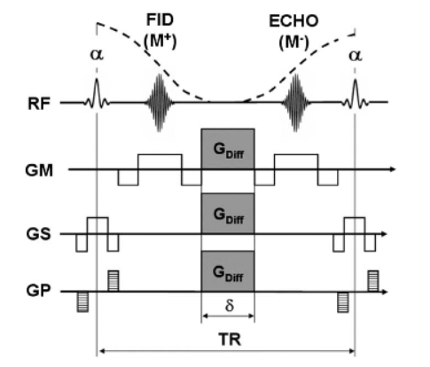  
Figure 3: One cycle of a diffusion-weighted SSFP sequence

In contrast to spin and stimulated echoes, the signal formation in SSFP is however a complex interplay between numerous spin and stimulated echoes which may be formed through a multitude of coherence path ways, limited only by the natural decaytimesT1andT2.

This complex signal formation renders the quantification of diffusion very difficult and the diffusion attenuation (b-factor) may vary from tissue to tissue since the b-factor for this sequence is also determined by parameters like relaxation times and B1-uniformity .

In contrast to spin echo and stimulated echo-based DWI one therefore has to deal not only with‘T2-shine-trough’ effects but also with the fact that b-values are weighted by the underlying relaxation times and other confounding factors.

2*-**DWI Pulse Sequence**

Modern diffusion-weighted (DW) sequences all trace their origin to the pulsed gradient spin echo (PGSE) technique developed by Edward Stejskal and John Tanner in the mid-1960's. As shown in the diagram right, symmetric, strong diffusion-sensitizing gradients (DG's) are applied on either side of the 180°-pulse. The phases of stationary spins are unaffected by the DG pair since any phase accumulation from the first gradient lobe is reversed by the second. Diffusing spins, however, move into different locations between the first and second lobes, falling out of phase and losing signal.

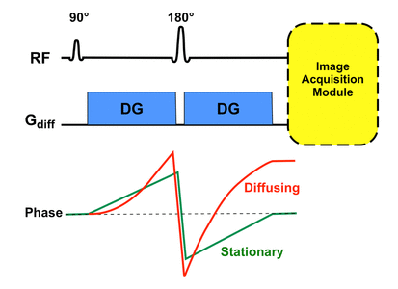

Immediately following the second DG, an image acquisition module is played out. This is typically an echo-planar sequence using rapidly oscillating phase and frequency gradients that generate multiple gradient echoes. Rapid image acquisition is generally required to minimize the effects of bulk motion (such as vascular pulsations) on the DW images. Other modules (such as fast spin echo) are possible, but are not as widely used at the present time.   
  
Modern implementations of DWI retain the basic features of Stejskal's and Tanner's original PGSE technique with certain modifications. To suppress chemical shift artifacts, all commercial DWI sequences utilize some sort of fat suppression method.

This may be a chemically-selective fat saturation pulse or a nonselective "STIR-like" inverting pulse applied immediately before the 90°-pulse.  Alternatively, the 90°-pulse itself may be selectively tuned to excite water protons only.

To suppress eddy currents and reduce spatial distortion artifacts a "twice-refocused" PGSE sequence may be used.

This technique employs a second 180°-refocusing pulse just before the image acquisition module begins.

A third common modification to reduce eddy current artifacts involves the use of bipolar (rather than unipolar) DG's.

With the core pulse sequence defined as above, the following steps are automatically performed to generate DW images and their associated maps:

1. The DW pulse sequence is first run with the DG's turned off or set to a very low value. This generates a set of b0 ("b-zero") images that are T2-weighted and will serve as a baseline for later calculated maps.  (For abdominal imaging b50 images are often obtained, the small but nonzero gradient amplitude helping to suppress signal in vessels).
2. The DW sequence is then run with the DG's turned on individually or in combination and at various strengths. This produces DW source images sensitized to diffusion in multiple different directions.
3. The DW source images are combined to produce a set of Trace DW images, the first-line images used for clinical diagnosis.
4. An Apparent Diffusion Coefficient (ADC) map is then calculated using the data from the the b0 and source images. The ADC map is used to clarify abnormalities seen on the trace images.
5. Further advanced processing can be optionally performed, creating additional calculated image sets for analysis. These may include exponential ADC maps, fractional anisotropy images, principal diffusion direction maps, and fiber tracking maps.