MR FORMATION

Modern diffusion-weighted (DW) sequences all trace their origin to the echo pulsed

gradient spin (PGSE) technique developed by Edward Stejskal and John Tanner [Stejskal EO, Tanner JE. [Spin diffusion measurements: spin echoes in the presence of time-dependent field gradient](http://mriquestions.com/uploads/3/4/5/7/34572113/stejskal_and_tanner1965.pdf). J Chem Phys 1965; 42:288-292. (This is the "classic").] in the mid-1960. As shown in the diagram right, symmetric, strong diffusion-sensitizing gradients **(DG's)** are applied on either side of the 180°-pulse. The stationary spin phases are uninfluenced by the DG pair as any phase accumulation from the first gradient lobe is reversed by the second. However, diffusing spins move around in different locations between the first and second lobes, falling out of phase and losing signal.

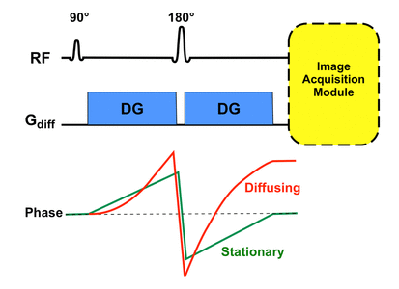

Immediately after the second DG a module for image acquisition is played out. This is typically an echo-planar sequence with rapidly oscillating phase and frequency gradients generating multiple echoes of gradients. Generally speedy image acquisition is needed to minimize the effects of bulk motion (such as vascular pulsations) on DW images. Other modules (such as the rapid spin echo) are possible, but are currently not as widely used.

Modern DWI implementations retain the basic features of the original PGSE technique used by Stejskal and Tanner [Stejskal EO, Tanner JE. [Spin diffusion measurements: spin echoes in the presence of time-dependent field gradient](http://mriquestions.com/uploads/3/4/5/7/34572113/stejskal_and_tanner1965.pdf). J Chem Phys 1965; 42:288-292. (This is the "classic").] with some modifications [ Sinnaeve D. [The Stejskal–Tanner equation generalized for any gradient shape—an overview of most pulse sequences measuring free diffusion](http://mriquestions.com/uploads/3/4/5/7/34572113/diffusion_shapes_sinnaeve-2012-concepts_in_magnetic_resonance_part_a.pdf). Concepts Magn Reson Part A 2012; 40A:39-65.].

All commercial DWI sequences use some form of fat suppression method to suppress artifacts from chemical shifts. This can be a chemical-selective fat saturation pulse or a non-selective inverting pulse "STIR-like" applied immediately before the 90 ° pulse. Alternatively, it is possible to selectively tune the 90 ° -pulse itself to only excites water protons. Suppress eddy currents and reduce artifacts of spatial distortion [Alexander AL, Tsuruda JS, Parker DL. [Elimination of eddy current artifacts in diffusion-weighted echo-planar images: the use of bipolar gradients](http://mriquestions.com/uploads/3/4/5/7/34572113/alexander_bipolar_diff_mrm_1997.pdf). Magn Reson Med 1997; 38:1016–21.] a "twice-refocused" PGSE sequence can be used. This technique uses a second 180 ° -refocusing pulse at [Reese TG, Heid O, Weisskoff RM, Wedeen VJ. [Reduction of eddy-current-induced distortion in diffusion MRI using a twice-refocused spin echo](http://mriquestions.com/uploads/3/4/5/7/34572113/reese.pdf). Magn Reson Med 2003; 49:177-182.] A third common modification to reduce eddy current artifacts is the use of bipolar (rather than unipolar) DG's.

With the core pulse sequence defined as above, DW images and their associated maps are automatically generated with the following steps:

**B0 image**

The DW pulse sequence is initially executed with the DG switched off or set to a very low value. This generates a set of T2-weighted **b0 ("b-zero") images** which will serve as a baseline for the later calculated maps. (**B50 images** are also collected for abdominal imaging, the low but non-null gradient amplitude helping to suppress signal in the vessels). And the figure below shows an example of b0 images.

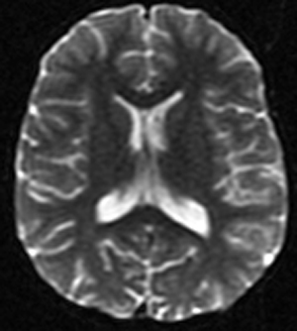

**DW source image**

The DW sequence is then executed individually or in combination with the DG's turned on and at different strengths. It produces **DW source images** that are sensitized to diffusion in several different directions. And the figure below shows an example of DW source images.

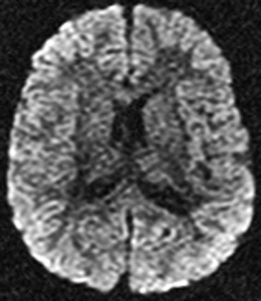

**Trace DW image**

A collection of **Trace DW images**, the first-line images used for clinical diagnosis, are paired with the DW source images. And the figure below shows an example of Trace DW images.

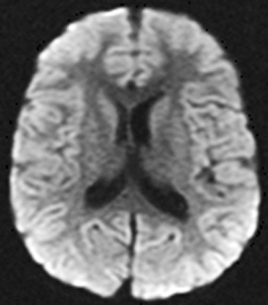

**Apparent Diffusion Coefficient (ADC) map**

Then a map of the **Apparent Diffusion Coefficient (ADC)** is calculated using the b0 data and the source images. The ADC chart is used to explain any anomalies found on the trace images.

And the figure below shows an example of ADC map.

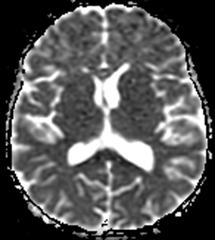

**Additional calculated image sets**

Optionally, more advanced processing may be done, generating additional computed image sets for analysis. These may include **exponential ADC maps**, **fractional anisotropy images**, **principal diffusion direction maps**, and **fiber tracking maps**. The figure below illustrates these advanced processing and the additional image sets.

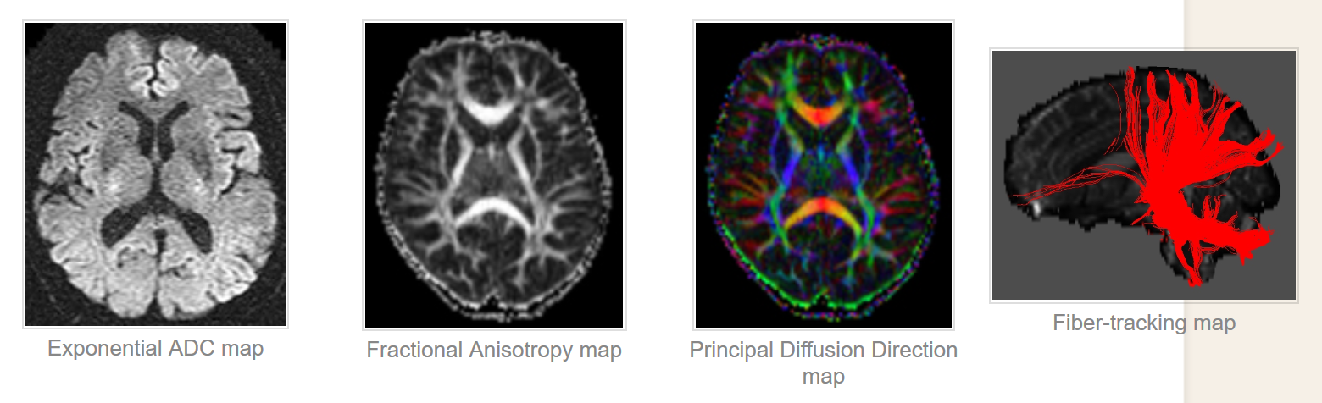

IMAGE QUALITY AND ARTIFACTS

**Resolution, SNR and contrast**

DW images tend to be of lower resolution than conventional MR images such as T2WI. This is due to multiple factors such as low resistance scanners, faster image acquisition techniques such as Single-Shot Echo Planar Imaging and limitations of general acquisition parameters such as field of view ( FOV), slice thickness etc. Lower strength scanners contribute weaker signals to the image co pared to high-resistance scanners and thus provide lower resolution than low-resistance scanners. Fast acquisition techniques such as SS-EPI focus on acquiring images in a very short time before the complete decline of the signal and thus limit the maximum achievable resolution of DW images. Also related to spatial resolution are general MR acquisition parameters such as FOV, slice thickness, matrix size etc... Increasing FOV but maintaining the same matrix size would decrease image resolution (in-plan spatial image resolution can be calculated by dividing FOV with matrix size) and increase matrix size would increase in-plan resolution if FOV remains constant. In general, the resolution along the direction of the slice (through-plane) is lower than the direction of the image (in-plan). The maximum resolution that can be achieved by optimizing these parameters is therefore constrained by the scanner's hardware limitations. Low resolution can be a challenge in radiotherapy planning treatment since DW images are used in conjunction with T2-weighted images along with ADC maps, which are typically of higher resolution. Given the difference in the respective resolutions, if ADC and T2WI were to be superimposed due to ADC / DWI's low resolution, it would overestimate the area of the lesion because of its lower resolution. And in general, images with higher resolution are preferred because they offer more data and accurate details compared to images with lower resolution.

DW images also suffer from low SNR due to the presence of large amounts of noise, in addition to the low resolution. Image contrast is also a crucial issue as higher contrast is very beneficial in precisely delineating abnormality regions using diffusion coefficient values from ADC maps. Lower SNR and contrast-to-noise-ratio (CNR) will restrict the capability of accurate interpretation of ADC maps and DW images.

**Artifacts**

DW images are often susceptible to a variety of artifacts such as distortion, ringing, etc. that arise from a host of factors. Distortion is one of the most important artifacts in DW images. Distortion of the images may occur due to field inhomogeneity and magnetic susceptibility variations in the area being imaged.

In the early 2000s, widely used 3 T scanners were introduced and quickly adapted due to their ability to achieve higher spatial resolution, higher SNR, and better contrast than 1.5 T machines. However, increased field strength in the image contributed to higher artifacts related to magnetic susceptibility. The magnetic field B1, in which the patient is placed, becomes more inhomogeneous as the field strength increases, thus contributing to more errors in image acquisition [Stafford RJ. High Field MRI: Technology, Applications, Safety, and Limitations. American Association of Physicists in Medicine (AAPM); 2005.]. Sequences like EPI require very homogeneous magnetic fields to ensure that the spins of the proton adhere to the spin rate and do not dephase, thus ensuring accuracy of the signal. However, in some instances, such as at air-tissue interfaces, protons at the interface undergo phase change that is different from the expected due to variations in magnetic susceptibility resulting in geometric distortion of the image. **Figure 4A** shows an image weighted by T2, and **Figure 4B** shows a phantom's corresponding DW image. In the DW image**, Figure 4B**, the phantom is put in the air and scanned because of the distortion occurring around the edges with air-interfacing.

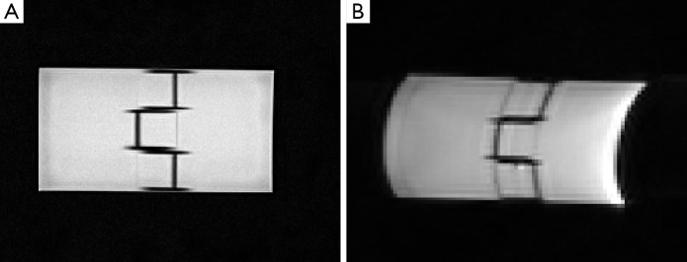

This distortion can also be observed when imaging is done in metal implant tissues, due to region-wide field variation. The gradient system can also cause this susceptibility related artifacts, which could introduce inhomogeneity in the magnetic field. Powerful and rapidly switching gradients induce local currents, called eddy currents, which in turn produce their own local magnetic fields, thus disturbing field homogeneity. Such eddy currents help to distort and shift images by manipulating the gradient strengths encountered by spins [Le Bihan D, Poupon C, Amadon A, Lethimonnier F.Artifacts and pitfalls in diffusion MRI. J Magn Reson Imaging 2006;24:478-88.], Which affect accurate interpretation of the image and ADC estimation and clinical diagnosis thereby. Other artifacts such as ghosting can also be a result from eddy currents [Le Bihan D, Poupon C, Amadon A, Lethimonnier F.Artifacts and pitfalls in diffusion MRI. J Magn Reson Imaging 2006;24:478-88.].

Apart from distortion, sequences of EPIs are sensitive to motion, whether microscopic or macroscopic, resulting from different factors. Macroscopic motion results in severe motion-related artifacts causing the DW image to ghost or blur. This could greatly affect the measurements of diffusion for DW imaging, and could render incorrect data. Although precautions can be taken to minimize the voluntary movement of patients, involuntary movements such as breathing, blood flow or mechanical vibrations resulting from the scanner's patient table remain unavoidable.

## Technological advancement in addressing the challenges

DW images often have lower image quality compared to other traditional MR images due to problems with image quality such as distortion, noise, poor resolution and the presence of artifacts, most of which result from the use of faster image acquisition techniques such as EPI, necessary to capture the diffusion signal until it becomes null.

Most of these problems can be solved by altering DW-MR protocol variables such as echo time (TE), gradient strengths, adjusting techniques for image acquisition etc. Broadly speaking, the approaches to address the inherent challenges associated with DWI fall into four categories: hardware upgrades or enhancements, use of contrast agents, optimizing acquisition parameters, and post-processing techniques based on software. None of these approaches address all of the challenges individually, as they may present their own challenges such as increased acquisition time, etc.

**Challenges of DWI and some approaches to address these challenges**

|  |  |
| --- | --- |
| **Challenge** | **Some common approaches to address challenges** |
| Low resolution | |  | | --- | | Hardware improvements | | Increasing field strength of scanners | | Multi-shot sequences | | Post-processing | | Interpolation techniques; super-resolution reconstruction | |
| SNR | |  | | --- | | Hardware improvements | | Increasing field strength of scanners; High strength gradients | | Multi-shot sequences | | Acquisition parameters | | Averaging | |
| Contrast Acquisition time | Contrast agents   |  | | --- | | Hardware improvements | | Increasing field strength of scanners; high strength gradients | | Single-shot sequences | | Parallel imaging | | Acquisition parameters | | Optimal TR, TE, number of b-values | |
| Distortion from susceptibility differences and eddy currents | |  | | --- | | Hardware improvements | | Increasing field strength of scanners; high strength gradients; shimming coils | | Non-EPI based sequences | | Calibration scans and pre-emphasized pulses | | Acquisition parameters | | Increasing receiver bandwidth or decreasing peak gradient amplitudes | | Post-processing | | Acquiring field maps and correction algorithms | |
| Motion artifacts | |  | | --- | | Hardware improvements | | Single-shot EPI; Non-EPI based sequences; | | Cardiac and Respiratory triggering or bi-polar gradient pulses Navigator based and readout-segmented acquisition methods | | Acquisition parameters | | Averaging | |
| ADC accuracy | |  | | --- | | Acquisition parameters | | Optimal number of b-values | | Diffusion modelling in tissue | | Post-processing | |