1. **Preparations**

In a DWI sequence diffusion sensitization gradients are applied at both sides of the 180° refocusing pulse. The parameter which decides the diffusion weighting is called “b value” and is represented in s/mm2. It is proportional to the square value of the duration and amplitude of the applied gradient. Diffusion is evaluated qualitatively on trace images and quantitatively by the parameter which called apparent diffusion coefficient (ADC). Tissues with restricted diffusion are bright on the trace image and hypo-intense on the ADC map.

The algorithms which used in the acquisition of DWI make several assumptions, e.g., infinitely rapid gradient changes, perfect field homogeneity, and RF pulses perfectly shaped, etc. However, with the accessible technology, the gradient coils are capable of generating gradient magnitudes and switching rate of the order of 40 mTm-1 and 200 Tm-1·s-1 respectively. Such discrepancies limit DWI accuracy and lead to lower quality of image and image artifacts [[74](https://www.ncbi.nlm.nih.gov/pmc/articles/PMC5039674/#B74)]. The major limitations of DWI are experienced in body imaging and are hugely due to being an Echo-Planar Imaging sequence [[59](https://www.ncbi.nlm.nih.gov/pmc/articles/PMC5039674/#B59),[60](https://www.ncbi.nlm.nih.gov/pmc/articles/PMC5039674/" \l "B60)]. DWI is vulnerable to different artifacts, e.g., T2 black out, ghosting, T2 shine through, distortions and blurring. Tissues with very long relaxation times may tend to keep signal on high b value images. This is defined as “T2 shine through” effect. The corresponding bright signal of such lesions on the ADC map helps to distinguish it from restricted diffusion, which looks dark on ADC maps. T2 blackout effect is the term used on the ADC map for low signal because of a lack of sufficient water protons and not restricted diffusion. The diagnostic sign for such an effect is the low signal on T2 weighted fat saturated images.

Another disquieting limitation of DWI is the questionable reproducibility of ADC values. ADC values can differ even if the same MR system is used. This variability was attributable to the inherent low SNR, distortions and artifacts related to SS EPI sequence. Rapid on/off transition of diffusion gradients during EPI sequence leads to eddy-current related distortions resulting in image degradation and systemic errors in ADC calculations.

**Table 1**

|  |  |  |  |  |  |  |  |
| --- | --- | --- | --- | --- | --- | --- | --- |
| Display | Post processing | Acquisition  Time  (min)* | Maximal  Gradient  Strength  (sec/mm2) | No. of  Gradient  Directions | 3.0 T and  High Gradient  Strength  Capabilities |  | Technique  and  Reference |
| Gray-scale sections | None | 1–3 | ≤1000 | 1 | Optional |  | Diffusion weighted  imaging |

**Technical Requirements of Diffusion MRI Techniques**

1. **Usefulness compared to other modalities and sequences**

MRI provided an excellent contrast resolution not only from tissue (proton) density, but also from tissue relaxation properties. After primary focus on T1 and T2 relaxation properties researchers investigated other methods for generating contrast using other properties of water molecules. Diffusion weighted imaging (DWI) was the result of such researchers' efforts as Stejskal, Tanner and Le Bihan[[2](https://www.ncbi.nlm.nih.gov/pmc/articles/PMC5039674/" \l "B2)] [ Le Bihan D. Diffusion MRI: what water tells us about the brain. EMBO Mol Med. 2014;6:569–573.].

* 1. **Diffusion-weighted MR Imaging**

Diffusion-weighted MRI is considered as the simplest form of diffusion imaging. A diffusion-weighted image is considered one of the components required to reconstruct the complete probability density function as in diffusion spectrum imaging. A diffusion weighted image is the unprocessed outcome of a single pulsed gradient SE sequence being applied in one gradient direction, and it matches up to one point in q-space. Although such an image is fairly simple, it contains some diffusion information. In ,[Figure 13](https://pubs.rsna.org/doi/10.1148/rg.26si065510" \l "F13), the left splenium of the corpus callosum appears bright, whereas the right splenium appears dark. In regions like the right splenium, in which the main direction of diffusion is aligned with the diffusion gradient applied, the signal intensity decreases markedly and the region appears darker on the image. Diffusion in the ventricles is free and substantial in all directions including the direction of applied gradient, and so the whole of the ventricles appears dark. Despite its simplicity, diffusion-weighted imaging is frequently used in stroke investigations (,[15](https://pubs.rsna.org/doi/10.1148/rg.26si065510" \l "R15)). Indeed, in an acute stroke, the local cell swelling produces increased water mobility restrictions and hence a bright image appearance due to high signal intensity in the lesion area. The advantage of diffusion-weighted imaging is that the acquisition time is short, because only one image is required.

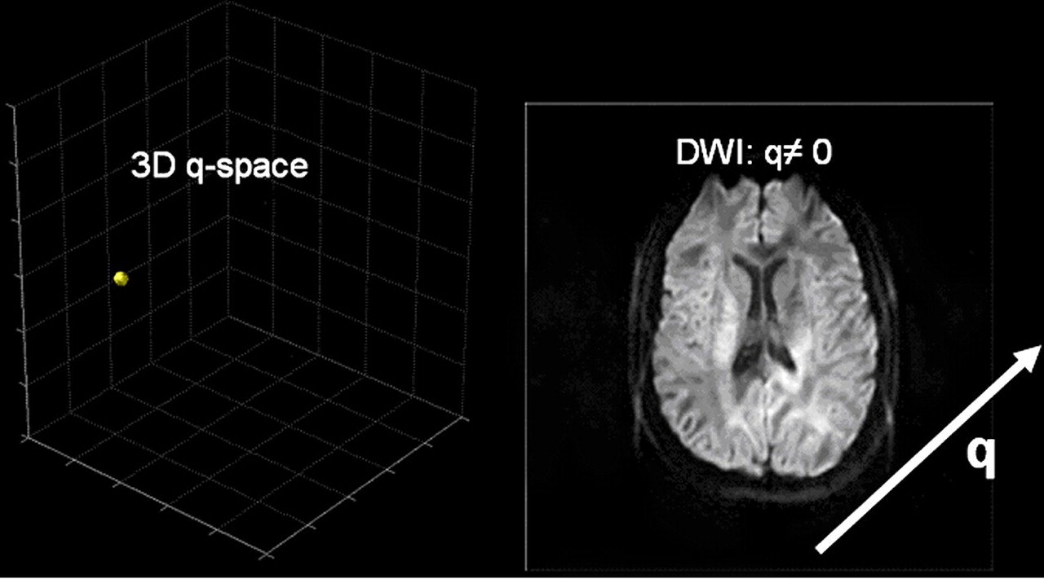

**Figure 13.**Diffusion-weighted image (right) from signal sampling at a single point in 3D q-space (left). Brain areas in which diffusion is intense in the direction of the applied gradient $\left(\overset{⃑}{q}\right)$  appear darker due to a decrease in the measured signal that results from de-phasing.

* DWI may be useful to demonstrate persistent or progressive tumor despite the lack of contrast enhancement. Pseudo-progression is seen in the edema setting associated with the inflammatory response, rather than the true tumor progression.
* DW-MRI is applied in neoplasms of the head and neck.
* DWI can be used for distinguishing malignant from benign and inflammatory lung lesions and helps in differentiation of small cell cancers (SCLC) from non-small cell cancers (NSCLC).
* DWI can differentiate benign renal cysts from solid neoplasmseasily.
* DW MRI's exquisite sensitivity to microstructural changes allows us to detect the abnormalities long before conventional image changes.
* DWI improves cervical and endometrial tumors diagnosis [[62](https://www.ncbi.nlm.nih.gov/pmc/articles/PMC5039674/#B62)]. DW MRI is particularly useful in determining the depth of myometric invasion in patients with endometrial cancer**.**

Hepatobiliary pancreatic cancers

DWI is useful in the detection and characterization of focal liver lesions and can be used as an alternative to Gadolinium-enhanced MRI in renal dysfunction patientsDW MRI clinical applications include the monitoring of treatment response and prognosis in patients receiving systemic and focal ablative hepatic and pancreatic malignancies therapies [[43](https://www.ncbi.nlm.nih.gov/pmc/articles/PMC5039674/#B43)-[46](https://www.ncbi.nlm.nih.gov/pmc/articles/PMC5039674/#B46)]. Hardie et al[[47](https://www.ncbi.nlm.nih.gov/pmc/articles/PMC5039674/" \l "B47)] compared the usefulness of DWI in liver metastases detection. They reported that DWI has 66.3% sensitivity compared to 73.5% for CE-MRI and therfore it can serve as a useful alternative for this purpose. DW MRI in diffuse hepatic parenchymal disease such as non-alcoholic fatty liver disease and hepatic fibrosis has been investigated.

Bowel disorders

DWI is useful for detecting nodal and hepatic metastases, colorectal cancer and predicting the response after radio-chemotherapy for locally advanced rectal cancer[[50](https://www.ncbi.nlm.nih.gov/pmc/articles/PMC5039674/" \l "B50)-[52](https://www.ncbi.nlm.nih.gov/pmc/articles/PMC5039674/#B52)]. DWI detects changes in lesion vascularity induced by therapy during anti-angiogenic therapy before significant size changes are evident [[53](https://www.ncbi.nlm.nih.gov/pmc/articles/PMC5039674/#B53),[54](https://www.ncbi.nlm.nih.gov/pmc/articles/PMC5039674/" \l "B54)]. DWIBS has been reported as a useful instrument for detecting colorectal cancer nodal metastasis [[55](https://www.ncbi.nlm.nih.gov/pmc/articles/PMC5039674/#B55)]. Besides its usefulness in abdominal malignancies, DWI was also found to be useful in inflammatory bowel disease. Qi et al[[56](https://www.ncbi.nlm.nih.gov/pmc/articles/PMC5039674/" \l "B56)] reported that DWI combined with MR enterography (MRE) has higher diagnostic accuracy (92%) than MRE alone (79%) for disease activity. It was also found useful when detecting and characterizing extraintestinal manifestations and complications [[57](https://www.ncbi.nlm.nih.gov/pmc/articles/PMC5039674/#B57)]. Use of DWI with MR enterography improves the detection of mesenteric and small bowel tumors compared to unenhanced MR-enterography.

As there are a lot of techniques of diffusion MR, we can list them as following:

1. Diffusion-weighted MR Imaging
2. Trace and ADC imaging
3. Diffusion tensor imaging
4. q-Ball imaging
5. Diffusion spectrum imaging

Hence we are going to clarify in **table 1** the advantages and drawbacks of this various techniques,

|  |  |  |  |
| --- | --- | --- | --- |
| Drawbacks | Advantages | Information Obtained | Technique |
| Provides unidirectional diffusion measurement only, limited information. Voxel intensity is not a natural physical unit but a measure of restriction. | Short acquisition time, no post processing, images easy to interpret. Examination well tolerated by patients. Adequate hardware capabilities readily available. | Diffusion measurement in  one direction | Diffusion-weighted imaging |
| Hypothesis based (hypothesis not always true). Limited information (no measurement of orientation or anisotropy) | Short acquisition time, nearly no (or automated) post processing, images easy to interpret. Voxel intensity has physical meaning. Examination well tolerated by patients. Adequate hardware capabilities readily available. | Estimated diffusion coefficient | Trace and ADC imaging |
| Hypothesis based (hypothesis not always true). Does not provide accurate map of complex fiber architecture. Tractography results are vulnerable to severe artifacts. | Short acquisition time, some post processing required (automated on recent imaging systems). Provides information about diffusion orientation and anisotropy. Examination well tolerated by patients. Adequate hardware capabilities readily available. | Estimated diffusion tensor | Diffusion tensor imaging |
| Hypothesis based. Although results seem correct in important brain areas, accuracy is not guaranteed in all brain regions. Further validation is required. Hardware requirements are high. | Feasible with reasonable acquisition time. Provides information about diffusion orientation and anisotropy, accurate depiction of fiber crossings. Examination tolerated by most patients. | Estimated map of orientation distribution function values | q-Ball imaging |
| Hardware requirements are high, and acquisition time is comparatively long. Whole-brain studies were not tolerable for patients. Recent improvements in hardware and imaging techniques have made shorter acquisition times possible, allowing future patient studies. | Principle based, hypothesis free, has already received theoretical and practical validation. Provides accurate depiction of fiber crossings with a specific angular resolution. Maps the entire field of diffusion, providing 6D data and increasing the possibility of quantitation. Provides diffusion tensor information. | Full 3D diffusion probability  density function map,  true 6D images | Diffusion spectrum imaging  . |

Table 1

Advantages and Drawbacks of Diffusion MRI Techniques