1- Sequence Objective.

1.1 – What is diffusion?

Diffusion relates to the unexpected, microscopic motion of water and other small molecules owing to thermal collisions. Diffusion is often defined as Brownian motion, labeled after the Scottish botanist , Robert Brown, who first identified spontaneous oscillations of pollen particles under a microscope in 1827.

For comparison, the rate of diffusion of water molecules at room temperature is 2.2 × 10−5 cm2 / s. That is, on average, the water molecule moves and covers a patch area of 0.000022 cm2 every second.(Fig. 1).

Water diffusion relies on the microscopic structural conditions in the tissues, and analysis may offer useful insights into regional morphological and anatomical shifts in disease states.

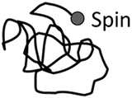Figure 1

The fastest degree of diffusion happens in free water with no limit. In brain tissue, the borders of cell membranes limit the motion of water to a degree that relies on the mean free path of water molecules.

Of starters, in cerebral ventricles, the diffusion of water is fairly unimpeded and the CSF has a strong diffusion coefficient.

Gray matter (GM) and white matter (WM) have a weaker diffusion coefficient than CSF owing to their diverse tissue composition.

1.2 – DWI objective

Water constitutes a significant proportion of body weight as intra-and extra-cellular fluids in the human body. In biological tissues, the movement of water molecules assumes a sequence of tissue composition and properties.

In some pathological conditions, such as acute stroke, this pattern of diffusion is disturbed and the quantity of diffusion changes in the injured region. The irregularities may be observed by observing these variations in diffusion.

That can be accomplished utilizing a sophisticated magnetic resonance imaging method named Diffusion Weighted MRI (DW-MRI) or DWI, where the movement of water molecules is used to imagine internal physiology. The image contrast in DWI represents the variation in the rate of diffusion across tissues.

The diffusion of water may be observed or calculated using diffusion-weighted imaging (DWI) technology.

DWI is sensitized to random molecular motion of water in tissue by applying magnetic field gradients (diffusion gradients) to the RF pulse sequence.

In the DWI series, the diffusion weighting is calculated by the "b-value" variable, which would be in the second unit per square millimeter (s / mm2).
High "b-value" results in high diffusion weighting, and no diffusion weighting is produced when b = 0.

On a diffusion-weighted picture, the tissue that contain high levels of diffusing water produces a hypo-intense signal. The chart of the apparent coefficient of diffusion (ADC) of the water molecules can be determined from the diffusion-weighted picture.

Diffusion-weighted imaging(DWI) has been repetitively improved to probe random microscopic motion of water protons on a per pixel basis.

Such DWI methods have developed far beyond the experimental field to routine therapeutic uses in ischemia which are also the field of study in other diseases, including multiple sclerosis, dyslexia, schizophrenia or trauma.

Alterations in proton self-diffusion are an early sign of altered cell homeostasis in acute ischaemic stroke.[1][M.E. Moseley, J. Kucharczyk, J. Mintorovitch, Y. Cohen, J. Kurhanewicz, N. Derugin, H. Asgari, D. Norman Diffusion-weighted MR imaging of acute stroke: correlation with T2-weighted and magnetic susceptibility-enhanced MR imaging in cats .Am. J. Neuroradiol., 11 (1990), pp. 423-429]

Early identification of such changes may have a significant effect on clinical plans and the medical result for stroke patients.[2] [M.G. Lansberg, A.M. Norbash, M.P. Marks, D.C. Tong, M.E. Moseley, G.W. Albers Advantages of adding diffusion-weighted magnetic resonance imaging to conventional magnetic resonance imaging for evaluating acute stroke Arch. Neurol., 57 (2000), pp. 1311-1316]

2 – Basic pulse sequences for DWI

2.1 Spin echo- and stimulated echo-based

Merboldt et al. [10] [K.D. Merboldt, W. Hanicke, H. Bruhn, M.L. Gyngell, J. Frahm Diffusion imaging of the human brain in vivo using high-speed STEAM MRI Magn. Reson. Med., 23 (1992), pp. 179-192] Inserted one diffusion-encoding gradient between the first and the second 90 ° pulse and one after the third 90 ° pulse of the stimulated echo sequence (Fig . 2) to create diffusion-weighted images.

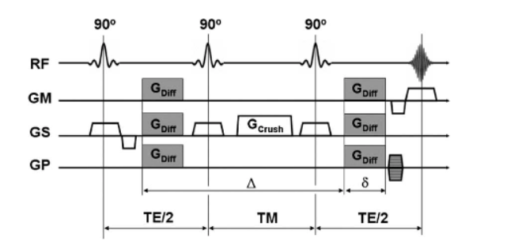Figure 2: Diffusion-weighted stimulated echo sequence: Diffusion-weighting powergradients are performed on the first and third RF pulses. The second RF tips half the spins down down the z-axis. During the mixing time (TM) these spins are only influenced by the somewhat slower-relaxation time. During TMspoils the transverse magnetization free, which may interact with the diffusion-weighted signal when the induced echo is created.

The stimulated echo may be produced by three RF-pulses (note that the RF-pulses must not actually be 90 ° -pulses to create a stimulated echo): the spins are rotated to the transverse plane by the first RF-pulse and lose their phase coherence.

The second RF-pulse brings half of the transverse magnetisation (i.e. all vector components perpendicular to the phase of the second RF-pulse) from the transverse plane along the z-axis.

While magnetization is 'stored' along the z-axis (TM), it is only affected by the much slower T1-relaxation process. At the center, after the third RF-pulse, which rotates back into the transverse plane, and after the second precession period (TE/2), a diffusion-weighted induced echo is produced at the time of TE+TM.

Diffusion-weighted induced echo series is of special importance to tissues with brief T2-relaxation periods ( e.g. liver) and may often be paired with a number of reading techniques, such as Echo Planar Imaging (EPI) or Spiral Imaging.

Diffusion-weighting is primarily determined by the T1-sensitive TM-interval and thus enables one to select brief echo times for a rational diffusion-weighting. It should be kept in mind, however, that the stimulated echoes technically provide only half the signal compared to the spin echoes, with the corresponding signal equation.

2.2 SSFP diffusion-weighted imaging

When a train of equidistant RF pulses with flip angle and TR < T2 is added, a state of steady state free precession (SSFP) may develop; because of the very brief TR SSFP imagery, rapid image creation is feasible. SSFP imaging has long been known for its high flow and diffusion sensitivity in the presence of magnetic field gradients (Fig . 3) and has therefore received some attention from a number of research groups.
[11][D. Le Bihan, R. Turner, J.R. MacFall Effects of intravoxel incoherent motions (IVIM) in steady-state free precession (SSFP) imaging: application to molecular diffusion imaging Magn. Reson. Med., 10 (1989), pp. 324-337]

[12] [E.X. Wu, R.B. Buxton Effects of diffusion on the steady-state magnetization with pulsed field gradients J. Magn. Reson., 90 (1990), pp. 243-253]

[13] [R.B. BuxtonThe diffusion sensitivity of fast steady-state free precession imaging Magn. Reson. Med., 29 (1993), pp. 235-243]

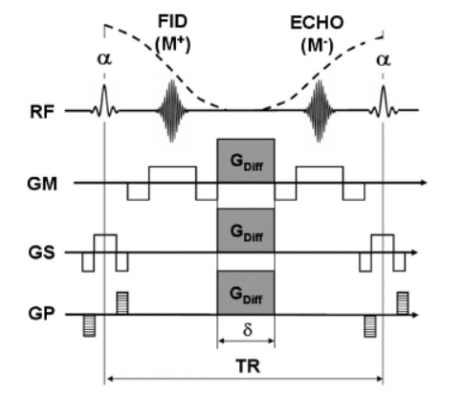Figure 3: One cycle of a diffusion-weighted SSFP sequence:The ECHO part is usually very responsive to diffusion. For this example chain, all gradients are fully balanced and the overall effective gradient is equivalent in each cycle to create a steady state. To minimize the voluminous motion response, bipolar diffusion gradients can be used to decrease the first gradient moment and even (spiral) navigator echoes can be used.

Compared to spin and stimulated echoes, the signal construction in SSFP is, however, a complex mixture between various spin and stimulated echoes, which can be established by a multitude of coherent pathways, limited only by the natural decay times T1 and T2.

This complex signal structure allows the measurement of diffusion very complicated and the diffusion attenuation (b-factor) that differ from tissue to tissue, as the b-factor for this series is often defined by parameters such as relaxation periods and B1-uniformity.

Thus, in comparison to spin echo and induced DWI-based echo, one has to contend not only with 'T2-shine-trough' results, but also with the possibility that b-values are weighted by the underlying stimulation periods and other conflicting variables.

[16] [J. Hennig Echoes—how to generate, recognize, use or avoid them in MR-imaging sequences: Part 1 Concepts Magn. Reson., 3 (1991), pp. 125-143]

[17] [K. Scheffler A pictorial description of steady-states in rapid magnetic resonance imaging
Concepts Magn. Reson., 11 (1999), pp. 291-304]

