1- Sequence Objective.

1.1 – What is diffusion?

Diffusion refers to the random, microscopic movement of water and other small molecules due to thermal collisions. Diffusion is also known as Brownian motion, named in honor of Scottish botanist Robert Brown who first observed spontaneous vibration of pollen particles under the microscope in 1827.

For reference, the diffusion coefficient of water molecules is 2.2 × 10−5 cm2/s at room temperature. That is, on average a water molecule moves and covers a patch of area 0.000022 cm2 every second (Fig. 1).

Water diffusion depends on the microscopic structural environment in the tissue, and measurement of it can provide valuable insights into the regional functional and structural changes occurring in disease states.

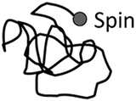Figure 1

The greatest diffusion rate occurs in free water with no boundaries. In brain tissue, the boundaries of cell membranes restrict the motion of water to a degree which depends upon the mean free path of the water molecules.
For example, in cerebral ventricles, water diffusion is relatively unimpeded and CSF has a high diffusion coefficient.
Gray matter (GM) and white matter (WM) have lower diffusion coefficient than CSF because of their complex tissue structure.

1.2 – DWI objective

Water forms a large percentage of body weight composition as intra and extra cellular fluids in human body. In biological tissues, diffusion of water molecules follows a pattern according to tissue structure and properties.

In some pathological conditions like acute stroke, this diffusion pattern is disturbed and the amount of diffusion changes in affected area. Through studying these changes in diffusion, the abnormalities can be detected.

This can be achieved using a specialized magnetic resonance imaging technique called Diffusion Weighted MRI (DW-MRI) or DWI, wherein the diffusion of the water molecules is exploited to visualize internal physiology. The image contrast in DWI reflects the difference in rate of diffusion between tissues.

The water diffusion can be detected or measured using the diffusion-weighted imaging (DWI) technology.

DWI is sensitized to the random molecular motion of water in tissue by applying magnetic field gradients (diffusion gradients) in the RF pulse sequence.

In a DWI sequence, the diffusion weighting is determined by a parameter called “b-value,” which is in the unit of second per square millimeter (s/mm2).
High “b-value” generates high diffusion weighting, and no diffusion weighting is generated when b = 0.

On a diffusion-weighted image, the tissue that contains high diffusing water generates hypo intense signal. A map of apparent diffusion coefficient (ADC) of water molecules can be calculated from the diffusion-weighted image.

Diffusion-weighted imaging(DWI) has been continuously improved to probe random microscopic motion of water protons on a per pixel basis.

Such DWI techniques have advanced far beyond the experimental arena into routine clinical applications in ischemia and are also the subject of research in other diseases, such as multiple sclerosis, dyslexia, schizophrenia, or trauma

[3] [M. Nakahara, K. Ericson, B.M. Bellander Diffusion-weighted MR and apparent diffusion coefficient in the evaluation of severe brain injury
Acta Radiol., 42 (2001), pp. 365-369]
[4] [M. Filippi, M. Cercignani, M. Inglese, M.A. Horsfield, G. Comi Diffusion tensor magnetic resonance imaging in multiple sclerosis Neurology, 56 (2001), pp. 304-311]

[5] [R. Bammer, F. Fazekas Diffusion imaging in multiple sclerosis Neuro imaging Clin. N. Am., 12 (2002), pp. 71-106]

[6] [T. Klingberg, M. Hedehus, E. Temple, T. Salz, J.D. Gabrieli, M.E. Moseley, R.A. Poldrack Microstructure of temporo-parietal white matter as a basis for reading ability: evidence from diffusion tensor magnetic resonance imaging
Neuron, 25 (2000), pp. 493-500 ]

Changes in proton self-diffusion are an early indicator of alterations of cellular homeostasis in acute ischemic stroke [1][M.E. Moseley, J. Kucharczyk, J. Mintorovitch, Y. Cohen, J. Kurhanewicz, N. Derugin, H. Asgari, D. Norman Diffusion-weighted MR imaging of acute stroke: correlation with T2-weighted and magnetic susceptibility-enhanced MR imaging in cats .Am. J. Neuroradiol., 11 (1990), pp. 423-429]
.

An early detection of these alterations can dramatically impact treatment decisions and the therapeutic outcome for stroke victims [2] [M.G. Lansberg, A.M. Norbash, M.P. Marks, D.C. Tong, M.E. Moseley, G.W. Albers Advantages of adding diffusion-weighted magnetic resonance imaging to conventional magnetic resonance imaging for evaluating acute stroke Arch. Neurol., 57 (2000), pp. 1311-1316]

2 – Basic pulse sequences for DWI

2.1 Spin echo- and stimulated echo-based

Merboldt et al. [10] [K.D. Merboldt, W. Hanicke, H. Bruhn, M.L. Gyngell, J. Frahm Diffusion imaging of the human brain in vivo using high-speed STEAM MRI Magn. Reson. Med., 23 (1992), pp. 179-192] placed one diffusion-encoding gradient between the first and the second 90° pulse and another one after the third 90° pulse of a stimulated echo sequence (Fig. 2) to generate diffusion-weighted images.

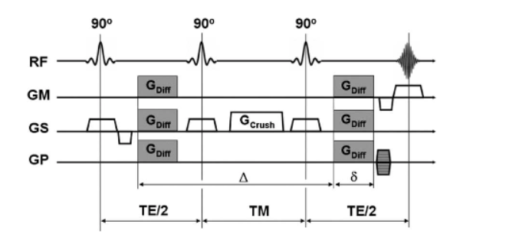Figure 2: Diffusion-weighted stimulated echo sequence: Diffusion-weighting gradients of strength are played out after the first and the third RF pulse. The second RF tips half of the spins back along the z-axis. During the mixing time (TM) these spins are affected only by the much slower -relaxation time. During TMspoils transverse magnetization away that could interfere with the diffusion-weighted signal when the stimulated echo is formed.

A stimulated echo can be formed by three RF-pulses (note that the RF-pulses must not necessarily be 90°-pulses to form a stimulated echo): Spins are tipped into the transverse plane by the first RF-pulse and lose their phase coherence.

The second RF- pulse brings half of the transverse magnetization (i.e. all vector components perpendicular to the phase of the second RF-pulse) from the transverse plane along the z-axis.

While the magnetization is ‘stored’ along the z-axis (TM), it is affected solely by the much slower T1-relaxation process. Ultimately, after the third RF-pulse, which tips spins back in to the transverse plane, and after the second precession interval (TE/2), a diffusion-weighted stimulated echo is formed at time TE+TM .

The diffusion-weighted stimulated echo sequence is of particular interest for tissues with short T2-relaxation times (e.g. liver) and can also be combined with different readout strategies, such as echo planar imaging (EPI) or spiral imaging.

The diffusion-weighting is mainly deter-mined by the T1-sensitive TM-interval and therefore allows one to choose short echo times with reasonable diffusion-weighting. However, it should be kept in mind that stimulated echoes theoretically provide only half the signal compared to spin echoes, whereby the corresponding signal equation is

2.2 SSFP diffusion-weighted imaging

If a train of equidistant RF pulses with flip angle and TR < T2 is applied, a condition of steady-state free precession (SSFP) will develop; because of the very short TR SSFP imaging allows rapid image formation. SSFP imaging has long been known for its high sensitivity to flow and diffusion in the presence of magnetic field gradients (Fig. 3) and has therefore gotten some attention from several research groups.
[11][D. Le Bihan, R. Turner, J.R. MacFall Effects of intravoxel incoherent motions (IVIM) in steady-state free precession (SSFP) imaging: application to molecular diffusion imaging Magn. Reson. Med., 10 (1989), pp. 324-337]

[12] [E.X. Wu, R.B. Buxton Effects of diffusion on the steady-state magnetization with pulsed field gradients J. Magn. Reson., 90 (1990), pp. 243-253]

[13] [R.B. BuxtonThe diffusion sensitivity of fast steady-state free precession imaging Magn. Reson. Med., 29 (1993), pp. 235-243]

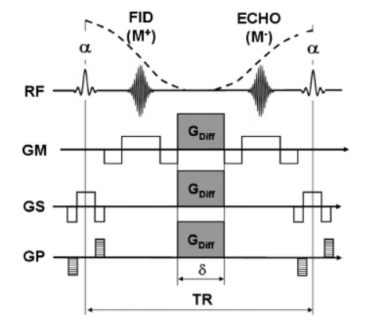Figure 3: One cycle of a diffusion-weighted SSFP sequence:The ECHO-component is generally very sensitive to diffusion. All imaging gradients are completely balanced in this example sequence and the total effective gradient is equal in each cycle to establish a steady state. To diminish the bulk motion sensitivity bipolar diffusion gradients can be used to reduce the first gradient moment and also (spiral) navigator echoes can be implemented.

In contrast to spin and stimulated echoes, the signal formation in SSFP is however a complex interplay between numerous spin and stimulated echoes which may be formed through a multitude of coherence path ways, limited only by the natural decay times T1 and T2.

This complex signal formation renders the quantification of diffusion very difficult and the diffusion attenuation (b-factor) may vary from tissue to tissue since the b-factor for this sequence is also determined by parameters like relaxation times and B1-uniformity .

In contrast to spin echo and stimulated echo-based DWI one therefore has to deal not only with‘T2-shine-trough’ effects but also with the fact that b-values are weighted by the underlying relaxation times and other confounding factors.

[16] [J. Hennig Echoes—how to generate, recognize, use or avoid them in MR-imaging sequences: Part 1 Concepts Magn. Reson., 3 (1991), pp. 125-143]

[17] [K. Scheffler A pictorial description of steady-states in rapid magnetic resonance imaging
Concepts Magn. Reson., 11 (1999), pp. 291-304]

