GET HANDS-ON & LEARN BEST PRACTICES FOR AWS DATA MIGRATIONS

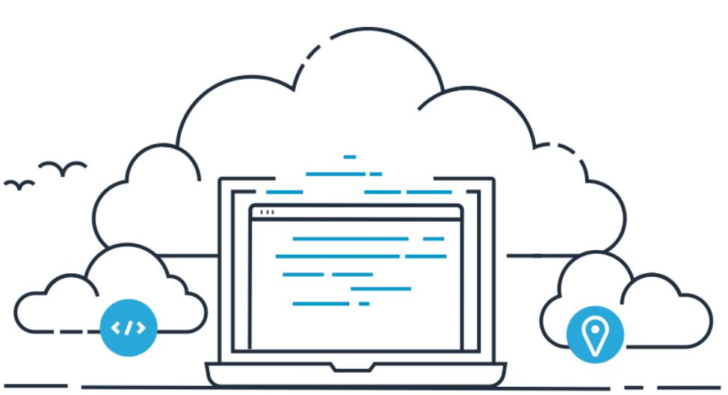

OVERVIEW



The prospect of moving data workloads to the cloud can be daunting, so can trying to make sense of the array of tools, protocols, and mechanisms available to move data into AWS.

**Objective of workshop** - Get hands on experience in transferring data at scale using theavailable AWS online & hybrid services, where you will copy 10,000 local small files to Amazon S3, using AWS File Gateway.

**CLIENT REQUIREMENTS**

**AWS account** –you will need an AWS account to deploy & run this workshop

**Browser** –It is recommended that you use the latest version of Chrome or Firefox

**Remote Desktop Client** - You will need a RDP client to logon to the Windows EC2 instance(Windows RDP)

**Key Pair** –You will need a valid EC2 Key Pair in the AWS region you choose for yourworkshop (US-EAST-1 N.Virginia). Instructions are provided in this workshop on generating and downloading an EC2 Key Pair.

**WORKSHOP MODULES**

This workshop encompasses 2 modules

**Module 1** - Deploy resources

**Module 2** - AWS File Gateway

MODULE 1: DEPLOY RESOURCES



**INTRODUCTION**

In this module you will firstly deploy the base AWS VPC network environment via the first CloudFormation template, then using the second CloudFormation template deploy the workshop resources into the **US-EAST-1 (N.VIRGINIA)** region which contains the following:

1 x Windows instance (used as the access machine for the workshop) 1 x Linux Instance (used to perform the data migrations)

**LOG INTO AWS CONSOLE**

1. From your local workstation, open a web browser and go to the following URL <https://dashboard.eventengine.run/login>
2. In the Textbox, input the 12 character Hash given to you by the organizers.

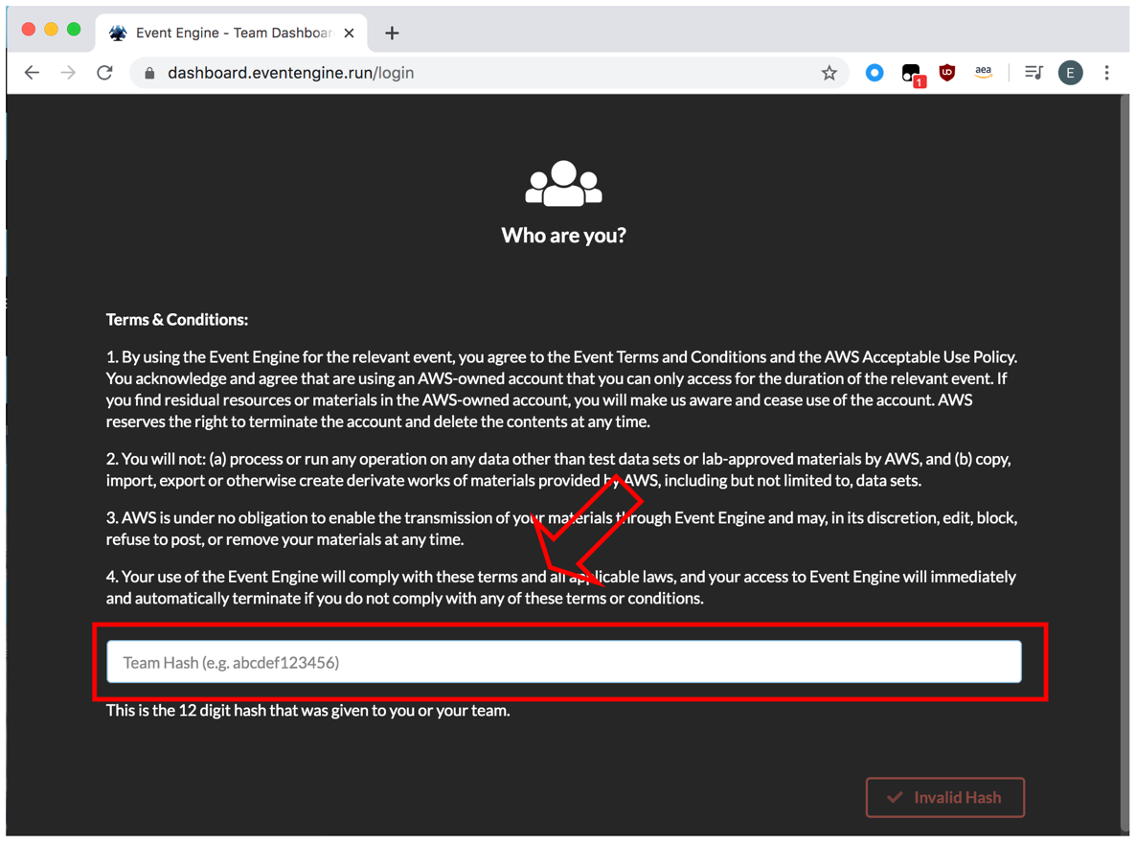

1. Click Accept Terms & Login

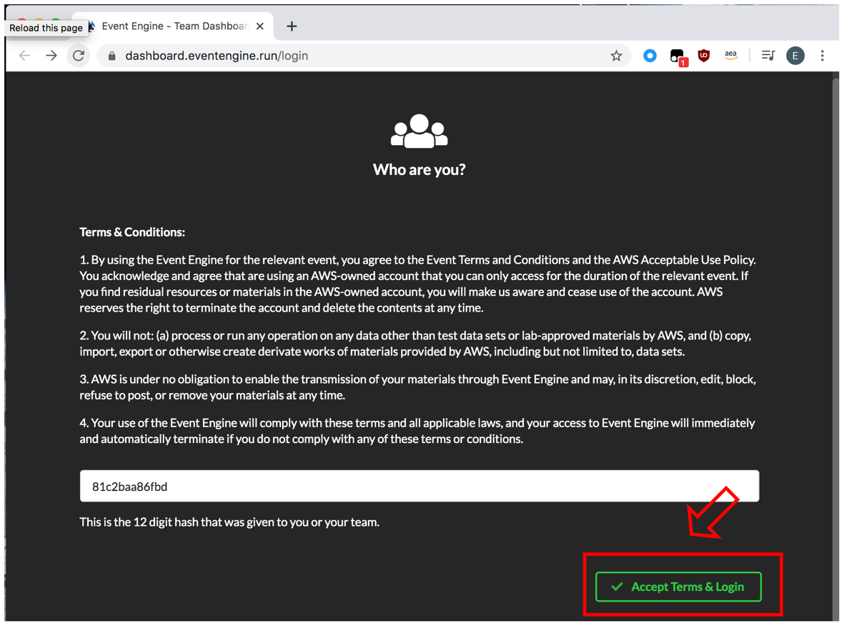

1. Click **AWS Console**

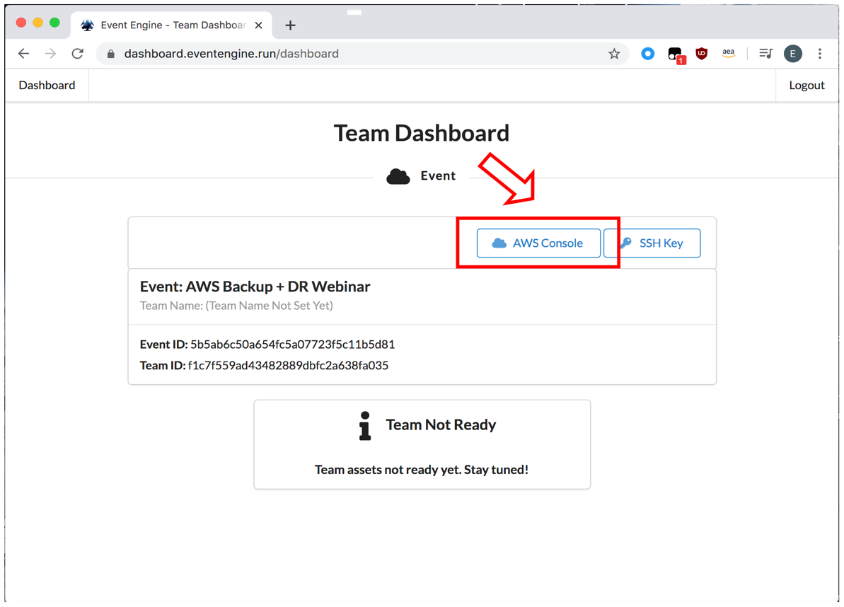

1. Click **Open AWS Console**

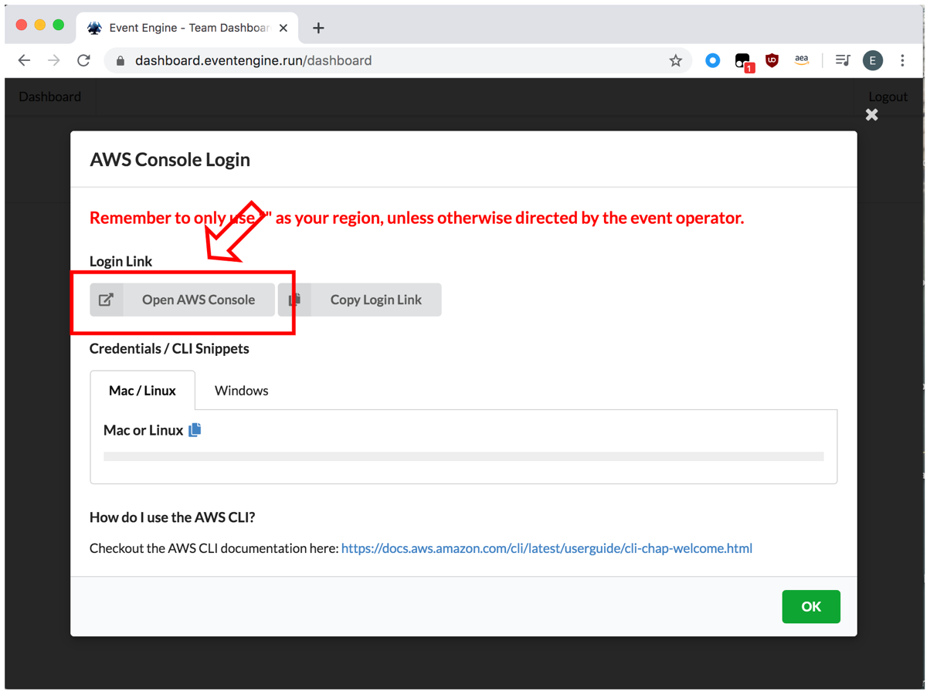

**CREATE KEYPAIR**

1. In the AWS Console window that you opened, in the top right hand corner, next to your account name, click on the drop down and change your region to **us-east-1** **(N.Virginia)**



1. From the top left of the screen click **Services** and type & select **EC2**
2. From the left hand window pane, navigate to **Network & Security**, and select **Key Pairs** from the menu

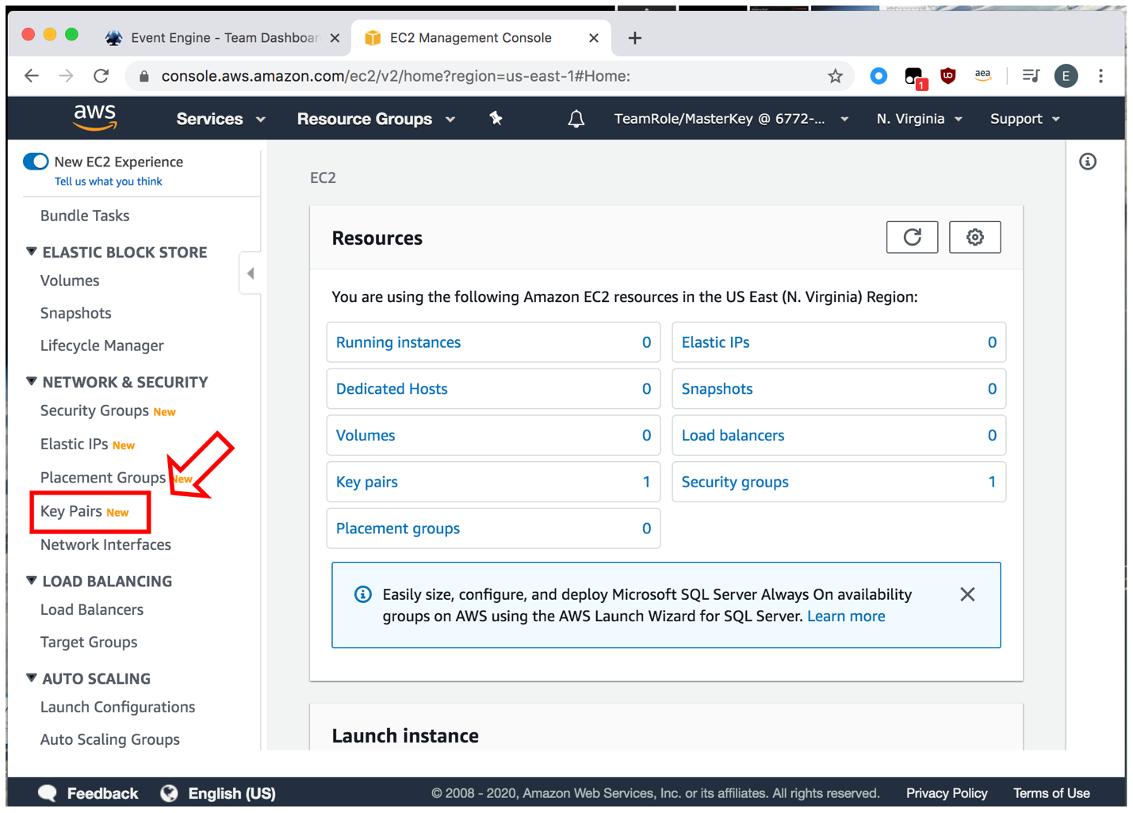

* Click **Create key pair**
* Enter the Key pair name of : **stg316 key** Select **PEM** file format
* Select **Create**

1. It will then download a *.pem file to your users **“downloads”** folder (or a location you have specified). If you are using Google Chrome, the downloaded file will also be shown at the bottom of the screen for reference.



**Note:** Take note of the location of this .pem file you download, as you will copy this to yourdeployed Windows EC2 instance (after the deploying the below CloudFormation template

**DEPLOY VPC ENVIRONMENT**



**Note:** Make sure you set your region to **us-east-1 (N.Virginia)**

1. From the AWS console on your local laptop/workstation, click **Services** and type & select **CloudFormation**
2. In the top right hand corner, next to your account name, click on the drop down and change your region to **us-east-1 (N.Virginia)**



1. Now in the CloudFormation page click on **Create stack** o Click on **With new resources** from the drop down

o Under Amazon S3 URL copy and paste this URL

<https://ee-assets-prod-us-east-1.s3.amazonaws.com/modules/2343f58921ff4b66b136904c1265d64b/v1/part-1-deploy-vpc.json>

* 1. Click on **Next** at the bottom of the window

1. Enter the **Stack name** of **STG316-VPC**
2. Leave all other values as unchanged

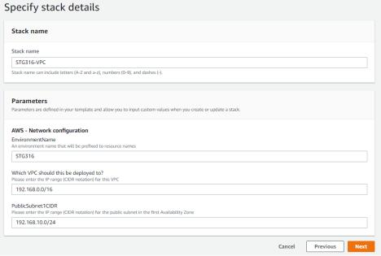

1. Click on **Next** to continue
2. On the next page scroll to the bottom and click on **Next** to continue
3. Click on **Create stack**
4. Click on the **Stack info** tab and click on the **refresh** icon as highlighted in **RED** until the status value changes to **CREATE_COMPLETE** (this may take 1-2 minutes) as shown below, you can then progress to the next steps

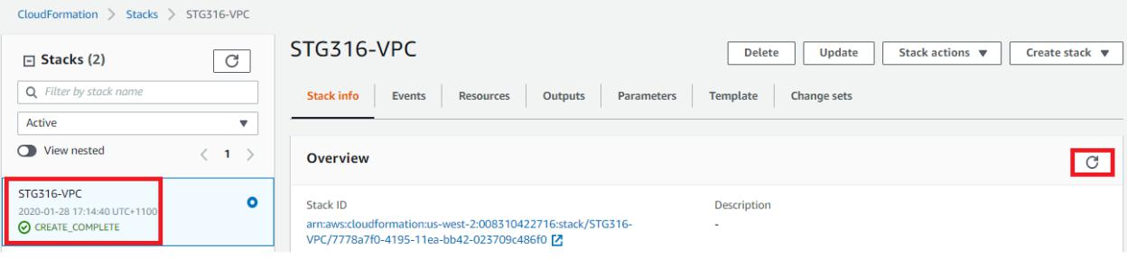

**DEPLOY WORKSHOP RESOURCES**



**Note:** Make sure your region is set to **us-east-1(N.Virginia)**

1. From the AWS console on your local laptop/workstation, click **Services** and type & select **CloudFormation**

o Click on **Create stack**

o Click on **With new resources** from the drop down o Under Amazon S3 URL enter this address

<https://ee-assets-prod-us-east-1.s3.amazonaws.com/modules/2343f58921ff4b66b136904c1265d64b/v1/part-2-deploy-resources.json>

* 1. Click on **Next** at the bottom of the window

1. Enter the **Stack name** of **STG316-Resources**
2. Select the following for the other values
   1. **VPC** : Select option that has **STG316** in the name
3. **subnet** : Select option that has **STG316 Public Subnet-AZ1** in the nameo **KeyName** : Select the key pair name you created in the previous step

o **SecurityGroupIds**: Select **STG316-BastionHostSG**

o Do not modify the two values for **LatestWindowsAmiID & LatestLinuxAmiID**

1. Click on **Next** to continue

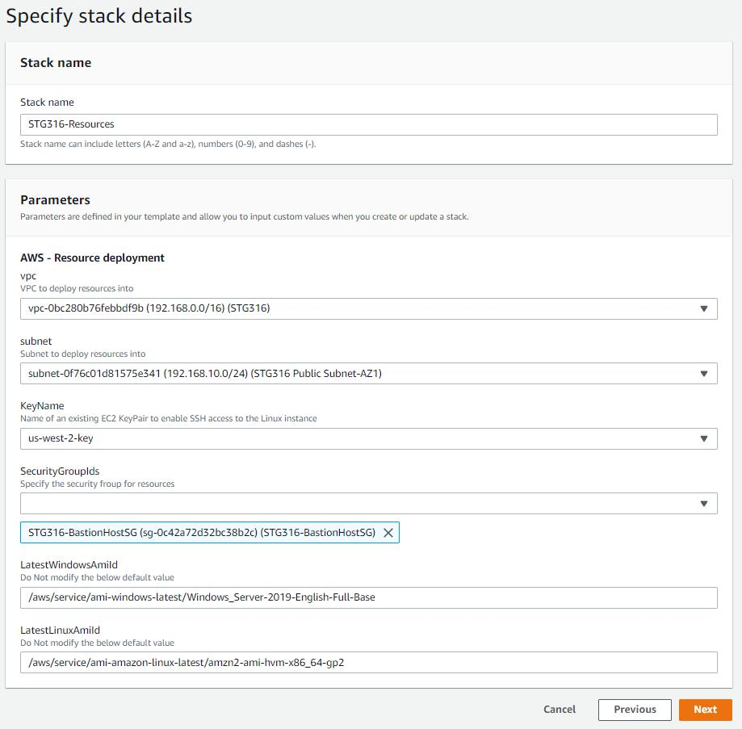

1. Scroll to the bottom of the next screen and click on **Next**
2. Scroll to the bottom of the next screen, check the **CloudFormation** **acknowledgement** box and click on **Create stack**

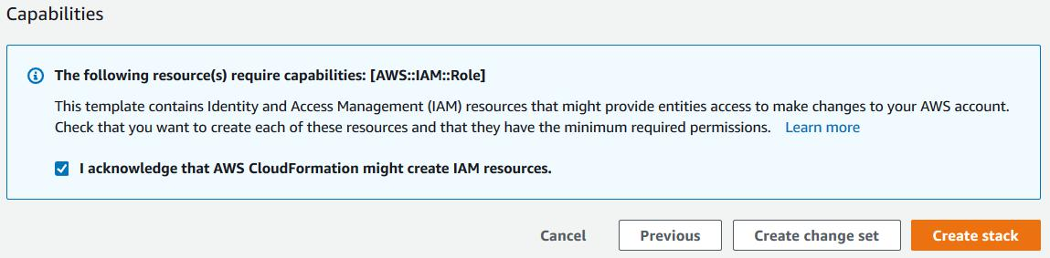

1. You will be taken to the CloudFormation stack status page
2. Click on the **Stack info** tab and click on the **refresh** icon as highlighted in **RED** until the status value changes to **CREATE_COMPLETE** (this may take approx. 4-5 minutes) as shown below, you can then progress to the next steps

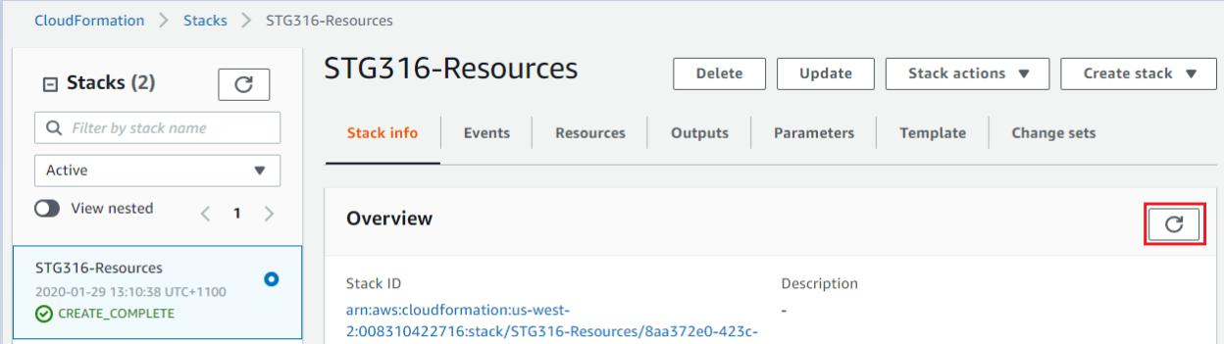

**SUMMARY**

In this module you deployed your base VPC, subnets, security groups, Amazon EC2 instances and the SSH key that that you will use for the remainder of the workshop.

**END OF MODULE 1**