IST 687: Introduction to Applied Data Science
Title: Project Update #1, Federal Aviation Administration (FAA) Wildlife strike Database.
Date: 08/19/2026
Adis Delanovic


Key achievements
- Identified a dataset that I will be working with. This is the Federal Aviation Administration (FAA) Wildlife strike database. Wildlife Hazard Mitigation | Federal Aviation Administration.
- This database contains voluntary wildlife strikes spanning from 1990-present.
- Explored the dataset, read through the data dictionary, identified initial business questions and columns as they relate to them.
- Using the dataset, I was able to generate our first graph plotting strikes over year (excluding 2026) where we see a significant dip during the COVID-19 pandemic as shown in Figure 1.
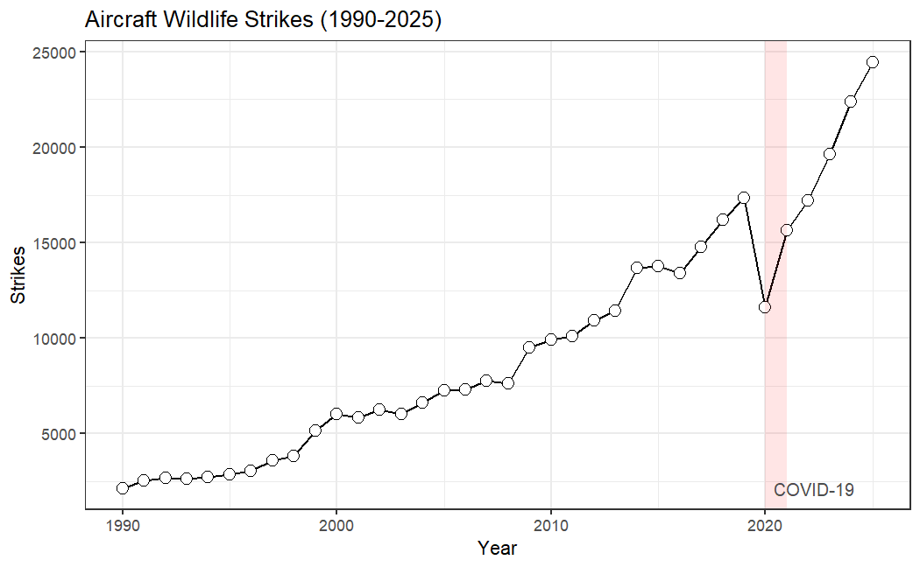
Figure 1 - WIldlife strikes over year

Challenges
- The database is massive and spans over multiple decades. It contains 351,867 rows and 102 columns (~35.9 million data points!). The dataset comes with an extensive data dictionary which helped alleviate this challenge.
- The size of the database is 152 MB. Loading the data into R takes a few minutes and I encountered an errors/warnings where the R identified some columns as the wrong datatype. I.e “Warning Expected numeric”, “Warning Expected logical”.
- I worked through this challenge by exploring how R ingests and assigns data types. My finding was that R goes through a small sample of the data and not all of it. Using “guess_max = nrows” while I loaded the dataset forced R into checking all the rows. This increased loading of the data drastically but I no longer had data type issues.
- The data does not contain all wildlife strikes because it is voluntary reporting.

Business Questions
There are the business questions and columns I’ve identified to be relevant to them. These questions may change or continue to evolve as I explore the dataset.
- Do strikes cluster seasonally, and does the seasonal pattern differ by species group or region? Relevant variables: INCIDENT_MONTH, INCIDENT_YEAR, SPECIES, STATE FAAREGION
- Can we segment airports into risk profiles based on their strike patterns? Relevant variables: AIRPORT_ID, Strike Total, % damaging Strikes, % occurring at night, Seasonality
- Which combination of species, phases of flight, and time of day carry the highest damage risk? Relevant variables: SPECIES, SIZE, PHASE_OF_FLIGHT, TIME_OF_DAY, DAMAGE_LEVEL

- Given conditions known before or at impact, can we predict whether a strike will cause damage? Relevant variables: INDICATED_DAMAGE, SIZE, SPECIES, PHASE_OF_FLIGHT, HEIGHT, SPEED, TIME_OF_DAY, AC_MASS, NUM_ENGS, TYPE_ENG, NUM_STRUCK

Next steps
- Reports come from a wide range of contributors; pilots, mechanics, air traffic controllers, and ground personnel, with no standardized entry process, so records vary in completeness and consistency. Cleaning this is my primary next focus, starting with explicitly specifying column types on import to resolve the datatype errors noted above.
- The dataset has 102 columns; my business questions require roughly 20. I will work from a reduced subset while retaining the full file, since my questions may still evolve.
- Continue exploring and refining business questions ahead of Project Update #2.

Image Credit: Aviation Bird Strikes - Precise Flight

