IST 687: Introduction to Data Science
Title: Project Update #2, Federal Aviation Administration (FAA) Wildlife strike Database.
Date: 09/02/2026
Adis Delanovic


Key achievements
- Explored the dataset in more detail, identifying and understanding the variables more clearly.
- Placed all project files into a GitHub repository
- Developed and deployed a data visualization dashboard based on some of my initial business questions
  - Streamlit – Allows for the visual exploration of the dataset.
  - Leveraged my experience as a Software Developer as well as Anthropic Claude Code. Note: All the other analysis for the graphs/charts will be done in R and in alignment with the course material. I just really wanted to do this part as an addition.
  - I fixed an issue where Streamlit app was crashing due to a caching issue that was exceeding the websites 1GB free tier allotment.
  - Dashboard GitHub: adelanovic/IST687_FAA_Dashboard: FAA Wildlife strike dashboard.
    - The GitHub contains the Claude Prompt used to generate this.
- R Files GitHub: adelanovic/IST687_FAA_Wildstrikes: Class project for IST687
  - Generated several charts exploring some of my business questions as shown in Figure 1 and Figure 2
  - Explored the data to figure out how much of it was missing and where the gaps are.
  - Everything is organized and easy to follow
- Got more comfortable with R.
  - Learned about mutate(), saveRDS/loadRDS, twimws(), saving and loading CSV data, creating plots, binning/ordering/factoring things into categories.
  - Using the %>% pipe/tidyverse methods more often and clearly
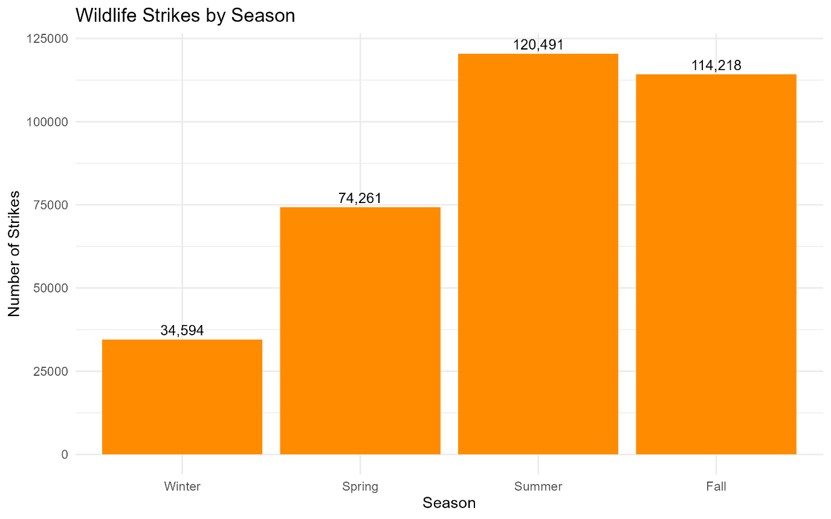
Figure 1 - Wildlife Strikes by Season
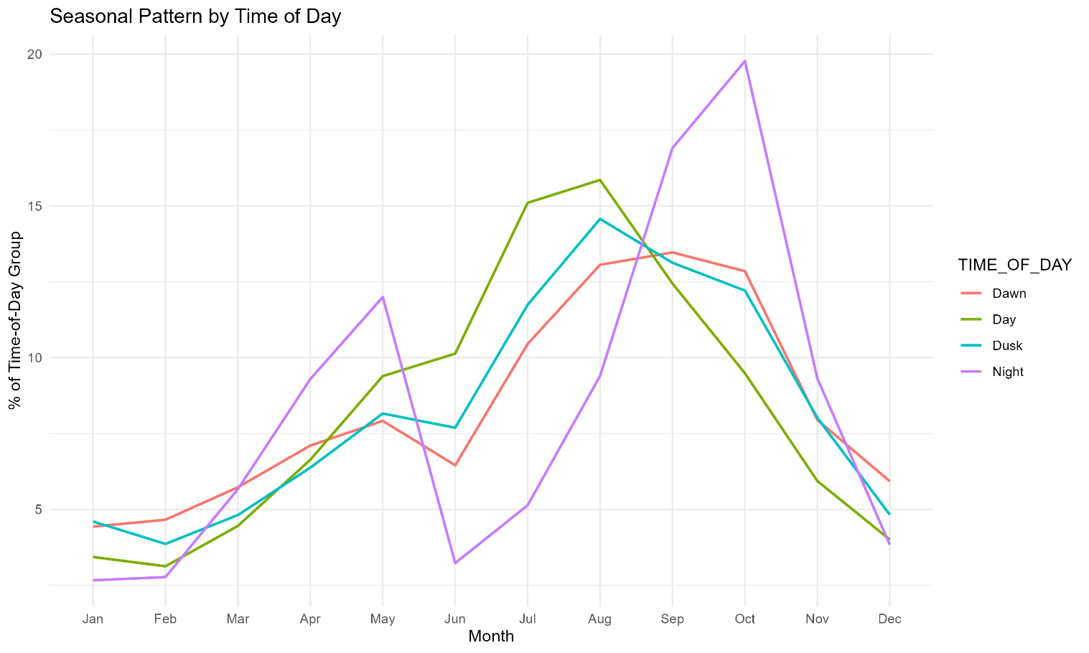
Figure 2 - Wildlife Strikes by Time of Day

Challenges
- The “SPECIES” column contains over 900+ species.
- Self-reported data and some of the names of the species are inconsistent
  - Example: “Eastern” vs “tern”
- There are a lot of missing values. This is all due to no required reporting/everything is voluntary.
  - TIME_OF_DAY: 153k missing
  - FAAREGION: 47k missing but AIRPORT_ID has 0 missing.
  - INCIDENT_MONTH, YEAR, SPECIES has 0 missing
    - SPECIES has a lot of “Unknown” categorized to “Unknown bird – small, medium” totaling up to approximately 130k~ values.
  - PHASE_OF_FLIGHT has 138k missing and TIME_OF_DAY has 153k missing values.
  - Several other fields have these same issues, but these are the ones that are impacting me the most at the moment.

Next steps
- Continue cleaning and working through the data. I have a good understanding of what it contains now and where the gaps are
- Refine my business questions as necessary depending on my findings
- Improve generated/charts and graphs and start to do some analysis for the final word document
- Start planning on can be done with neural networks/deep learning/logistic regression/SVM models/rpart regarding some of my prediction business questions.

Image Credit: Aviation Bird Strikes - Precise Flight

