Aviation Wildlife Strike Risk
An analysis of FAA Wildlife strike reports
Adis Delanovic
09/21/2026
IST 687: Introduction to Data Science

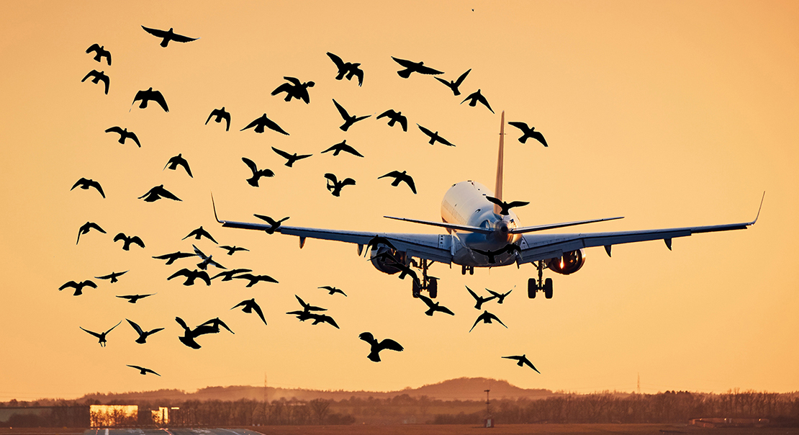

Executive Summary
This project examined when wildlife strikes are reported, which wildlife and strike conditions are associated with aircraft damage, how airports and regions compare, and whether two classification models can predict damage. The analysis combines data cleaning, seasonal comparisons, relative location scores, species and strike-condition comparisons, and classification models.
The original export contained 351,867 reports and 102 columns. Cleaning produced 351,859 records and 42 fields. Most descriptive comparisons use the 343,560 reports from 1990 through 2025, excluding the incomplete 2026 year. Missing information and broad wildlife labels were the largest preparation challenges.
Reported strikes were concentrated from July through October. White-tailed deer produced the most damage reports among named species, while mule deer had the highest eligible species damage rate. Deer also dominated the highest-rate combinations of wildlife group, flight phase and time of day.
Airport profiles combined damage-rate and recent-report-volume percentiles with equal weights. AEA (Eastern) and ASO (Southern) tie for the highest score at 68.8, and are the only two regions in the High band. The rpart model detected 57.5% of damaging test strikes, compared with 42.8% for SVM. Both models missed many damaging events, even though their overall accuracies were 86.0% and 92.4%.
The main recommendations are to concentrate additional mitigation during the busiest reporting months, examine high-scoring locations more closely, improve runway deer control, and improve the completeness and consistency of wildlife-strike reporting and species identification.
GitHub Source: Project repository

Project Background and Questions
Wildlife-strike reports provide a way to study patterns across many years, locations and operating conditions. They also create a practical data-science challenge: the reports come from different contributors, contain uneven detail, and do not cover every strike. A high report count can reflect traffic volume or reporting practices as well as wildlife activity.

Business Questions
The project asked four questions: When are reported wildlife strikes most common, and how do seasonal patterns vary by time of day? Can airports be organized into relative risk profiles? Which combinations of wildlife group, flight phase and time of day have the highest damage rates? Can conditions recorded around a strike predict whether damage occurred?

Growth in Reported Wildlife Strikes
In the annual trend chart, reported strikes rise from 2,120 in 1990 to 24,459 in 2025, while damaging reports rise from 371 to 904. Both are single-year totals, not cumulative counts across the dataset. Reported strikes in 2025 are about 11.5 times the 1990 figure; damaging reports are about 2.4 times. These are endpoint comparisons and not yearly growth rates.
The two series grow at very different speeds, and that gap is itself informative. The share of reports involving damage fell from 17.5% in 1990 to 3.7% in 2025.
Neither the trend nor its fitted line establishes why reports increased. Reporting behavior, awareness, air traffic volume, and wildlife populations could all contribute. The project did not use flight-volume data to separate those explanations.
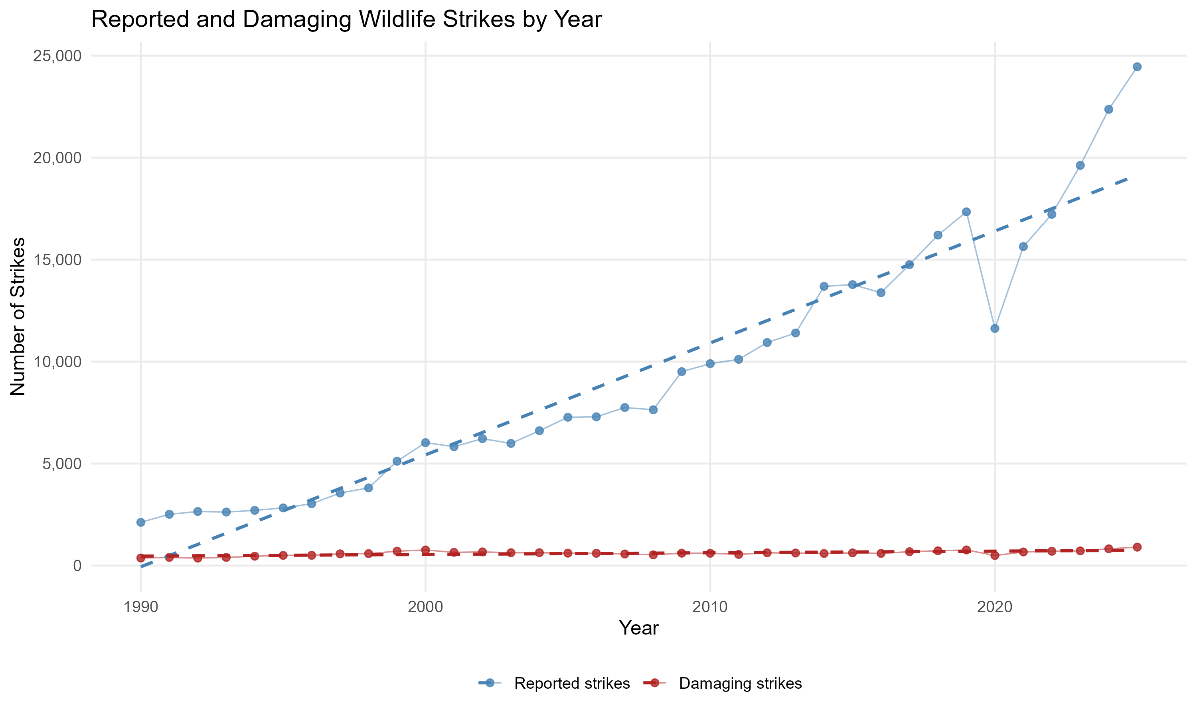
Figure 1. Annual reported and damaging strikes, 1990-2025

Data preparation and missing information
The original dataset contained 351,867 strike reports and 102 columns. After removing eight records with duplicate incident identifiers, the cleaned dataset contained 351,859 reports and 42 columns: 35 original fields retained from the source data and seven derived fields. The incomplete 2026 reporting year is retained in the cleaned file and excluded at the analysis stage.

Basic cleaning
The cleanup script imports selected fields as text before explicitly converting numeric and date fields. It removes extra spaces and standardizes missing-value markers. Height values outside 0-60,000 feet and speed values outside 0-700 are replaced with missing values. The original species names remain available alongside the grouped field.
I selected the business questions and relevant fields after reviewing the data dictionary. I used AI to check, simplify, and improve the R code, then reviewed the outputs and decided which changes to keep. I saved the cleaned dataset so the analysis scripts could reuse it.
INDICATED_DAMAGE supplies the binary outcome. DAMAGED expresses it as Yes or No. Question marks are removed from DAMAGE_LEVEL codes, and a missing damage-level value becomes N only when INDICATED_DAMAGE indicates no damage. Missing predictors are not used to invent a damage outcome.

Time-of-day recovery
TIME_OF_DAY was missing for 153,368 cleaned records. Where a usable incident TIME existed, the script compared it with approximate monthly sunrise and sunset cutoffs. It assigned Dawn for the 30 minutes before sunrise, Day between sunrise and sunset, Dusk for the 30 minutes after sunset, and Night otherwise. Existing time-of-day reports were retained.
This recovered 38,189 values: about 24.9% of the original missing values. Missingness fell from 43.6% to 32.7%, a reduction of 10.9 percentage points. The remaining 115,179 records lacked usable time information. An earlier blank-time-to-midnight conversion was corrected so blank times no longer become Night.
I chose to use recorded times where available and leave unusable records blank. AI supplied the approximate monthly sunrise/sunset cutoffs and helped implement the conversion function. The same cutoffs are applied across airports, so the filled labels are approximate rather than locally calculated. I used TIME_OF_DAY_FILLED for descriptive time-of-day and combination analyses; the models use the original TIME_OF_DAY field with training-derived imputation.

Airport and region information
AIRPORT_ID had no blank values, but 47,669 records used ZZZZ, meaning an unknown airport. FAAREGION was missing in 47,746 records in both the original and cleaned data. The script attempts recovery from other reports for the same known airport, but this did not reduce the region-missing count. Unknown airports are excluded from airport summaries, not from every analysis.

Source: Data cleanup script
Source: AI Usage Statement: time-of-day filling and data preparation

Wildlife and flight-phase groups

Wildlife grouping and review
There are 974 distinct species labels, including exact species names, broad labels such as Gulls, and unknown categories. To make models and group-level comparisons manageable, the project uses 17 groups.
AI helped propose categories and write the grouping rules. I reviewed the most common assignments against taxonomy and corrected seven errors involving microbats and several swallow labels. The final cleanup uses an exact-name lookup, preserves the original species labels, and marks unmatched labels as Needs review.
Groups include Bats, Deer, Other mammals, Reptiles & amphibians, Raptors, Gulls & terns, Waterfowl, Wading birds, Shorebirds, Seabirds, Doves & pigeons, Corvids, Upland game birds, Perching birds, Other birds, Unknown and Unknown bird. Coots and rails are included in the broad Wading birds bucket, not Waterfowl. The existing Deer bucket also includes certain other large grazing animals.

Four flight-phase groups
Group | Original flight phases
Ground | Parked; Taxi
Departure | Take-off Run; Climb; Departure
Arrival | Approach; Descent; Landing Roll; Arrival
En route | En Route; Local

PHASE_GROUP is derived from the reported flight phase. A separate PHASE_GROUP_FILLED field uses height of zero for Ground or at least 1,500 feet for En route when phase is missing. Only 213 values were recovered. When flight phase was missing, height and speed were almost always missing too: 138,370 of 138,759 records, or 99.7%, lacked both. Speed alone was not used to determine a phase.
The final models and combination analysis use PHASE_GROUP, not the height-filled version. Species groups are also used for seasonal comparisons. Individual-species rankings keep original species labels, while airport scores do not use wildlife group or phase group.

Source: Grouping and derived fields in the cleanup script

Seasonality and approximate migration periods
The final seasonal comparisons use 343,560 reports from 1990-2025. August has the most reports (48,114), followed by September (46,595), October (43,782) and July (43,710). Together, July through October account for 53.0% of these reports. February has the fewest, at 10,372.
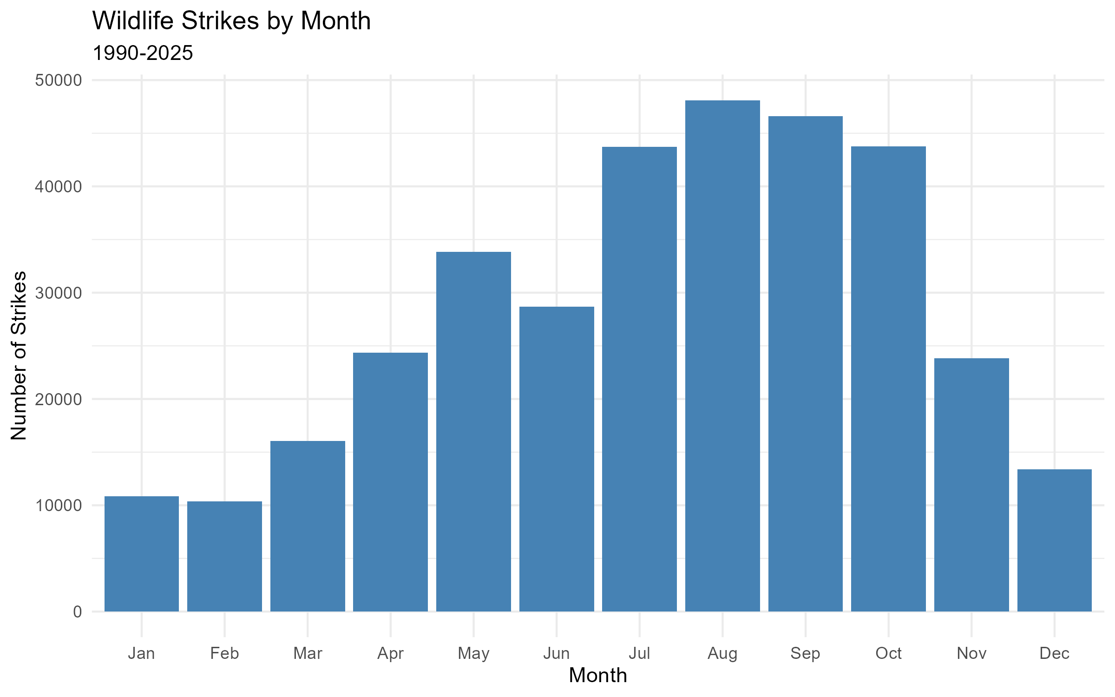
Figure 2. Monthly report totals, 1990-2025

Seasonal and approximate migration periods
Calendar seasons and migration periods answer slightly different descriptive questions. Calendar seasons use Winter (December-February), Spring (March-May), Summer (June-August) and Fall (September-November). Summer accounts for 35.1% of reports and fall for 33.2%.

Approximate period | Months | Reports | Share
Winter | December-February | 34,594 | 10.1%
Spring migration | March-June | 102,925 | 30.0%
Summer/breeding | July | 43,710 | 12.7%
Fall migration | August-November | 162,331 | 47.2%

These are fixed, non-overlapping month bins, not observations of actual migration. June is assigned to spring migration so it is counted once. The periods have different lengths, and the data include nonmigratory birds and non-bird wildlife. The results therefore cannot establish that migration caused a specific strike.
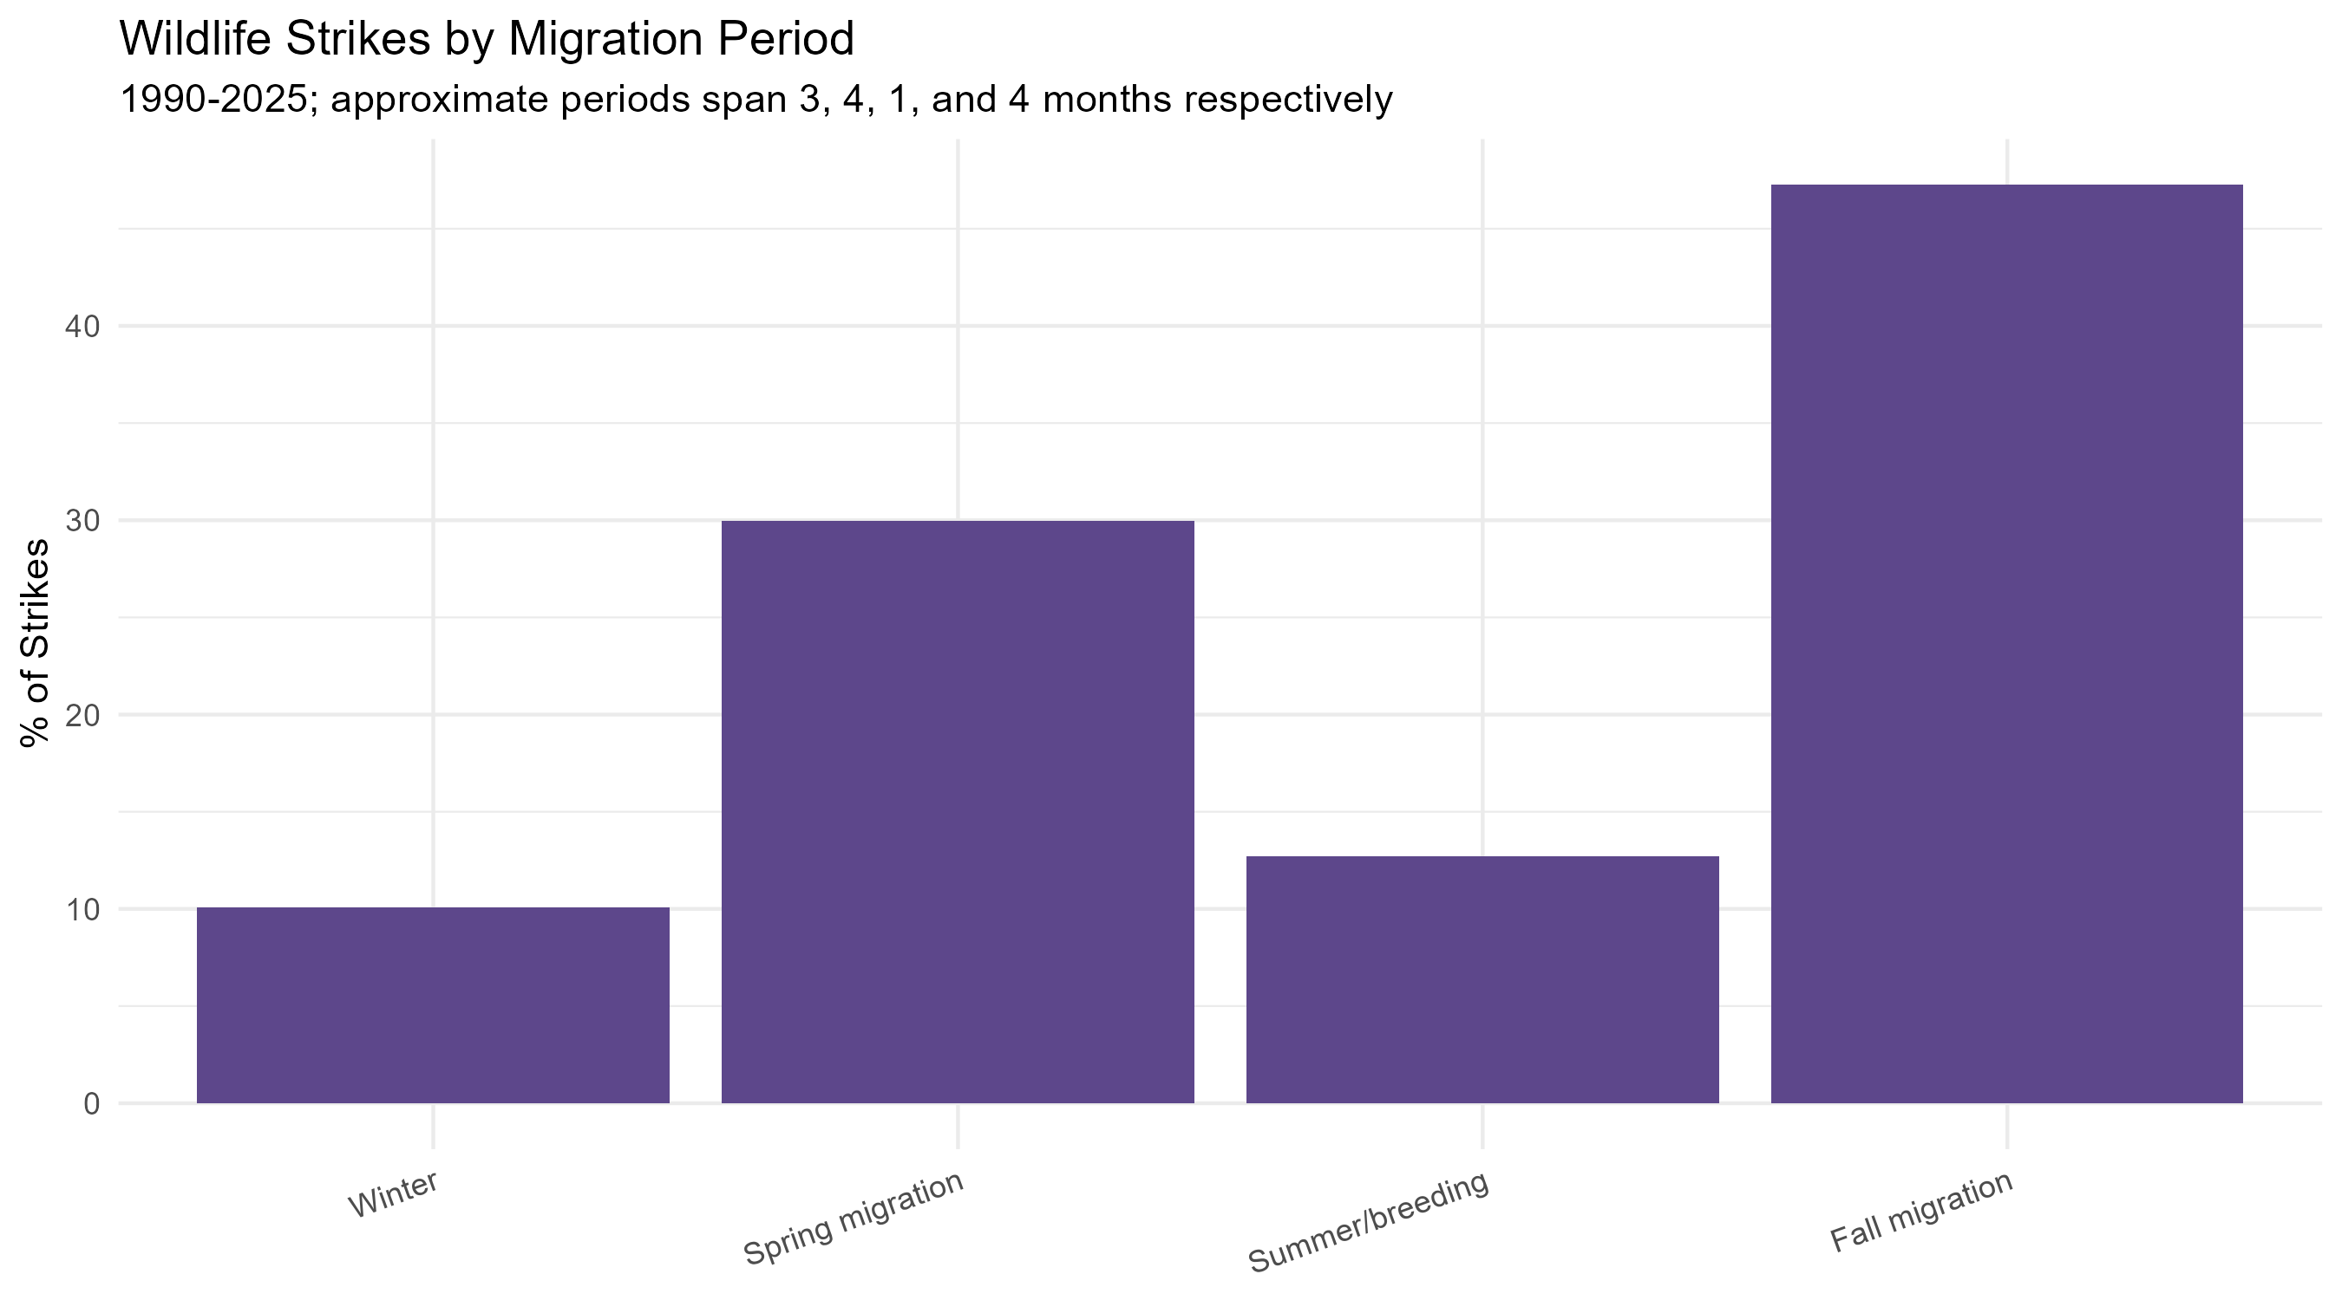
Figure 3. Reported strikes by approximate migration period

Seasonal pattern by time of day
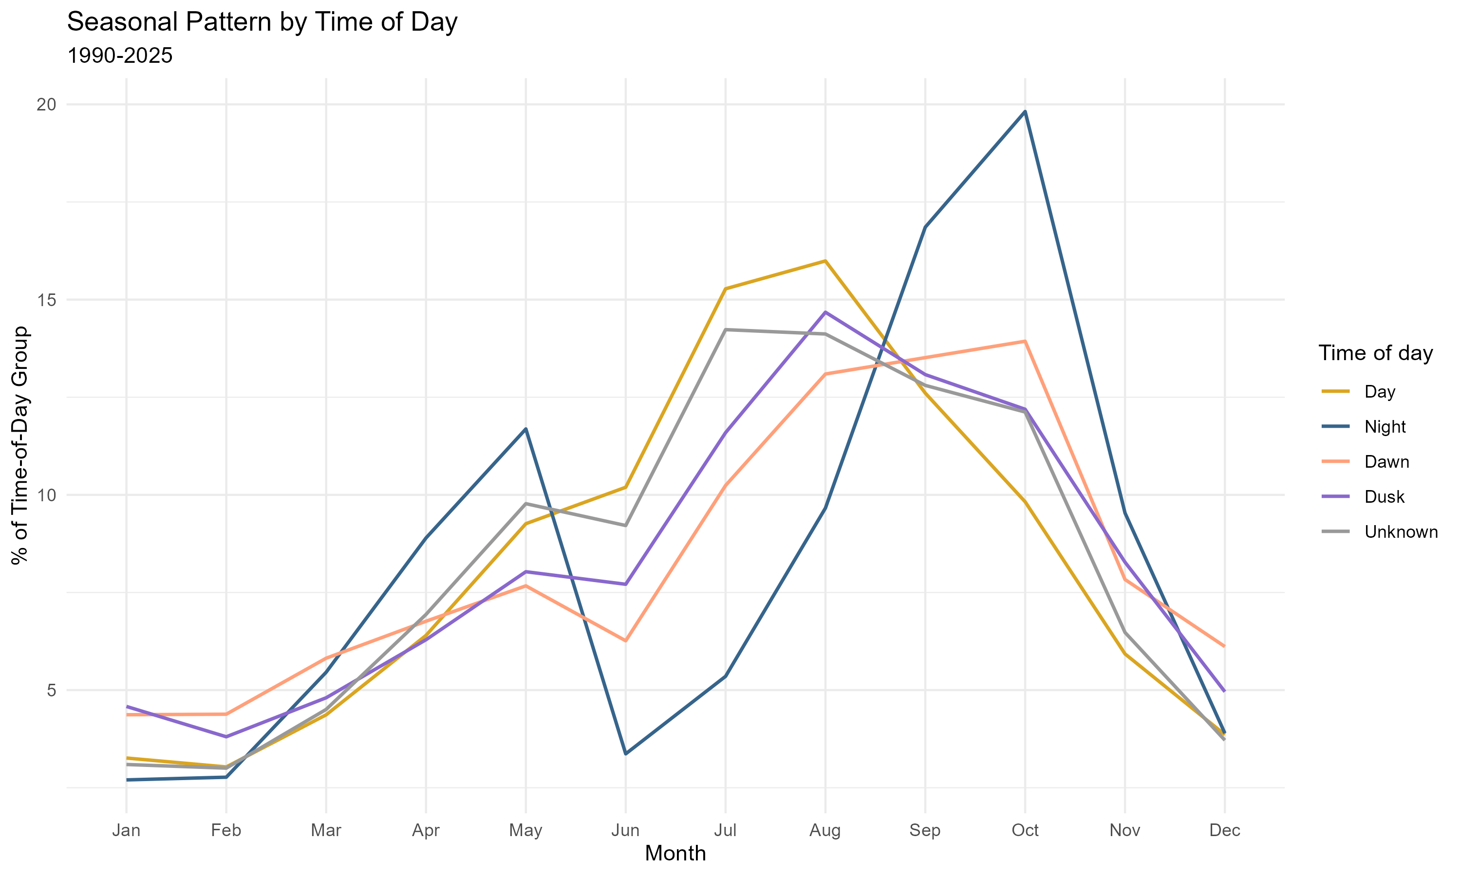
Figure 4. Monthly distribution within each time-of-day category, using the cleaned time-of-day field
The time-of-day seasonality chart normalizes each line within its own time category. A value of 10% for Night in one month means 10% of all night reports occurred then, not that 10% of that month’s reports were at night. This also explains why seasonal lines cannot be read as overall Day-versus-Night totals. Each line is scaled to its own category total, so Dawn and Dusk appear as prominent as Day despite representing far fewer reports. Daytime reports peak in August, while nighttime reports peak in October. October accounts for approximately 19.8% of nighttime reports, compared with August’s 16.0% share of daytime reports.

Source: Seasonality and migration-period analysis
Source: Monthly report totals

Wildlife damage counts and rates
The three species charts separate broad or unknown labels, named-species damage counts, and named-species damage rates. This prevents labels such as Gulls from being treated as one exact species and keeps how often a species causes damage distinct from how likely damage is when it is struck.

Broad and unknown groups
Unknown bird - medium has 4,608 damage reports, followed by Unknown bird (1,631), Unknown bird - large (1,457) and Unknown bird - small (1,424). Gulls lead the broad wildlife labels with 1,167 damage reports. These are original report labels, not the analytical groups created during cleaning. They show how much damage reporting lacks exact identification.
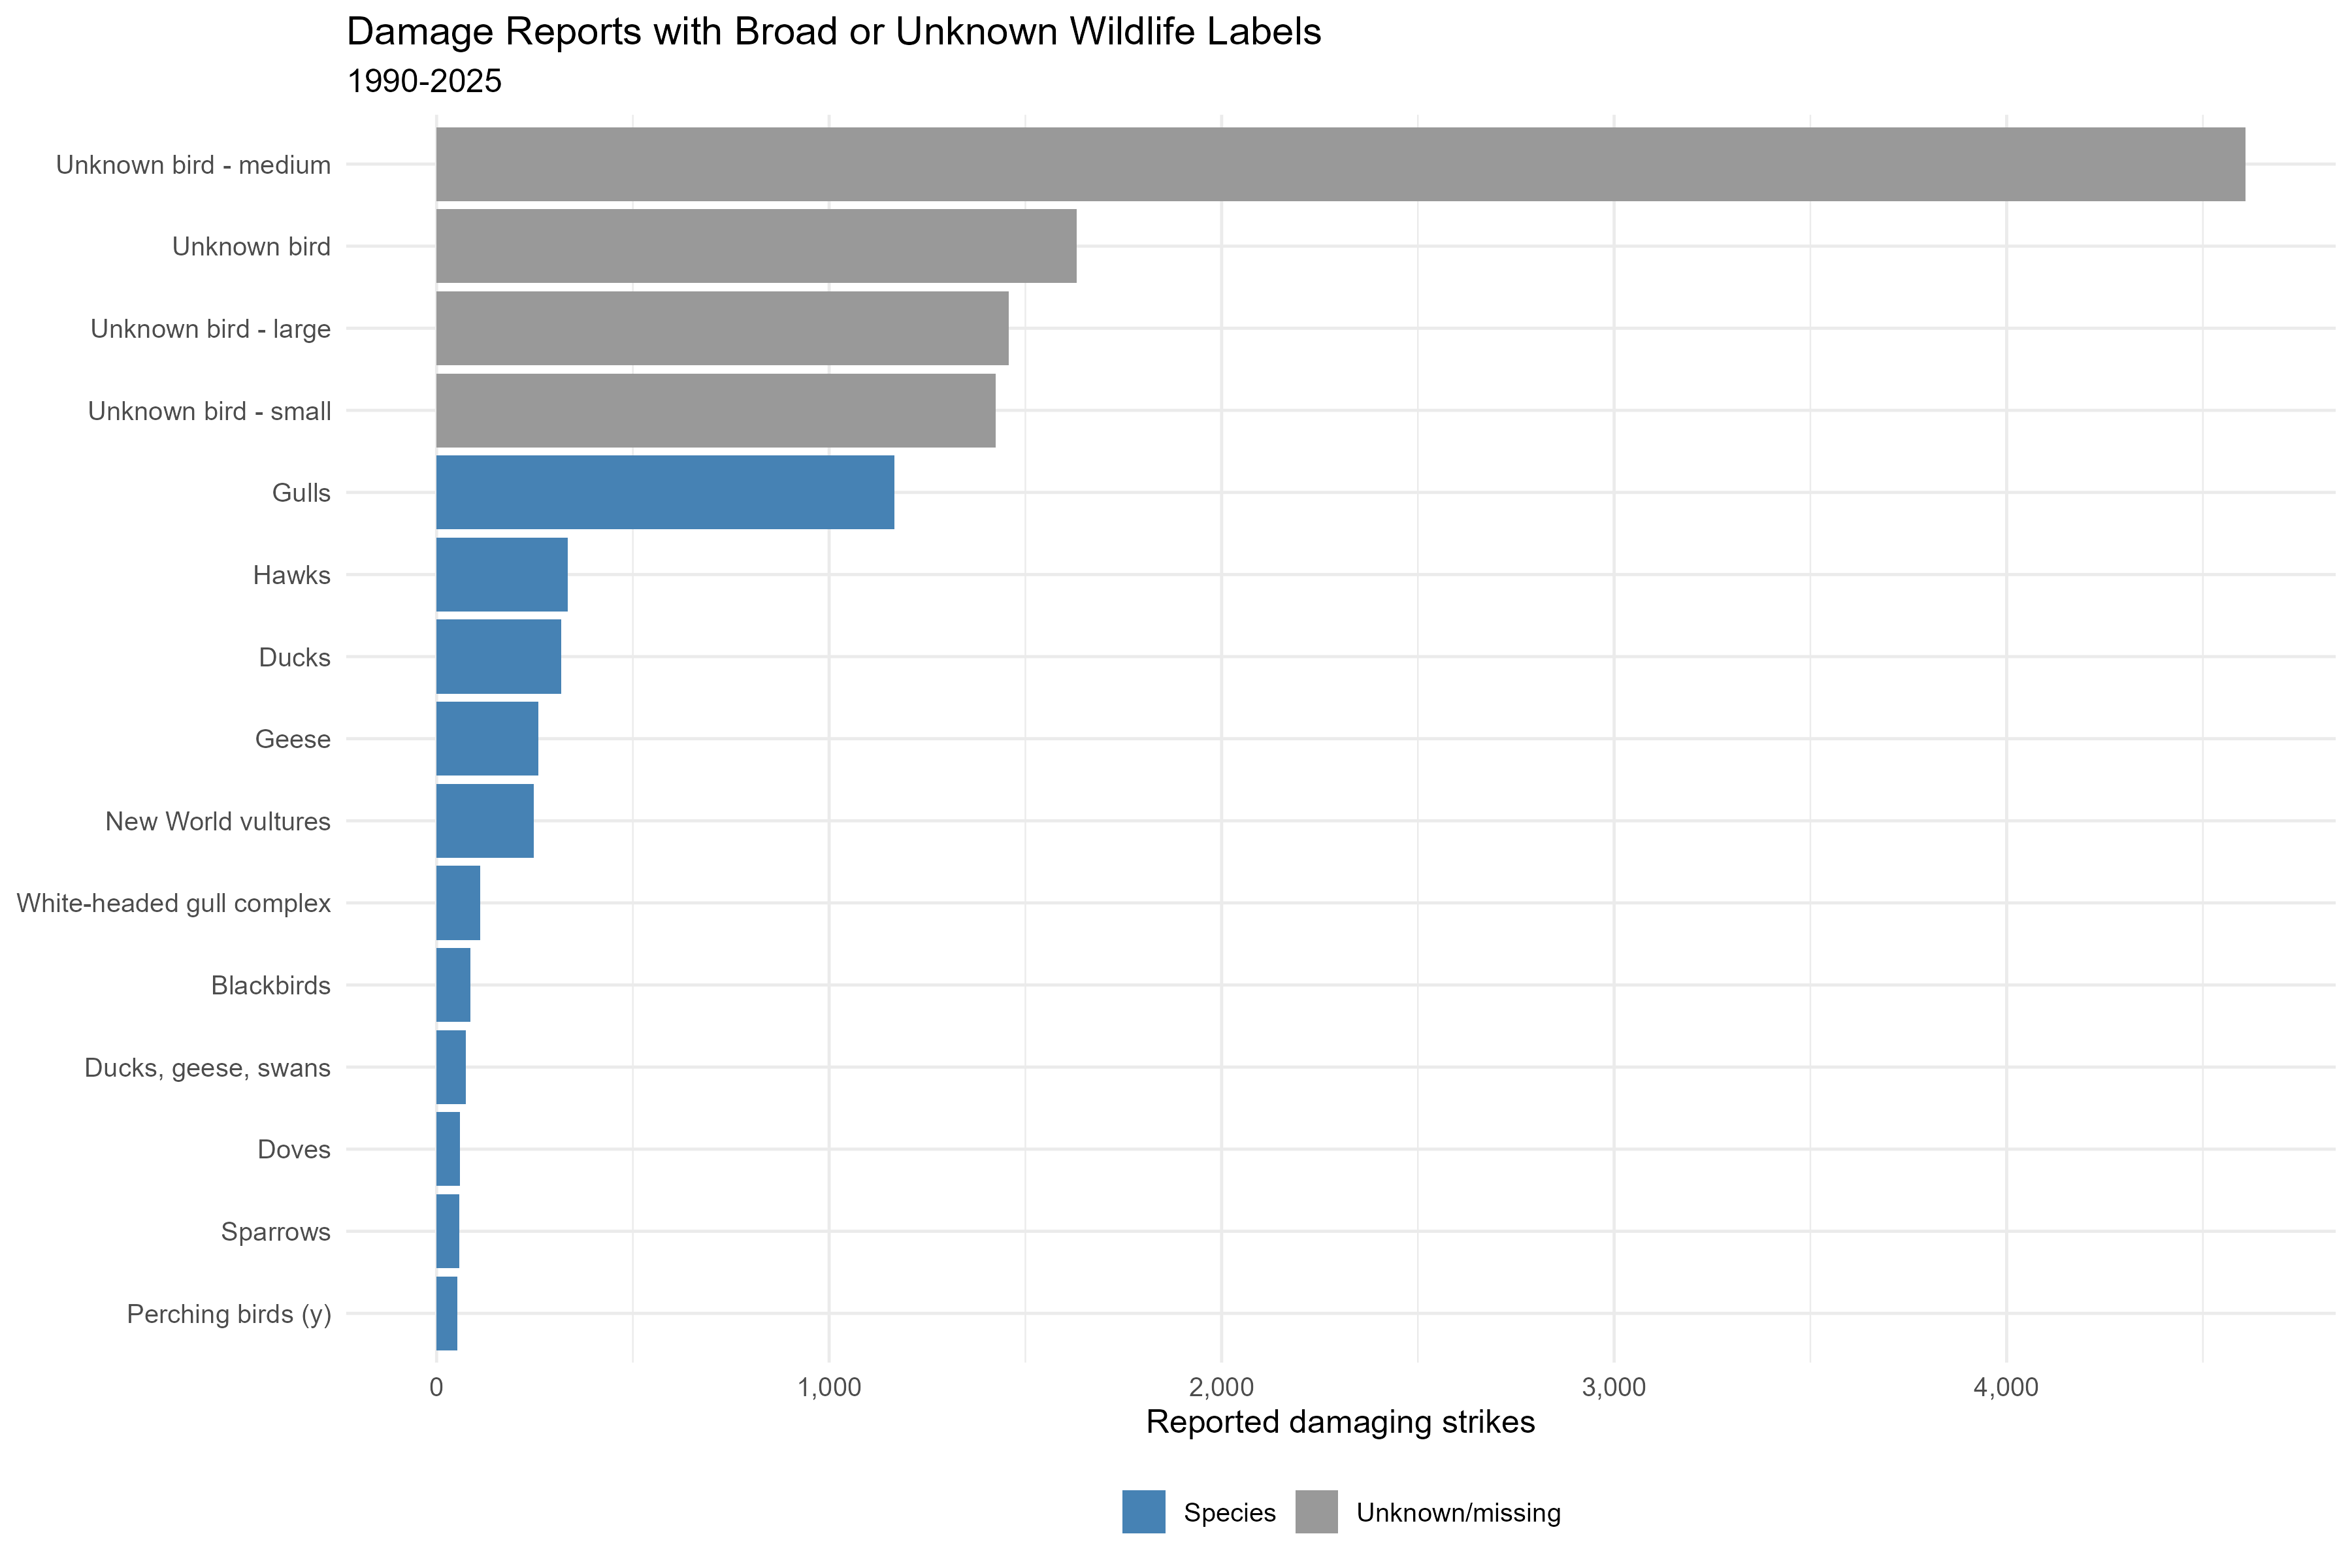
Figure 5. Damage reports recorded under broad or unknown wildlife labels

Individual-species damage counts
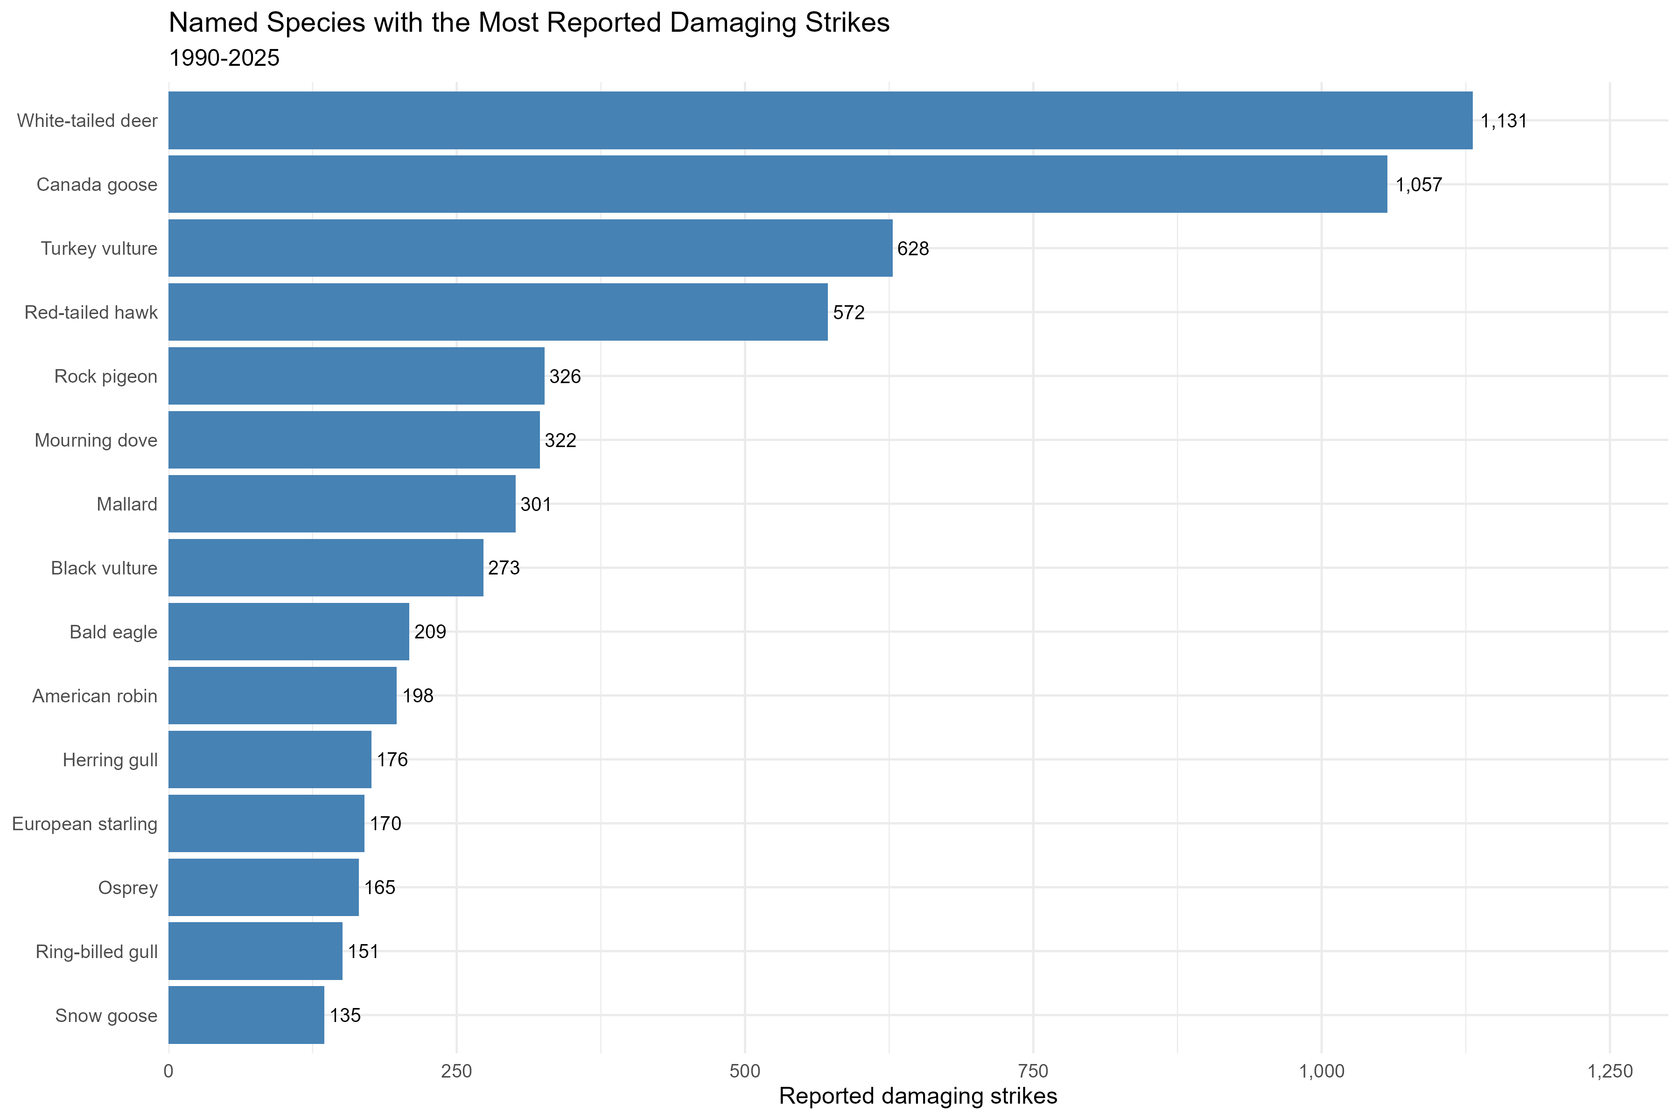
Figure 6. Named species ranked by number of damaging reports.
Among named species, White-tailed deer (1,131), Canada goose (1,057) and Turkey vulture (628) have the most damaging reports. This is a count of damaging strikes, so it reflects both how likely a species is to cause damage and how often it is struck at all. The rate chart that follows separates those two things, dividing each species' damaging strikes by its reports with a known damage outcome.

Individual-species damage rates
Species | Damage reports | Known outcomes | Damage rate
White-tailed deer | 1,131 | 1,383 | 81.8%
Canada goose | 1,057 | 2,300 | 46.0%
Turkey vulture | 628 | 1,335 | 47.0%
Mule deer | 79 | 93 | 84.9%
Snow goose | 135 | 205 | 65.9%
White-tailed deer, Canada geese and Turkey vultures lead the damage-count ranking. Mule deer, white-tailed deer and snow geese lead the damage-rate ranking, which requires at least 30 reports with a known outcome. For mule deer, 79 divided by 93 gives 84.9%; the other 14 reports indicated no damage.
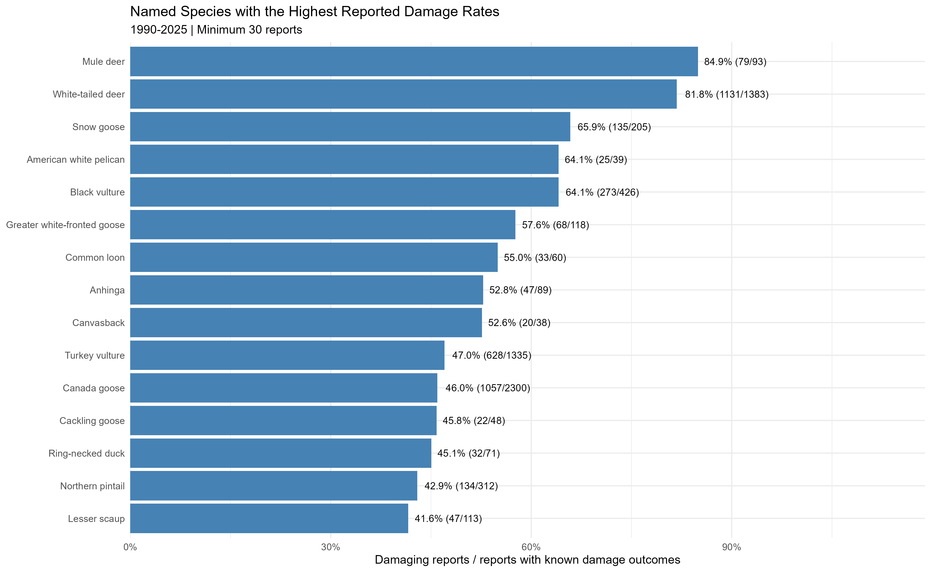
Figure 7. Highest eligible named-species damage rates, 1990-2025. Labels show damage reports / known outcomes.
Source: Individual-species damage rankings

Damage combinations
The combination analysis uses wildlife group, the four reported flight-phase groups, and filled time of day. Records missing any of these are excluded, retaining 194,690 of 343,560 reports from 1990-2025, or 56.7%. The exclusions are driven almost entirely by missing flight phase and missing time of day; no records were dropped for an unreviewed wildlife group or an unknown damage outcome. Unknown wildlife identities remain eligible. Of the 242 observed combinations, 122 meet the 30-report minimum, and combinations with no damaging strikes are retained.
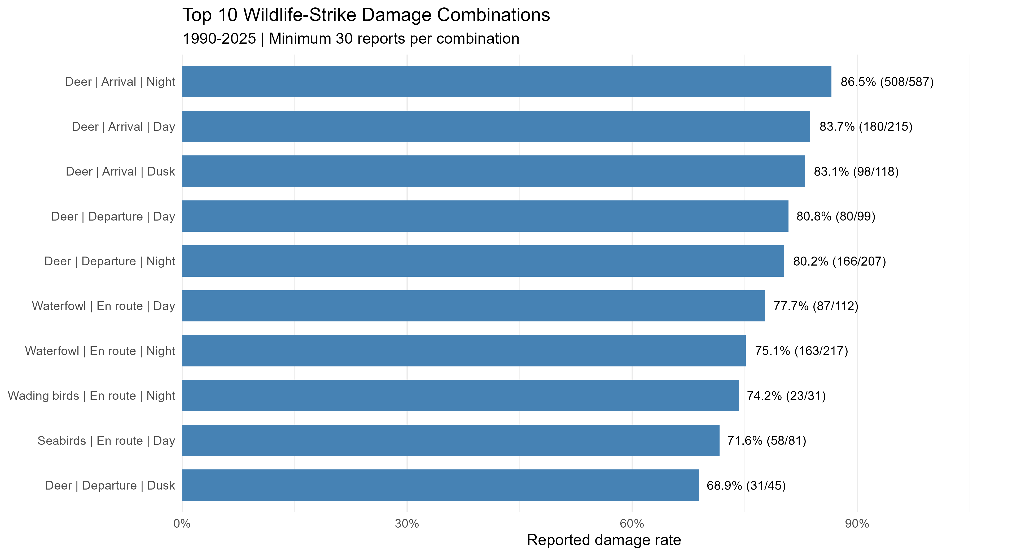
Figure 8. Highest damage-rate combinations across all wildlife groups. Labels show percentage and damaging / total reports.
All six deer combinations that meet the minimum rank in the top ten, with rates from 68.9% to 86.5%. Deer had high damage rates across several flight phases and times of day. Arrival at night leads at 86.5% (508 of 587), followed by arrival during the day at 83.7% (180 of 215) and at dusk at 83.1% (98 of 118). High deer rates also occur during departure. The pattern is therefore not limited to nighttime.
Waterfowl during en-route flight show rates of 77.7% in the day and 75.1% at night. These are associations within reported strikes, not causal effects of time or flight phase. Small eligible combinations still need caution; for example, Wading birds / En route / Night has only 31 reports.

Damage-rate heatmap: the five most reported groups
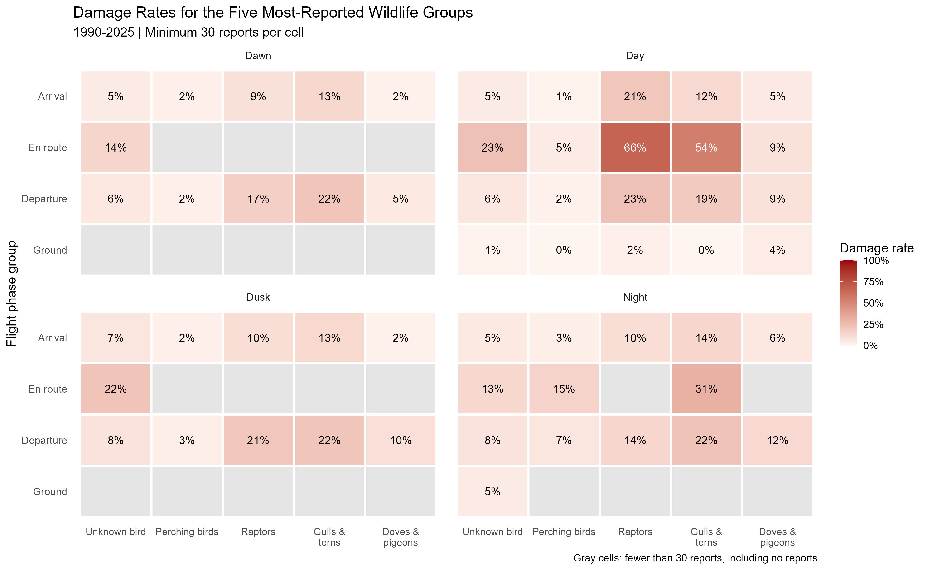
Figure 9. Damage rates by flight phase and time of day for the five most-reported wildlife groups.

The heatmap first selects the five most-reported groups in the complete-case analysis: Unknown bird, Perching birds, Raptors, Gulls & terns, and Doves & pigeons. It then displays their rates by phase and time. Deer, waterfowl, and seabirds hold most of the top-ten combinations but are too infrequent to make the heatmap. Raptors during daytime en-route flight have a 66.1% damage rate (329/498), and gulls and terns have 54.2% (96/177). Gray cells represent fewer than 30 reports, including no reports, rather than zero damage.
Unknown-bird combinations were not automatically excluded. Their highest eligible rate is 23.3% for daytime en-route flight (444/1,903), ranked 32nd overall. Many damage reports can coexist with a lower damage rate when the denominator is large.

Source: Prepare grouped strike combinations
Source: Rank grouped damage combinations
Source: Grouped damage-rate charts and heatmap

Airport profiles and scoring method
Reports were summarized by known AIRPORT_ID, producing records for 2,770 airports after excluding ZZZZ. Each airport summary includes its name and location, total strikes, damaging strikes, damage rate, and recent strike activity.

Equal weighting
Each airport’s score combines two equally weighted measures: its damage-rate percentile and its recent-strike-count percentile, calculated among the 663 airports with at least 20 reports. These percentiles show how an airport ranks compared with the other eligible airports, not its probability of a damaging strike. The two percentile values, expressed from 0 to 1, are averaged, multiplied by 100, and rounded to one decimal place.
For example, an airport in the 80th percentile for damage rate and the 60th percentile for recent strikes scores 70: 100 * (0.50 * 0.80 + 0.50 * 0.60). A score of 67 or above is High, a score of 33 or higher but below 67 is Moderate, and below 33 is Low. I chose these cutoffs; they are not FAA standards.

Airport profile | Number of airports
High | 75
Moderate | 499
Low | 89
Limited data | 2,107
Total | 2,770
Only 663 airports meet the minimum of 20 reports and receive a score. The remaining 2,107 are labeled Limited data.

Examples from the airport ranking
Airport | Score | Reported strikes
Sacramento International | 85.9 | 4,263
Executive Airport, Orlando Florida | 82.1 | 310
Naples Municipal | 80.3 | 197
Salt Lake City International | 79.8 | 4,367
Joe Foss Field Airport | 79.8 | 488

Higher scores indicate higher relative damage rates, recent activity, or both. The airport pipeline stops at 2025, the same range used for the descriptive charts, so airport totals and the monthly and seasonal figures cover identical years. The recent-activity component uses 2021-2025, five complete calendar years.

Source: Airport-level aggregation
Source: Risk-score calculation and maps

State and FAA-region results
Both maps pool damaging and total reports within each area before calculating rates and ranking the two score components. They do not average airport risk scores. State percentiles are computed among states plus DC, while region percentiles are computed among nine FAA regions. Scores from the two maps therefore use different comparison sets. Both maps cover the 50 states and DC only. Airports outside that set, mostly foreign locations, are excluded, so map totals are lower than the full airport dataset.
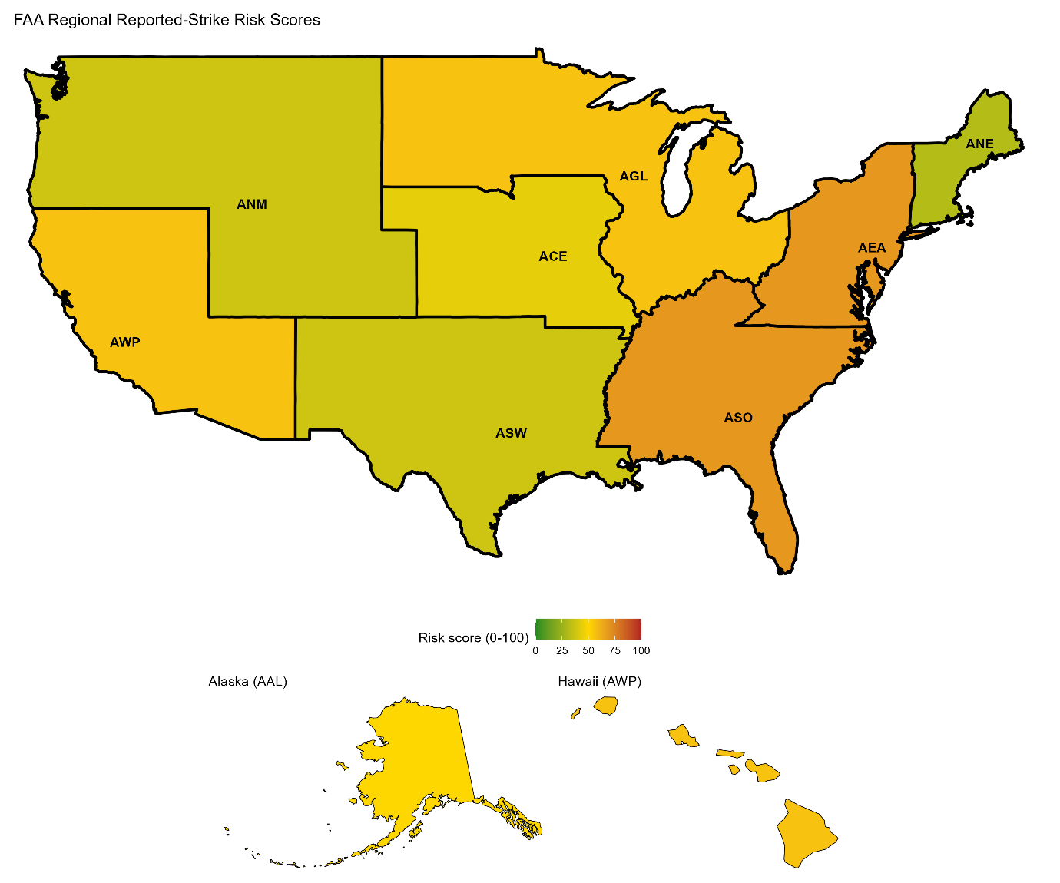
Figure 10. FAA-region relative reported-strike scores, including Alaska and Hawaii

AEA (Eastern) and ASO (Southern) tie for the highest score at 68.8 and are the only two regions in the High band. AGL (Great Lakes) and AWP (Western-Pacific) follow, also tied, at 56.2. ANE (New England) is lowest at 31.2 and the only region rated Low. AEA combines a 6.61% damage rate with 9,383 recent reports; ASO has a lower damage rate of 5.72% but the most recent reports of any region, 20,993.
Alaska had the highest reported damage rate at 12.97%, approximately twice the Eastern Region’s rate, but only 399 recent reports. Its score is therefore 50.0. This illustrates why the highest damage rate alone does not guarantee the highest combined score.

State-level results
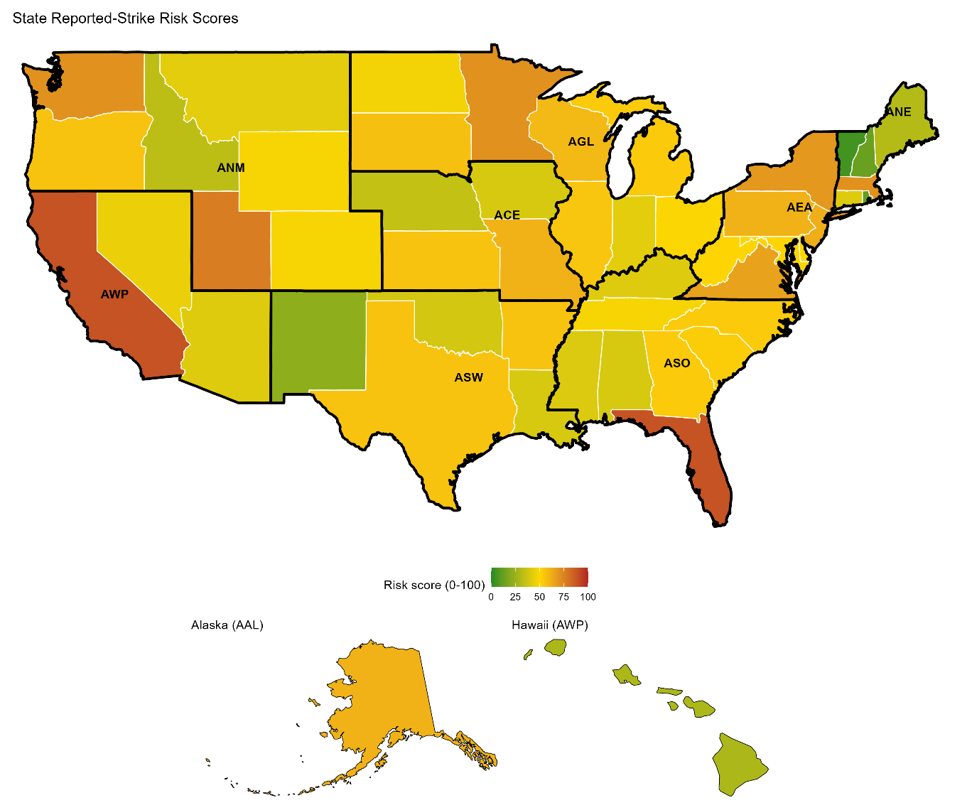
Figure 11. State-level relative reported-strike scores, including Alaska and Hawaii.
California and Florida tie for the highest state score at 89. The other High-band states are Utah (77), Massachusetts, Minnesota and Washington (all at 71), and New York (69). Utah scores High while its region, ANM, scores only Moderate, because regional pooling and the different comparison sets change the ranking. State outlines are dissolved into FAA regions for the regional map.

Source: FAA-region scores
Source: State scores

Damage-prediction methods
The target is whether a reported strike involved aircraft damage. rpart builds a decision tree using a sequence of splits; SVM separates the classes using several predictors together. Neither model predicts whether a flight will strike wildlife, and some inputs, such as species identity, may only become available after investigation.

Training and testing
Both models were trained on a random sample of 12,000 reports from 1990-2020, drawn from 244,242 eligible records, and tested on all 46,829 eligible reports from 2024-2025. This date-based split evaluates the models on later records than they were trained on.
The smaller training sample kept fitting times manageable. The 52,489 records from 2021-2023 are not used in the final training or test scripts.

Predictors and missing values
Shared preparation includes size, species group, phase group, original time of day, engine type, number struck, warning status, incident month, height, speed and number of engines. Numeric missing values use medians from the training sample. Missing or unseen categorical values use the training mode. These are replacements for modeling, not recovered observations.
I selected the models, ran them and reviewed their output. AI helped explain functions, check code and suggest a smaller training sample when fitting was slow. Imputation rules are learned from training data rather than from the test outcomes, keeping the later test records separate from model preparation.
Categorical indicators encode groups as separate numeric columns. NUM_STRUCK uses ordered values for the bands 1, 2-10, 11-100 and more than 100; those values represent bands, not exact animal counts. The models do not use AC_MASS in the final predictor set.

Rpart configuration
The tree uses size, height, speed, original time of day, number struck, species group and phase group. I kept the tree relatively small so its decisions would be easier to interpret. The model places a larger penalty on missed damaging strikes than on false damage warnings. Exact settings are available in the linked R script.

SVM configuration
SVM uses the full prepared predictor set with a radial kernel and scaled inputs. I weighted the damaging class by the ratio of non-damaging to damaging training reports, giving more attention to the less common outcome. The training sample is drawn with a fixed random seed, so both models train on the same 12,000 reports and rerunning the scripts reproduces the same results. Exact settings are available in the linked R script.

Source: Model preparation, encoding and imputation
Source: rpart model
Source: SVM model

Model results and interpretation

Actual outcome | rpart: No | rpart: Yes | SVM: No | SVM: Yes
No damage | 39,274 | 5,829 | 42,513 | 2,590
Damage | 734 | 992 | 988 | 738

Metric | rpart | SVM
Accuracy | 85.99% | 92.36%
Damage recall | 57.47% | 42.76%
Balanced Accuracy | 72.28% | 68.51%

Recall is the share of actual damaging strikes detected. Accuracy is the share of all correct classifications; balanced accuracy averages the detection rates of the two classes. The rpart model achieved a balanced accuracy of 72.28%, compared with 68.51% for SVM. Although SVM had higher overall accuracy, rpart performed better when both outcomes were given equal importance.

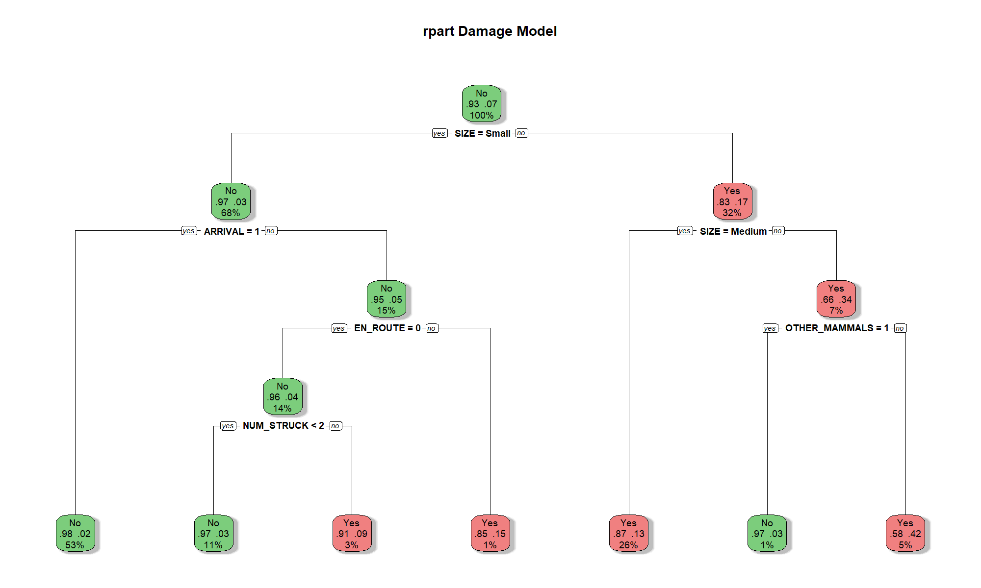
Figure 12. Final rpart tree.
Wildlife size forms the first split. Medium or large wildlife are generally associated with greater damage likelihood than small wildlife, with later splits refining the result.
rpart detects 992 of 1,726 damaging test strikes, while SVM detects 738. rpart catches more damage but raises more false alarms. SVM has higher accuracy but misses more damaging strikes. An always-No model would be 96.31% accurate because 45,103 test reports have no damage, yet it would detect none of the damaging reports. This is why overall accuracy alone is misleading.

Reading the SVM confusion matrix
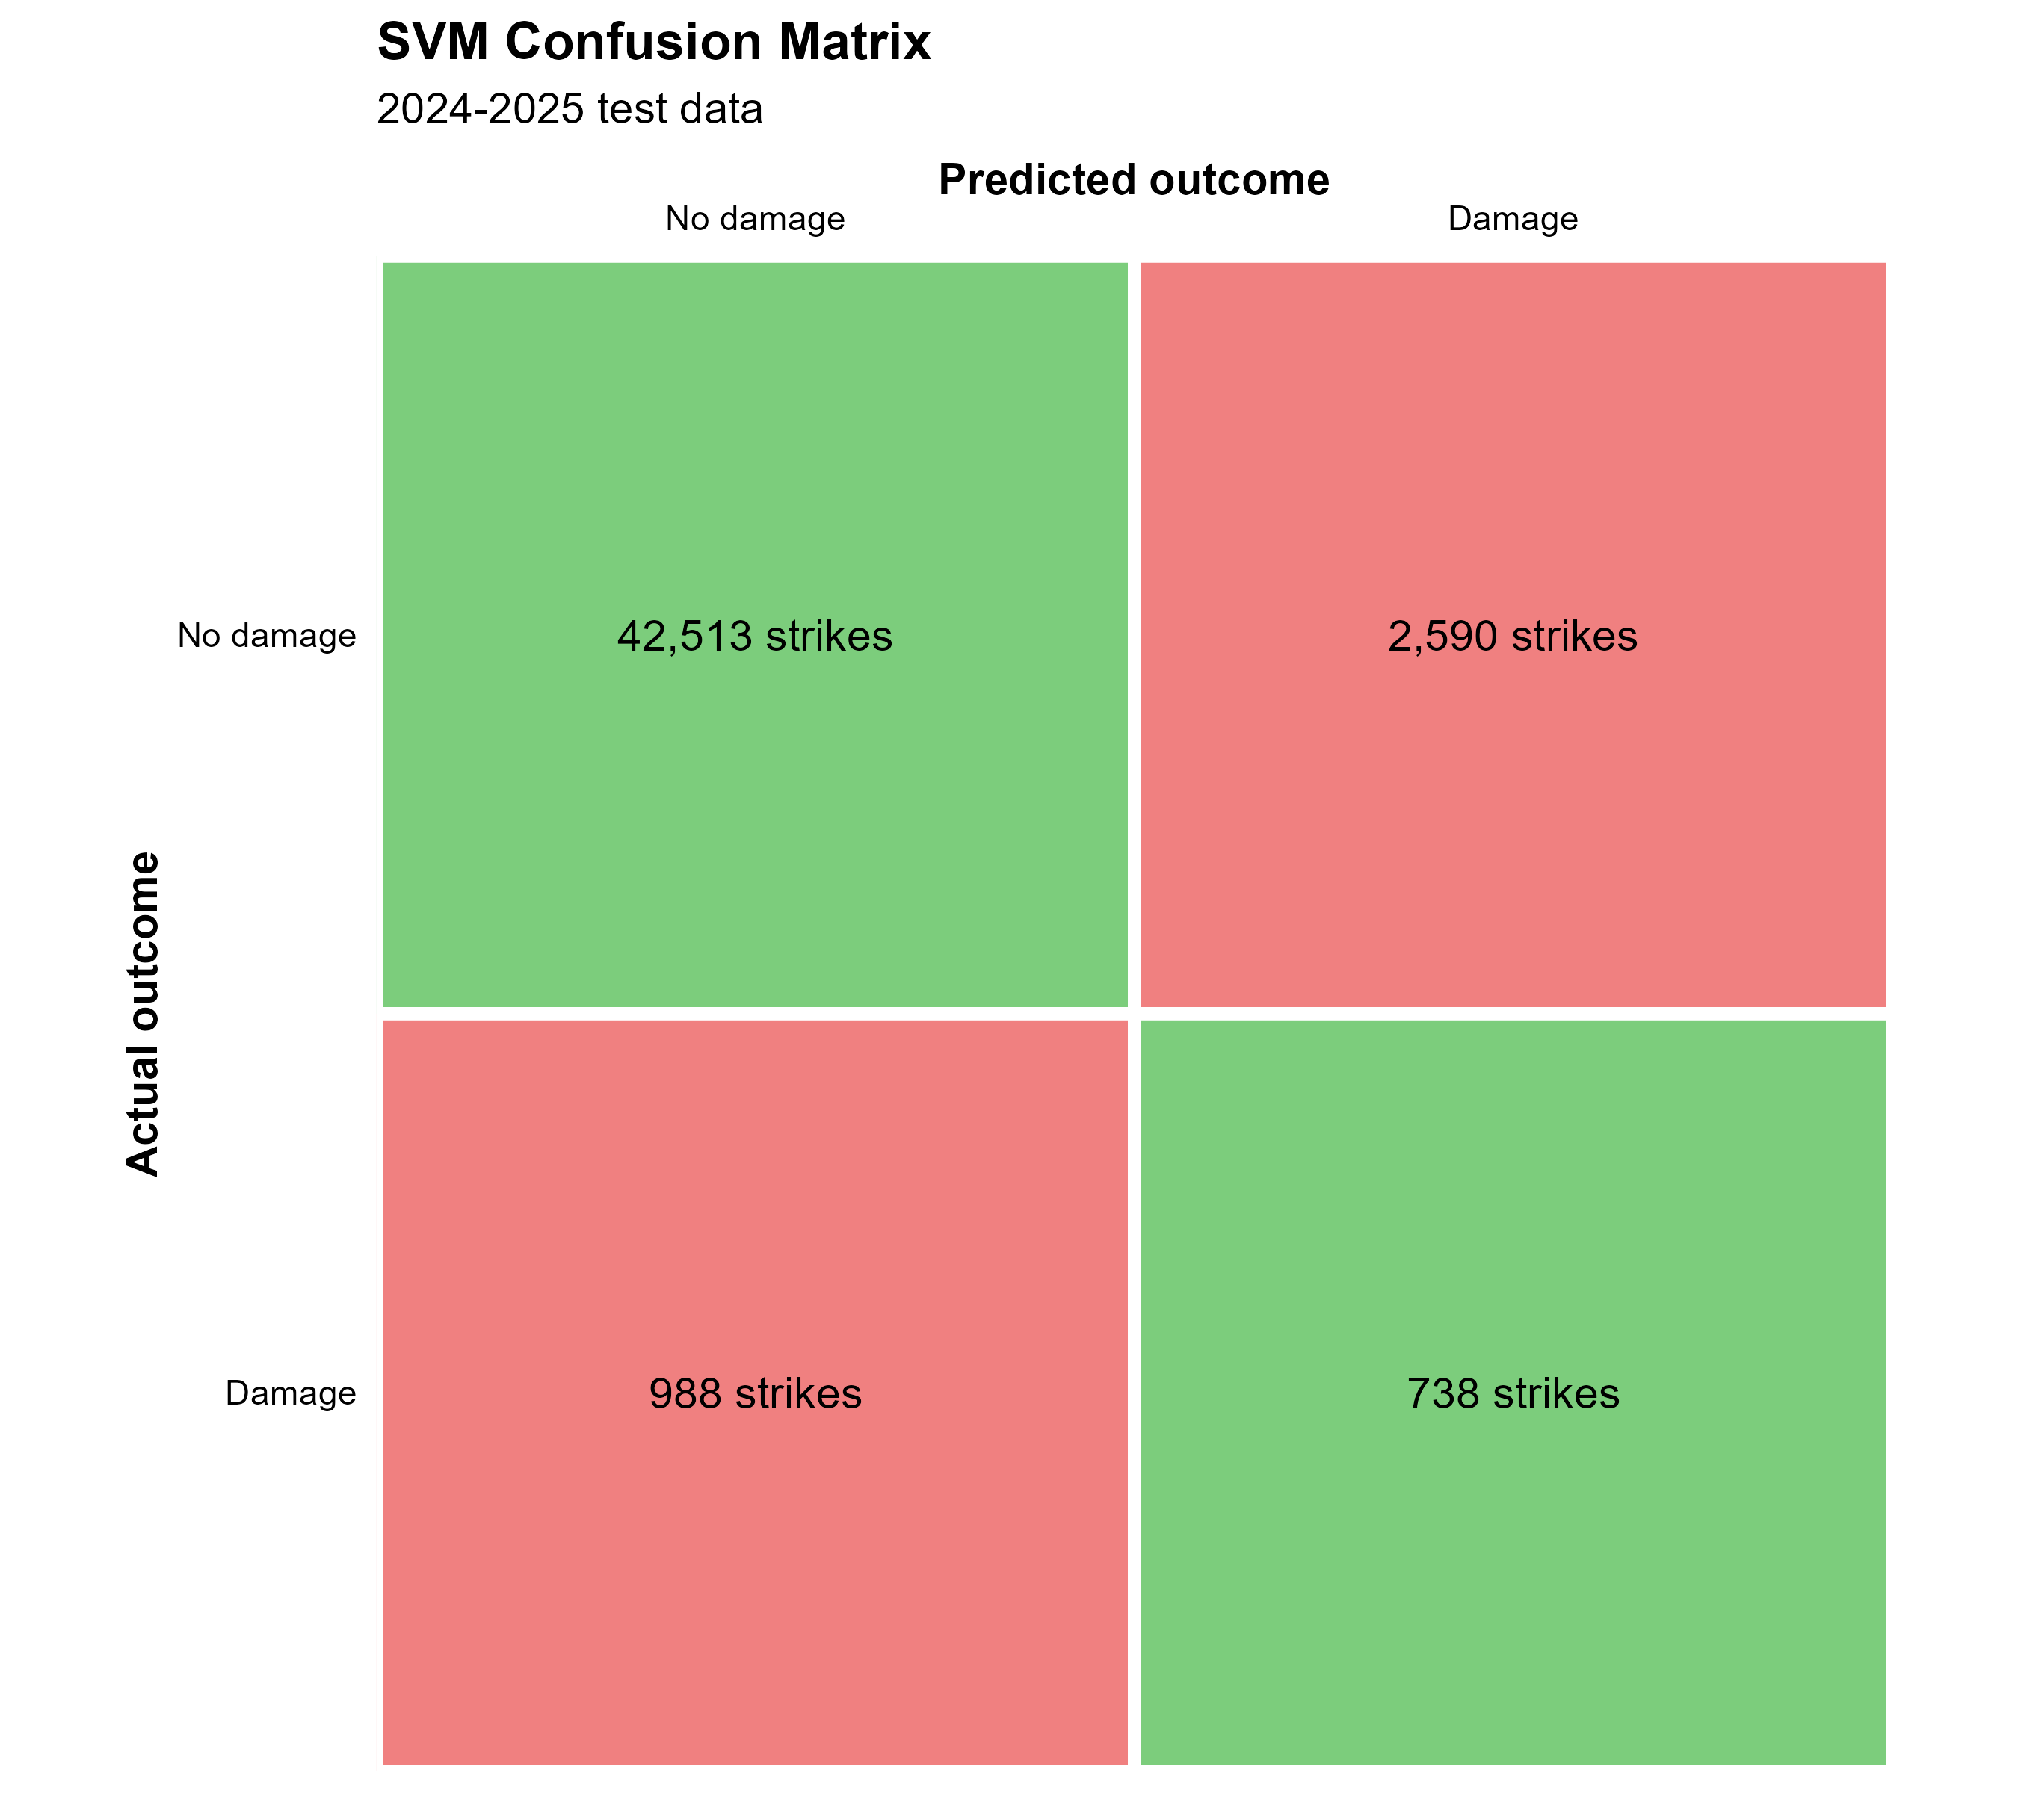
Figure 13. SVM confusion matrix for the combined 2024-2025 test set.

The model correctly classifies 42,513 non-damaging strikes and 738 damaging strikes. It misses 988 damaging strikes and labels 2,590 non-damaging strikes as damaging. Correct classifications lie on the diagonal. These counts show why high overall accuracy should be considered alongside damage recall: most test reports involve no damage.

Limitations and recommendations

Limitations
Reporting is voluntary and incomplete. Counts describe reported incidents, not every encounter. The analysis does not include flight movements, so it cannot calculate strikes per flight. Regional and airport scores can reflect traffic and reporting practices as well as wildlife conditions.
Unknown species, remaining grouping errors and approximate time-of-day filling affect interpretation. The grouping review covered common labels and 177 unmatched labels, not an independent audit of all 974. The lookup makes the choices visible and repeatable, but does not eliminate uncertainty.
Complete-case combination results exclude many records and may differ from excluded reports. Small denominators can produce unstable damage rates even above 30 reports. Calendar migration bins are approximations; uneven period lengths and all-wildlife coverage prevent them from being treated as direct migration measurements.
Both models use a relatively small historical training sample, simple missing-value replacements and imbalanced outcomes. They were assessed on later reports, but they are not validated for operational deployment. Wildlife identification obtained after impact also limits claims about prediction before a strike.

Recommendations
Seasonal attention: Concentrate mitigation efforts during July–October, when 53% of reported strikes occurred.
Location priorities: Examine high-scoring airports and the Eastern and Southern regions more closely. Treat the scores as a starting point rather than an allocation formula. Half of each score is recent reporting volume, so busy airports and regions tend to rank high by construction. Local conditions, traffic levels, and reporting effort should inform any decision before resources are assigned by rank.
Deer control: Strengthen attention to deer access to runways and movement areas. All six deer combinations that met the reporting minimum rank in the top ten, with damage rates from 68.9% to 86.5%. Because those rates hold across arrival and departure and across day, night, and dusk, this is a consistent finding rather than a nighttime pattern and fencing and access control apply throughout the day.
Reporting and identification: Standardize reporting of both damaging and non-damaging strikes and consider stronger reporting requirements. Use feather examination or DNA analysis when suitable remains are available. Approximately 41.8% of damaging reports listed an unknown bird, sometimes identified only by size.

Business questions answered

When are reported strikes most common?
July through October account for 53.0% of the 1990-2025 reports, with August the highest month. The approximate fall-migration period contains 47.2% of reports. These patterns support focusing additional attention on late summer and fall.

Can airports be segmented into risk profiles?
Yes. Equal weighting of damage-rate and recent-strike-count percentiles places 75 airports in High, 499 in Moderate and 89 in Low. Another 2,107 have too few reports to score. Sacramento International has the highest airport score. At the regional level, AEA and ASO score highest.

Which wildlife and strike conditions are associated with damage?
White-tailed deer have the most damage reports among named species, while mule deer have the highest eligible named-species damage rate. Deer account for six of the ten highest-rate group, phase and time combinations; nighttime arrival leads at 86.5%. Among the five most-reported groups shown in the heatmap, daytime en-route strikes involving raptors and gulls/terns stand out. Deer are absent from that heatmap because selection is based on report volume, not damage rate.

Can recorded strike characteristics predict damage?
The models identify some damaging strikes, but neither is reliable enough to use alone for operational decisions. On the same 2024-2025 test records, rpart detects 57.5% of damaging strikes and SVM detects 42.8%. SVM has higher overall accuracy and fewer false alarms; rpart detects more damage. Class imbalance, missing information and wildlife identities learned after an incident limit how these results should be used.

Sources and reproducibility

Source data and supporting references
FAA Wildlife Strike Database: https://wildlife.faa.gov/home. The local FAA export, rather than a newly downloaded dataset, is the basis of the analysis.
BirdCast (Cornell Lab) / All about birds: BirdCast describes most nocturnal spring migration as occurring from mid-March to mid-June and fall migration from mid-August to mid-November. https://birdcast.org/science-center/peak-migration/ https://www.allaboutbirds.org/news/the-basics-how-why-and-where-of-bird-migration/
FAA, Smithsonian Institution Feather Identification Lab: https://www.faa.gov/airports/airport_safety/wildlife/smithsonian. This describes identification using feathers and DNA-bearing remains.
Species lookup conventions and reference links are recorded in data/reference/species_group_lookup_notes.md. Sources include Cornell Lab of Ornithology species/family accounts, Animal Diversity Web and the Mammal Diversity Database. Migration month ranges remain analyst-defined approximations rather than exact dates for every species or location.

Code and output access
The source links throughout this report open the relevant R scripts or result tables directly in the project GitHub repository. Each section identifies the code supporting its methods. The links target the main branch, which can change as the project is updated.

Source: Project repository
Source: Cleaning and derived variables
Source: Full AI Usage Statement

AI disclosure and responsibility
Details about AI assistance and my review process are provided in the linked AI Usage Statement as well as throughout this document.

